Vastu/Nashik/12/2024/012749/2309328
03/6-26 -RPBS
Date: 03.12.2024

To, `
The Branch Manager,
Bank of Baroda
Regional Office Nashik Road Branch
BSNL Building, Datta Mandir Road, Nashik Road,
Nashik -422 101, State - Maharashtra, Country - India.

Sub: Vetting of Extra Amenities

Sir,

With reference to above subject, we have evaluated the Extra Amenities for Residential Flat No. B-302, 3rd Floor, Wing - B, "HARIOM PARADISE Apartment", Behind Audumber banquet & lawns, Shree Samarth Road, Meri- Rasbihari Link Road, Village - Mhasrul, Taluka - Nashik, District - Nashik, Nashik, 422004, State - Maharashtra, India belongs to M/s. HARIOM GROUP. Name of Proposed Purchaser is Mr. Rahul Prakash Deore & Mrs. Vrushali Rahul Deore.

We have verified the rates quoted as per current market rates. Details of Extra Amenities considered as per copy of Agreement for Extra Amenities issued by to Mr. Rahul Prakash Deore & Mrs. Vrushali Rahul Deore (First Party) and Mr. Chintan Prakash Patel (Second Party) received on dated 26.11.2024. The Extra Amenities amount is Rs.8,00,000/- (Rupees Eight Lakh Only.)

The said Cost Vetting Certificate is valid upto next 6 months Only.

Thanking you

Sincerely yours

Manoj B. Chalikwar
Registered Valuer
Chartered Engineer (India)
Reg. No. CAT-I-F-1763
Reg. No. IBBI/RV/07/2018/10366
BOB Empanelment No.: ZO:MZ:ADV:46:941
Encl: Valuation report.

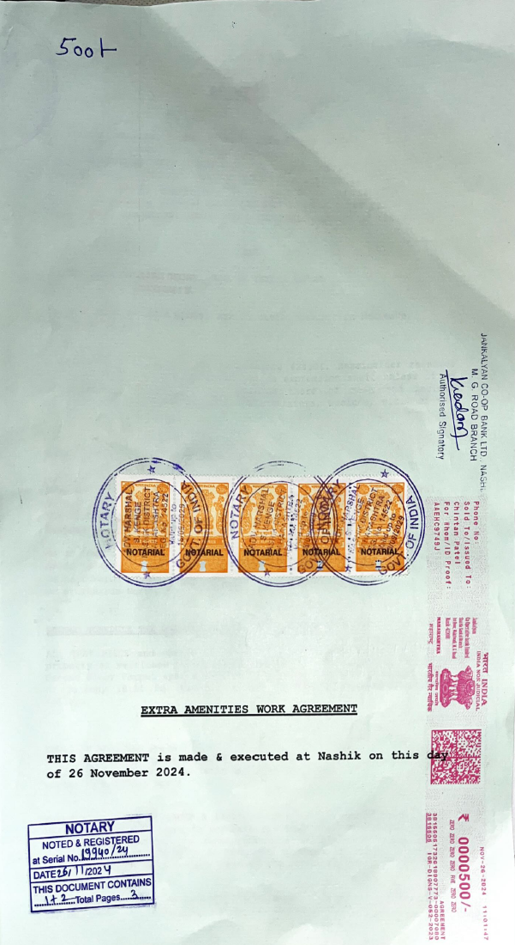
Agreement of Extra Amenities
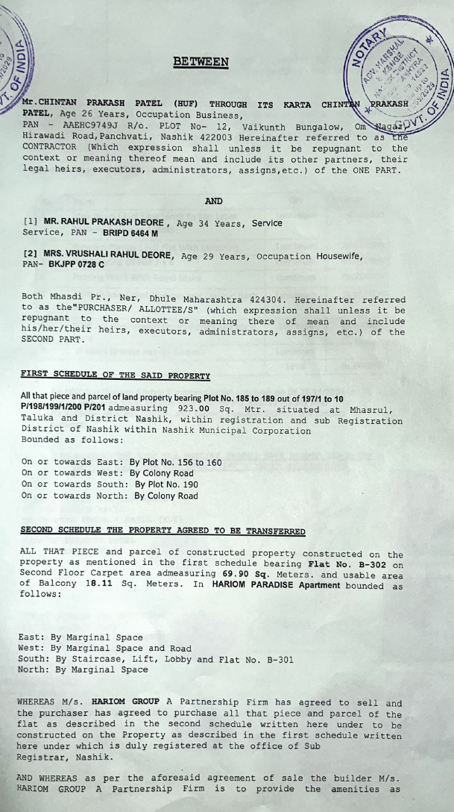

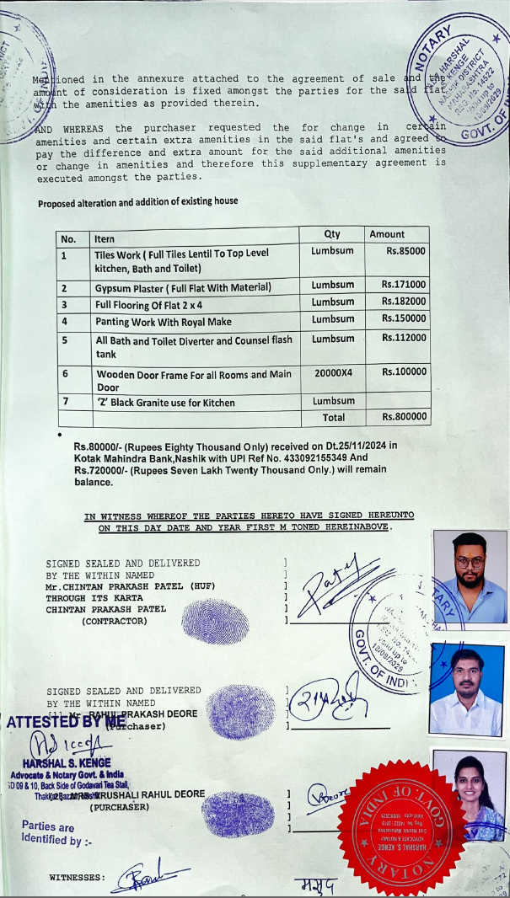

The Extra Work amount is Rs.8,00,000/- (Rupees Eight Lakh Only.)

