Valuation Report of the Immovable Property

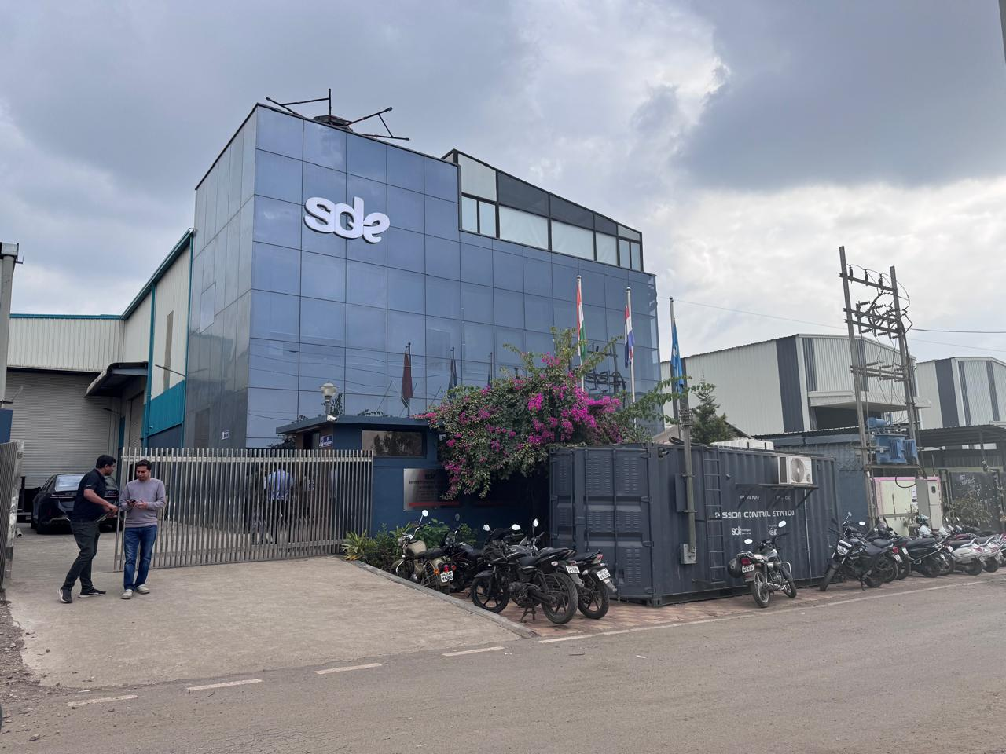

Details of the property under consideration:

Name of Owner: M/s. Ramkamalprasad Tribhuwan Singh

Industrial Land and Building on Plot No. PAP-V-13, Chakan Industrial Area Ph – II, Village – Wasuli, Taluka – Khed, District – Pune, State - Maharashtra, India

Longitude Latitude: 18°46'35.3"N 73°46'00.2"E

Valuation Done for:

State Bank of India
Shivsagar Estate Branch Worli (South)
Devchand House, Ground Floor, Dr. Annie Besant Road, Worli, Mumbai - 400 018,
State - Maharashtra, Country – India.

Vastu/Mumbai/12/2024/12709/2304367
06/1-69-APU
Date: 05.12.2024

VALUATION OPINION REPORT

This is to certify that the property bearing Industrial Land and Building on Plot No. PAP-V-13, Chakan Industrial Area Ph – II, Village – Wasuli, Taluka – Khed, District – Pune, State - Maharashtra, India belongs to M/s. Ramkamalprasad Tribhuwan Singh
Boundaries of the property.

North | : | Open Plot
South | : | Road
East | : | Industrial Shed
West | : | Open Plot/ Industrial Shed
Considering various parameters recorded, existing economic scenario, and the information that is available with reference to the development of neighborhood and method selected for valuation, we are of the opinion that, the property premises can be assessed and Fair market value of the property for banking purpose at
` 4,10,47,670.00 (Rupees Four Crore Ten Lakhs Forty Seven Thousand Six Hundred and Seventy Only)
The valuation of the property is based on the documents produced by the concern. Legal aspects have not been taken into considerations while preparing this valuation report.

Hence certified

Manoj B. Chalikwar
Registered Valuer
Chartered Engineer (India)
Reg. No. CAT-I-F-1763
BOM Emp. No. AX33/CREMON/Valuer / Empanelment/2021-22
Encl: Valuation report.
Vastukala Consultants (I) Pvt. Ltd.
B1-001, U/B Floor, Boomerang, Chandivali Farm Road, Powai, Andheri (East), Mumbai - 400 072.

To,
The Branch Manager,
State Bank of India
Shivsagar Estate Branch Worli (South)
Devchand House, Ground Floor,
Dr. Annie Besant Road, Worli, Mumbai - 400 018,
State - Maharashtra, Country – India.

VALUATION REPORT (IN RESPECT OF LAND AND BUILDING)
I | General
1. | Purpose for which the valuation is made |  | : | As per the request from State Bank of India, Shivsagar Estate Branch Worli (South), to assess Fair market value of the property for banking purpose.
2. | a) | Date of inspection | : | 03.12.2024
 | b) | Date on which the valuation is made | : | 05.12.2024
3. | List of documents produced for perusal
- Copy of Deed of Assignment Dated 12.08.2021 between Mr. Ramkamalprasad Tribhuwan Singh (The Assignee) and Mr. Ramkamalprasad Tribhuwan Singh (The Assignor).
- Copy of Letter for the permission to sub-letting to M/s. Sagar Defence Engineering Pvt. Ltd. issued by MIDC vide Letter No. MIDC/RO(PUNE)/Chakan Ph-II/LMS-384/A-06132 dated 02.02.2024.
- Copy of Allotment Letter No. ROP/CH-II/L-4173 Dated 06.07.2023 Issued by Maharashtra Industrial Development Corporation.
- Copy of Occupancy Certificate Vide Letter No. EE(P)/TB/CHK/PH–II/B-54026/ of 2020 by Office of Executive Engineer, MIDC, Project Division, Chinchwad, Pune – 411 019.
- Copy of Investigation of Tile in respect of immovable property dated 09.04.2024.
- Copy of Layout Plan approved by MIDC vide Inward No. SWC/237/521/2017/1010/518879 Dated 26.12.2017.
4. | Name of the owner(s) and his / their address (es) with Phone no. (details of share of each owner in case of joint ownership) |  | : | M/s. Ramkamalprasad Tribhuwan Singh  Address: Industrial Land and Building on Plot No. PAP-V-13, Chakan Industrial Area Ph – II, Village – Wasuli, Taluka – Khed, District – Pune, State - Maharashtra, India  Mr. Saurabh Patil-Chief Engineer for R&D and Future Program of Sagar Defence Engineering Pvt. Ltd. and Mr. Lakshay Dang-Chief Technology Officer & Co-founder of Sagar Defence Engineering Pvt. Ltd.  Individual Ownership
5. | Brief description of the property (Including Leasehold / freehold etc.):  The Subject Plot Nos. is about 16.6 kms from Talegaon railway station, falling in village Wasuli, Taluka Khed, Pune District. The subject plot is fully developed plot with ample water supply & electricity. The area is having all the necessary civic amenities like Roads, Electricity, Markets and Easy access to Railway Station, National Highway etc. The property on Plot Nos PAP-V-13 is lease for 95 years.
Property
The industrial Building is Standing with the Ground plus Three Upper Floor of Land bearing State Plot No. PAP-V-13, The property is located in a developed area having good infrastructure, well connected by Road and Railway. The immovable property comprises of leasehold Industrial land and structures thereof. It is located at about 16.6 Km. from Talegaon Railway Station.

As per Lease Deed and Approved Plan, the land area is
Sr. No. | Plot No. | Area in Sq. M
1 | PAP-V-13 | 1,215.00
 | Total | 1,215.00
Which is considered for the purpose of valuation.

As per MIDC approved Plan, the structure areas are as below:-

S. No. | Items | FSI Area (Sq. M) | Double Height FSI Area (Sq. M) | Total FSI Area (Sq. M)
1 | Ground Floor | 556.50 | 244.59 | 801.09
2 | First Floor | 69.49 | 0.00 | 69.49
 | Total | 625.98 | 244.59 | 870.57

During our visit we have taken the measurement of structure and the BUA is as under:-

S. No. | Items | Type of Structure | Total BUA (Sq. M)
1 | Office Block | RCC | 347.16
2 | Production Shed | PEB | 474.78
3 | Lean to Shed | PEB | 114.10
4 | Mezzanine Floor | MS | 108.45
 | Total |  | 1,044.49

The allowable Built-Up Area (BUA) is 1,215.00 square meters, while the actual construction, based on our measurements, is 1,044.49 square meters, therefor for the purpose of Valuation, we have taken the Built-Up Area as per our measurements. Company should take revised approval for Layout plan from MIDC.
6. | Location of property |  | :
 | a) | Plot No. / Survey No. | : | Plot No. PAP-V-13, MIDC
 | b) | Door No. | : | Not applicable
 | c) | T.S. No. / Village | : | Village Wasuli
 | d) | Ward / Taluka | : | Taluka Khed
 | e) | Mandal / District | : | Pune
7. | Postal address of the property |  | : | Industrial Land and Building on Plot No. PAP-V-13, Chakan Industrial Area Ph – II, Village – Wasuli, Taluka – Khed, District – Pune, State - Maharashtra, India
8. | City / Town |  | : | Pune
 | Residential area |  | : | Yes
 | Commercial area |  | : | No
 | Industrial area |  | : | Yes
9. | Classification of the area |  | :
 | i) High / Middle / Poor |  | : | Middle Class
 | ii) Urban / Semi Urban / Rural |  | : | Semi Urban
10. | Coming under Corporation limit / Village Panchayat / Municipality |  | : | Village – Wasuli, MIDC Pimpri industrial Area
11. | Whether covered under any State / Central Govt. enactments (e.g., Urban Land Ceiling Act) or notified under agency area/ scheduled area / cantonment area |  | : | No
12. | In Case it is Agricultural land, any conversion to house site plots is contemplated |  | : | N.A.
13. | Boundaries of the property |  |  | As per Document | As per Site Visits
 | North |  | : | Plot No. PAP – V –12 & PAP – V 11 & PAP – V - 9 | Open Plot
 | South |  | : | Plot No. PAP – V –14/1 & PAP – V 14/2 & PAP – V – 14/3 | Road
 | East |  | : | Plot No. PAP – V - 8 | Industrial Shed
 | West |  | : | MIDC Road 15.00 Om Road Wide | Open Plot/ Industrial Shed
14.1 | Dimensions of the site
 |  |  |  | A As per the Deed | B Actuals
 | North |  | : | - | -
 | South |  | : | - | -
 | East |  | : | - | -
 | West |  | : | - | -
14.2 | Latitude, Longitude & Co-ordinates of property |  | : | 18°46'35.3"N 73°46'00.2"E
14. | Extent of the site |  | : | Total plot Area = 1,215.00 Sq. M.  (Area as per Lease Deed & Approved Plan)  Structure Area:- As mentioned above
15. | Extent of the site considered for Valuation (least of 14A& 14B) |  | :
16 | Whether occupied by the owner / tenant? If occupied by tenant since how long? Rent received per month. |  | : | Premises under the possession of the Tenant (M/s. Sagar Defence Engineering Pvt. Ltd.)
II | CHARACTERSTICS OF THE SITE
 | Classification of locality |  | : | Middle class
 | Development of surrounding areas |  | : | Good
 | Possibility of frequent flooding/ sub-merging |  | : | No
 | Feasibility to the Civic amenities like School, Hospital, Bus Stop, Market etc. |  | : | All available near by
 | Level of land with topographical conditions |  | : | Plain
 | Shape of land |  | : | Rectangle
 | Type of use to which it can be put |  | : | For industrial purpose
 | Any usage restriction |  | : | Industrial
 | Is plot in town planning approved layout? |  | : | MIDC Pimpri industrial Area
 | Corner plot or intermittent plot? |  | : | Intermittent
 | Road facilities |  | : | Yes
 | Type of road available at present |  | : | B.T. Road
 | Width of road – is it below 20 ft. or more than 20 ft. |  | : | more than 12.00 M. wide road
 | Is it a Land – Locked land? |  | : | No
 | Water potentiality |  | : | Connected to Municipal line
 | Underground sewerage system |  | : | Connected to Municipal sewer
 | Is Power supply is available in the site |  | : | No
 | Advantages of the site |  | : | Located in developed area
 | Special remarks, if any like threat of acquisition of land for publics service purposes, road widening or applicability of CRZ provisions etc. (Distance from sea-cost / tidal level must be incorporated) |  | : | No
Part – A (Valuation of land)
1 | Size of plot |  | : | Total Plot area = 1,215.00 Sq. M.  (Area as per Lease Deed & Approved Plan)
 | North & South |  | : | -
 | East & West |  | : | -
2 | Total extent of the plot |  | : | Total Plot area = 1,215.00 Sq. M.  (Area as per Lease Deed & Approved Plan)
3 | Prevailing market rate (Along With details / reference of at least two latest deals / transactions with respect to adjacent properties in the areas) |  | : | ` 11,000.00 to ` 13,000.00 per Sq. M. for Industrial Land Details of recent transactions/online listings are attached with the report.
4 | Municipal circle Rates from Government Portal (evidence thereof to be enclosed) |  | : | MIDC Land Rate is ` 5,780.00 per Sq. M. for land.
5 | Assessed / adopted rate of valuation |  | : | As per attached the table below
  Land Area: 1,215.00 Sq.M | ` 12,000.00 Per Sq.M | ` 1,45,80,000.00
6 | Estimated value of land |  | : | ` 1,45,80,000.00
Part – B (Valuation of Building)
1 | Technical details of the building |  | :
 | - Type of Building (Residential / Commercial / Industrial) |  | : | Industrial Building
 | - Type of construction (Load bearing / RCC / Steel Framed) |  | :
  S. No. | Items | Type of Structure
  1 | Office Block | RCC Structure
  2 | Production Shed | PEB
  3 | Lean to Shed | PEB
  4 | Mezzanine Floor | MS
 | - Year of construction |  | : | Proposed RCC Framed Structure
 | - Number of floors and height of each floor including basement, if any |  | : | As per Brief Description
 | - Plinth area floor-wise |  | : | Structure Area
  S. No. | Items | Total BUA (Sq. M)
  1 | Office Block | 347.16
  2 | Production Shed | 474.78
  3 | Lean to Shed | 114.10
  4 | Mezzanine Floor | 108.45
   | Total | 1,044.49
 | - Condition of the building |  | :
 | - Exterior – Excellent, Good, Normal, Poor |  | : | Normal
 | - Interior – Excellent, Good, Normal, Poor |  | : | Normal
 | - Date of issue and validity of layout of approved map |  | : | Copy of Layout Plan approved by MIDC vide Inward No. SWC/237/521/2017/1010/518879 Dated 26.12.2017.
 | - Approved map / plan issuing authority |  | :
 | - Whether genuineness or authenticity of approved map / plan is verified |  | : | Yes
 | - Any other comments by our empanelled valuers on authentic of approved plan |  | : | No.

Specifications of construction (floor-wise) in respect of

Sr. No. | Description
 | Foundation | : | R.C.C. Footing
 | Basement | : | No
 | Superstructure | : | Refer Brief Description
 | Joinery / Doors & Windows (Please furnish details about size of frames, shutters, glazing, fitting etc. and specify the species of timber | : | N. A
 | RCC Works | : | Footing, Column, Beam, Part Slab
 | Plastering | : | Sand faced
 | Flooring, Skirting, dado | : | Kadappa & Spartex
 | Special finish as marble, granite, wooden paneling, grills etc. | : | No
 | Roofing including weather proof course | : | Yes
 | Drainage | : | Connected to Municiapal line

2. | Compound Wall | :
 | Height | : | 5'.0" High, R.C.C. columns with B. B. Masonry wall.
 | Length | : | 5'.0" High, R.C.C. columns with B. B. Masonry wall.
 | Type of construction | : | 5'.0" High, R.C.C. columns with B. B. Masonry wall.
3. | Electrical installation | :
 | Type of wiring | : | Provided as per requirement
 | Class of fittings (superior / ordinary / poor) | : | Provided as per requirement
 | Number of light points | : | Provided as per requirement
 | Fan points | : | Provided as per requirement
 | Spare plug points | : | Provided as per requirement
 | Any other item | : | -
4. | Plumbing installation
 | - No. of water closets and their type | : | Provided as per requirement
 | - No. of wash basins | : | Provided as per requirement
 | - No. of urinals | : | Provided as per requirement
 | - No. of bath tubs | : | Provided as per requirement
 | - Water meters, taps etc. | : | Provided as per requirement
 | - Any other fixtures | : | Provided as per requirement

Structure (as per approved plan)

Structure No. | Built Up Area | Total Life of Structure | Estimated Replacement Rate | Age of Build. In Years | Final Depreciated Rate to be considered | Final Depreciated Value to be considered | Estimated Replacement Cost / Insurable Value
 | (Sq. M.) |  | (`) |  | (`) | (`) | (`)
Office Block | 347.16 | 50 | 30,000 | 28 | 30,000 | 1,04,14,800 | 1,04,14,800
Production Shed | 474.78 | 50 | 25,000 | 28 | 25,000 | 1,18,69,620 | 1,18,69,620
Lean to Shed | 114.10 | 50 | 10,000 | 28 | 10,000 | 11,41,000 | 11,41,000
Mezzanine Floor | 108.45 | 50 | 5,000 | 28 | 5,000 | 5,42,250 | 5,42,250
Land Development |  |  |  |  |  | 25,00,000 | 25,00,000
Total | 1,044.49 |  |  |  |  | 2,64,67,670 | 2,64,67,670

Part – C (Extra Items) |  | : | Amount in `
 | Portico | : | Included in the Cost of Construction
 | Ornamental front door | :
 | Sit out / Verandah with steel grills | :
 | Overhead water tank | :
 | Extra steel / collapsible gates | :
 | Total

Part – D (Amenities) |  | : | Amount in `
 | Wardrobes | : | Included in the Cost of Construction
 | Glazed tiles | :
 | Extra sinks and bath tub | :
 | Marble / ceramic tiles flooring | :
 | Interior decorations | :
 | Architectural elevation works
 | Paneling works
 | Aluminum works
 | Aluminum hand rails
 | False ceiling
 | Total

Part – E (Miscellaneous) |  | : | Amount in `
 | Separate toilet room | : | Included in the Cost of Construction
 | Separate lumber room | :
 | Separate water tank / sump | :
 | Trees, gardening | :
 | Total

Part – F (Services) |  | : | Amount in `
 | Water supply arrangements | : | Included in the Cost of Construction
 | Drainage arrangements | :
 | Compound wall | :
 | C.B. deposits, fittings etc. | :
 | Pavement
 | Total

Total abstract of the entire property
Part – A | Land | : | ` 1,45,80,000.00
Part – B | Building | : | ` 2,64,67,670.00
Part – C | Compound wall | :
Part – D | Amenities | :
Part – E | Pavement | :
Part – F | Services | :
 | Total Fair Market Value | : | ` 4,10,47,670.00
 | Total Realizable value | : | ` 3,48,90,520.00
 | Total Distress value | : | ` 2,87,33,369.00
 | Total Insurable value | : | ` 2,64,67,670.00
Remarks

Proposed development potential method is adopted for valuation. In this method we have analysed the development potential of land in terms of FSI Applicable and other development control regulations are taken into consideration. Accordingly, we have calculated development potential as a commercial cum residential project development. As the subject location is very premium for commercial showroom and residential project, we have considered the same for evaluation process.

We have considered prevailing market rates Industrial properties for calculation of sale price.

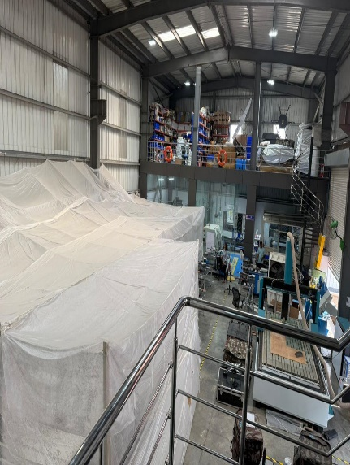
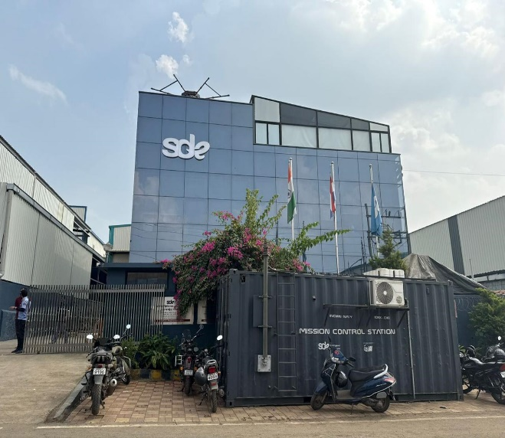
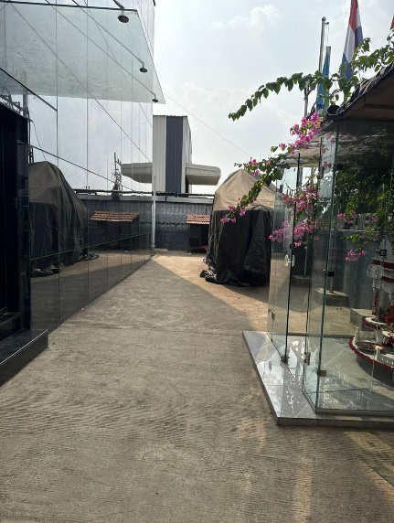
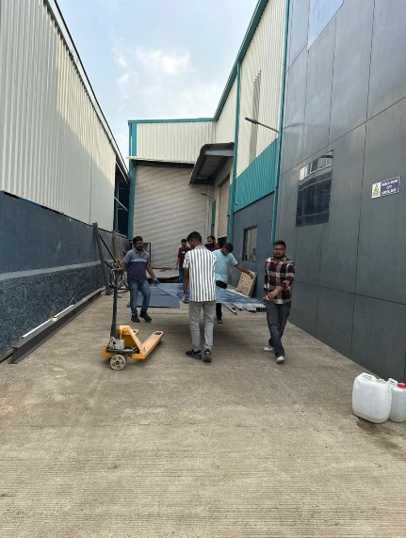
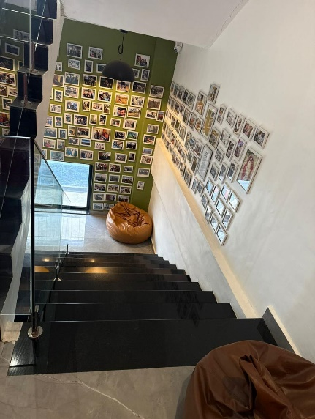
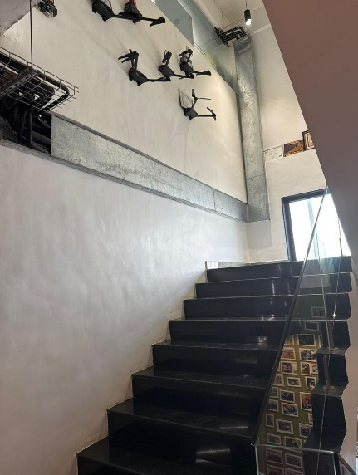
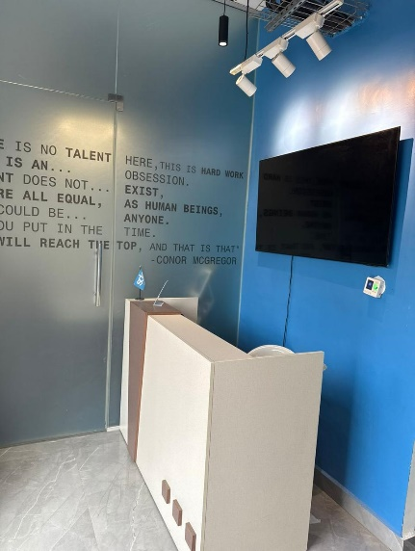
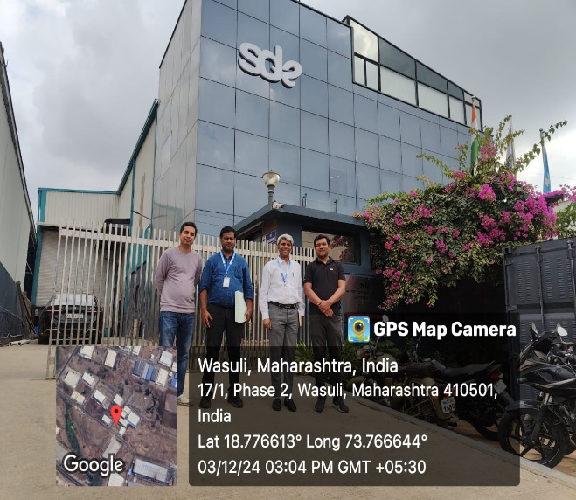
Actual Site Photographs

Route Map of the property

Site u/r
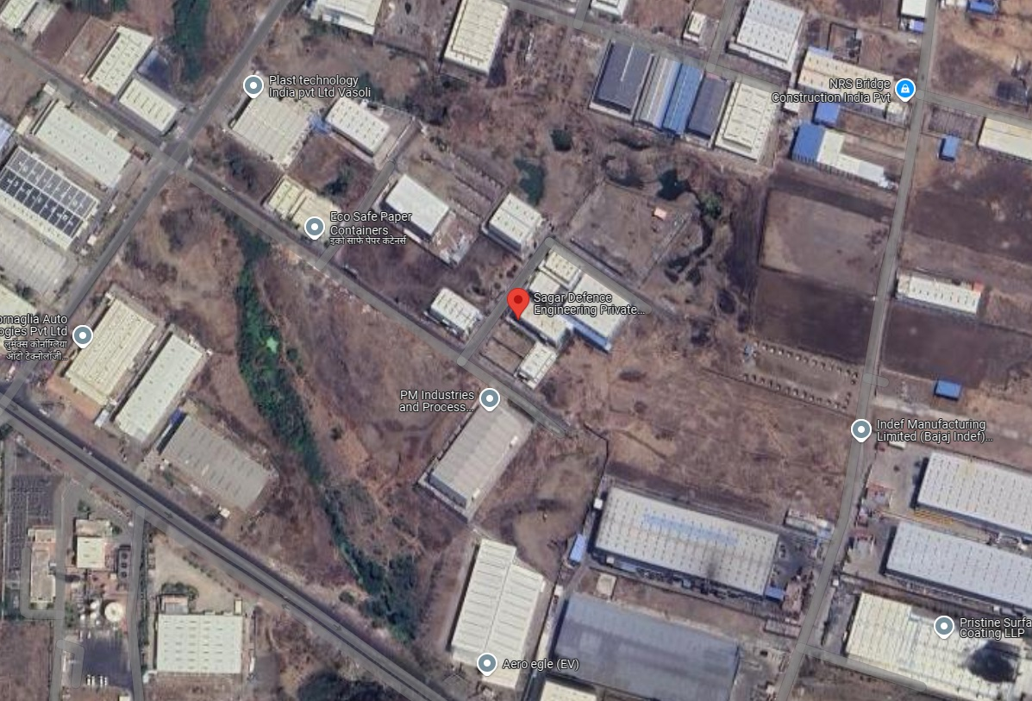

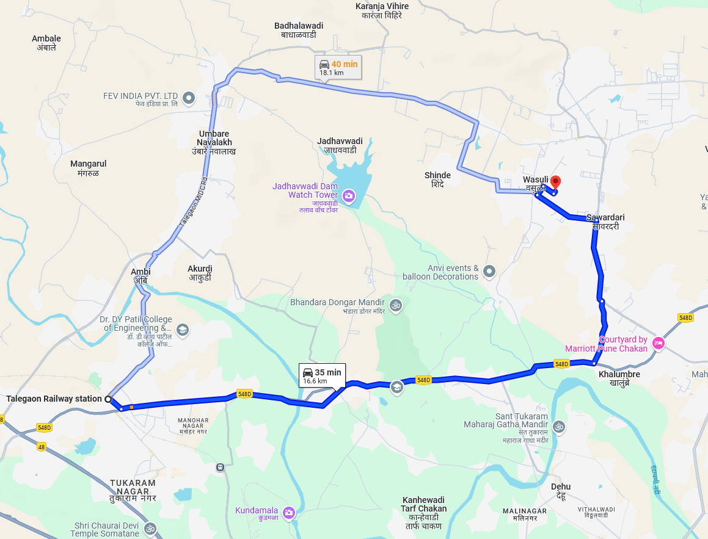

Longitude Latitude: 18°46'35.3"N 73°46'00.2"E

Note: The Blue line shows the route to site from nearest Railway station (Talegaon – 16.6 Km.)

MIDC LAND RATES
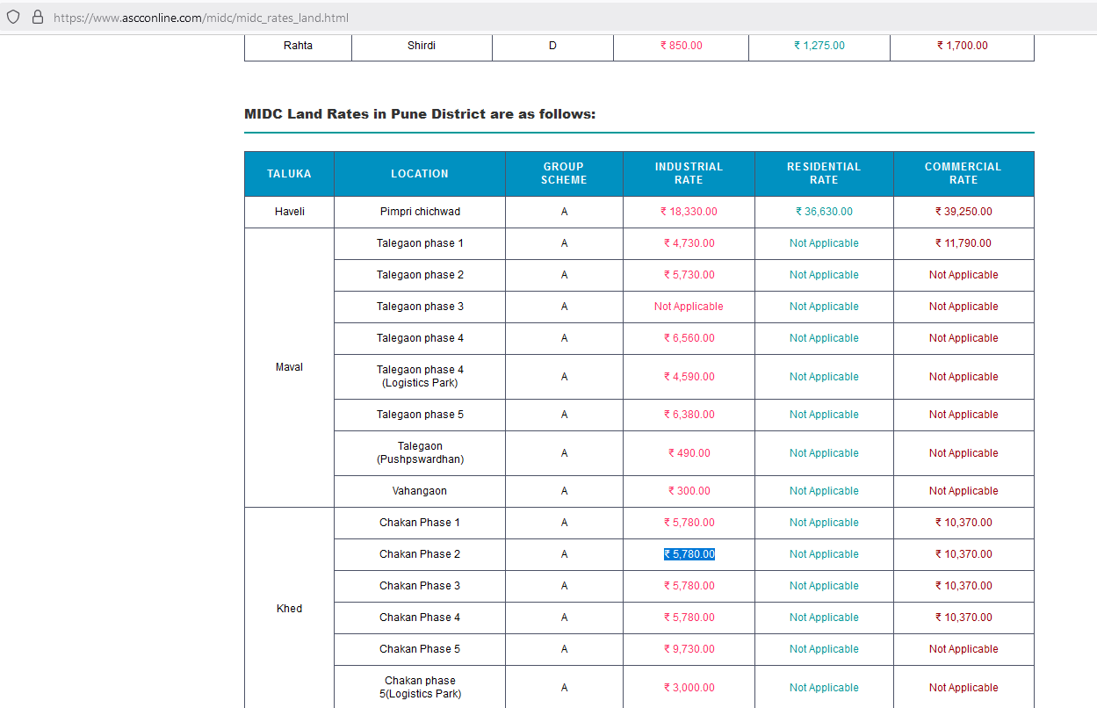
Price Indicators for Industrial Estate

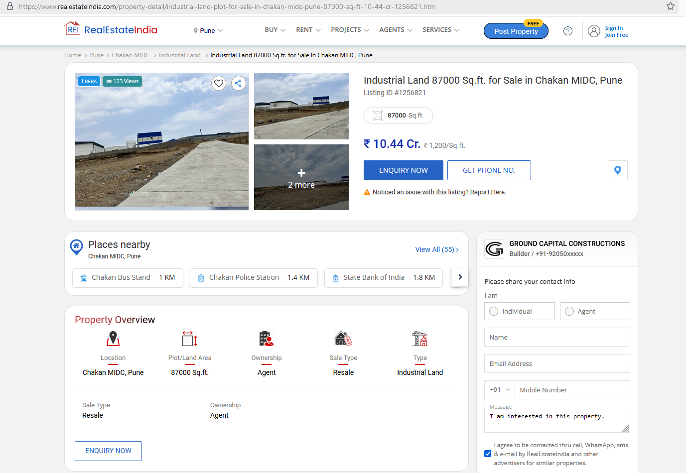

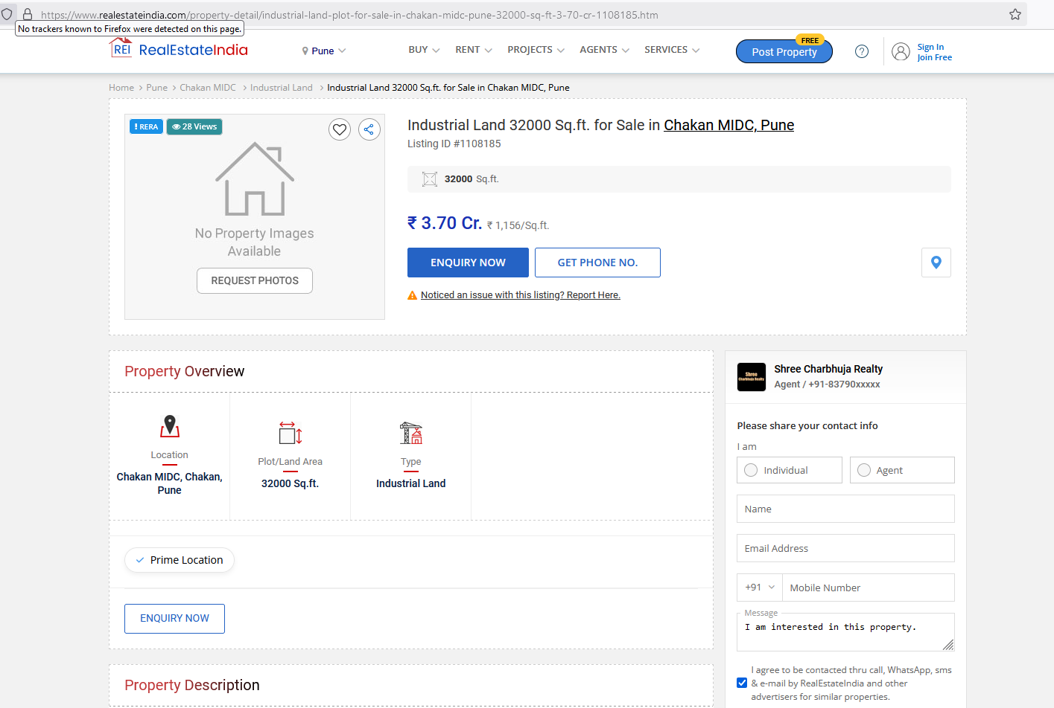
As a result of my appraisal and analysis, it is my considered opinion that the Fair market value of the property for banking purpose at of the above property in the prevailing condition with aforesaid specification is
` 4,10,47,670.00 (Rupees Four Crore Ten Lakhs Forty Seven Thousand Six Hundred and Seventy Only). The Realizable Value of the above property is ` 3,48,90,520.00 (Rupees Three Crore Forty Eight Lakh Ninety Thousand Five Hundred and Twenty Only). The distress value ` 2,87,33,369.00 (Rupees Two Crore Eighty Seven Lakh Thirty Three Thousand Three Hundred and Sixty Nine Only).

Place: Mumbai
Date: 05.12.2024

Manoj B. Chalikwar
Registered Valuer
Chartered Engineer (India)
Reg. No. CAT-I-F-1763
BOM Emp. No. AX33/CREMON/Valuer / Empanelment/2021-22
Encl: Valuation report.

The undersigned has inspected the property detailed in the Valuation Report dated _______________________

on ____________________. We are satisfied that the fair and reasonable market value of the property is

`_________________________ (Rupees ________________________________________________________

________________________________________only).

Date
Signature
(Name & Designation of the Inspecting Official/s)

Countersigned
(BRANCH MANAGER)

Enclosures
 | Declaration-cum-undertaking from the valuer (Annexure- I) | Attached
 | Model code of conduct for valuer - (Annexure - II) | Attached
(Annexure-I)

DECLARATION-CUM-UNDERTAKING

I, Manoj B.Chalikwar son of Shri. Baburao Chalikwar do hereby solemnly affirm and state that:

- I am a citizen of India.

- I will not undertake valuation of any assets in which I have a direct or indirect interest or become so interested at any time during a period of three years prior to my appointment as valuer or three years after the valuation of assets was conducted by me.

- The information furnished in my valuation report dated 05.12.2024 is true and correct to the best of my knowledge and belief and I have made an impartial and true valuation of the property.

- I/ my authorized representative has personally inspected the property on 03.12.2024. The work is not sub - contracted to any other valuer and carried out by myself.

- Valuation report is submitted in the format as prescribed by the bank.

- I have not been depanelled / delisted by any other bank and in case any such depanelment by other banks during my empanelment with you, I will inform you within 3 days of such depanelment.

- I have not been removed / dismissed from service / employment earlier.

- I have not been convicted of any offence and sentenced to a term of imprisonment

- I have not been found guilty of misconduct in my professional capacity.

- I have not been declared to be unsound mind

- I am not an undischarged bankrupt, or has not applied to be adjudicated as a bankrupt;

- I am not an undischarged insolvent.

- I have not been levied a penalty under section 271J of Income-tax Act, 1961 (43 of 1961) and time limit for filing appeal before Commissioner of Income-tax (Appeals) or Income-tax Appellate Tribunal, as the case may be having expired, or such penalty has been confirmed by Income-tax Appellate Tribunal, and five years have not elapsed after levy of such penalty

- I have not been convicted of an offence connected with any proceeding under the Income Tax Act 1961, Wealth Tax Act 1957 or Gift Tax Act 1958 and

- My PAN Card number as applicable is AEAPC0117Q

- I undertake to keep you informed of any events or happenings which would make me ineligible for empanelment as a valuer

- I have not concealed or suppressed any material information, facts and records and I have made a complete and full disclosure

- I have read the Handbook on Policy, Standards and procedure for Real Estate Valuation, 2011 of the IBA and this report is in conformity to the "Standards" enshrined for valuation in the Part - B of the above handbook to the best of my ability.

- I have read the International Valuation Standards (IVS) and the report submitted to the Bank for the respective asset class is in conformity to the "Standards" as enshrined for valuation in the IVS in "General Standards" and "Asset Standards" as applicable. The valuation report is submitted in the prescribed format of the bank.

- I am registered under Section 34 AB of the Wealth Tax Act, 1957.

- I am valuer registered with Insolvency & Bankruptcy Board of India (IBBI)

- My CIBIL Score and credit worthiness is as per Bank's guidelines.

- I am Chairman & Managing Director of the company, who is competent to sign this valuation report.

- I will undertake the valuation work on receipt of Letter of Engagement generated from the system (i.e., LLMS / LOS) only.

- Further, I hereby provide the following information.
 | Particulars | Valuer comment
 | Background information of the asset being valued; | The land is leased form MIDC for the period of 95 years.
 | Purpose of valuation and appointing authority | As per the request from State Bank of India, Shivsagar Estate Branch Worli (South), to assess Fair market value of the property for banking purpose.
 | Identity of the Valuer and any other experts involved in the valuation; | Manoj B. Chalikwar – Regd. Valuer  Umang Patel – Regd. Valuer  Avinash Pandey– Valuation Engineer
 | Disclosure of Valuer interest or conflict, if any; | We have no interest, either direct or indirect, in the property valued. Further to state that we do not have relation or any connection with property owner / applicant directly or indirectly. Further to state that we are an independent Valuer and in no way related to property owner / applicant
 | Date of appointment, valuation date and date of report; | Date of Appointment – 30.11.2024  Valuation Date – 05.12.2024  Date of Report – 05.12.2024
 | Inspections and/or investigations undertaken; | Physical Inspection done on date 03.12.2024
 | Nature and sources of the information used or relied upon; | Market Survey at the time of site visit  Ready Reckoner rates / Circle rates  Online search for Registered Transactions  Online Price Indicators on real estate portals  Enquiries with Real estate consultants  Existing data of Valuation assignments carried out by us
 | Procedures adopted in carrying out the valuation and valuation standards followed; | Proposed development potential method is adopted for valuation. In this method we have analysed the development potential of land in terms of FSI Applicable, TDR, Fungible FSI and other development control regulations are taken into consideration.  Accordingly, we have calculated development potential as a commercial cum residential project development.  As the subject location is very premium for commercial showroom and residential project, we have considered the same for evaluation process.  We have considered prevailing market rates for residential & commercial properties for calculation of sale price.
 | Restrictions on use of the report, if any; | This valuation is for the use of the party to whom it is addressed and for no other purpose. No responsibility is accepted to any third party who may use or rely on the whole or any part of this valuation. The valuer has no pecuniary interest that would conflict with the proper valuation of the property.
 | Major factors that were taken into account during the valuation; | Current market conditions, demand and supply position, industrial land size, location, sustained demand for industrial land, all round development of commercial and industrial application in the locality etc.
 | Caveats, limitations and disclaimers to the extent they explain or elucidate the limitations faced by valuer, which shall not be for the purpose of limiting his responsibility for the valuation report. | Attached

Assumptions, Disclaimers, Limitations & Qualifications
Value Subject to Change
The subject appraisal exercise is based on prevailing market dynamics as on 05th December 2024. and does not take into account any unforeseeable developments which could impact the same in the future.
Our Investigations
We are not engaged to carry out all possible investigations in relation to the subject property. Where in our report we identify certain limitations to our investigations, this is to enable the reliant party to instruct further investigations where considered appropriate or where we recommend as necessary prior to reliance. Vastukala Consultants India Pvt. Ltd. (VCIPL) is not liable for any loss occasioned by a decision not to conduct further investigations
Assumptions
Assumptions are a necessary part of undertaking valuations. VCIPL adopts assumptions for the purpose of providing valuation advise because some matters are not capable of accurate calculations or fall outside the scope of our expertise, or out instructions. The reliant party accepts that the valuation contains certain specific assumptions and acknowledge and accept the risk of that if any of the assumptions adopted in the valuation are incorrect, then this may have an effect on the valuation.
Information Supplied by Others
The appraisal is based on the information provided by the client. The same has been assumed to be correct and has been used for appraisal exercise. Where it is stated in the report that another party has supplied information to VCIPL, this information is believed to be reliable but VCIPL can accept no responsibility if this should prove not to be so.
Future Matters
To the extent that the valuation includes any statement as to a future matter, that statement is provided as an estimate and/or opinion based on the information known to VCIPL at the date of this document. VCIPL does not warrant that such statements are accurate or correct.
Map and Plans
Any sketch, plan or map in this report is included to assist the reader while visualising the property and assume no responsibility in connection with such matters.
Site Details
Based on inputs received from Client's representative and site visit conducted, we understand that the subject property is currently a contiguous and non-agricultural land parcel admeasuring 1,215.00 Sq. M. and structures thereof. The property is owned by Mr. Ramkamalprasad Tribhuwan Singh At present, the property is Owner occupied. Further, VCIPL has assumed that the subject property is free from any encroachment and is available as on the date of the appraisal.
Property Title
Based on our discussion with the Client, we understand that the property is owned by
Mr. Ramkamalprasad Tribhuwan Singh For the purpose of this appraisal exercise, we have assumed that the subject property has a clear title and is free from any encumbrances, disputes and claims. VCIPL has made no further enquiries with the relevant local authorities in this regard and does not certify the property as having a clear and marketable title. Further, no legal advice regarding the title and ownership of the subject property has been obtained for the purpose of this appraisal exercise. It has been assumed that the title deeds are clear and marketable.
Environmental Conditions
We have assumed that the subject property is not contaminated and is not adversely affected by any existing or proposed environmental law and any processes which are carried out on the property are regulated by environmental legislation and are properly licensed by the appropriate authorities.
Town Planning
The permissible land use, zoning, achievable FSI, area statement adopted for purpose of this valuation is based on the information provided by the Client's representative and the same has been adopted for this valuation purpose. VCIPL has assumed the same to be correct and permissible. VCIPL has not validated the same from any authority.
Area
Based on the information provided by the Client's representative, we understand that the subject property is contiguous and non-agricultural land parcel admeasuring 1,215.00 Sq. M. and structure thereof.
Condition & Repair
In the absence of any information to the contrary, we have assumed that there are no abnormal ground conditions, nor archaeological remains present which might adversely affect the current or future occupation, development or value of the property. The property is free from rat, infestation, structural or latent defect. No currently known deleterious or hazardous materials or suspect techniques will be used in the construction of or subsequent alteration or additions to the property and comments made in the property details do not purport to express an opinion about, or advise upon, the condition of uninspected parts and should not be taken as making an implied representation or statement about such parts
Valuation Methodology
For the purpose of this valuation exercise, the valuation methodology used is Proposed development potential Method and proposed Highest and Best Use model is used for analysing development potential.
In this method we have analysed the development potential of land in terms of FSI Applicable, TDR, Fungible FSI and other development control regulations are taken into consideration. Accordingly we have calculated development potential as a commercial cum residential project development. As the subject location is very premium for commercial showroom and residential project, we have considered the same for evaluation process. We have considered prevailing market rates for residential & commercial properties for calculation of sale price.
In case of inadequate recent transaction activity in the subject micro-market, the appraiser would collate details of older transactions. Subsequently, the appraiser would analyse rental / capital value trends in the subject micro-market in order to calculate the percentage increase / decrease in values since the date of the identified transactions. This percentage would then be adopted to project the current value of the same.
Where reliance has been placed upon external sources of information in applying the valuation methodologies, unless otherwise specifically instructed by Client and/or stated in the valuation, VCIPL has not independently verified that information and VCIPL does not advise nor accept it as reliable. The person or entity to whom the report is addressed acknowledges and accepts the risk that if any of the unverified information in the valuation is incorrect, then this may have an effect on the valuation.
Not a Structural Survey
We state that this is a valuation report and not a structural survey
Other
All measurements, areas and ages quoted in our report are approximate
Legal
We have not made any allowances with respect to any existing or proposed local legislation relating to taxation on realization of the sale value of the subject property. VCIPL is not required to give testimony or to appear in court by reason of this appraisal report, with reference to the property in question, unless arrangement has been made thereof. Further, no legal advice on any aspects has been obtained for the purpose of this appraisal exercise
Property specific assumptions
Based on inputs received from the client and site visit conducted, we understand that the subject property is currently owner occupied, contiguous and non-agricultural land parcel admeasuring 1,215.00 Sq. M. and structure thereof

ASSUMPTIONS, CAVEATS, LIMITATION AND DISCLAIMERS
- We assume no responsibility for matters of legal nature affecting the property appraised or the title thereto, nor do we render our opinion as to the title, which is assumed to be good and marketable.
- The property is valued as though under responsible ownership.
- It is assumed that the property is free of liens and encumbrances.
- It is assumed that there are no hidden or unapparent conditions of the subsoil or structure that would render it more or less valuable. No responsibility is assumed for such conditions or for engineering that might be required to discover such factors.
- There is no direct/ indirect interest in the property valued.
- The rates for valuation of the property are in accordance with the Govt. approved rates and prevailing market rates
DEFINITION OF VALUE FOR THIS SPECIFIC PURPOSE

This exercise is to assess Fair Market Value of the property under reference as on 05th December 2024.

The term Fair Market Value is defined as

“The most probable price, as of a specified date, in cash, terms equivalent to cash, or in other precisely revealed terms for which the specified property rights would sell after reasonable exposure in a competitive market under all conditions requisite to a fair sale, with the buyer and seller each acting prudently knowledgeably and for self interest assuming that neither is under undue duress”.

Fundamental assumptions and conditions presumed in this definition are:

1. Buyer and seller are motivated by self-interest.
2. Buyer and seller are well informed and are acting prudently.
3. The property is exposed for a reasonable time on the open market.
4. Payment is made in cash or equivalent or in specified financing terms.
DECLARATION OF PROFESSIONAL FEES CHARGED

We hereby declare that, our professional fees are not contingent upon the valuation findings. However, if the statute AND/OR clients demands that, the fees should be charged on the percentage of assessed value then, with the full knowledge of the AND/OR end user, it is being charged accordingly.

VALUATION OF THE PROPERTY PREMISES

Considering various parameters recorded, existing economic scenario, and the information that is available with reference to the development of neighborhood and method selected for valuation, we are of the opinion that, the property premises can be assessed and Fair market value of the property for banking purpose at
` 4,10,47,670.00 (Rupees Four Crore Ten Lakhs Forty Seven Thousand Six Hundred and Seventy Only).

Manoj B. Chalikwar
Registered Valuer
Chartered Engineer (India)
Reg. No. CAT-I-F-1763
BOM Emp. No. AX33/CREMON/Valuer / Empanelment/2021-22
Encl: Valuation report.

