Valuation Report of the Immovable Property

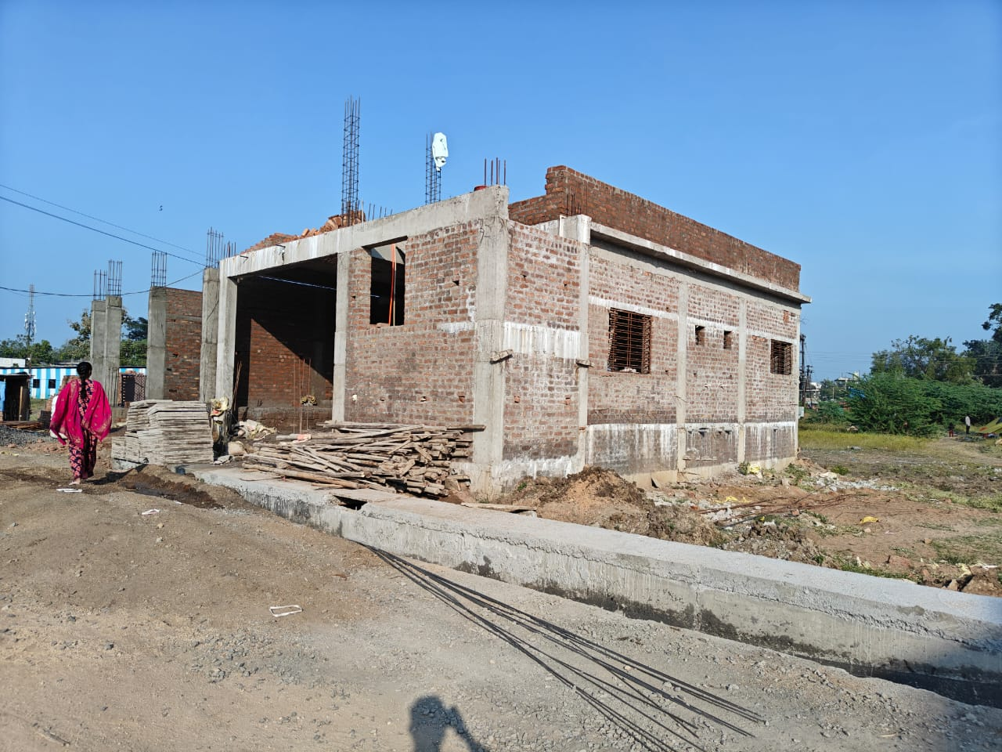

**Details of the property under consideration:**

**Name of Owner: Shri. Sainath S/o Pandhari Pujarwad.**

M. H. No. 1065/28, Plot No.28, S.No.187/2, Behind Hanuman Temple, Sahara Colony, Mauje Ratnali, Taluka. Dharmabad, Dist. Nanded, State – Maharashtra, Country - India.

# **Longitude Latitude: 18°53'12.6"N 77°50'26.6"E**

**Valuation Done for:**

**Axis Bank**

Branch Nanded.

Vastu/Nanded/10/2024/12698/2308760

22/18-300-SPPY

Date: 04.12.2024

|  |  |  |  |  |  |
| --- | --- | --- | --- | --- | --- |
| **Recommended Valuation of the Property in Rs** | | | | | |
|  | | | | | |
| Recommended rate of the plot per Sqm | Rs.10,000.00 | Plot Area in Sqm | | 117.00 | 11,70,000.00 |
| Estimated Cost of Construction |  | Built up Area in Sqm | | | 28,52,226.00 |
| Ground Floor | | 70.20 |
| First Floor | | 70.20 |
| Estimated Cost of Amenities | | Bore well | | | 1,00,000.00 |
| Total Value of Land & Building After 100 % Completion | | | | | **41,22,226.00** |
| Stage of Construction | | | Ground Floor Work is in Progress. | | |
| % Work completed | | | 52 % | | |
| % Disbursement Recommended | | | 55 % | | |
| Value of the property as on the date (52 % Work Completed) 11,70,000.00 + 52 % (28,52,226.00 +1,00,000.00) | | | 27,53,158.00 | | |
| Distressed value of property (52 % work as on date) | | | 21,43,558.00 | | |
| Total Amount of Estimate submitted by client | | |  | | |
| Total Estimated cost of renovation as per prevailing market rate | | | N.A. | | |

Remarks:

* Plot & Built-Up Area Considered as per Approved Building Plan.
* 52 % Work Completed.
* There is deviation in actual construction & Municipal Sanctioned Plan. Refer Point No 10.13, Page No. 5 for construction deviation.
* Estimate is as per Municipal Sanction Plan.

For, **Vastukala Consultants (I) Pvt. Ltd.**

**Sharadkumar B. Chalikwar**

B.E. (Civil), M.E. (Civil), M.Sc. (Real Estate Valuation), M.Sc. (P&M Valuation), FIE (I), FIV, FIWRS

Chairman & Managing Director

Govt. Reg. Valuer

Chartered Engineer (India)

Reg. No. (N) CCIT/1-14/52/2008-09

IBBI Reg.No. IBBI/RV/07/2019/11744

|  |  |  |  |  |  |  |  |  |  |  |  |  |  |  |  |  |  |  |  |  |  |  |  |  |  |  |  |  |  |  |  |  |  |  |  |  |  |  |  |  |  |  |  |  |  |  |  |  |  |  |  |  |  |  |  |  |  |  |  |  |  |  |  |  |  |  |  |  |  |  |  |  |  |  |  |  |  |  |  |  |  |  |  |  |  |  |  |  |  |  |  |  |  |  |  |  |  |  |  |  |  |  |  |  |  |  |  |  |  |  |  |  |  |  |  |  |  |  |  |  |  |  |  |  |  |  |  |  |  |  |  |  |  |  |  |  |  |  |  |  |  |  |  |  |  |  |  |  |  |  |  |  |  |  |  |  |  |  |  |  |  |  |  |  |  |  |  |  |  |  |  |  |  |  |  |  |  |  |  |  |  |  |  |  |  |  |  |  |  |  |  |  |  |  |  |  |  |  |  |  |  |  |  |  |  |  |  |  |  |  |  |  |  |  |  |  |  |  |  |  |  |  |  |  |  |  |  |  |  |  |  |  |  |  |  |  |  |  |  |  |  |  |  |  |  |  |  |  |  |  |  |  |  |  |  |  |  |  |  |  |  |  |  |  |  |  |  |  |  |  |  |  |  |  |  |  |  |  |  |  |  |  |  |  |  |  |  |  |  |  |  |  |  |  |  |  |  |  |  |  |  |  |  |  |  |  |  |  |  |  |  |  |  |  |  |  |  |  |  |  |  |  |  |  |  |  |  |  |  |  |  |  |  |  |  |  |  |  |  |  |  |  |  |  |  |  |  |  |  |  |  |  |  |  |  |  |  |  |  |  |  |  |  |  |  |  |  |  |  |  |  |  |  |  |  |  |  |  |  |  |  |  |  |  |  |  |  |  |  |  |  |  |  |  |  |  |  |  |  |  |  |  |  |  |  |  |  |  |  |  |  |  |  |  |  |  |  |  |  |  |  |  |  |  |  |  |  |  |  |  |  |  |  |  |  |  |  |  |  |  |  |  |  |  |  |  |  |  |  |  |  |  |  |  |  |  |  |  |  |  |  |  |  |  |  |  |  |  |  |  |  |  |  |  |  |  |  |  |  |  |  |  |  |  |  |  |  |  |  |  |  |  |  |  |  |  |  |  |  |  |  |  |  |  |  |  |  |  |  |  |  |  |  |  |  |  |  |  |  |  |  |  |  |  |  |  |  |  |  |  |  |  |  |  |  |  |  |  |  |  |  |  |  |  |  |  |  |  |  |  |  |  |  |  |  |  |  |  |  |  |  |  |  |  |  |  |  |  |  |  |  |  |  |  |  |  |  |  |  |  |  |  |  |  |  |  |  |  |  |  |  |  |  |  |  |  |  |  |  |  |  |  |  |  |  |  |  |  |  |  |  |  |  |  |  |  |  |  |  |  |  |  |  |  |  |  |  |  |  |  |  |  |  |  |  |  |  |  |  |  |  |  |  |  |  |  |  |  |  |  |  |  |  |  |  |  |  |  |  |  |  |  |  |  |  |  |  |  |  |  |  |  |  |  |  |  |  |  |  |  |  |  |  |  |  |  |  |  |  |  |  |  |  |  |  |  |  |  |  |  |  |  |  |  |  |  |  |  |  |  |  |  |  |  |  |  |  |  |  |  |  |  |  |  |  |  |  |  |  |  |  |  |  |  |  |  |  |  |  |  |  |  |  |  |  |  |  |  |  |  |  |  |  |  |  |  |  |  |  |  |  |  |  |  |  |  |  |  |  |  |  |  |  |  |  |  |  |  |  |  |  |  |  |  |  |  |  |  |  |  |  |  |  |  |  |  |  |  |  |  |  |  |  |  |  |  |  |  |  |  |  |  |  |  |  |  |  |  |  |  |  |  |  |  |  |  |  |  |  |  |  |  |  |  |  |  |  |  |  |  |  |  |  |  |  |  |  |  |  |  |  |  |  |  |  |  |  |  |  |  |  |  |  |  |  |  |  |  |  |  |  |  |  |  |  |  |  |  |  |  |  |  |  |  |  |  |  |  |  |  |  |  |  |  |  |  |  |  |  |  |  |  |  |  |  |  |  |  |  |  |  |  |  |  |  |  |  |  |  |  |  |  |  |  |  |  |  |  |  |  |  |  |  |  |  |  |  |  |  |  |  |  |  |  |  |  |  |  |  |  |  |  |  |  |  |  |  |  |  |  |  |  |  |  |  |  |  |  |  |  |  |  |  |  |  |  |  |  |  |  |  |  |  |  |  |  |  |  |  |  |  |  |  |  |  |  |  |  |  |  |  |  |  |  |  |  |  |  |  |  |  |  |  |  |  |  |  |  |  |  |  |  |  |  |  |  |  |  |  |  |  |  |  |  |  |  |  |  |  |  |  |  |  |  |  |  |  |  |  |  |  |  |  |  |  |  |  |  |  |  |  |  |  |  |  |  |  |  |  |  |  |  |  |  |  |  |  |  |  |  |  |  |  |  |  |  |  |  |  |  |  |  |  |  |  |  |  |  |  |  |  |  |  |  |  |  |  |  |  |  |  |  |  |  |  |  |  |  |  |  |  |  |  |  |  |  |  |  |  |  |  |  |  |  |  |  |  |  |  |  |  |  |  |  |  |  |  |  |  |  |  |  |  |  |  |  |  |  |  |  |  |  |  |  |  |  |  |  |  |  |  |  |  |  |  |  |  |  |  |  |  |  |  |  |  |  |  |  |  |  |  |  |  |  |  |  |  |  |  |  |  |  |  |  |  |  |  |  |  |  |  |  |  |  |  |  |  |  |  |  |  |  |  |  |  |  |  |  |  |  |  |  |  |  |  |  |  |  |  |  |  |  |  |  |  |  |  |  |  |  |  |  |  |  |  |  |  |  |  |  |  |  |  |  |  |  |  |  |  |  |  |  |  |  |  |  |  |  |  |  |  |  |  |  |  |  |  |  |  |  |  |  |  |  |  |  |  |  |  |  |  |  |  |  |  |  |  |  |  |  |  |  |  |  |  |  |  |  |  |  |  |  |  |  |  |  |  |  |  |  |  |  |  |  |  |  |  |  |  |  |  |  |  |  |  |  |  |  |  |  |  |  |  |  |  |  |  |  |  |  |  |  |  |  |  |  |  |  |  |  |  |  |  |  |  |  |  |  |  |  |  |  |  |  |  |  |  |  |  |  |  |  |  |  |  |  |  |  |  |  |  |  |  |  |  |  |  |  |  |  |  |  |  |  |  |  |  |  |  |  |  |  |  |  |  |  |  |  |  |  |  |  |  |  |  |  |  |  |  |  |  |  |  |  |  |  |  |  |  |  |  |  |  |  |  |  |  |  |  |  |  |  |  |  |  |  |  |  |  |  |  |  |  |  |  |  |  |  |  |  |  |  |  |  |  |  |  |  |  |  |  |  |  |  |  |  |  |  |  |  |  |  |  |  |  |  |  |  |  |  |  |  |  |  |  |  |  |  |  |  |  |  |  |  |  |  |  |  |  |  |  |  |  |  |  |  |  |  |  |  |  |  |  |  |  |  |  |  |  |  |  |  |  |  |  |  |  |  |  |  |  |  |  |  |  |  |  |  |  |  |  |  |  |  |  |  |  |  |  |  |  |  |  |  |  |  |  |  |  |  |  |  |  |  |  |  |  |  |  |  |  |  |  |  |  |  |  |  |  |  |  |  |  |  |  |  |  |  |  |  |  |  |  |  |  |  |  |  |  |  |  |  |  |  |  |  |  |  |  |  |  |  |  |  |  |  |  |  |  |  |  |  |  |  |  |  |  |  |  |  |  |  |  |  |  |  |  |  |  |  |  |  |  |  |  |  |  |  |  |  |  |  |  |  |  |  |  |  |  |  |  |  |  |  |  |  |  |  |  |  |  |  |  |  |  |  |  |  |  |  |  |  |  |  |  |  |  |  |  |  |  |  |  |  |  |  |  |  |  |  |  |  |  |  |  |  |  |  |  |  |  |  |  |  |  |  |  |  |  |  |  |  |  |  |  |  |  |  |  |  |  |  |  |  |  |  |  |  |  |  |  |  |  |  |  |  |  |  |  |  |  |  |  |  |  |  |  |  |  |  |  |  |  |  |  |  |  |  |  |  |  |  |  |  |  |  |  |  |  |  |  |  |  |  |  |  |  |  |  |  |  |  |  |  |  |  |  |  |  |  |  |  |  |  |  |  |  |  |  |  |  |  |  |  |  |  |  |  |  |  |  |  |  |  |  |  |  |  |  |  |  |  |  |  |  |  |  |  |  |  |  |  |  |  |  |  |  |  |  |  |  |  |  |  |  |  |  |  |  |  |  |  |  |  |  |  |  |  |  |  |  |  |  |  |  |  |  |  |  |  |  |  |  |  |  |  |  |  |  |  |  |  |  |  |  |  |  |  |  |  |  |  |  |  |  |  |  |  |  |  |  |  |  |  |  |  |  |  |  |  |  |  |  |  |  |  |  |  |  |  |  |  |  |  |  |  |  |  |  |  |  |  |  |  |  |  |  |  |  |  |  |  |  |  |  |  |  |  |  |  |  |  |  |  |  |  |  |  |  |  |  |  |  |  |  |  |  |  |  |  |  |  |  |  |  |  |  |  |  |  |  |  |  |  |  |  |  |  |  |  |  |  |  |  |  |  |  |  |  |  |  |  |  |  |  |  |  |  |  |  |  |  |  |  |  |  |  |  |  |  |  |  |  |  |  |  |  |  |  |  |  |  |  |  |  |  |  |  |  |  |  |  |  |  |  |  |  |  |  |  |  |  |  |  |  |  |  |  |  |  |  |  |  |  |  |  |  |  |  |  |  |  |  |  |  |  |  |  |  |  |  |  |  |  |  |  |  |  |  |  |  |  |  |  |  |  |  |  |  |  |  |  |  |  |  |  |  |  |  |  |  |  |  |  |  |  |  |  |  |  |  |  |  |  |  |  |  |  |  |  |  |  |  |  |  |  |  |  |  |  |  |  |  |  |  |  |  |  |  |  |  |  |  |  |  |  |  |  |  |  |  |  |  |  |  |  |  |  |  |  |  |  |  |  |  |  |  |  |  |  |  |  |  |  |  |  |  |  |  |  |  |  |  |  |  |  |  |  |  |  |  |  |  |  |  |  |  |  |  |  |  |  |  |  |  |  |  |  |  |  |  |  |  |  |  |  |  |  |  |  |  |  |  |  |  |  |  |  |  |  |  |  |  |  |  |  |  |  |  |  |  |  |  |  |  |  |  |  |  |  |  |  |  |  |  |  |  |  |  |  |  |  |  |  |  |  |  |  |  |  |  |  |  |  |  |  |  |  |  |  |  |  |  |  |  |  |  |  |  |  |  |  |  |  |  |  |  |  |  |  |  |  |  |  |  |  |  |  |  |  |  |  |  |  |  |  |  |  |  |  |  |  |  |  |  |  |  |  |  |  |  |  |  |  |  |  |  |  |  |  |  |  |  |  |  |  |  |  |  |  |  |  |  |  |  |  |  |  |  |  |  |  |  |  |  |  |  |  |  |  |  |  |  |  |  |  |  |  |  |  |  |  |  |  |  |  |  |  |  |  |  |  |  |  |  |  |  |  |  |  |  |  |  |  |  |  |  |  |  |  |  |  |  |  |  |  |  |  |  |  |  |  |  |  |  |  |  |  |  |  |  |  |  |  |  |  |  |  |  |  |  |  |  |  |  |  |  |  |  |  |  |  |  |  |  |  |  |  |  |  |  |  |  |  |  |  |  |  |  |  |  |  |  |  |  |  |  |  |  |  |  |  |  |  |  |  |  |  |  |  |  |  |  |  |  |  |  |  |  |  |  |  |  |  |  |  |  |  |  |  |  |  |  |  |  |  |  |  |  |  |  |  |  |  |  |  |  |  |  |  |  |  |  |  |  |  |  |  |  |  |  |  |  |  |  |  |  |  |  |  |  |  |  |  |  |  |  |  |  |  |  |  |  |  |  |  |  |  |  |  |  |  |  |  |  |  |  |  |  |  |  |  |  |  |  |  |  |  |  |  |  |  |  |  |  |  |  |  |  |  |  |  |  |  |  |  |  |  |  |  |  |  |  |  |  |  |  |  |  |  |  |  |  |  |  |  |  |  |  |  |  |  |  |  |  |  |  |  |  |  |  |  |  |  |  |  |  |  |  |  |  |  |  |  |  |  |  |  |  |  |  |  |  |  |  |  |  |  |  |  |  |  |  |  |  |  |  |  |  |  |  |  |  |  |  |  |  |  |  |  |  |  |  |  |  |  |  |  |  |  |  |  |  |  |  |  |  |  |  |  |  |  |  |  |  |  |  |  |  |  |  |  |  |  |  |  |  |  |  |  |  |  |  |  |  |  |  |  |  |  |  |  |  |  |  |  |  |  |  |  |  |  |  |  |  |  |  |  |  |  |  |  |  |  |  |  |  |  |  |  |  |  |  |  |  |  |  |  |  |  |  |  |  |  |  |  |  |  |  |  |  |  |  |  |  |  |  |  |  |  |  |  |  |  |  |  |  |  |  |  |  |  |  |  |  |  |  |  |  |  |  |  |  |  |  |  |  |  |  |  |  |  |  |  |  |  |  |  |  |  |  |  |  |  |  |  |  |  |  |  |  |  |  |  |  |  |  |  |  |  |  |  |  |  |  |  |  |  |  |  |  |  |  |  |  |  |  |  |  |  |  |  |  |  |  |  |  |  |  |  |  |  |  |  |  |  |  |  |  |  |  |  |  |  |  |  |  |  |  |  |  |  |  |  |  |  |  |  |  |  |  |  |  |  |  |  |  |  |  |  |  |  |  |  |  |  |  |  |  |  |  |  |  |  |  |  |  |  |  |  |  |  |  |  |  |  |  |  |  |  |  |  |  |  |  |  |  |  |  |  |  |  |  |  |  |  |  |  |  |  |  |  |  |  |  |  |  |  |  |  |  |  |  |  |  |  |  |  |  |  |  |  |  |  |  |  |  |  |  |  |  |  |  |  |  |  |  |  |  |  |  |  |  |  |  |  |  |  |  |  |  |  |  |  |  |  |  |  |  |  |  |  |  |  |  |  |  |  |  |  |  |  |  |  |  |  |  |  |  |  |  |  |  |  |  |  |  |  |  |  |  |  |  |  |  |  |  |  |  |  |  |  |  |  |  |  |  |  |  |  |  |  |  |  |  |  |  |  |  |  |  |  |  |  |  |  |  |  |  |  |  |  |  |  |  |  |  |  |  |  |  |  |  |  |  |  |  |  |  |  |  |  |  |  |  |  |  |  |  |  |  |  |  |  |  |  |  |  |  |  |  |  |  |  |  |  |  |  |  |  |  |  |  |  |  |  |  |  |  |  |  |  |  |  |  |  |  |  |  |  |  |  |  |  |  |  |  |  |  |  |  |  |  |  |  |  |  |  |  |  |  |  |  |  |  |  |  |  |  |  |  |  |  |  |  |  |  |  |  |  |  |  |  |  |  |  |  |  |  |  |  |  |  |  |  |  |  |  |  |  |  |  |  |  |  |  |  |  |  |  |  |  |  |  |  |  |  |  |  |  |  |  |  |  |  |  |  |  |  |  |  |  |  |  |  |  |  |  |  |  |  |  |  |  |  |  |  |  |  |  |  |  |  |  |  |  |  |  |  |  |  |  |  |  |  |  |  |  |  |  |  |  |  |  |  |  |  |  |  |  |  |  |  |  |  |  |  |  |  |  |  |  |  |  |  |  |  |  |  |  |  |  |  |  |  |  |  |  |  |  |  |  |  |  |  |  |  |  |  |  |  |  |  |  |  |  |  |  |  |  |  |  |  |  |  |  |  |  |  |  |  |  |  |  |  |  |  |  |  |  |  |  |  |  |  |  |  |  |  |  |  |  |  |  |  |  |  |  |  |  |  |  |  |  |  |  |  |  |  |  |  |  |  |  |  |  |  |  |  |  |  |  |  |  |  |  |  |  |  |  |  |  |  |  |  |  |  |  |  |  |  |  |  |  |  |  |  |  |  |  |  |  |  |  |  |  |  |  |  |  |  |  |  |  |  |  |  |  |  |  |  |  |  |  |  |  |  |  |  |  |  |  |  |  |  |  |  |  |  |  |  |  |  |  |  |  |  |  |  |  |  |  |  |  |  |  |  |  |  |  |  |  |  |  |  |  |  |  |  |  |  |  |  |  |  |  |  |  |  |  |  |  |  |  |  |  |  |  |  |  |  |  |  |  |  |  |  |  |  |  |  |  |  |  |  |  |  |  |  |  |  |  |  |  |  |  |  |  |  |  |  |  |  |  |  |  |  |  |  |  |  |  |  |  |  |  |  |  |  |  |  |  |  |  |  |  |  |  |  |  |  |  |  |  |  |  |  |  |  |  |  |  |  |  |  |  |  |  |  |  |  |  |  |  |  |  |  |  |  |  |  |  |  |  |  |  |  |  |  |  |  |  |  |  |  |  |  |  |  |  |  |  |  |  |  |  |  |  |  |  |  |  |  |  |  |  |  |  |  |  |  |  |  |  |  |  |  |  |  |  |  |  |  |  |  |  |  |  |  |  |  |  |  |  |  |  |  |  |  |  |  |  |  |  |  |  |  |  |  |  |  |  |  |  |  |  |  |  |  |  |  |  |  |  |  |  |  |  |  |  |  |  |  |  |  |  |  |  |  |  |  |  |  |  |  |  |  |  |  |  |  |  |  |  |  |  |  |  |  |  |  |  |  |  |  |  |  |  |  |  |  |  |  |  |  |  |  |  |  |  |  |  |  |  |  |  |  |  |  |  |  |  |  |  |  |  |  |  |  |  |  |  |  |  |  |  |  |  |  |  |  |  |  |  |  |  |  |  |  |  |  |  |  |  |  |  |  |  |  |  |  |  |  |  |  |  |  |  |  |  |  |  |  |  |  |  |  |  |  |  |  |  |  |  |  |  |  |  |  |  |  |  |  |  |  |  |  |  |  |  |  |  |  |  |  |  |  |  |  |  |  |  |  |  |  |  |  |  |  |  |  |  |  |  |  |  |  |  |  |  |  |  |  |  |  |  |  |  |  |  |  |  |  |  |  |  |  |  |  |  |  |  |  |  |  |  |  |  |  |  |  |  |  |  |  |  |  |  |  |  |  |  |  |  |  |  |  |  |  |  |  |  |  |  |  |  |  |  |  |  |  |  |  |  |  |  |  |  |  |  |  |  |  |  |  |  |  |  |  |  |  |  |  |  |  |  |  |  |  |  |  |  |  |  |  |  |  |  |  |  |  |  |  |  |  |  |  |  |  |  |  |  |  |  |  |  |  |  |  |  |  |  |  |  |  |  |  |  |  |  |  |  |  |  |  |  |  |  |  |  |  |  |  |  |  |  |  |  |  |  |  |  |  |  |  |  |  |  |  |  |  |  |  |  |  |  |  |  |  |  |  |  |  |  |  |  |  |  |  |  |  |  |  |  |  |  |  |  |  |  |  |  |  |  |  |  |  |  |  |  |  |  |  |  |  |  |  |  |  |  |  |  |  |  |  |  |  |  |  |  |  |  |  |  |  |  |  |  |  |  |  |  |  |  |  |  |  |  |  |
| --- | --- | --- | --- | --- | --- | --- | --- | --- | --- | --- | --- | --- | --- | --- | --- | --- | --- | --- | --- | --- | --- | --- | --- | --- | --- | --- | --- | --- | --- | --- | --- | --- | --- | --- | --- | --- | --- | --- | --- | --- | --- | --- | --- | --- | --- | --- | --- | --- | --- | --- | --- | --- | --- | --- | --- | --- | --- | --- | --- | --- | --- | --- | --- | --- | --- | --- | --- | --- | --- | --- | --- | --- | --- | --- | --- | --- | --- | --- | --- | --- | --- | --- | --- | --- | --- | --- | --- | --- | --- | --- | --- | --- | --- | --- | --- | --- | --- | --- | --- | --- | --- | --- | --- | --- | --- | --- | --- | --- | --- | --- | --- | --- | --- | --- | --- | --- | --- | --- | --- | --- | --- | --- | --- | --- | --- | --- | --- | --- | --- | --- | --- | --- | --- | --- | --- | --- | --- | --- | --- | --- | --- | --- | --- | --- | --- | --- | --- | --- | --- | --- | --- | --- | --- | --- | --- | --- | --- | --- | --- | --- | --- | --- | --- | --- | --- | --- | --- | --- | --- | --- | --- | --- | --- | --- | --- | --- | --- | --- | --- | --- | --- | --- | --- | --- | --- | --- | --- | --- | --- | --- | --- | --- | --- | --- | --- | --- | --- | --- | --- | --- | --- | --- | --- | --- | --- | --- | --- | --- | --- | --- | --- | --- | --- | --- | --- | --- | --- | --- | --- | --- | --- | --- | --- | --- | --- | --- | --- | --- | --- | --- | --- | --- | --- | --- | --- | --- | --- | --- | --- | --- | --- | --- | --- | --- | --- | --- | --- | --- | --- | --- | --- | --- | --- | --- | --- | --- | --- | --- | --- | --- | --- | --- | --- | --- | --- | --- | --- | --- | --- | --- | --- | --- | --- | --- | --- | --- | --- | --- | --- | --- | --- | --- | --- | --- | --- | --- | --- | --- | --- | --- | --- | --- | --- | --- | --- | --- | --- | --- | --- | --- | --- | --- | --- | --- | --- | --- | --- | --- | --- | --- | --- | --- | --- | --- | --- | --- | --- | --- | --- | --- | --- | --- | --- | --- | --- | --- | --- | --- | --- | --- | --- | --- | --- | --- | --- | --- | --- | --- | --- | --- | --- | --- | --- | --- | --- | --- | --- | --- | --- | --- | --- | --- | --- | --- | --- | --- | --- | --- | --- | --- | --- | --- | --- | --- | --- | --- | --- | --- | --- | --- | --- | --- | --- | --- | --- | --- | --- | --- | --- | --- | --- | --- | --- | --- | --- | --- | --- | --- | --- | --- | --- | --- | --- | --- | --- | --- | --- | --- | --- | --- | --- | --- | --- | --- | --- | --- | --- | --- | --- | --- | --- | --- | --- | --- | --- | --- | --- | --- | --- | --- | --- | --- | --- | --- | --- | --- | --- | --- | --- | --- | --- | --- | --- | --- | --- | --- | --- | --- | --- | --- | --- | --- | --- | --- | --- | --- | --- | --- | --- | --- | --- | --- | --- | --- | --- | --- | --- | --- | --- | --- | --- | --- | --- | --- | --- | --- | --- | --- | --- | --- | --- | --- | --- | --- | --- | --- | --- | --- | --- | --- | --- | --- | --- | --- | --- | --- | --- | --- | --- | --- | --- | --- | --- | --- | --- | --- | --- | --- | --- | --- | --- | --- | --- | --- | --- | --- | --- | --- | --- | --- | --- | --- | --- | --- | --- | --- | --- | --- | --- | --- | --- | --- | --- | --- | --- | --- | --- | --- | --- | --- | --- | --- | --- | --- | --- | --- | --- | --- | --- | --- | --- | --- | --- | --- | --- | --- | --- | --- | --- | --- | --- | --- | --- | --- | --- | --- | --- | --- | --- | --- | --- | --- | --- | --- | --- | --- | --- | --- | --- | --- | --- | --- | --- | --- | --- | --- | --- | --- | --- | --- | --- | --- | --- | --- | --- | --- | --- | --- | --- | --- | --- | --- | --- | --- | --- | --- | --- | --- | --- | --- | --- | --- | --- | --- | --- | --- | --- | --- | --- | --- | --- | --- | --- | --- | --- | --- | --- | --- | --- | --- | --- | --- | --- | --- | --- | --- | --- | --- | --- | --- | --- | --- | --- | --- | --- | --- | --- | --- | --- | --- | --- | --- | --- | --- | --- | --- | --- | --- | --- | --- | --- | --- | --- | --- | --- | --- | --- | --- | --- | --- | --- | --- | --- | --- | --- | --- | --- | --- | --- | --- | --- | --- | --- | --- | --- | --- | --- | --- | --- | --- | --- | --- | --- | --- | --- | --- | --- | --- | --- | --- | --- | --- | --- | --- | --- | --- | --- | --- | --- | --- | --- | --- | --- | --- | --- | --- | --- | --- | --- | --- | --- | --- | --- | --- | --- | --- | --- | --- | --- | --- | --- | --- | --- | --- | --- | --- | --- | --- | --- | --- | --- | --- | --- | --- | --- | --- | --- | --- | --- | --- | --- | --- | --- | --- | --- | --- | --- | --- | --- | --- | --- | --- | --- | --- | --- | --- | --- | --- | --- | --- | --- | --- | --- | --- | --- | --- | --- | --- | --- | --- | --- | --- | --- | --- | --- | --- | --- | --- | --- | --- | --- | --- | --- | --- | --- | --- | --- | --- | --- | --- | --- | --- | --- | --- | --- | --- | --- | --- | --- | --- | --- | --- | --- | --- | --- | --- | --- | --- | --- | --- | --- | --- | --- | --- | --- | --- | --- | --- | --- | --- | --- | --- | --- | --- | --- | --- | --- | --- | --- | --- | --- | --- | --- | --- | --- | --- | --- | --- | --- | --- | --- | --- | --- | --- | --- | --- | --- | --- | --- | --- | --- | --- | --- | --- | --- | --- | --- | --- | --- | --- | --- | --- | --- | --- | --- | --- | --- | --- | --- | --- | --- | --- | --- | --- | --- | --- | --- | --- | --- | --- | --- | --- | --- | --- | --- | --- | --- | --- | --- | --- | --- | --- | --- | --- | --- | --- | --- | --- | --- | --- | --- | --- | --- | --- | --- | --- | --- | --- | --- | --- | --- | --- | --- | --- | --- | --- | --- | --- | --- | --- | --- | --- | --- | --- | --- | --- | --- | --- | --- | --- | --- | --- | --- | --- | --- | --- | --- | --- | --- | --- | --- | --- | --- | --- | --- | --- | --- | --- | --- | --- | --- | --- | --- | --- | --- | --- | --- | --- | --- | --- | --- | --- | --- | --- | --- | --- | --- | --- | --- | --- | --- | --- | --- | --- | --- | --- | --- | --- | --- | --- | --- | --- | --- | --- | --- | --- | --- | --- | --- | --- | --- | --- | --- | --- | --- | --- | --- | --- | --- | --- | --- | --- | --- | --- | --- | --- | --- | --- | --- | --- | --- | --- | --- | --- | --- | --- | --- | --- | --- | --- | --- | --- | --- | --- | --- | --- | --- | --- | --- | --- | --- | --- | --- | --- | --- | --- | --- | --- | --- | --- | --- | --- | --- | --- | --- | --- | --- | --- | --- | --- | --- | --- | --- | --- | --- | --- | --- | --- | --- | --- | --- | --- | --- | --- | --- | --- | --- | --- | --- | --- | --- | --- | --- | --- | --- | --- | --- | --- | --- | --- | --- | --- | --- | --- | --- | --- | --- | --- | --- | --- | --- | --- | --- | --- | --- | --- | --- | --- | --- | --- | --- | --- | --- | --- | --- | --- | --- | --- | --- | --- | --- | --- | --- | --- | --- | --- | --- | --- | --- | --- | --- | --- | --- | --- | --- | --- | --- | --- | --- | --- | --- | --- | --- | --- | --- | --- | --- | --- | --- | --- | --- | --- | --- | --- | --- | --- | --- | --- | --- | --- | --- | --- | --- | --- | --- | --- | --- | --- | --- | --- | --- | --- | --- | --- | --- | --- | --- | --- | --- | --- | --- | --- | --- | --- | --- | --- | --- | --- | --- | --- | --- | --- | --- | --- | --- | --- | --- | --- | --- | --- | --- | --- | --- | --- | --- | --- | --- | --- | --- | --- | --- | --- | --- | --- | --- | --- | --- | --- | --- | --- | --- | --- | --- | --- | --- | --- | --- | --- | --- | --- | --- | --- | --- | --- | --- | --- | --- | --- | --- | --- | --- | --- | --- | --- | --- | --- | --- | --- | --- | --- | --- | --- | --- | --- | --- | --- | --- | --- | --- | --- | --- | --- | --- | --- | --- | --- | --- | --- | --- | --- | --- | --- | --- | --- | --- | --- | --- | --- | --- | --- | --- | --- | --- | --- | --- | --- | --- | --- | --- | --- | --- | --- | --- | --- | --- | --- | --- | --- | --- | --- | --- | --- | --- | --- | --- | --- | --- | --- | --- | --- | --- | --- | --- | --- | --- | --- | --- | --- | --- | --- | --- | --- | --- | --- | --- | --- | --- | --- | --- | --- | --- | --- | --- | --- | --- | --- | --- | --- | --- | --- | --- | --- | --- | --- | --- | --- | --- | --- | --- | --- | --- | --- | --- | --- | --- | --- | --- | --- | --- | --- | --- | --- | --- | --- | --- | --- | --- | --- | --- | --- | --- | --- | --- | --- | --- | --- | --- | --- | --- | --- | --- | --- | --- | --- | --- | --- | --- | --- | --- | --- | --- | --- | --- | --- | --- | --- | --- | --- | --- | --- | --- | --- | --- | --- | --- | --- | --- | --- | --- | --- | --- | --- | --- | --- | --- | --- | --- | --- | --- | --- | --- | --- | --- | --- | --- | --- | --- | --- | --- | --- | --- | --- | --- | --- | --- | --- | --- | --- | --- | --- | --- | --- | --- | --- | --- | --- | --- | --- | --- | --- | --- | --- | --- | --- | --- | --- | --- | --- | --- | --- | --- | --- | --- | --- | --- | --- | --- | --- | --- | --- | --- | --- | --- | --- | --- | --- | --- | --- | --- | --- | --- | --- | --- | --- | --- | --- | --- | --- | --- | --- | --- | --- | --- | --- | --- | --- | --- | --- | --- | --- | --- | --- | --- | --- | --- | --- | --- | --- | --- | --- | --- | --- | --- | --- | --- | --- | --- | --- | --- | --- | --- | --- | --- | --- | --- | --- | --- | --- | --- | --- | --- | --- | --- | --- | --- | --- | --- | --- | --- | --- | --- | --- | --- | --- | --- | --- | --- | --- | --- | --- | --- | --- | --- | --- | --- | --- | --- | --- | --- | --- | --- | --- | --- | --- | --- | --- | --- | --- | --- | --- | --- | --- | --- | --- | --- | --- | --- | --- | --- | --- | --- | --- | --- | --- | --- | --- | --- | --- | --- | --- | --- | --- | --- | --- | --- | --- | --- | --- | --- | --- | --- | --- | --- | --- | --- | --- | --- | --- | --- | --- | --- | --- | --- | --- | --- | --- | --- | --- | --- | --- | --- | --- | --- | --- | --- | --- | --- | --- | --- | --- | --- | --- | --- | --- | --- | --- | --- | --- | --- | --- | --- | --- | --- | --- | --- | --- | --- | --- | --- | --- | --- | --- | --- | --- | --- | --- | --- | --- | --- | --- | --- | --- | --- | --- | --- | --- | --- | --- | --- | --- | --- | --- | --- | --- | --- | --- | --- | --- | --- | --- | --- | --- | --- | --- | --- | --- | --- | --- | --- | --- | --- | --- | --- | --- | --- | --- | --- | --- | --- | --- | --- | --- | --- | --- | --- | --- | --- | --- | --- | --- | --- | --- | --- | --- | --- | --- | --- | --- | --- | --- | --- | --- | --- | --- | --- | --- | --- | --- | --- | --- | --- | --- | --- | --- | --- | --- | --- | --- | --- | --- | --- | --- | --- | --- | --- | --- | --- | --- | --- | --- | --- | --- | --- | --- | --- | --- | --- | --- | --- | --- | --- | --- | --- | --- | --- | --- | --- | --- | --- | --- | --- | --- | --- | --- | --- | --- | --- | --- | --- | --- | --- | --- | --- | --- | --- | --- | --- | --- | --- | --- | --- | --- | --- | --- | --- | --- | --- | --- | --- | --- | --- | --- | --- | --- | --- | --- | --- | --- | --- | --- | --- | --- | --- | --- | --- | --- | --- | --- | --- | --- | --- | --- | --- | --- | --- | --- | --- | --- | --- | --- | --- | --- | --- | --- | --- | --- | --- | --- | --- | --- | --- | --- | --- | --- | --- | --- | --- | --- | --- | --- | --- | --- | --- | --- | --- | --- | --- | --- | --- | --- | --- | --- | --- | --- | --- | --- | --- | --- | --- | --- | --- | --- | --- | --- | --- | --- | --- | --- | --- | --- | --- | --- | --- | --- | --- | --- | --- | --- | --- | --- | --- | --- | --- | --- | --- | --- | --- | --- | --- | --- | --- | --- | --- | --- | --- | --- | --- | --- | --- | --- | --- | --- | --- | --- | --- | --- | --- | --- | --- | --- | --- | --- | --- | --- | --- | --- | --- | --- | --- | --- | --- | --- | --- | --- | --- | --- | --- | --- | --- | --- | --- | --- | --- | --- | --- | --- | --- | --- | --- | --- | --- | --- | --- | --- | --- | --- | --- | --- | --- | --- | --- | --- | --- | --- | --- | --- | --- | --- | --- | --- | --- | --- | --- | --- | --- | --- | --- | --- | --- | --- | --- | --- | --- | --- | --- | --- | --- | --- | --- | --- | --- | --- | --- | --- | --- | --- | --- | --- | --- | --- | --- | --- | --- | --- | --- | --- | --- | --- | --- | --- | --- | --- | --- | --- | --- | --- | --- | --- | --- | --- | --- | --- | --- | --- | --- | --- | --- | --- | --- | --- | --- | --- | --- | --- | --- | --- | --- | --- | --- | --- | --- | --- | --- | --- | --- | --- | --- | --- | --- | --- | --- | --- | --- | --- | --- | --- | --- | --- | --- | --- | --- | --- | --- | --- | --- | --- | --- | --- | --- | --- | --- | --- | --- | --- | --- | --- | --- | --- | --- | --- | --- | --- | --- | --- | --- | --- | --- | --- | --- | --- | --- | --- | --- | --- | --- | --- | --- | --- | --- | --- | --- | --- | --- | --- | --- | --- | --- | --- | --- | --- | --- | --- | --- | --- | --- | --- | --- | --- | --- | --- | --- | --- | --- | --- | --- | --- | --- | --- | --- | --- | --- | --- | --- | --- | --- | --- | --- | --- | --- | --- | --- | --- | --- | --- | --- | --- | --- | --- | --- | --- | --- | --- | --- | --- | --- | --- | --- | --- | --- | --- | --- | --- | --- | --- | --- | --- | --- | --- | --- | --- | --- | --- | --- | --- | --- | --- | --- | --- | --- | --- | --- | --- | --- | --- | --- | --- | --- | --- | --- | --- | --- | --- | --- | --- | --- | --- | --- | --- | --- | --- | --- | --- | --- | --- | --- | --- | --- | --- | --- | --- | --- | --- | --- | --- | --- | --- | --- | --- | --- | --- | --- | --- | --- | --- | --- | --- | --- | --- | --- | --- | --- | --- | --- | --- | --- | --- | --- | --- | --- | --- | --- | --- | --- | --- | --- | --- | --- | --- | --- | --- | --- | --- | --- | --- | --- | --- | --- | --- | --- | --- | --- | --- | --- | --- | --- | --- | --- | --- | --- | --- | --- | --- | --- | --- | --- | --- | --- | --- | --- | --- | --- | --- | --- | --- | --- | --- | --- | --- | --- | --- | --- | --- | --- | --- | --- | --- | --- | --- | --- | --- | --- | --- | --- | --- | --- | --- | --- | --- | --- | --- | --- | --- | --- | --- | --- | --- | --- | --- | --- | --- | --- | --- | --- | --- | --- | --- | --- | --- | --- | --- | --- | --- | --- | --- | --- | --- | --- | --- | --- | --- | --- | --- | --- | --- | --- | --- | --- | --- | --- | --- | --- | --- | --- | --- | --- | --- | --- | --- | --- | --- | --- | --- | --- | --- | --- | --- | --- | --- | --- | --- | --- | --- | --- | --- | --- | --- | --- | --- | --- | --- | --- | --- | --- | --- | --- | --- | --- | --- | --- | --- | --- | --- | --- | --- | --- | --- | --- | --- | --- | --- | --- | --- | --- | --- | --- | --- | --- | --- | --- | --- | --- | --- | --- | --- | --- | --- | --- | --- | --- | --- | --- | --- | --- | --- | --- | --- | --- | --- | --- | --- | --- | --- | --- | --- | --- | --- | --- | --- | --- | --- | --- | --- | --- | --- | --- | --- | --- | --- | --- | --- | --- | --- | --- | --- | --- | --- | --- | --- | --- | --- | --- | --- | --- | --- | --- | --- | --- | --- | --- | --- | --- | --- | --- | --- | --- | --- | --- | --- | --- | --- | --- | --- | --- | --- | --- | --- | --- | --- | --- | --- | --- | --- | --- | --- | --- | --- | --- | --- | --- | --- | --- | --- | --- | --- | --- | --- | --- | --- | --- | --- | --- | --- | --- | --- | --- | --- | --- | --- | --- | --- | --- | --- | --- | --- | --- | --- | --- | --- | --- | --- | --- | --- | --- | --- | --- | --- | --- | --- | --- | --- | --- | --- | --- | --- | --- | --- | --- | --- | --- | --- | --- | --- | --- | --- | --- | --- | --- | --- | --- | --- | --- | --- | --- | --- | --- | --- | --- | --- | --- | --- | --- | --- | --- | --- | --- | --- | --- | --- | --- | --- | --- | --- | --- | --- | --- | --- | --- | --- | --- | --- | --- | --- | --- | --- | --- | --- | --- | --- | --- | --- | --- | --- | --- | --- | --- | --- | --- | --- | --- | --- | --- | --- | --- | --- | --- | --- | --- | --- | --- | --- | --- | --- | --- | --- | --- | --- | --- | --- | --- | --- | --- | --- | --- | --- | --- | --- | --- | --- | --- | --- | --- | --- | --- | --- | --- | --- | --- | --- | --- | --- | --- | --- | --- | --- | --- | --- | --- | --- | --- | --- | --- | --- | --- | --- | --- | --- | --- | --- | --- | --- | --- | --- | --- | --- | --- | --- | --- | --- | --- | --- | --- | --- | --- | --- | --- | --- | --- | --- | --- | --- | --- | --- | --- | --- | --- | --- | --- | --- | --- | --- | --- | --- | --- | --- | --- | --- | --- | --- | --- | --- | --- | --- | --- | --- | --- | --- | --- | --- | --- | --- | --- | --- | --- | --- | --- | --- | --- | --- | --- | --- | --- | --- | --- | --- | --- | --- | --- | --- | --- | --- | --- | --- | --- | --- | --- | --- | --- | --- | --- | --- | --- | --- | --- | --- | --- | --- | --- | --- | --- | --- | --- | --- | --- | --- | --- | --- | --- | --- | --- | --- | --- | --- | --- | --- | --- | --- | --- | --- | --- | --- | --- | --- | --- | --- | --- | --- | --- | --- | --- | --- | --- | --- | --- | --- | --- | --- | --- | --- | --- | --- | --- | --- | --- | --- | --- | --- | --- | --- | --- | --- | --- | --- | --- | --- | --- | --- | --- | --- | --- | --- | --- | --- | --- | --- | --- | --- | --- | --- | --- | --- | --- | --- | --- | --- | --- | --- | --- | --- | --- | --- | --- | --- | --- | --- | --- | --- | --- | --- | --- | --- | --- | --- | --- | --- | --- | --- | --- | --- | --- | --- | --- | --- | --- | --- | --- | --- | --- | --- | --- | --- | --- | --- | --- | --- | --- | --- | --- | --- | --- | --- | --- | --- | --- | --- | --- | --- | --- | --- | --- | --- | --- | --- | --- | --- | --- | --- | --- | --- | --- | --- | --- | --- | --- | --- | --- | --- | --- | --- | --- | --- | --- | --- | --- | --- | --- | --- | --- | --- | --- | --- | --- | --- | --- | --- | --- | --- | --- | --- | --- | --- | --- | --- | --- | --- | --- | --- | --- | --- | --- | --- | --- | --- | --- | --- | --- | --- | --- | --- | --- | --- | --- | --- | --- | --- | --- | --- | --- | --- | --- | --- | --- | --- | --- | --- | --- | --- | --- | --- | --- | --- | --- | --- | --- | --- | --- | --- | --- | --- | --- | --- | --- | --- | --- | --- | --- | --- | --- | --- | --- | --- | --- | --- | --- | --- | --- | --- | --- | --- | --- | --- | --- | --- | --- | --- | --- | --- | --- | --- | --- | --- | --- | --- | --- | --- | --- | --- | --- | --- | --- | --- | --- | --- | --- | --- | --- | --- | --- | --- | --- | --- | --- | --- | --- | --- | --- | --- | --- | --- | --- | --- | --- | --- | --- | --- | --- | --- | --- | --- | --- | --- | --- | --- | --- | --- | --- | --- | --- | --- | --- | --- | --- | --- | --- | --- | --- | --- | --- | --- | --- | --- | --- | --- | --- | --- | --- | --- | --- | --- | --- | --- | --- | --- | --- | --- | --- | --- | --- | --- | --- | --- | --- | --- | --- | --- | --- | --- | --- | --- | --- | --- | --- | --- | --- | --- | --- | --- | --- | --- | --- | --- | --- | --- | --- | --- | --- | --- | --- | --- | --- | --- | --- | --- | --- | --- | --- | --- | --- | --- | --- | --- | --- | --- | --- | --- | --- | --- | --- | --- | --- | --- | --- | --- | --- | --- | --- | --- | --- | --- | --- | --- | --- | --- | --- | --- | --- | --- | --- | --- | --- | --- | --- | --- | --- | --- | --- | --- | --- | --- | --- | --- | --- | --- | --- | --- | --- | --- | --- | --- | --- | --- | --- | --- | --- | --- | --- | --- | --- | --- | --- | --- | --- | --- | --- | --- | --- | --- | --- | --- | --- | --- | --- | --- | --- | --- | --- | --- | --- | --- | --- | --- | --- | --- | --- | --- | --- | --- | --- | --- | --- | --- | --- | --- | --- | --- | --- | --- | --- | --- | --- | --- | --- | --- | --- | --- | --- | --- | --- | --- | --- | --- | --- | --- | --- | --- | --- | --- | --- | --- | --- | --- | --- | --- | --- | --- | --- | --- | --- | --- | --- | --- | --- | --- | --- | --- | --- | --- | --- | --- | --- | --- | --- | --- | --- | --- | --- | --- | --- | --- | --- | --- | --- | --- | --- | --- | --- | --- | --- | --- | --- | --- | --- | --- | --- | --- | --- | --- | --- | --- | --- | --- | --- | --- | --- | --- | --- | --- | --- | --- | --- | --- | --- | --- | --- | --- | --- | --- | --- | --- | --- | --- | --- | --- | --- | --- | --- | --- | --- | --- | --- | --- | --- | --- | --- | --- | --- | --- | --- | --- | --- | --- | --- | --- | --- | --- | --- | --- | --- | --- | --- | --- | --- | --- | --- | --- | --- | --- | --- | --- | --- | --- | --- | --- | --- | --- | --- | --- | --- | --- | --- | --- | --- | --- | --- | --- | --- | --- | --- | --- | --- | --- | --- | --- | --- | --- | --- | --- | --- | --- | --- | --- | --- | --- | --- | --- | --- | --- | --- | --- | --- | --- | --- | --- | --- | --- | --- | --- | --- | --- | --- | --- | --- | --- | --- | --- | --- | --- | --- | --- | --- | --- | --- | --- | --- | --- | --- | --- | --- | --- | --- | --- | --- | --- | --- | --- | --- | --- | --- | --- | --- | --- | --- | --- | --- | --- | --- | --- | --- | --- | --- | --- | --- | --- | --- | --- | --- | --- | --- | --- | --- | --- | --- | --- | --- | --- | --- | --- | --- | --- | --- | --- | --- | --- | --- | --- | --- | --- | --- | --- | --- | --- | --- | --- | --- | --- | --- | --- | --- | --- | --- | --- | --- | --- | --- | --- | --- | --- | --- | --- | --- | --- | --- | --- | --- | --- | --- | --- | --- | --- | --- | --- | --- | --- | --- | --- | --- | --- | --- | --- | --- | --- | --- | --- | --- | --- | --- | --- | --- | --- | --- | --- | --- | --- | --- | --- | --- | --- | --- | --- | --- | --- | --- | --- | --- | --- | --- | --- | --- | --- | --- | --- | --- | --- | --- | --- | --- | --- | --- | --- | --- | --- | --- | --- | --- | --- | --- | --- | --- | --- | --- | --- | --- | --- | --- | --- | --- | --- | --- | --- | --- | --- | --- | --- | --- | --- | --- | --- | --- | --- | --- | --- | --- | --- | --- | --- | --- | --- | --- | --- | --- | --- | --- | --- | --- | --- | --- | --- | --- | --- | --- | --- | --- | --- | --- | --- | --- | --- | --- | --- | --- | --- | --- | --- | --- | --- | --- | --- | --- | --- | --- | --- | --- | --- | --- | --- | --- | --- | --- | --- | --- | --- | --- | --- | --- | --- | --- | --- | --- | --- | --- | --- | --- | --- | --- | --- | --- | --- | --- | --- | --- | --- | --- | --- | --- | --- | --- | --- | --- | --- | --- | --- | --- | --- | --- | --- | --- | --- | --- | --- | --- | --- | --- | --- | --- | --- | --- | --- | --- | --- | --- | --- | --- | --- | --- | --- | --- | --- | --- | --- | --- | --- | --- | --- | --- | --- | --- | --- | --- | --- | --- | --- | --- | --- | --- | --- | --- | --- | --- | --- | --- | --- | --- | --- | --- | --- | --- | --- | --- | --- | --- | --- | --- | --- | --- | --- | --- | --- | --- | --- | --- | --- | --- | --- | --- | --- | --- | --- | --- | --- | --- | --- | --- | --- | --- | --- | --- | --- | --- | --- | --- | --- | --- | --- | --- | --- | --- | --- | --- | --- | --- | --- | --- | --- | --- | --- | --- | --- | --- | --- | --- | --- | --- | --- | --- | --- | --- | --- | --- | --- | --- | --- | --- | --- | --- | --- | --- | --- | --- | --- | --- | --- | --- | --- | --- | --- | --- | --- | --- | --- | --- | --- | --- | --- | --- | --- | --- | --- | --- | --- | --- | --- | --- | --- | --- | --- | --- | --- | --- | --- | --- | --- | --- | --- | --- | --- | --- | --- | --- | --- | --- | --- | --- | --- | --- | --- | --- | --- | --- | --- | --- | --- | --- | --- | --- | --- | --- | --- | --- | --- | --- | --- | --- | --- | --- | --- | --- | --- | --- | --- | --- | --- | --- | --- | --- | --- | --- | --- | --- | --- | --- | --- | --- | --- | --- | --- | --- | --- | --- | --- | --- | --- | --- | --- | --- | --- | --- | --- | --- | --- | --- | --- | --- | --- | --- | --- | --- | --- | --- | --- | --- | --- | --- | --- | --- | --- | --- | --- | --- | --- | --- | --- | --- | --- | --- | --- | --- | --- | --- | --- | --- | --- | --- | --- | --- | --- | --- | --- | --- | --- | --- | --- | --- | --- | --- | --- | --- | --- | --- | --- | --- | --- | --- | --- | --- | --- | --- | --- | --- | --- | --- | --- | --- | --- | --- | --- | --- | --- | --- | --- | --- | --- | --- | --- | --- | --- | --- | --- | --- | --- | --- | --- | --- | --- | --- | --- | --- | --- | --- | --- | --- | --- | --- | --- | --- | --- | --- | --- | --- | --- | --- | --- | --- | --- | --- | --- | --- | --- | --- | --- | --- | --- | --- | --- | --- | --- | --- | --- | --- | --- | --- | --- | --- | --- | --- | --- | --- | --- | --- | --- | --- | --- | --- | --- | --- | --- | --- | --- | --- | --- | --- | --- | --- | --- | --- | --- | --- | --- | --- | --- | --- | --- | --- | --- | --- | --- | --- | --- | --- | --- | --- | --- | --- | --- | --- | --- | --- | --- | --- | --- | --- | --- | --- | --- | --- | --- | --- | --- | --- | --- | --- | --- | --- | --- | --- | --- | --- | --- | --- | --- | --- | --- | --- | --- | --- | --- | --- | --- | --- | --- | --- | --- | --- | --- | --- | --- | --- | --- | --- | --- | --- | --- | --- | --- | --- | --- | --- | --- | --- | --- | --- | --- | --- | --- | --- | --- | --- | --- | --- | --- | --- | --- | --- | --- | --- | --- | --- | --- | --- | --- | --- | --- | --- | --- | --- | --- | --- | --- | --- | --- | --- | --- | --- | --- | --- | --- | --- | --- | --- | --- | --- | --- | --- | --- | --- | --- | --- | --- | --- | --- | --- | --- | --- | --- | --- | --- | --- | --- | --- | --- | --- | --- | --- | --- | --- | --- | --- | --- | --- | --- | --- | --- | --- | --- | --- | --- | --- | --- | --- | --- | --- | --- | --- | --- | --- | --- | --- | --- | --- | --- | --- |
| **VALUATION REPORT (IN RESPECT OF RESIDENTIAL LAND AND BUILDING)**   |  |  |  |  |  |  |  |  |  |  |  |  |  |  |  |  |  |  |  |  |  |  |  |  |  |  |  |  |  |  |  |  |  |  | | --- | --- | --- | --- | --- | --- | --- | --- | --- | --- | --- | --- | --- | --- | --- | --- | --- | --- | --- | --- | --- | --- | --- | --- | --- | --- | --- | --- | --- | --- | --- | --- | --- | --- | | 1. | CBB/CCMC/CCSU | | | | | |  | | | | | | | | | | | Assignment No | | | | | | | | | | - | | | | | | | Proposal No. | | | | | | | | | | - | | | | | | | 2. | Name of Owner & Address: | | | | | | | | | | | | | | | | | **Mr. Sainath S/o Pandhari Pujarwad.**  **R/o.** 1179, Gokul Nagar, Prabhag 3.6, Tal. Dharmabad, Dist. Nanded, State – Maharashtra, Country - India  Mob. No. +91 9011137065 | | | | | | | | | | | | | | | | | Name of Borrower & Address | | | | | | | | | | | | | | | | | **Mr. Sainath S/o Pandhari Pujarwad.**  **R/o.** 1179, Gokul Nagar, Prabhag 3.6, Tal. Dharmabad, Dist. Nanded, State – Maharashtra, Country – India    Mob. No. +91 9011137065 | | | | | | | | | | | | | | | | | 3. | Name of the Bank Official Present | | | | | | | | | | | | | | | | | - | | | | | | | | | | | | | | | | | Name of the Representative & Mobile No. | | | | | | | | | | | | | | | | | **Mrs. Radhika Sainath Pujarwad.** | | | | | | | | | | | | | | | | | **4.** | **Details of the Property Being Valued** | | | | | | | | | | | | | | | | | | | | | | | | | | | | | | | | | | 4.1 | Description of the Property | | | | | | | | | | | | | | | | | **Proposed G + 1 Storied Residential Building.** | | | | | | | | | | | | | | | | | 4.2 | Location of Property | | | | | | | | | | | | | | | | | M. H. No. 1065/28, Plot No.28, S.No.187/2, Behind Hanuman Temple, Sahara Colony, Mauje Ratnali, Tal. Dharmabad, Dist. Nanded. State – Maharashtra, Country - India. | | | | | | | | | | | | | | | | | (Rural / Semi Urban / Urban) | | | | | | | | | | | | | | | | | Urban. | | | | | | | | | | | | | | | | |  | Documents Provided: | | | | | | | | | | | | | | | | | | | | | | | | | | | | | | | | | | 1 | | | Photo Copy of Sale Deed No. 829/2015, dated 22.07.2015, Executed at Joint Sub Registrar, Gread-1 Dharmabad. | | | | | | | | | | | | | | | | | | | | | | | | | | | | | | | 2 | | | Photo Copy of Dharmabad Nagar parishad, Dharmabad Tax Receipt No 062, Book No.059, dated 31.03.2015. | | | | | | | | | | | | | | | | | | | | | | | | | | | | | | | 3 | | | Photo Copy of 7/12 Extract PU-ID:36397816034, dated 12.08.2024. | | | | | | | | | | | | | | | | | | | | | | | | | | | | | | | 4 | | | Photo Copy of N.A. Order No. २०१०/मशाका -२/जमा/ एनएपी/टे -१/सीआर-१ १ २, dated 16.07.2012 by District Officer, Nanded. | | | | | | | | | | | | | | | | | | | | | | | | | | | | | | | 5 | | | Photo Copy of N.A Layout dated.04.06.2011by Assistant Director Town Planning, Nanded. | | | | | | | | | | | | | | | | | | | | | | | | | | | | | | | 6 | | | Photo Copy of Construction Permission Letter Permit No: CCNDM/B/2024/APL/00426, Building Permit No.279476, dated 13.08.2024 Chief Officer, Dharmabad Municipal Council. | | | | | | | | | | | | | | | | | | | | | | | | | | | | | | | 7 | | | Photo Copy of Construction Permission Plan Permit No: CCNDM/B/2024/APL/00426, Building Permit No.279476, dated 13.08.2024 Chief Officer, Dharmabad Municipal Council. | | | | | | | | | | | | | | | | | | | | | | | | | | | | | | | 4.4 | Plot No / Survey No. / Gut No. / Khasra No: | | | | | | | S.No.187/2. | | | | | | | | | | | | | | Road | | 12.00 m. wide Road towards West | | | | | | | | | | | 4.5 | Colony / Nagar / Sector | | | | | | | Sahara Colony | | | | | | | | | | | | | | Locality / Landmark | | Behind Hanuman Temple, Sahara Colony. | | | | | | | | | | | 4.6 | Village/Town/City | | | | | | | Mauje Ratnali. | | | | | | | | | | | | | | District: | | Nanded | | | | | | | | | | | 4.7 | State | | | | | | | Maharashtra | | | | | | | | | | | | | | Pin code: | | 431 809 | | | | | | | | | | | 4.8 | Distance from Area Office | | | | | | | | | | | | | | | | | | | | | @ 76.8 Km from Nanded Main Branch | | | | | | | | | | | | | **5.** | **Type of Property** | | | | | | | | | | | | | | | | | | | | | | | | | | | | | | | | | |  | **(A) Plot:** (Residential / Commercial / Industrial) | | | | | | | | | | | | | | | | | | | | | | Residential | | | | | | | | | | | | Level of land with topographical conditions | | | | | | | | | | | | | | | | | | | | | | Leveled | | | | | | | | | | | | Whether situated in Municipal / Corporation Limit | | | | | | | | | | | | | | | | | | | | | | Corporation Limit | | | | | | | | | | | | Any construction observed on plot | | | | | | | | | | | | | | | | | | | | | | Yes. | | | | | | | | | | | | **(B) Residential Property: (**Independent house / Bungalow / Row House / Flat) | | | | | | | | | | | | | | | | | | | | | | Independent House construction work in progress. | | | | | | | | | | | | Civic Amenities like school, hospital, market, etc. (Available, within the radius of Km./ Not Available) | | | | | | | | | | | | | | | | | | | | | | All available nearby. | | | | | | | | | | | | **(C) Commercial / Industrial Property: (**Office / Shop / Unit in a Mall / Gowdown) | | | | | | | | | | | | | | | | | | | | | | No. | | | | | | | | | | | | **6.** | **Accessibility / Boundaries / Others** | | | | | | | | | | | | | | | | | | | | | | | | | | | | | | | | | | 6.1 | Availability of local transport (Metro / Local Train / Bus / Personal Transport) | | | | | | | | | | | | | | | | | | | | | | Local Transport, Bus Stand, Railway Station. | | | | | | | | | | | | 6.2 | Distance from Nanded Railway station @ 76.8 km. | | | | | | | | | | | | | | | | | | | | | | Bus stop/ Taxi/ Auto Stand @ 1.00 Km | | | | | | | | | | | | 6.3 | Does the approach road to the Property / Building is independent and accessible | | | | | | | | | | | | | | | | | Yes. | | | | | Will it be able to accommodate a fire extinguisher | | | | | | | | | | No. | | 6.4 | Does the property fall under land locked area | | | | | | | | | | | | | | | | | No. | | | | | Does the property falls in a community dominated area | | | | | | | | | | No. | | 6.5 | Cornered / Intermittent Plot | | | | | | | | | | | | | | | | | | | | | | Intermittent | | | | | | | | | | | | **6.6** | **Boundaries** | | | | | **As Per Site** | | | | | | | | | | | | | | | | | **As Per Documents** | | | | | | | | | | | |  | **North** | | | | | Plot No.27. | | | | | | | | | | | | | | | | | Plot No.27. | | | | | | | | | | | | **South** | | | | | Plot No.29. | | | | | | | | | | | | | | | | | Plot No.29. | | | | | | | | | | | | **East** | | | | | Plot No.25. | | | | | | | | | | | | | | | | | Plot No.25. | | | | | | | | | | | | **West** | | | | | 12.00 m Wide Road. | | | | | | | | | | | | | | | | | 12.00 m Wide Road. | | | | | | | | | | | | 6.7 | Class of locality (Posh / Higher Middle Class / Middle Class / Lower Middle Class / Poor) | | | | | | | | | | | | | | | | | | | | | | Middle Class | | | | | | | | | | | | 6.8 | Quality of Infrastructure in the vicinity (Excellent / Good / Average / Poor) | | | | | | | | | | | | | | | | | | | | | | Average. | | | | | | | | | | | | 6.9 | Ownership Status of the Property (Free Hold / Reg. Lease / Govt. Authority) | | | | | | | | | | | | | | | | | | | | | | Freehold. | | | | | | | | | | | | 6.10 | Approved usage of property (Industrial / Commercial / Residential / Mix) | | | | | | | | | | | | | | Residential | | | | | | | | Actual usage of property (Industrial / Commercial / Residential / Mix) | | | | | | | Residential | | | | | 6.11 | Restrictive covenants in regards to Land Use, (if any) | | | | | | | | | | | | | | | | | | | | | | Residential. | | | | | | | | | | | | 6.12 | Type of Structure (Load Bearing / RCC / Alu form shuttering) | | | | | | | | | | | | | | | | | | | | | | RCC Framed Structure. | | | | | | | | | | | | 6.13 | Number of floors | | | | | | | | | | | As per Actual | | | | | | | | | | | Plinth level work in progress. | | | | | | | | | | | | As per Sanctioned Plan | | | | | | | | | | | Proposed Ground Floor + 1st Floor. | | | | | | | | | | | | 6.14 | Occupancy Details (Self-Occupied / Rented / Vacant) | | | | | | | | | | | | | | | | | | | | | | Work in progress. | | | | | | | | | | | | **7.** | **If the property is on rent:** | | | | | | | | | | | | | | | | | | | | | | | | | | | | | | | | | | 7.1 | Name of tenant / lease | | | | | | | | | | | | | | | | N.A. | | | | Number of years in tenancy | | | | | | | | | | N. A. | | | | 7.2 | Was there any resistance for valuation: | | | | | | | | | | | | | | | | No. | | | | If yes, from the current occupants | | | | | | | | | | N.A. | | | | 7.3 | Does property have basic amenities | | | | | | | | | | | | | | | | Yes | | | | Development of surrounding area Underdeveloped / Developing / Developed | | | | | | | | | | Developing | | | | **8.** | **If the property is Leasehold** | | | | | | | | | | | | | | | | | | | | | | | | | | | | | | | | | | 8.1 | Name of Lesser: | | | | | | | | | | | | | | | N.A. | | | | | Nature of Lease: | | | | | | | | | | N.A. | | | | 8.2 | Total Period of Lease: | | | | | | | | | | | | | | | N.A. | | | | | If yes, from the current occupants: | | | | | | | | | | N.A. | | | | 8.3 | Does property have basic amenities | | | | | | | | | | | | | | | Yes. | | | | | Development of surrounding area Underdeveloped / Developing / Developed | | | | | | | | | | Developing | | | | **9.** | **Approval Details** | | | | | | | | | | | | | | | | | | | | | | | | | | | | | | | | | | 9.1 | RERA Registration Number | | | | | | | | | | | | | | | | | | Not Applicable | | | | | | | | | | | | | | | | 9.2 | Layout Approval Number: | | | | | | | | | | | | | | | | | | Permit No. 757, File No. B/5/17/10-11 | | | | | | | | | | | | | | | | Date of Approval | | | | | | | | | | | | | | | | | | 13.12.2011 | | | | | | | | | | | | | | | | Expiry Date | | | | | | | | | | | | | | | | | | N.A. | | | | | | | | | | | | | | | | 9.3 | Building Plan Approval Number: | | | | | | | | | | | | | | | | | | Permit No: CCNDM/B/2024/APL/00426, Building Permit No.279476, dated 13.08.2024 Chief Officer, Dharmabad Municipal Council. | | | | | | | | | | | | | | | | Date of Approval | | | | | | | | | | | | | | | | | | 13.08.2024 | | | | | | | | | | | | | | | | Expiry Date | | | | | | | | | | | | | | | | | | As per UDCPR valid till construction completion. | | | | | | | | | | | | | | | | **10.** | **Plot Area Details.** | | | | | | | | | | | | | | | | | | | | | | | | | | | | | | | | | | **10.01** | **Plot Area** | | | | | | | | | | | | | | | | | | | | | | | | | | **Area in Sqm.** | | | | | | | | 10.02 | Plot Area As per Documents | | | | | | | | | | | | | | | | | | | | | | | | | | 117.00 | | | | | | | | 10.03 | Plot Area As per Sanctioned Plan | | | | | | | | | | | | | | | | | | | | | | | | | | **117.00** | | | | | | | | 10.04 | Demarcation at Site | | | | | | | | | | | | | | | | | | | | | | | | | | Yes. | | | | | | | | 10.05 | Plot Area Considered for Valuation | | | | | | | | | | | | | | | | | | | | | | | | | | **117.00** | | | | | | | | **10.06** | **Construction Area Details** | | | | | | | | | | | | | | | | | | | | | | | | | | | | | | | | | |  | **Sr. No.** | | | | **Floor** | | | | | | | | | | | | | | | | **Sanctioned Plan Built up Area in Sqm.** | | | | | | | | | | | | | | 1. | | | | Ground Floor | | | | | | | | | | | | | | | | 70.20 | | | | | | | | | | | | | | 2. | | | | First Floor | | | | | | | | | | | | | | | | 70.20 | | | | | | | | | | | | | | **Total** | | | | | | | | | | | | | | | | | | | | **140.40** | | | | | | | | | | | | | | 10.07 | * Sanctioned Plan Built up Area Considered for Valuation**: 140.40 Sqm.** | | | | | | | | | | | | | | | | | | | | | | | | | | | | | | | | | | **10.08** | **Floor wise break up as follows** | | | | | | | | | | | | | | | | | | | | **Current Usage** | | | | | | | | | | | | | |  | **Floor** | | | | | **Actual Built-up Area in Sqm.** | | | | | | | | | | | | | | | (Storage / Parking / Commercial /Residential) | | | | | | | | | | | | | | Ground Floor | | | | | 70.20 | | | | | | | | | | | | | | | Residential | | | | | | | | | | | | | | First Floor | | | | | 70.20 | | | | | | | | | | | | | | | | 10.9 | Amenities Details (if any): | | | | | | | | | | | | | | | | | | | | Borewell etc. | | | | | | | | | | | | | | 10.10 | Floor Space Index permissible. | | | | | | | | | | | | | | | | | | | | Basic FSI | | | | | | | | 1.10 | | | | | | Premium FSI | | | | | | | | 0.30 | | | | | | TDR | | | | | | | | 0.60 | | | | | | Ancillary FSI | | | | | | | | 60% | | | | | | Maximum building potential on Plot including in-situ FSI | | | | | | | | 2.00 | | | | | | 10.11 | FSI Utilized | | | | | | | | | | | | | | | | | | | | 1.20 | | | | | | | | | | | | | | 10.12 | Whether the construction is as per approved  building plan and / or local building bye laws: | | | | | | | | | | | | | | | | | | | | * The Construction work is in progress and completed up to 1st Floor Slab. * The Construction is not as per the approved building permission plan. * To assess the Fair Market Value the plinth area as per Permit No: CCNDM/B/2024/APL/00426, Building Permit No.279476, dated 13.08.2024 Chief Officer, Dharmabad Municipal Council. is considered for Valuation. | | | | | | | | | | | | | | 10.13 | Details of Extra Construction | | | | | | | | | | | | | | | | | | | | Floor | | | | | | | | Sanctioned Plan Built up in sqm. | | | Built up Area in Sqm. | | | Ground Floor | | | | | | | | 70.20 | | | 116.64 | | | First Floor | | | | | | | | 70.20 | | | Nil | | | Total Extra Construction | | | | | | | | **140.40** | | | **116.64** | | | 10.14 | Percentage of Extra Construction | | | | | | | | | | | | | | | | | | | | **66.15%** | | | | | | | | | | | | | | 10.15 | Whether the extra construction is Compoundable OR Non-Compoundable? | | | | | | | | | | | | | | | | | | | | Non-Compoundable. | | | | | | | | | | | | | | 10.16 | Quality of construction | | | | | | | | | | | | | | | | | | | | Good. | | | | | | | | | | | | | | 10.17 | Maintenance of the Property | | | | | | | | | | | | | | | | | | | | Work in Progress. | | | | | | | | | | | | | | 10.18 | Condition of Building | | | | | | | | | | | | | | | | | | | | Work in Progress. | | | | | | | | | | | | | | 10.19 | Current Life of the structure | | | | | | | | | 0 Years. | | | | | | | | | | Projected Future Life of the Structure | | | | | 60 Years after completion | | | | | | | | | | 10.20 | Land Revenue / Taxes Paid up to (for Land) | | | | | | | | | Details not available | | | | | | | | | | Municipal Taxes Paid up to (for Building) | | | | | As per the Tax Receipt No. 62, Book No. 59 dated 31.03.2015. Rs.74.00 paid. | | | | | | | | | | **11.** | **Details of Valuation:** | | | | | | | | | | | | | | | | | | | | | | | | | | | | | | | | | |  | **S. L** | | **Particulars of Item** | | | | | | **Plinth / Built up Area In Sq. M.** | | | | | **Age of Building** | | | | | | **Estimated Cost of Construction** | | | **Replacement Cost** | | | | | | **Net Value after Completion** | | | **Remarks** | | | 1. | | Ground Floor | | | | | | 70.20 | | | | | 0 | | | | | | 20,315.00 | | | **Nil** | | | | | | 14,26,113.00 | | | About 52 % Completed | | | 2. | | First Floor | | | | | | 70.20 | | | | | 0 | | | | | | 20,315.00 | | | **Nil** | | | | | | 14,26,113.00 | | | | **Total (1+2+3)** | | | | | | | | | | | | | | | | | | | | | | | | | | | | **28,52,226.00** | | | | **12.** | **Details of Amenities** | | | | | | | | | | | | | | | | | | | | | | | | | | | | | | | | | |  | 1 | | | Bore well with Pump | | | | | | | | | | | | | | | | | | | | | | | | | | | 1,00,000.00 | | | | **Total** | | | | | | | | | | | | | | | | | | | | | | | | | | | | | | **1,00,000.00** | | | | **13.** | | **Government Guideline value (After Completion)** | | | | | | | | | | | | | | | | | | | | | | | | | | | | | | | | |  | | **Particulars** | | | | | | | | | **Area in Sq. M.** | | | | | | | | | | **Rate in Rs.** | | | | | | | | | | **Value in Rs.** | | | | 1 | | **Land** | | | | | | | | | **117.00** | | | | | | | | | | 960.00 | | | | | | | | | | 1,12,320.00 | | | | 2 | | **Building** | | | | | | | | |  | | | | | | | | | |  | | | | | | | | | | 28,52,226.00 | | | |  | | **TOTAL** | | | | | | | | | | | | | | | | | | | | | | | | | | | | | **29,64,546.00** | | | | 14. | | **Fair Market Value of Land & Building (After Completion)** | | | | | | | | | | | | | | | | | | | | | | | | | | | | | | | | |  | | **Particulars** | | | | | | | | | | | **Area in Sq. M.** | | | | | | | | **Rate in Rs.** | | | | | | | | | | **Value in Rs.** | | | | 1 | | **Land** | | | | | | | | | | | **117.00** | | | | | | | | 10,000.00 | | | | | | | | | | 11,70,000.00 | | | | 2 | | **Building** | | | | | | | | | | |  | | | | | | | |  | | | | | | | | | | 28,52,226.00 | | | | 3 | | **Amenities** | | | | | | | | | | |  | | | | | | | |  | | | | | | | | | | 1,00,000.00 | | | |  | | **TOTAL** | | | | | | | | | | | | | | | | | | | | | | | | | | | | | **41,22,226.00** | | | | 15. | | **Value of the Property (After Completion)** | | | | | | | | | | | | | | | | | | | | | | | | | | | | | | | | |  | |  | | | | | | | | | | | | **Land** | | | | | | | **Building** | | | | | **Amenities** | | | | | **Total** | | | | Government Guideline value | | | | | | | | | | | | **1,12,320.00** | | | | | | | **28,52,226.00** | | | | |  | | | | | **29,64,546.00** | | | | Market Value | | | | | | | | | | | | **11,70,000.00** | | | | | | | **28,52,226.00** | | | | | **1,00,000.00** | | | | | **41,22,226.00** | | | | Realizable Value | | | | | | | | | | | |  | | | | | | | | | | | | | | | | | **37,10,003.00** | | | | Distressed/Forced Sale Value | | | | | | | | | | | |  | | | | | | | | | | | | | | | | | **32,97,780.00** | | | | Insurable Value | | | | | | | | | | | |  | | | | | | | | | | | | | | | | | **22,81,780.00** | | |  | | **Remarks** | | | | | | | | | | | | | | | | | | | | | | | | | | | | | | | | | * Subject Property under valuation is situated in under developed layout. * To assess the Fair Market Value by Land and Building method, the land rate of Rs.10,000.00 per Sqm is considered which is fair & reasonable. * The cost of construction after completion is arrived as per the proposed estimates. * The value of construction may deviate due to change in construction specification. | | | | | | | | | | | | | | | | | | | | | | | | | | | | | | | |   **Undertaking:**   1. I have / our / representative Md. Shareq Salim Md. Jilani Pasha (Technical Assistant) has inspected the subject property on 29.11.2024 along with Owner's Representative Mrs. Radhika Sainath Pujarwad identified the same based on the documents provided. 2. I/We have no direct or Indirect interest in the property being valued. 3. The information furnished above is true and correct to my/our knowledge 4. I/ we have not been dismissed or removed from govt. Service or convicted of an offence connected with any proceedings of income tax act, wealth tax act or gift tax act or have been blacklisted by any bank/ financial institution/ govt. Department/ public sector enterprise/ body corporate etc. 5. This valuation is prepared without any prejudice or bias to any person or institution. 6. The value of land is taken into account by making due enquires in the locality and ascertaining the sales value of the properties in the locality. 7. Any additions/alterations made to the property after the date of valuations shall not fall under the scope of this report.   For, **Vastukala Consultants (I) Pvt. Ltd.**  **Sharadkumar B. Chalikwar**  B.E. (Civil), M.E. (Civil), M.Sc. (Real Estate Valuation), M.Sc. (P&M Valuation), FIE (I), FIV, FIWRS  Chairman & Managing Director  Govt. Reg. Valuer  Chartered Engineer (India)  Reg. No. (N) CCIT/1-14/52/2008-09  IBBI Reg. No. IBBI/RV/07/2019/11744  Date: 04.12.2024   |  |  |  | | --- | --- | --- | | **Attachments** | | | | Photographs of the Property from inside & outside | : | Attached | | Location sketch for the property: | : | Attached. | | Geo Tagging | : | Attached. | | Topography | : | Levelled Land. | | Government Value Document | : | Attached. | |

**Actual Site Photographs**

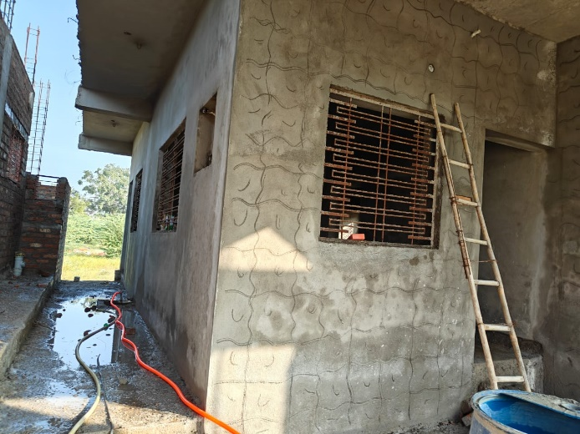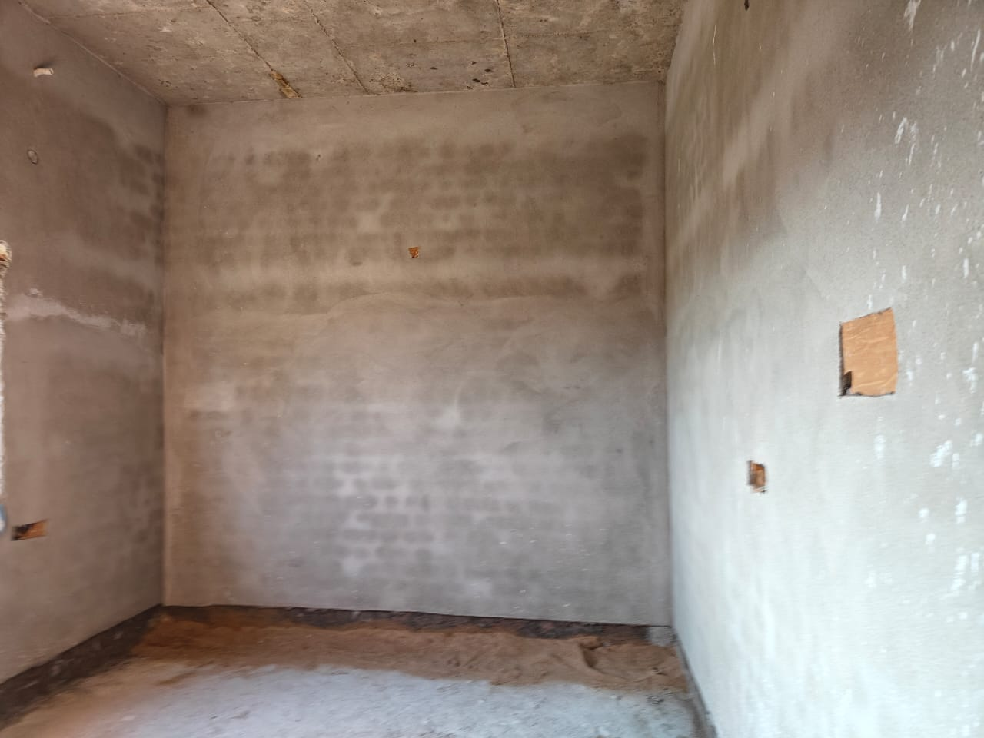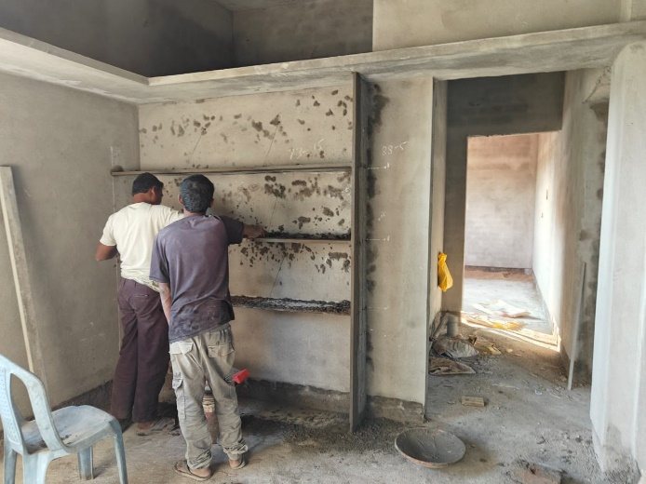

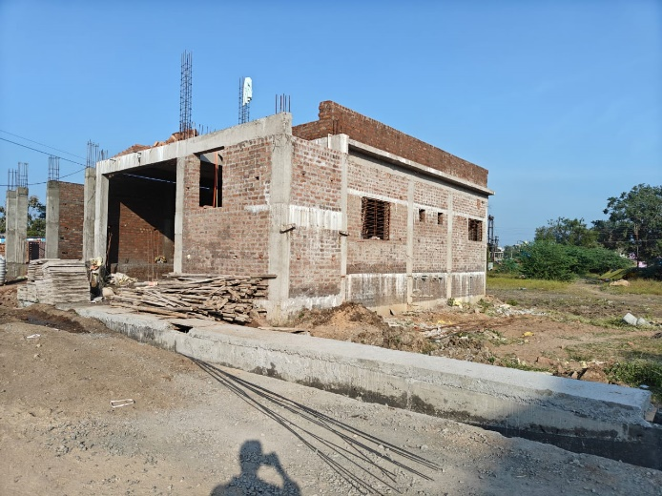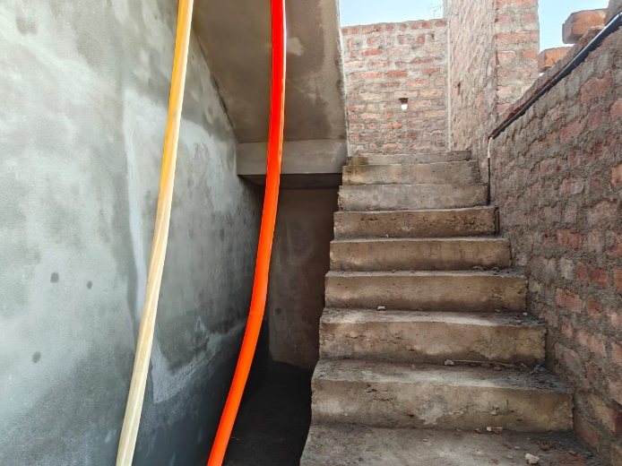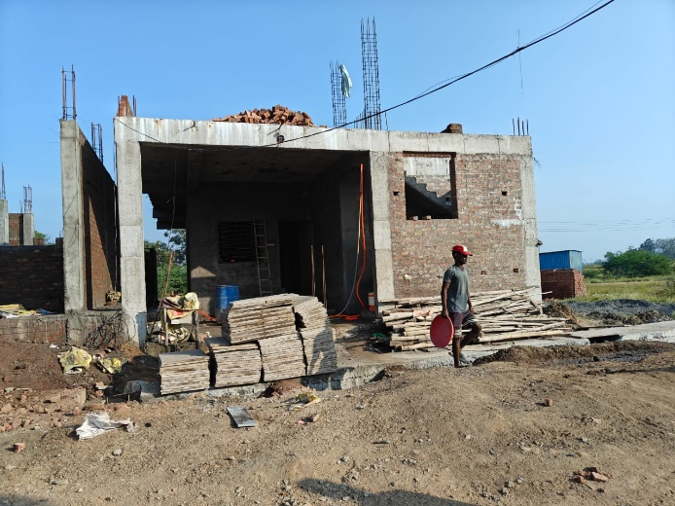

**Route Map of the Property**

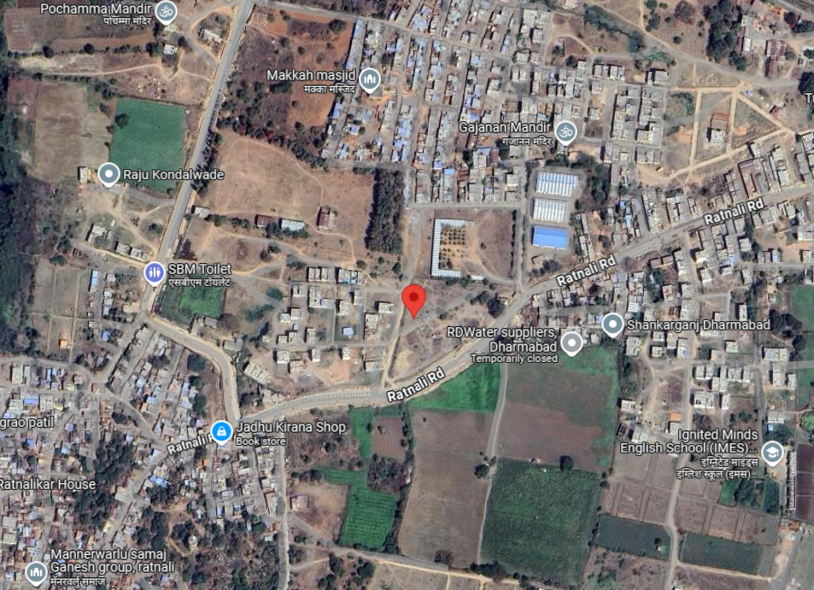

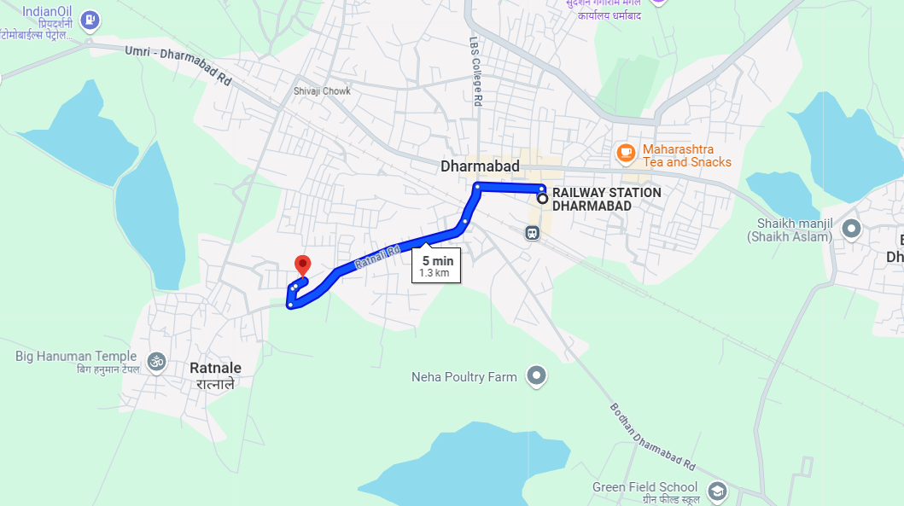

# **Longitude Latitude: 18°53'12.6"N 77°50'26.6"E**

# **Note**:

* Red Pointer shows Approx. Property Location.
* Blue line shows Route from Dharmabad Railway Station@ 1.3 Km.

**Ready Reckoner Rate**

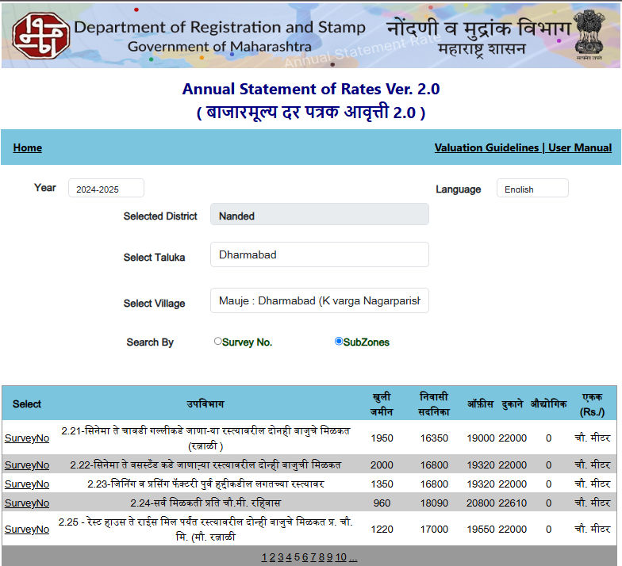

**ASSUMPTIONS, CAVEATS, LIMITATION AND DISCLAIMERS**

1. We assume no responsibility for matters of legal nature affecting the property appraised or the title thereto, nor do we render our opinion as to the title, which is assumed to be good and marketable.
2. The property is valued as though under responsible ownership.
3. It is assumed that the property is free of liens and encumbrances.
4. It is assumed that there are no hidden or unapparent conditions of the subsoil or structure that would render it more or less valuable. No responsibility is assumed for such conditions or for engineering that might be required to discover such factors.
5. The rates for valuation of the property are in accordance with the Govt. approved rates and prevailing market rates

For, **Vastukala Consultants (I) Pvt. Ltd.**

**Sharadkumar B. Chalikwar**

B.E. (Civil), M.E. (Civil), M.Sc. (Real Estate Valuation), M.Sc. (P&M Valuation), FIE (I), FIV, FIWRS

Chairman & Managing Director

Govt. Reg. Valuer

Chartered Engineer (India)

Reg. No. (N) CCIT/1-14/52/2008-09

IBBI Reg. No. IBBI/RV/07/2019/11744

Date: 04.12.2024

Place: Nanded.