Vastu/Mumbai/12/2024/012697/407814

07/27-162-SKM

Date: 07.12.2024

To,

The Manager,

Cosmos Bank

APMC Branch

C-1, Phase-II, APMC Masala Market,

Sector -19, Vashi Navi Mumbai 400703.

**Sub.:** Justification of value for Property valuation submitted by us

**Ref:** Justification of value Property.

**Our Valuation report No.** Vastu/Mumbai/12/2024/012697/2309311 dated 02.12.2024

**Owner Name -** Kisan Mahadu Bhoir, Ravindra Kisan Bhoir & Kalpana Kisan Bhoir

**Property Address:** Residential Flat No. 1714, 17th Floor, Wing - B (i.e. Tower No. 1-I as per the sanctioned plans), **"Dosti Pride",** Dosti Greater Thane, Cluster 2, Phase - 1, Sector 3A, Village - Purna, Taluka - Bhiwandi, District - Thane, PIN - 421 302, Maharashtra, India.

RERA Carpet Area in Sq. Ft. = 269.00

Enclosed Balcony Area in Sq. Ft. = 61.00

Open Balcony Area in Sq. Ft. = 9.00

Total Carpet Area in Sq. Ft. = 339.00

(Area as per Agreement for Sale)

Dear Sir,

We on your request have given our Valuation Opinion Report of above-mentioned property belonging to Kisan Mahadu Bhoir, Ravindra Kisan Bhoir & Kalpana Kisan Bhoir.

The scope of Work: Analysis of Market Value, Realizable Value & Distress Value of above mentioned Residential Flat for Banking Purpose. The site inspection was carried out along with Miss. Farhat Khan, Customer Relationship Manager of Adrika Developers Pvt. Ltd. (Contact No. 8655498972). We have submitted the valuation report accordingly.

Factors considered for Fair Market Valuation, approach adopted and comparable considered as follows:

We have carried out market search for present prices for similar properties in surrounding locality.

**Registered Sale Transactions for Residential Flat located in the same building were as follows:**

|  |  |  |  |
| --- | --- | --- | --- |
| Property | Flat | | |
| Source | Index II | | |
| Floor | - | | |
|  | **Carpet** | **Built Up** | **Saleable** |
| **Area** | 339.00 | 373.00 | - |
| **Percentage** | 10% | - | - |
| **Rate Per Sq. Ft.** | ₹ 11,147.00 | ₹ 10,134.00 | - |

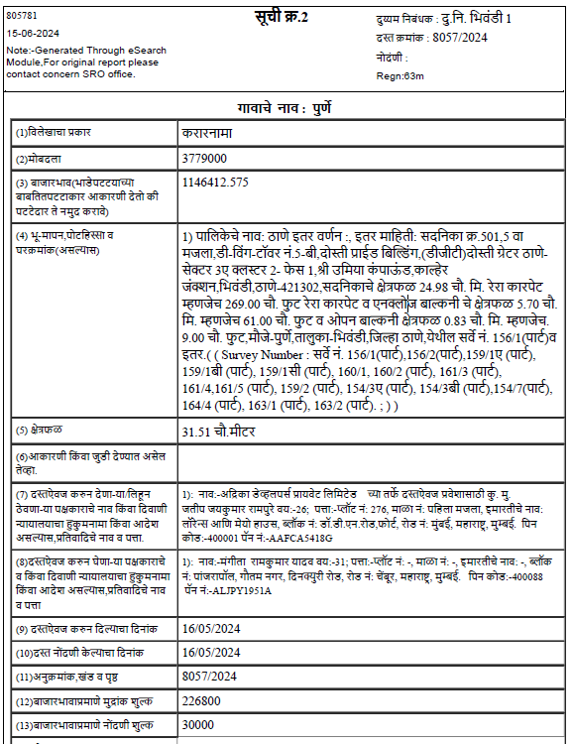

|  |  |  |  |
| --- | --- | --- | --- |
| Property | Flat | | |
| Source | Index II | | |
| Floor | - | | |
|  | **Carpet** | **Built Up** | **Saleable** |
| **Area** | 339.00 | 373.00 | - |
| **Percentage** | 10% | - | - |
| **Rate Per Sq. Ft.** | ₹ 11,206.00 | ₹ 10,188.00 | - |

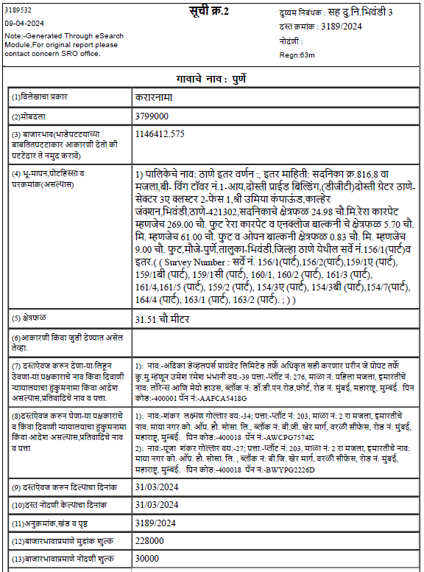

**Asking Rate for Residential Flat located in the same building were as follows:**

|  |  |  |  |
| --- | --- | --- | --- |
| Property | Flat | | |
| Source | Magicbricks.com | | |
| Floor | - | | |
|  | **Carpet** | **Built Up** | **Saleable** |
| **Area** | 371.00 | 408.00 | - |
| **Percentage** | 10% | - | - |
| **Rate Per Sq. Ft.** | ₹ 11,860.00 | ₹ 10,782.00 | - |

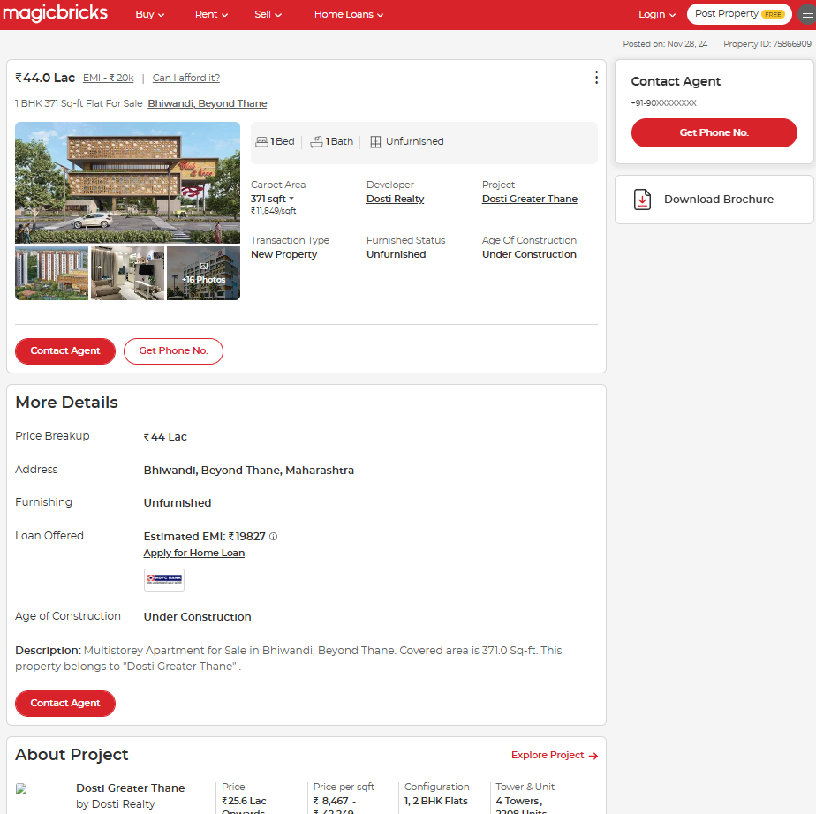

|  |  |  |  |
| --- | --- | --- | --- |
| Property | Flat | | |
| Source | Magicbricks.com | | |
| Floor | - | | |
|  | **Carpet** | **Built Up** | **Saleable** |
| **Area** | 339.00 | 373.00 | - |
| **Percentage** | 10% | - | - |
| **Rate Per Sq. Ft.** | ₹ 11,858.00 | ₹ 10,780.00 | - |

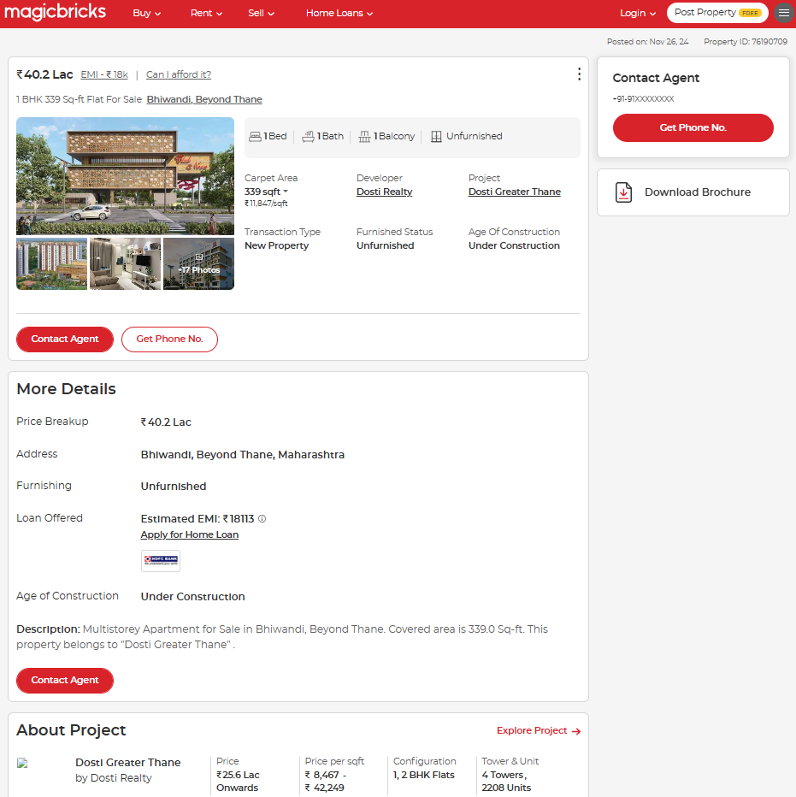

The Market Value of the property was based on facts of market data discovered by us during our enquiries.

We have considered the rate of ` 11,300/- per Sq. Ft. on Carpet Area.

**Property Value:**

|  |  |
| --- | --- |
| Area as per Agreement | |
| Carpet Area in Sq. Ft. | **339.00** |
| Rate adopted for valuation (Rs. / per Sq. Ft.) | **11,300.00** |
| Fair Market Value | **38,30,700.00** |
| Realizable Value | **34,47,630.00** |
| Distress Value | **30,64,560.00** |

The Online Price Indicators of the surrounding area available for sale are attached herewith for your ready reference. Which should be treated as most relevant as far as comparable sales method of valuation is considered. Hence rates per Sq. Ft. considered for valuation were in line with as on date market rates which are reasonable and justified.

**The Bases of value:**

**Market Value** is the estimated amount for which an assets or liability should exchange on the valuation date between a willing buyer and a willing seller in the arm’s length transaction, after proper marketing and where the parties had each acted knowledgeably, prudently and without compulsion.

We have carried valuation based upon The **Sales Comparison Approach** which compares recently-sold local similar properties to the subject property. Price adjustments are made for differences in the **comparable** and subject property. It is a process used to determine the current market **value** of a property based on recent **sales** of **comparable** properties in the area. Where there is no sales data available, we have taken search for online property listings available for sale. These listings are mostly posted by owners and real estate agents on real estate portals like

[www.magicbricks.com](http://www.magicbricks.com)

[www.99acres.com](http://www.99acres.com)

[www.realestateindia.com](http://www.realestateindia.com)

[www.housing.com](http://www.housing.com)

[www.nestoria.com](http://www.nestoria.com)

As these listings shows maximum asking price by the owner/agent for a specific property which are generally further negotiable, we take some discounting factor based upon type of property.

Based on above factors the valuation report submitted by us was fair and reasonable on the date of valuation and in the best interest of the bank / financial institution for Banking purpose.

Thanking you.

Sincerely yours

**For Vastukala Consultants (I) Pvt. Ltd.**

**Manoj Chalikwar**

Approved Valuer

Chartered Engineer (India)

Reg. No. IBBI/RV/07/2018/10366

Cosmos Bank Empanelment No.: HO/Credit/87/2022-23