Vastu/Nashik/112024//012673/2309265
29/6-350-RYBS
Date: 29.11.2024
To,
The Branch Manager,
Bank of Baroda
Regional Office
BSNL Building, Datta Mandir Road, Nashik Road,
Nashik, PIN – 422 101, State - Maharashtra, Country - India.

Sub: Vetting of Extra Amenities

Sir,

With reference to above subject, we have evaluated the Extra Amenities For Residential Flat No. A-16, 3rd Floor, Wing - A, " Rameshwar Park Apartment ", Behind Icon Fitness Hub Unisex Gym, Upendar Nagar, More Mala, Survey No - 304/ 1/ 2/ 1, Plot No. 81+82, Ambad - Trimurti Chowk Link Road, Village - Ambad Khurd, Taluka - Nashik, District - Nashik, Nashik, PIN Code - 422 010, State - Maharashtra, Country -India belongs to Shri. Machindra Dyaneshwar Sonawane. Name of Proposed Purchaser is Shri. Aditya Bhagwan Rahane & Sau. Radhika Aditya Rahane.

We have verified the rates quoted as per current market rates. Details of Extra Amenities considered as per copy of Extra Amenities Agreement between Shri. Aditya Bhagwan Rahane & Sau. Radhika Aditya Rahane (First Party). Shri. Rahul Baban Shelke (Second Party) received on dated.24.11.2024. The Extra Amenities amount is Rs. 4,00,000/- (Rupees Four Lakh Only)

The said Cost Vetting Certificate is valid upto next 6 months Only.

Thanking you

Sincerely yours

Manoj B. Chalikwar
Registered Valuer
Chartered Engineer (India)
Reg. No. CAT-I-F-1763
Reg. No. IBBI/RV/07/2018/10366
BOB Empanelment No.: ZO:MZ:ADV:46:941
Encl: Valuation report.

Agreement for Extra Amenities
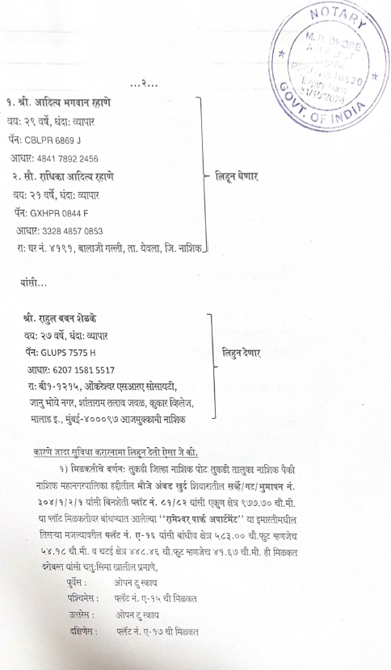
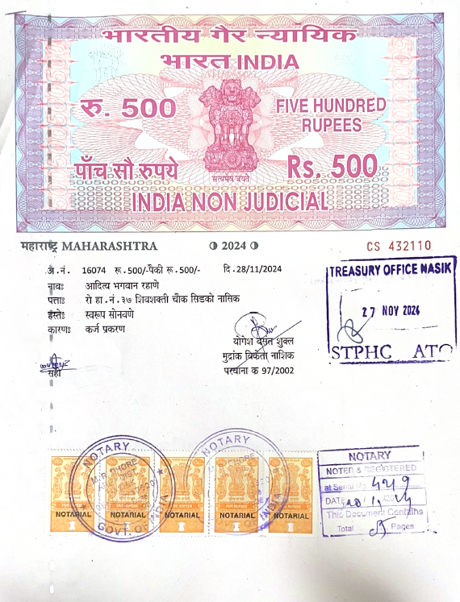

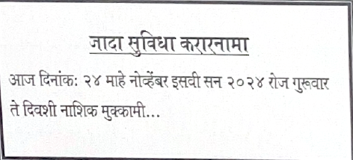

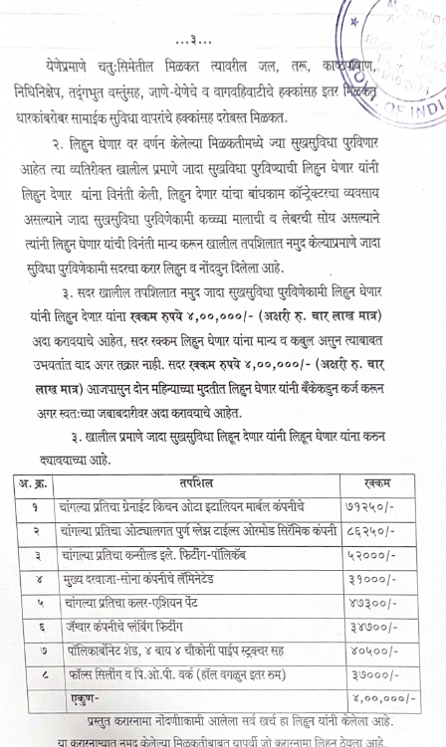
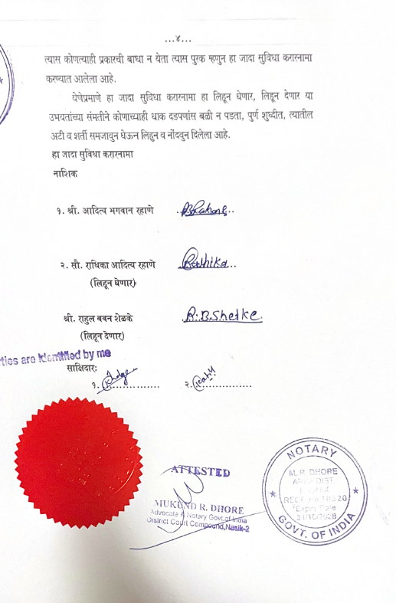

The Extra Amenities amount is Rs. 4,00,000/- (Rupees Four Lakh Only)

