Vastu/Nashik/11/2024/012620 /2309216
27/2-301-RPBS
Date: 27.11.2024

To, `
The Branch Manager,
Bank of Baroda
Regional Office Nashik Road Branch
BSNL Building, Datta Mandir Road, Nashik Road,
Nashik -422 101, State - Maharashtra, Country - India.

Sub: Vetting of Extra Amenities

Sir,

With reference to above subject, we have evaluated the Extra Amenities for Residential Flat No. A-406, 4th Floor, Wing - A, "Vraj Landmark 1A ", Near Vibgyor School, Samarth Nagar, Plot No. 1A, Village - Nashik, Taluka - Nashik, District -
Nashik, Nashik, Pincode - 422 004, State - Maharashtra, India belongs to Mr. Dhananjay Vijay Joshi & Mrs. Anuja
Dhananjay Joshi.

We have verified the rates quoted as per current market rates. Details of Extra Amenities considered as per copy of Agreement for Extra Amenities issued by to Mr. Dhananjay Vijay Joshi (First Party) and Mr. Prasanna Prakash Joshi (Second Party) received on dated 25.11.2024. The Extra Amenities amount is Rs.7,00,000/- (Rupees Seven Lakh Only.)

The said Cost Vetting Certificate is valid upto next 6 months Only.

Thanking you

Sincerely yours

Manoj B. Chalikwar
Registered Valuer
Chartered Engineer (India)
Reg. No. CAT-I-F-1763
Reg. No. IBBI/RV/07/2018/10366
BOB Empanelment No.: ZO:MZ:ADV:46:941
Encl: Valuation report.

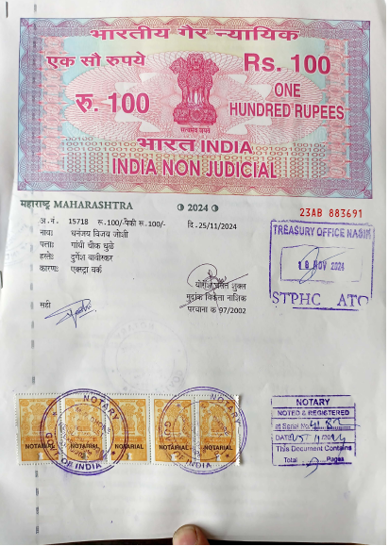
Agreement of Extra Amenities
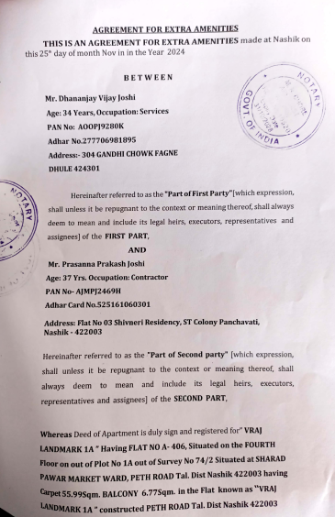

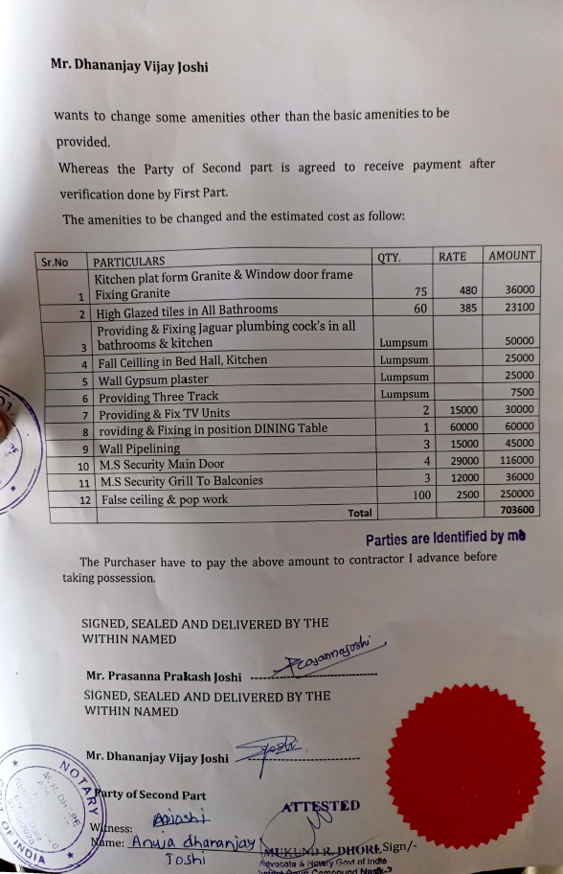

The Extra Work amount is Rs.7,00,000/- (Rupees Seven Lakh Only.)

