Vastu/Nashik/08/2024/010863/2307900
27/19-378-RPBS
Date: 30.09.2024

To, `
The Branch Manager,
State Bank of lndia
RACPC Nashik
1st Floor, Patel Plaza, N.D.Patel Road, Opp BSNL,
Landmark Seawoods Navratna Hotel Nashik-422001.

Sub: Vetting of Extra Amenities

Sir,

With reference to above subject, we have evaluated the Vetting of Extra Amenities Agreement for Residential Flat No. 402, 4th Floor, Building No 2, Wing - C, "Laxminarayan Heaven", Near St. Thomas Bethany Convent School, Plot No. 1+2, Sunrise Road, Pathardi Gaulane Road, Village - Pathardi , Taluka - Nashik, District - Nashik, 422010 belongs to Shri.Nilesh Ashok Salve.

We have verified the rates quoted as per current market rates. Details of work and Extra Amenities considered as per copy of Extra Amenities Agreement Between Shri.Nilesh Ashok Salve (First Party) Shri.Dhruti Vipul Navapariya (Second Party) received on dated 19.11.2024 The Vetting of Extra Amenities amount is Rs.1,30,000/- (Rupees One Lakh Thirty Thousand Only)

The said Cost Vetting Certificate is valid upto next 6 months Only.

Thanking you

Sincerely yours

Manoj B. Chalikwar
Registered Valuer
Chartered Engineer (India)
Reg. No. CAT-I-F-1763
Reg. No. IBBI/RV/07/2018/10366
BOB Empanelment No.: ZO:MZ:ADV:46:941
Encl: Valuation report.

Vetting of Extra Amenities Agreement
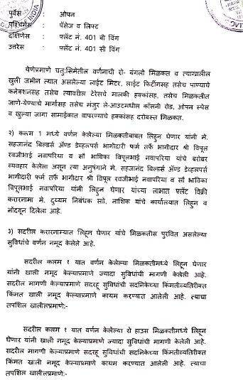
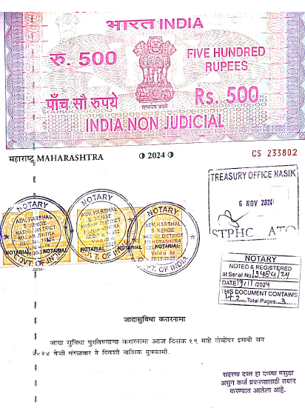

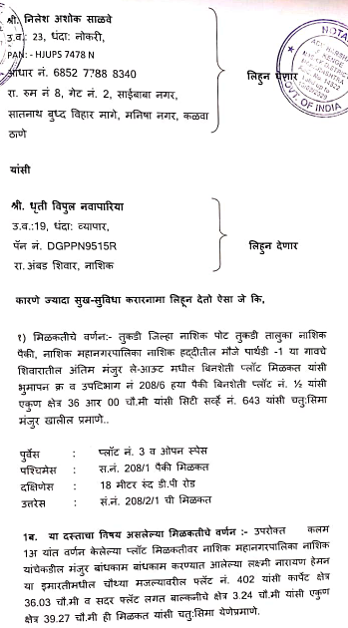
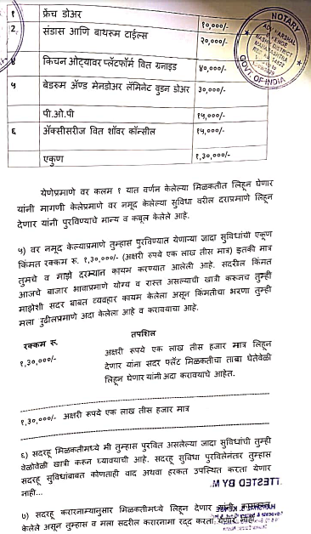

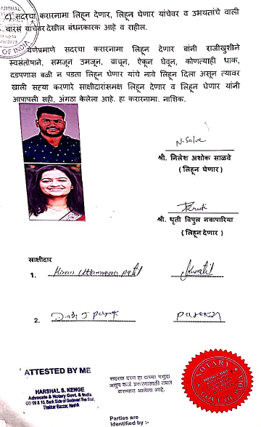

The Extra Amenities amount is Rs.1,30,000/- (Rupees One Lakh Thirty Thousand Only)

