Vastu/Nashik/11/012570/2309190
25/10-275-RYRJ
Date: 25.11.2024
To,
The Branch Manager,
Bank of Baroda
Regional Office
BSNL Building, Datta Mandir Road, Nashik Road,
Nashik, PIN – 422 101, State - Maharashtra, Country - India.

Sub: Vetting of Extra Amenities

Sir,

With reference to above subject, we have evaluated the Extra Amenities for Residential Flat No. 4, 2nd Floor, " Tulsi Heights ", Near Sai Mandir, Survey No. 59/ 3/ 1/ 2/ 3, Plot No. 70, Dhruv Nagar, Satpur Colony, Gangapur - Satpur Link Road, Village - Gangapur, Taluka - Nashik, District - Nashik PIN Code - 422 007, State - Maharashtra, lndia belongs to Shri. Sampat Santu Chumbhale & Shri. Sunil Sampat Chumbhale. Name of Proposed Purchaser is Shri. Sagar Balasaheb Zoman & Sau. Sunanda Balasaheb Zoman.

We have verified the rates quoted as per current market rates. Details of Extra Amenities considered as per copy of Extra Amenities Agreement between Shri. Sagar Balasaheb Zoman & Sau. Sunanda Balasaheb Zoman (First Party). Shri. Avinash Sanjay Bansode (Second Party) received on dated.25.11.2024. The Extra Amenities amount is Rs. 7,00,000/- (Rupees Seven Lakh Only)

The said Cost Vetting Certificate is valid upto next 6 months Only.

Thanking you

Sincerely yours

Manoj B. Chalikwar
Registered Valuer
Chartered Engineer (India)
Reg. No. CAT-I-F-1763
Reg. No. IBBI/RV/07/2018/10366
BOB Empanelment No.: ZO:MZ:ADV:46:941
Encl: Valuation report.

Agreement for Extra Amenities
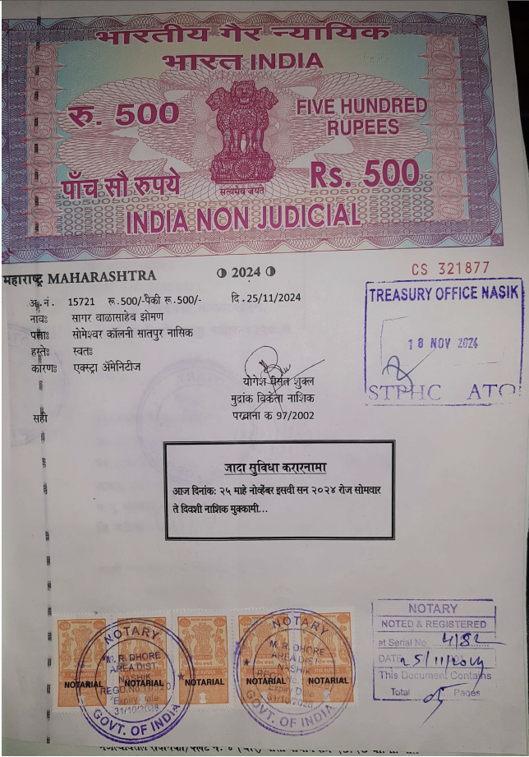
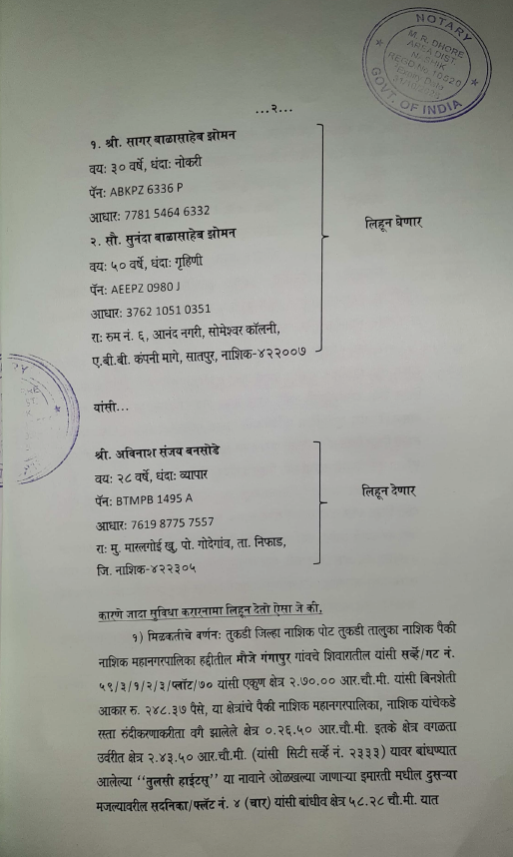

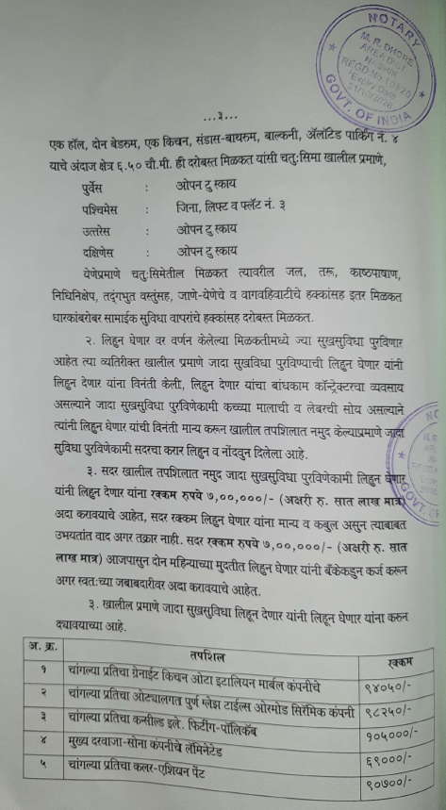
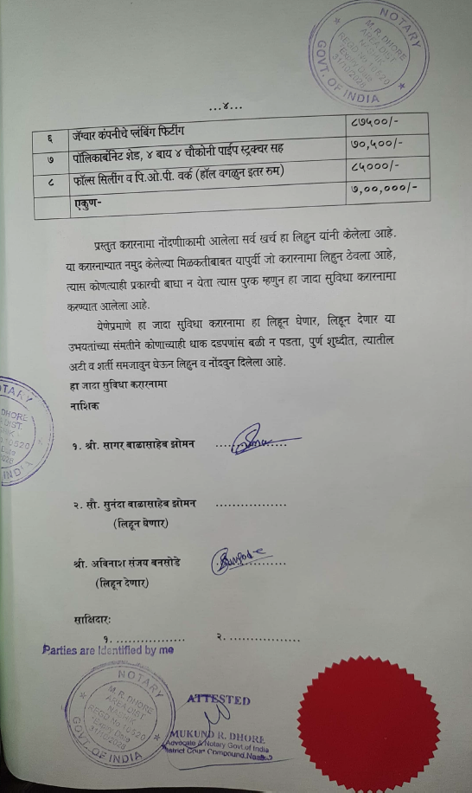

The Extra Amenities amount is Rs. 7,00 ,000/- (Rupees Seven Lakh Only)

