Valuation Report of the Immovable Property

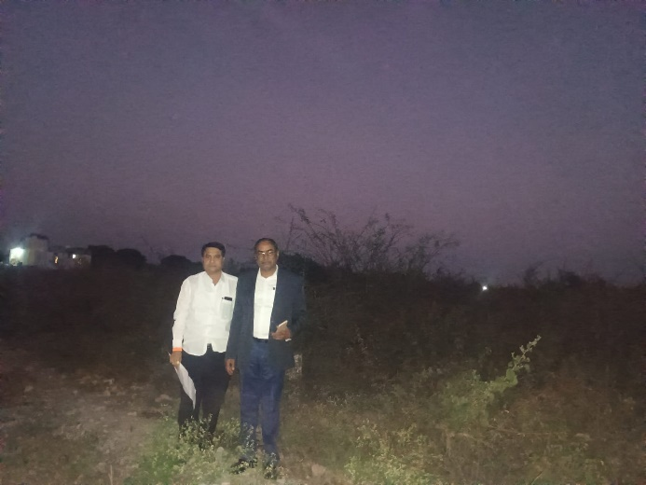

**Details of the property under consideration:**

Name of Client: **Sanjay Baburao Jogdand**

Plot No. 168, 169, 170, Gut No. 358, Taroda Budruk Road, Mauje - Taroda Bu. Tal. & Dist. Nanded,

PIN – 431 605, State – Maharashtra, Country - India.

# **Longitude Latitude: 19.205253, 77.300668**

**Intended Users:**

**Axis Bank**

**Regional Legal & Tech. Manager**

 Stellar Enclave, Shop No. 203-204, 2nd Floor, Above McDonalds, Aundh,

Pune- 411 007, State – Maharashtra, India.

Vastu/Nanded/12/2024/012563/2308750

22/8-290-BHBS

Date: 05.12.2024

# **VALUER’S OPINION REPORT**

This is to certify that the property situated on Plot No. 168, 169, 170, Gut No. 358, Taroda Budruk Road, Mauje - Taroda Bu. Tal. & Dist. Nanded, PIN – 431 605, State – Maharashtra, Country – India is belongs to **Sanjay Baburao Jogdand.**

|  |  |  |
| --- | --- | --- |
| Boundaries of the property. | | |
|  |  | **As Per Site** | | **As per mail** |
| North | : | Plot No. 167 | | Plot No. 167 |
| South | : | Shiv Road | | Road |
| East | : | Gut No. 357 | | 30 ft wide Road |
| West | : | 30 ft wide Road | | Gut No. 357 |

Considering various parameters recorded, existing economic scenario, and the information that is available with reference to the development of neighborhood and method selected for valuation, we are of the opinion that, the property premises can be assessed are as under :

|  |  |
| --- | --- |
| **Guideline Value of the Property** | **Rs. 17,42,611.00** |
| **Fair Market Value of the Property** | **Rs. 1,12,42,770.00** |
| **Realizable Value of the Property** | **Rs. 1,01,18,493.00** |
| **Forced/ Distress Sale value of the Property.** | **Rs. 89,94,216.00** |

The valuation of the property is based on the documents produced by the concern. Legal aspects have not been taken into considerations while preparing this valuation report.

Hence certified

For, **Vastukala Consultants (I) Pvt. Ltd.**

**Sharadkumar B. Chalikwar**

B.E. (Civil), M.E. (Civil), M.Sc. (Real Estate Valuation), M.Sc. (P&M Valuation), FIE (I), FIV, FIWRS

Chairman & Managing Director

Govt. Reg. Valuer

Chartered Engineer (India)

Reg. No. (N) CCIT/1-14/52/2008-09

IBBI Reg.No. IBBI/RV/07/2019/11744

Encl: Valuation report.

|  |  |  |  |  |  |  |  |  |  |  |  |  |  |  |  |  |  |  |  |  |  |  |  |  |  |  |  |  |  |  |  |  |  |  |  |  |  |  |  |  |  |  |  |  |  |  |  |  |  |  |  |  |  |  |  |  |  |  |  |  |  |  |  |  |  |  |  |  |  |  |  |  |  |  |  |  |  |  |  |  |  |  |  |  |  |  |  |  |  |  |  |  |  |  |  |  |  |  |  |  |  |  |  |  |  |  |  |  |  |  |  |  |  |  |  |  |  |  |  |  |  |  |  |  |  |  |  |  |  |  |  |  |  |  |  |  |  |  |  |  |  |  |  |  |  |  |  |  |  |  |  |  |  |  |  |  |  |  |  |  |  |  |  |  |  |  |  |  |  |  |  |  |  |  |  |  |  |  |  |  |  |  |  |  |  |  |  |  |  |  |  |  |  |  |  |  |  |  |  |  |  |  |  |  |  |  |  |  |  |  |  |  |  |  |  |  |  |  |  |  |  |  |  |  |  |  |  |  |  |  |  |  |  |  |  |  |  |  |  |  |  |  |  |  |  |  |  |  |  |  |  |  |  |  |  |  |  |  |  |  |  |  |  |  |  |  |  |  |  |  |  |  |  |  |  |  |  |  |  |  |  |  |  |  |  |  |  |  |  |  |  |  |  |  |  |  |  |  |  |  |  |  |  |  |  |  |  |  |  |  |  |  |  |  |  |  |  |  |  |  |  |  |  |  |  |  |  |  |  |  |  |  |  |  |  |  |  |  |  |  |  |  |  |  |  |  |  |  |  |  |  |  |  |  |  |  |  |  |  |  |  |  |  |  |  |  |  |  |  |  |  |  |  |  |  |  |  |  |  |  |  |  |  |  |  |  |  |  |  |  |  |  |  |  |  |  |  |  |  |  |  |  |  |  |  |  |  |  |  |  |  |  |  |  |  |  |  |  |  |  |  |  |  |  |  |  |  |  |  |  |  |  |  |  |  |  |  |  |  |  |  |  |  |  |  |  |  |  |  |  |  |  |  |  |  |  |  |  |  |  |  |  |  |  |  |  |  |  |  |  |  |  |  |  |  |  |  |  |  |  |  |  |  |  |  |  |  |  |  |  |  |  |  |  |  |  |  |  |  |  |  |  |  |  |  |  |  |  |  |  |  |  |  |  |  |  |  |  |  |  |  |  |  |  |  |  |  |  |  |  |  |  |  |  |  |  |  |  |  |  |  |  |  |  |  |  |  |  |  |  |  |  |  |  |  |  |  |  |  |  |  |  |  |  |  |  |  |  |  |  |  |  |  |  |  |  |  |  |  |  |  |  |  |  |  |  |  |  |  |  |  |  |  |  |  |  |  |  |  |  |  |  |  |  |  |  |  |  |  |  |  |  |  |  |  |  |  |  |  |  |  |  |  |  |  |  |  |  |  |  |  |  |  |  |  |  |  |  |  |  |  |  |  |  |  |  |  |  |  |  |  |  |  |  |  |  |  |  |  |  |  |  |  |  |  |  |  |  |  |  |  |  |  |  |  |  |  |  |  |  |  |  |  |  |  |  |  |  |  |  |  |  |  |  |  |  |  |  |  |  |  |  |  |  |  |  |  |  |  |  |  |  |  |  |  |  |  |  |  |  |  |  |  |  |  |  |  |  |  |  |  |  |  |  |  |  |  |  |  |  |  |  |  |  |  |  |  |  |  |  |  |  |  |  |  |  |  |  |  |  |  |  |  |  |  |  |  |  |  |  |  |  |  |  |  |  |  |  |  |  |  |  |  |  |  |  |  |  |  |  |  |  |  |  |  |  |  |  |  |  |  |  |  |  |  |  |  |  |  |  |  |  |  |  |  |  |  |  |  |  |  |  |  |  |  |  |  |  |  |  |  |  |  |  |  |  |  |  |  |  |  |  |  |  |  |  |  |  |  |  |  |  |  |  |  |  |  |  |  |  |  |  |  |  |  |  |  |  |  |  |  |  |  |  |  |  |  |  |  |  |  |  |  |  |  |  |  |  |  |  |  |  |  |  |  |  |  |  |  |  |  |  |  |  |  |  |  |  |  |  |  |  |  |  |  |  |  |  |  |  |  |  |  |  |  |  |  |  |  |  |  |  |  |  |  |  |  |  |  |  |  |  |  |  |  |  |  |  |  |  |  |  |  |  |  |  |  |  |  |  |  |  |  |  |  |  |  |  |  |  |  |  |  |  |  |  |  |  |  |  |  |  |  |  |  |  |  |  |  |  |  |  |  |  |  |  |  |  |  |  |  |  |  |  |  |  |  |  |  |  |  |  |  |  |  |  |  |  |  |  |  |  |  |  |  |  |  |  |  |  |  |  |  |  |  |  |  |  |  |  |  |  |  |  |  |  |  |  |  |  |  |  |  |  |  |  |  |  |  |  |  |  |  |  |  |  |  |  |  |  |  |  |  |  |  |  |  |  |  |  |  |  |  |  |  |  |  |  |  |  |  |  |  |  |  |  |  |  |  |  |  |  |  |  |  |  |  |  |  |  |  |  |  |  |  |  |  |  |  |  |  |  |  |  |  |  |  |  |  |  |  |  |  |  |  |  |  |  |  |  |  |  |  |  |  |  |  |  |  |  |  |  |  |  |  |  |  |  |  |  |  |  |  |  |  |  |  |  |  |  |  |  |  |  |  |  |  |  |  |  |  |  |  |  |  |  |  |  |  |  |  |  |  |  |  |  |  |  |  |  |  |  |  |  |  |  |  |  |  |  |  |  |  |  |  |  |  |  |  |  |  |  |  |  |  |  |  |  |  |  |  |  |  |  |  |  |  |  |  |  |  |  |  |  |  |  |  |  |  |  |  |  |  |  |  |  |  |  |  |  |  |  |  |  |  |  |  |  |  |  |  |  |  |  |  |  |  |  |  |  |  |  |  |  |  |  |  |  |  |  |  |  |  |  |  |  |  |  |  |  |  |  |  |  |  |  |  |  |  |  |  |  |  |  |  |  |  |  |  |  |  |  |  |  |  |  |  |  |  |  |  |  |  |  |  |  |  |  |  |  |  |  |  |  |  |  |  |  |  |  |  |  |  |  |  |  |  |  |  |  |  |  |  |  |  |  |  |  |  |  |  |  |  |  |  |  |  |  |  |  |  |  |  |  |  |  |  |  |  |  |  |  |  |  |  |  |  |  |  |  |  |  |  |  |  |  |  |  |  |  |  |  |  |  |  |  |  |  |  |  |  |  |  |  |  |  |  |  |  |  |  |  |  |  |  |  |  |  |  |  |  |  |  |  |  |  |  |  |  |  |  |  |  |  |  |  |  |  |  |  |  |  |  |  |  |  |  |  |  |  |  |  |  |  |  |  |  |  |  |  |  |  |  |  |  |  |  |  |  |  |  |  |  |  |  |  |  |  |  |  |  |  |  |  |  |  |  |  |  |  |  |  |  |  |  |  |  |  |  |  |  |  |  |  |  |  |  |  |  |  |  |  |  |  |  |  |  |  |  |  |  |  |  |  |  |  |  |  |  |  |  |  |  |  |  |  |  |  |  |  |  |  |  |  |  |  |  |  |  |  |  |  |  |  |  |  |  |  |  |  |  |  |  |  |  |  |  |  |  |  |  |  |  |  |  |  |  |  |  |  |  |  |  |  |  |  |  |  |  |  |  |  |  |  |  |  |  |  |  |  |  |  |  |  |  |  |  |  |  |  |  |  |  |  |  |  |  |  |  |  |  |  |  |  |  |  |  |  |  |  |  |  |  |  |  |  |  |  |  |  |  |  |  |  |  |  |  |  |  |  |  |  |  |  |  |  |  |  |  |  |  |  |  |  |  |  |  |  |  |  |  |  |  |  |  |  |  |  |  |  |  |  |  |  |  |  |  |  |  |  |  |  |  |  |  |  |  |  |  |  |  |  |  |  |  |  |  |  |  |  |  |  |  |  |  |  |  |  |  |  |  |  |  |  |  |  |  |  |  |  |  |  |  |  |  |  |  |  |  |  |  |  |  |  |  |  |  |  |  |  |  |  |  |  |  |  |  |  |  |  |  |  |  |  |  |  |  |  |  |  |  |  |  |  |  |  |  |  |  |  |  |  |  |  |  |  |  |  |  |  |  |  |  |  |  |  |  |  |  |  |  |  |  |  |  |  |  |  |  |  |  |  |  |  |  |  |  |  |  |  |  |  |  |  |  |  |  |  |  |  |  |  |  |  |  |  |  |  |  |  |  |  |  |  |  |  |  |  |  |  |  |  |  |  |  |  |  |  |  |  |  |  |  |  |  |  |  |  |  |  |  |  |  |  |  |  |  |  |  |  |  |  |  |  |  |  |  |  |  |  |  |  |  |  |  |  |  |  |  |  |  |  |  |  |  |  |  |  |  |  |  |  |  |  |  |  |  |  |  |  |  |  |  |  |  |  |  |  |  |  |  |  |  |  |  |  |  |  |  |  |  |  |  |  |  |  |  |  |  |  |  |  |  |  |  |  |  |  |  |  |  |  |  |  |  |  |  |  |  |  |  |  |  |  |  |  |  |  |  |  |  |  |  |  |  |  |  |  |  |  |  |  |  |  |  |  |  |  |  |  |  |  |  |  |  |  |  |  |  |  |  |  |  |  |  |  |  |  |  |  |  |  |  |  |  |  |  |  |  |  |  |  |  |  |  |  |  |  |  |  |  |  |  |  |  |  |  |  |  |  |  |  |  |  |  |  |  |  |  |  |  |  |  |  |  |  |  |  |  |  |  |  |  |  |  |  |  |  |  |  |  |  |  |  |  |  |  |  |  |  |  |  |  |  |  |  |  |  |  |  |  |  |  |  |  |  |  |  |  |  |  |  |  |  |  |  |  |  |  |  |  |  |  |  |  |  |  |  |  |  |  |  |  |  |  |  |  |  |  |  |  |  |  |  |  |  |  |  |  |  |  |  |  |  |  |  |  |  |  |  |  |  |  |  |  |  |  |  |  |  |  |  |  |  |  |  |  |  |  |  |  |  |  |  |  |  |  |  |  |  |  |  |  |  |  |  |  |  |  |  |  |  |  |  |  |  |  |  |  |  |  |  |  |  |  |  |  |  |  |  |  |  |  |  |  |  |  |  |  |  |  |  |  |  |  |  |  |  |  |  |  |  |  |  |  |  |  |  |  |  |  |  |  |  |  |  |  |  |  |  |  |  |  |  |  |  |  |  |  |  |  |  |  |  |  |  |  |  |  |  |  |  |  |  |  |  |  |  |  |  |  |  |  |  |  |  |  |  |  |  |  |  |  |  |  |  |  |  |  |  |  |  |  |  |  |  |  |  |  |  |  |  |  |  |  |  |  |  |  |  |  |  |  |  |  |  |  |  |  |  |  |  |  |  |  |  |  |  |  |  |  |  |  |  |  |  |  |  |  |  |  |  |  |  |  |  |  |  |  |  |  |  |  |  |  |  |  |  |  |  |  |  |  |  |  |  |  |  |  |  |  |  |  |  |  |  |  |  |  |  |  |  |  |  |  |  |  |  |  |  |  |  |  |  |  |  |  |  |  |  |  |  |  |  |  |  |  |  |  |  |  |  |  |  |  |  |  |  |  |  |  |  |  |  |  |  |  |  |  |  |  |  |  |  |  |  |  |  |  |  |  |  |  |  |  |  |  |  |  |  |  |  |  |  |  |  |  |  |  |  |  |  |  |  |  |  |  |  |  |  |  |  |  |  |  |  |  |  |  |  |  |  |  |  |  |  |  |  |  |  |  |  |  |  |  |  |  |  |  |  |  |  |  |  |  |  |  |  |
| --- | --- | --- | --- | --- | --- | --- | --- | --- | --- | --- | --- | --- | --- | --- | --- | --- | --- | --- | --- | --- | --- | --- | --- | --- | --- | --- | --- | --- | --- | --- | --- | --- | --- | --- | --- | --- | --- | --- | --- | --- | --- | --- | --- | --- | --- | --- | --- | --- | --- | --- | --- | --- | --- | --- | --- | --- | --- | --- | --- | --- | --- | --- | --- | --- | --- | --- | --- | --- | --- | --- | --- | --- | --- | --- | --- | --- | --- | --- | --- | --- | --- | --- | --- | --- | --- | --- | --- | --- | --- | --- | --- | --- | --- | --- | --- | --- | --- | --- | --- | --- | --- | --- | --- | --- | --- | --- | --- | --- | --- | --- | --- | --- | --- | --- | --- | --- | --- | --- | --- | --- | --- | --- | --- | --- | --- | --- | --- | --- | --- | --- | --- | --- | --- | --- | --- | --- | --- | --- | --- | --- | --- | --- | --- | --- | --- | --- | --- | --- | --- | --- | --- | --- | --- | --- | --- | --- | --- | --- | --- | --- | --- | --- | --- | --- | --- | --- | --- | --- | --- | --- | --- | --- | --- | --- | --- | --- | --- | --- | --- | --- | --- | --- | --- | --- | --- | --- | --- | --- | --- | --- | --- | --- | --- | --- | --- | --- | --- | --- | --- | --- | --- | --- | --- | --- | --- | --- | --- | --- | --- | --- | --- | --- | --- | --- | --- | --- | --- | --- | --- | --- | --- | --- | --- | --- | --- | --- | --- | --- | --- | --- | --- | --- | --- | --- | --- | --- | --- | --- | --- | --- | --- | --- | --- | --- | --- | --- | --- | --- | --- | --- | --- | --- | --- | --- | --- | --- | --- | --- | --- | --- | --- | --- | --- | --- | --- | --- | --- | --- | --- | --- | --- | --- | --- | --- | --- | --- | --- | --- | --- | --- | --- | --- | --- | --- | --- | --- | --- | --- | --- | --- | --- | --- | --- | --- | --- | --- | --- | --- | --- | --- | --- | --- | --- | --- | --- | --- | --- | --- | --- | --- | --- | --- | --- | --- | --- | --- | --- | --- | --- | --- | --- | --- | --- | --- | --- | --- | --- | --- | --- | --- | --- | --- | --- | --- | --- | --- | --- | --- | --- | --- | --- | --- | --- | --- | --- | --- | --- | --- | --- | --- | --- | --- | --- | --- | --- | --- | --- | --- | --- | --- | --- | --- | --- | --- | --- | --- | --- | --- | --- | --- | --- | --- | --- | --- | --- | --- | --- | --- | --- | --- | --- | --- | --- | --- | --- | --- | --- | --- | --- | --- | --- | --- | --- | --- | --- | --- | --- | --- | --- | --- | --- | --- | --- | --- | --- | --- | --- | --- | --- | --- | --- | --- | --- | --- | --- | --- | --- | --- | --- | --- | --- | --- | --- | --- | --- | --- | --- | --- | --- | --- | --- | --- | --- | --- | --- | --- | --- | --- | --- | --- | --- | --- | --- | --- | --- | --- | --- | --- | --- | --- | --- | --- | --- | --- | --- | --- | --- | --- | --- | --- | --- | --- | --- | --- | --- | --- | --- | --- | --- | --- | --- | --- | --- | --- | --- | --- | --- | --- | --- | --- | --- | --- | --- | --- | --- | --- | --- | --- | --- | --- | --- | --- | --- | --- | --- | --- | --- | --- | --- | --- | --- | --- | --- | --- | --- | --- | --- | --- | --- | --- | --- | --- | --- | --- | --- | --- | --- | --- | --- | --- | --- | --- | --- | --- | --- | --- | --- | --- | --- | --- | --- | --- | --- | --- | --- | --- | --- | --- | --- | --- | --- | --- | --- | --- | --- | --- | --- | --- | --- | --- | --- | --- | --- | --- | --- | --- | --- | --- | --- | --- | --- | --- | --- | --- | --- | --- | --- | --- | --- | --- | --- | --- | --- | --- | --- | --- | --- | --- | --- | --- | --- | --- | --- | --- | --- | --- | --- | --- | --- | --- | --- | --- | --- | --- | --- | --- | --- | --- | --- | --- | --- | --- | --- | --- | --- | --- | --- | --- | --- | --- | --- | --- | --- | --- | --- | --- | --- | --- | --- | --- | --- | --- | --- | --- | --- | --- | --- | --- | --- | --- | --- | --- | --- | --- | --- | --- | --- | --- | --- | --- | --- | --- | --- | --- | --- | --- | --- | --- | --- | --- | --- | --- | --- | --- | --- | --- | --- | --- | --- | --- | --- | --- | --- | --- | --- | --- | --- | --- | --- | --- | --- | --- | --- | --- | --- | --- | --- | --- | --- | --- | --- | --- | --- | --- | --- | --- | --- | --- | --- | --- | --- | --- | --- | --- | --- | --- | --- | --- | --- | --- | --- | --- | --- | --- | --- | --- | --- | --- | --- | --- | --- | --- | --- | --- | --- | --- | --- | --- | --- | --- | --- | --- | --- | --- | --- | --- | --- | --- | --- | --- | --- | --- | --- | --- | --- | --- | --- | --- | --- | --- | --- | --- | --- | --- | --- | --- | --- | --- | --- | --- | --- | --- | --- | --- | --- | --- | --- | --- | --- | --- | --- | --- | --- | --- | --- | --- | --- | --- | --- | --- | --- | --- | --- | --- | --- | --- | --- | --- | --- | --- | --- | --- | --- | --- | --- | --- | --- | --- | --- | --- | --- | --- | --- | --- | --- | --- | --- | --- | --- | --- | --- | --- | --- | --- | --- | --- | --- | --- | --- | --- | --- | --- | --- | --- | --- | --- | --- | --- | --- | --- | --- | --- | --- | --- | --- | --- | --- | --- | --- | --- | --- | --- | --- | --- | --- | --- | --- | --- | --- | --- | --- | --- | --- | --- | --- | --- | --- | --- | --- | --- | --- | --- | --- | --- | --- | --- | --- | --- | --- | --- | --- | --- | --- | --- | --- | --- | --- | --- | --- | --- | --- | --- | --- | --- | --- | --- | --- | --- | --- | --- | --- | --- | --- | --- | --- | --- | --- | --- | --- | --- | --- | --- | --- | --- | --- | --- | --- | --- | --- | --- | --- | --- | --- | --- | --- | --- | --- | --- | --- | --- | --- | --- | --- | --- | --- | --- | --- | --- | --- | --- | --- | --- | --- | --- | --- | --- | --- | --- | --- | --- | --- | --- | --- | --- | --- | --- | --- | --- | --- | --- | --- | --- | --- | --- | --- | --- | --- | --- | --- | --- | --- | --- | --- | --- | --- | --- | --- | --- | --- | --- | --- | --- | --- | --- | --- | --- | --- | --- | --- | --- | --- | --- | --- | --- | --- | --- | --- | --- | --- | --- | --- | --- | --- | --- | --- | --- | --- | --- | --- | --- | --- | --- | --- | --- | --- | --- | --- | --- | --- | --- | --- | --- | --- | --- | --- | --- | --- | --- | --- | --- | --- | --- | --- | --- | --- | --- | --- | --- | --- | --- | --- | --- | --- | --- | --- | --- | --- | --- | --- | --- | --- | --- | --- | --- | --- | --- | --- | --- | --- | --- | --- | --- | --- | --- | --- | --- | --- | --- | --- | --- | --- | --- | --- | --- | --- | --- | --- | --- | --- | --- | --- | --- | --- | --- | --- | --- | --- | --- | --- | --- | --- | --- | --- | --- | --- | --- | --- | --- | --- | --- | --- | --- | --- | --- | --- | --- | --- | --- | --- | --- | --- | --- | --- | --- | --- | --- | --- | --- | --- | --- | --- | --- | --- | --- | --- | --- | --- | --- | --- | --- | --- | --- | --- | --- | --- | --- | --- | --- | --- | --- | --- | --- | --- | --- | --- | --- | --- | --- | --- | --- | --- | --- | --- | --- | --- | --- | --- | --- | --- | --- | --- | --- | --- | --- | --- | --- | --- | --- | --- | --- | --- | --- | --- | --- | --- | --- | --- | --- | --- | --- | --- | --- | --- | --- | --- | --- | --- | --- | --- | --- | --- | --- | --- | --- | --- | --- | --- | --- | --- | --- | --- | --- | --- | --- | --- | --- | --- | --- | --- | --- | --- | --- | --- | --- | --- | --- | --- | --- | --- | --- | --- | --- | --- | --- | --- | --- | --- | --- | --- | --- | --- | --- | --- | --- | --- | --- | --- | --- | --- | --- | --- | --- | --- | --- | --- | --- | --- | --- | --- | --- | --- | --- | --- | --- | --- | --- | --- | --- | --- | --- | --- | --- | --- | --- | --- | --- | --- | --- | --- | --- | --- | --- | --- | --- | --- | --- | --- | --- | --- | --- | --- | --- | --- | --- | --- | --- | --- | --- | --- | --- | --- | --- | --- | --- | --- | --- | --- | --- | --- | --- | --- | --- | --- | --- | --- | --- | --- | --- | --- | --- | --- | --- | --- | --- | --- | --- | --- | --- | --- | --- | --- | --- | --- | --- | --- | --- | --- | --- | --- | --- | --- | --- | --- | --- | --- | --- | --- | --- | --- | --- | --- | --- | --- | --- | --- | --- | --- | --- | --- | --- | --- | --- | --- | --- | --- | --- | --- | --- | --- | --- | --- | --- | --- | --- | --- | --- | --- | --- | --- | --- | --- | --- | --- | --- | --- | --- | --- | --- | --- | --- | --- | --- | --- | --- | --- | --- | --- | --- | --- | --- | --- | --- | --- | --- | --- | --- | --- | --- | --- | --- | --- | --- | --- | --- | --- | --- | --- | --- | --- | --- | --- | --- | --- | --- | --- | --- | --- | --- | --- | --- | --- | --- | --- | --- | --- | --- | --- | --- | --- | --- | --- | --- | --- | --- | --- | --- | --- | --- | --- | --- | --- | --- | --- | --- | --- | --- | --- | --- | --- | --- | --- | --- | --- | --- | --- | --- | --- | --- | --- | --- | --- | --- | --- | --- | --- | --- | --- | --- | --- | --- | --- | --- | --- | --- | --- | --- | --- | --- | --- | --- | --- | --- | --- | --- | --- | --- | --- | --- | --- | --- | --- | --- | --- | --- | --- | --- | --- | --- | --- | --- | --- | --- | --- | --- | --- | --- | --- | --- | --- | --- | --- | --- | --- | --- | --- | --- | --- | --- | --- | --- | --- | --- | --- | --- | --- | --- | --- | --- | --- | --- | --- | --- | --- | --- | --- | --- | --- | --- | --- | --- | --- | --- | --- | --- | --- | --- | --- | --- | --- | --- | --- | --- | --- | --- | --- | --- | --- | --- | --- | --- | --- | --- | --- | --- | --- | --- | --- | --- | --- | --- | --- | --- | --- | --- | --- | --- | --- | --- | --- | --- | --- | --- | --- | --- | --- | --- | --- | --- | --- | --- | --- | --- | --- | --- | --- | --- | --- | --- | --- | --- | --- | --- | --- | --- | --- | --- | --- | --- | --- | --- | --- | --- | --- | --- | --- | --- | --- | --- | --- | --- | --- | --- | --- | --- | --- | --- | --- | --- | --- | --- | --- | --- | --- | --- | --- | --- | --- | --- | --- | --- | --- | --- | --- | --- | --- | --- | --- | --- | --- | --- | --- | --- | --- | --- | --- | --- | --- | --- | --- | --- | --- | --- | --- | --- | --- | --- | --- | --- | --- | --- | --- | --- | --- | --- | --- | --- | --- | --- | --- | --- | --- | --- | --- | --- | --- | --- | --- | --- | --- | --- | --- | --- | --- | --- | --- | --- | --- | --- | --- | --- | --- | --- | --- | --- | --- | --- | --- | --- | --- | --- | --- | --- | --- | --- | --- | --- | --- | --- | --- | --- | --- | --- | --- | --- | --- | --- | --- | --- | --- | --- | --- | --- | --- | --- | --- | --- | --- | --- | --- | --- | --- | --- | --- | --- | --- | --- | --- | --- | --- | --- | --- | --- | --- | --- | --- | --- | --- | --- | --- | --- | --- | --- | --- | --- | --- | --- | --- | --- | --- | --- | --- | --- | --- | --- | --- | --- | --- | --- | --- | --- | --- | --- | --- | --- | --- | --- | --- | --- | --- | --- | --- | --- | --- | --- | --- | --- | --- | --- | --- | --- | --- | --- | --- | --- | --- | --- | --- | --- | --- | --- | --- | --- | --- | --- | --- | --- | --- | --- | --- | --- | --- | --- | --- | --- | --- | --- | --- | --- | --- | --- | --- | --- | --- | --- | --- | --- | --- | --- | --- | --- | --- | --- | --- | --- | --- | --- | --- | --- | --- | --- | --- | --- | --- | --- | --- | --- | --- | --- | --- | --- | --- | --- | --- | --- | --- | --- | --- | --- | --- | --- | --- | --- | --- | --- | --- | --- | --- | --- | --- | --- | --- | --- | --- | --- | --- | --- | --- | --- | --- | --- | --- | --- | --- | --- | --- | --- | --- | --- | --- | --- | --- | --- | --- | --- | --- | --- | --- | --- | --- | --- | --- | --- | --- | --- | --- | --- | --- | --- | --- | --- | --- | --- | --- | --- | --- | --- | --- | --- | --- | --- | --- | --- | --- | --- | --- | --- | --- | --- | --- | --- | --- | --- | --- | --- | --- | --- | --- | --- | --- | --- | --- | --- | --- | --- | --- | --- | --- | --- | --- | --- | --- | --- | --- | --- | --- | --- | --- | --- | --- | --- | --- | --- | --- | --- | --- | --- | --- | --- | --- | --- | --- | --- | --- | --- | --- | --- | --- | --- | --- | --- | --- | --- | --- | --- | --- | --- | --- | --- | --- | --- | --- | --- | --- | --- | --- | --- | --- | --- | --- | --- | --- | --- | --- | --- | --- | --- | --- | --- | --- | --- | --- | --- | --- | --- | --- | --- | --- | --- | --- | --- | --- | --- | --- | --- | --- | --- | --- | --- | --- | --- | --- | --- | --- | --- | --- | --- | --- | --- | --- | --- | --- | --- | --- | --- | --- | --- | --- | --- | --- | --- | --- | --- | --- | --- | --- | --- | --- | --- | --- | --- | --- | --- | --- | --- | --- | --- | --- | --- | --- | --- | --- | --- | --- | --- | --- | --- | --- | --- | --- | --- | --- | --- | --- | --- | --- | --- | --- | --- | --- | --- | --- | --- | --- | --- | --- | --- | --- | --- | --- | --- | --- | --- | --- | --- | --- | --- | --- | --- | --- | --- | --- | --- | --- | --- | --- | --- | --- | --- | --- | --- | --- | --- | --- | --- | --- | --- | --- | --- | --- | --- | --- | --- | --- | --- | --- | --- | --- | --- | --- | --- | --- | --- | --- | --- | --- | --- | --- | --- | --- | --- | --- | --- | --- | --- | --- | --- | --- | --- | --- | --- | --- | --- | --- | --- | --- | --- | --- | --- | --- | --- | --- | --- | --- | --- | --- | --- | --- | --- | --- | --- | --- | --- | --- | --- | --- | --- | --- | --- | --- | --- | --- | --- | --- | --- | --- | --- | --- | --- | --- | --- | --- | --- | --- | --- | --- | --- | --- | --- | --- | --- | --- | --- | --- | --- | --- | --- | --- | --- | --- | --- | --- | --- | --- | --- | --- | --- | --- | --- | --- | --- | --- | --- | --- | --- | --- | --- | --- | --- | --- | --- | --- | --- | --- | --- | --- | --- | --- | --- | --- | --- | --- | --- | --- | --- | --- | --- | --- | --- | --- | --- | --- | --- | --- | --- | --- | --- | --- | --- | --- | --- | --- | --- | --- | --- | --- | --- | --- | --- | --- | --- | --- | --- | --- | --- | --- | --- | --- | --- | --- | --- | --- | --- | --- | --- | --- | --- | --- | --- | --- | --- | --- | --- | --- | --- | --- | --- | --- | --- | --- | --- | --- | --- | --- | --- | --- | --- | --- | --- | --- | --- | --- | --- | --- | --- | --- | --- | --- | --- | --- | --- | --- | --- | --- | --- | --- | --- | --- | --- | --- | --- | --- | --- | --- | --- | --- | --- | --- | --- | --- | --- | --- | --- | --- | --- | --- | --- | --- | --- | --- | --- | --- | --- | --- | --- | --- | --- | --- | --- | --- | --- | --- | --- | --- | --- | --- | --- | --- | --- | --- | --- | --- | --- | --- | --- | --- | --- | --- | --- | --- | --- | --- | --- | --- | --- | --- | --- | --- | --- | --- | --- | --- | --- | --- | --- | --- | --- | --- | --- | --- | --- | --- | --- | --- | --- | --- | --- | --- | --- | --- | --- | --- | --- | --- | --- | --- | --- | --- | --- | --- | --- | --- | --- | --- | --- | --- | --- | --- | --- | --- | --- | --- | --- | --- | --- | --- | --- | --- | --- | --- | --- | --- | --- | --- | --- | --- | --- | --- | --- | --- | --- | --- | --- | --- | --- | --- | --- | --- | --- | --- | --- | --- | --- | --- | --- | --- | --- | --- | --- | --- | --- | --- | --- | --- | --- | --- | --- | --- | --- | --- | --- | --- | --- | --- | --- | --- | --- | --- | --- | --- | --- | --- | --- | --- | --- | --- | --- | --- | --- | --- | --- | --- | --- | --- | --- | --- | --- | --- | --- | --- | --- | --- | --- | --- | --- | --- | --- | --- | --- | --- | --- | --- | --- | --- | --- | --- | --- | --- | --- | --- | --- | --- | --- | --- | --- | --- | --- | --- | --- | --- | --- | --- | --- | --- | --- | --- | --- | --- | --- |
| **VALUATION REPORT (IN RESPECT OF RESIDENTIAL LAND AND BUILDING)**   |  |  |  |  |  |  |  |  |  |  |  |  |  |  |  |  |  |  |  |  |  |  |  |  |  |  |  |  |  |  |  | | --- | --- | --- | --- | --- | --- | --- | --- | --- | --- | --- | --- | --- | --- | --- | --- | --- | --- | --- | --- | --- | --- | --- | --- | --- | --- | --- | --- | --- | --- | --- | | 1. | CBB/CCMC/CCSU | | | |  | | | | | | | | Assignment No | | | | | | | | | | | - | | | | | | | | Proposal No. | | | | | | | | | | | - | | | | | | | | 2. | Name of Client & Security Description Address: | | | | | | | | | | | | **Sanjay Baburao Jogdand**  R/o. Gat No 358 Plot No 168, 169, 170 Pin No 40113071128 At Ambika Suncity Within Nanded-Waghala MC Limit Taroda Bk, Tal. & Dist. Nanded    Mob. No. # 9850015032 | | | | | | | | | | | | | | | | | | | 3. | Name of the Bank Official Present | | | | | | | | | | | | No. | | | | | | | | | | | | | | | | | | | **4.** | **Details of the Property Being Valued** | | | | | | | | | | | | | | | | | | | | | | | | | | | | | | | 4.1 | Description of the Property | | | | | | | | | | | | **Open Plot** | | | | | | | | | | | | | | | | | | | 4.2 | Location of Property | | | | | | | | | | | | Plot No. 168, 169, 170, Gut No. 358, Taroda Budruk Road, Mauje - Taroda Bu. Tal. & Dist. Nanded, PIN – 431 605, State – Maharashtra, Country – India | | | | | | | | | | | | | | | | | | | (Rural / Semi Urban / Urban) | | | | | | | | | | | | Rural | | | | | | | | | | | | | | | | | | | 4.3 | Documents Provided : | | | | | | | | | | | | | | | | | | | | | | | | | | | | | | | 1 | | Details as per Mail Dated 23.11.2024 of Shri. Sandesh Burde (Regional Legal and Tech Manager of Axis Bank) | | | | | | | | | | | | | | | | | | | | | | | | | | | | | 4.4 | Plot No / Survey No. / Gut No. / Khasra No: | | | | | Plot No. 168, 169, 170, Gut No. 358 | | | | | | | | | | | Road | | | | Taroda Budruk Road | | | | | | | | | | | 4.5 | Colony / Nagar / Sector | | | | | Taroda | | | | | | | | | | | Locality / Landmark | | | | Reddy Function Hall | | | | | | | | | | | 4.6 | Village/Town/City | | | | | Nanded | | | | | | | | | | | District: | | | | Nanded | | | | | | | | | | | 4.7 | State | | | | | Maharashtra | | | | | | | | | | | Pin code: | | | | 431 605 | | | | | | | | | | | 4.8 | Distance from Area Office (Nanded Branch) | | | | | | | | | | | | | | | | @ 5.2 Km. | | | | | | | | | | | | | | | **5.** | **Type of Property** | | | | | | | | | | | | | | | | | | | | | | | | | | | | | | | **No** | **(A) Plot:** (Residential / Commercial / Industrial) | | | | | | | | | | | | | | | | | | | Open Plot | | | | | | | | | | | | Level of land with topographical conditions | | | | | | | | | | | | | | | | | | | Levelled | | | | | | | | | | | | Whether situated in Municipal / Corporation Limit | | | | | | | | | | | | | | | | | | | Village Panchayat | | | | | | | | | | | | Any construction observed on plot | | | | | | | | | | | | | | | | | | | No | | | | | | | | | | | | **(B) Residential Property: (**Independent house / Bungalow / Row House / Flat) | | | | | | | | | | | | | | | | | | | Open Plot | | | | | | | | | | | | Civic Amenities like school, hospital, market, etc. (Available, within the radius of Km./ Not Available) | | | | | | | | | | | | | | | | | | | All available nearby. | | | | | | | | | | | | **(C) Commercial / Industrial Property:** (Office / Shop / Unit in a Mall / Gowdown) | | | | | | | | | | | | | | | | | | | N.A. | | | | | | | | | | | | **6.** | **Accessibility / Boundaries / Others** | | | | | | | | | | | | | | | | | | | | | | | | | | | | | | | 6.1 | Availability of local transport (Metro / Local Train / Bus / Personal Transport) | | | | | | | | | | | | | | | | | | Local Transport, Bus Stand, Railway Station. | | | | | | | | | | | | | 6.2 | Distance from Nanded Railway station 6.4 Kms. | | | | | | | | | | | | | | | | | | Bus stop/ Taxi/ Auto Stand 2.0 kms | | | | | | | | | | | | | 6.3 | Does the approach road to the Property / Building is independent and accessible | | | | | | | | | | | | | Yes. | | | | | Will it be able to accommodate a fire extinguisher | | | | | | | | | | | No. | | 6.4 | Does the property falls under land locked area | | | | | | | | | | | | | No. | | | | | Does the property falls in a community dominated area | | | | | | | | | | | No. | | 6.5 | Cornered / Intermittent Plot | | | | | | | | | | | | | | | | | | Intermittent. | | | | | | | | | | | | | **6.6** | **Boundaries** | | | **As Per Site** | | | | | | | | | | | | | | | **As Per Mail** | | | | | | | | | | | | |  | **North** | | | Plot No. 167 | | | | | | | | | | | | | | | Plot No. 167 | | | | | | | | | | | | | **South** | | | Shiv Road | | | | | | | | | | | | | | | Road | | | | | | | | | | | | | **East** | | | Gut No. 357 | | | | | | | | | | | | | | | 30 ft wide Road | | | | | | | | | | | | | **West** | | | 30 ft wide Road | | | | | | | | | | | | | | | Gut No. 357 | | | | | | | | | | | | | 6.7 | Class of locality (Posh / Higher Middle Class / Middle Class / Lower Middle Class / Poor) | | | | | | | | | | | | | | | | | | Middle Class | | | | | | | | | | | | | 6.8 | Quality of Infrastructure in the vicinity (Excellent / Good / Average / Poor) | | | | | | | | | | | | | | | | | | Good | | | | | | | | | | | | | 6.9 | Ownership Status of the Property (Free Hold / Reg. Lease / Govt. Authority) | | | | | | | | | | | | | | | | | | Freehold | | | | | | | | | | | | | 6.10 | Approved usage of property (Industrial / Commercial / Residential / Mix) | | | | | | | | | | | Residential | | | | | | | Actual usage of property (Industrial / Commercial / Residential / Mix) | | | | | | | | | Residential | | | | 6.11 | Restrictive covenants in regards to Land Use, (if any) | | | | | | | | | | | | | | | | | | N.A | | | | | | | | | | | | | 6.12 | Type of Structure (Load Bearing / RCC / Aluform shuttering) | | | | | | | | | | | | | | | | | | Open Plot | | | | | | | | | | | | | 6.13 | Number of floors | | | | | | | | Open Plot | | | | | | | | | | Open Plot | | | | | | | | | | | | | 6.14 | Occupancy Details (Self-Occupied / Rented / Vacant) | | | | | | | | | | | | | | | | | | Open Plot | | | | | | | | | | | | | **7.** | **If the property is on rent:** | | | | | | | | | | | | | | | | | | | | | | | | | | | | | | | 7.1 | Name of tenant / lease: N.A., | | | | | | | | | | | | | | Number of years in tenancy: N. A. | | | | | | | | | | | | | | | | | 7.2 | Was there any resistance for valuation: No | | | | | | | | | | | | | | If yes, from the current occupants: N.A. | | | | | | | | | | | | | | | | | 7.3 | Does property have basic amenities | | | | | | | | | | Yes. | | | | Development of surrounding area Underdeveloped / Developing / Developed | | | | | | | | | | | | | | Developed. | | | **8.** | **If the property is Leasehold** | | | | | | | | | | | | | | | | | | | | | | | | | | | | | | | 8.1 | Name of Lesser: N.A. | | | | | | | | Nature of Lease: N.A. | | | | | | | | | | | | | | | | | | | | | | | 8.2 | Total Period of Lease: N.A. | | | | | | | | If yes, from the current occupants: N.A. | | | | | | | | | | | | | | | | | | | | | | | 8.3 | Does property have basic amenities | | | | | | No. | | Development of surrounding area Underdeveloped / Developing / Developed | | | | | | | | | | | | | | | | Developed | | | | | | | **9.** | **Approval Details** | | | | | | | | | | | | | | | | | | | | | | | | | | | | | | | 9.1 | RERA Registration Number | | | | | | | | | | | | | | | Not Applicable | | | | | | | | | | | | | | | | 9.2 | Layout Approval Number: | | | | | | | | | | | | | | | Not Available. | | | | | | | | | | | | | | | | Date of Approval | | | | | | | | | | | | | | | N.A. | | | | | | | | | | | | | | | | Expiry Date | | | | | | | | | | | | | | | N.A. | | | | | | | | | | | | | | | | 9.3 | Building Plan Approval Number: | | | | | | | | | | | | | | | Not Available. | | | | | | | | | | | | | | | | Date of Approval | | | | | | | | | | | | | | | N.A. | | | | | | | | | | | | | | | | Expiry Date | | | | | | | | | | | | | | | N.A. | | | | | | | | | | | | | | | | **10.** | **Plot Area Details.** | | | | | | | | | | | | | | | | | | | | | | | | | | | | | | | **10.01** | **Plot Area** | | | | | | | | | | | | | | | | | | | | | | **Area in Sq. Ft** | | | | | | | | | 10.02 | Plot Area As per Attached Mail | | | | | | | | | | | | | | | | | | | | | | 3747.59 | | | | | | | | | 10.03 | Plot Area As per Gram panchayat Sanctioned Plan | | | | | | | | | | | | | | | | | | | | | |  | | | | | | | | | 10.04 | Demarcation at Site | | | | | | | | | | | | | | | | | | | | | |  | | | | | | | | | 10.05 | Plot Area Considered for Valuation | | | | | | | | | | | | | | | | | | | | | | **3747.59** | | | | | | | | | **11.** | **Details of Amenities** | | | | | | | | | | | | | | | | | | | | | | | | | | | | | | |  | **1** | |  | | | | | | | | | | | | | | | | | | | | | | | | |  | | | | **Total** | | | | | | | | | | | | | | | | | | | | | | | | | | |  | | | | **12.** | | **Government Guideline value** | | | | | | | | | | | | | | | | | | | | | | | | | | | | | |  | | **Particulars** | | | | | | **Area in Sq. Ft** | | | | | | | | | | **Rate in Rs.** | | | | | | | | **Value in Rs.** | | | | | | 1 | | **Land** | | | | | | 3747.59 | | | | | | | | | | 465.00 | | | | | | | | 17,42,611.00 | | | | | | 2 | |  | | | | | |  | | | | | | | | | |  | | | | | | | |  | | | | | |  | | **TOTAL** | | | | | | | | | | | | | | | | | | | | | | | | **17,42,611.00** | | | | | | 14. | | **Market Value of Land** | | | | | | | | | | | | | | | | | | | | | | | | | | | | | |  | | **Particulars** | | | | | | | | **Area in Sq. Ft.** | | | | | | | | **Rate in Rs.** | | | | | | | | **Value in Rs.** | | | | | | **Land** | | | | | | | | 3747.59 | | | | | | | | 3,000.00 | | | | | | | | **1,12,42,770.00** | | | | | | 15. | | **Value of the Property** | | | | | | | | | | | | | | | | | | | | | | | | | | | | | |  | |  | | | | | | | | | **Area** | | | | | | | **Rate** | | | |  | | | | | **Total** | | | | | Government Guideline value | | | | | | | | | 3747.59 | | | | | | | 3,000.00 | | | |  | | | | | **17,42,611.00** | | | | | Market Value | | | | | | | | |  | | | | | | |  | | | |  | | | | | **1,12,42,770.00** | | | | | Distressed/Forced Sale Value | | | | | | | | |  | | | | | | | | | | | | | | | | **1,01,18,493.00.00** | | | | | Realizable Value | | | | | | | | |  | | | | | | | | | | | | | | | | **89,94,216.00.00** | | | | | **Remarks** | | | | | | | | | | | | | | | | | | | | | | | | | | | | | | 1. **Boundaries are mismatch corrected boundaries as per attached mail.** 2. **Area of Valuation is Consider as per Mail Dated 23.11.2024 of Shri. Sandesh Burde (Regional Legal and Tech Manager of Axis Bank)** | | | | | | | | | | | | | | | | | | | | | | | | | | | | |   **Undertaking:**   1. I have / our / representative Sharadkumar B. Chalikwar (Chairman & Managing Director) has inspected the subject property on 28.11.2024 2. I/We have no direct or Indirect interest in the property being valued. 3. The information furnished above is true and correct to my/our knowledge 4. I/ we have not been dismissed or removed from govt. Service or convicted of an offence connected with any proceedings of income tax act, wealth tax act or gift tax act or have been blacklisted by any bank/ financial institution/ govt. Department/ public sector enterprise/ body corporate etc. 5. This valuation is prepared without any prejudice or bias to any person or institution. 6. The value of land is taken into account by making due enquires in the locality and ascertaining the sales value of the properties in the locality. 7. Any additions/alterations made to the property after the date of valuations shall not fall under the scope of this report.   For, **Vastukala Consultants (I) Pvt. Ltd.**  **Sharadkumar B. Chalikwar**  B.E. (Civil), M.E. (Civil), M.Sc. (Real Estate Valuation), M.Sc. (P&M Valuation), FIE (I), FIV, FIWRS  Chairman & Managing Director  Govt. Reg. Valuer  Chartered Engineer (India)  Reg. No. (N) CCIT/1-14/52/2008-09  IBBI Reg. No. IBBI/RV/07/2019/11744  Date: 05.12.2024   |  |  |  | | --- | --- | --- | | **Attachments** | | | | Photographs of the Property from inside & outside | : | Attached | | Location sketch for the property: | : | Attached. | | Geo Tagging | : | Attached. | | Topography | : | Leveled Land. | | Government Value Document | : | Attached. | |

**Actual Site Photographs**

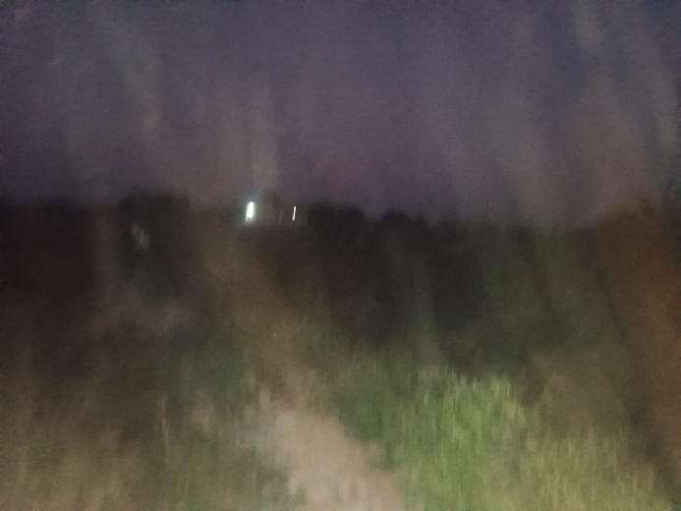

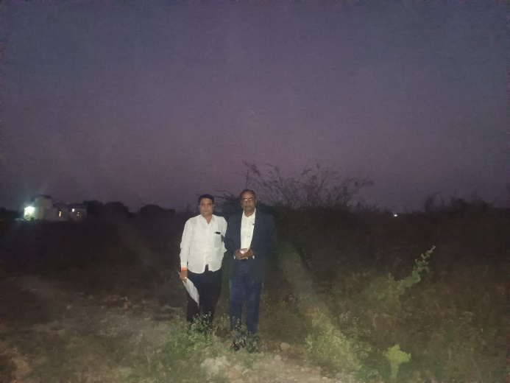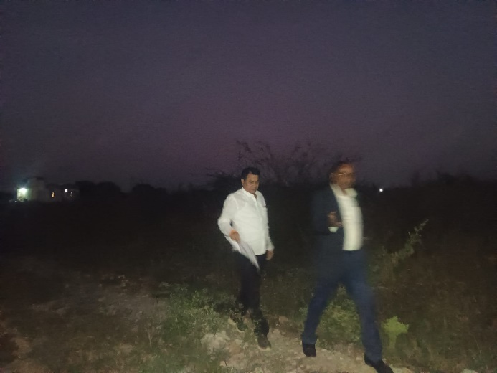

**Route Map of the Property**

# 

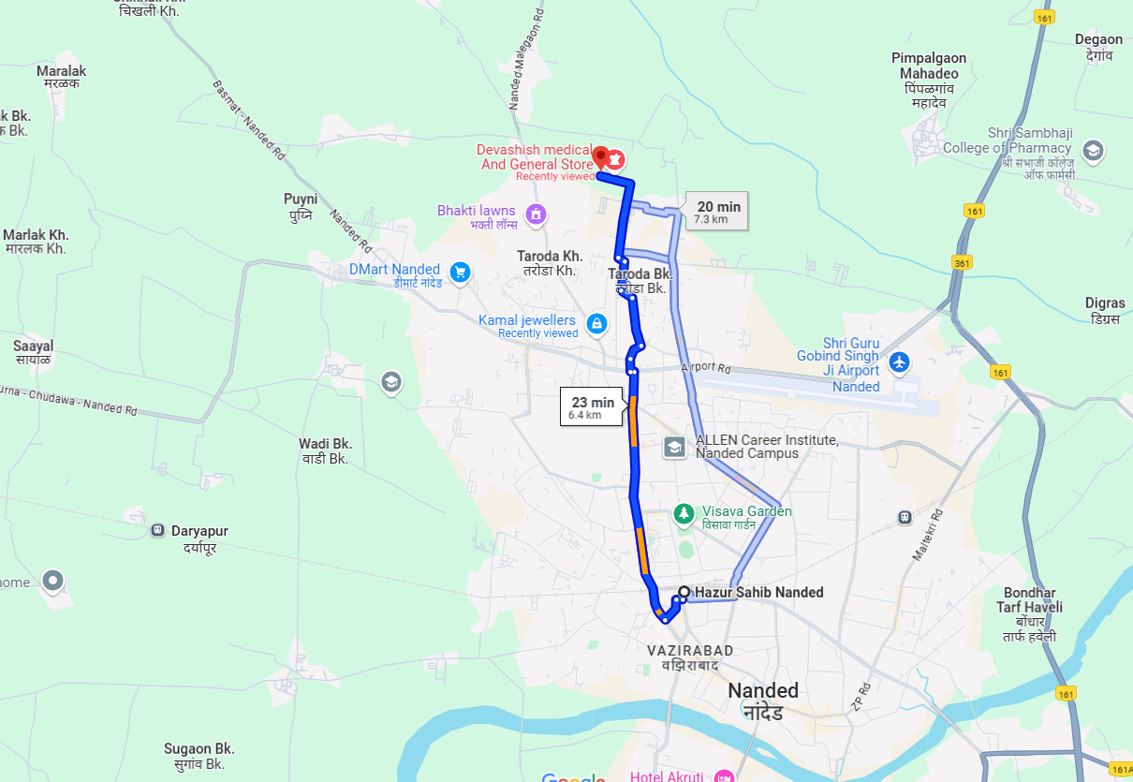

# **Longitude Latitude: 19.205253, 77.300668**

# **Note**:

* Red Pointer shows Approx. Property Location.
* Blue line shows Route from Nanded Railway Station@ 6.4 Km**.**

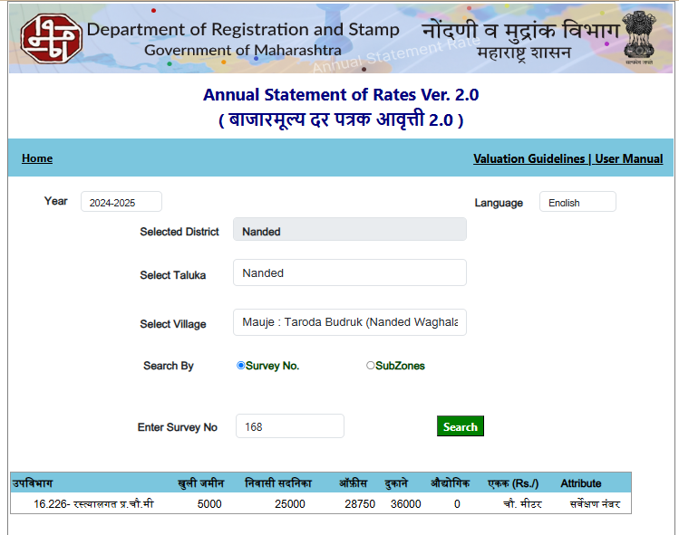**Ready Reckoner Rate**

**Gmail Attachment**

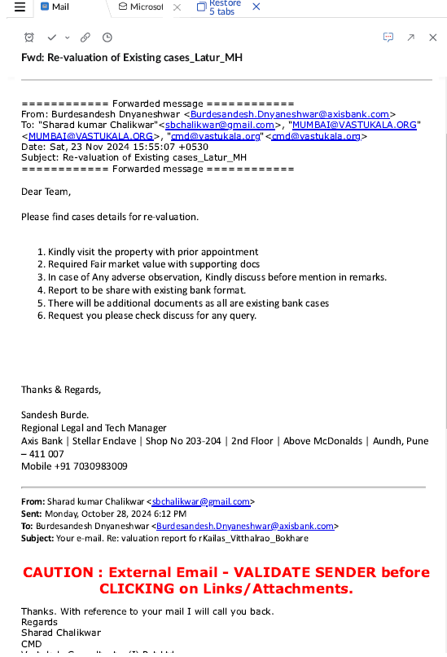

**Gmail Attachment**

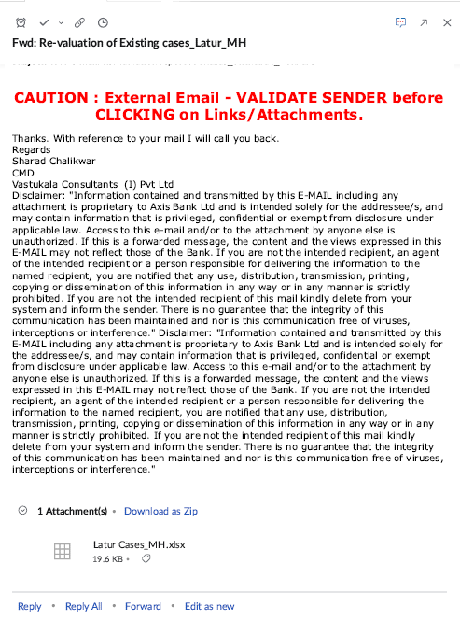

**ASSUMPTIONS, CAVEATS, LIMITATION AND DISCLAIMERS**

1. We assume no responsibility for matters of legal nature affecting the property appraised or the title thereto, nor do we render our opinion as to the title, which is assumed to be good and marketable.
2. The property is valued as though under responsible ownership.
3. It is assumed that the property is free of liens and encumbrances.
4. It is assumed that there are no hidden or unapparent conditions of the subsoil or structure that would render it more or less valuable. No responsibility is assumed for such conditions or for engineering that might be required to discover such factors.
5. The rates for valuation of the property are in accordance with the Govt. approved rates and prevailing market rates

For, **Vastukala Consultants (I) Pvt. Ltd.**

**Sharadkumar B. Chalikwar**

B.E. (Civil), M.E. (Civil), M.Sc. (Real Estate Valuation), M.Sc. (P&M Valuation), FIE (I), FIV, FIWRS

Chairman & Managing Director

Govt. Reg. Valuer

Chartered Engineer (India)

Reg. No. (N) CCIT/1-14/52/2008-09

IBBI Reg.No. IBBI/RV/07/2019/11744

Date: 05.12.2024

Place: Nanded.