Vastu/Nashik/11/2024/0012554/2309192
25/12-277-RPV
Date: 25.11.2024

To, `
The Branch Manager,
State Bank of lndia
RACPC Nashik
1st Floor, Patel Plaza, N.D.Patel Road, Opp BSNL,
Landmark Seawoods Navratna Hotel Nashik-422001.

Sub: Vetting of Supplementary Agreement

Sir,

With reference to above subject, we have evaluated the Vetting of Supplementary Agreement for Residential Flat No. A-11, 3rd Floor, "Shree Ganesh Park" Plot No. 1, Survey No.103/1B/2, 103/1C/2 at Village – Chunchale, Lane No. 3, Medage Nagar, Taluka - Nashik, District - Nashik, PIN Code - 422 007, State - Maharashtra, Country - India belongs to M/s. B Y Builders & Developers.

We have verified the rates quoted as per current market rates. Details of work and Extra Amenities considered as per copy of Supplementary Agreement issued by Mr. Prasad Ganesh Yeole (First Party) & Mr. Allwyn Victor Mariyan & Mrs. Elizabeth Jems John (Second Party) received on dated 18.11.2024. The Supplementary Agreement amount is Rs. 5,50,000/- (Rupees Five Lakh Fifty Thousand Only.)

The said Cost Vetting Certificate is valid upto next 6 months Only.

Thanking you

Sincerely yours

Manoj B. Chalikwar
Registered Valuer
Chartered Engineer (India)
Reg. No. CAT-I-F-1763
Reg. No. IBBI/RV/07/2018/10366
BOB Empanelment No.: ZO:MZ:ADV:46:941
Encl: Valuation report.

Supplementary Agreement
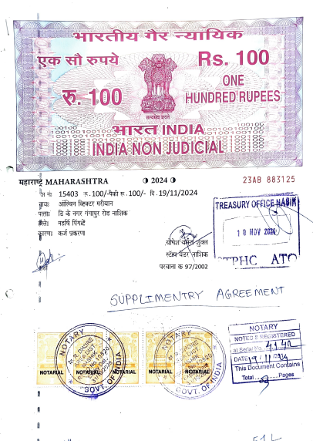
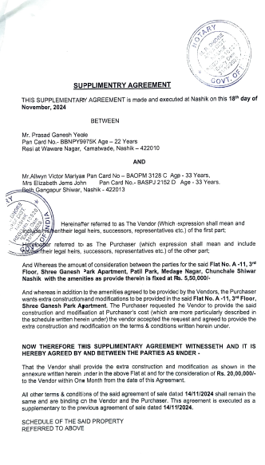

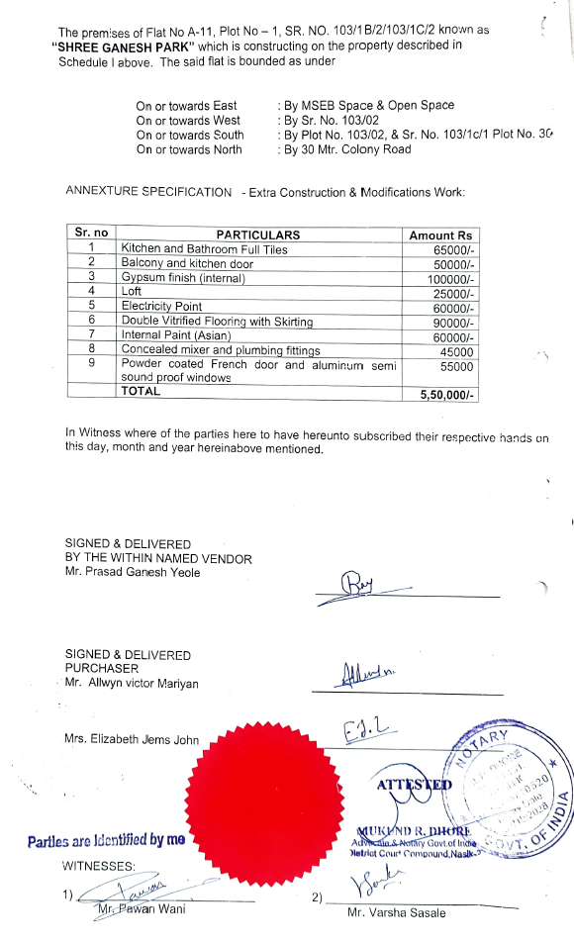

The Extra Amenities amount is Rs. 5,50,000/- (Rupees Five Lakh Fifty Thousand Only.)

