Vastu/Nashik/09/2024/011565/2308453
30/24-459 -RPBS
Date: 16.11.2024

To,
The Chief Manager,
Bank of Baroda
SME Loan Factory Branch
BSNL Factory Building, Datta Mandir Road, Nashik Road,
Nashik - 422 101, State - Maharashtra, Country - India.

Sub: Vetting of Estimate

Sir,

With reference to above subject, we have evaluated the Estimate Industrial Land and Proposed Hotel Building " Hotel Curry Leaves " on Plot No.C-4/3 , Nashik Industrial Co. Operative Estate Limited ( NICE ) MIDC Satpur , Nashik, MIDC Road Street No.8, Opposite Asia Automotive Limited Company , Mahatma Nagar Water Tank Road , Village – Satpur M.I.D.C, Taluka - Nashik, District – Nashik, PIN Code – 422 007, State – Maharashtra, Country – India belongs to M/s. Hotel Curry Leaves.

We have verified the rates quoted as per current market rates. Details of Estimate considered as per copy of Estimate provided to us by Client of Architecture Aniket R. Khade. The Estimate amount is Rs.15,44,51,569/- (Rupees Fifteen Crore Forty Four Lakh Fifty One Thousand Five Hundred Sixty Nine Only). For Structure & Infrastructure Cost is Rs.75,00,000/- (Rupees Seventy Five Lakh Only)
After Considering Amenities Taken by Architect & Copy of Estimate Given to us by Owner, we have reached to Conclusion That the Above Estimate is Rs.16,73,17,910/- (Rupees Sixteen Crore Seventy Three Lakh Seventeen Thousand Nine Hundred Ten Only).
Items | Area In Sq. M. | Full Rate | Age Of Build. | Rate to be considered | Value to be considered | Value / Full Value
Proposed  Basement+ Ground Floor + +Eleventh Floor | 9842.23 | 17,000.00  (Including Infrastructure Cost) | Building is Under Construction | 17,000.00 | 16,73,17,910.00 | 16,73,17,910.00
 |  |  |  | TOTAL | 16,73,17,910.00 | 16,73,17,910.00
TOTAL |  |  |  |  |  | 16,73,17,910.00

Note: 1) The said Cost Vetting Certificate is valid upto next 6 months Only.
2) It is Advisable to get periodic work completion status, Bills prior to disbursement of loan.

Thanking you

Sincerely yours

Manoj B. Chalikwar
Registered Valuer
Chartered Engineer (India)
Reg. No. CAT-I-F-1763
Reg. No. IBBI/RV/07/2018/10366
BOB Empanelment No.: ZO:MZ:ADV:46:941
Encl: Valuation report

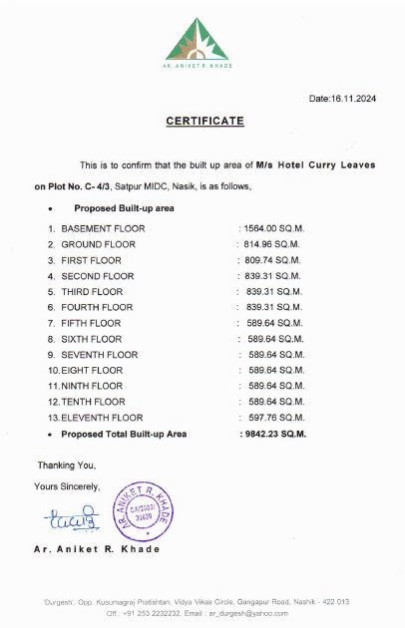

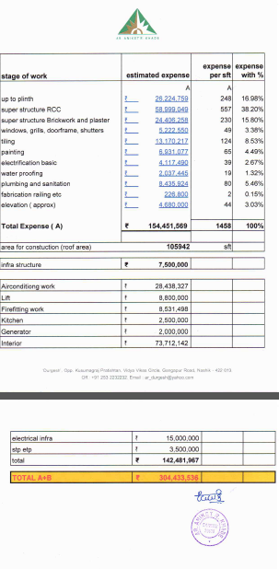
Infrastructure Cost Sheet

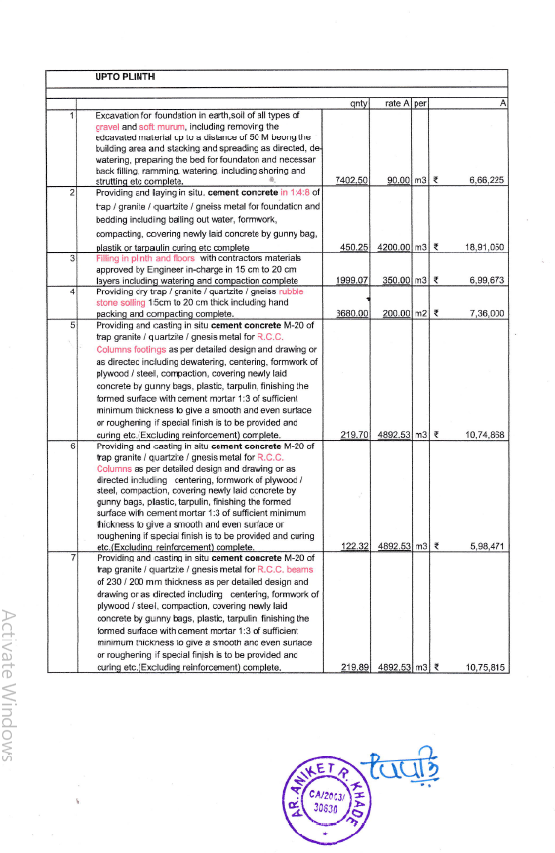

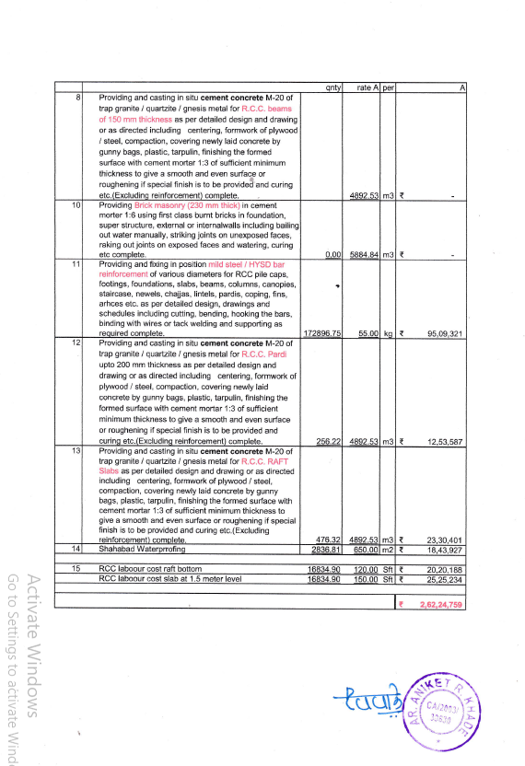

.

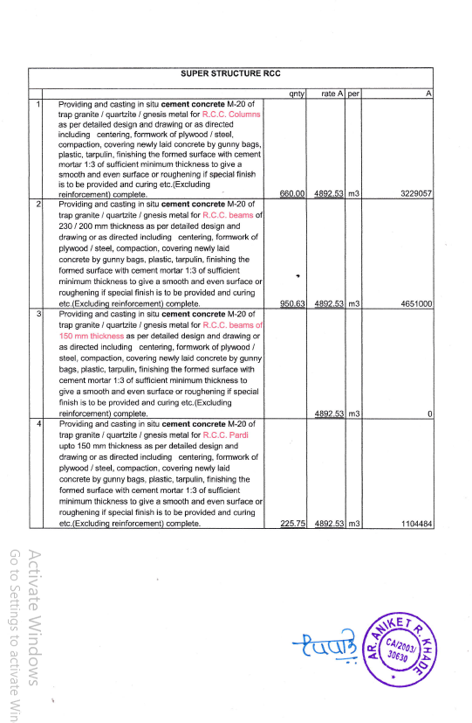

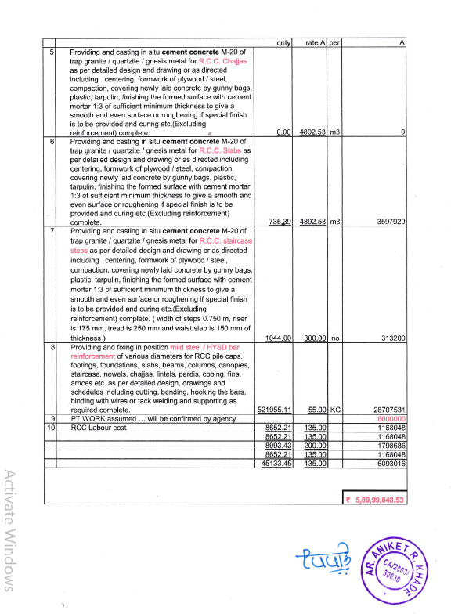

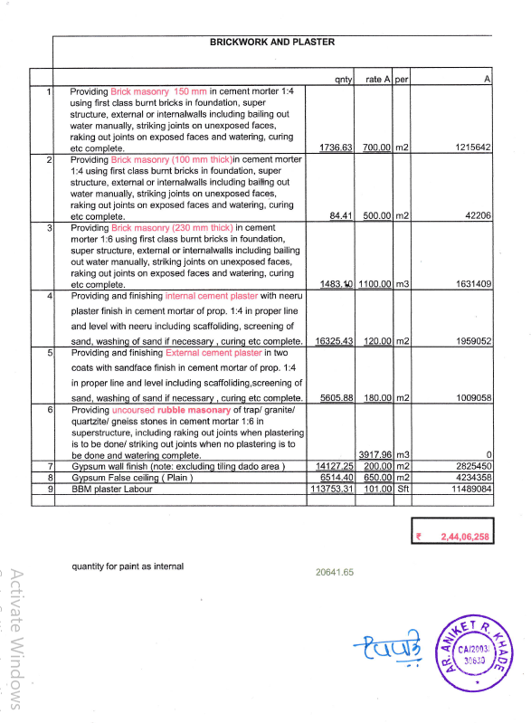

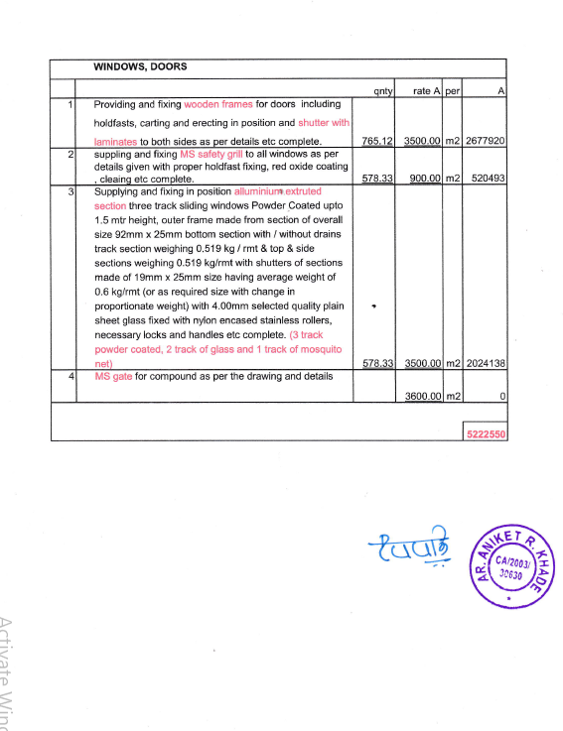

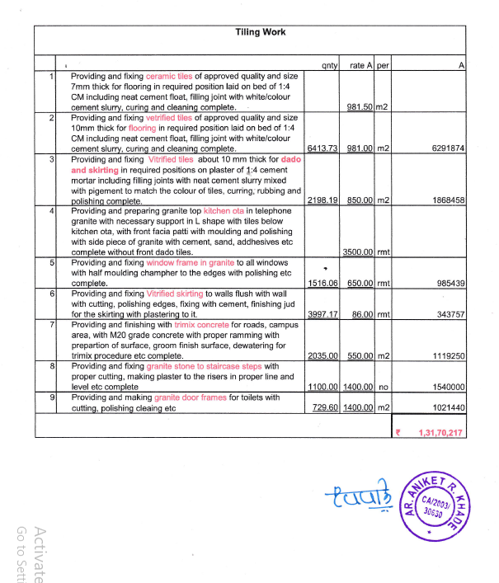

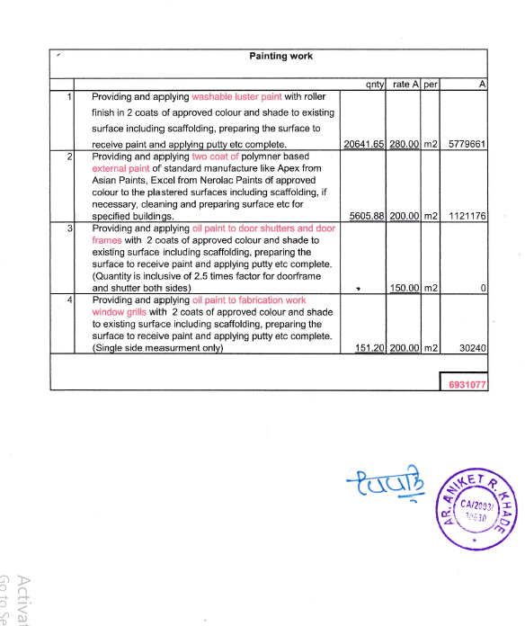

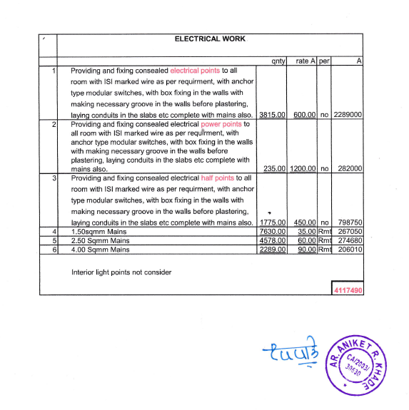

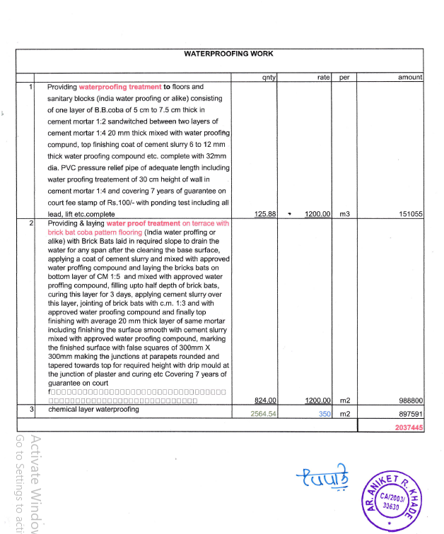

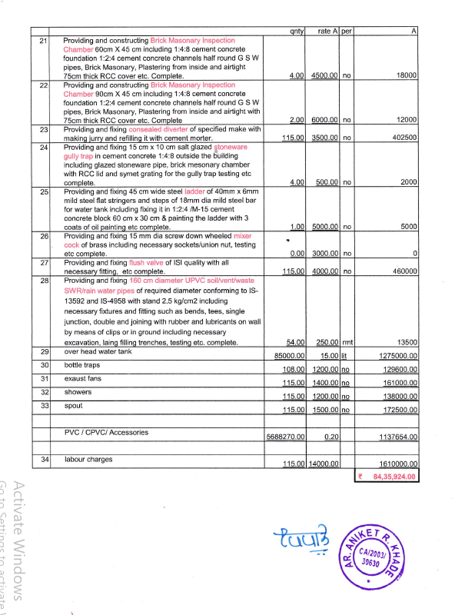

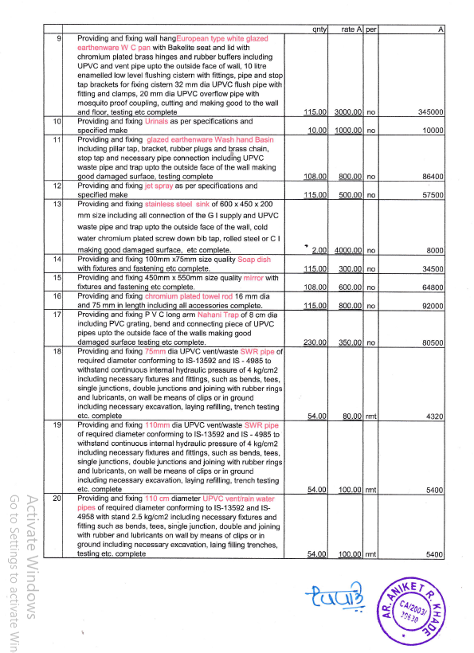

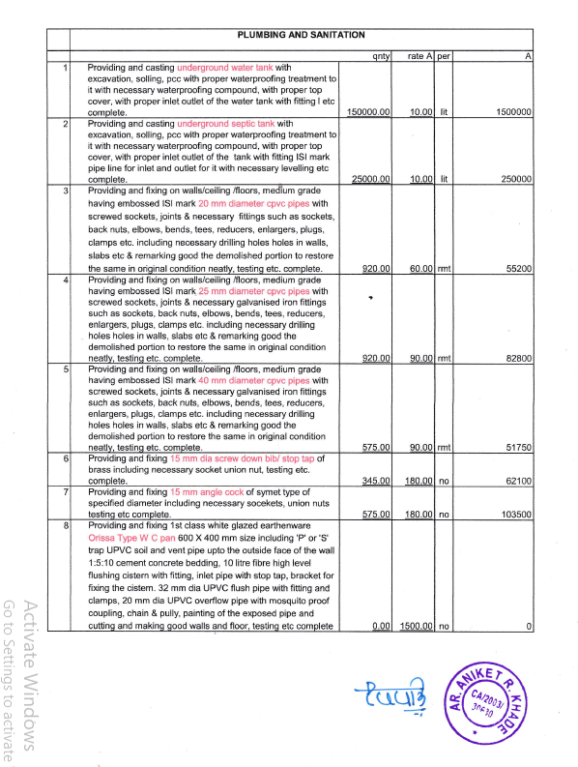

The Estimate amount is Rs.16,73,17,910/- (Rupees Sixteen Crore Seventy Three Lakh Seventeen Thousand Nine Hundred Ten Only)

