Vastu/Nashik/11/012510/2309154
22/6-239-RYRJ
Date: 22.11.2024
To,
The Branch Manager,
Bank of Baroda
Regional Office
BSNL Building, Datta Mandir Road, Nashik Road,
Nashik, PIN – 422 101, State - Maharashtra, Country - India.

Sub: Vetting of Extra Amenities

Sir,

With reference to above subject, we have evaluated the Extra Amenities For Residential Flat No. 703, 7th Floor, "Dream Aura", Survey No. 323/ 1/ A/ 1, Plot No. 3, Behind Jatra Hotel, Near Ramleela Mangal Karyalay & Lawns, Swami Samarth Nagar, Off Jatra Nandur Link Road, Village - Adgaon, Taluka - Nashik, District - Nashik, Nashik, PIN Code - 422 003, State - Maharashtra, Country - India belongs to Shri. Dyaneshwar Ramesh Patil & Sau. Kalyani Dyaneshwar Patil.

We have verified the rates quoted as per current market rates. Details of Extra Amenities considered as per copy of Extra Amenities Agreement between Shri. Dyaneshwar Ramesh Patil & Sau. Kalyani Dyaneshwar Patil (First Party). Shri. Ganesh Shivdas Wagh (Second Party) received on dated.15.11.2024. The Extra Amenities amount is
Rs. 7,50,000/- (Rupees Seven Lakh Fifty Thousand Only)

The said Cost Vetting Certificate is valid upto next 6 months Only.

Thanking you

Sincerely yours

Manoj B. Chalikwar
Registered Valuer
Chartered Engineer (India)
Reg. No. CAT-I-F-1763
Reg. No. IBBI/RV/07/2018/10366
BOB Empanelment No.: ZO:MZ:ADV:46:941
Encl: Valuation report.

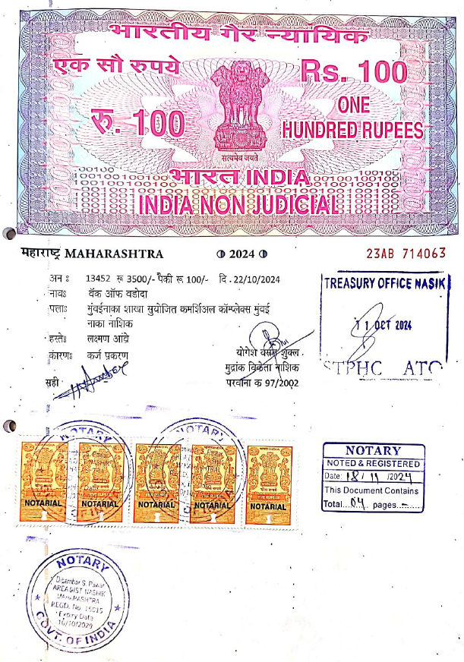
Agreement for Extra Amenities
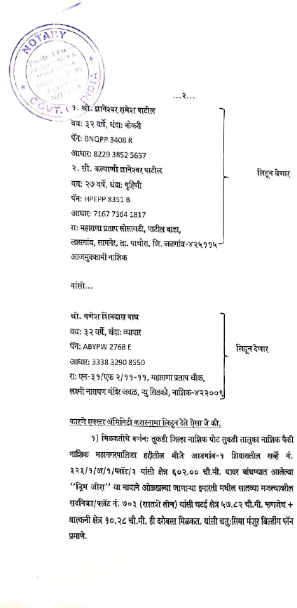

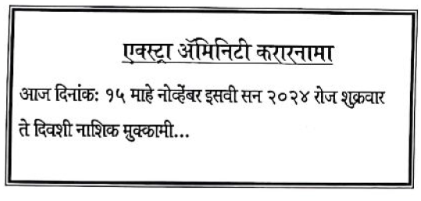

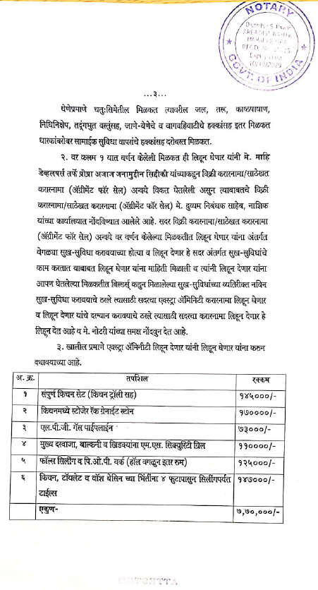
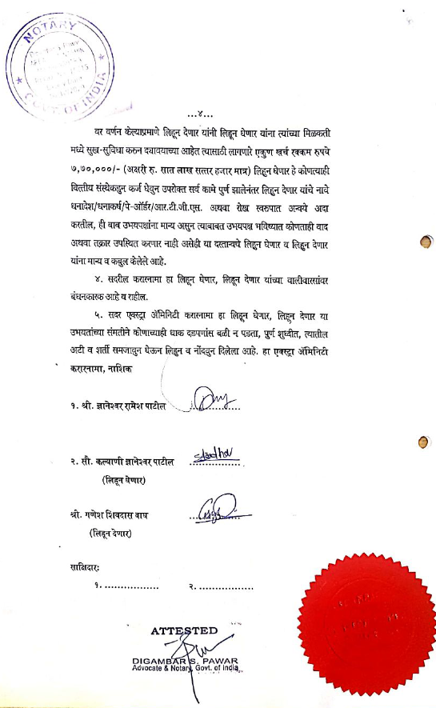

The Extra Amenities amount is Rs. 7,50,000/- (Rupees Seven Lakh Fifty Thousand Only)

