Vastu/Nashik/11/2024/012491/2309152
22/4-237-CCRJ
Date: 21.11.2024

To,
The Assistant General Manager,
Bank of Baroda
Regional Office
BSNL Building, Datta Mandir Road, Nashik Road,
Nashik, PIN – 422 101, State - Maharashtra, Country - India.

Sub: Vetting of Estimate

Sir,

With reference to above subject, we have evaluated the Estimate for Residential Land and Proposed Bungalow on C.T.S No. 204 & 205, Ground + First Floor, Near Sagar Kirana Store, Village - Dhakambe, Taluka – Dindori, District – Nashik,
Pin Code – 422 004, State - Maharashtra, Country – India belongs Shri.Sudhir Nivrutti Kedar.

We have verified the rates quoted as per current market rates. Details of Estimate considered as per copy of Estimate Provided by Er.V.G.Bhoyate on dated.21.11.2024. The Estimate amount is Rs.50,95,500/- (Rupees Fifty Lakh Ninety-Five Thousand Five Hundred Only.)

Note:1) The said Cost Vetting Certificate is valid upto next 6 months Only.

Thanking you

Sincerely yours

Manoj B. Chalikwar
Registered Valuer
Chartered Engineer (India)
Reg. No. CAT-I-F-1763
Reg. No. IBBI/RV/07/2018/10366
BOB Empanelment No.: ZO:MZ:ADV:46:941
Encl: Valuation Report

Estimate
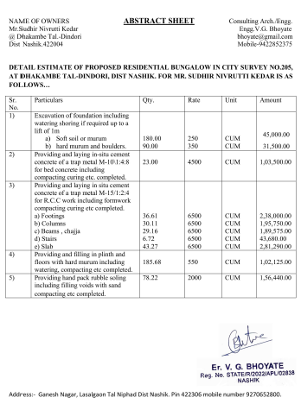
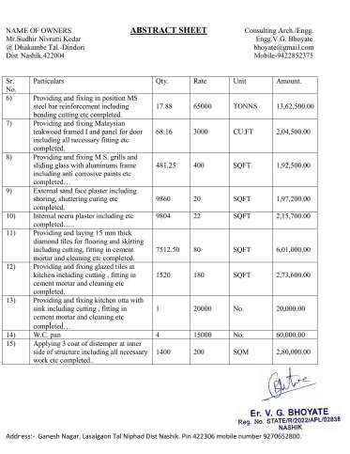

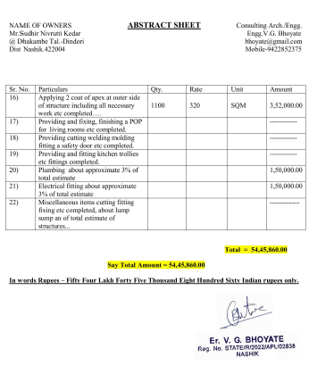
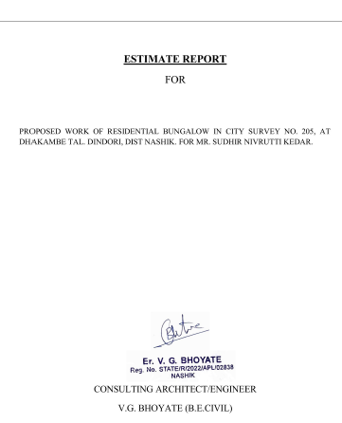

The Estimate amount is Rs.50,95,500/- (Rupees Fifty Lakh Ninety-Five Thousand Five Hundred Only.)

