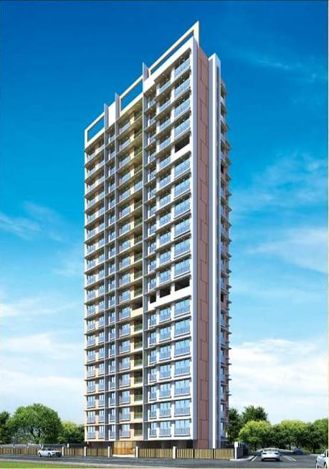6th LENDERS INDEPENDENT ENGINEER REPORT

**Details of the property under consideration:**

**Name of Project: Amey Apartments**

**"Amey Apartments", Proposed Redevelopment on Plot bearing C.T.S. No. 182/C, 182/D & 182/E,**

**Village Mogra, K/E Ward, Near Ravindra Joshi Medical Foundation Hospital, Andheri (East),**

**Mumbai – 400 069, State – Maharashtra, Country – India**

**Latitude Longitude: 19°07'29.2"N 72°51'17.8"E**

Intended User:

State Bank of India

SME Chembur Branch

Unit No. 11, Building No. 11, Ground Floor, Corporate Park, Sion Trombay Road,

Chembur, Mumbai, Pin Code – 400 071, State - Maharashtra, Country – India

Vastu/Mumbai/SBI/11/2024/12410/2307399

15/10-403-PY

Date: - 15.11.2024

SIXTH LENDERS INDEPENDENT ENGINEER REPORT

**To,**

**State Bank of India**

SME Chembur Branch

Unit No. 11, Building No. 11,

Ground Floor, Corporate Park,

Sion Trombay Road, Chembur,

Mumbai, Pin Code – 400 071,

State - Maharashtra, Country – India

Subject: Construction of Proposed Redevelopment on Plot bearing C.T.S. No. 182/C, 182/D & 182/E, Village Mogra, K/E Ward, Near Ravindra Joshi Medical Foundation Hospital, Andheri (East), Mumbai – 400 069, State – Maharashtra, Country – India.

**Ref:** You’re Request for Lenders Independent Engineer Report of under Construction Building.

**Dear Sir,**

1. As per your instruction, we have inspected the under-construction Maternity, Rehab and Sale Building project situated on plot bearing C.T.S. No. 182/C, 182/D & 182/E, Village Mogra, K/E Ward, Near Ravindra Joshi Medical Foundation Hospital, Andheri (East), Mumbai – 400 069, State – Maharashtra, Country – India which is being developed by M/s. Amey Realty and Construction LLP in order to give the physical progress at site and to certify cost incurred towards project as on 30/09/2024.
2. **The Construction work as per approved plan was in progress during the site visit on 8th October 2024.**
3. **Status of work:**
4. **For Maternity Building (Wing B):** 100% work is completed & Occupancy Certificate is received.
5. **For Rehab cum Sale Building (Wing A):** 12th Floor Slab work, 1st & 11th floor block work, 1st to 10th floor plasterwork, Gypsum work, water proofing, kitchen platform, toilet dadoing, door & window frames work is completed, 13th floor shuttering work is in progress.

**Rehab cum Sale building (Wing A) work is delay by 18 months.**

1. As per cost incurred certificate issued by **CA Certificate actual total expenditure occurred as on 30/09/2024 is ` 45.93 Cr. for Maternity, Rehab & Sale Building (Wing A & B) & overall financial progress is 71.56% estimated cost of project.**
2. As per bills **actual total expenditure occurred as on 30/09/2024 is ` 45.39 Cr. for Residential of Maternity, Rehab & Sale Building (Wing A & B) & overall financial progress is 70.72% estimated cost of project.**
3. Overall Physical progress of the maternity building (Wing B) construction as on 08/10/2024 is 100.00% as per physical site inspection.
4. Overall Physical progress of the rehab cum sale building (Wing A) construction as on 08/10/2024 is 42.28% as per physical site inspection.
5. Overall Physical progress of the maternity, rehab & sale building (Wing A & B) construction as on 08/10/2024 is 51.30% as per physical site inspection.

**DECLARATION**

1. The information furnished in the report is based on our 6th site visit Dated 08/10/2024 & Document Provided by Client.
2. Vastukala 5th LIE Report of the project dated 25/07/2024.
3. I have no direct and indirect interest in the property examined for report.
4. I have not been found guilty of misconduct in my professional capacity.

**Manoj B. Chalikwar**

Registered Valuer

Chartered Engineer (India)

Reg. No. IBBI/RV/07/2018/10366

Encl.: LIE report

# Purpose & Methodology

• State Bank of India Banks and financial institutions require monitoring & an independent review of the progress of the sanctioned projects

**VCIPL** undertakes such study to independently review the progress of the project and put forward a comprehensive analysis

# Advantages:

* Assurance on present practices
* Identification of risk
* Analyzing the performance of third parties
* Recommendations

# The Methodology

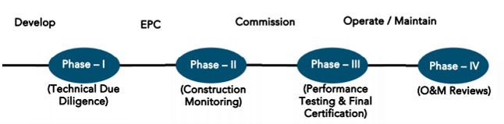

**SIXTH LENDERS INDEPENDENT ENGINEER REPORT**

**OF**

**"AMEY AMPARTMENTS"**

**"Amey Apartments",** Proposed Redevelopment on Plot bearing C.T.S. No. 182/C, 182/D & 182/E,

Village Mogra, K/E Ward, Near Ravindra Joshi Medical Foundation Hospital, Andheri (East),

Mumbai – 400 069, State – Maharashtra, Country – India

**Latitude Longitude: 19°07'29.2"N 72°51'17.8"E**

**NAME OF DEVELOPER: M/s. Amey Realty and Construction LLP**

|  |
| --- |
| Pursuant to instructions from State of India, SME Chembur Branch, Mumbai we have duly visited, inspected, surveyed & assessed the above said property on **08th October 2024** to determine the fair & reasonable market value of the said property/project as on Quarter ending **30th September 2024** for LIE purpose.  **1. Location Details:**  Proposed Redevelopment on Plot bearing C.T.S. No. 182/C, 182/D & 182/E, Village Mogra, K/E Ward, Near Ravindra Joshi Medical Foundation Hospital, Andheri (East), Mumbai – 400 069. It is about 2.3 Km. walking distance from Andheri East Railway station. Surface transport to the property is by buses, taxis & private vehicles. The property is in developed locality. All the amenities like shops, banks, hotels, markets, schools, hospitals, etc. are all available in the surrounding locality. The area is higher middle class & developed. |

**2. Developer Details:**

|  |  |
| --- | --- |
| **Name of builder** | **M/s. Amey Realty and Construction LLP** |
| **Project Rera Registration Number** | **P51800045221** |
| **Registered office address** | Office at 201-A, Vertex Vikas, Sir M.V. Road, Andheri (East), Mumbai – 400 069, State - Maharashtra, Country – India |
| **Contact details** | **Contact Person:**  Mrs. Mona Mehta  Mobile No. 7977952834 |
| **E – mail ID and website** |  |

**3. Boundaries of the Property:**

|  |  |
| --- | --- |
| **Direction** | **Particulars** |
| **On or towards North** | Open Plot/R G Reservation |
| **On or towards South** | 18.30 D P Road |
| **On or towards East** | 9.0 M. D P Road |
| **On or towards West** | CTS No. 185 |

# Introduction

**As per Information on site M/s. Amey Realty and Construction LLP** has acquired land by multiple surrender & supplementary & conveyance Agreement dated 21.12.2006, 10.02.2022, 02.01.2021, 06.02.2014, 17.01.2014, 28.06.2013, 13.02.2006, 13.03.2018, 08.04.2019 admeasuring **area is 1,693.09 Sq. M.** bearing **CTS No. 182/C, 182/D & 183/E.** For the Proposed Residential Building.

# Area Statement:

# Land:

|  |  |  |
| --- | --- | --- |
| **Date** | **Particular** | **Area in Sq. M.** |
| 10.02.2022 | CTS No. 182/C | 1,486.10 |
| CTS No. 183/D | 65.90 |
| CTS No. 183/E | 141.09 |
| TOTAL | | 1,693.09 |

1. Copy of Deed of Conveyance dated 21.12.2006 between Smt. Rajudulari Pandey & Others (The Vendors) and M/s. Amey Constructions (The Purchaser) registered vide No. BDR1-02605-2007 dated 28.03.2007.
2. Copy of Supplementary Agreement dated 10.02.2022 M/s. Amey Constructions (The Owner) and Mr. Vinod Shantilal Trivedi (The Tenants) registered vide No. BDR1-2331-2022 dated 10.02.2022
3. Copy of Supplementary Agreement dated 10.02.2022 M/s. Amey Constructions (The Owner) and Mr. Bhupendra Shantilal Trivedi (The Tenants) registered vide No. BDR1-2330-2022 dated 10.02.2022
4. Copy of Deed of Surrender of Tenancy dated 02.01.2021 between Shri Pankaj Pandey + 1 Other (The Tenant) and M/s. Amey Realty & Construction LLP (The Purchaser)
5. Copy of Deed of Surrender of Tenancy dated 06.02.2014 between Shri Bheem K. Tiwari (The Tenant) and M/s. Amey Realty & Construction LLP (The Purchaser)
6. Copy of Deed of Surrender of Tenancy dated 17.01.2014 between Shri Ashokkumar M. Tiwari (The Tenant) and M/s. Amey Realty & Construction LLP (The Purchaser)
7. Copy of Deed of Surrender of Tenancy dated 17.01.2014 between Shri Lalji C. Tiwari + 1 Other (The Tenant) and M/s. Amey Realty & Construction LLP (The Purchaser)
8. Copy of Deed of Surrender dated 28.06.2013 between Mrs. Asha Ramesh Tiwari & Others (The Tenants) and M/s. Amey Constructions (The Owner)
9. Copy of Deed of Surrender dated 13.02.2006 between M/s. Bagwe housing Pvt. Ltd. (The Developers) and Smt. Rajdulari Pande & Others (The Owner)
10. Copy of Declaration Cum Indemnity Agreement dated 28.06.2013 between Mrs. Asha Ramesh Tiwari & Others (The Tenants) and M/s. Amey Constructions (The Owner)
11. Copy of Declaration Cum Indemnity Agreement dated 06.02.2014 between Shri Bheem K. Tiwari (The Tenants) and M/s. Amey Constructions (The Owner)
12. Copy of Declaration Cum Indemnity Agreement dated 17.01.2014 between Shri Ashokkumar M. Tiwari (The Tenants) and M/s. Amey Constructions (The Owner)
13. Copy of Declaration Cum Indemnity Agreement dated 17.01.2014 between Shri Lalji C. Tiwari & other (The Tenants) and M/s. Amey Constructions (The Owner)
14. Copy of Alternate Accommodation Agreement dated 13.03.2018 between M/s. Amey Constructions (The Owner) and Mr. Deepchand C. Chandel (The Tenants) registered vide no. BDR -18 / 2521 dated 13.03.2018.
15. Copy of Alternate Accommodation Agreement dated 08.04.2019 between M/s. Amey Constructions (The Owner) and Mr. Vinod Shantilal Trivedi (The Tenants) registered vide no. BDR -18 / 4213 dated 08.04.2019.
16. Copy of Alternate Accommodation Agreement dated 08.04.2019 between M/s. Amey Constructions (The Owner) and Mr. Bhupendra Shantilal Trivedi (The Tenants) registered vide no. BDR -18 / 4214 dated 08.04.2019.
17. Copy of Power of Attorney dated 06.02.2014
18. Copy of Power of Attorney dated 17.01.2014
19. Copy of Power of Attorney dated 28.01.2013
20. Copy of Power of Attorney dated 17.01.2014
21. Copy of Special Power of Attorney dated 15.01.2007 given by Smt. Pushpavati R. Pandey
22. Copy of Special Power of Attorney dated 15.01.2007 given by Shri Vijaykumar R. Pandey
23. Copy of Special Power of Attorney dated 15.01.2007 given by Smt. Rajudulari R. Pandey
24. Copy of Special Power of Attorney dated 15.01.2007 given by Shri Santoshkumar R. Pandey
25. Copy of Special Power of Attorney dated 15.01.2007 given by Shri Laxminarayan R. Pandey
26. Copy of Special Power of Attorney dated 15.01.2007 given by Shri Seshnarayan R. Pandey

# Building Area:

# As per Approved Plan:

|  |  |  |
| --- | --- | --- |
| Sr. No. | Particulars | Area in Sq. M. |
| 1 | Area of Plot CTS Nos. 182C, 182D & 182E | 1,693.00 |
| 2 | Deduction for |  |
|  | (a) Proposed Set Back Area | 4.81 |
|  | (b) Proposed D P Road CTS No. 182D | 65.90 |
|  | (c) Any Reservation (M H Reservation) | - |
|  | (d) Deduct Area of Plot to be handed over | 648.92 |
|  | (e) Other | - |
| 3 | Balance Area of Plot | 973.37 |
| 4 | Deduction for 15% Recreational Ground, 10% Amenity space (If Deductible for Ind) | - |
| 5 | Net Plot Area (3-4) | 973.37 |
| 6 | Add area of Plot to be handed over | 648.92 |
| 7 | Additions for Floor Space Index (Proposed D P Road (65.90 X 2)) | 131.80 |
|  | Setbacks Area | 9.62 |
| 8 | Total Area (5+6+7) | 1,763.71 |
| 9 | Floor Space Index Permissible | 1.00 |
| 10 | Floor Space Index Credit available by |  |
|  | (i) Govt. FSI (50%) | 811.15 |
|  | (ii) TDR (90%) as per table of DCPR (1464.39 - (65.90 X 2) - 754.16) | 566.71 |
|  | (iii) 40% of area in lieu of Land to be handed over to MCGM | 648.92 |
|  | (iv) Built up area in lieu of handing over built-up Amenity free of cost | 751.93 |
|  | (v) Total | 2,778.71 |
| 11 | Permissible Floor Area (8 X 9) Plus (V) above | 4,542.42 |
| 12 | Built up area proposed | 4,368.92 |
| 13 | Fungible built up area component permissible vide DCPR 2034 (4548.51 X 0.35) | 1,529.12 |
| 14 | Fungible built up area component proposed vide DCPR 2034 | 1,529.12 |
| 15 | Total Gross Built up area permissible | 5,898.04 |
| 16 | Total Gross Built up area proposed | 6,898.02 |
| 17 | FSI consumed on Net Holding Area 16/3 | 4.49 |
| Tenement Statement | | |
| a | Proposed Area Item A - 12 above | 4,368.92 |
| b | Less Deduction for Non Resi. Built Up Area | - |
| c | Area Available for Tenements | 4,368.92 |
| d | Tenement Permissible = 240.93 | 197 Nos |
| e | Tenement Proposed | 72 Nos |
| f | Tenement Existing | - |
| g | Total No. of Tenements | 72 Nos. |
| Parking Statement | | |
| 1 | Parking Required | 77 |
| 2 | Parking Proposed | 78 |
| 3 | Scooter / Motor Cycle |  |

# List of Approvals:

1. Copy of Amended Approved Plan No. CE/8215/WS/AK/337/2/Amend dated 23.12.2021 issued by Municipal Corporation of Greater Mumbai

**Approved upto:**

**Wing A: Ground Floor + 1st to 13th Upper Residential Floor**

**Wing B: Ground Floor + 1st to 9th Upper Maternity Floor**

1. Copy of 1st Amended Approved Plan No. CE/8215/WS/AK/ dated 16.02.2023 issued by Municipal Corporation of Greater Mumbai

**Approved upto:**

**Wing A: Ground Floor + 1st to 12th Upper Residential Floor**

**Wing B: Ground Floor + 1st to 9th Upper Maternity Floor**

1. Copy of 2nd Amended Approved Plan No. CE/8215/WS/AK dated 13.08.2024 issued by Municipal Corporation of Greater Mumbai

**Approved upto:**

**Wing A: Ground Floor + 1st to 18th Upper Residential Floor**

**Wing B: Ground Floor + 1st to 9th Upper Maternity Floor**

1. Copy of Concession Drawing Plan No. CE/8215/WS/AK/337/ dated 15.06.2021 issued by Municipal Corporation of Greater Mumbai

**Approved upto:**

**Wing A: Ground Floor + 1st to 19th Upper Residential Floor**

**Wing B: Ground Floor + 1st to 9th Upper Maternity Floor**

1. Copy of 1st Commencement Certificate No. CE/8215/WS/AK/CC/1/New dated 10.03.2022 issued by Municipal Corporation of Greater Mumbai.

**(This CC is endorsed for the work upto Plinth Level of Wing A & B)**

1. Copy of 2nd Commencement Certificate No. CE/8215/WS/AK/FCC/1/New dated 07.04.2022 valid till 06.04.2023 issued by Municipal Corporation of Greater Mumbai.

**(This CC is endorsed for the work upto Ground Floor + 1st to 5th Upper Residential Floor of Wing A)**

1. Copy of 3rd Commencement Certificate No. CE/8215/WS/AK/FCC/1/Amend dated 16.03.2023 valid till 09.03.2024 issued by Municipal Corporation of Greater Mumbai.

**(This CC is endorsed for the work upto Ground Floor + 1st to 12th Upper Residential Floor of Wing A & Ground Floor + 1st to 9th Upper Residential Floor of Wing B)**

1. Copy of 4th Commencement Certificate No. CE/8215/WS/AK/FCC/1/Amend dated 21.08.2024 valid till 09.03.2025 issued by Municipal Corporation of Greater Mumbai.

**(This CC is endorsed for the work upto Ground Floor + 1st to 18th Upper Residential Floor + LMR/OHT of Wing A & Ground Floor + 1st to 9th Upper Residential Floor of Wing B as per last approved plan dated 13.08.2024)**

1. Copy of Occupation Approved Plan No. CE/8215/WS/AK dated 26.06.2024 for Wing B issued by Municipal Corporation of Greater Mumbai

**(Approved upto : Wing B: Ground Floor + 1st to 9th Upper Municipal Maternity Floor)**

1. Copy of Occupation Certificate No. CE/8215/WS/AK/OCC/1/New dated 26.06.2024 for Wing B issued by Municipal Corporation of Greater Mumbai

**(Approved upto : Wing B: Ground Floor + 1st to 9th Upper Municipal Maternity Floor)**

# LEVEL OF COMPLETION:

# Maternity Building (Wing B)

| Sr. No | Floor No. | Construction Area in Sq. M. | Completed Area in Sq. M. | Work Completion as on 08.10.2024 | Work Completion as on 5th LIE Report dated 25.07.2024 |
| --- | --- | --- | --- | --- | --- |
| 1 | Excavation & Shore Piling | | | Work is Completed | Work is Completed |
| 2 | Ground Floor | 151.28 | 151.28 | 100% work is completed & OC is received | 100% work is completed & OC is received |
| 3 | 1st Floor | 178.38 | 178.38 | 100% work is completed & OC is received | 100% work is completed & OC is received |
| 4 | 2nd Floor | 178.38 | 178.38 | 100% work is completed & OC is received | 100% work is completed & OC is received |
| 5 | 3rd Floor | 178.38 | 178.38 | 100% work is completed & OC is received | 100% work is completed & OC is received |
| 6 | 4th Floor | 178.38 | 178.38 | 100% work is completed & OC is received | 100% work is completed & OC is received |
| 7 | 5th Floor | 178.38 | 178.38 | 100% work is completed & OC is received | 100% work is completed & OC is received |
| 8 | 6th Floor | 178.38 | 178.38 | 100% work is completed & OC is received | 100% work is completed & OC is received |
| 9 | 7th Floor | 178.38 | 178.38 | 100% work is completed & OC is received | 100% work is completed & OC is received |
| 10 | 8th Floor | 178.38 | 178.38 | 100% work is completed & OC is received | 100% work is completed & OC is received |
| 11 | 9th Floor | 178.38 | 178.38 | 100% work is completed & OC is received | 100% work is completed & OC is received |
| 22 | Terrace Floor | 59.03 | 59.03 | 100% work is completed & OC is received | 100% work is completed & OC is received |
| Total | | 1,815.73 | 1,815.73 |  |  |

# Rehab cum Sales Building (Wing A)

| Sr. No | Floor No. | Construction Area in Sq. M. | Completed Area in Sq. M. | Work Completion as on 08.10.2024 | Work Completion as on 5th LIE Report dated 25.07.2024 |
| --- | --- | --- | --- | --- | --- |
| 1 | Excavation & Shore Piling | | | Work is Completed | Work is Completed |
| 2 | Ground Floor | 320.22 | 320.22 | Slab Work, Blockwork, Plaster work are completed | Slab Work, Blockwork, Plaster work are completed |
| 3 | 1st Floor | 397.21 | 397.21 | All the flats are 100% work is completed, External painting Lobby, lift & passage work is pending are completed | All the flats are 100% work is completed, External painting Lobby, lift & passage work is pending are completed |
| 4 | 2nd Floor | 411.34 | 411.34 | Slab Work, Blockwork, Plaster work, Gypsum work, water proofing, Kitchen Platform, toilet dadoing & Door and window frames works are completed | Slab Work, Blockwork, Plaster work, Gypsum work, water proofing, Kitchen Platform, toilet dadoing & Door and window frames works are completed |
| 5 | 3rd Floor | 411.34 | 411.34 | Slab Work, Blockwork, Plaster work, Gypsum work, water proofing, Kitchen Platform, toilet dadoing & Door and window frames works are completed | Slab Work, Blockwork, Plaster work, Gypsum work, water proofing, Kitchen Platform, toilet dadoing & Door and window frames works are completed |
| 6 | 4th Floor | 411.34 | 411.34 | Slab Work, Blockwork, Plaster work, Gypsum work, water proofing, Kitchen Platform, toilet dadoing & Door and window frames works are completed | Slab Work, Blockwork, Plaster work, Gypsum work, water proofing, Kitchen Platform, toilet dadoing & Door and window frames works are completed |
| 7 | 5th Floor | 411.34 | 411.34 | Slab Work, Blockwork, Plaster work, Gypsum work, water proofing, Kitchen Platform, toilet dadoing & Door and window frames works are completed | Slab Work, Blockwork, Plaster work, Gypsum work, water proofing, Kitchen Platform, toilet dadoing & Door and window frames works are completed |
| 8 | 6th Floor | 411.34 | 411.34 | Slab Work, Blockwork, Plaster work, Gypsum work, water proofing, Kitchen Platform, toilet dadoing & Door and window frames works are completed | Slab Work, Blockwork, Plaster work, Gypsum work, water proofing, Kitchen Platform, toilet dadoing & Door and window frames works are completed |
| 9 | 7th Floor | 411.34 | 411.34 | Slab Work, Blockwork, Plaster work, Gypsum work, water proofing, Kitchen Platform, toilet dadoing & Door and window frames works are completed | Slab Work, Blockwork, Plaster work, Gypsum work, water proofing & Door and window frames works are completed |
| 10 | 8th Floor | 416.98 | 416.98 | Slab Work, Blockwork, Plaster work, Gypsum work, water proofing, Kitchen Platform, toilet dadoing & Door and window frames works are completed | Slab Work, Blockwork, Plaster work, Gypsum work, water proofing & Door and window frames works are completed |
| 11 | 9th Floor | 411.34 | 411.34 | Slab Work, Blockwork, Plaster work, Gypsum work, water proofing, Kitchen Platform, toilet dadoing & Door and window frames works are completed | Slab Work, Blockwork, Plaster work, Gypsum work, water proofing & Door and window frames works are completed |
| 12 | 10th Floor | 411.34 | 411.34 | Slab Work, Blockwork, Plaster work, Gypsum work, water proofing, Kitchen Platform, toilet dadoing & Door and window frames works are completed | Slab Work, Blockwork, Plaster work, Gypsum work, water proofing & Door and window frames works are completed |
| 13 | 11th Floor | 411.34 | 411.34 | Slab Work, Blockwork, Plaster work, Gypsum work, water proofing & Door and window frames works are completed | Slab Work, Blockwork, Plaster work, Gypsum work, water proofing & Door and window frames works are completed |
| 14 | 12th Floor | 411.34 | 411.34 | Slab Work is completed | Slab Work is completed |
| 15 | 13th Floor | 411.34 |  | Shuttering work is in progress | Shuttering work is in progress |
| 16 | 14th Floor | 411.34 |  |  |  |
| 17 | 15th Floor | 412.94 |  |  |  |
| 18 | 16th Floor | 411.34 |  |  |  |
| 19 | 17th Floor | 411.34 |  |  |  |
| 20 | 18th Floor | 411.34 |  |  |  |
| 21 | 19th Floor | 411.34 |  |  |  |
| 22 | Terrace Floor | 72.56 |  |  |  |
| Total | | 8,201.35 | 5,247.81 |  |  |
| No. of Car Parking | | 96 Nos |  |  |  |

# Details of the Project as Financed By SBI:

# Project Cost: (as per C.A. Certificate)

|  |  |  |  |  |
| --- | --- | --- | --- | --- |
| **Particulars** | **Estimated Cost (in Cr.)** | **Incurred Cost (In Cr.) till 30.09.2024 by M/s. Varma & Associates** | **Incurred Cost (In Cr.) till 30.06.2024 by M/s. Varma & Associates** | **Net** |
| Land Cost | 3.08 | 3.08 | 3.08 | - |
| Rent Cost | 0.27 | 0.48 | 0.41 | 0.07 |
| Construction cost of Building | 34.85 | 22.87 | 19.96 | 2.91 |
| Premium Cost / FSI / GOM Charges / fees / security Deposits & TDR Cost | 14.94 | 7.78 | 8.54 | -0.76 |
| Architect Cost, RCC & Other Professional Cost | 1.74 | 0.74 | 0.66 | 0.08 |
| Administrative Cost | 1.39 | 7.05 | 5.88 | 1.17 |
| Marketing Cost | 3.16 |
| Interest Cost (Bank Loan) | 3.70 | 3.04 | 2.71 | 0.33 |
| Contingency Cost | 1.05 | 0.89 | 0.89 | - |
| **Total** | **64.18** | **45.93** | **42.13** | **3.80** |

* **The Builder has incurred about 0.48 Cr. Rent Cost, 22.87 Cr. as construction cost, 7.78 Cr. for approval cost & TDR cost of project, 0.74 Cr. for professional charges, 7.05 Cr. for admin & marketing cost, 3.04 Cr. for interest cost of bank loan and 0.89 Cr. for DSRA amount in last quarter till 30.09.2024 as per C.A. certificate issued by M/s. Varma & Associates dated 15.10.2024.**

# Project Cost: (as per Bills):

|  |  |  |  |
| --- | --- | --- | --- |
| **Particulars** | **Incurred Cost (in Cr.)** | | **Net** |
| **30.09.2024 as per Bill (Inclusive GST)** | **30.06.2024 as per Bill (Inclusive GST)** |
| Land Cost | 3.08 | 3.08 | - |
| Rent Cost | 0.48 | 0.43 | 0.05 |
| Construction cost of Building | 20.69 | 18.76 | 1.93 |
| Premium Cost / FSI / GOM Charges / fees / security Deposits & TDR Cost | 9.40 | 8.52 | 0.89 |
| Architect Cost, RCC & Other Professional Cost | 0.67 | 0.57 | 0.09 |
| Administrative Cost | 3.64 | 3.49 | 0.15 |
| Marketing Cost | 4.38 | 3.28 | 1.10 |
| Interest Cost | 3.04 | 2.71 | 0.33 |
| Contingency Cost | - | - | - |
| **Total** | **45.39** | **40.84** | **4.55** |

Note:

# Land Cost:

| Sr. No. | Date | Description | Total Cost in ` | Incurred Cost in ` | Seller Name | Purchaser Name |
| --- | --- | --- | --- | --- | --- | --- |
| 1 | 28.06.2013 | Deed of Surrender | 30,00,000.00 | 30,00,000.00 | Mrs. Asha Ramesh Tiwari + 2 Others | M/s. Amey Construction |
| 2 | Declaration Cum Indemnity | 200.00 | 200.00 |
| 3 | Power of Attorney | 100.00 | 100.00 |
| 4 | 06.02.2014 | Deed of Surrender | 50,00,000.00 | 50,00,000.00 | Bheem Kamlashankar Tiwari |
| 5 | Power of Attorney | 1,420.00 | 1,420.00 |
| 6 | Declaration Cum Indemnity | 100.00 | 100.00 |
| 7 | 17.01.2014 | Deed of Surrender | 70,00,000.00 | 70,00,000.00 | Lalji Chandrabali Tiwari and 1 other |
| 8 | Power of Attorney | 1,020.00 | 1,020.00 |
| 9 | Declaration Cum Indemnity | 110.00 | 110.00 |
| 10 | Deed of Surrender | 25,00,000.00 | 25,00,000.00 | Ashokkumar Mahabali Tiwari |
| 11 | Declaration Cum Indemnity | 720.00 | 720.00 |
| 12 | Power of Attorney | 510.00 | 510.00 |
| 13 | 13.02.2006 | Deed of Surrender | 5,00,000.00 | 5,00,000.00 | M/s. Bagwe Housing Pvt.Ltd | Raamdular pandey |
| 14 | 21.12.2006 | Conveyance Deed | 72,00,000.00 | 72,00,000.00 | Paamdular Pandey | M/s. Amey Construction |
| 15 | Stamp Duty | 4,62,500.00 | 4,62,500.00 |
| 16 | Penalty Fees | 37,000.00 | 37,000.00 |
| 17 | Reg. Fees | 31,040.00 | 31,040.00 |
| 18 | 100.00 | 100.00 |
| 19 | 15.01.2007 | Power of Attorney | 110.00 | 110.00 | Smt. Pushpavati Pandey |
| 20 | Power of Attorney | 110.00 | 110.00 | Shri Vijaykumar Pandey |
| 21 | Power of Attorney | 110.00 | 110.00 | Smt. Rajdulari Pandey |
| 22 | Power of Attorney | 110.00 | 110.00 | Shri Santoshkumar Pandey |
| 23 | Power of Attorney | 110.00 | 110.00 | Shri Laxminarayan Pandey |
| 24 | 10.01.2007 | Reg. Fees | 310.00 | 310.00 |  |
| 25 | 12.04.2019 | Alternate Accommodation Agreement | 800.00 | 800.00 | Vinod Trivedi |
| 26 | Reg. Fees | 100.00 | 100.00 |
| 27 | Stamp Duty | 500.00 | 500.00 |
| 28 | 13.03.2018 | Alternate Accommodation Agreement | - | - | Deepchand Chandel |
| 29 | Stamp Duty | 43,000.00 | 43,000.00 |
| 30 | Reg. Fees | 8,600.00 | 8,600.00 |
| 31 | 08.04.2019 | Alternate Accommodation Agreement | 800.00 | 800.00 | Bhupendra Trivedi |
| 32 | Stamp Duty | 14,000.00 | 14,000.00 |  |
| 33 | Reg. Fees | 2,500.00 | 2,500.00 |  |
| 34 | 02.01.2021 | Deed of Surrender | 45,00,000.00 | 45,00,000.00 | Pankaj Pandey + 1 |
| 35 | 14.02.2022 | Supplementary Agreement | 1,50,000.00 | 1,50,000.00 |  |
| 36 | Stamp Duty | 32,300.00 | 32,300.00 |  |
| 37 | Reg. Fees | 6,500.00 | 6,500.00 |  |
| 38 |  | 1,300.00 | 1,300.00 |  |
| 39 | 10.02.2022 | Supplementary Agreement | 2,50,000.00 | 2,50,000.00 |  |
| 40 | Stamp Duty | 51,300.00 | 51,300.00 |  |
| 41 | Reg. Fees | 10,300.00 | 10,300.00 |  |
| 42 |  |  | 1,300.00 | 1,300.00 |  |
| Total | | | 3,08,08,980.00 | 3,08,08,980.00 |  |  |

As per multiple surrender agreement, conveyance deed & supplementary agreement.

|  |  |  |  |  |  |  |
| --- | --- | --- | --- | --- | --- | --- |
| **Summary of Bills** | | | | | | |
| **Sr. No.** | **Particulars** | **Amount in `**  **(till 30.09.2024)** | **Amount in ` (in Cr.)** | **Amount in `**  **(till 30.06.2024)** | **Amount in ` (in Cr.)** | **Net** |
| **1** | Construction Cost | 20,69,47,659.00 | 20.69 | 18,76,33,567.00 | 18.76 | 1.93 |
| **2** | Rent Cost | 47,71,340.00 | 0.48 | 42,89,576.00 | 0.43 | 0.05 |
| **3** | Premium Cost / FSI / GOM Charges / fees / security Deposits & TDR Cost | 9,40,29,996.00 | 9.40 | 8,51,50,986.00 | 8.52 | 0.89 |
| **4** | Professional Cost | 66,69,615.00 | 0.67 | 57,42,875.00 | 0.57 | 0.09 |
| **5** | Administrative Cost | 3,64,31,530.00 | 3.64 | 3,49,03,655.00 | 3.49 | 0.15 |
| **6** | Marketing Cost | 4,37,82,262.00 | 4.38 | 3,27,82,408.00 | 3.28 | 1.10 |
| **TOTAL** | | **39,26,32,402.00** | **39.26** | **35,05,03,065.00** | **35.05** | **4.21** |

Note: Bills were provided by the client up to 30.09.2024

# Interest Cost:

|  |  |  |  |  |  |  |
| --- | --- | --- | --- | --- | --- | --- |
| **Sr. No** | **Particulars** | **Estimate Amount in `** | **Incurred Amount in ` (till 30.09.2024)** | **Incurred Amount in ` (till 30.06.2024)** | **Difference in `** | **Balance Amount in `** |
| **1** | Interest Cost | 3,70,00,000.00 | 3,04,13,576.00 | 2,70,89,576.00 | 33,24,000.00 | 65,86,424.00 |
| **TOTAL** | | **3,70,00,000.00** | **3,04,13,576.00** | **2,70,89,576.00** | **33,24,000.00** | **65,86,424.00** |

Interest Cost is based on discussion with the client.

Note: We have not considered the unsecured loan interest cost for the LIE calculation.

# Cost of Construction as on 08th October 2024:

# Maternity Building (Wing B)

|  |  |  |  |  |  |  |
| --- | --- | --- | --- | --- | --- | --- |
| Plinth Area Calculation | | | | | | |
| Floors | **Construction Area in Sq. M.** | **Completed Area in Sq. M.** | **Rate per Sq. M.** | **Full Value after completion** | **Percentage of work completed** | **Actual Expenditure till date in `** |
| Ground Floor | 151.28 | 151.28 | 30,000.00 | 45,38,400.00 | 100% | 45,38,400.00 |
| 1st Floor | 178.38 | 178.38 | 30,000.00 | 53,51,400.00 | 100% | 53,51,400.00 |
| 2nd Floor | 178.38 | 178.38 | 30,000.00 | 53,51,400.00 | 100% | 53,51,400.00 |
| 3rd Floor | 178.38 | 178.38 | 30,000.00 | 53,51,400.00 | 100% | 53,51,400.00 |
| 4th Floor | 178.38 | 178.38 | 30,000.00 | 53,51,400.00 | 100% | 53,51,400.00 |
| 5th Floor | 178.38 | 178.38 | 30,000.00 | 53,51,400.00 | 100% | 53,51,400.00 |
| 6th Floor | 178.38 | 178.38 | 30,000.00 | 53,51,400.00 | 100% | 53,51,400.00 |
| 7th Floor | 178.38 | 178.38 | 30,000.00 | 53,51,400.00 | 100% | 53,51,400.00 |
| 8th Floor | 178.38 | 178.38 | 30,000.00 | 53,51,400.00 | 100% | 53,51,400.00 |
| 9th Floor | 178.38 | 178.38 | 30,000.00 | 53,51,400.00 | 100% | 53,51,400.00 |
| Terrace & OHT | 59.03 | 59.03 | 30,000.00 | 17,70,900.00 | 100% | 17,70,900.00 |
| TOTAL | **1,815.73** | **1,815.73** |  | **5,44,71,900.00** | **100%** | **5,44,71,900.00** |

##### Note: Details of work completed is as per site visit dated 08.10.2024 but report is prepared for 30th September quarter 2024.

# Rehab cum Sales Building (Wing A)

|  |  |  |  |  |  |  |
| --- | --- | --- | --- | --- | --- | --- |
| Plinth Area Calculation | | | | | | |
| Floors | **Construction Area in Sq. M.** | **Completed Area in Sq. M.** | **Rate per Sq. M.** | **Full Value after completion** | **% of work completed** | **Actual Expenditure till date in `** |
| Ground Floor | 320.22 | 320.22 | 30,000.00 | 96,06,600.00 | 70% | 67,24,620.00 |
| 1st Floor | 397.21 | 397.21 | 30,000.00 | 1,19,16,300.00 | 90% | 1,07,24,670.00 |
| 2nd Floor | 411.34 | 411.34 | 30,000.00 | 1,23,40,200.00 | 85% | 1,04,89,170.00 |
| 3rd Floor | 411.34 | 411.34 | 30,000.00 | 1,23,40,200.00 | 85% | 1,04,89,170.00 |
| 4th Floor | 411.34 | 411.34 | 30,000.00 | 1,23,40,200.00 | 85% | 1,04,89,170.00 |
| 5th Floor | 411.34 | 411.34 | 30,000.00 | 1,23,40,200.00 | 85% | 1,04,89,170.00 |
| 6th Floor | 411.34 | 411.34 | 30,000.00 | 1,23,40,200.00 | 85% | 1,04,89,170.00 |
| 7th Floor | 411.34 | 411.34 | 30,000.00 | 1,23,40,200.00 | 80% | 98,72,160.00 |
| 8th Floor | 416.98 | 416.98 | 30,000.00 | 1,25,09,400.00 | 80% | 1,00,07,520.00 |
| 9th Floor | 411.34 | 411.34 | 30,000.00 | 1,23,40,200.00 | 80% | 98,72,160.00 |
| 10th Floor | 411.34 | 411.34 | 30,000.00 | 1,23,40,200.00 | 80% | 98,72,160.00 |
| 11th Floor | 411.34 | 411.34 | 30,000.00 | 1,23,40,200.00 | 70% | 86,38,140.00 |
| 12th Floor | 411.34 | 411.34 | 30,000.00 | 1,23,40,200.00 | 50% | 61,70,100.00 |
| 13th Floor | 411.34 |  | 30,000.00 | 1,23,40,200.00 |  | - |
| 14th Floor | 411.34 |  | 30,000.00 | 1,23,40,200.00 |  | - |
| 15th Floor | 412.94 |  | 30,000.00 | 1,23,88,200.00 |  | - |
| 16th Floor | 411.34 |  | 30,000.00 | 1,23,40,200.00 |  | - |
| 17th Floor | 411.34 |  | 30,000.00 | 1,23,40,200.00 |  | - |
| 18th Floor | 411.34 |  | 30,000.00 | 1,23,40,200.00 |  | - |
| 19th Floor | 411.34 |  | 30,000.00 | 1,23,40,200.00 |  | - |
| Terrace & OHT | 72.56 |  | 30,000.00 | 21,76,800.00 |  | - |
| Sub – TOTAL | **8,201.35** | **5,247.81** |  | **24,60,40,500.00** | **50.53%** | **12,43,27,380.00** |
| No. of Car Parking | **96** |  | **5,00,000.00** | **4,80,00,000.00** |  | **-** |
| TOTAL | | | | **29,40,40,500.00** | **42.28%** | **12,43,27,380.00** |

##### Note: Details of work completed is as per site visit dated 08.10.2024 but report is prepared for 30th September quarter 2024.

|  |  |  |  |  |  |
| --- | --- | --- | --- | --- | --- |
| **Particulars** | **Estimated Cost**  **(In Cr.)** | **Incurred Cost (in Cr.)** | | | **Net** |
| **Issued dated 15.10.2024 till 30.09.2024 as per CA** | **As per Bills upto 30.09.2024** | **As per Bills upto 30.06.2024** |
| Land Cost | 3.08 | 3.08 | 3.08 | 3.08 | - |
| Rent Cost | 0.27 | 0.48 | 0.48 | 0.43 | 0.05 |
| Construction cost of Building | 34.85 | 22.87 | 20.69 | 18.76 | 1.93 |
| Premium Cost / FSI / GOM Charges / fees / security Deposits & TDR Cost | 14.94 | 7.78 | 9.40 | 8.52 | 0.89 |
| Architect Cost, RCC & Other Professional Cost | 1.74 | 0.74 | 0.67 | 0.57 | 0.09 |
| Administrative Cost | 1.39 | 7.05 | 3.64 | 3.49 | 0.15  1.10 |
| Marketing Cost | 3.16 | 4.38 | 3.28 |
| Interest Cost | 3.70 | 3.04 | 3.04 | 2.71 | 0.33 |
| Contingency Cost | 1.05 | 0.89 | - | - | - |
| **Total** | **64.18** | **45.93** | **45.39** | **40.84** | **4.55** |

Note:

We have considered Other Expenses, Printing & Stationery, and Water Bills cost is consider in on-site expenditure cost header but CA has considered them in cost of construction header .

We have considered Stamp Duty, Registration Charges and Brokerage against of sale flat are cosnidered in marketing cost header.

As per CA Certificate, DSRA amount of ` 0.89 Cr. in contingency header but for LIE report we have not considered this amount.

As per site inpsection, 100% of total work is completed, which amounts to` 5.45 Cr. for Wing B and 42.28% of total work is completed, which amounts to ` 12.43 Cr. for Wing A. Hence 51.30% of total work is completed in project, which amounts to ` 17.88 Cr. However, as per data provided by client, they have incurred the cost of ` 20.69 Cr. till 30.09.2024 which consits of adavnces to vendors and cost incurred for on site matertial.

# Comparison of Cost incurred on dated 30.09.2024 & 30.06.2024

|  |  |  |  |  |
| --- | --- | --- | --- | --- |
| Particulars | 30.09.2024 as per Bill | 30.06.2024 as per Bill | Net | % of net amount |
| Land Cost | 3.08 | 3.08 | - | 0.00% |
| Rent Cost | 0.48 | 0.43 | 0.05 | 0.11% |
| Construction cost of Building | 20.69 | 18.76 | 1.93 | 4.25% |
| Premium Cost / FSI / GOM Charges / fees / security Deposits & TDR Cost | 9.40 | 8.52 | 0.89 | 1.96% |
| Architect Cost, RCC & Other Professional Cost | 0.67 | 0.57 | 0.09 | 0.20% |
| Administrative Cost | 3.64 | 3.49 | 0.15 | 0.33% |
| Marketing Cost | 4.38 | 3.28 | 1.10 | 2.42% |
| Interest Cost | 3.04 | 2.71 | 0.33 | 0.73% |
| Contingency Cost | - | - | - | 0.00% |
| Total | **45.39** | **40.84** | **4.55** | **10.03%** |

# % of Fund Utilised till 30th September 2024

|  |  |  |  |  |
| --- | --- | --- | --- | --- |
| Particulars | Estimated Project Cost  (in Cr.) | Incurred cost as on 30.09.2024 | % of Incurred Cost | % of Estimated Project Cost |
| Land Cost | 3.08 | 3.08 | 100.00% | 4.80% |
| Rent Cost | 0.27 | 0.48 | 176.72% | 0.74% |
| Construction cost of Building | 34.85 | 20.69 | 59.38% | 32.24% |
| Premium Cost / FSI / GOM Charges / fees / security Deposits | 14.94 | 9.40 | 62.94% | 14.65% |
| Architect Cost, RCC & Other Professional Cost | 1.74 | 0.67 | 38.33% | 1.04% |
| Administrative Cost | 1.39 | 3.64 | 262.10% | 5.68% |
| Marketing Cost | 3.16 | 4.38 | 138.55% | 6.82% |
| Interest Cost | 3.70 | 3.04 | 82.20% | 4.74% |
| Contingency Cost | 1.05 | - | 0.00% | 0.00% |
| Total | **64.18** | **45.39** | **70.72%** | **70.72%** |

Based on above Calculation it is found that total Project cost incurred is 70.72% of the Total Project Cost.

# Means of Finance:

|  |  |  |
| --- | --- | --- |
| **Sr. No.** | **Particulars** | **Exp. Cumulative (Cr.)** |
|  | Equity share capital / Quassi Loan from Promoter | 6.14 |
|  | Sales (Advance from customer) | 29.42 |
|  | Bank Laon Amount | 15.12 |
|  | Unsecured Loan Amount | - |
|  | **Total** | **50.68** |

The Details of the Means of Finance are provided by Client as on 30.06.2024

# Mandatory Arrangements:

|  |  |  |
| --- | --- | --- |
| **Sr. No.** | **Particulars** | **Status** |
|  | Rainwater Harvesting | To be executed after RCC Structure |
|  | Firefighting System | To be executed after RCC Structure |
|  | Solid Waste Management | To be executed after RCC Structure |

# Quality of Construction:

|  |  |  |
| --- | --- | --- |
| **Sr. No.** | **Particulars** | **Status** |
|  | Soundness of Structures | Executing as per approved Structural Design |
|  | Look of Structures | Good |
|  | Quality of Material Used | Good |
|  | Safety Measures for Construction/labour | Taken Care by Contractor |

# Schedule V/s. Actual Progress:

| Activity | Date of Implementation | Date of Completion | Status |
| --- | --- | --- | --- |
| Land |  |  | Completed |
| Development of Land |  |  | Completed |
| Foundation Work |  |  | Completed |
| Ground Floor Slab |  |  | Wing A & B Slab work is Completed |
| 1st Floor Slab | September 2022 | | Wing A & B Slab work is Completed |
| 2nd Floor Slab | Wing A & B Slab work is Completed |
| 3rd Floor Slab | Wing A & B Slab work is Completed |
| 4th Floor Slab | December 2022 | | Wing A & B Slab work is Completed |
| 5th Floor Slab | Wing A & B Slab work is Completed |
| 6th Floor Slab | Wing A & B Slab work is Completed |
| 7th Floor Slab | Wing A & B Slab work is Completed |
| 8th Floor Slab | Wing A & B Slab work is Completed |
| 9th Floor Slab | March 2023 | | Wing A & B Slab work is Completed |
| 10th Floor Slab | Wing A Slab work is Completed |
| 11th Floor Slab | Wing A Slab work is Completed |
| 12th Floor Slab | June 2023 | | Wing A Slab work is Completed |
| 13th Floor Slab | Shuttering work is progress |
| 14th Floor Slab |  |
| 15th Floor Slab |  |
| 16th Floor Slab |  |
| 17th Floor Slab | September 2023 | |  |
| 18th Floor Slab |  |
| 19th Floor Slab |  |
| Block work / Internal Plaster work | September 2022 | December 2023 | Wing A: - Till 9th floor blockwork is completed  Wing B: - Till 11th floor blockwork is completed |
| Terrace Parapet wall / Overhead water tank / Lift Machine room / compound wall / External Plaster work | September 2023 | December 2023 | Wing B – Work is completed |
| Electric Work | December 2022 | March 2024 | Wing B – Work is completed  Wing A - Work is in progress |
| Water Proofing | Wing B – Work is completed |
| Plumbing Work | Wing A - Work is in progress |
| Tiling / Marble Flooring | Wing A: - Till 6th floor blockwork is completed  Wing B – Work is completed |
| Door Frames | Wing A: - Till 11th floor blockwork is completed  Wing B – Work is completed |
| Window Installation | Wing B – Work is completed |
| Staircase Flooring | Wing B – Work is completed |
| Staircase Railing | Wing B – Work is completed |
| Refuge Area Flooring | Wing B – Work is completed |
| Internal Painting | June 2023 | March 2024 | Wing B – Work is completed |
| External Painting | Wing B – Work is completed |
| Lift Work | Wing B – Work is completed |
| Fire Fighting Installation | Wing B – Work is completed |
| Stack Parking | Wing B – Work is completed |
| CP Fitting & Sanitary Work | Wing B – Work is completed |
| Final Finishing & Fitting | Wing B – Work is completed |

**Rehab cum Sale building (Wing A) work is delay by 18 months**.

# Action initiated to complete the project in time:

1. **For Maternity Building (Wing B):** 100% work is completed & Occupancy Certificate is received.
2. **For Rehab cum Sale Building (Wing A):** 12th Floor Slab work, 1st & 11th floor block work, 1st to 10th floor plasterwork, Gypsum work, water proofing, kitchen platform, toilet dadoing, door & window frames work is completed, 13th floor shuttering work is in progress.

**Rehab cum Sale building (Wing A) work is delay by 18 months.**

**The developers have Major work on themselves only hence (all Manpower (Labour Contractor) and material resources) shall be enhanced by the Developer to meet the TimeLine. Detailed periodic progress report needs to be checked for timely completion of project.**

**Multiple activists to be done for achieving the timely progress & detailed periodic bar chart, is to be submitted for the further next quarter.**

# Comments related to cost overrun if any:

The cost of Rehab cum Sales Building is ` 64.18 Cr., project cost will overrun due to Rent cost, Admin cost & Marketing cost has been overrun in this quarter & even project is overrun by 18 months.

# Balance investment required for completion of project:

We opinion amount of **` 18.79 Cr.** Will be required to complete the Project.

# Mandatory Approval Status:

| **Sr. No.** | **Particulars** | **Name of Department** | **Status** | **Order Details** |
| --- | --- | --- | --- | --- |
| **1** | IOD of Building | Municipal Corporation of Greater Mumbai (MCGM). | Obtained and available at site | CE/8215/WS/AK/337/2/Amend dated 23.12.2021 |
| **1A** | 1st Amended | Municipal Corporation of Greater Mumbai (MCGM). | Obtained and available at site | CE/8215/WS/AK dated 16.02.2023 |
| **1B** | 2nd Amended | Municipal Corporation of Greater Mumbai (MCGM). | Obtained and available at site | CE/8215/WS/AK dated 13.08.2024 |
| **1C** | 3rd Amended | Municipal Corporation of Greater Mumbai (MCGM). | Pending | - |
| **2A** | First C.C. | Municipal Corporation of Greater Mumbai (MCGM). | Obtained and available at site | CE/8215/WS/AK/CC/1/New dated 10.03.2022. This CC is endorsed for the work upto Plinth level for Wing A & B |
| **2B** | Second C.C. | Municipal Corporation of Greater Mumbai (MCGM). | Obtained and available at site | CE/8215/WS/AK/FCC/1/New dated 07.04.2022 valid till 06.04.2023. This CC is endorsed for the work upto Ground Floor + 1st to 5th Upper Residential Floor of Wing A |
| **2C** | Third C.C. | Municipal Corporation of Greater Mumbai (MCGM). | Obtained and available at site | CE/8215/WS/AK/FCC/1/Amend dated 16.03.2023 valid till 09.03.2024. This CC is endorsed for the work upto Ground Floor + 1st to 12th Upper Residential Floor of Wing A & Ground Floor + 1st to 9th Upper Residential Floor of Wing B |
| **2D** | Fourth C.C. | Municipal Corporation of Greater Mumbai (MCGM). | Obtained and available at site | CE/8215/WS/AK/FCC/1/Amend dated 21.08.2024 valid till 09.03.2025. This CC is endorsed for the work upto Ground Floor + 1st to 18th Upper Residential Floor + LMR/OHT of Wing A & Ground Floor + 1st to 9th Upper Residential Floor of Wing B as per last approved plan dated 13.08.2024 |
| **2E** | Fifth C.C. | Municipal Corporation of Greater Mumbai (MCGM). | Pending |  |
| **3A** | Occupancy | Municipal Corporation of Greater Mumbai (MCGM). | Obtained and available at site | CE/8215/WS/AK/OCC/1/New dated 26.06.2024.  Approved upto: Wing B: Ground Floor + 1st to 9th Upper Municipal Maternity Floor |
| **3B** | Occupancy | Municipal Corporation of Greater Mumbai (MCGM). | Pending (Project is not completed) |  |

# Status Insurance Coverage:

Information not provided

# Assumptions & Remarks:

* The adequacy of Engineering / Structural design is beyond the scope of our assignment.
* As per Bank sanctioned letter Maternity, Rehab cum sale building estimated project completion date is 31st March 2024.
* Maternity building work is completed & Rehab cum Sale building work is delay by 18 months as per schedule mentioned in the bank sanctioned letter.
* We opinion that the project is will be completed as per estimated completion date mentioned in RERA Certificate as 31.12.2025.
* As per RERA Certificate estimated project completion date is 31/12/2025.
* The cost is certified based on the assumptions that the project will be completed within period. Few assumptions were made regarding inflation & cost rise etc. during construction period.

**Manoj B. Chalikwar**

Registered Valuer

Chartered Engineer (India)

Reg. No. IBBI/RV/07/2018/10366

**About the Project:**

|  |  |  |
| --- | --- | --- |
| **1. Introduction** | |  |
| a) | Project Name  (With Address & Phone Nos.) | **"Amey Apartments",** Proposed Redevelopment on Plot bearing C.T.S. No. 182/C, 182/D & 182/E, Village Mogra, K/E Ward, Near Ravindra Joshi Medical Foundation Hospital, Andheri (East), Mumbai – 400 069, State – Maharashtra, Country – India.  Contact Person:  Mrs. Mona Mehta  Mobile No. 79779 52834 |
| b) | Purpose of Valuation | As per request from State Bank of India, SME Chembur Branch to assess fair market value of the Project for LIE purpose. |
| c) | Date of Inspection of Property | 08.10.2024 |
| d) | Date of LIE Report | 15.11.2024 |
| e) | Name of the Developer of Property  (in case of developer built properties) | M/s. Amey Realty and Construction LLP  Office at 201-A, Vertex Vikas, Sir M.V. Road, Andheri (East), Mumbai-400 069, State - Maharashtra, Country – India |
| **2. Physical Characteristics of the Property** | | |
| a) | Location of the Property | **"Amey Apartments",** Proposed Redevelopment on Plot bearing C.T.S. No. 182/C, 182/D & 182/E, Village Mogra, K/E Ward, Near Ravindra Joshi Medical Foundation Hospital, Andheri (East), Mumbai – 400 069, State – Maharashtra, Country – India. |
| Brief description of the property |  |
|  | **TYPE OF THE BUILDING**   1. **Rehab cum Sales Building (Wing A)**  |  |  | | --- | --- | | No. of Floors | Ground Floor + 1st to 19th Upper Residential Floor | | Building type | Residential Rehab cum Sale building |  1. **Maternity Building (Wing B)**  |  |  | | --- | --- | | No. of Floors | Ground Floor + 1st to 9th Upper Residential Floor | | Building type | Maternity building |   Rehab cum Sales and Maternity Building work is given on contract based for RCC contract. Developer has grant to the contractor do the work of construction and completion includes Concrete work, Reinforcement work, Masonry, Internal Plaster, External Plaster and other miscellaneous work such as repairing, joints b/w concrete and masonry surface, etc. Bill must be paid on measurement of construction area exclusive of Steel, Cement & other construction material.  Lift & lift installation contract is not finalized till now.  Firefighting work contract is not finalized.  **PROPOSED DATE OF COMPLETION & FUTURE LIFE:**  Expected completion date as per RERA is 31st December 2025  **ABOUT PROJECT:**  Amey Apartments by M/s. Amey Realty and Construction LLP is situated in Andheri East, Mumbai. The project focuses on one sense of open space to create a perfect living space. Each home is open to let the positive vibes come in, with impressive views of lush greenery. Every convenience you need is close at hand. Opulent and Efficient, Amey Apartments is a place that is filled up with tranquillity and calmness. The homes have everything for your convenience and promise a luxurious yet comfortable lifestyle. Feel the essence of freshness inside the house and indulge into a peaceful gathering with your loved ones.  It has an availability of comfy apartments of 2 and 3 BHK in the Andheri region of Mumbai. The apartments are all ready to move in phase. Necessities including park, bank, hospital, bus station, petrol pump, ATM, restaurant all are available in the neighbourhood. The other guarantees of the project are a contamination free setting along with covered parking space for each apartment, gym, club house, and security for 24 hours, a power back up system and much more. The price range of the apartments is about Rs 4.1 to 4.8 crore. | |
|  | Nearby landmark | Near Ravindra Joshi Hospital |
| Postal Address of the Property | **"Amey Apartments",** Proposed Redevelopment on Plot bearing C.T.S. No. 182/C, 182/D & 182/E, Village Mogra, K/E Ward, Near Ravindra Joshi Medical Foundation Hospital, Andheri (East), Mumbai – 400 069, State – Maharashtra, Country – India. |
|  | Area of the plot/land  (Supported by a plan) | Plot Area: 1,693.00 Sq. M. |
| Type of Land: Solid, Rocky, Marsh land, reclaimed land, Water-logged, Land locked. | Solid land |
|  | Independent access/approach to the property etc. | Yes |
| Google Map Location of the Property with a neighborhood layout map | Provided |
|  | Details of roads abutting the property | 30 M wide road |
| Description of adjoining property | Located in Higher Middle-class locality |
| Plot No. Survey No. | C.T.S. No. 182/C, 182/D & 182/E, |
| Ward/Village/Taluka | Village Mogra, Taluka – Andheri |
| Sub-Registry/Block | Mumbai Suburban |
| District | District - Mumbai Suburban |
| b) | **Boundaries of the Plot** |  |
|  | |  |  |  |  | | --- | --- | --- | --- | |  | **As per Agreement** | **As per RERA Certificate** | **Actual** | | **North** | CTS No.183 & 184 | Open Plot / R G Reservation | Open Plot | | **South** | CTS No.176 & 177 | 18.30 D P Road | Road | | **East** | CTS No.175 & 183 | 9.0 M. D P Road | Road | | **West** | CTS No.181 & 185 | CTS No. 185 | Building | | |

|  |  |
| --- | --- |
| **4. Document Details and Legal Aspects of Property:** | |
| a) | Ownership Documents (**Building Permission, Commencement Certificate & Status of Plan)** |
|  | Sale Deed, Gift Deed, Lease Deed |
| 1. Copy of Deed of Conveyance dated 21.12.2006 between Smt. Rajudulari Pandey & Others (The Vendors) and M/s. Amey Constructions (The Purchaser) registered vide No. BDR1-02605-2007 dated 28.03.2007. |
| 1. Copy of Supplementary Agreement dated 10.02.2022 M/s. Amey Constructions (The Owner) and Mr. Vinod Shantilal Trivedi (The Tenants) registered vide No. BDR1-2331-2022 dated 10.02.2022 |
| 1. Copy of Supplementary Agreement dated 10.02.2022 M/s. Amey Constructions (The Owner) and Mr. Bhupendra Shantilal Trivedi (The Tenants) registered vide No. BDR1-2330-2022 dated 10.02.2022 |
| 1. Copy of Deed of Surrender of Tenancy dated 02.01.2021 between Shri Pankaj Pandey + 1 Other (The Tenant) and M/s. Amey Realty & Construction LLP (The Purchaser) |
| 1. Copy of Deed of Surrender of Tenancy dated 06.02.2014 between Shri Bheem K. Tiwari (The Tenant) and M/s. Amey Realty & Construction LLP (The Purchaser) |
| 1. Copy of Deed of Surrender of Tenancy dated 17.01.2014 between Shri Ashokkumar M. Tiwari (The Tenant) and M/s. Amey Realty & Construction LLP (The Purchaser) |
| 1. Copy of Deed of Surrender of Tenancy dated 17.01.2014 between Shri Lalji C. Tiwari + 1 Other (The Tenant) and M/s. Amey Realty & Construction LLP (The Purchaser) |
| 1. Copy of Deed of Surrender dated 28.06.2013 between Mrs. Asha Ramesh Tiwari & Others (The Tenants) and M/s. Amey Constructions (The Owner) |
| 1. Copy of Deed of Surrender dated 13.02.2006 between M/s. Bagwe housing Pvt. Ltd. (The Developers) and Smt. Rajdulari Pande & Others (The Owner) |
| 1. Copy of Declaration Cum Indemnity Agreement dated 28.06.2013 between Mrs. Asha Ramesh Tiwari & Others (The Tenants) and M/s. Amey Constructions (The Owner) |
| 1. Copy of Declaration Cum Indemnity Agreement dated 06.02.2014 between Shri Bheem K. Tiwari (The Tenants) and M/s. Amey Constructions (The Owner) |
| 1. Copy of Declaration Cum Indemnity Agreement dated 17.01.2014 between Shri Ashokkumar M. Tiwari (The Tenants) and M/s. Amey Constructions (The Owner) |
| 1. Copy of Declaration Cum Indemnity Agreement dated 17.01.2014 between Shri Lalji C. Tiwari & other (The Tenants) and M/s. Amey Constructions (The Owner) |
| 1. Copy of Alternate Accommodation Agreement dated 13.03.2018 between M/s. Amey Constructions (The Owner) and Mr. Deepchand C. Chandel (The Tenants) registered vide no. BDR -18 / 2521 dated 13.03.2018. |
| 1. Copy of Alternate Accommodation Agreement dated 08.04.2019 between M/s. Amey Constructions (The Owner) and Mr. Vinod Shantilal Trivedi (The Tenants) registered vide no. BDR -18 / 4213 dated 08.04.2019. |
| 1. Copy of Alternate Accommodation Agreement dated 08.04.2019 between M/s. Amey Constructions (The Owner) and Mr. Bhupendra Shantilal Trivedi (The Tenants) registered vide no. BDR -18 / 4214 dated 08.04.2019. |
| 1. Copy of Power of Attorney dated 06.02.2014 |
| 1. Copy of Power of Attorney dated 17.01.2014 |
| 1. Copy of Power of Attorney dated 28.01.2013 |
| 1. Copy of Power of Attorney dated 17.01.2014 |
| 1. Copy of Special Power of Attorney dated 15.01.2007 given by Smt. Pushpavati R. Pandey |
| 1. Copy of Special Power of Attorney dated 15.01.2007 given by Shri Vijaykumar R. Pandey |
| 1. Copy of Special Power of Attorney dated 15.01.2007 given by Smt. Rajudulari R. Pandey |
| 1. Copy of Special Power of Attorney dated 15.01.2007 given by Shri Santoshkumar R. Pandey |
| 1. Copy of Special Power of Attorney dated 15.01.2007 given by Shri Laxminarayan R. Pandey |
| 1. Copy of Special Power of Attorney dated 15.01.2007 given by Shri Seshnarayan R. Pandey |
| 1. Copy of Title Investigation Report No. H/1613/2006 dated 22.08.2019 issued by Mr. Sandeep Ashok Shedge. |
| 1. Copy of Title Investigation Report No. H/1613/2006-22 dated 02.04.2022 issued by M/s. Mehta & Co. |
| 1. Copy of Property Tax |
| 1. Copy of Fire NOC No. CE/8215/WS/AK-CFO dated 15.09.2019 issued by Municipal Corporation of Greater Mumbai. |
| 1. Copy of Amended Approved Plan No. CE/8215/WS/AK/337/2/Amend dated 23.12.2021 issued by Municipal Corporation of Greater Mumbai.   **Approved upto:**  **Wing A: Ground Floor + 1st to 13th Upper Residential Floor**  **Wing B: Ground Floor + 1st to 9th Upper Maternity Floor** |
| 1. Copy of Commencement Certificate No. CE/8215/WS/AK/CC/1/New dated 10.03.2022 issued by Municipal Corporation of Greater Mumbai.   **(This CC is endorsed for the work upto Plinth Level of Wing A & B)** |
| 1. Copy of Concession Drawing Plan No. CE/8215/WS/AK/337/ dated 15.06.2021 issued by Municipal Corporation of Greater Mumbai   **Approved upto:**  **Wing A: Ground Floor + 1st to 19th Upper Residential Floor**  **Wing B: Ground Floor + 1st to 9th Upper Maternity Floor** |
| 1. Copy of CA Certificate dated 03.06.2022 for cost incurred till 30.04.2022 issued by M/s. Varma & Associates |
| 1. Copy of RERA Certificate No. P51800045221 dated 10.05.2022 issued by Maharashtra Real Estate Regulatory Authority. |
| 1. Copy of Amended Approved Plan No. CE/8215/WS/AK/ dated 16.02.2023 issued by Municipal Corporation of Greater Mumbai   **Approved upto:**  **Wing A: Ground Floor + 1st to 12th Upper Residential Floor**  **Wing B: Ground Floor + 1st to 9th Upper Maternity Floor** |
| 1. Copy of 2nd Commencement Certificate No. CE/8215/WS/AK/FCC/1/New dated 07.04.2022 valid till 06.04.2023 issued by Municipal Corporation of Greater Mumbai.   **(This CC is endorsed for the work upto Ground Floor + 1st to 5th Upper Residential Floor of Wing A)** |
| 1. Copy of 3rd Commencement Certificate No. CE/8215/WS/AK/FCC/1/Amend dated 16.03.2023 valid till 09.03.2024 issued by Municipal Corporation of Greater Mumbai.   **(This CC is endorsed for the work upto Ground Floor + 1st to 12th Upper Residential Floor of Wing A & Ground Floor + 1st to 9th Upper Residential Floor of Wing B)** |
| 1. Bills Upto 30.04.2023 |
| 1. Copy of CA Certificate dated 10.05.2023 for cost incurred till 30.04.2023 issued by M/s. Varma & Associates |
| 1. Copy of CA Certificate dated 30.09.2023 for cost incurred till 15.09.2023 issued by M/s. Varma & Associates. |
| 1. Copy of Bills from 01.05.2023 to 15.09.2023 |
| 1. Copy of CA Certificate dated 20.01.2024 for cost incurred till 31.12.2023 issued by M/s. Varma & Associates. |
| 1. Copy of Bills from 16.09.2023 to 31.12.2023 |
|  | 1. Copy of CA Certificate dated 25.04.2024 for cost incurred till 31.03.2024 issued by M/s. Varma & Associates. |
| 1. Copy of Bills from 01.01.2024 to 31.03.2024 |
|  | 1. Copy of CA Certificate dated 17.06.2024 for cost incurred till 30.06.2024 issued by M/s. Varma & Associates. |
|  | 1. Copy of Bills from 01.04.2024 to 30.06.2024 |
|  | 1. Copy of Occupation Approved Plan No. CE/8215/WS/AK dated 26.06.2024 for Wing B issued by Municipal Corporation of Greater Mumbai   **(Approved upto : Wing B: Ground Floor + 1st to 9th Upper Municipal Maternity Floor)** |
|  | 1. Copy of Occupation Certificate No. CE/8215/WS/AK/OCC/1/New dated 26.06.2024 for Wing B issued by Municipal Corporation of Greater Mumbai   **(Approved upto : Wing B: Ground Floor + 1st to 9th Upper Municipal Maternity Floor)** |

|  |  |
| --- | --- |
| b) | **Documents verified for present LIE report** |
|  | 1. Copy of CA Certificate dated 15.10.2024 for cost incurred till 30.09.2024 issued by M/s. Varma & Associates. |
| 1. Copy of Bills from 01.07.2024 to 30.09.2024 |
| 1. Copy of 2nd Amended Approved Plan No. CE/8215/WS/AK dated 13.08.2024 issued by Municipal Corporation of Greater Mumbai   **Approved upto:**  **Wing A: Ground Floor + 1st to 18th Upper Residential Floor**  **Wing B: Ground Floor + 1st to 9th Upper Maternity Floor** |
| 1. Copy of 4th Commencement Certificate No. CE/8215/WS/AK/FCC/1/Amend dated 21.08.2024 valid till 09.03.2025 issued by Municipal Corporation of Greater Mumbai.   **(This CC is endorsed for the work upto Ground Floor + 1st to 18th Upper Residential Floor + LMR/OHT of Wing A & Ground Floor + 1st to 9th Upper Residential Floor of Wing B as per last approved plan dated 13.08.2024)** |
|  | 1. Copy of Bank Sanctioned Letter Dated 27.07.2022 issued by State Bank of India. |

**Actual Site Photographs As on 08.10.2024**

**Maternity Building (Wing B)**

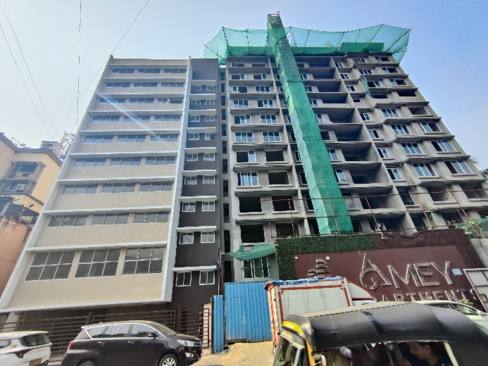

**Actual Site Photographs As on 08.10.2024**

**Rehab cum Sales Building (Wing A)**

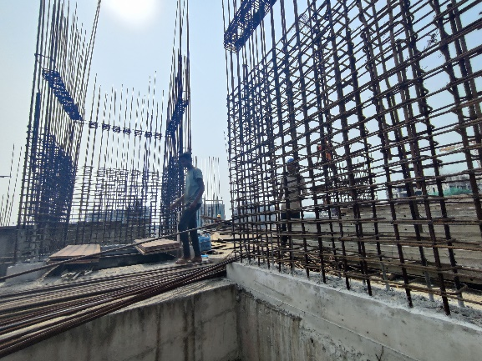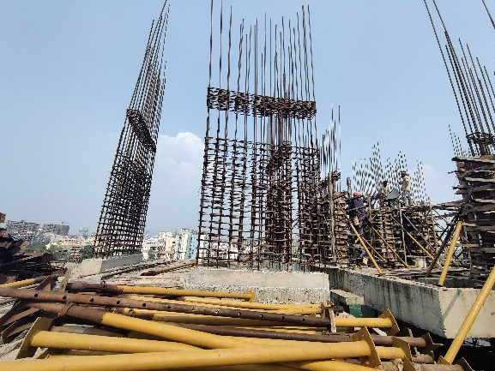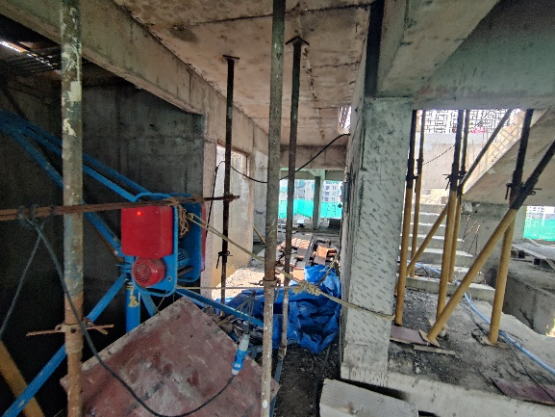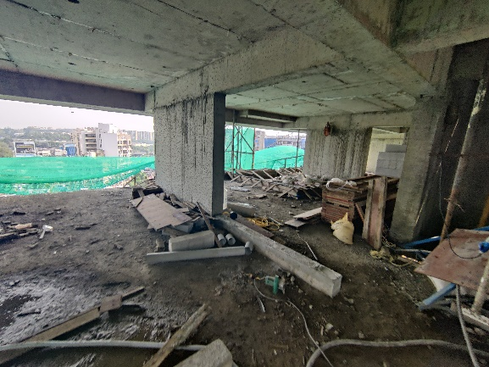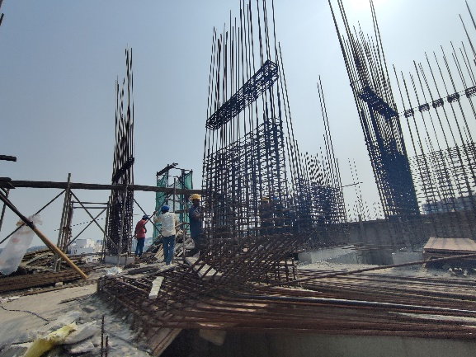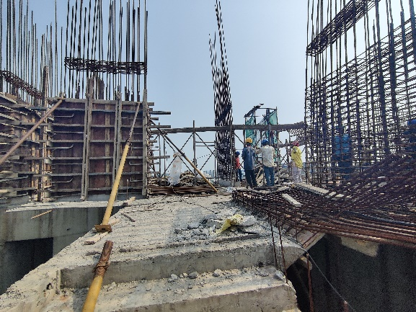

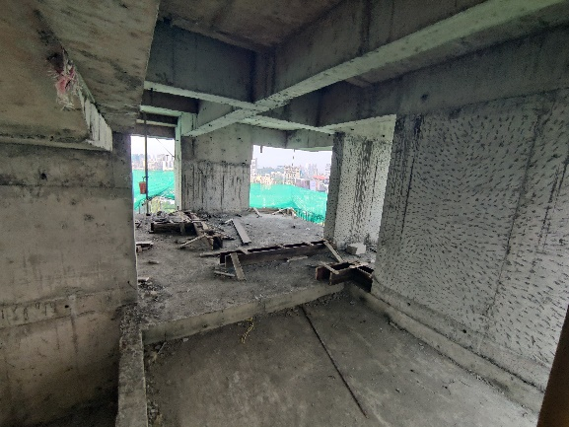**Actual Site Photographs As on 08.10.2024**

**Rehab cum Sales Building (Wing A)**

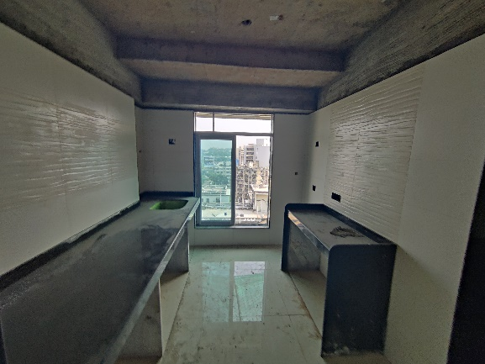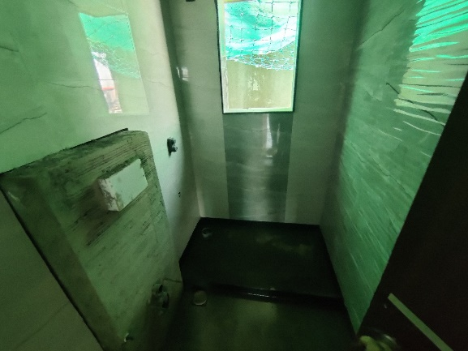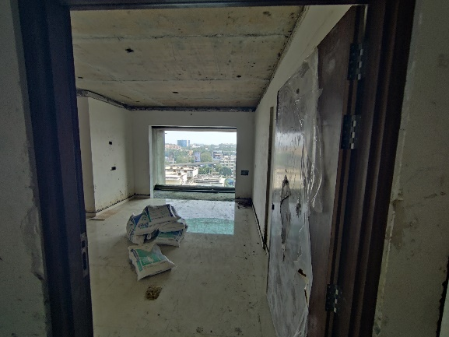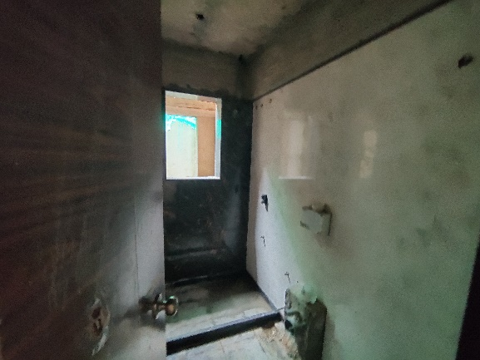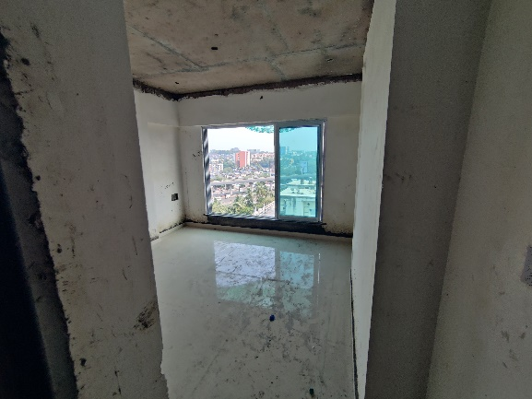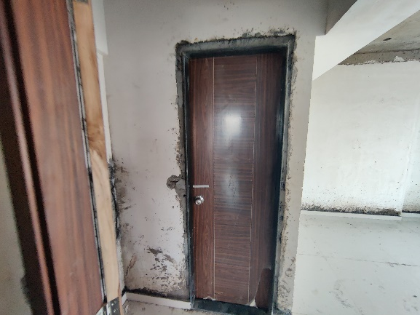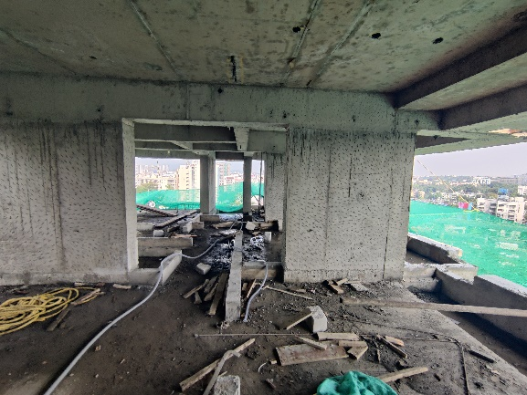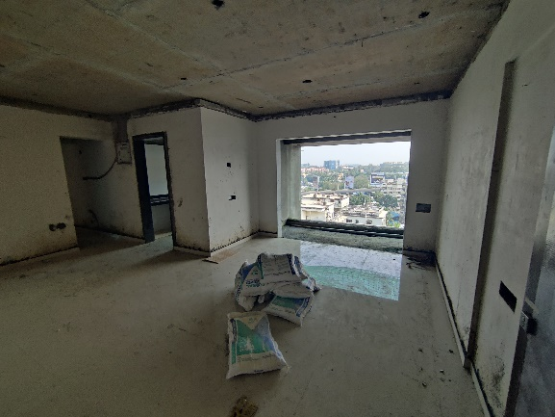

**Actual Site Photographs As on 08.10.2024**

**Rehab cum Sales Building (Wing A)**

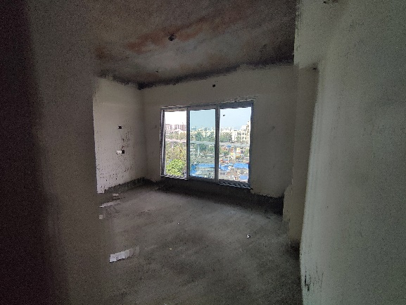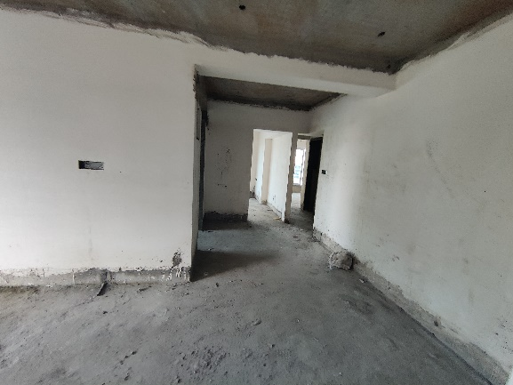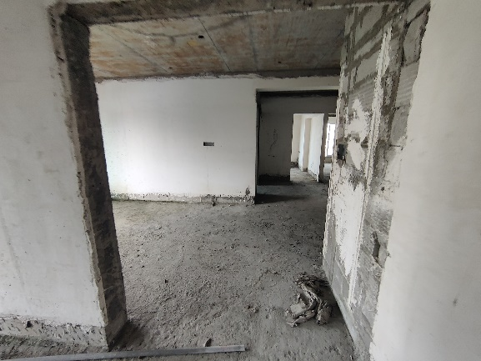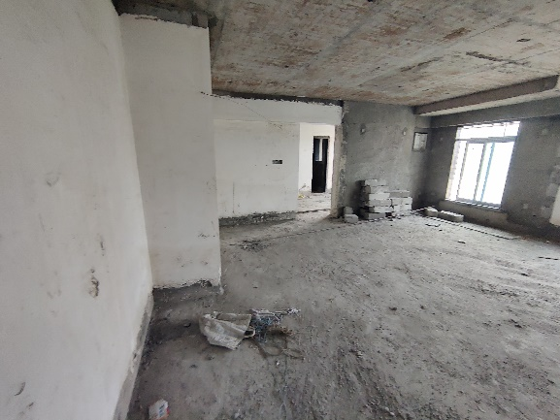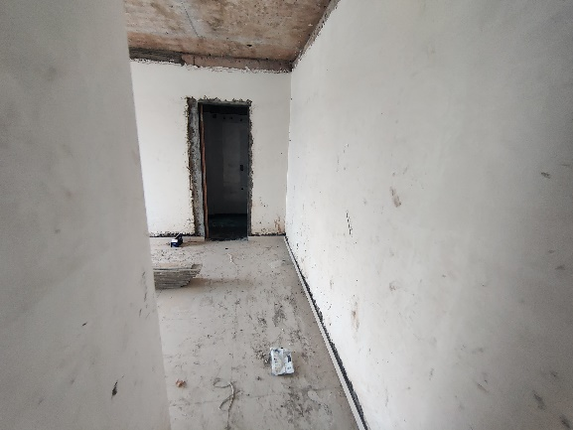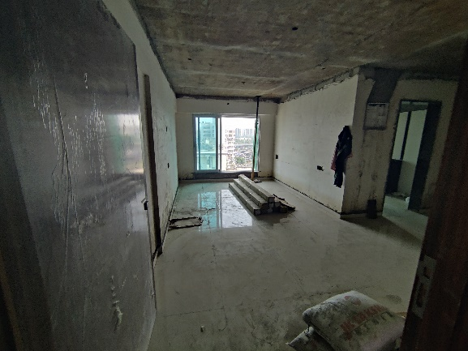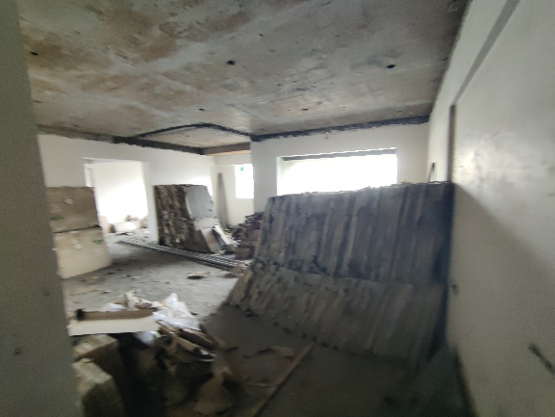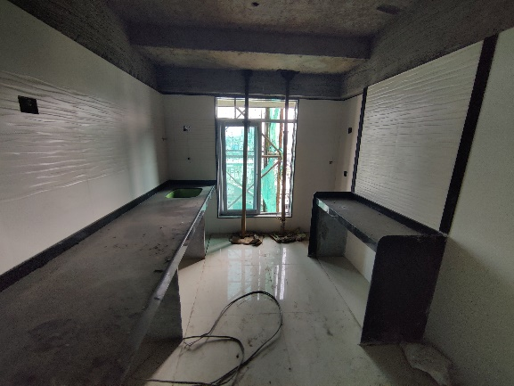

**Actual Site Photographs As on 08.10.2024**

**Rehab cum Sales Building (Wing A)**

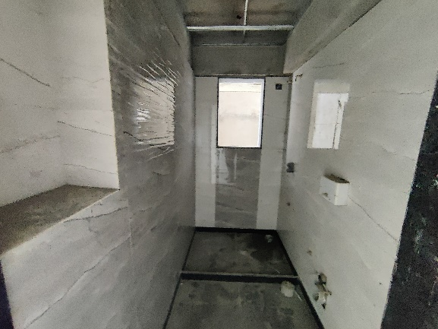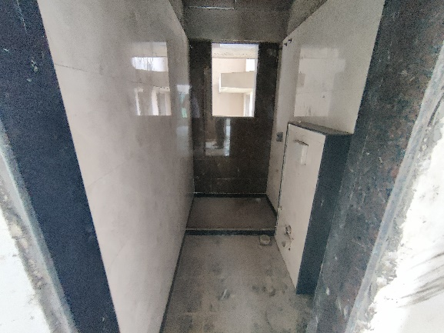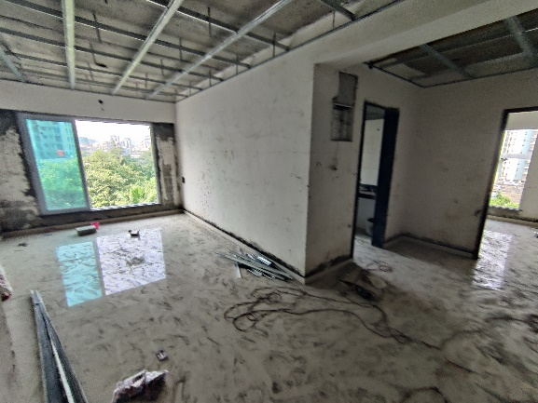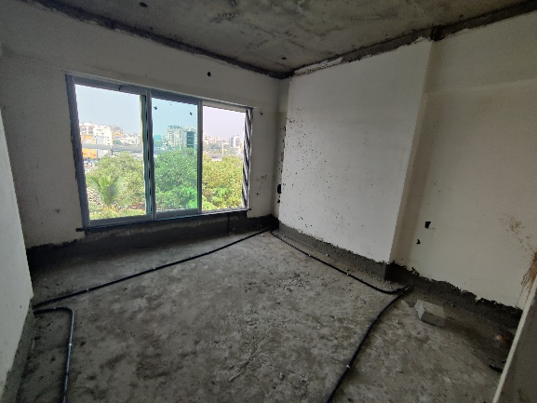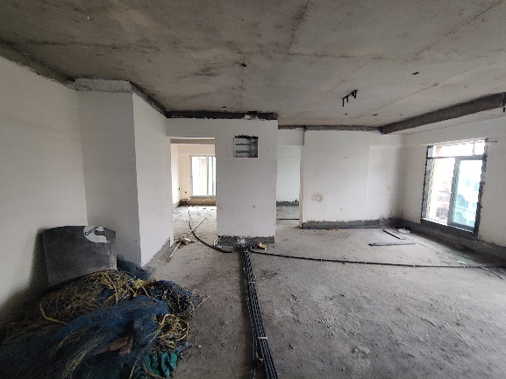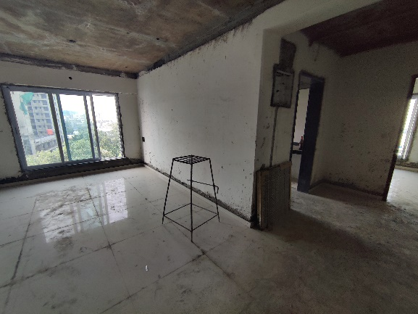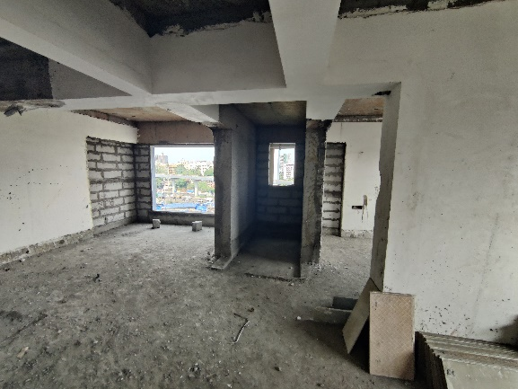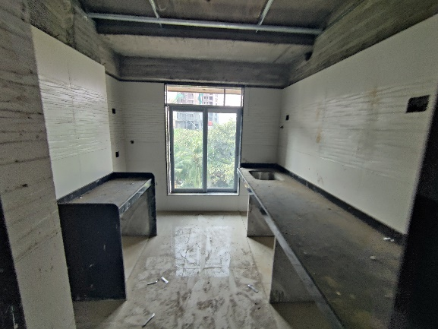

**Actual Site Photographs As on 08.10.2024**

**Rehab cum Sales Building (Wing A)**

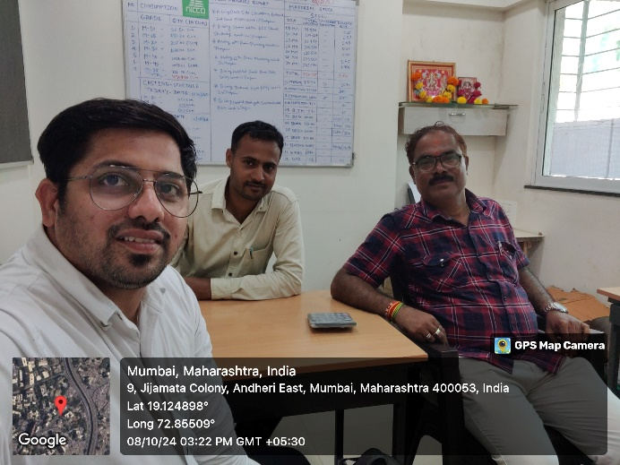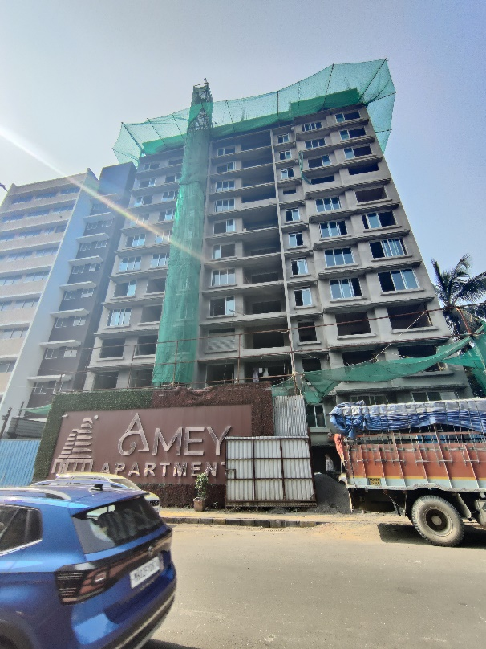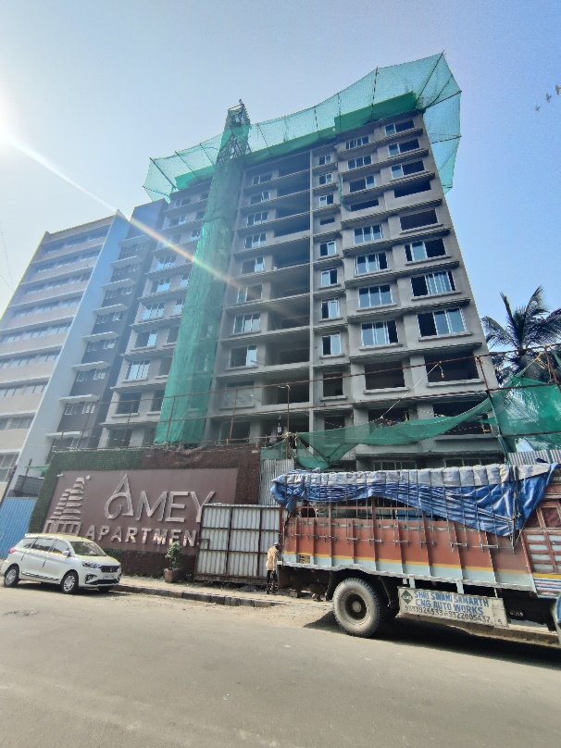

**Route Map of the property**

**Site u/r**

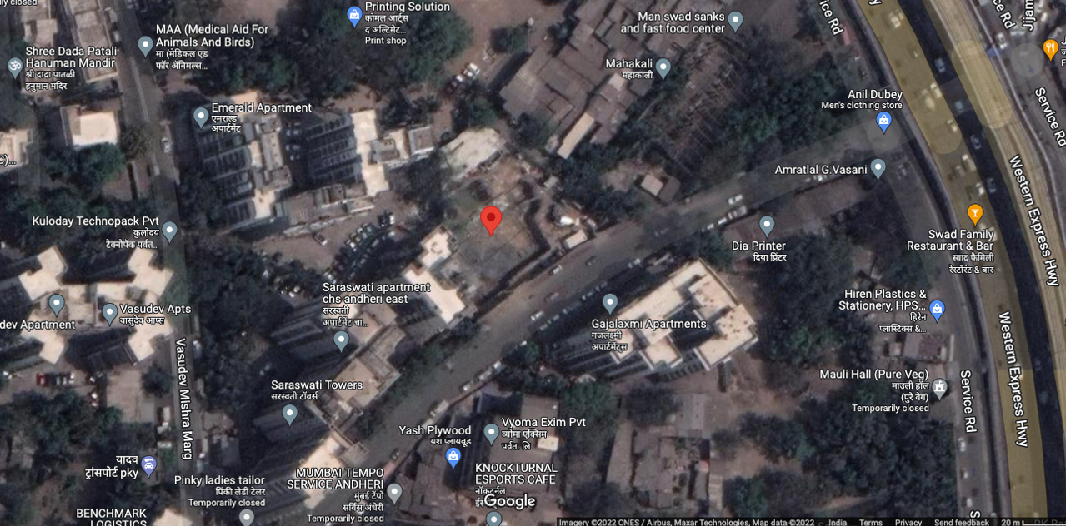

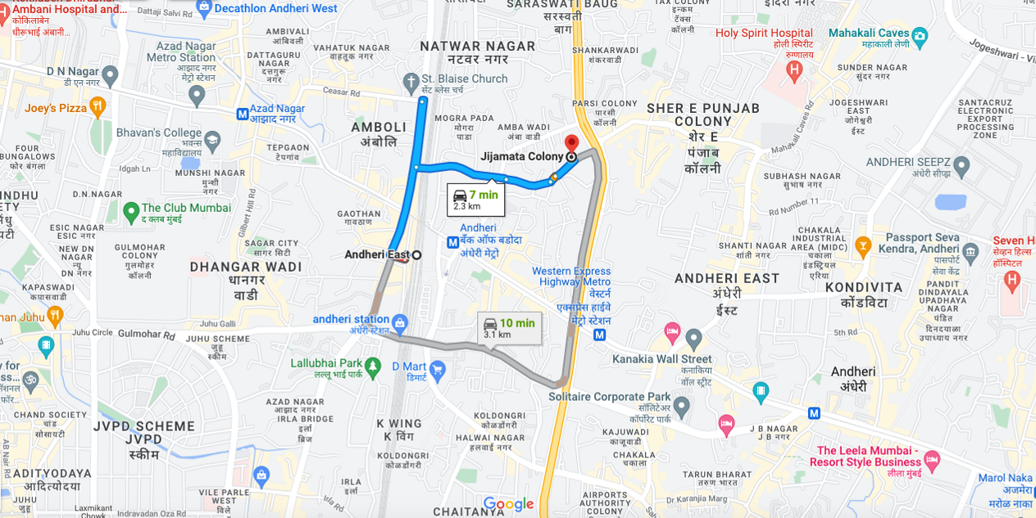

## Latitude Longitude: 19°07'29.2"N 72°51'17.8"E

Note: The Blue line shows the route to site from nearest railway station (Andheri – 2.30 Km.)

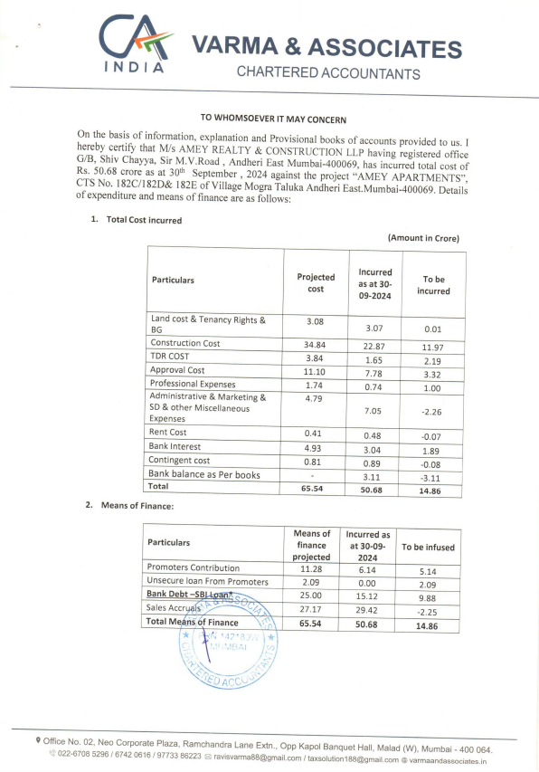**CA Certificate Dated 15.10.2024 till 30.09.2024**

**CA Certificate Dated 15.10.2024 till 30.09.2024**

