Vastu/Nashik/11/2024/012406 /2309078
15/24-163-CCBS
Date: 15.11.2024

To, `
The Branch Manager,
Bank of Baroda
Regional Office Nashik Road Branch
BSNL Building, Datta Mandir Road, Nashik Road,
Nashik -422 101, State - Maharashtra, Country - India.

Sub: Vetting of Extra Amenities

Sir,

With reference to above subject, we have evaluated the Extra Amenities for Residential Land and House on Plot No.20, Ground Floor, Neighborhood Chaitra, Sector C-1, Opposite Shree Gopinath Munde Garden , Hedgewar Nagar , Village – CIDCO, Taluka – Nashik, District – Nashik, Pin Code – 422 008, State - Maharashtra, Country – India belongs Smt. Abeda Kadar Shaikh & Other Three Name of Proposed Purchaser: Javed Alhibaksh Chaudhari & Afrin Javed Chaudhari

We have verified the rates quoted as per current market rates. Details of work and Extra Amenities considered as per copy of Agreement for Extra Amenities between Javed Alhibaksh Chaudhari & Afrin Javed Chaudhari. (First Party) and Shri. Tanveer Qureshi (Second Party) received on dated 13.11.2024. The Extra Amenities amount is Rs.4,50,000/- (Rupees Four Lakh Fifty Thousand Only.)

The said Cost Vetting Certificate is valid upto next 6 months Only.

Thanking you

Sincerely yours

Manoj B. Chalikwar
Registered Valuer
Chartered Engineer (India)
Reg. No. CAT-I-F-1763
Reg. No. IBBI/RV/07/2018/10366
BOB Empanelment No.: ZO:MZ:ADV:46:941
Encl: Valuation report.

Agreement for Extra Amenities
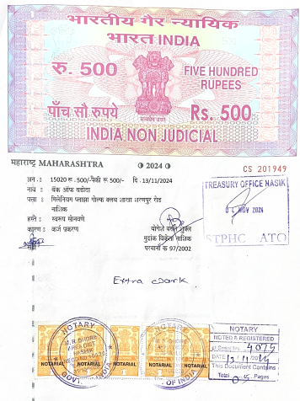
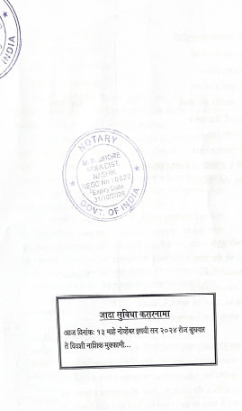

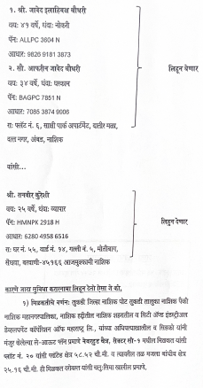
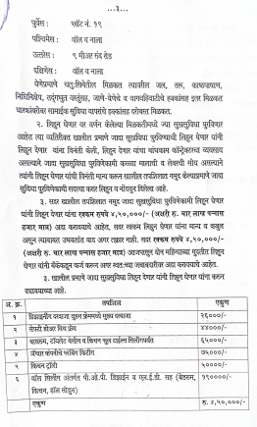

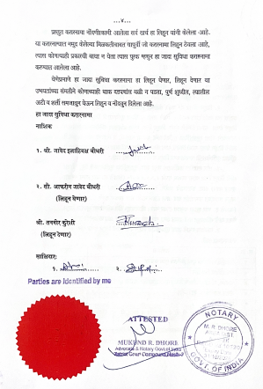

The Extra Amenities amount is Rs.4,50,000/- (Rupees Four Lakh Fifty Thousand Only.)

