1st LENDERS INDEPENDENT ENGINEER REPORT
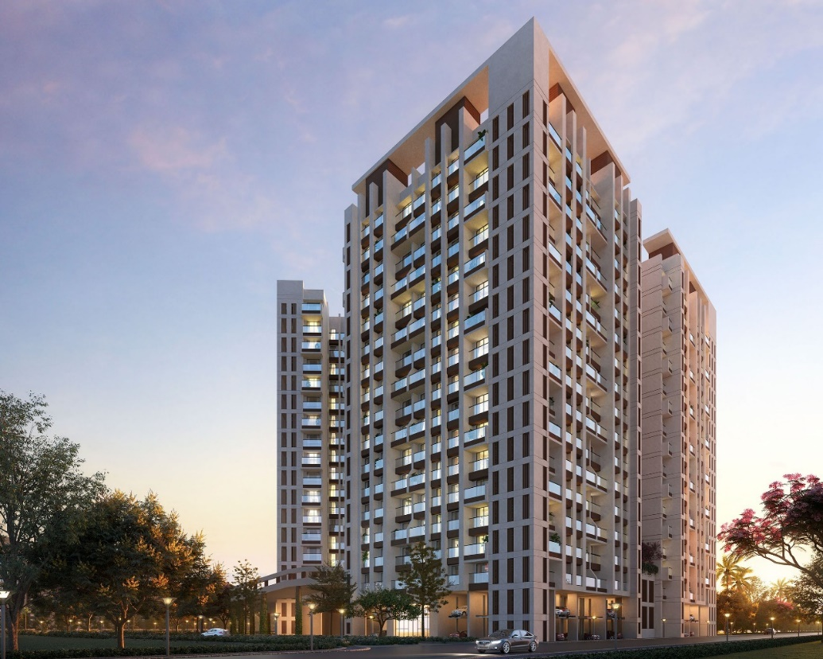

Details of the property under consideration:

Name of Project: Blossom Bldg. 6 Wing C & D

"Blossom Bldg. 6 Wing C & D", Proposed Residential Building on Plot bearing Survey No. 121, Hissa No. 5 & 6 (A & B), Survey No. 125, Hissa No. 4 (4A, 4B, 4C) & 7 (7A, 7B), Suyog Nagar,
Village – Diwanman, Vasai (West), Taluka – Vasai, District – Palghar, Pin Code – 401 202,
State – Maharashtra, Country – India

Latitude Longitude: 19°22'29.3"N 72°48'58.2"E

Intended User:

State Bank of India
Vasai Tal. Ind. Est. Branch
Gavrai Pada, Vasai (East), Taluka – Vasai, District – Palghar,
Pin Code – 401 201, State - Maharashtra, Country – India

Vastu/SBI/Mumbai/11/2024/12394/2305834
30/15-582-PY
Date: - 15.11.2024

FIRST LENDERS INDEPENDENT ENGINEER REPORT

To,
State Bank of India
Vasai Tal. Ind. Est. Branch
Gavrai Pada, Vasai (East),
Taluka – Vasai, District – Palghar,
Pin Code – 401 201,
State - Maharashtra, Country – India.

Subject: Construction of Proposed Redevelopment of existing building known as Ram Niwas, Nath Niwas, & Gool Sorab on Plot bearing CTS. No. 802, 803 & 804, Khetwadi 7th Lane, Girgaon Division, Girgaon, Mumbai – 400 004, State – Maharashtra, Country – India

Ref: You’re Request for Lenders Independent Engineer Report of under Construction Building.
Dear Ma’am,
- As per your instruction, we have inspected the under-construction Sale Building project situated on plot bearing Survey No. 121, Hissa No. 5 & 6 (A & B), Survey No. 125, Hissa No. 4 (4A, 4B, 4C) & 7 (7A, 7B), Suyog Nagar, Village – Diwanman, Vasai (West), Taluka – Vasai, District – Palghar, Pin Code – 401 202, State – Maharashtra, Country – India which is being developed by M/s. Ananda Developers in order to give the physical progress at site and to certify cost incurred towards project as on 31/08/2024.
- The Construction work as per approved plan was in progress during the site visit on 08th August 2024.
- Status of work:
- For Sale Building (Wing C): Till 3rd Floor Slab work is completed.
Sale building (Wing C) work is delay by 5 months.

- For Sale Building (Wing D): Till 13th Floor Slab work, 1st & 8th floor block work, 1st to 4th floor 40% plaster work is completed, 14th floor shuttering work is in progress & 9th floor block work is in progress.
Sale building (Wing D) work is delay by 1 month.

- As per cost incurred certificate issued by CA Certificate actual total expenditure occurred as on 31/08/2024 is ` 35.68 Cr. for Sale Building (Wing C & D) & overall financial progress is 32.88% estimated cost of project.
- As per bills actual total expenditure occurred as on 31/08/2024 is ` 35.82 Cr. for Residential of Sale Building (Wing C & D) & overall financial progress is 33.01% estimated cost of project.
- Overall Physical progress of the sale building (Wing C) construction as on 08/08/2024 is 23.82% as per physical site inspection.

- Overall Physical progress of the sale building (Wing D) construction as on 08/08/2024 is 51.12% as per physical site inspection.

- Overall Physical progress of the sale building (Wing C & D) construction as on 08/08/2024 is 31.46% as per physical site inspection.

DECLARATION
- The information furnished in the report is based on our 1st site visit Dated 08/08/2024 & Document Provided by Client.
- Vastukala Project Report of the project dated 26/02/2023.
- Vastukala Cost Vetting Report of the project dated 26/02/2023.
- I have no direct and indirect interest in the property examined for report.
- I have not been found guilty of misconduct in my professional capacity.

Manoj B. Chalikwar
Registered Valuer
Chartered Engineer (India)
Reg. No. IBBI/RV/07/2018/10366
Encl.: LIE report

Purpose & Methodology
• State Bank of India Banks and financial institutions require monitoring & an independent review of the progress of the sanctioned projects
VCIPL undertakes such study to independently review the progress of the project and put forward a comprehensive analysis

Advantages:
- Assurance on present practices
- Identification of risk
- Analyzing the performance of third parties
- Recommendations

The Methodology
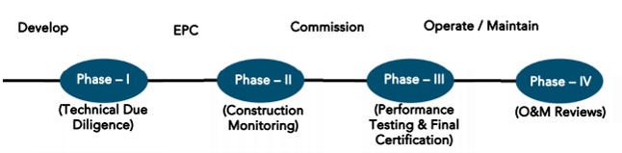
FIRST LENDERS INDEPENDENT ENGINEER REPORT
OF
"BLOSSOM BLDG. 6 WING C & D"
"Blossom Bldg. 6 Wing C & D", Proposed Residential Building on Plot bearing Survey No. 121,
Hissa No. 5 & 6 (A & B), Survey No. 125, Hissa No. 4 (4A, 4B, 4C) & 7 (7A, 7B), Suyog Nagar,
Village – Diwanman, Vasai (West), Taluka – Vasai, District – Palghar, Pin Code – 401 202,
State – Maharashtra, Country – India

Latitude Longitude: 19°22'29.3"N 72°48'58.2"E

NAME OF DEVELOPER: M/s. Ananda Developers
Pursuant to instructions from State of India, Vasai Ind. East Branch, Vasai we have duly visited, inspected, surveyed & assessed the above said property on 08th August 2024 to determine the fair & reasonable market value of the said property/project as on Quarter ending 31st August 2024 for LIE purpose.

1. Location Details:
Proposed Residential Building on Plot bearing Survey No. 121, Hissa No. 5 & 6 (A & B), Survey No. 125, Hissa No. 4 (4A, 4B, 4C) & 7 (7A, 7B), Suyog Nagar, Village – Diwanman, Vasai (West), Taluka – Vasai, District – Palghar, Pin Code – 401 202, State – Maharashtra, Country – India. It is about 5.10 Km. travelling distance from Vasai Road Railway station. Surface transport to the property is by buses, taxis & private vehicles. The property is in developed locality. All the amenities like shops, banks, hotels, markets, schools, hospitals, etc. are all available in the surrounding locality. The area is higher middle class & developed.
2. Developer Details:
Name of builder | M/s. Ananda Developers
Project Rera Registration Number | P99000055687
Registered office address | G/101, 1st Floor, Iris Wing G, Chulna Bhabola Road, Vasai (West), Taluka – Vasai, District – Palghar, Pin Code – 401 202, State - Maharashtra, Country – India
Contact details | Contact Person:  Mr. Puneet Ajmera (Director)  Mobile No. 9822507507
E – mail ID and website
3. Boundaries of the Property:
Direction | Particulars
On or towards North | Blossom Building 6 Wing A & B
On or towards South | Road
On or towards East | Open Plot
On or towards West | Jhaveri Complex

Introduction
As per Information on site M/s. Ananda Developers has acquired land by Development Agreement dated 05.01.2024 registered vide No. Vasai-1/95/2024 dated 05.01.2024 admeasuring area 1,671.159 Sq. M. bearing Survey No. 121, Hissa No. 5 & 6 (A & B), Survey No. 125, Hissa No. 4 (4A, 4B, 4C) & 7 (7A, 7B).
For the Proposed Development Residential Building.

Area Statement:

Land:
Date | Particular | Area in Sq. M.
05.01.2024 | Survey No. 121, Hissa No. 5 & 6 (A & B), Survey No. 125, Hissa No. 4 (4A, 4B, 4C) & 7 (7A, 7B) | 1,671.159
TOTAL |  | 1,671.159

- Copy of Development Agreement dated 05.01.2024 between M/s. Ajmera Developers (The Owner) and M/s. Ananda Developers (The Developer) through Registered Agreement Doc. No. Vasai-1/95/2024 dated 05.01.2024.
- Copy of Irrevocable General Power of Attorney dated 05.01.2024, M/s. Ajmera Developers (The Owner) and M/s. Ananda Developers (The Developer) through registered agreement Doc. No. Vasai-1/96/2024 dated 05.01.2024

List of Approvals:
- Copy of Approved Plan (Wing C) No. VVCMC/TP/AMEND/VP/0104/635/2022-23 dated 31.03.2023 issued by Vasai Virar City Municipal Corporation (VVCMC).
Approved upto: Basement + Stilt Floor + 1st & 2nd (Part Podium Floor & Part Residential Floor) + 3rd to 16th Upper Floors
- Copy of Approved Plan (Wing D) No. VVCMC/TP/CC/VP/0104/506/2021-22 dated 04.01.2022 issued by Vasai Virar City Municipal Corporation (VVCMC).
Approved Upto: Basement + Stilt Floor + 1st & 2nd (Part Podium Floor & Part Residential Floor) + 3rd to 16th Upper Floors
- Copy of Commencement Certificate No. VCMC/TP/RDP/VP-0104/635/2022-23 dated 31.03.2023 issued by Vasai Virar City Municipal Corporation (VVCMC).
Approved Upto: (Wing C & D): Basement + Stilt floor + 1st & 2nd (Part Podium Floor & Part Residential Floor) + 3rd to 16th Upper Floors

LEVEL OF COMPLETION:

Podium Joing Area of Sales Building (Wing C & D)
Sr. No | Floor No. | Construction Area in Sq. M. | Completed Area in Sq. M. | Work Completion as on 08.08.2024
1 | Podium Joining Area | 2,592.34 | - | Work not yet started
Total |  | 2,592.34 | -

Sales Building (Wing C)
Sr. No | Floor No. | Construction Area in Sq. M. | Completed Area in Sq. M. | Work Completion as on 08.08.2024
1 | Excavation & Shore Piling |  |  | Work is Completed
2 | Basement | 517.23 | 517.23 | Slab Work is completed
3 | Ground Floor | 854.00 | 854.00 | Slab Work is completed
4 | 1st Floor & (Pt. Podium) | 891.54 | 891.54 | Slab Work is completed
5 | 2nd Floor & (Pt. Podium) | 451.43 | 451.43 | Slab Work is completed
6 | 3rd Floor | 469.98 | 469.98 | Slab Work is completed
7 | 4th Floor | 492.75 |  | Shuttering work is in progress
8 | 5th Floor | 469.98
9 | 6th Floor | 492.75
10 | 7th Floor | 469.98
11 | 8th Floor | 492.75
12 | 9th Floor | 469.98
13 | 10th Floor | 492.75
14 | 11th Floor | 469.98
15 | 12th Floor | 492.75
16 | 13th Floor | 469.98
17 | 14th Floor | 492.75
18 | 15th Floor | 469.98
19 | 16th Floor | 492.75
20 | Terrace Floor | 84.30
Total |  | 9,537.60 | 3,184.18

Sales Building (Wing D)
Sr. No | Floor No. | Construction Area in Sq. M. | Completed Area in Sq. M. | Work Completion as on 08.08.2024
1 | Excavation & Shore Piling |  |  | Work is Completed
2 | Basement | 673.35 | 673.35 | Slab Work is completed
3 | Ground Floor | 750.25 | 750.25 | Slab Work is completed
4 | 1st Floor & (Pt. Podium) | 745.76 | 745.76 | Slab Work & Block work & 40 % plaster work is completed
5 | 2nd Floor & (Pt. Podium) | 321.45 | 321.45 | Slab Work & Block work & 40 % plaster work is completed
6 | 3rd Floor | 342.14 | 342.14 | Slab Work & Block work & 40 % plaster work is completed
7 | 4th Floor | 360.23 | 360.23 | Slab Work & Block work & 40 % plaster work is completed
8 | 5th Floor | 342.14 | 342.14 | Slab Work & Block work is completed
9 | 6th Floor | 360.23 | 360.23 | Slab Work & Block work is completed
10 | 7th Floor | 342.14 | 342.14 | Slab Work & Block work is completed
11 | 8th Floor | 360.23 | 360.23 | Slab Work & Block work is completed
12 | 9th Floor | 342.14 | 342.14 | Slab Work is completed
13 | 10th Floor | 360.23 | 360.23 | Slab Work is completed
14 | 11th Floor | 342.14 | 342.14 | Slab Work is completed
15 | 12th Floor | 360.23 | 360.23 | Slab Work is completed
16 | 13th Floor | 342.14 | 342.14 | Slab Work is completed
17 | 14th Floor | 360.23 |  | Shuttering work is in progress
18 | 15th Floor | 342.14
19 | 16th Floor | 360.23
20 | Terrace Floor | 67.69
Total |  | 9,537.60 | 6,344.78

Details of the Project as Financed By SBI:

Estimated Project Cost: (As per Cost Vetting Report)
Particulars | Estimated Cost (in Cr.)
Land & Stamp Cost | 23.30
Construction Cost of Sale Building | 63.92
Approval Cost | 0.75
Professional Cost | 0.64
Administrative Cost | 3.20
Marketing Cost | 2.75
Interest Cost (Bank Loan) | 12.04
Contingency Cost | 1.92
Total | 108.52

Project Cost: (as per C.A. Certificate)
Particulars | Incurred Cost (In Cr.) till 31.08.2024 dated 01.10.2024 by M/s. G Y Shah & Associates
Land & Stamp Cost | 23.30
Construction Cost of Sale Building | 11.48
Approval Cost | -
Professional Cost | 0.72
Administrative Cost
Marketing Cost
Interest Cost (Bank Loan) | 0.18
Contingency Cost | -
Total | 35.68

- The Builder has incurred about 23.30 Cr. as land cost, 11.48 Cr. as construction cost, 0.72 Cr. for professional charges, admin cost and marketing cost & 0.18 Cr. for interest cost in last quarter till 31.08.2024 as per C.A. certificate issued by M/s. G Y Shah & Associates dated 01.10.2024.

Project Cost: (as per Bills):
Particulars | Incurred Cost (in Cr.)
 | 31.08.2024 as per Bill (Inclusive GST)
Land & Stamp Cost | 23.30
Construction Cost of Sale Building | 11.49
Approval Cost | -
Professional Cost | 0.10
Administrative Cost | 0.70
Marketing Cost | 0.06
Interest Cost (Bank Loan) | 0.18
Contingency Cost | -
Total | 35.82
Note:

Land Cost:
Sr. No. | Agreement Name | Date | Particulars | Total Amount in ` | Incurred Amount in `
1 | Development Agreement | 01-05-2024 | Purchase Cost | 22,00,00,000.00 | 22,00,00,000.00
2 |  |  | Stamp Duty | 1,29,50,600.00 | 1,29,50,600.00
3 |  |  | Reg. Fees | 30,000.00 | 30,000.00
4 |  |  |  | 1,760.00 | 1,760.00
5 | Power of Attorney | 01-05-2024 | Stamp Duty | 500.00 | 500.00
6 |  |  | Reg. Fees | 680.00 | 680.00
7 |  |  |  | 100.00 | 100.00
 | TOTAL |  |  | 23,29,83,640.00 | 23,29,83,640.00
As per developer agreement.
Summary of Bills
Sr. No. | Particulars | Amount in ` (till 31.08.2024) | Amount in ` (in Cr.)
1 | Construction Cost | 11,48,92,025.00 | 11.49
2 | Approval Cost | - | -
3 | Professional Cost | 9,73,748.00 | 0.10
4 | Administrative Cost | 69,80,694.00 | 0.70
5 | Marketing Cost | 5,79,924.00 | 0.06
6 | Contingency Cost | - | -
TOTAL |  | 12,34,26,391.00 | 12.34
Note: Bills were provided by the client up to 31.08.2024

Interest Cost:
Sr. No | Particulars | Estimate Amount in ` | Incurred Amount in ` (till 31.08.2024) | Balance Amount in `
1 | Interest Cost | 12,04,00,000.00 | 18,25,344.00 | 11,85,74,656.00
TOTAL |  | 12,04,00,000.00 | 18,25,344.00 | 11,85,74,656.00
Interest Cost is based on discussion with the client.

Cost of Construction as on 08th August 2024:

Podium Joining Area of Sales Building (Wing C & D)
Sr. No. | Floor | Total Construction Area in Sq. M. | Completed Area in Sq. M. | Rate per Sq. M. | Full Value after completion | % of work completed | Actual Expenditure till date in `
1 | Podium Joining Area | 2,592.34 |  |  | 7,77,70,200.00 | - | -
TOTAL |  | 2,592.34 | - |  | 7,77,70,200.00 | - | -

Sales Building (Wing C)
Sr. No. | Floor | Total Construction Area in Sq. M. | Completed Area in Sq. M. | Rate per Sq. M. | Full Value after completion | % of work completed | Actual Expenditure till date in `
1 | Excavation Cost |  |  |  | 2,86,12,809.00 | 100% | 2,86,12,809.00
2 | Basement | 517.23 | 517.23 | 30,000.00 | 1,55,16,900.00 | 50% | 77,58,450.00
3 | Ground Floor | 854.00 | 854.00 | 30,000.00 | 2,56,20,000.00 | 50% | 1,28,10,000.00
4 | 1st Floor | 891.54 | 891.54 | 30,000.00 | 2,67,46,200.00 | 50% | 1,33,73,100.00
5 | 2nd Floor | 451.43 | 451.43 | 30,000.00 | 1,35,42,900.00 | 50% | 67,71,450.00
6 | 3rd Floor | 469.98 | 469.98 | 30,000.00 | 1,40,99,400.00 | 40% | 56,39,760.00
7 | 4th Floor | 492.75 |  | 30,000.00 | 1,47,82,470.00 |  | -
8 | 5th Floor | 469.98 |  | 30,000.00 | 1,40,99,400.00 |  | -
9 | 6th Floor | 492.75 |  | 30,000.00 | 1,47,82,470.00 |  | -
10 | 7th Floor | 469.98 |  | 30,000.00 | 1,40,99,400.00 |  | -
11 | 8th Floor | 492.75 |  | 30,000.00 | 1,47,82,470.00 |  | -
12 | 9th Floor | 469.98 |  | 30,000.00 | 1,40,99,400.00 |  | -
13 | 10th Floor | 492.75 |  | 30,000.00 | 1,47,82,470.00 |  | -
14 | 11th Floor | 469.98 |  | 30,000.00 | 1,40,99,400.00 |  | -
15 | 12th Floor | 492.75 |  | 30,000.00 | 1,47,82,470.00 |  | -
16 | 13th Floor | 469.98 |  | 30,000.00 | 1,40,99,400.00 |  | -
17 | 14th Floor | 492.75 |  | 30,000.00 | 1,47,82,470.00 |  | -
18 | 15th Floor | 469.98 |  | 30,000.00 | 1,40,99,400.00 |  | -
19 | 16th Floor | 492.75 |  | 30,000.00 | 1,47,82,470.00 |  | -
20 | OHT / LMR | 84.30 |  | 30,000.00 | 25,29,000.00 |  | -
TOTAL |  | 9,537.60 | 3,184.18 |  | 31,47,40,899.00 | 23.82% | 7,49,65,569.00

Sales Building (Wing D)
Sr. No. | Floor | Total Construction Area in Sq. M. | Completed Area in Sq. M. | Rate per Sq. M. | Full Value after completion | % of work completed | Actual Expenditure till date in `
1 | Excavation Cost |  |  |  | 2,24,25,171.00 | 100% | 2,24,25,171.00
2 | Basement | 673.35 | 673.35 | 30,000.00 | 2,02,00,410.00 | 50% | 1,01,00,205.00
3 | Ground Floor | 750.25 | 750.25 | 30,000.00 | 2,25,07,560.00 | 50% | 1,12,53,780.00
4 | 1st Floor | 745.76 | 745.76 | 30,000.00 | 2,23,72,890.00 | 60% | 1,34,23,734.00
5 | 2nd Floor | 321.45 | 321.45 | 30,000.00 | 96,43,500.00 | 60% | 57,86,100.00
6 | 3rd Floor | 342.14 | 342.14 | 30,000.00 | 1,02,64,200.00 | 60% | 61,58,520.00
7 | 4th Floor | 360.23 | 360.23 | 30,000.00 | 1,08,06,750.00 | 60% | 64,84,050.00
8 | 5th Floor | 342.14 | 342.14 | 30,000.00 | 1,02,64,200.00 | 60% | 61,58,520.00
9 | 6th Floor | 360.23 | 360.23 | 30,000.00 | 1,08,06,750.00 | 60% | 64,84,050.00
10 | 7th Floor | 342.14 | 342.14 | 30,000.00 | 1,02,64,200.00 | 60% | 61,58,520.00
11 | 8th Floor | 360.23 | 360.23 | 30,000.00 | 1,08,06,750.00 | 60% | 64,84,050.00
12 | 9th Floor | 342.14 | 342.14 | 30,000.00 | 1,02,64,200.00 | 50% | 51,32,100.00
13 | 10th Floor | 360.23 | 360.23 | 30,000.00 | 1,08,06,750.00 | 50% | 54,03,375.00
14 | 11th Floor | 342.14 | 342.14 | 30,000.00 | 1,02,64,200.00 | 50% | 51,32,100.00
15 | 12th Floor | 360.23 | 360.23 | 30,000.00 | 1,08,06,750.00 | 50% | 54,03,375.00
16 | 13th Floor | 342.14 | 342.14 | 30,000.00 | 1,02,64,200.00 | 40% | 41,05,680.00
17 | 14th Floor | 360.23 |  | 30,000.00 | 1,08,06,750.00 |  | -
18 | 15th Floor | 342.14 |  | 30,000.00 | 1,02,64,200.00 |  | -
19 | 16th Floor | 360.23 |  | 30,000.00 | 1,08,06,750.00 |  | -
20 | OHT / LMR | 67.69 |  | 30,000.00 | 20,30,700.00 |  | -
TOTAL |  | 7,475.06 | 6,344.78 |  | 31,47,40,899.00 | 51.12% | 12,60,93,330.00

Total Summary of Sales Building (Wing C & D)
S. No | Wing | Total Construction Area in Sq. M. | Value after Completion | % work completed | Actual Expenditure till date in `
1 | Podium Joining Area | 2,592.34 | 7,77,70,200.00 | 0.00% | -
2 | Construction Cost of Wing C | 9,537.60 | 31,47,40,899.00 | 23.82% | 7,49,65,569.00
3 | Construction Cost of Wing D | 7,475.06 | 24,66,76,881.00 | 51.12% | 12,60,93,330.00
TOTAL |  | 19,605.00 | 63,91,87,980.00 | 31.46% | 20,10,58,899.00

Note: Details of work completed is as per site visit dated 08.08.2024 but report is prepared for 31st August quarter 2024.

Particulars | Estimated Cost  (In Cr.) | Incurred Cost (in Cr.) |  | Net
 |  | Issued dated 01.10.2024 till 31.08.2024 as per CA | As per Bills upto 31.08.2024
Land & Stamp Cost | 23.30 | 23.30 | 23.30 | -
Construction Cost of Sale Building | 63.92 | 11.48 | 11.49 | 0.01
Approval Cost | 0.75 | - | - | -
Professional Cost | 0.64 | 0.72 | 0.10 | 0.13
Administrative Cost | 3.20 |  | 0.70
Marketing Cost | 2.75 |  | 0.06
Interest Cost (Bank Loan) | 12.04 | 0.18 | 0.18 | -
Contingency Cost | 1.92 | - | - | -
Total | 108.52 | 35.68 | 35.82 | 0.14
Note:
- As per plinth area, calculation the work completed is up to 31.46% of total work, which comes to ` 20.11 Cr. However, company has incurred cost of ` 11.49 Cr. till 31.08.2024 as per bill .

Comparison of Cost incurred on dated 31.08.2024 & CA Certificate
Particulars | 31.08.2024 as per Bill | As per CA Certiifcate | Net | % of net amount
Land & Stamp Cost | 23.30 | 23.30 | - | 0.00%
Construction Cost of Sale Building | 11.49 | 11.48 | 0.01 | 0.03%
Approval Cost | - | - | - | 0.00%
Professional Cost | 0.10 | 0.72 | 0.13 | 0.37%
Administrative Cost | 0.70
Marketing Cost | 0.06
Interest Cost (Bank Loan) | 0.18 | 0.18 | - | 0.00%
Contingency Cost | - | - | - | 0.00%
Total | 35.82 | 35.68 | 0.14 | 0.39%

% of Fund Utilised till 31st August 2024
Particulars | Estimated Project Cost (in Cr.) | Incurred cost as on 31.08.2024 | % of Incurred Cost | % of Estimated Project Cost
Land & Stamp Cost | 23.30 | 23.30 | 99.99% | 21.47%
Construction Cost of Sale Building | 63.92 | 11.49 | 17.97% | 10.59%
Approval Cost | 0.75 | - | 0.00% | 0.00%
Professional Cost | 0.64 | 0.10 | 15.21% | 0.09%
Administrative Cost | 3.20 | 0.70 | 21.81% | 0.64%
Marketing Cost | 2.75 | 0.06 | 2.11% | 0.05%
Interest Cost (Bank Loan) | 12.04 | 0.18 | 1.52% | 0.17%
Contingency Cost | 1.92 | - | 0.00% | 0.00%
Total | 108.52 | 35.82 | 33.01% | 33.01%
Based on above Calculation it is found that total Project cost incurred is 33.01% of the Total Project Cost.

Means of Finance:
Sr. No. | Particulars | Exp. Cumulative (Cr.)
 | Equity share capital / Quassi Loan from Promoter | 27.66
 | Sales (Advance from customer) | -
 | Bank Laon Amount | 8.01
 | Unsecured Loan amount | -
 | Total | 35.67
The Details of the Means of Finance are provided by Client as on 31.08.2024.

Mandatory Arrangements:
Sr. No. | Particulars | Status
 | Rainwater Harvesting | To be executed after RCC Structure
 | Firefighting System | To be executed after RCC Structure
 | Solid Waste Management | To be executed after RCC Structure

Quality of Construction:
Sr. No. | Particulars | Status
 | Soundness of Structures | Executing as per approved Structural Design
 | Look of Structures | Good
 | Quality of Material Used | Good
 | Safety Measures for Construction/labour | Taken Care by Contractor

Schedule V/s. Actual Progress:

SALE BUILDING (WING C)
Activity | Date of Implementation | Date of Completion | Status
Land | December 2023 |  | Completed
Development of Land |  |  | Completed
Foundation Work |  |  | Completed
Ground Floor Slab |  |  | Slab work is Completed
1st Floor Slab | March 2024 |  | Slab work is Completed
2nd Floor Slab |  |  | Slab work is Completed
3rd Floor Slab | June 2024 |  | Slab work is Completed, Delay by 5 months
4th Floor Slab
5th Floor Slab
6th Floor Slab | September 2024
7th Floor Slab
8th Floor Slab
9th Floor Slab | December 2024
10th Floor Slab
11th Floor Slab
12th Floor Slab | March 2025
13th Floor Slab
14th Floor Slab
15th Floor Slab | June 2025
16th Floor Slab
Block work / Internal Plaster work | June 2024 | June 2025
Terrace Parapet wall / Overhead water tank / Lift Machine room / compound wall / External Plaster work | June 2025
Electric Work | June 2024 | December 2025
Water Proofing |  | March 2026
Plumbing Work
Tiling / Marble Flooring | March 2025 | March 2026
Door Frames | June 2024 | March 2026
Window Installation | March 2025 | March 2026
Staircase Flooring
Staircase Railing
Refuge Area Flooring
Internal Painting | September 2025 | December 2026
External Painting
Lift Work | June 2025
Fire Fighting Installation
CP Fitting & Sanitary Work
Final Finishing & Fitting | June 2026
Sale Building (Wing C) work is delay by 5 months

SALE BUILDING (WING D)
Activity | Date of Implementation | Date of Completion | Status
Land | December 2023 |  | Completed
Development of Land |  |  | Completed
Foundation Work |  |  | Completed
Ground Floor Slab |  |  | Slab work is Completed
1st Floor Slab |  |  | Slab work is Completed
2nd Floor Slab |  |  | Slab work is Completed
3rd Floor Slab |  |  | Slab work is Completed
4th Floor Slab |  |  | Slab work is Completed
5th Floor Slab |  |  | Slab work is Completed
6th Floor Slab |  |  | Slab work is Completed
7th Floor Slab |  |  | Slab work is Completed
8th Floor Slab | March 2024 |  | Slab work is Completed
9th Floor Slab |  |  | Slab work is Completed
10th Floor Slab |  |  | Slab work is Completed
11th Floor Slab |  |  | Slab work is Completed
12th Floor Slab | September 2024 |  | Slab work is Completed
13th Floor Slab |  |  | Slab work is Completed
14th Floor Slab
15th Floor Slab
16th Floor Slab
Block work / Internal Plaster work | June 2024 | March 2025 | 1st to 8th floor block work is completed & 40% internal plaster work from 1st to 4th floor is completed
Terrace Parapet wall / Overhead water tank / Lift Machine room / compound wall / External Plaster work | September 2024
Electric Work | June 2024 | September 2025
Water Proofing
Plumbing Work
Tiling / Marble Flooring | September 2024 | September 2025
Door Frames | June 2024
Window Installation | September 2024
Staircase Flooring
Staircase Railing
Refuge Area Flooring
Internal Painting | March 2025 | September 2026
External Painting
Lift Work | December 2024
Fire Fighting Installation
CP Fitting & Sanitary Work | March 2025
Final Finishing & Fitting
Sale Building (Wing C) work is delay by 1 month

Action initiated to complete the project in time:
- For Sale Building (Wing C): Till 3rd Floor Slab work is completed.
Sale building (Wing C) work is delay by 5 months.

- For Sale Building (Wing D): Till 13th Floor Slab work, 1st & 8th floor block work, 1st to 4th floor 40% plaster work is completed, 14th floor shuttering work is in progress & 9th floor block work is in progress.
Sale building (Wing D) work is delay by 1 month

The developers have Major work on themselves only hence (all Manpower (Labour Contractor) and material resources) shall be enhanced by the Developer to meet the TimeLine. Detailed periodic progress report needs to be checked for timely completion of project.

Multiple activists to be done for achieving the timely progress & detailed periodic bar chart, is to be submitted for the further next quarter.

Comments related to cost overrun if any:
The cost of Sales Building is ` 108.52 Cr.

Balance investment required for completion of project:
We opinion amount of ` 72.70 Cr. Will be required to complete the Project.

Mandatory Approval Status:
Sr. No. | Particulars | Name of Department | Status | Order Details
1A | Approved Plan (Wing C) | Vasai Virar City Municipal Corporation (VVCMC) | Obtained and available at site | VVCMC/TP/AMEND/VP/0104/635/2022-23 dated 31.03.2023
1B | Approved Plan (Wing D) | Vasai Virar City Municipal Corporation (VVCMC) | Obtained and available at site | VVCMC/TP/CC/VP/0104/506/2021-22 dated 04.01.2022
2A | First C.C. | Vasai Virar City Municipal Corporation (VVCMC) | Obtained and available at site | VCMC/TP/RDP/VP-0104/635/2022-23 dated 31.03.2023.  (This CC is endorsed for the work up to (Wing C & D): Basement + Stilt floor + 1st & 2nd (Part Podium Floor & Part Residential Floor) + 3rd to 16th Upper Floors).
3B | Occupancy | Vasai Virar City Municipal Corporation (VVCMC) | Pending (Project is not completed)

Status Insurance Coverage:
Particulars | Descriptions | Particulars | Descriptions
Policy No. | 5004/352393749/00/000 | Policy Issued Date | 18/07/2024
Period of Insurance | From 21/11/2023 to 20/01/2027 | Total Sum Insured | ` 70,00,00,000.00
Insurance Policy Name | Contractors All Risk Policy | Issued By | ICICI Lombard
Type of Cover / Benefit | 1. Material Damage / Contract Price  2. Third Party Liabilities/ All accidents during policy period

Assumptions & Remarks:
- The adequacy of Engineering / Structural design is beyond the scope of our assignment.
- As per Bank sanctioned letter sale building (Wing C & D) estimated project completion date is 31st December 2026.
- Sale building (Wing C) work is delay by 5 months & Sale building (Wing D) work is delay by 1 month as per schedule mentioned in the bank sanctioned letter.
- We opinion that the project is will be completed as per estimated completion date mentioned in sanctioned letter.
- As per RERA Certificate estimated project completion date is 01/01/2027.
- The cost is certified based on the assumptions that the project will be completed within period. Few assumptions were made regarding inflation & cost rise etc. during construction period.

Manoj B. Chalikwar
Registered Valuer
Chartered Engineer (India)
Reg. No. IBBI/RV/07/2018/10366

About the Project:
1. Introduction
a) | Project Name  (With Address & Phone Nos.) | "Blossom Bldg. 6 Wing C & D", Proposed Residential Building on Plot bearing Survey No. 121, Hissa No. 5 & 6 (A & B), Survey No. 125, Hissa No. 4 (4A, 4B, 4C) & 7 (7A, 7B), Suyog Nagar, Village – Diwanman, Vasai (West), Taluka – Vasai, District – Palghar, Pin Code – 401 202, State – Maharashtra, Country – India  Contact Person:  Mr. Puneet Ajmera (Director)  Mobile No. 9822507507
b) | Purpose of Valuation | As per request from State Bank of India, Vasai Ind. Est. Branch to give the physical progress at site and to certify cost incurred towards project as on 31/08/2024 of the Project for LIE purpose.
c) | Date of Inspection of Property | 08.08.2024
d) | Date of LIE Report | 15.11.2024
e) | Name of the Developer of Property  (in case of developer built properties) | M/s. Ananda Developers  G/101, 1st Floor, Iris Wing G, Chulna Bhabola Road, Vasai (West), Taluka – Vasai, District – Palghar, Pin Code – 401 202, State - Maharashtra, Country – India
2. Physical Characteristics of the Property
a) | Location of the Property | "Blossom Bldg. 6 Wing C & D", Proposed Residential Building on Plot bearing Survey No. 121, Hissa No. 5 & 6 (A & B), Survey No. 125, Hissa No. 4 (4A, 4B, 4C) & 7 (7A, 7B), Suyog Nagar, Village – Diwanman, Vasai (West), Taluka – Vasai, District – Palghar, Pin Code – 401 202, State – Maharashtra, Country – India
 | Brief description of the property
TYPE OF THE BUILDING
Sales Building (Wing C & D)

No. of Floors | Basement + Ground Floor + 1st & 2nd (Part Podium Floor & Part Residential Floor) + 3rd to 16th Upper Floors
Building type | Sale building (Wing C & D)

Sales Building work is given on contract based for RCC contract. Developer has grant to the contractor do the work of construction and completion includes Concrete work, Reinforcement work, Masonry, Internal Plaster, External Plaster and other miscellaneous work such as repairing, joints b/w concrete and masonry surface, etc. Bill must be paid on measurement of construction area exclusive of Steel, Cement & other construction material.
Lift & lift installation contract is not finalized till now.
Firefighting work contract is not finalized.

PROPOSED DATE OF COMPLETION & FUTURE LIFE:
Expected completion date as per RERA is 01.01.2027
 | Nearby landmark
 | Postal Address of the Property | "Blossom Bldg. 6 Wing C & D", Proposed Residential Building on Plot bearing Survey No. 121, Hissa No. 5 & 6 (A & B), Survey No. 125, Hissa No. 4 (4A, 4B, 4C) & 7 (7A, 7B), Suyog Nagar, Village – Diwanman, Vasai (West), Taluka – Vasai, District – Palghar, Pin Code – 401 202, State – Maharashtra, Country – India
 | Area of the plot/land  (Supported by a plan) | Plot area = 1,671.159 Sq. M.  (Plot Area as per Developer Agreement)
 | Type of Land: Solid, Rocky, Marsh land, reclaimed land, Water-logged, Land locked. | Solid land
 | Independent access/approach to the property etc. | Yes
 | Google Map Location of the Property with a neighborhood layout map | Provided
 | Details of roads abutting the property | 15 M wide road
 | Description of adjoining property | Located in Middle-class locality
 | Plot No. Survey No. | Survey No. 121, Hissa No. 5 & 6 (A & B), Survey No. 125, Hissa No. 4 (4A, 4B, 4C) & 7 (7A, 7B)
 | Ward/Village/Taluka | Village – Diwanman, Vasai (West), Taluka – Vasai
 | Sub-Registry/Block | Vasai
 | District | District - Palghar
b) | Boundaries of the Plot
 | As per Agreement | As per RERA Certificate | Actual
North | Information not available | Information not available | Blossom Building 6 Wing A & B
South | Information not available | Information not available | Road
East | Information not available | Information not available | Open Plot
West | Information not available | Information not available | Jhaveri Complex

4. Document Details and Legal Aspects of Property:
a) | Ownership Documents (Building Permission, Commencement Certificate & Status of Plan)
 | Sale Deed, Gift Deed, Lease Deed
 | - Copy of Development Agreement dated 05.01.2024 between M/s. Ajmera Developers (The Owner) and M/s. Ananda Developers (The Developer) through Registered Agreement Doc. No. Vasai-1/95/2024 dated 05.01.2024.
 | - Copy of Irrevocable General Power of Attorney dated 05.01.2024, M/s. Ajmera Developers (The Owner) and M/s. Ananda Developers (The Developer) through registered agreement Doc. No. Vasai-1/96/2024 dated 05.01.2024.
- Copy of Approved Plan (Wing C) No. VVCMC/TP/AMEND/VP/0104/635/2022-23 dated 31.03.2023 issued by Vasai Virar City Municipal Corporation (VVCMC).
Approved upto: Basement + Stilt Floor + 1st & 2nd (Part Podium Floor & Part Residential Floor) + 3rd to 16th Upper Floors
- Copy of Approved Plan (Wing D) No. VVCMC/TP/CC/VP/0104/506/2021-22 dated 04.01.2022 issued by Vasai Virar City Municipal Corporation (VVCMC).
Approved Upto: Basement + Stilt Floor + 1st & 2nd (Part Podium Floor & Part Residential Floor) + 3rd to 16th Upper Floors
- Copy of Commencement Certificate No. VCMC/TP/RDP/VP-0104/635/2022-23 dated 31.03.2023 issued by Vasai Virar City Municipal Corporation (VVCMC).
Approved Upto: (Wing C & D): Basement + Stilt floor + 1st & 2nd (Part Podium Floor & Part Residential Floor) + 3rd to 16th Upper Floors
 | - Copy of CA Certificate (Form 3) dated 18.01.2024 issued by M/s. G Y Shah & Associates.
 | - Copy of Architect Certificate dated 15.01.2024 issued by M/s. Prithvi Arch Consultants.
 | - Copy of Engineer Certificate dated 15.01.2024 issued by M/s. Prithvi Arch Consultants.
 | - Copy of RERA Certificate RERA No. P99000055687 dated 08.04.2024 issued by Maharashtra Real Estate Regulatory Authority (MAHRERA).
 | - Copy of Bills till 31.08.2024
 | - Copy of CA Certificate dated 01.10.2024 issued by M/s. G Y Shah & Associates.
Actual Site Photographs As on 08.08.2024 (C Wing)
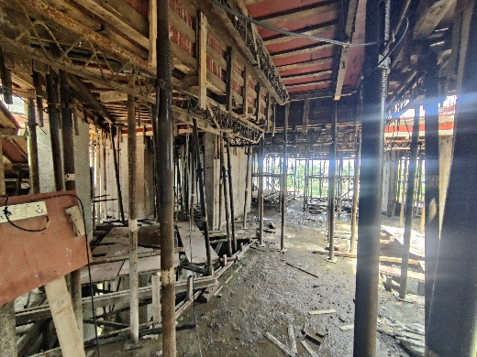
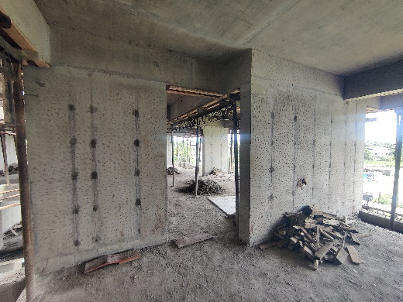
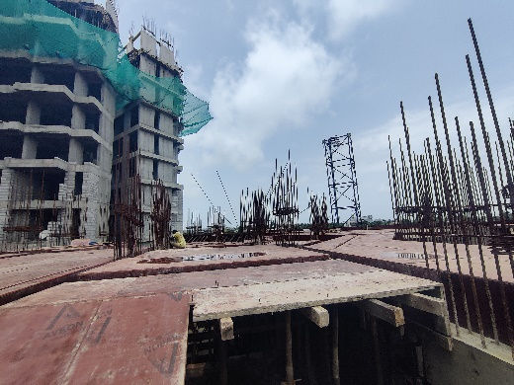
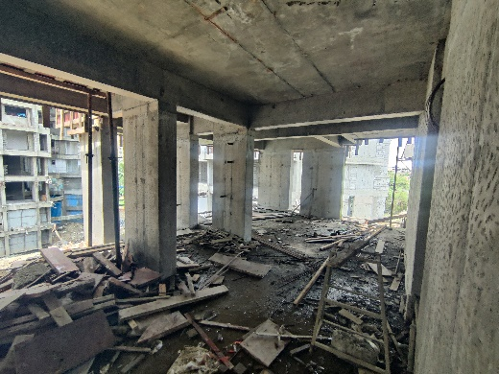
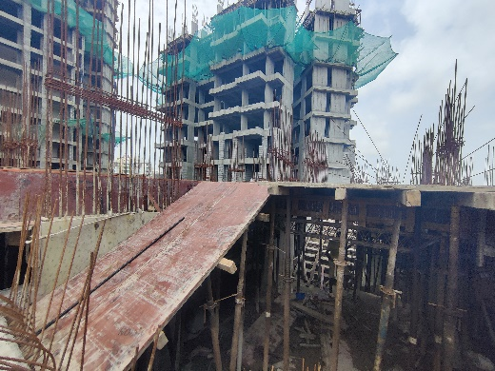
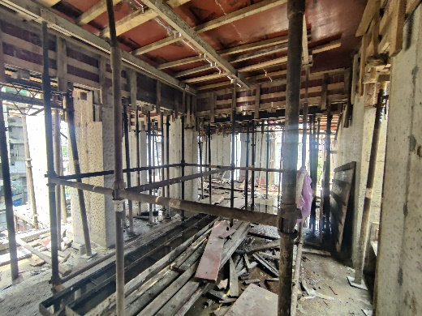
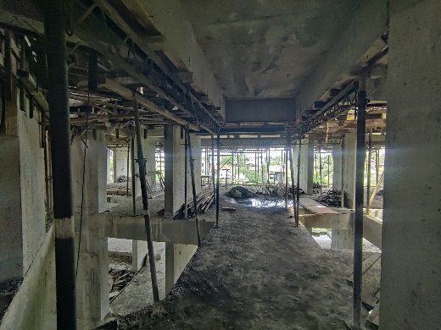
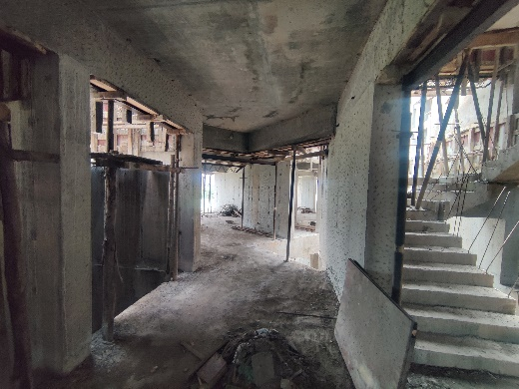
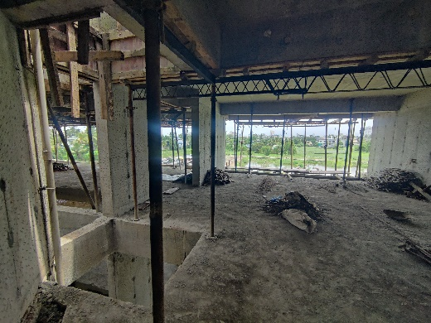
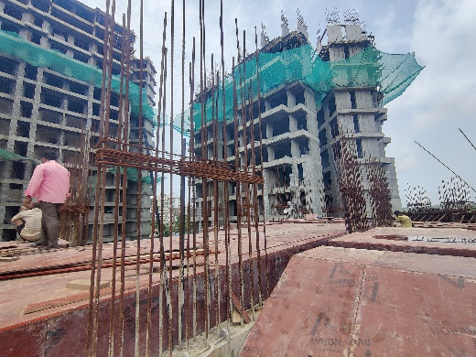
Actual Site Photographs As on 08.08.2024 (C Wing)
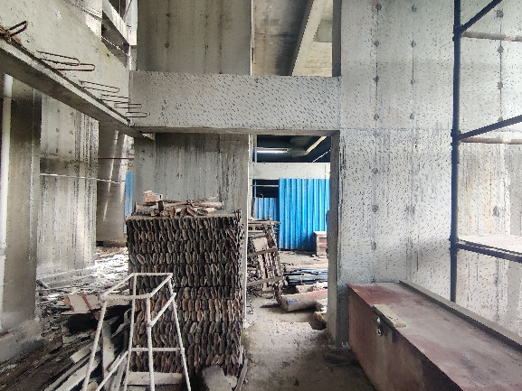
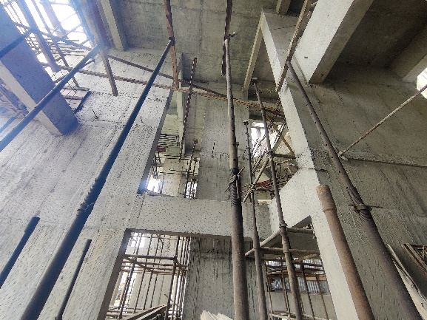
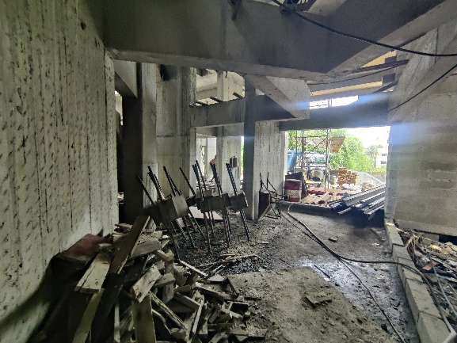
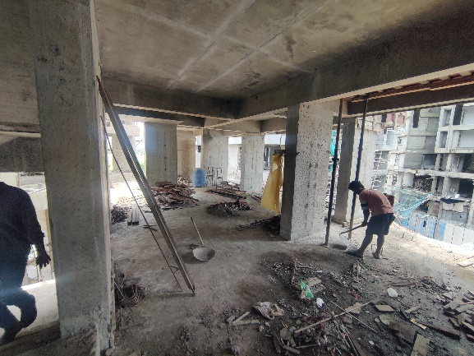
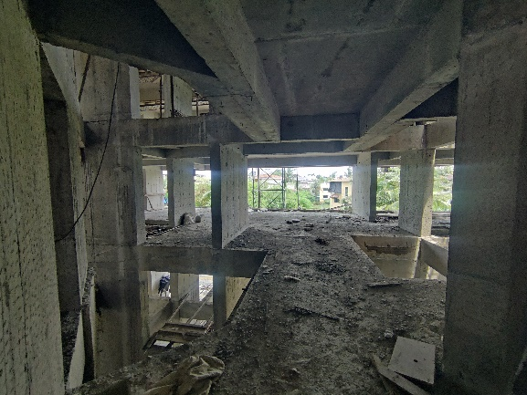
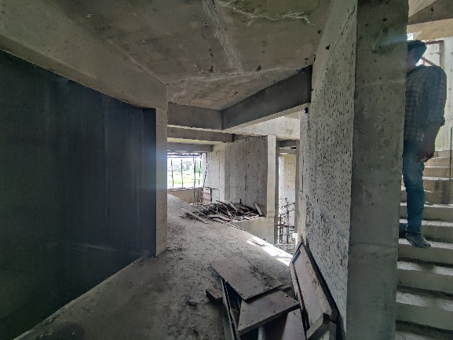
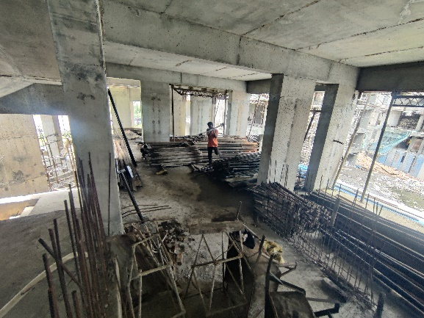
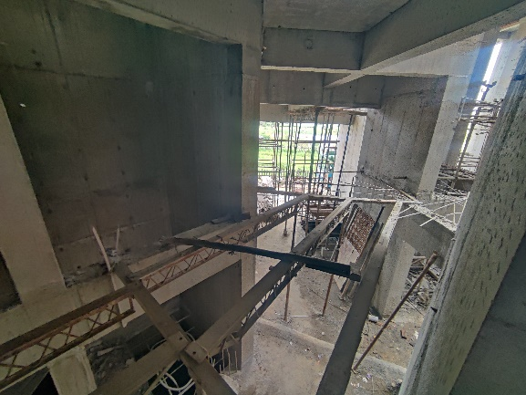
Actual Site Photographs As on 08.08.2024 (C Wing)
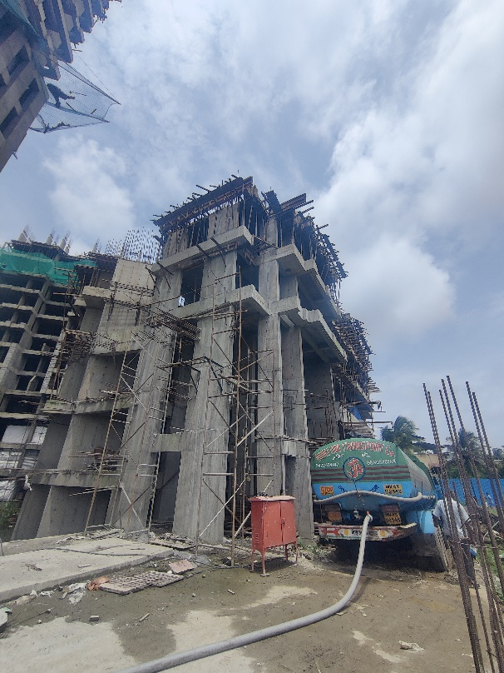
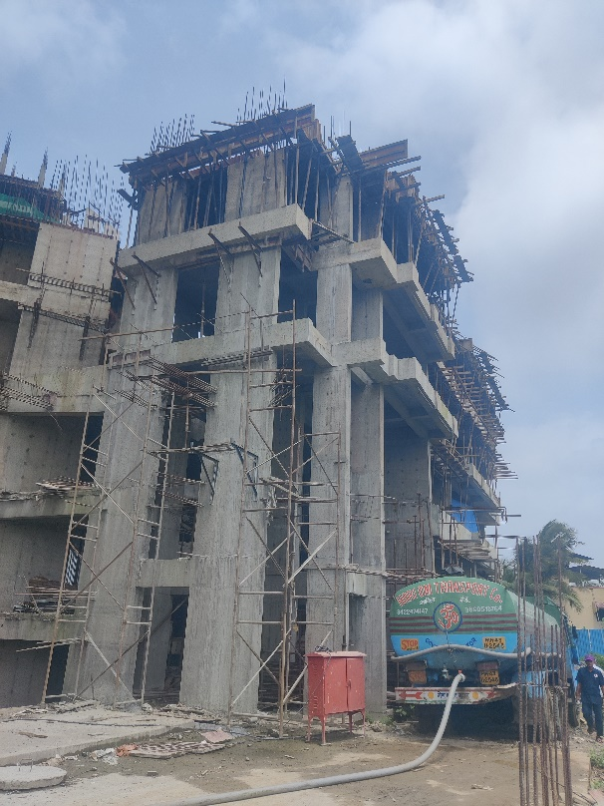
Actual Site Photographs As on 08.08.2024 (D Wing)
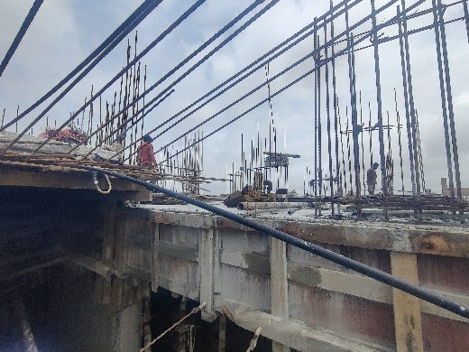
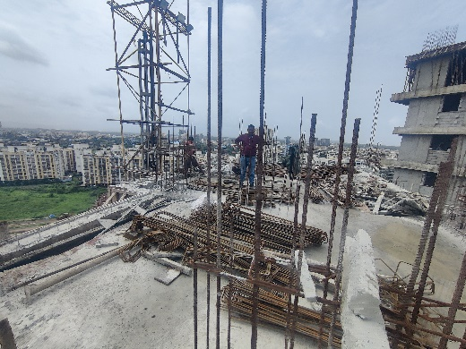
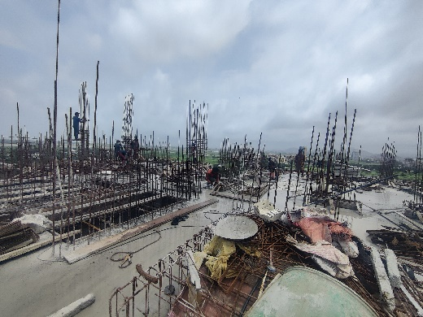
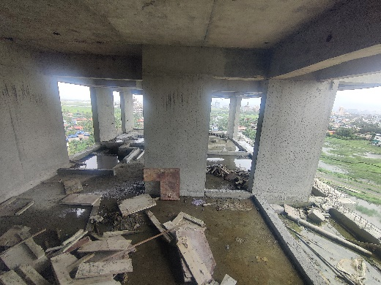
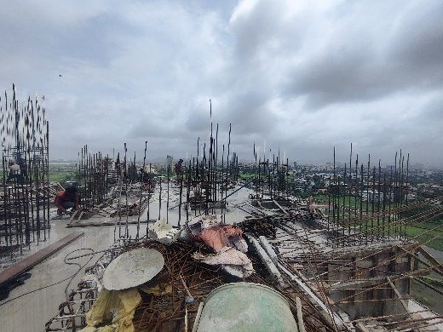
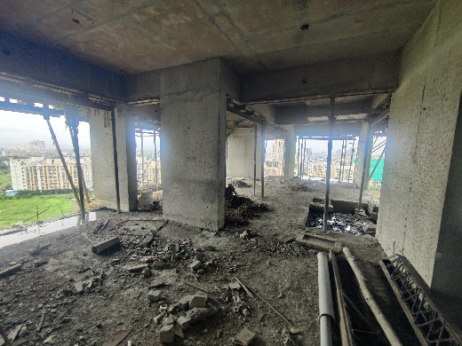
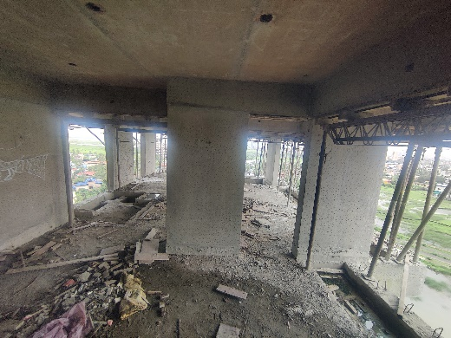
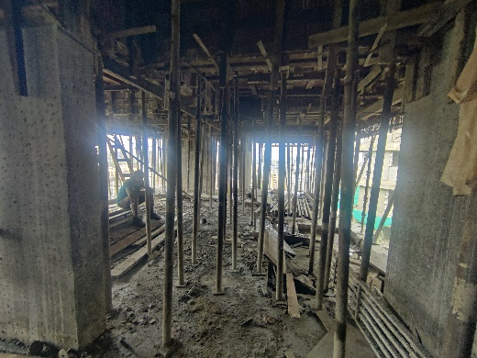
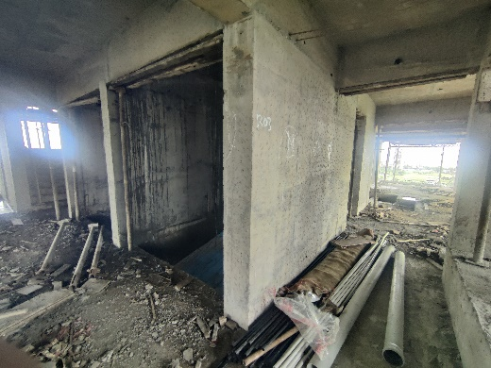
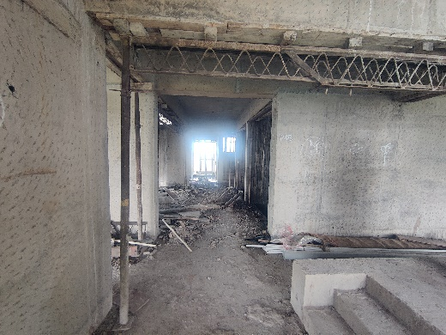
Actual Site Photographs As on 08.08.2024 (D Wing)
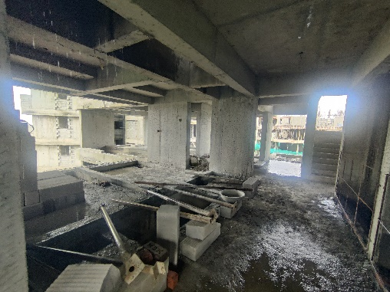
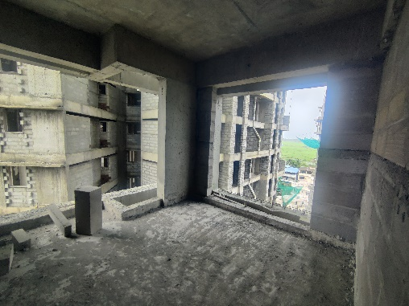
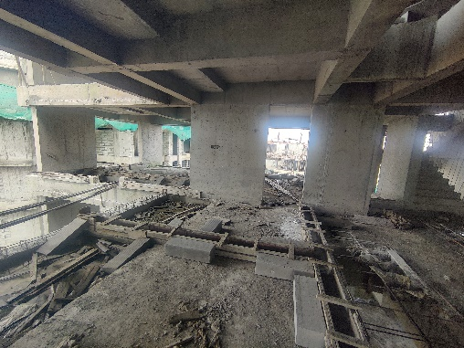
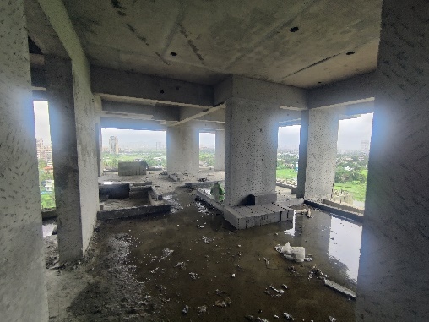
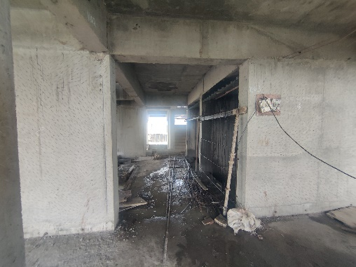
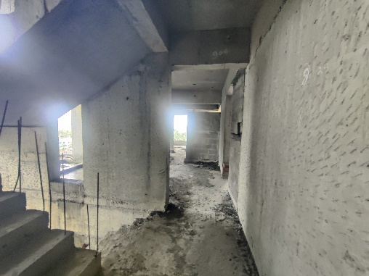
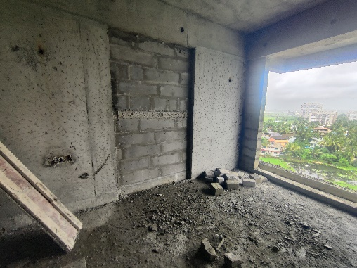
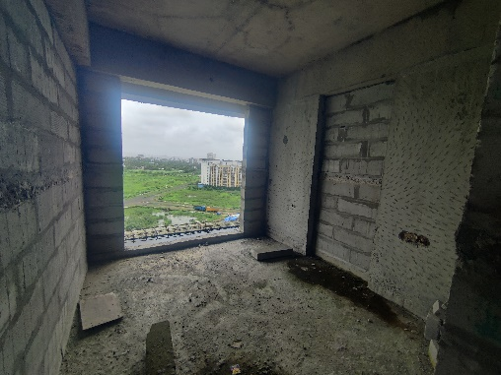
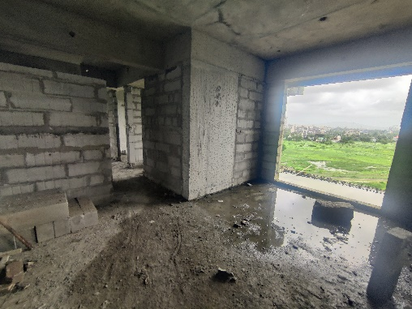
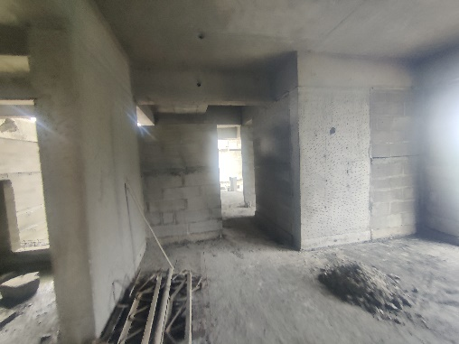
Actual Site Photographs As on 08.08.2024 (D Wing)
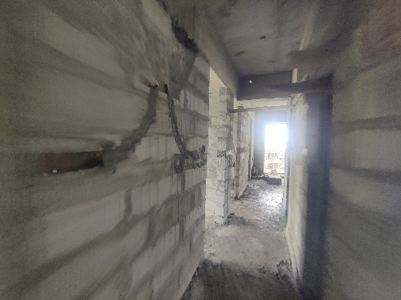
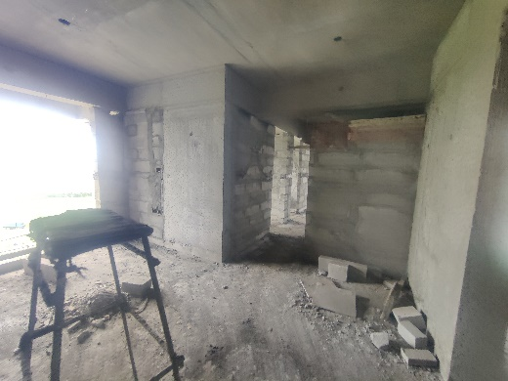
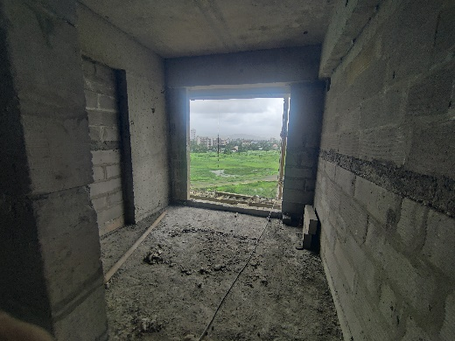
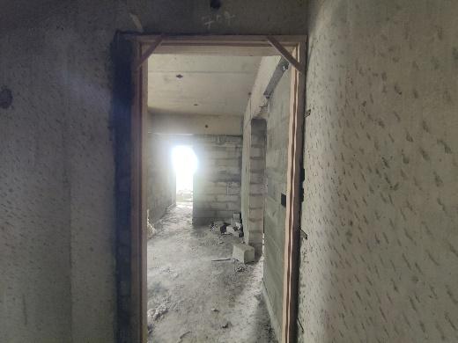
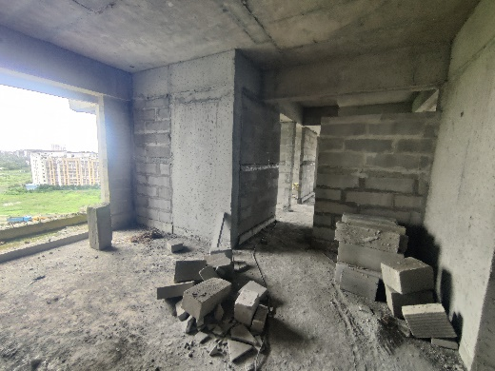
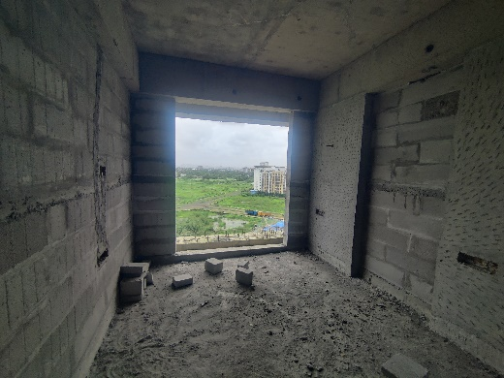
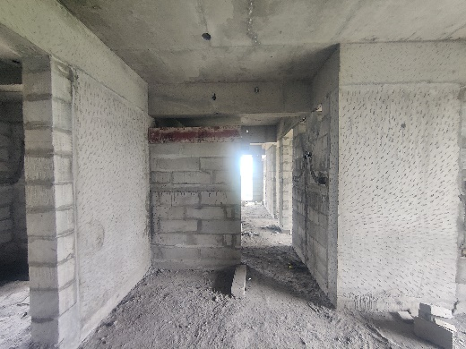
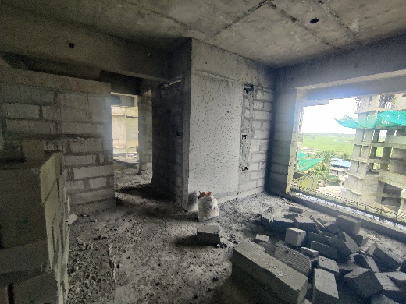
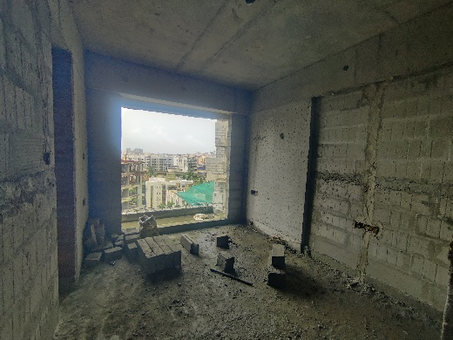
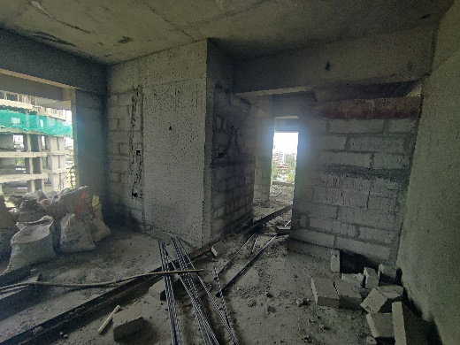
Actual Site Photographs As on 08.08.2024 (D Wing)
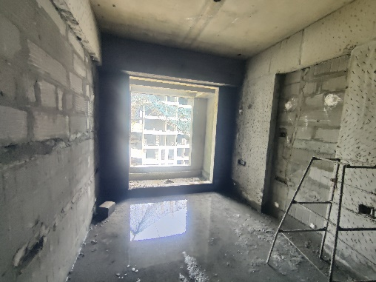
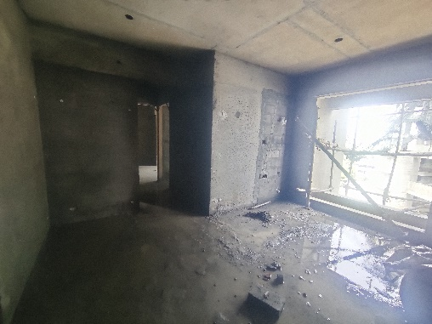
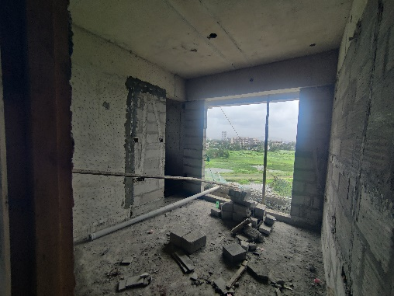
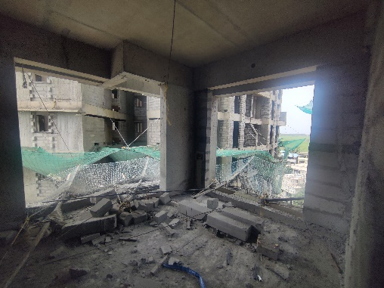
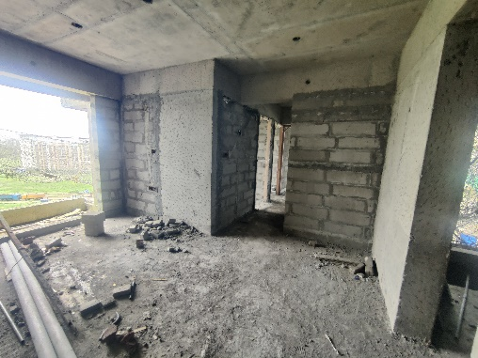
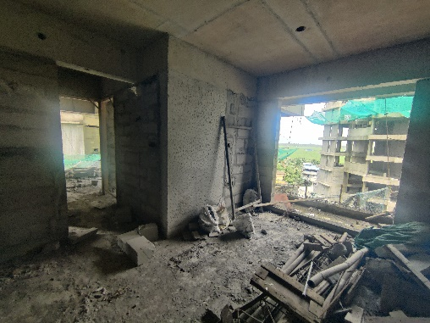
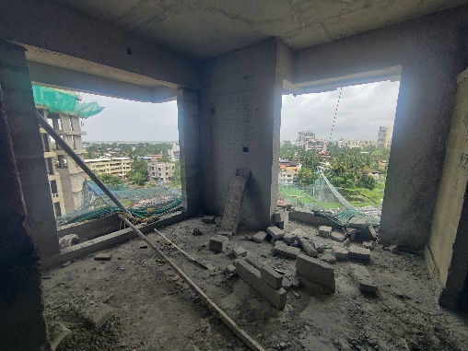
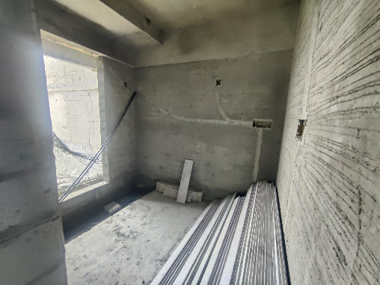
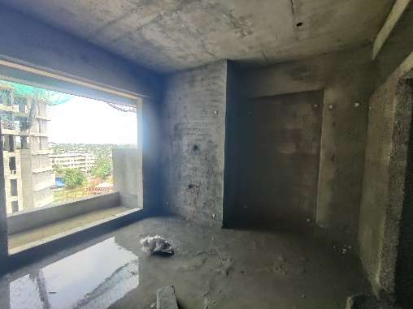
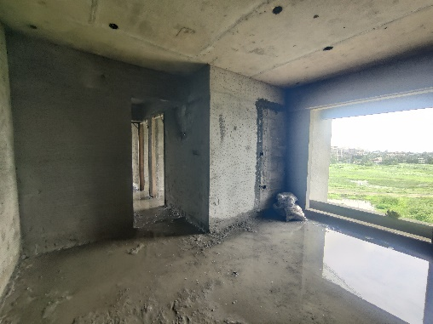
Actual Site Photographs As on 08.08.2024 (D Wing)
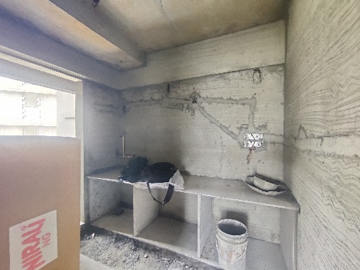
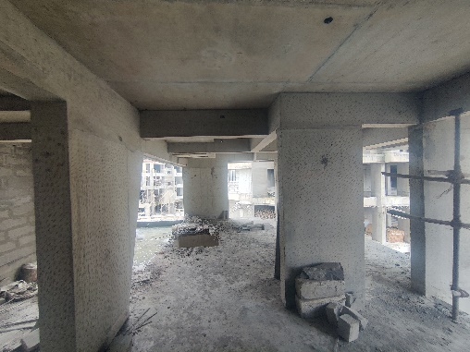
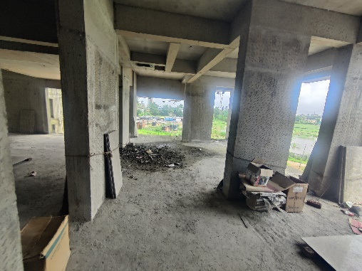
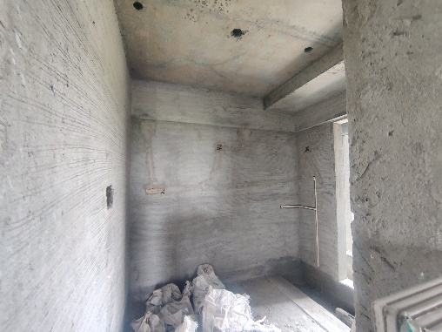
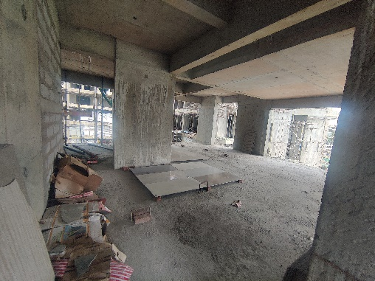
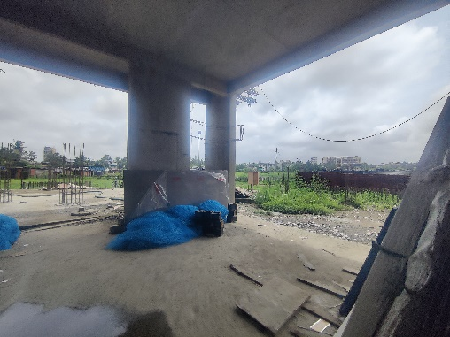
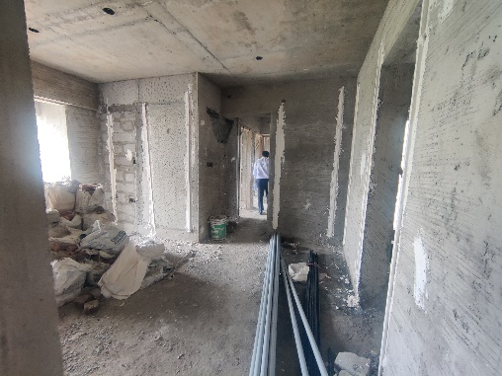
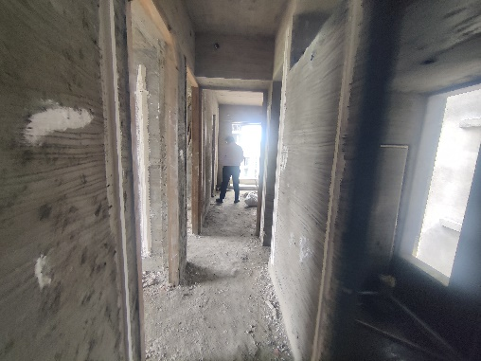
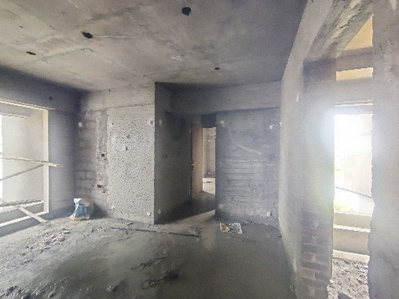
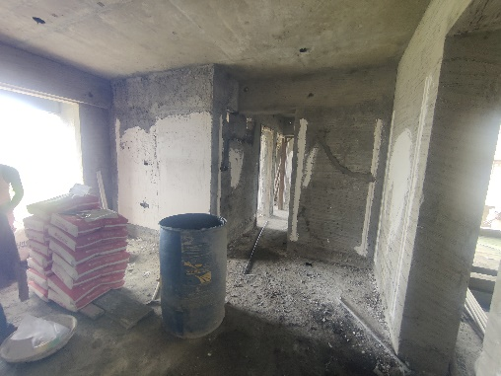
Actual Site Photographs As on 08.08.2024 (D Wing)
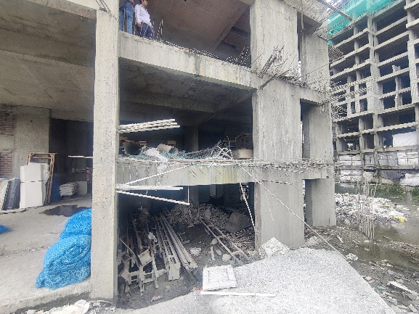
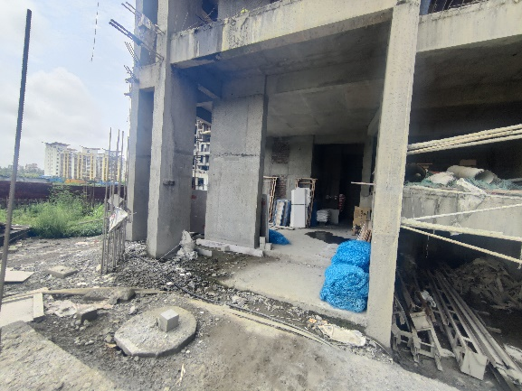

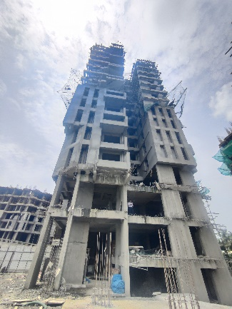
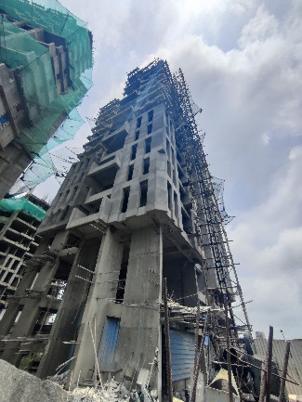
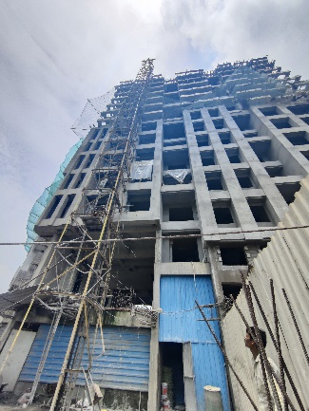
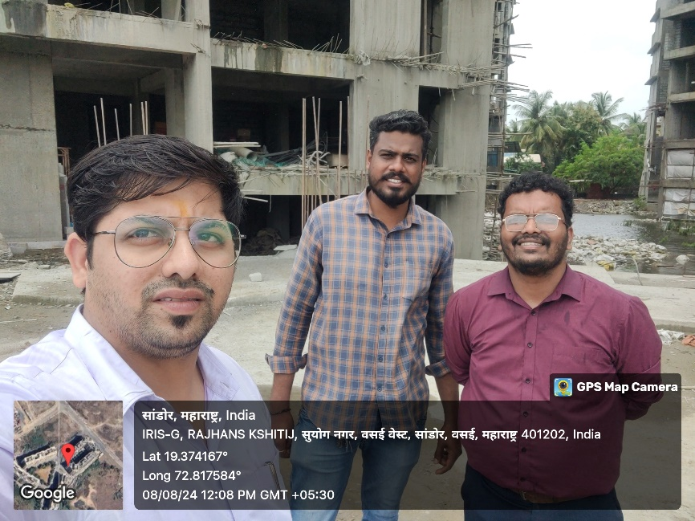
Route Map of the property
Site u/r
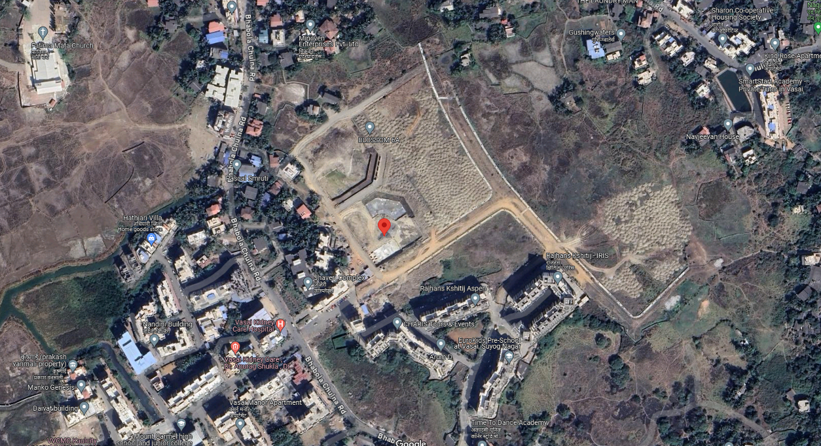

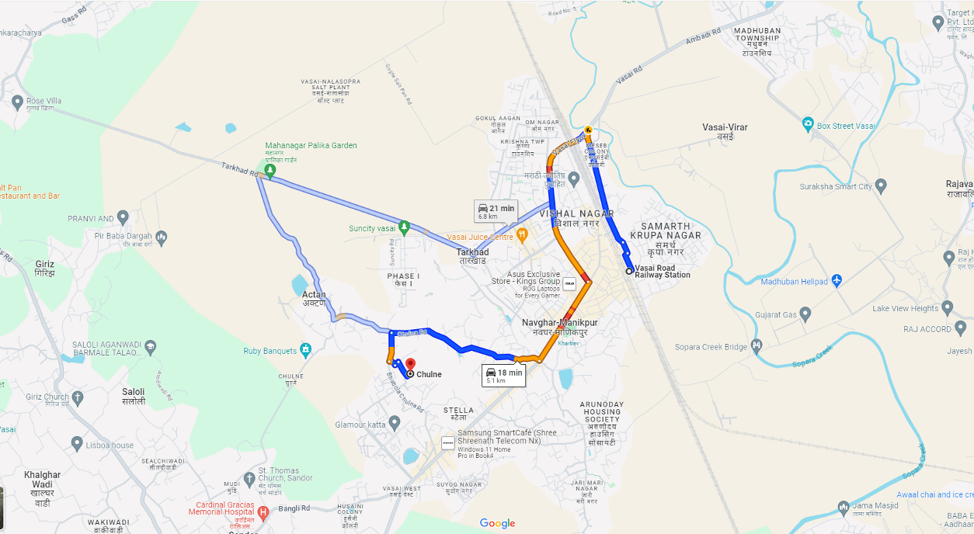

Latitude Longitude: 19°22'29.3"N 72°48'58.2"E

Note: The Blue line shows the route to site from nearest railway station (Vasai Road – 5.10 Km.)
CA Certificate Dated 01.10.2024 till 31.08.2024
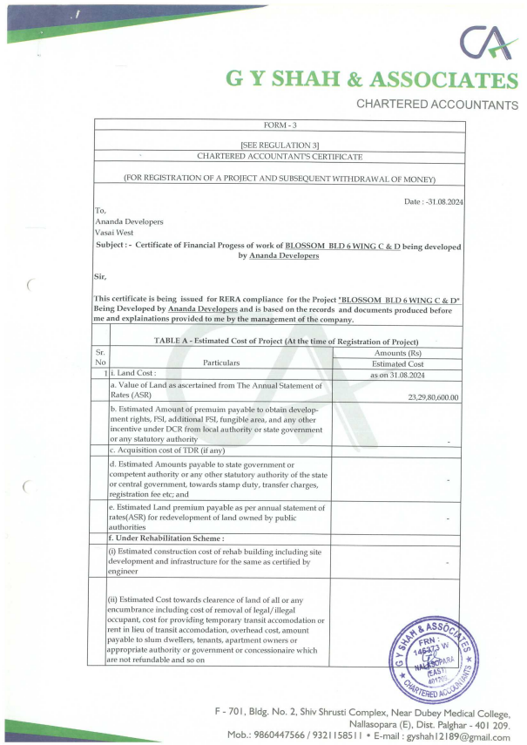
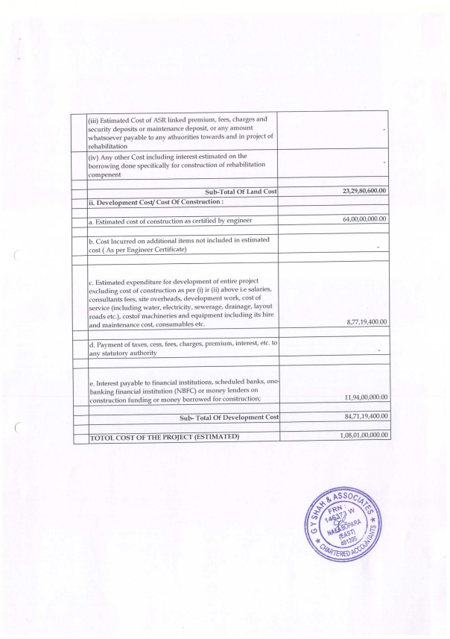
CA Certificate Dated 01.10.2024 till 31.08.2024

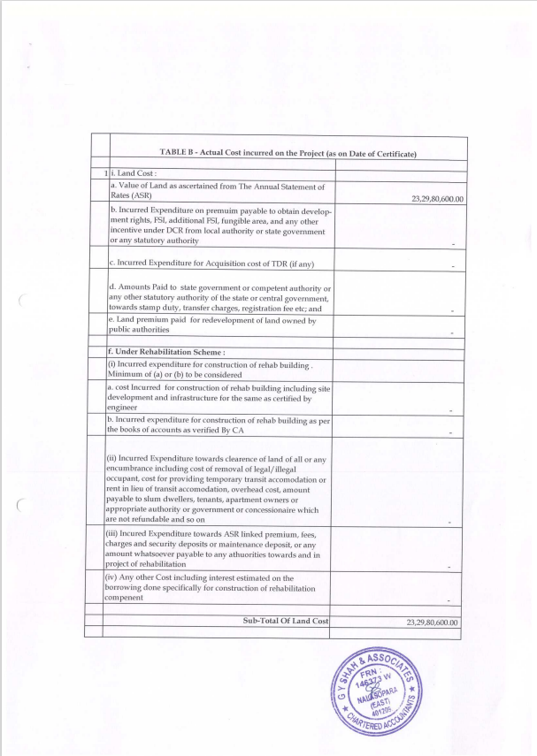
CA Certificate Dated 01.10.2024 till 31.08.2024

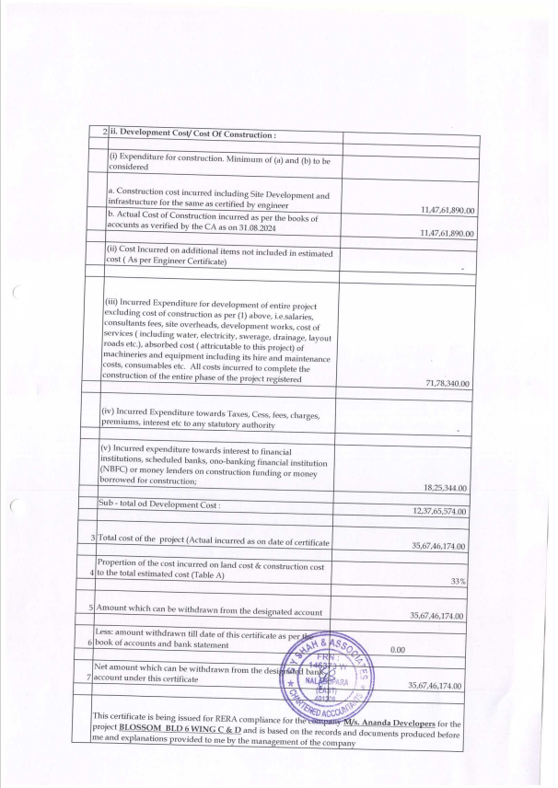
CA Certificate Dated 01.10.2024 till 31.08.2024

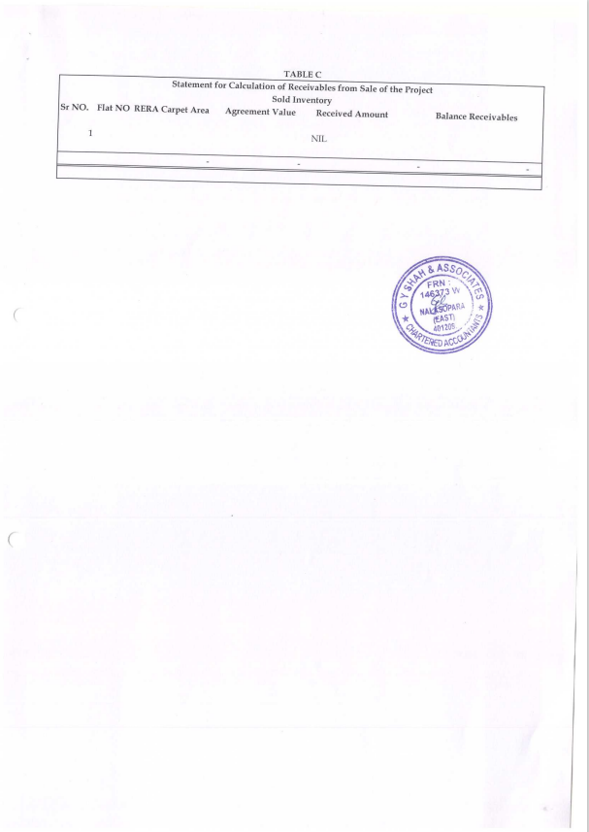
CA Certificate Dated 01.10.2024 till 31.08.2024

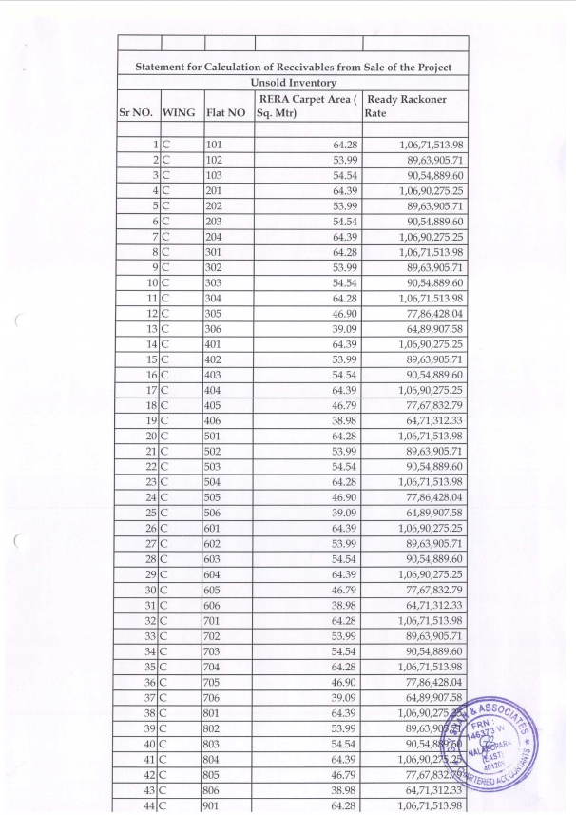
CA Certificate Dated 01.10.2024 till 31.08.2024

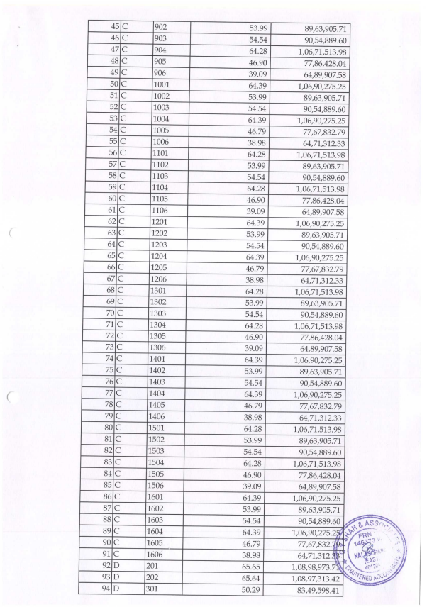
CA Certificate Dated 01.10.2024 till 31.08.2024

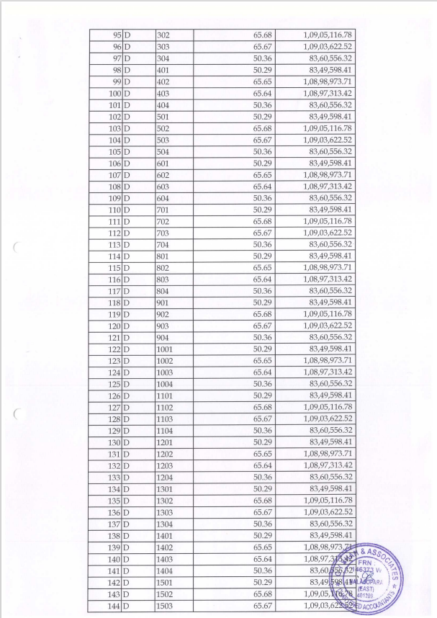
CA Certificate Dated 01.10.2024 till 31.08.2024

CA Certificate Dated 01.10.2024 till 31.08.2024
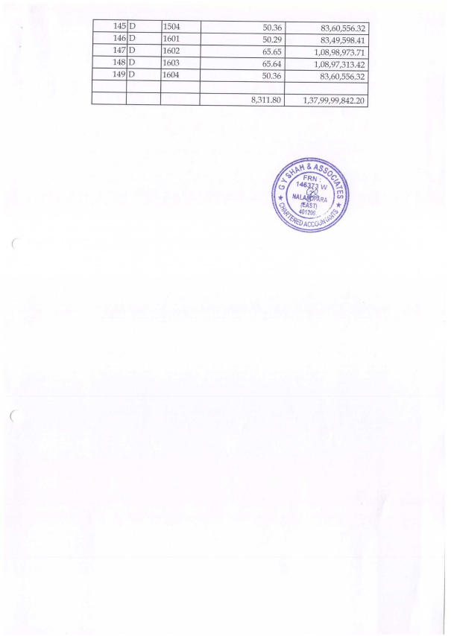
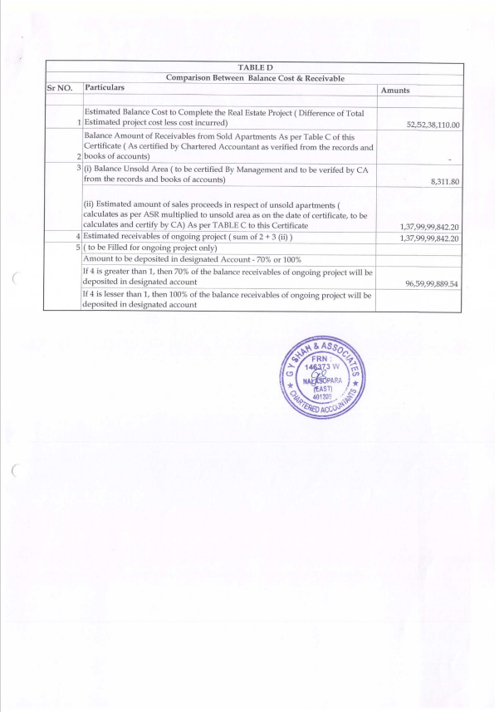
CA Certificate Dated 01.10.2024 till 31.08.2024

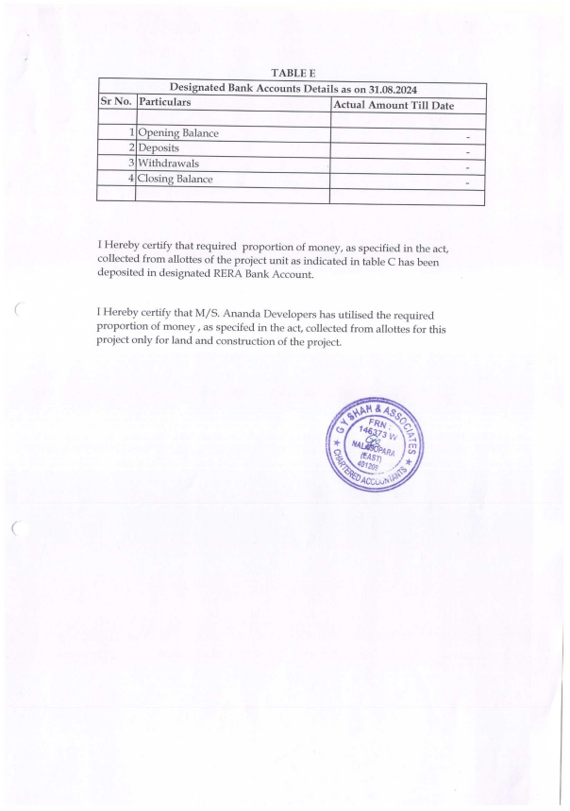
CA Certificate Dated 01.10.2024 till 31.08.2024

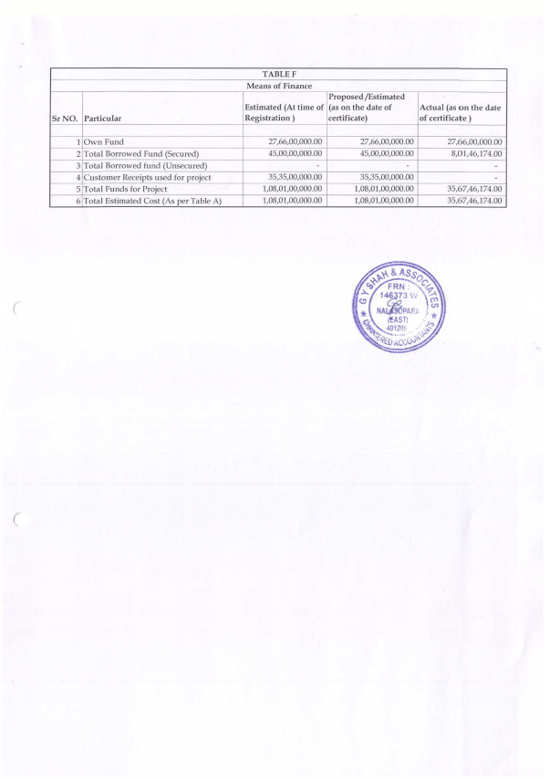
CA Certificate Dated 01.10.2024 till 31.08.2024

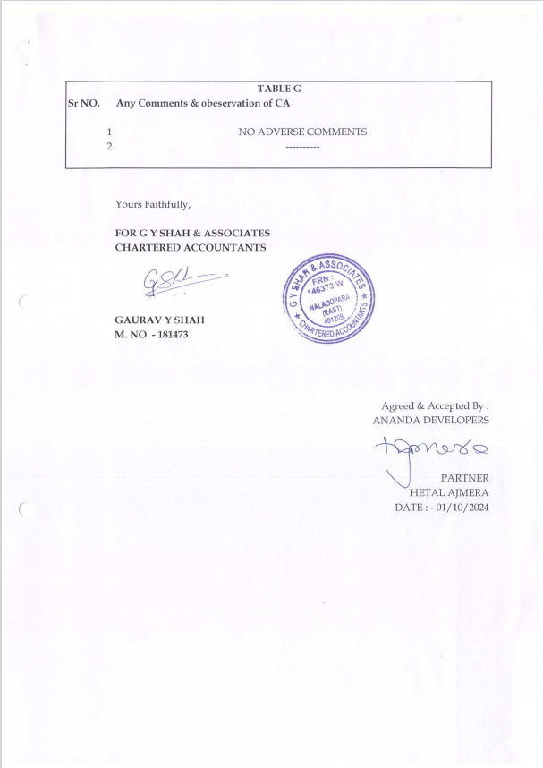
CA Certificate Dated 01.10.2024 till 31.08.2024

