Vastu/Nashik/11/2024/012361 /2309042
14/6-127-CCBS
Date: 14.11.2024

To,
The Branch Manager
Union Bank of India
Nashik City Branch
Navondar Sankul, 1366, M-1 Racca Colony, Sharanpur Road
Nashik – 422 002, State - Maharashtra, Country - lndia.

Sub: Vetting of Estimate

Sir,

With reference to above subject, we have evaluated the Estimate for Proposed Commercial Land and Building on Plot No.3, Gat No.132, Opposite Vector Transformers LLP, Saputara-Nashik Road, At – Dhakambe, Taluka – Dindori , District - Nashik,PIN - 422 004, State - Maharashtra, Country – India belongs to Campet Bottles Pvt.Ltd ( Proposed ).

We have verified the rates quoted as per current market rates. Details of Estimate considered as per copy of Estimate Provided by Ar.Hemant Bhavsar received on dated 14.11.2024. The Estimate amount is Rs.96,00,000/- (Rupees Ninety-Six Lakh Only.)

Note:1) The said Cost Vetting Certificate is valid upto next 6 months Only.

Thanking you

Sincerely yours

Sharadkumar B. Chalikwar
Govt. Reg. Valuer
Chartered Engineer (India)
Reg. No. (N) CCIT/1-14/52/2008-09

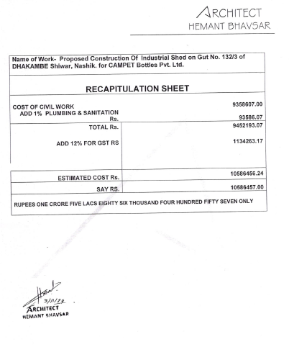
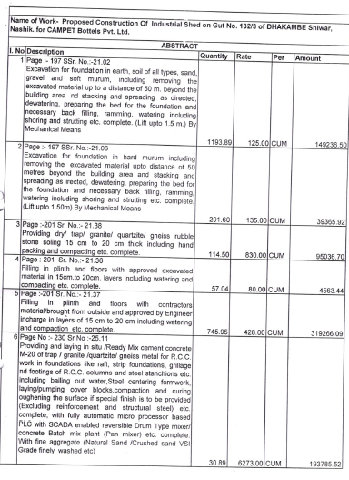
Estimate

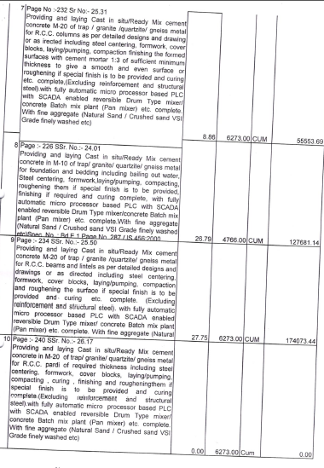
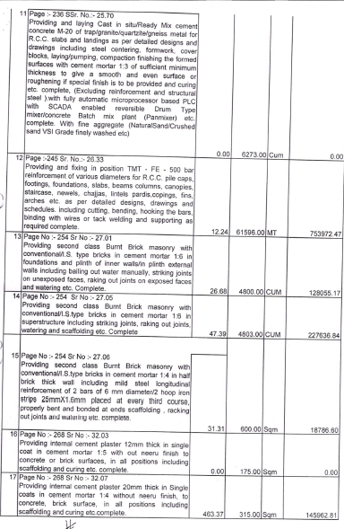

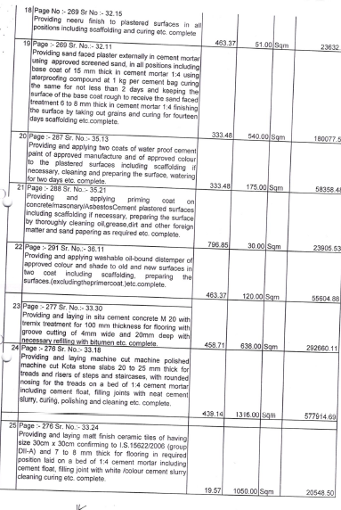
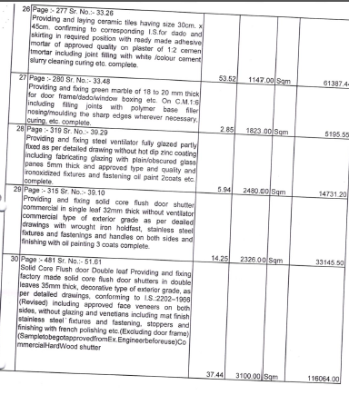

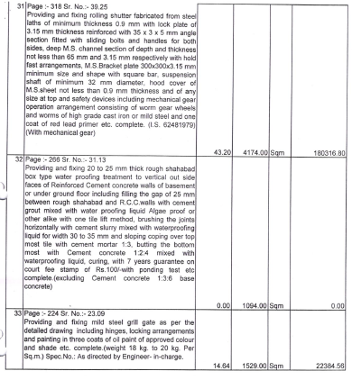
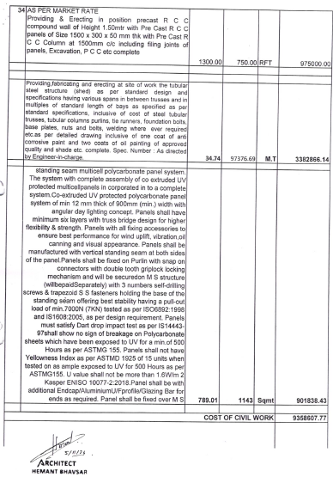

The Estimate amount is Rs.96,00,000/- (Rupees Ninety-Six Lakh Only.)

