Vastu/Thane/11/2024/12339/2307513
31/9-517-APU
Date: 13.11.2024

CE CERTIFICATE FOR MACHINE VERIFICATION

To,

The Manager,

Credit Saison India,
Revenue Village- Kondivita, 2nd Level,
33 CTS No. 195-A, Kalpatru Square, Andheri-Kurla Road,
Andheri East, Mumbai-400 059,
State - Maharashtra, Country – India.

Sub: CE Certificate for Verification of High Precision Cold Rolling Machine with complete mechanical and electrical accessories, Model: TP-CRM-40.

Ref: Tax Invoice, Bill of Entry, Packing List and Gatepass - Custodian Copy – OOC, Technical Specification received from Client.

Dear Sir,

With reference to above subject, we have visited the Unit of M/s. Jay Jagdamba Limited located at Gut No. 92/3, 422, 423,424 Village Abitghar, Shirispada Shahapur Road Taluka-Wada, District- Palghar PIN Code- 421 303, State-Maharashtra, Country-India on 08.11.2024. During the time of our visit, we found that the machinery is arrived at site and kept in the boxes. Party has provided the Packing List and we verified the same and the details for the same is as under: -
S. No. | No. mentioned on Box | Name | Weight (Kg) | Box Dimension (mm) | Remark
1 | 9/64 | Servo Motor 1 | 74 | 650 x 350 x 500 | 1# Wooden Box, Including 1 Coding wire
2 | 10/64 | Servo Motor 2 | 74 | 650 x 350 x 500 | 2# Wooden Box, Including 1 Coding wire
3 | 14/64 | Jacking Tube (3 Pieces) | 63 | 6000 x 120 x 50
4 | 24/64 | Synchronization Gear 1 (Z = 27) | 903 | 1150 x 800 x 950 | 6 - Wooden Box
4 | 24/64 | Synchronization Gear 1 (Z = 29) | 903 | 1150 x 800 x 950 | 6 - Wooden Box
4 | 24/64 | Anchor bolts (2 sets each) | 903 | 1150 x 800 x 950 | 6 - Wooden Box
4 | 24/64 | Spacer | 903 | 1150 x 800 x 950 | 6 - Wooden Box
4 | 24/64 | Support Angle Steel | 903 | 1150 x 800 x 950 | 6 - Wooden Box
4 | 24/64 | Sychronization Gear 1 (Z = 29) | 903 | 1150 x 800 x 950 | 6 - Wooden Box
4 | 24/64 | Sychronization Gear 1 (Z = 29) | 903 | 1150 x 800 x 950 | 6 - Wooden Box
4 | 24/64 | Support Angle 1 | 903 | 1150 x 800 x 950 | 6 - Wooden Box
4 | 24/64 | Support Angle 2 | 903 | 1150 x 800 x 950 | 6 - Wooden Box
5 | 26/64 | Core Rod (3 Sets) | 167 | 6300 x 120 x 70
6 | 28/64 | Main Motor Base 1 | 631 | 1200 x 800 x 900
7 | 29/64 | Host Box 1 | 7,194 | 5000 x 1350 x 1500
8 | 30/64 | Case Cover 1 | 128 | 2010 x 920 x 650
9 | 31/64 | Middle bed 1 | 2,891 | 7100 x 650 x 320
10 | 32/64 | Bed Leg 1 | 109 | 520 x 300 x 550
11 | 33/64 | Rotary Feed Box with Base 1 | 2,877 | 2700 x 1200 x 1260
12 | 34/64 | Servo Motor 1 - 1 | 67 | 650 x 350 x 500 | 9# Wooden Box, Including 1 Coding wire
13 | 35/64 | Servo Motor 1 - 2 | 67 | 650 x 350 x 500 | 10# Wooden Box, Including 1 Coding wire
14 | 36/64 | Front Support Device 1 | 253 | 800 x 600 x 1200
15 | 37/64 | Loading V - Frame Device 1 | 743 | 11500 x 350 x 850
16 | 38/64 | Loading Rack Support 1 (5 Pieces) | 139 | 1500 x 450 x 1000
17 | 39/64 | Loading Channel Steel 1 (4 Pieces) | 72 | 3100 x 100 x 60
18 | 41/64 | Discharging Angle Steel 2 Pieces | 281 | 9000 x 150 x 120
19 | 43/64 | Pilley Protection Saftey Cover 1 | 87 | 2600 x 300 x 1200
20 | 44/64 | Chassis Cover Oil Shield (4 Pieces) | 97 | 3100 x 200 x 200
21 | 46/64 | Hydraulic Station 1 | 65 | 600 x 450 x 550 | 12# Wooden Box
22 | 47/64 | Electrical Control Cabinet 1 | 349 | 1270 x 950 x 2300 | 13# Wooden Box
23 | 54/64 | Servo Motor 2 - 1 | 61 | 650 x 350 x 500 | 14# Wooden Box, Including 1 Coding wire
24 | 55/64 | Servo Motor 2 - 2 | 61 | 650 x 350 x 500 | 15# Wooden Box, Including 1 Coding wire
25 | 58/64 | Loading Rack Support 2 (5 Pieces) | 146 | 1500 x 450 x 1000
26 | 59/64 | Loading Channel Steel 2 (4 Pieces) | 68 | 3100 x 100 x 60
27 | 63/64 | Hydraulic Station 2 | 65 | 600 x 450 x 550 | 17# Wooden Box
28 | 64/64 | Electrical Control Cabinet 2 | 348 | 1270 x 950 x 2300 | 18# Wooden Box
 |  | Total | 18,080

OBSERVATION:-
- The Machinery arrived at site and kept in the boxes and few items of the said machine in open lots.
- During on our site visit, total 28 nos. of boxes and loose items for the said machine are found at site.
- We have inspected each 28 nos. of boxes and loose items as per Packing list provided by the Company.

As per documents provided by the company and observation made during our site visit. we are at opinion that the High Precision Cold Rolling Machine with complete mechanical and electrical accessories, Model: TP-CRM-40, are arrived at Site and kept in the premises of M/s. Jay Jagdamba Limited locate at Gut No. 92/3, 422, 423,424 Village Abitghar, Shirispada Shahapur Road Taluka-Wada, District- Palghar PIN Code- 421 303, State-Maharashtra, Country-India and the photographs for the same is enclosed for ready reference.

Hence Certified.

This report is prepared for Credit Saison India, Mumbai.

We further declare that: --

In the preparation of the CE Certificate, we have relied on the information provided by the client.

The information furnished in this Certificate is true and correct to the best of our knowledge and belief.

We have no direct or indirect interest in the Unit.

For Vastukala Consultants (I) Pvt. Ltd.

Date: -13.11.2024
Place: - Thane
Umang Ashwin Patel
Regd. Valuer
Chartered Engineer (India)
Reg. No. IBBI/RV/04/2019/10803
ACTUAL SITE PHOTOGRAPHS: -
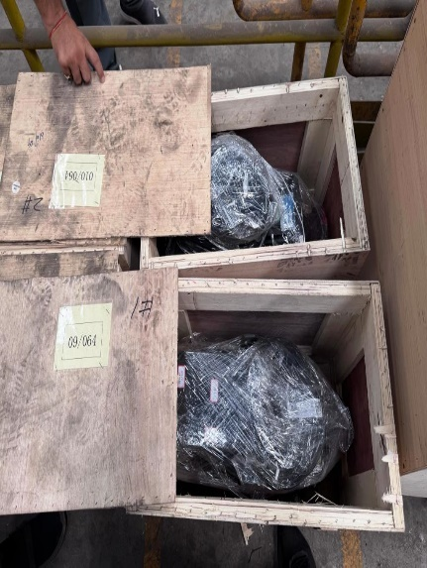
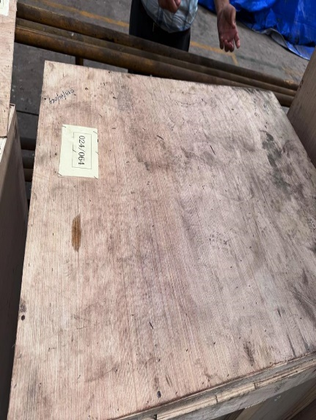
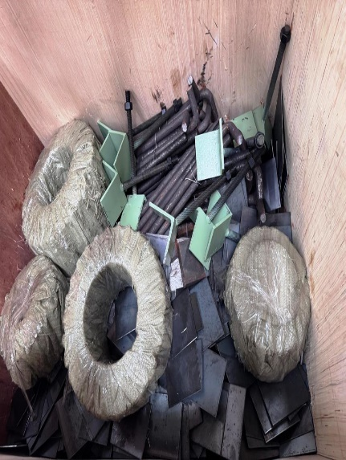
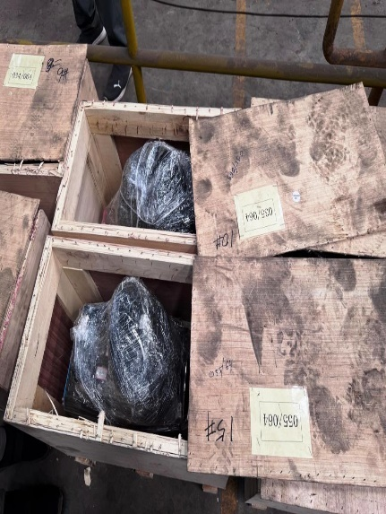
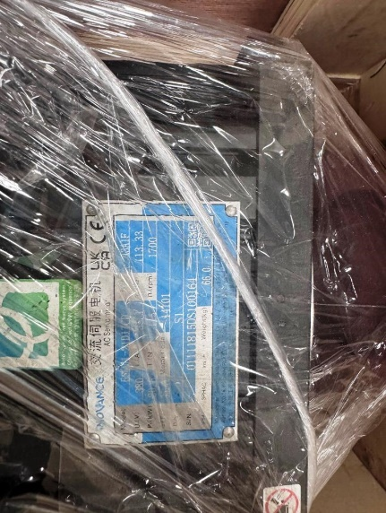
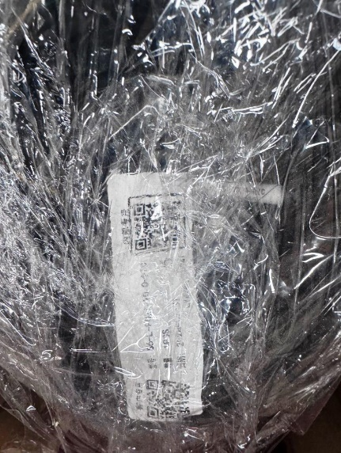
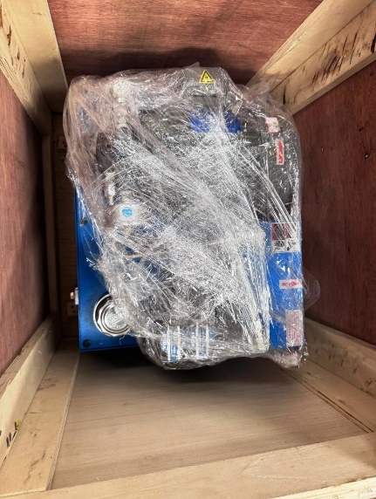
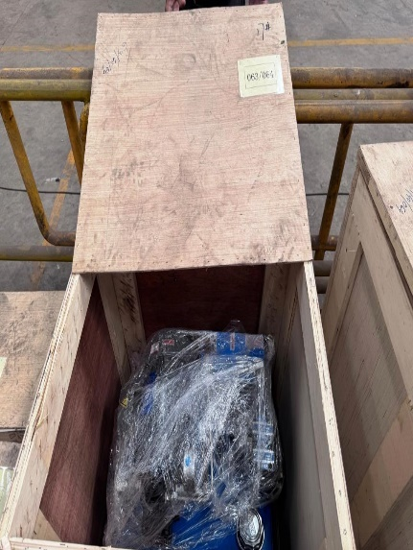
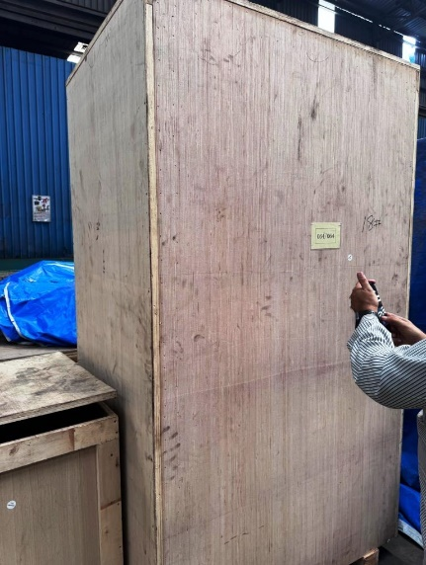
ACTUAL SITE PHOTOGRAPHS: -
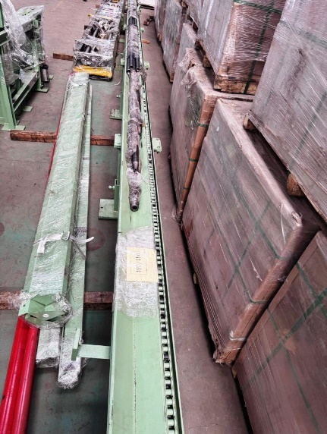
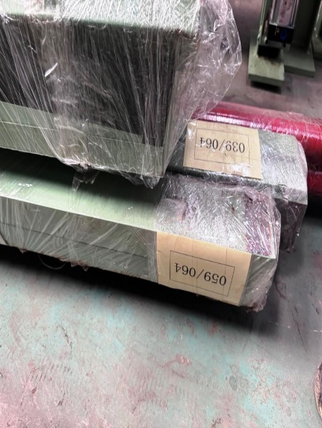
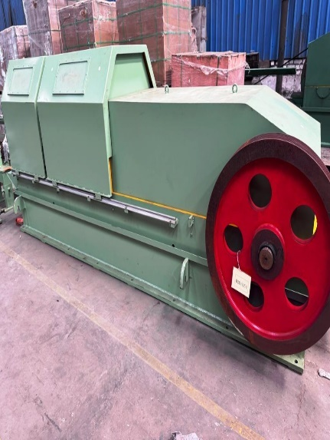
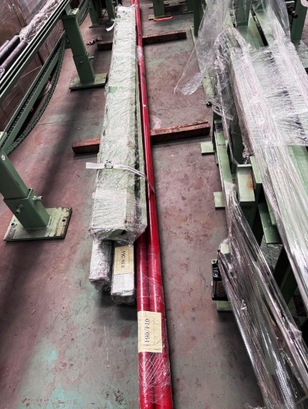
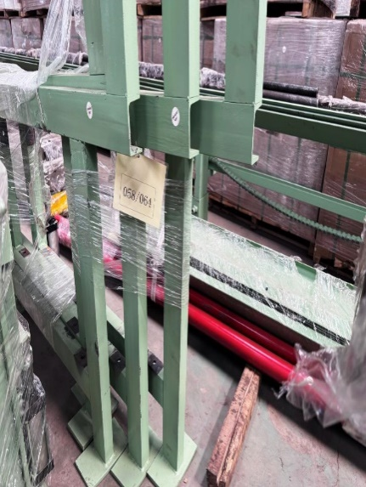
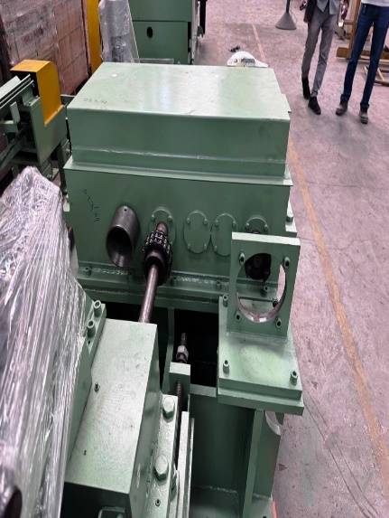
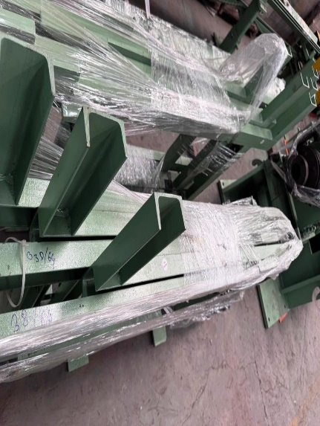
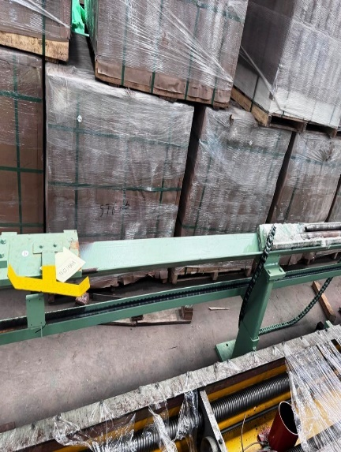
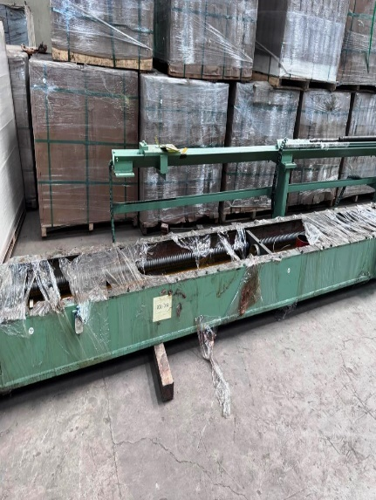
ACTUAL SITE PHOTOGRAPHS: -
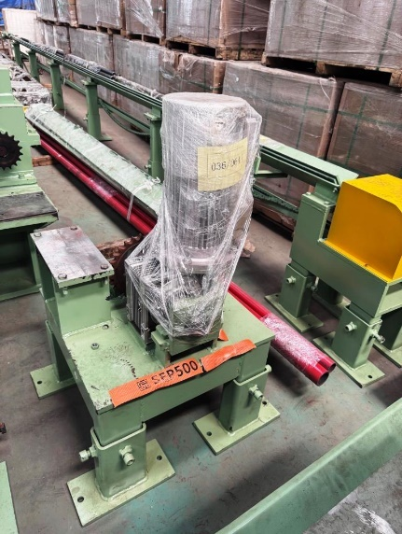
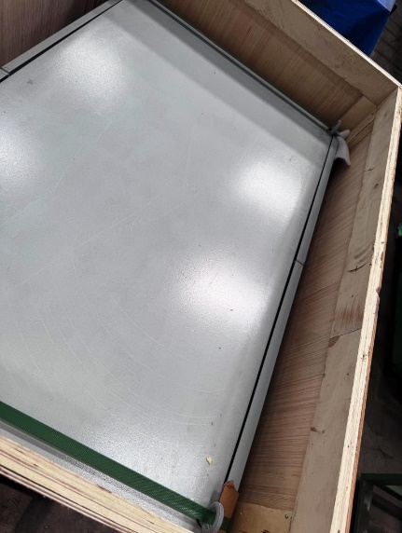
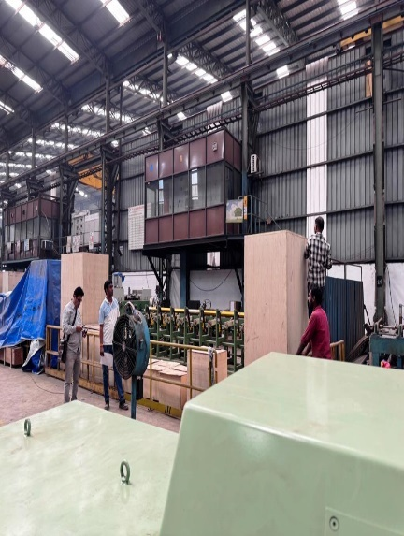

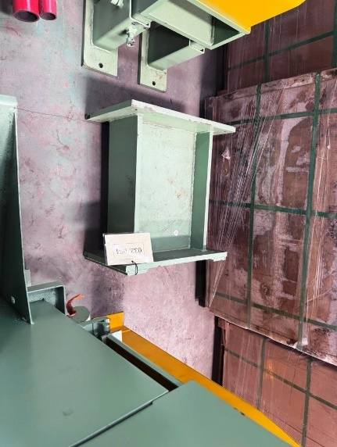
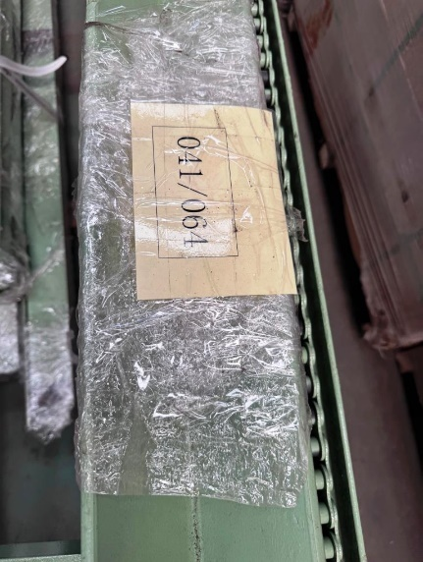
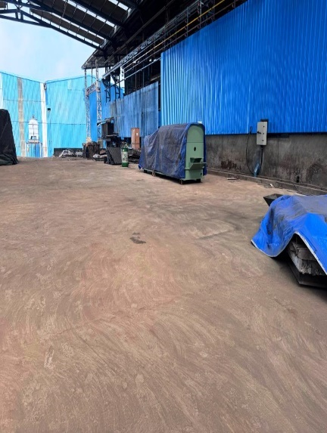
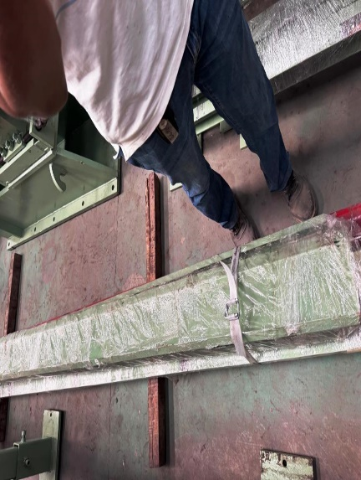
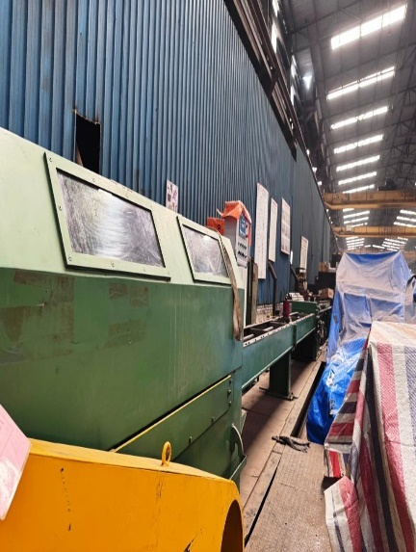
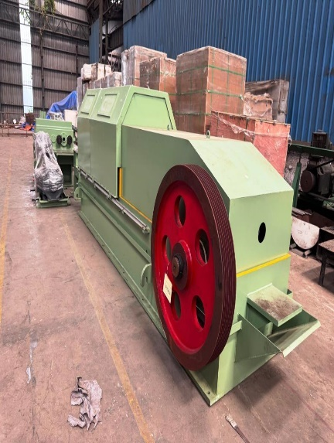
ACTUAL SITE PHOTOGRAPHS: -
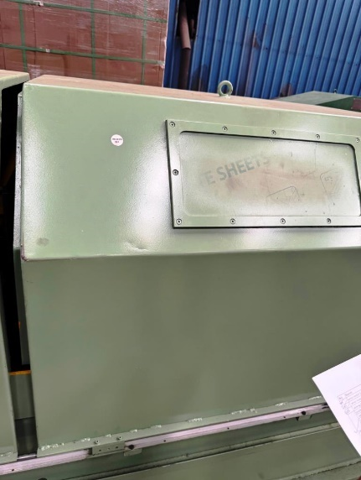
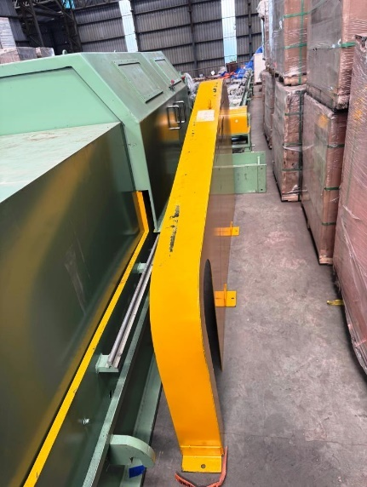
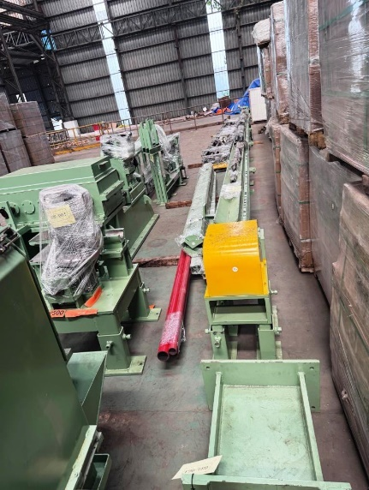
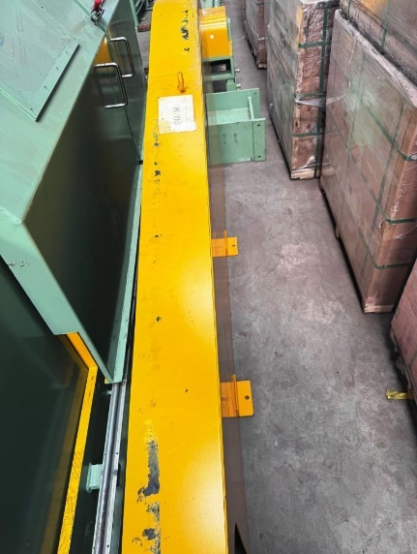
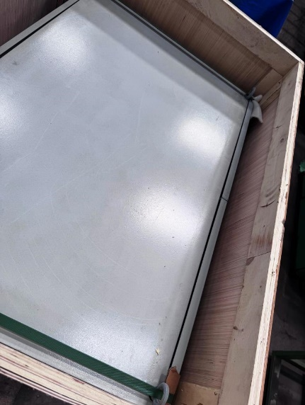
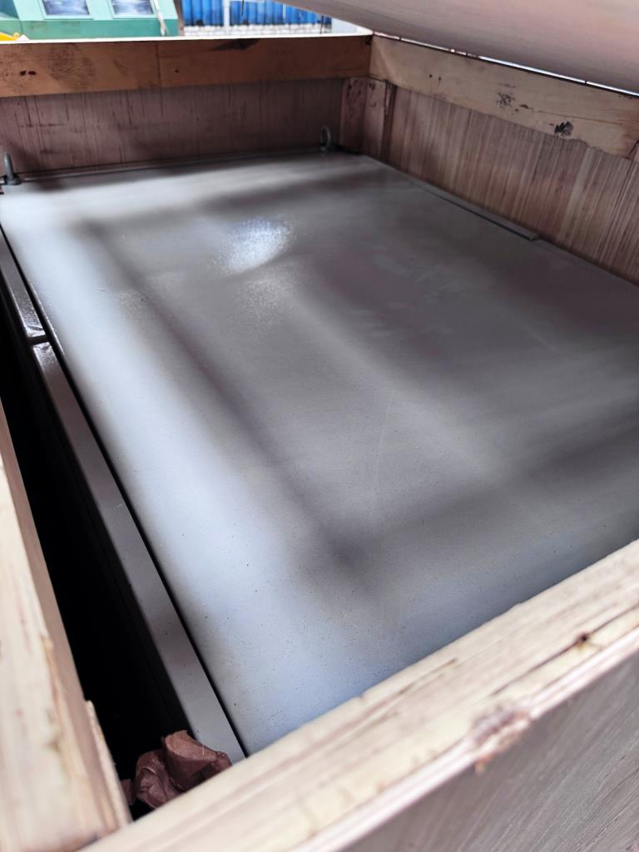
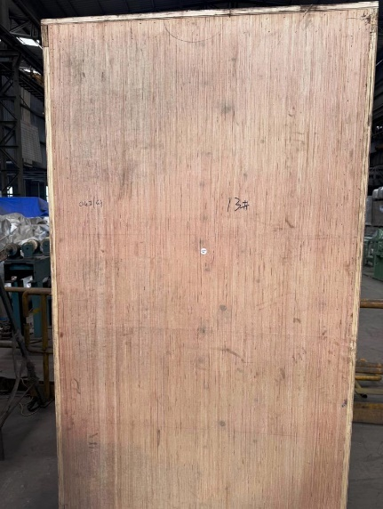
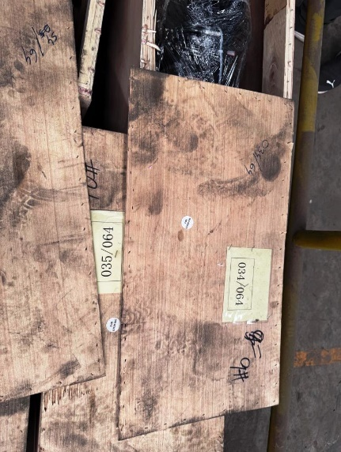
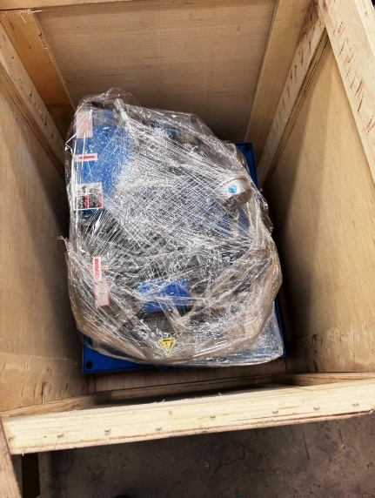
ACTUAL SITE PHOTOGRAPHS: -
