16th LENDER’S INDEPENDENT ENGINEER REPORT
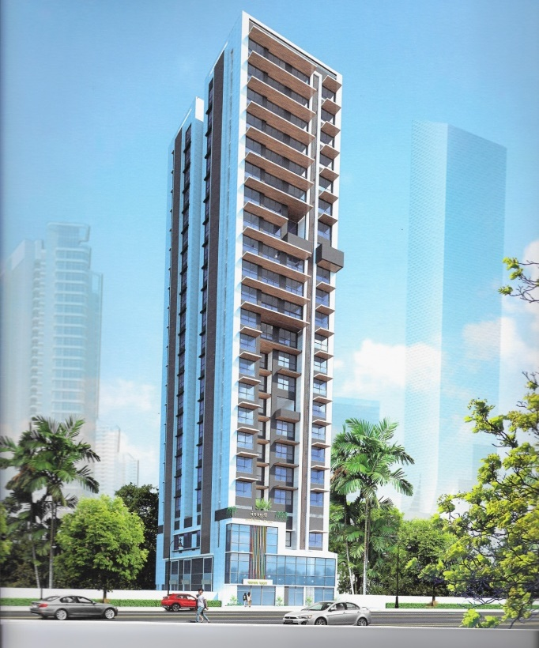

Details of the property under consideration:

Name of Project: Sai Aradhya

“Sai Aradhya”, Proposed Redevelopment of Building Bearing F.P. No. 188 & 195, C. S. No. 1654 & 1/1654,
TPS IV of Mahim Division at D. L. Vaidya Road, Dadar (West), Mumbai, Pin Code - 400 028,
State - Maharashtra, Country – India

Latitude Longitude: 19°01'24.5"N 72°50'24.4"E

Intended User:

State Bank of India
SME Chembur Branch
Unit No. 11, Building No. 11, Ground Floor, Corporate Park, Sion Trombay Road,
Chembur, Mumbai, Pin Code – 400 071, State - Maharashtra, Country – India

Vastu/SBI/Mumbai/11/2024/12324/2309015
12/19-100-PY
Date: - 12.11.2024

SIXTEENTH LENDER’S INDEPENDENT ENGINEER REPORT

To,
State Bank of India
SME Chembur Branch
Unit No. 11, Building No. 11, Ground Floor,
Corporate Park, Sion Trombay Road, Chembur,
Mumbai, Pin Code – 400 071,
State - Maharashtra, Country – India.

Subject: Construction of Residential Building “Sai Aradhya”, Proposed Redevelopment of Building Bearing F.P. No. 188 & 195, C. S. No. 1654 & 1/1654, TPS IV of Mahim Division at D. L. Vaidya Road, Dadar (West), Mumbai, Pin Code - 400 028, State - Maharashtra, Country - India.

Ref: Your Request for Lender’s Independent Engineer Report of under Construction Building.
Dear Sir,
- As per your instruction, we have inspected the under-construction Rehab cum Sale Building project situated on plot bearing F.P. No. 188 & 195, C. S. No. 1654 & 1/1654, TPS IV of Mahim Division at D. L. Vaidya Road, Dadar (West), Mumbai, Pin Code - 400 028, State - Maharashtra, Country - India which is being developed by M/s. Mangal Murti Developers in order to give the physical progress at site and to certify cost incurred towards project as on 30/09/2024.
- The Construction work as per approved plan was in progress during the site visit on 16th October 2024.
- Status of work:
- For Rehab cum Sale Building: Slab work, blockwork, plaster work, flooring, kitchen platform, kitchen & toilet tiling, waterproofing, firefighting, gypsum work, plumbing & electrical concealed work are completed, Doors & Windows & 1 lift are installed & 1 Lift, Painting, Sanitary fitting & final finishing work is in progress.
Rehab cum Sale building work is delay by 1 year.

- As per cost incurred certificate issued by CA Certificate actual total expenditure occurred as on 30/09/2024 is ` 55.19 Cr. for Rehab cum Sale Building & overall financial progress is 108.58% estimated cost of project.
- As per bills actual total expenditure occurred as on 30/09/2024 is ` 55.20 Cr. for Residential of Rehab cum Sale Building & overall financial progress is 108.59% estimated cost of project.
- Overall Physical progress of the rehab cum sale building construction as on 16/10/2024 is 94.01% as per physical site inspection.

DECLARATION
- The information furnished in the report is based on our 16th site visit Dated 16/10/2024 & Document Provided by Client.
- Vastukala 15th LIE Report of the project dated 27.07.2024.
- I have no direct and indirect interest in the property examined for report.
- I have not been found guilty of misconduct in my professional capacity.

Manoj B. Chalikwar
Registered Valuer
Chartered Engineer (India)
Reg. No. IBBI/RV/07/2018/10366
Encl.: LIE report

Purpose & Methodology
• State Bank of India Banks and financial institutions require monitoring & an independent review of the progress of the sanctioned projects
VCIPL undertakes such study to independently review the progress of the project and put forward a comprehensive analysis.

Advantages:
- Assurance on present practices
- Identification of risk
- Analyzing the performance of third parties
- Recommendations

The Methodology
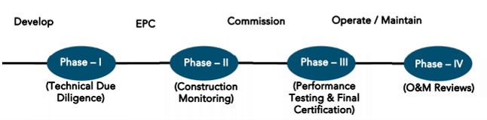
SIXTEENTH LENDER’S INDEPENDENT ENGINEER REPORT
OF
"Sai Aradhya"
“Sai Aradhya”, Proposed Redevelopment of Building Bearing F.P. No. 188 & 195, C. S. No. 1654 & 1/1654, TPS IV of Mahim Division at D. L. Vaidya Road, Dadar (West), Mumbai, Pin Code - 400 028,
State - Maharashtra, Country - India

Latitude Longitude: 19°01'24.5"N 72°50'24.4"E

NAME OF DEVELOPER: M/s. Mangal Murti Developers
Pursuant to instructions from State of India, SME Chembur Branch, Mumbai we have duly visited, inspected, surveyed & assessed the above said property on 16th October 2024 to determine the fair & reasonable market value of the said property/project as on Quarter ending 30th September 2024 for LIE purpose.

1. Location Details:
The property is situated at Plot Bearing F.P. No. 188 & 195, C. S. No. 1654 & 1/1654, TPS IV of Mahim Division at D. L. Vaidya Road, Dadar (West), Mumbai, Pin Code - 400 028. It is about 1.90 Km. distance from Dadar railway station of Western railway line. Surface transport to the property is by buses, Auto, taxis & private vehicles. The property is in developed locality. All the amenities like shops, banks, hotels, markets, schools, hospitals, etc. are all available in the nearby locality. The locality is higher middle class & developed.

- Developer Details:
Name of builder | M/s. Mangal Murti Developers
Project Rera Registration Number | P51900023477
Registered office address | Office No. 3, Ground Floor, Girdhari Sadan, Near Shiv Sena Bhavan Path, Dadar (W), Mumbai, Pin Code - 400 028, State - Maharashtra, Country - India.
Contact details | Contact Person:  Mr. Shivaji Mane (Mob No. 9322505784 / 9619002021)
Email ID and website | info@mangalmurtidevelopers.com
3. Boundaries of the Property:
Direction | Particulars
On or towards North | Shree Ram Krupa Building
On or towards South | Vision Eternity Building
On or towards East | 15.00 M wide D. L. Vaidya Road
On or towards West | 6.00 M wide SBVN Path Road

Introduction
As per Information on site M/s. Mangal Murti Developers has acquired land by conveyance agreement Dt.31.08.2009 & Dt.29.11.2010 admeasuring 258.27 Sq. M. and 332.03 Sq. M. respectively totally admeasuring area is 590.30 Sq. M. bearing F.P. No. 188 & 195, C. S. No. 1654 & 1/1654, TPS IV of Mahim Division at D. L. Vaidya Road, Dadar (West), Mumbai, Pin Code - 400 028. For the Redevelopment of residential Building.

Area Statement:

Land:
Date | Particular | Area in Sq. M.
31.08.2009 | F. P. No. 188, C.S. 1/1654 | 258.27
29.11.2010 | F. P. No. 195, C.S. 1654 | 332.03
 | Total Plot Area | 590.30

- Copy of Deed of Conveyance dated 31.07.2009 b/w M/s. Mahasukhbhai Lallubhai & 4 others (Vendor) And M/s. Mangal Murti Developers (The Purchaser) (C. S. No. 1/1654) (Purchase Amount ` 75,00,000.00).
- Copy of Deed of Conveyance dated 29.10.2010 b/w M/s. Amit Ramkrishna Achrekar (Vendor) And M/s. Mangal Murti Developers (The Purchaser) (C. S. No. 1654) (Purchase Amount ` 1,05,00,000.00).

Building Area:
Sr. No. | Particulars |  | Total in Sq. M.
1 | Area of Plot (258.37 + 332.03) |  | 590.30
2 | Deduction for |  | -
a | Road Set Back Area |  | -
b | Proposed Area |  | -
c | Any Reservation (sub - plot) |  | -
d | % Amenity space as per DCR 56/57 |  | -
3 | Other |  | -
4 | Balance Area of Plot (1 - 2) |  | 590.30
5 | Deduction for 15% recreational ground / 10% Amenity Space (If Deductible for IND) |  | -
6 | Net Area of Plot (3 -4) |  | -
 | Addition for Floor Space Index |  | -
a | 100% for D.P. Road |  | -
b | 100% for Setback |  | -
7 | Total Area (5 + 6) |  | 590.30
8 | Floor Space Index Permissible |  | Incentive
9 | Floor Space Index Credit available by development right (restricted ____% of the balance area vide 3 Above) |  | -
 | Addition for Floor Space Index |  | -
10 | Permissible Floor Area as per DCR 33(7) |  | 3,062.84
11 | Existing Floor Area |  | -
12 | Proposed Built Up Area |  | -
13 | Excess Balcony Area taken in FSI |  | -
14A | Purely Residential Built-Up Area |  | 2,638.17
14B | Remaining Non - Residential Built-Up Area |  | 424.67
14 | TOTAL BUILT UP PROPOSED (11 + 12 + 13)  (As per Old Approved Plan Dt. Prior to 16.01.2012) |  | 3,062.84
15 | FSI Consumed on Net Holding = 14/3
B. | DETAILS OF FSI AVAILED AS PER DCPR 31(3) |  | Permissible | Proposed
1 | Fungible Built up area component permissible/proposed vide DCR 31(3) for Purely Residential = OR 14A X 0.35 | REHAB | 521.36 | 459.64
 |  | Sale | 401.99 | 397.27
2 | Fungible Built up area component permissible/proposed vide DCR 31(3) for Non-Residential = OR 14B X 0.36 | REHAB | 148.63 | 88.02
 |  | Sale
3 | TOTAL Fungible Built Up Vide DCR 31(3) = B.1 + B.2 |  | 1,071.98 | 994.93
4 | TOTAL Gross Built Up Area Proposed (14 + B.3) |  | 4,134.82
 | Less Deficit Area |  | 122.33
 | Net Permissible |  | 4,012.49 | 4,007.77
C. | TENANT STATEMENT
1 | Proposed Area
2 | Less Deduction of Non-Residential Area
3 | Area available for tenants
4 | Tenements Permissible
5 | Tenements Existing
D. | PARKING STATEMENT
1 | Parking required by regulations for Car, Scooter, Motorcycle, Outsiders
2 | Covered Garage Permissible
3 | Covered Garage Proposed Car, Scooter, Motorcycle, Outsiders
E. | TRANSPORT VEHICLES PARKING
1 | Spaces for Transport Vehicles Parking required by regulations
2 | Total No. of Transport Vehicles Parking spaces provided

List of Approvals:
- Copy of Proposed Redevelopment Plan No. CHE/CTY/4236/G/N/337(NEW) dated 23.05.2019 issued by M/s. Municipal Corporation of Greater Mumbai.
- Copy of IOD No. CHE/CTY/4236/G/N/337 dated 23.05.2019 issued by Mumbai Corporation of Greater Mumbai.
- Copy of Revised Approved Plan No. CHE/CTY/4236/G/N/337(NEW) dated 21.03.2023 issued by M/s. Municipal Corporation of Greater Mumbai.
- Copy of First Commencement Certificate no. CHE/CTY/4236/G/N/337/(NEW)/CC/1/NEW dated 12.12.2019., this C.C. is granted up to plinth level as per approved amended plan dated 23.05.2019, it is valid up to 11.12.2020 issued by Mumbai Corporation of Greater Mumbai.
- Copy of Second Commencement Certificate no. CHE/CTY/4236/G/N/337/(NEW)/OTHER/2/NEW dated 21.01.2021., this C.C. is granted up to plinth level as per approved amended plan dated 23.05.2019, it is revalidated up to 11.12.2021 issued by Mumbai Corporation of Greater Mumbai.
- Copy of Third Commencement Certificate no. CHE/CTY/4236/G/N/337/(NEW)/FCC/1/New dated 25.10.2021., this C.C. is granted up to 19th floor level as per approved IOD plan dated 23.05.2019, it is revalidated up to 11.12.2021 issued by Mumbai Corporation of Greater Mumbai.
- Copy of Fourth Commencement Certificate no. CHE/CTY/4236/G/N/337/(NEW)/FCC/1/New dated 12.01.2022., this C.C. is granted up to 19th floor level as per approved IOD plan dated 23.05.2019, it is revalidated up to 11.12.2022 issued by Mumbai Corporation of Greater Mumbai.
- Copy of Fifth Commencement Certificate no. CHE/CTY/4236/G/N/337/(NEW)/FCC/2/Amend dated 02.05.2023., this C.C. is granted up to 21st floor i.e., full C. C. including LMR & OHT as per approved amended plan dated 21.03.2023, it is revalidated up to 11.12.2023 issued by Mumbai Corporation of Greater Mumbai.
- Copy of Sixth Commencement Certificate no. CHE/CTY/4236/G/N/337/(NEW)/FCC/2/Amend dated 21.02.2024., this C.C. is granted up to 21st floor i.e., full C. C. including LMR & OHT as per approved amended plan dated 21.03.2023, it is revalidated up to 11.12.2024 issued by Mumbai Corporation of Greater Mumbai.
- Copy of Part Occupancy Certificate no. CHE/CTY/4236/G/N/337/(NEW)/OCC/1/New dated 02.07.2024 issued by Mumbai Corporation of Greater Mumbai.
Approved Upto: Ground Floor + 1st & 2nd (part) Floors

LEVEL OF COMPLETION:

Rehab cum Sales Building
Sr. No. | Floor | Construction area as per plan (Sq. ft.) | Completed area (Sq. ft.) | Work Completion as 15th LIE Report | Work Completion as on 16.10.2024
1 | Ground / Stilt Floor | 3,291.03 | 3,291.03 | Slab work is completed, blockwork, plasterwork & shop no. 1 (Sales Offices) gypsum works, flooring, internal painting, rolling shutter, electrical work and sanitary works were completed. Restaurant final finishing is completed and possession given to tenant & it has start functioning. | Slab work is completed, blockwork, plasterwork & shop no. 1 (Sales Offices) gypsum works, flooring, internal painting, rolling shutter, electrical work and sanitary works were completed. Restaurant final finishing is completed and possession given to tenant & it has start functioning.
2 | 1st Floor | 3,560.45 | 3,560.45 | Slab work is completed, blockwork, plasterwork & unit no. 1 (Office) gypsum works, flooring, internal painting, firefighting, electrical work, and sanitary works were completed. Restaurant final finishing is completed and possession given to tenant & it has start functioning. | Slab work is completed, blockwork, plasterwork & unit no. 1 (Office) gypsum works, flooring, internal painting, firefighting, electrical work, and sanitary works were completed. Restaurant final finishing is completed and possession given to tenant & it has start functioning.
3 | 2nd Floor | 3,560.45 | 3,560.45 | Slab work is completed, blockwork, plasterwork & flat no. 1 (Office) gypsum works, flooring, internal painting, rolling shutter, electrical work and sanitary works, flooring work, firefighting, were completed. Restaurant final finishing is completed and possession given to tenant & it has start functioning. | Slab work is completed, blockwork, plasterwork & flat no. 1 (Office) gypsum works, flooring, internal painting, rolling shutter, electrical work and sanitary works, flooring work, firefighting, were completed. Restaurant final finishing is completed and possession given to tenant & it has start functioning.
4 | 3rd Floor | 2,940.55 | 2,940.55 | Slab work, Blockwork, Plastering, Gypsum, Kitchen & Toilet Tiling, waterproofing, Kitchen platform, Flooring, Window & Door Frame, installation of Door & window and concealed work of Plumbing & Electrical works are completed | Slab work, Blockwork, Plastering, Gypsum, Kitchen & Toilet Tiling, waterproofing, Kitchen platform, Flooring, Window & Door Frame, installation of Door & window and concealed work of Plumbing & Electrical works are completed, sanitary fitting, painting, 1 lift work is in progress.
5 | 4th Floor | 2,965.31 | 2,965.31 | Slab work, Blockwork, Plastering, Gypsum, Kitchen & Toilet Tiling, waterproofing, Kitchen platform, Flooring, Window & Door Frame, installation of Door & window and concealed work of Plumbing & Electrical works are completed | Slab work, Blockwork, Plastering, Gypsum, Kitchen & Toilet Tiling, waterproofing, Kitchen platform, Flooring, Window & Door Frame, installation of Door & window and concealed work of Plumbing & Electrical works are completed, sanitary fitting, painting, 1 lift work is in progress.
6 | 5th Floor | 2,999.00 | 2,999.00 | Slab work, Blockwork, Plastering, Gypsum, Kitchen & Toilet Tiling, waterproofing, Kitchen platform, Flooring, Window & Door Frame, installation of Door & window and concealed work of Plumbing & Electrical works are completed | Slab work, Blockwork, Plastering, Gypsum, Kitchen & Toilet Tiling, waterproofing, Kitchen platform, Flooring, Window & Door Frame, installation of Door & window and concealed work of Plumbing & Electrical works are completed, sanitary fitting, painting, 1 lift work is in progress.
7 | 6th Floor | 3,081.13 | 3,081.13 | Slab work, Blockwork, Plastering, Gypsum, Kitchen & Toilet Tiling, waterproofing, Kitchen platform, Flooring, Window & Door Frame, installation of Door & window and concealed work of Plumbing & Electrical works are completed | Slab work, Blockwork, Plastering, Gypsum, Kitchen & Toilet Tiling, waterproofing, Kitchen platform, Flooring, Window & Door Frame, installation of Door & window and concealed work of Plumbing & Electrical works are completed, sanitary fitting, painting, 1 lift work is in progress.
8 | 7th Floor | 3,147.00 | 3,147.00 | Slab work, Blockwork, Plastering, Gypsum, Kitchen & Toilet Tiling, waterproofing, Kitchen platform, Flooring, Window & Door Frame, installation of Door & window and concealed work of Plumbing & Electrical works are completed | Slab work, Blockwork, Plastering, Gypsum, Kitchen & Toilet Tiling, waterproofing, Kitchen platform, Flooring, Window & Door Frame, installation of Door & window and concealed work of Plumbing & Electrical works are completed, sanitary fitting, painting, 1 lift work is in progress.
9 | 8th Floor | 3,101.47 | 3,101.47 | Slab work, Blockwork, Plastering, Gypsum, Kitchen & Toilet Tiling, waterproofing, Kitchen platform, Flooring, Window & Door Frame, installation of Door & window and concealed work of Plumbing & Electrical works are completed | Slab work, Blockwork, Plastering, Gypsum, Kitchen & Toilet Tiling, waterproofing, Kitchen platform, Flooring, Window & Door Frame, installation of Door & window and concealed work of Plumbing & Electrical works are completed, sanitary fitting, painting, 1 lift work is in progress.
10 | 9th Floor | 3,081.13 | 3,081.13 | Slab work, Blockwork, Plastering, Gypsum, Kitchen & Toilet Tiling, waterproofing, Kitchen platform, Flooring, Window & Door Frame, installation of Door & window and concealed work of Plumbing & Electrical works are completed | Slab work, Blockwork, Plastering, Gypsum, Kitchen & Toilet Tiling, waterproofing, Kitchen platform, Flooring, Window & Door Frame, installation of Door & window and concealed work of Plumbing & Electrical works are completed, sanitary fitting, painting, 1 lift work is in progress.
11 | 10th Floor | 3,127.31 | 3,127.31 | Slab work, Blockwork, Plastering, Gypsum, Kitchen & Toilet Tiling, waterproofing, Kitchen platform, Flooring, Window & Door Frame, installation of Door & window and concealed work of Plumbing & Electrical works are completed | Slab work, Blockwork, Plastering, Gypsum, Kitchen & Toilet Tiling, waterproofing, Kitchen platform, Flooring, Window & Door Frame, installation of Door & window and concealed work of Plumbing & Electrical works are completed, sanitary fitting, painting, 1 lift work is in progress.
12 | 11th Floor | 3,211.59 | 3,211.59 | Slab work, Blockwork, Plastering, Gypsum, Kitchen & Toilet Tiling, waterproofing, Kitchen platform, Flooring, Window & Door Frame, installation of Door & window and concealed work of Plumbing & Electrical works are completed | Slab work, Blockwork, Plastering, Gypsum, Kitchen & Toilet Tiling, waterproofing, Kitchen platform, Flooring, Window & Door Frame, installation of Door & window and concealed work of Plumbing & Electrical works are completed, sanitary fitting, painting, 1 lift work is in progress.
13 | 12th Floor | 3,225.26 | 3,225.26 | Slab work, Blockwork, Plastering, Gypsum, Kitchen & Toilet Tiling, waterproofing, Kitchen platform, Flooring, Window & Door Frame, installation of Door & window and concealed work of Plumbing & Electrical works are completed | Slab work, Blockwork, Plastering, Gypsum, Kitchen & Toilet Tiling, waterproofing, Kitchen platform, Flooring, Window & Door Frame, installation of Door & window and concealed work of Plumbing & Electrical works are completed, sanitary fitting, painting, 1 lift work is in progress.
14 | 13th Floor | 3,885.41 | 3,885.41 | Slab work, Blockwork, Plastering, Gypsum, Kitchen & Toilet Tiling, waterproofing, Kitchen platform, Flooring, Window & Door Frame, installation of Door & window and concealed work of Plumbing & Electrical works are completed | Slab work, Blockwork, Plastering, Gypsum, Kitchen & Toilet Tiling, waterproofing, Kitchen platform, Flooring, Window & Door Frame, installation of Door & window and concealed work of Plumbing & Electrical works are completed, sanitary fitting, painting, 1 lift work is in progress.
15 | 14th Floor | 3,346.89 | 3,346.89 | Slab work, Blockwork, Plastering, Gypsum, Kitchen & Toilet Tiling, waterproofing, Kitchen platform, Flooring, Window & Door Frame, installation of Door & window and concealed work of Plumbing & Electrical works are completed | Slab work, Blockwork, Plastering, Gypsum, Kitchen & Toilet Tiling, waterproofing, Kitchen platform, Flooring, Window & Door Frame, installation of Door & window and concealed work of Plumbing & Electrical works are completed, sanitary fitting, painting, 1 lift work is in progress.
16 | 15th Floor | 3,173.05 | 3,173.05 | Slab work, Blockwork, Plastering, Gypsum, Kitchen & Toilet Tiling, waterproofing, Kitchen platform, Flooring, Window & Door Frame, installation of Door & window and concealed work of Plumbing & Electrical works are completed | Slab work, Blockwork, Plastering, Gypsum, Kitchen & Toilet Tiling, waterproofing, Kitchen platform, Flooring, Window & Door Frame, installation of Door & window and concealed work of Plumbing & Electrical works are completed, sanitary fitting, painting, 1 lift work is in progress.
17 | 16th Floor | 3,237.53 | 3,237.53 | Slab work, Blockwork, Plastering, Gypsum, Kitchen & Toilet Tiling, waterproofing, Kitchen platform, Flooring, Window & Door Frame, installation of Door & window and concealed work of Plumbing & Electrical works are completed | Slab work, Blockwork, Plastering, Gypsum, Kitchen & Toilet Tiling, waterproofing, Kitchen platform, Flooring, Window & Door Frame, installation of Door & window and concealed work of Plumbing & Electrical works are completed, sanitary fitting, painting, 1 lift work is in progress.
18 | 17th Floor | 3,237.53 | 3,237.53 | Slab work, Blockwork, Plastering, Gypsum, Kitchen & Toilet Tiling, waterproofing, Kitchen platform, Flooring, Window & Door Frame, installation of Door & window and concealed work of Plumbing & Electrical works are completed | Slab work, Blockwork, Plastering, Gypsum, Kitchen & Toilet Tiling, waterproofing, Kitchen platform, Flooring, Window & Door Frame, installation of Door & window and concealed work of Plumbing & Electrical works are completed, sanitary fitting, painting, 1 lift work is in progress.
19 | 18th Floor | 3,237.53 | 3,237.53 | Slab work, Blockwork, Plastering, Gypsum, Kitchen & Toilet Tiling, waterproofing, Kitchen platform, Flooring, Window & Door Frame, installation of Door & window and concealed work of Plumbing & Electrical works are completed | Slab work, Blockwork, Plastering, Gypsum, Kitchen & Toilet Tiling, waterproofing, Kitchen platform, Flooring, Window & Door Frame, installation of Door & window and concealed work of Plumbing & Electrical works are completed, sanitary fitting, painting, 1 lift work is in progress.
20 | 19th Floor | 3,191.59 | 3,191.59 | Slab work, Blockwork, Plastering, Gypsum, Kitchen & Toilet Tiling, waterproofing, Kitchen platform, Flooring, Window & Door Frame, installation of Door & window and concealed work of Plumbing & Electrical works are completed | Slab work, Blockwork, Plastering, Gypsum, Kitchen & Toilet Tiling, waterproofing, Kitchen platform, Flooring, Window & Door Frame, installation of Door & window and concealed work of Plumbing & Electrical works are completed, sanitary fitting, painting, 1 lift work is in progress.
21 | 20th Floor | 3,187.91 | 3,187.91 | Slab work, Blockwork, Plastering, Gypsum, Kitchen & Toilet Tiling, waterproofing, Kitchen platform, Flooring, Window & Door Frame, installation of Door & window and concealed work of Plumbing & Electrical works are completed | Slab work, Blockwork, Plastering, Gypsum, Kitchen & Toilet Tiling, waterproofing, Kitchen platform, Flooring, Window & Door Frame, installation of Door & window and concealed work of Plumbing & Electrical works are completed, sanitary fitting, painting, 1 lift work is in progress.
22 | 21st Floor | 3,197.92 | 3,197.92 | Slab work, Blockwork, Plastering, Gypsum, Kitchen & Toilet Tiling, waterproofing, Kitchen platform, Flooring, Window & Door Frame, installation of Door & window and concealed work of Plumbing & Electrical works are completed | Slab work, Blockwork, Plastering, Gypsum, Kitchen & Toilet Tiling, waterproofing, Kitchen platform, Flooring, Window & Door Frame, installation of Door & window and concealed work of Plumbing & Electrical works are completed, sanitary fitting, painting, 1 lift work is in progress.
23 | Terrace Area | 497.08 | 497.08 | Slab work, Blockwork Plaster work, Plumbing, Flooring, firefighting & painting work is completed | Slab work, Blockwork, Plastering, waterproofing, installation of Door and concealed work of Plumbing & Electrical works are completed, painting, 1 lift work is in progress.
24 | LMR | 304.30 | 304.30 | Slab work, Blockwork Plaster work, Plumbing, Flooring, firefighting & painting work is completed | Slab work, Blockwork, Plastering, waterproofing, installation of Door and concealed work of Plumbing & Electrical works are completed, painting, 1 lift work is in progress.
25 | OHT | 328.84 | 328.84 | Slab work, Blockwork Plaster work, Plumbing, Flooring, firefighting & painting work is completed | Slab work, Blockwork, Plastering, waterproofing, installation of Door and concealed work of Plumbing & Electrical works are completed, painting, 1 lift work is in progress.
TOTAL AREA in Sq. ft. |  | 72,117.00 | 72,117.00
As per 15th LIE Report |  | 72,117.00 | 72,117.00
Difference |  | - | -

Note: - As per amended approved plan construction area is increase by 2,660.00 Sq. Ft. and total construction area considered in this LIE report is 72,117.00 Sq. Ft.

Details of the Project as Financed By SBI:

Project Cost: (as per C.A. Certificate)
Particulars | Revised Estimated Cost (in Cr.) | Incurred Cost  (In Cr.) till  30-09-2024 by M/s. Agarwal Iyer & Associates LLP | Incurred Cost  (In Cr.) till  30-06-2024 by M/s. Agarwal Iyer & Associates LLP | Net
Land Cost | 1.80 | 1.80 | 1.80 | -
Land clearance, temporary transit accommodation & overhead cost | 12.28 | 14.51 | 13.68 | 0.83
Construction cost of Building | 21.64 | 21.52 | 21.09 | 0.43
Premium Cost & BMC / FSI/ GOM Charges/ fees/ security Deposits | 8.42 | 8.50 | 8.50 | -
On- site expenditure for development / Professional / Marketing / Advance for Project/ Administrative Cost / Fixed Assets | 2.75 | 4.39 | 4.29 | 0.10
Interest Cost | 3.94 | 4.47 | 4.24 | 0.23
Total | 50.83 | 55.19 | 53.60 | 1.59

- The Builder has incurred about 14.51 Cr. for rent to tenants, 21.52 Cr. For cost of construction, 8.50 Cr. for approval cost, 4.39 Cr. for on – site expenditure & 4.47 Cr. For Interest Cost in last quarter as per C.A. certificate issued by M/s. Agarwal Iyer & Associates LLP dated 25.10.2024.

Project Cost: (as per Bills):
Particulars | Incurred Cost (in Cr.)
 | 30-09-2024 as per Bill (Inclusive GST) | 30-06-2024 as per Bill (Inclusive GST) | Net
Land Cost | 1.80 | 1.80 | -
Land clearance, temporary transit accommodation & overhead cost | 13.58 | 12.75 | 0.83
Construction cost of Building | 20.23 | 19.87 | 0.36
Premium Cost & BMC / FSI/ GOM Charges/ fees/ security Deposits | 9.18 | 9.18 | -
On- site expenditure for development / Professional / Marketing / Advance for Project/ Administrative Cost / Fixed Assets | 6.48 | 6.31 | 0.17
Interest Cost | 3.94 | 3.70 | 0.23
Total | 55.20 | 53.60 | 1.60

Land Cost:
Sr. No. | Date | C.T.S No. | Amount
1 | 31.08.2009 | 1/1654 | 75,00,000.00
2 | 29.11.2010 | 1654 | 1,05,00,000.00
TOTAL |  |  | 1,80,00,000.00
TOTAL in Cr. |  |  | 1.80
As per conveyance deed.
There is no cost incurred in land component in last Quarter.
Summary of Bills
Sr. No. | Particulars | Amount in ` (01.07.2019 to 30.09.2024) | Amount in `  (In Cr.) | Amount in ` (01.07.2019 to 30.06.2024) | Amount in `  (In Cr.) | Net in `  (In Cr.)
1 | Land clearance, temporary transit accommodation & overhead cost | 13,57,97,316.00 | 13.58 | 12,75,21,846.00 | 12.75 | 0.83
2 | Construction Cost | 20,22,62,432.00 | 20.23 | 19,86,54,204.00 | 19.87 | 0.36
3 | Premium Cost & BMC / FSI/ GOM Charges/ fees/ security Deposits | 9,17,60,923.00 | 9.18 | 9,17,60,923.00 | 9.18 | -
4 | Professional Cost | 1,82,81,294.00 | 1.83 | 1,75,72,586.00 | 1.76 | 0.07
5 | Administrative Cost | 4,09,27,349.00 | 4.09 | 3,99,09,517.00 | 3.99 | 0.10
6 | Marketing Cost | 55,81,315.00 | 0.56 | 55,81,315.00 | 0.56 | -
TOTAL |  | 49,46,10,629.00 | 49.46 | 48,10,00,391.00 | 48.10 | 1.36
Note: Bills were provided by the client up to 30.09.2024.
The Major Cost incurred is 0.83 Cr. for Tenant Rent Cost, 0.36 Cr. for Construction Cost, 0.07 Cr. for Professional Cost & 0.10 Cr. for Admin Cost in last Quarter. The total construction cost, rent cost, professional cost & admin cost incurred till 31st September 2024 is 13.58 Cr., 20.23 Cr., 9.18 Cr., 1.83 Cr. & 4.09 Cr. respectively.

Interest Cost:
Sr. No | Particulars | Revised Amount in ` | Incurred Amount in ` till 30-09-2024 | Incurred Amount in ` till 30-06-2024 | Net
1 | Interest Cost | 3,94,00,000.00 | 3,93,56,864.00 | 3,70,16,422.00 | 23,40,442.00
TOTAL |  | 3,94,00,000.00 | 3,93,56,864.00 | 3,70,16,422.00 | 23,40,442.00
Interest Cost is based on discussion with the bank officer.

Cost of Construction as on 16th October 2024:
Plinth Area Calculation
Sr. No. | Floor | Construction area as per plan (Sq. ft.) | Completed area  (Sq. ft.) | Rate per Sq. ft. | Full Value after completion | Percentage of work completed | Actual Expenditure till date in `
1 | Excavation & Plinth Level
2 | Ground / Stilt Floor | 3,291.03 | 3,291.03 | 3,000.00 | 98,73,077.00 | 100% | 98,73,077.00
3 | 1st Floor | 3,560.45 | 3,560.45 | 3,000.00 | 1,06,81,346.00 | 100% | 1,06,81,346.00
4 | 2nd Floor | 3,560.45 | 3,560.45 | 3,000.00 | 1,06,81,346.00 | 100% | 1,06,81,346.00
5 | 3rd Floor | 2,940.55 | 2,940.55 | 3,000.00 | 88,21,649.00 | 93% | 82,04,133.57
6 | 4th Floor | 2,965.31 | 2,965.31 | 3,000.00 | 88,95,921.00 | 93% | 82,73,206.53
7 | 5th Floor | 2,999.00 | 2,999.00 | 3,000.00 | 89,96,995.00 | 93% | 83,67,205.35
8 | 6th Floor | 3,081.13 | 3,081.13 | 3,000.00 | 92,43,383.00 | 93% | 85,96,346.19
9 | 7th Floor | 3,147.00 | 3,147.00 | 3,000.00 | 94,41,010.00 | 93% | 87,80,139.30
10 | 8th Floor | 3,101.47 | 3,101.47 | 3,000.00 | 93,04,415.00 | 93% | 86,53,105.95
11 | 9th Floor | 3,081.13 | 3,081.13 | 3,000.00 | 92,43,383.00 | 93% | 85,96,346.19
12 | 10th Floor | 3,127.31 | 3,127.31 | 3,000.00 | 93,81,916.00 | 93% | 87,25,181.88
13 | 11th Floor | 3,211.59 | 3,211.59 | 3,000.00 | 96,34,762.00 | 93% | 89,60,328.66
14 | 12th Floor | 3,225.26 | 3,225.26 | 3,000.00 | 96,75,773.00 | 93% | 89,98,468.89
15 | 13th Floor | 3,885.41 | 3,885.41 | 3,000.00 | 1,16,56,241.00 | 93% | 1,08,40,304.13
16 | 14th Floor | 3,346.89 | 3,346.89 | 3,000.00 | 1,00,40,672.00 | 93% | 93,37,824.96
17 | 15th Floor | 3,173.05 | 3,173.05 | 3,000.00 | 95,19,157.00 | 93% | 88,52,816.01
18 | 16th Floor | 3,237.53 | 3,237.53 | 3,000.00 | 97,12,586.00 | 93% | 90,32,704.98
19 | 17th Floor | 3,237.53 | 3,237.53 | 3,000.00 | 97,12,586.00 | 93% | 90,32,704.98
20 | 18th Floor | 3,237.53 | 3,237.53 | 3,000.00 | 97,12,586.00 | 93% | 90,32,704.98
21 | 19th Floor | 3,191.59 | 3,191.59 | 3,000.00 | 95,74,763.00 | 93% | 89,04,529.59
22 | 20th Floor | 3,187.91 | 3,187.91 | 3,000.00 | 95,63,720.00 | 93% | 88,94,259.60
23 | 21st Floor | 3,197.92 | 3,197.92 | 3,000.00 | 95,93,751.00 | 93% | 89,22,188.43
24 | Terrace | 497.08 | 497.08 | 3,000.00 | 14,91,245.00 | 93% | 13,86,857.85
25 | LMR | 304.30 | 304.30 | 3,000.00 | 9,12,895.00 | 93% | 8,48,992.35
26 | OHT | 328.84 | 328.84 | 3,000.00 | 9,86,521.00 | 93% | 9,17,464.53
Total |  | 72,117.00 | 72,117.00 |  | 21,63,51,669.00 | 94.01% | 20,33,93,584.00
Total As per 13th LIE Report |  | 72,117.00 | 72,117.00 |  | 21,63,51,669.00 | 92.93% | 20,10,48,771.00
Difference |  | - | - | - | - | 1.08% | 23,44,813.00

Note: Details of work completed is as per site visit dated 16.10.2024 but report is prepared for 30th September quarter 2024.

Particulars | Revised Estimated Cost (In Cr.) | Incurred Cost (in Cr.) |  |  | Net after previous report
 |  | As per CA Certificate up to 30-09-2024 | As per Bills up to 30-09-2024 | 14th LIE Report Bills up to  30-06-2024
Land Cost | 1.80 | 1.80 | 1.80 | 1.80 | -
Land clearance, temporary transit accommodation & overhead cost | 12.28 | 14.51 | 13.58 | 12.75 | 0.83
Construction cost of Building | 21.64 | 21.52 | 20.23 | 19.87 | 0.36
Premium Cost & BMC / FSI/ GOM Charges/ fees/ security Deposits | 8.42 | 8.50 | 9.18 | 9.18 | -
On- site expenditure for development / Professional / Marketing / Advance for Project/ Administrative Cost / Fixed Assets | 2.75 | 4.39 | 6.48 | 6.31 | 0.17
Interest Cost | 3.94 | 4.47 | 3.94 | 3.70 | 0.23
Total | 50.83 | 55.19 | 55.20 | 53.60 | 1.60

Remark: Project Cost is increased by ` 5.01 Cr. and hence, total revised project cost is ` 50.83 Cr.
We have considered bank processing fees, stamp duty & insurance cost in on-site expenditure cost header but CA has considered them in interest cost header.
We have considered stamp duty and other government cost in approval cost header, but CA has considered them in Rent cost header.
Project cost is over run by ` 4.37 Cr. the total project cost incurred till 30.09.2024 is ` 55.19 Cr. and estimated cost of project was ` 50.83 Cr.
As per plinth area, calculation the work completed is up to 94.01% of total work, which comes to ` 20.34 Cr. However, company has incurred cost of ` 20.23 Cr. till 30.09.2024 as per bill.

Comparison of Cost incurred on dated 30-09-2024 & 30-06-2024
Particulars | 30-09-2024 as per Bills | As 15th IE Report Bills up to 30-06-2024 | Net | % Of net amount
Land Cost | 1.80 | 1.80 | - | 0.00%
Land clearance, temporary transit accommodation & overhead cost | 13.58 | 12.75 | 0.83 | 37.32%
Construction cost of Building | 20.23 | 19.87 | 0.36 | 20.52%
Premium Cost & BMC / FSI/ GOM Charges/ fees/ security Deposits | 9.18 | 9.18 | - | 0.84%
On- site expenditure for development / Professional / Marketing / Advance for Project/ Administrative Cost/ Fixed Assets | 6.48 | 6.31 | 0.17 | 26.02%
Interest Cost | 3.94 | 3.70 | 0.23 | 15.31%
Total | 55.20 | 53.60 | 1.60 | 100.00%

% Of Fund Utilised till 30th September 2024
Particulars | Revised Estimated Project Cost  (In Cr.) | Incurred cost as on  30-09-2024 | % Of Incurred Cost | % Of Estimated Project Cost
Land Cost | 1.80 | 1.80 | 100.00% | 3.54%
Land clearance, temporary transit accommodation & overhead cost | 12.28 | 13.58 | 110.58% | 26.72%
Construction cost of Building | 21.64 | 20.23 | 93.47% | 39.79%
Premium Cost & BMC / FSI/ GOM Charges/ fees/ security Deposits | 8.42 | 9.18 | 108.98% | 18.05%
On- site expenditure for development / Professional / Marketing / Advance for Project/ Administrative Cost / Fixed Assets | 2.75 | 6.48 | 235.60% | 12.75%
Interest Cost | 3.94 | 3.94 | 99.89% | 7.74%
Total | 50.83 | 55.20 | 108.59% | 108.59%
Based on above Calculation it is found that Project incurred Cost is Completed upto 108.59% of the Total Project Cost.

Means of Finance:
Sr. No. | Particulars | Exp. Cumulative (Cr.)
 | Partner’s Capital | 13.18
 | Unsecured Loans | 0.45
 | Secured Loans from Bank | 7.00
 | Advance from Customer | 28.55
 | Payable to Creditors | 7.18
 | Balance in the Account | -1.16
 | Total | 55.20
The Details of the Means of Finance are provided by Client as on 30.09.2024.

Mandatory Arrangements:
Sr. No. | Particulars | Status
 | Rainwater Harvesting | To be executed after RCC Structure
 | Firefighting System | To be executed after RCC Structure
 | Solid Waste Management | To be executed after RCC Structure

Quality of Construction:
Sr. No. | Particulars | Status
 | Soundness of Structures | Executing as per approved Structural Design
 | Look of Structures | Good
 | Quality of Material Used | Good
 | Safety Measures for Construction / labour | Taken Care by Contractor

Schedule V/s. Actual Progress:
Activity | Date of Implementation | Initial Date of Completion | Revised Date of Completion | Status
Land |  |  |  | Completed
Development of Land |  |  |  | Completed
Foundation Work | October 2020 | March 2021 | Sept. 2021 | Completed and delay by 5 Months.
Ground Floor Slab | April 2021 | June 2021 | 06.10.2021 | Completed and delay by 7 Months.
1st Floor Slab |  |  | 04.12.2021 | Completed and delay by 7 Months.
2nd Floor Slab |  |  | 28.12.2021 | Completed and delay by 7 Months.
3rd Floor Slab | July 2021 | September 2021 | 15.02.2022 | Completed and delay by 6 Months
4th Floor Slab |  |  | 06.03.2022 | Completed and delay by 6 Months
5th Floor Slab |  |  | 06.04.2022 | Completed and delay by 6 Months
6th Floor Slab | October 2021 | December 2021 | 25.04.2022 | Completed and delay by 5 Months
7th Floor Slab |  |  | 20.05.2022 | Completed and delay by 6 Months
8th Floor Slab |  |  | 29.06.2022 | Completed and delay by 7 Months
9th Floor Slab |  |  | 15.07.2022 | Completed and delay by 7 Months
10th Floor Slab |  |  | 31.07.2022 | Completed and delay by 7 Months
11th Floor Slab | January 2022 | March 2022 | 14.08.2022 | Completed and delay by 5 Months
12th Floor Slab |  |  | 27.08.2022 | Completed and delay by 5 Months
13th Floor Slab | April 2022 | June 2022 | 14.09.2022 | Completed and delay by 3 Months
14th Floor Slab |  |  | 30.09.2022 | Completed and delay by 3 Months
15th Floor Slab |  |  | 22.10.2022 | Completed and delay by 3 Months
16th Floor Slab |  |  | 22.11.2022 | Completed and delay by 3 Months
17th Floor Slab | July 2022 | September 2022 | 8.12.2022 | Completed and delay by 3 Months
18th Floor Slab |  |  | 25.12.2022 | Completed and delay by 3 Months
19th Floor Slab |  |  |  | Completed and delay by 6 Months
20th Floor Slab |  |  |  | Completed and delay by 6 Months
21st Floor Slab | October 2022 | December 2022 |  | Completed and delay by 6 Months
Block work /Internal Plaster work | January 2022 | March 2022 |  | Work is completed
Terrace Parapet wall / Overhead water tank / Lift Machine room / compound wall / External Plaster work | April 2023 | June 2023 |  | Work is completed
Electric Work | January 2022 | March 2023 |  | Work is completed
Water Proofing |  |  |  | Work is completed
Plumbing Work |  |  |  | Work is in progress
Tiling / Marble Flooring |  |  |  | Work is completed
Door Frames |  |  |  | Work is completed
Window Installation |  |  |  | Work is completed
Staircase Flooring | April 2023 | June 2023 |  | Work is completed
Staircase Railing
Refuge Area Flooring | January 2022 | March 2023 |  | Work is completed
Internal Painting | April 2023 | June 2023 |  | Work is in progress
External Painting
Lift Work |  |  |  | Work is in progress
Fire Fighting Installation |  |  |  | Work is completed
Stack Parking |  |  |  | Slab work is completed
CP Fitting & Sanitary Work | January 2022 | March 2023 |  | Work is in progress
Final Finishing & Fitting | July 2023 | September 2023

Action initiated to complete the project in time:
For Rehab & Sales Building: Slab work, blockwork, plaster work, flooring, kitchen platform, kitchen & toilet tiling, waterproofing, firefighting, gypsum work, plumbing & electrical concealed work are completed, Doors & Windows & 1 lift are installed & 1 Lift, Painting, Sanitary fitting & final finishing work is in progress.
Hence, Project is delay by 1 Year.

The developers have Major work on themselves only hence (all Manpower (Labour Contractor) and material resources) shall be enhanced by the Developer to meet the TimeLine. Detailed periodic progress report needs to be checked for timely completion of project.

Multiple activists to be done for achieving the timely progress & detailed periodic bar chart, is to be submitted for the further next quarter.

Comments related to cost overrun if any:
Project cost is over run by ` 4.37 Cr. the total project cost incurred till 30.09.2024 is ` 55.20 Cr. and estimated cost of project was ` 50.83 Cr.

Balance investment required for completion of project:
We opinion that approx. amount of ` 2.53 Cr. will be required to complete the Project in which 1.30 Cr. will be required for construction cost and other amount for Admin, Professional, Marketing & Interest cost.

Mandatory Approval Status:
Sr. No. | Particulars | Name of Department | Status | Order Details
1 | IOD of Rehab Building No. 1 | Municipal Corporation of Greater Mumbai | Obtained and available at site | CHE/CTY/4236/G/N/337 dated 23.05.2019
1A | Revised Approved Plan | Municipal Corporation of Greater Mumbai | Obtained and available at site | CHE/CTY/4236/G/N/337(NEW) dated 21.03.2023
2A | First C.C. | Municipal Corporation of Greater Mumbai | Obtained and available at site | CHE/CTY/4236/G/N/337/(NEW)/CC/1/NEW dated 12.12.2019., this C.C. is granted up to plinth level as per approved amended plan dated 23.05.2019, it is valid up to 11.12.2020
2B | Second C.C. | Municipal Corporation of Greater Mumbai | Obtained and available at site | CHE/CTY/4236/G/N/337/(NEW)/OTHER/2/NEW dated 21.01.2021., this C.C. is granted up to plinth level as per approved amended plan dated 23.05.2019, it is revalidated up to 11.12.2021
2C | Third C.C. | Municipal Corporation of Greater Mumbai | Obtained and available at site | CHE/CTY/4236/G/N/337/(NEW)/FCC/1/New dated 25.10.2021., this C.C. is granted up to 19th floor level as per approved IOD plan dated 23.05.2019, it is revalidated up to 11.12.2021
2D | Fourth C.C. | Municipal Corporation of Greater Mumbai | Obtained and available at site | CHE/CTY/4236/G/N/337/(NEW)/FCC/1/New dated 12.01.2022., this C.C. is granted up to 19th floor level as per approved IOD plan dated 23.05.2019, it is revalidated up to 11.12.2022
2E | Fifth C.C. | Municipal Corporation of Greater Mumbai | Obtained and available at site | CHE/CTY/4236/G/N/337/(NEW)/FCC/2/Amend dated 02.05.2023., this C.C. is granted up to 21st floor i.e., full C. C. including LMR & OHT as per approved amended plan dated 21.03.2023, it is revalidated up to 11.12.2023
2F | Sixth C.C. | Municipal Corporation of Greater Mumbai | Obtained and available at site | CHE/CTY/4236/G/N/337/(NEW)/FCC/2/Amend dated 21.02.2024., this C.C. is granted up to 21st floor i.e., full C. C. including LMR & OHT as per approved amended plan dated 21.03.2023, it is revalidated up to 11.12.2024
3A | Part Occupancy | Municipal Corporation of Greater Mumbai | Obtained and available at site | CHE/CTY/4236/G/N/337/(NEW)/OCC/1/New dated 02.07.2024  Approved Upto: Ground Floor + 1st & 2nd (part) Floors
3B | Part Occupancy | Municipal Corporation of Greater Mumbai | Pending (Project is not completed)

Status Insurance Coverage:
Particulars | Descriptions | Particulars | Descriptions
Policy No. | 000000003556092 | Policy Issued Date | 18/10/2024
Period of Insurance | From 05/02/2021 to 31/03/2025 | Total Sum Insured | ` 21,00,00,000.00
Insurance Policy Name | Contractors All Risk Policy | Issued By | SBI General Insurance
Type of Cover / Benefit | 1. Material Damage / Contract Price  2. Third Party Liabilities/ All accidents during policy period

Assumptions & Remarks:
- The adequacy of Engineering / Structural design is beyond the scope of our assignment.
- Estimated project completion dated is 31/03/2025 for Rehab & Sales Building, respectively. The cost is certified based on the assumptions that the project will be completed within time period. Few assumptions were made regarding inflation & cost rise etc. during construction period.

Manoj B. Chalikwar
Registered Valuer
Chartered Engineer (India)
Reg. No. IBBI/RV/07/2018/10366

About the Project:
1. Introduction
a) | Project Name  (With Address & Phone Nos.) |  | “Sai Aradhya”, Proposed Redevelopment of Building Bearing F.P. No. 188 & 195, C. S. No. 1654 & 1/1654, TPS IV of Mahim Division at D. L. Vaidya Road, Dadar (West), Mumbai, Pin Code - 400 028, State - Maharashtra, Country – India.  Contact Person:  Mr. Shivaji Mane (Mob No. 9322505784 / 9619002021)
b) | Purpose of Valuation |  | As per request from State Bank of India, SIB Ghatkopar Branch to assess fair market value of the Project for LIE purpose.
c) | Date of Inspection of Property |  | 16.10.2024
d) | Date of LIE Report |  | 12.11.2024
e) | Name of the Developer of Property  (In case of developer-built properties) |  | M/s. Mangal Murti Developers  Office No. 3, Ground Floor, Girdhari Sadan, Near Shiv Sena Bhavan Path, Dadar (W), Mumbai, Pin Code - 400 028, State - Maharashtra, Country - India.
2. Physical Characteristics of the Property
a) | Location of the Property |  | “Sai Aradhya”, Proposed Redevelopment of Building Bearing F.P. No. 188 & 195, C. S. No. 1654 & 1/1654, TPS IV of Mahim Division at D. L. Vaidya Road, Dadar (West), Mumbai, Pin Code - 400 028, State - Maharashtra, Country - India
 | Brief description of the property
TYPE OF THE BUILDING
- Rehab cum Sales Building

No. of Floors | Ground / Stilt Floor + 1st to 21stupper floors
Building type | Residential cum commercial rehab building

Rehab & Sales Building labour contract work is given on contract basis. Developer has granted the labour contractor to do the work of construction and completion which includes Concrete work, Reinforcement work, Masonry, Internal Plaster, External Plaster, and other miscellaneous work such as repairing joints b/w concrete and masonry surface, etc. Bill must be paid on measurement of construction area. All the material required for construction are being provided by the Developer.
Lift & lift installation contract is not finalized till now.
Firefighting work contract is not finalized till now.

PROPOSED DATE OF COMPLETION & FUTURE LIFE:
Expected completion date as per RERA is 31st March 2025.

Locality:
Dadar is the first planned area of Mumbai. It is a densely populated residential and shopping neighborhood. It is also a prominent railway and bus service hub with local and national connectivity. Dadar is also a hub for the immigrant Marathi culture, which gradually replaced the native East Indian one, in Mumbai. Dadar has been growing importance in the current scenario because of its railway routes. The old chawls are giving way to new high-rise buildings, thus, changing the skyline of the place. The Khodadad circle and its surrounding buildings are a heritage site of Grade IIB.
Park Chowpatty or seashore Dadar West is widespread up to Reunion Restaurant where Mahim starts in north and up to Sayani Road Junction where Prabhadevi starts on south. Similarly, Dadar East is widespread up to Five Gardens where Matunga starts in North and up to Premier Theatre in South where Parel starts.
Dadar West market is a popular shopping destination for residents of central Mumbai, the suburbs, and distant satellite towns. Dadar vegetable market is the heart of the city. Both east and west areas in Dadar are dotted with women's and children's clothing shops.
Some Important Markets are,
1. Nakshatra Shopping Mall; 2. Swatantra veer Savarkar Market; 3. Meenatai Thackrey Flower Market; 4. Star Mall; 5. Hind Mata Market; 6. Manish Market; 7. Cotton King (Next to Plaza Cinema); 8. Cosmos Platinum Mall; 9. Dadar Vegetable Market; 10. Roop Sangam; 11. Roop Milan; 12. Pallari; 13. Lazaree; 14. Society Stores; 15. Dadar Departmental Stores; 16. Paneri; 17. Decor India, etc.
 | Nearby landmark |  | Near Shiv Sena Bhavan
 | Postal Address of the Property |  | “Sai Aradhya”, Proposed Redevelopment of Building Bearing F.P. No. 188 & 195, C. S. No. 1654 & 1/1654, TPS IV of Mahim Division at D. L. Vaidya Road, Dadar (West), Mumbai, Pin Code - 400 028, State - Maharashtra, Country - India
 | Area of the plot/land  (Supported by a plan) | Plot Area: 590.30 Sq. M.
 | Type of Land: Solid, Rocky, Marsh land, reclaimed land, Water-logged, Land locked. | Solid land
 | Independent access/approach to the property etc. | Yes
 | Google Map Location of the Property with a neighborhood layout map | Provided
 | Details of roads abutting the property | East Side: 15.00 M. wide B.T. Road  West Side: 6.00 M. wide B.T. Road
 | Description of adjoining property | Located in Higher Middle-class locality
 | Plot No. Survey No. | F.P. No. 188 & 195, C. S. No. 1654 & 1/1654, TPS IV of Mahim Division
 | Ward/Village/Taluka | TPS IV, Mahim Division
 | Sub-Registry/Block | Mumbai – 1
 | District | Mumbai
b) | Boundaries of the Plot
 | As per Sale Deed/TIR |  | Actual
 | C. S. No. 1654 | C.S. No.1/1654
North | Prem Bhuvan | Laxman Chintaman Tamhane | Shree Ram Krupa Building
South | Sadavdekar Niwas | Waman Vithoba Engineer | Vision Eternity Building
East | 40 Ft. D. L. Vaidya Road | 40 Ft. Road | 15.00 M wide D. L. Vaidya Road
West | 15 Ft. Shiv Sena Bhavan Path | 15 Ft. Passage | 6.00 M wide SBVN Path Road

4. Document Details and Legal Aspects of Property:
a) | Ownership Documents (Building Permission, Commencement Certificate & Status of Plan)
 | Sale Deed, Gift Deed, Lease Deed
 | - Copy of Deed of Conveyance dated 31.07.2009 b/w M/s. Mahasukhbhai Lallubhai& 4 others (Vendor) And M/s. Mangal Murti Developers (The Purchaser) (C. S. No. 1/1654)
 | - Copy of Deed of Conveyance dated 29.10.2010 b/w M/s. Amit Ramkrishna Achrekar (Vendor) And M/s. M/s. Mangal Murti Developers. (The Purchaser) (C. S. No. 1654)
 | - Copy of Title Certificate dated 02.06.2018 by Mr. M.R. Phal
 | - Copy of Partnership Deed dated 01.04.2015.
 | - Copy of Register of Firms dated 22.01.2018.
 | - Copy of Commencement Certificate no. CHE/CTY/4236/G/N/337/(NEW)/CC/1/NEW dated 12.12.2019., this C.C. is granted up to plinth level as per approved amended plan dated 23.05.2019, it is valid up to 11.12.2020 by Mumbai Corporation of Greater Mumbai.
 | - Copy of C.A. Certificated dated 25.11.2019 issued by M/s. Agarwal Iyer& Associates LLP
 | - Copy of IOD No. CHE/CTY/4236/G/N/337 dated 23.05.2019 issued by Mumbai Corporation of Greater Mumbai.
 | - Copy of RERA Certificate No. 51900023477 dated 16.12.2019
 | - Copy of Proposed Redevelopment Plan No. CHE/CTY/4236/G/N/337(NEW) dated 23.05.2019 issued by M/s. Municipal Corporation of Greater Mumbai.
 | - Copy of Remarks for Proposed Development No. MMRC/TP Unit /CBS/NOC/139/1262/2018 dated 25.04.2018 issued by Mumbai Metro Rail Corporation Limited.
 | - Copy of No Objection Certificate No. R/NOC/F-2575/3000/MBRRB-18 dated 23.04.2018 issued by MHADA.
 | - Copy of Revised No Objection Certificate No. R/NOC/F-2575/3642/M. B. R. & R. Board -19 dated 30.04.2019 issued by MHADA
 | - Copy of Fire Fighting NOC dated 27.08.2018 issued Mumbai Corporation of Greater Mumbai (Mumbai Fire Brigade).
 | - Copy of C.A. Certificated dated 21.08.2019 issued by M/s. Agarwal Iyer & Associates LLP
 | - Copy of C.A. Certificated dated 05.02.2021 issued by M/s. Agarwal Iyer & Associates LLP
 | - Copy of Architecture Certificate dated 11.06.2020 issued by M/s. Aparna Consultant.
 | - Copy of Commencement Certificate no. CHE/CTY/4236/G/N/337/(NEW)/OTHER/2/NEW dated 21.01.2021., this revised C.C. is granted up to plinth level as per approved amended plan dated 23.05.2019, it is revalidated up to 11.12.2021 by Mumbai Corporation of Greater Mumbai.
 | - Copy of Bills from 01.07.2019 to 30.06.2020
 | - Copy of Revised RERA Certificate dated 23.06.2020
 | - Copy of Architecture Certificate dated 31.03.2021 issued by M/s. Aparna Consultant.
 | - Copy of Commencement Certificate no. CHE/CTY/4236/G/N/337/(NEW)/FCC/1/New dated 25.10.2021., this C.C. is granted up to 19th floor level as per approved IOD plan dated 23.05.2019, it is revalidated up to 11.12.2021 by Mumbai Corporation of Greater Mumbai.
 | - Copy of CA Certificate dated 29.05.2021 issued by M/s. Bharti Thakkar & CO.
 | - Copy of Bills from 01.01.2021 to 31.03.2021.
 | - Copy of Insurance Policy No. 0000000038573750 dated 11.02.2021 issued by M/s. SBI General Insurance.
 | - Copy of Architecture Certificate dated 21.07.2021 issued by M/s. Aparna Consultant.
 | - Copy of CA Certificate dated 04.08.2021 issued by M/s. Agarwal Iyer & Associates LLP
 | - Copy of Bills from 01.04.2021 to 30.06.2021.
 | - Copy of CA Certificate dated 20.10.2021 issued by M/s. Agarwal Iyer & Associates LLP.
 | - Copy of Bills from 01.07.2021 to 30.09.2021.
 | - Copy of CA (Form 3) Certificate dated 08.01.2022 issued by M/s. Agarwal Iyer & Associates LLP
 | - Copy of Bills from 01.10.2021 to 31.12.2021
 | - Copy of CA Certificate dated 08.01.2022 issued by M/s. Agarwal Iyer & Associates LLP
 | - Copy of Architecture Certificate dated 05.01.2022 issued by M/s. Aparna Consultant
 | - Copy of Commencement Certificate no. CHE/CTY/4236/G/N/337/(NEW)/FCC/1/New dated 12.01.2022., this C.C. is granted up to 19th floor level as per approved IOD plan dated 23.05.2019, it is revalidated up to 11.12.2021 by Mumbai Corporation of Greater Mumbai.
 | - Copy of Revised RERA Certificate dated 08.09.2021 valid till 30.03.2024 issued by MAHRERA.
 | - Copy of CA (Form 3) Certificate dated 26.04.2022 issued by M/s. Agarwal Iyer & Associates LLP
 | - Copy of Bills from 01.01.2022 to 31.03.2022
 | - Copy of CA Certificate dated 26.04.2022 issued by M/s. Agarwal Iyer & Associates LLP
 | - Copy of Architecture Certificate dated 03.04.2022 issued by M/s. Aparna Consultant
 | - Copy of Engineer Certificate dated 05.04.2022 issued by Er. Yogesh Prabhakar Patil
 | - Copy of CA (Form 3) Certificate dated 12.07.2022 issued by M/s. Agarwal Iyer & Associates LLP
 | - Copy of Bills from 01.04.2022 to 30.06.2022
 | - Copy of CA Certificate dated 12.07.2022 issued by M/s. Agarwal Iyer & Associates LLP
 | - Copy of Architecture Certificate dated 02.07.2022 issued by M/s. AG Consultants
 | - Copy of Engineer Certificate dated 15.07.2022 issued by Er. Ganesh Sugandhrao Mhamunkar
 | - Copy of CA (Form 3) Certificate dated 18.10.2022 issued by M/s. Agarwal Iyer & Associates LLP
 | - Copy of Bills from 01.07.2022 to 30.09.2022
 | - Copy of Architecture Certificate dated 03.10.2022 issued by M/s. AG Consultants
 | - Copy of Engineer Certificate dated 03.10.2022 issued by Er. Ganesh Sugandhrao Mhamunkar
 | - Copy of CA (Form 3) Certificate dated 13.01.2023 issued by M/s. Agarwal Iyer & Associates LLP
 | - Copy of Bills from 01.10.2022 to 31.12.2022
 | - Copy of Architecture Certificate dated 01.01.2023 issued by M/s. AG Consultants
 | - Copy of Engineer Certificate dated 03.01.2023 issued by Er. Ganesh Sugandhrao Mhamunkar
 | - Copy of Revised Approved Plan No. CHE/CTY/4236/G/N/337(NEW) dated 21.03.2023 issued by M/s. Municipal Corporation of Greater Mumbai.
 | - Copy of Fifth Commencement Certificate no. CHE/CTY/4236/G/N/337/(NEW)/FCC/2/Amend dated 02.05.2023., this C.C. is granted up to 21st floor i.e., full C. C. including LMR & OHT as per approved amended plan dated 21.03.2023, it is revalidated up to 11.12.2023 by Mumbai Corporation of Greater Mumbai.
 | - Copy of CA (Form 3) Certificate dated 22.06.2023 issued by M/s. Agarwal Iyer & Associates LLP
 | - Copy of Bills from 01.01.2023 to 31.03.2023
 | - Copy of Architecture Certificate dated 05.04.2023 issued by M/s. AG Consultants
 | - Copy of CA (Form 3) Certificate dated 04.08.2023 issued by M/s. Agarwal Iyer & Associates LLP
 | - Copy of Bills from 01.04.2023 to 30.06.2023
 | - Copy of Architecture Certificate dated 05.07.2023 issued by M/s. AG Consultants
 | - Copy of CA (Form 3) Certificate dated 20.10.2023 issued by M/s. Agarwal Iyer & Associates LLP
 | - Copy of Bills from 01.07.2023 to 30.09.2023
 | - Copy of Architecture Certificate dated 05.10.2023 issued by M/s. AG Consultants
 | - Copy of CA Certificate dated 20.10.2023 issued by M/s. Agarwal Iyer & Associates LLP
 | - Copy of CA (Form 3) Certificate dated 09.01.2024 issued by M/s. Agarwal Iyer & Associates LLP
 | - Copy of Bills from 01.10.2023 to 31.12.2023
 | - Copy of Architecture Certificate dated 05.01.2024 issued by M/s. AG Consultants
 | - Copy of CA Certificate dated 09.01.2024 issued by M/s. Agarwal Iyer & Associates LLP
 | - Copy of CA (Form 3) Certificate dated 26.04.2024 issued by M/s. Agarwal Iyer & Associates LLP
 | - Copy of Bills from 01.01.2024 to 31.03.2024
 | - Copy of Architecture Certificate dated 05.04.2024 issued by M/s. AG Consultants
 | - Copy of CA Certificate dated 26.04.2024 issued by M/s. Agarwal Iyer & Associates LLP
 | - Copy of Revised RERA Certificate dated 03.01.2024 valid till 31.03.2025 issued by Maharashtra Real Estate Regulatory Authority (MAHRERA).
 | - Copy of CA (Form 3) Certificate dated 19.07.2024 issued by M/s. Agarwal Iyer & Associates LLP
 | - Copy of Bills from 01.04.2024 to 30.06.2024
 | - Copy of Engineer’s Certificate dated 19.07.2024 issued by Er. Ganesh Sugandhrao Mhamunkar.
 | - Copy of CA Certificate dated 19.07.2024 issued by M/s. Agarwal Iyer & Associates LLP
 | - Copy of Sixth Commencement Certificate no. CHE/CTY/4236/G/N/337/(NEW)/FCC/2/Amend dated 21.02.2024., this C.C. is granted up to 21st floor i.e., full C. C. including LMR & OHT as per approved amended plan dated 21.03.2023, it is revalidated up to 11.12.2024 issued by Mumbai Corporation of Greater Mumbai.
- Copy of Part Occupancy Certificate no. CHE/CTY/4236/G/N/337/(NEW)/OCC/1/New dated 02.07.2024 issued by Mumbai Corporation of Greater Mumbai.
Approved Upto: Ground Floor + 1st & 2nd (part) Floors
 | - Copy of CA (Form 3) Certificate dated 19.07.2024 issued by M/s. Agarwal Iyer & Associates LLP
 | - Copy of Bills from 01.04.2024 to 30.06.2024
 | - Copy of Engineer’s Certificate dated 19.07.2024 issued by Er. Ganesh Sugandhrao Mhamunkar.
 | - Copy of CA Certificate dated 19.07.2024 issued by M/s. Agarwal Iyer & Associates LLP

b) | Documents verified for present LIE report
 | - Copy of CA (Form 3) Certificate dated 25.10.2024 issued by M/s. Agarwal Iyer & Associates LLP
 | - Copy of Bills from 01.07.2024 to 30.09.2024
 | - Copy of Architect’s Certificate dated 05.10.2024 issued by M/s. AG Consultants.
 | - Copy of CA Certificate dated 25.10.2024 issued by M/s. Agarwal Iyer & Associates LLP
 | - Copy of Insurance Policy No. 000000003556092 dated 18.10.2024 issued by M/s. SBI General Insurance.

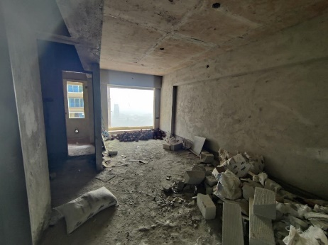
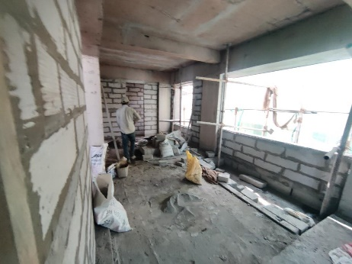
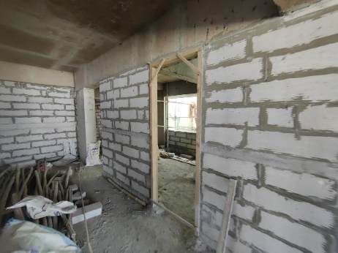
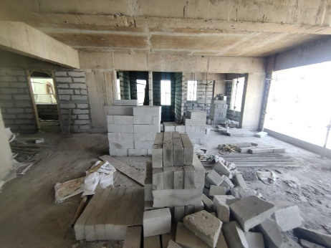
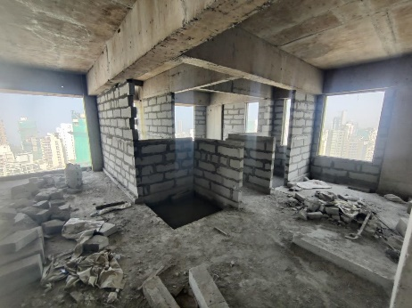
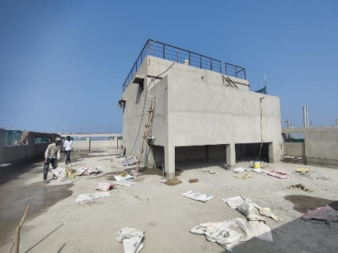
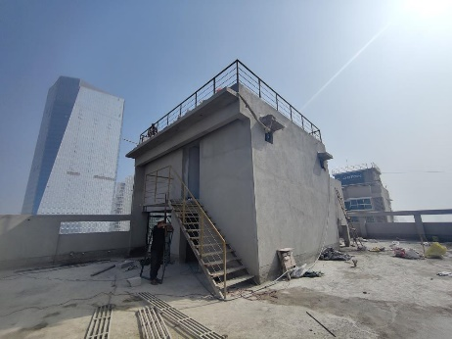
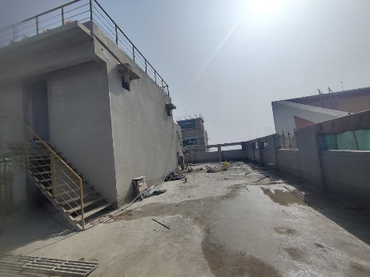
Actual Site Photographs as on 16.10.2024
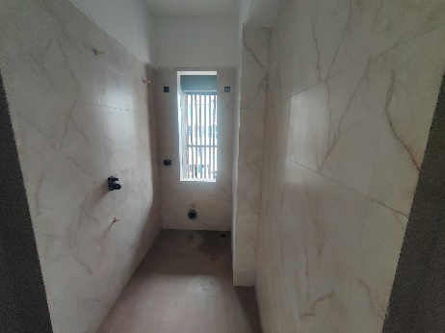
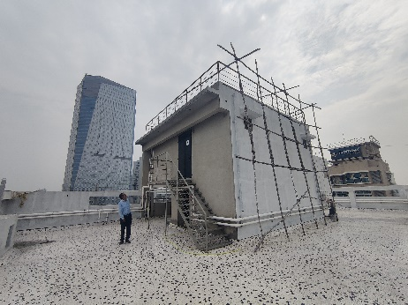
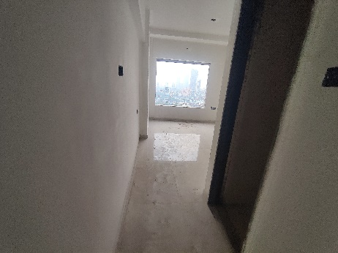
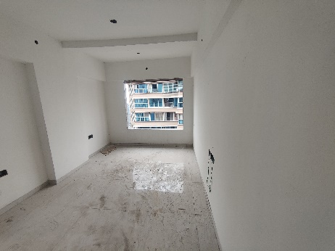
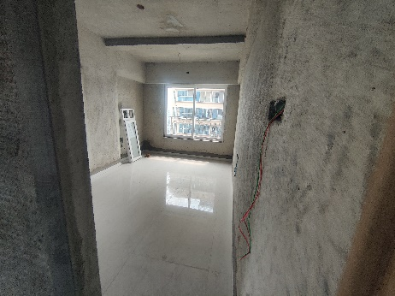
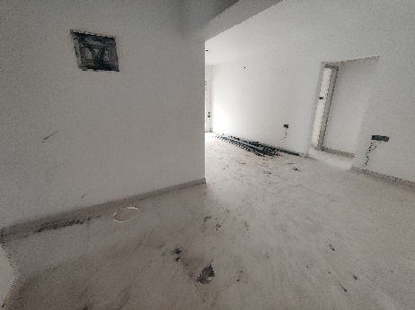
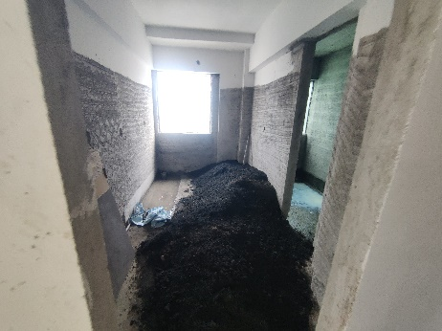
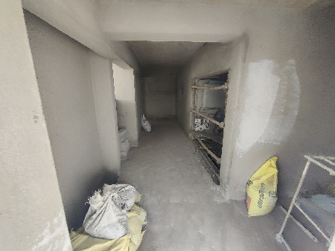
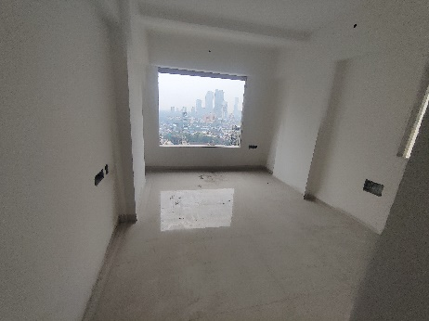
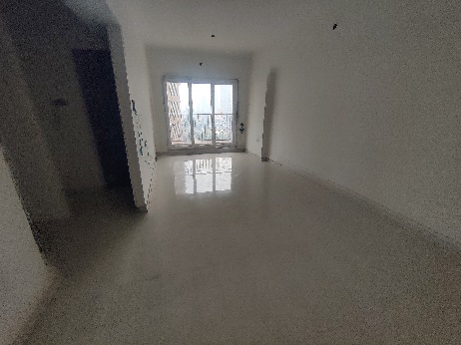
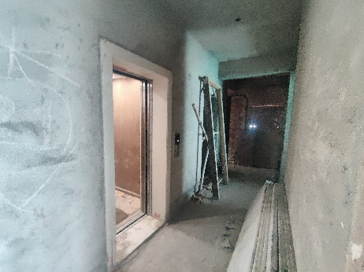
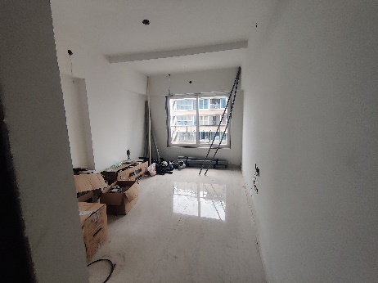
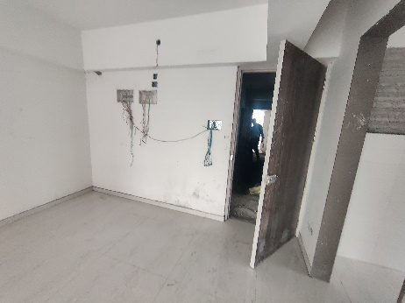
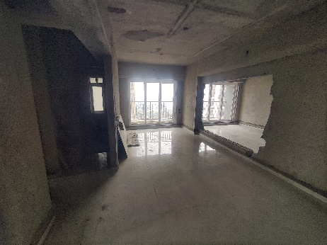
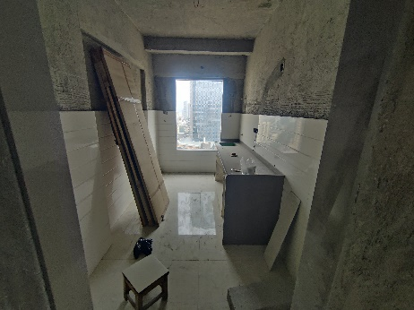
Actual Site Photographs as on 16.10.2024
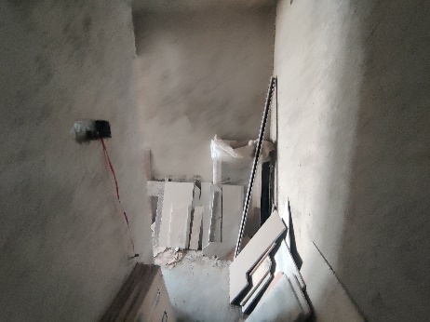
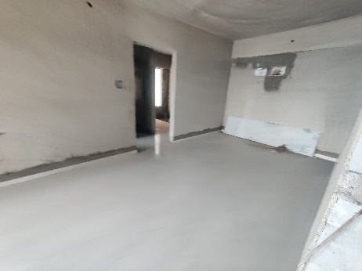
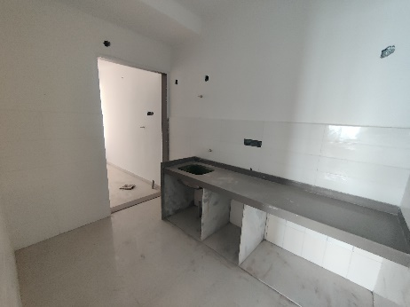
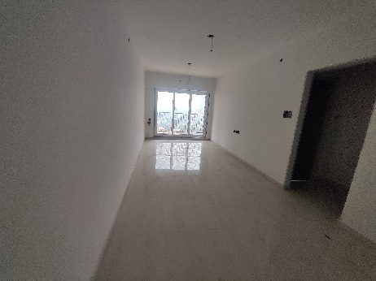
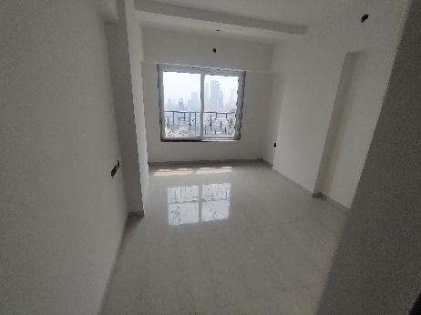
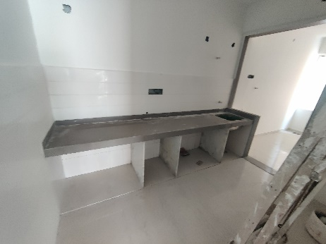
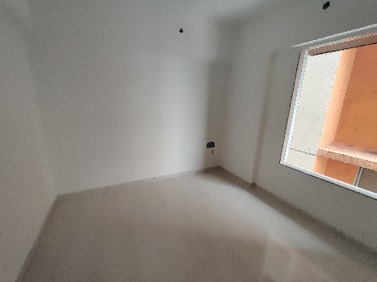
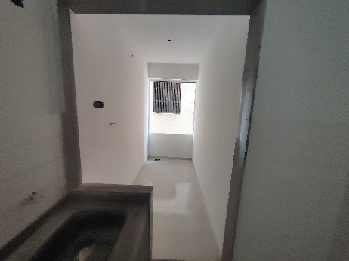
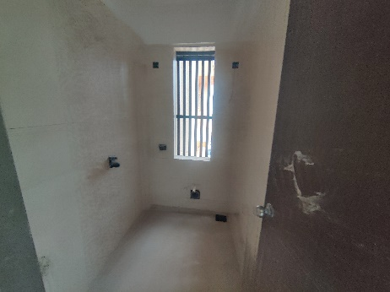
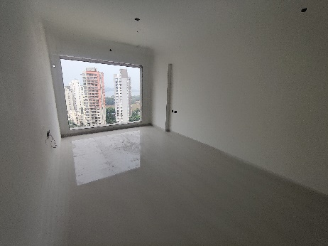
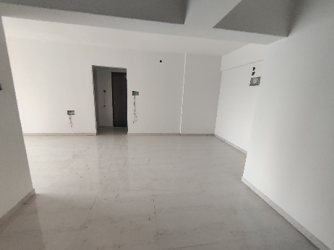
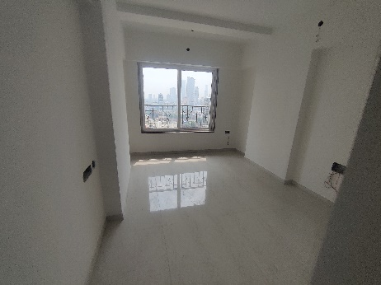
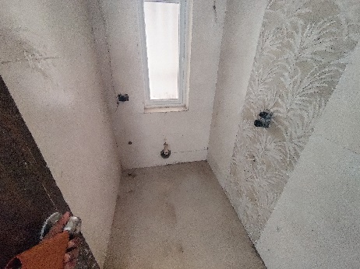
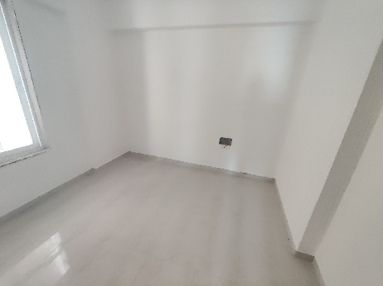
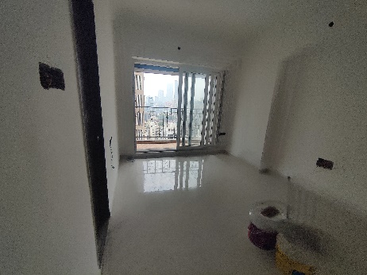
Actual Site Photographs as on 16.10.2024
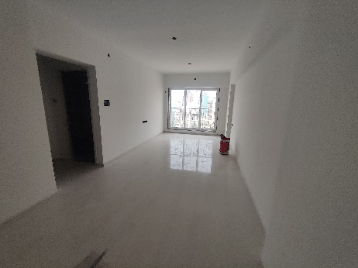
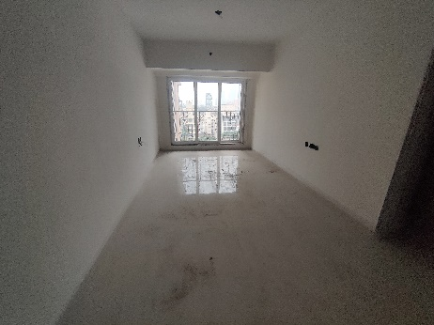
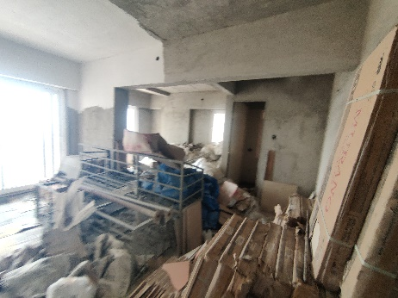
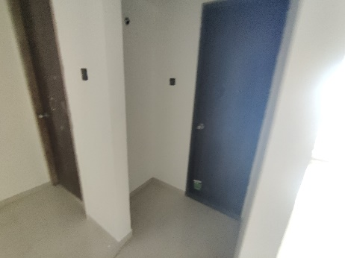
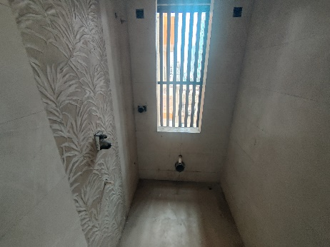
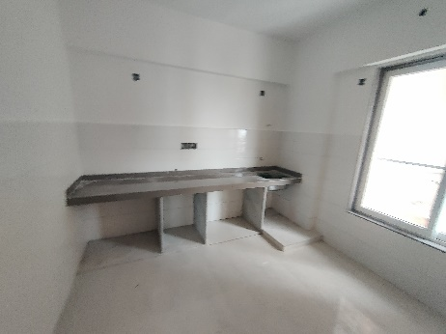
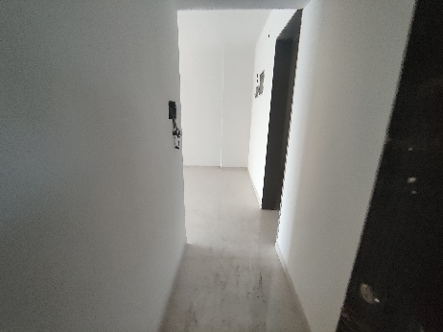
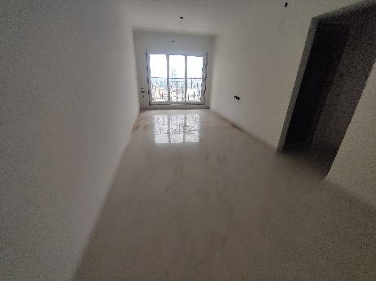
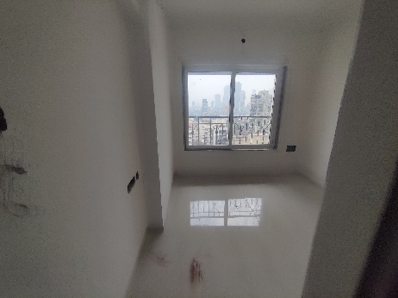
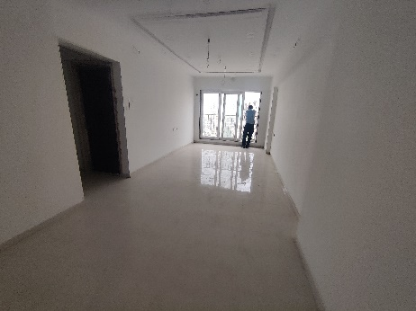
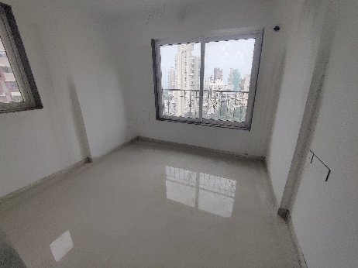
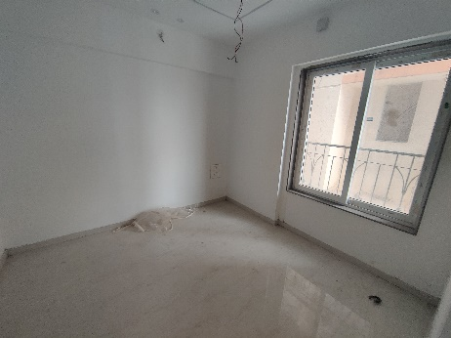
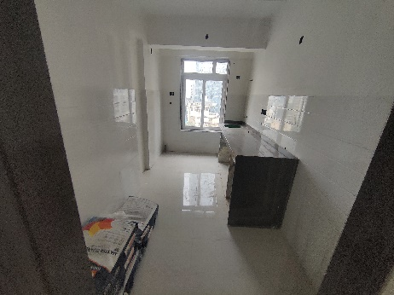
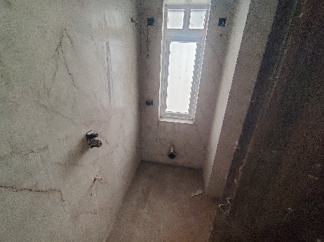
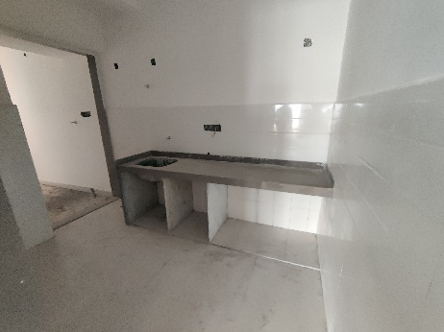
Actual Site Photographs as on 16.10.2024
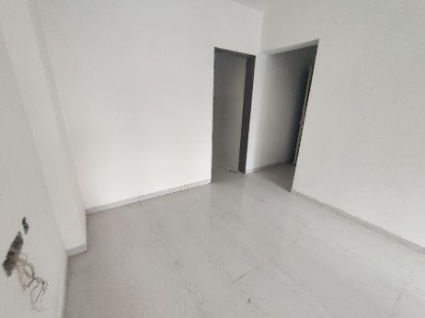
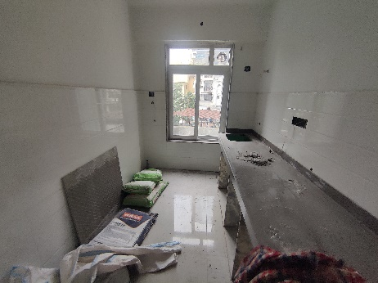
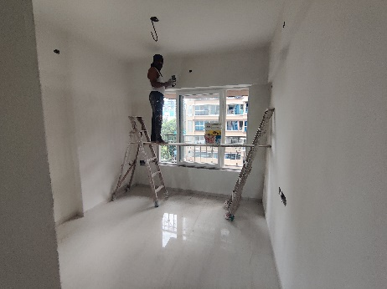
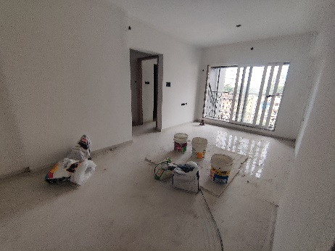
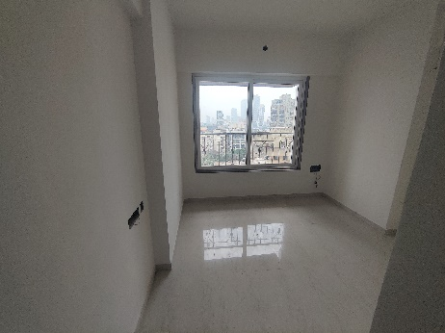
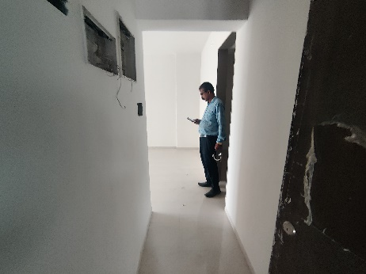
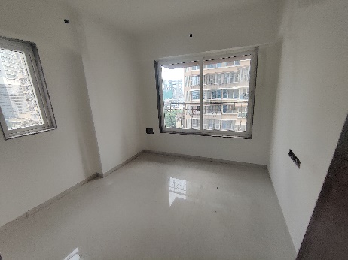
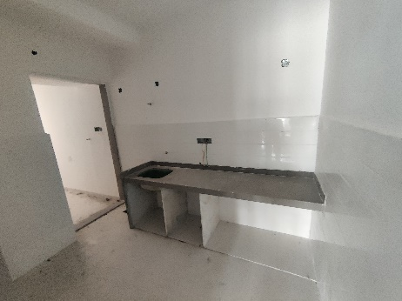
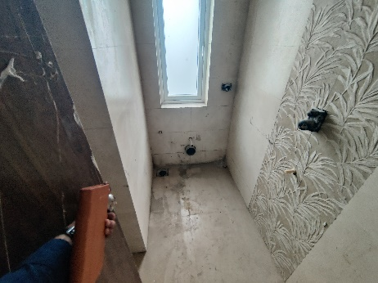
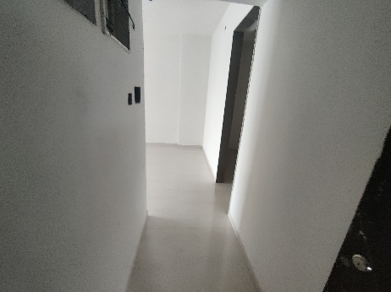
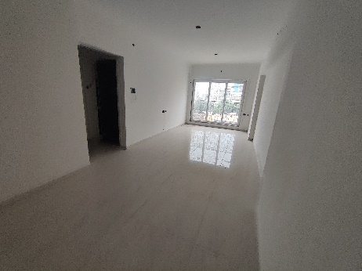
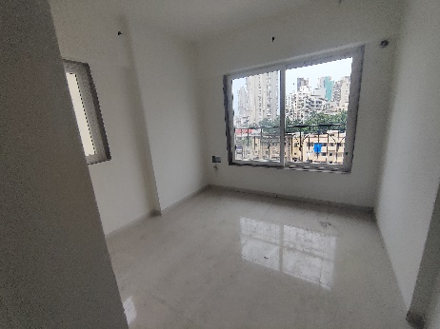
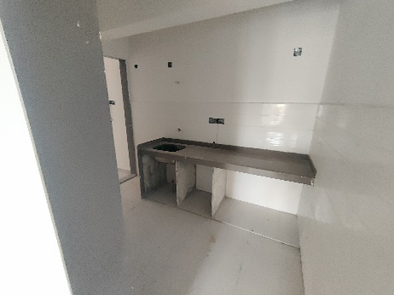
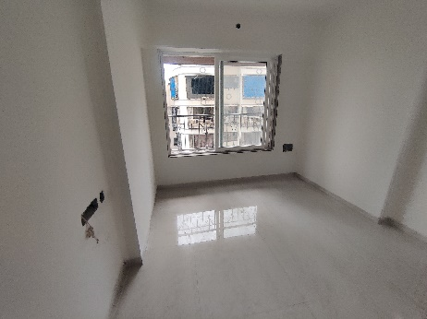
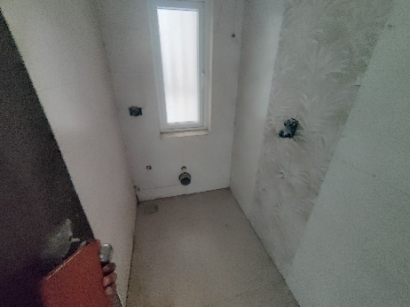
Actual Site Photographs as on 16.10.2024
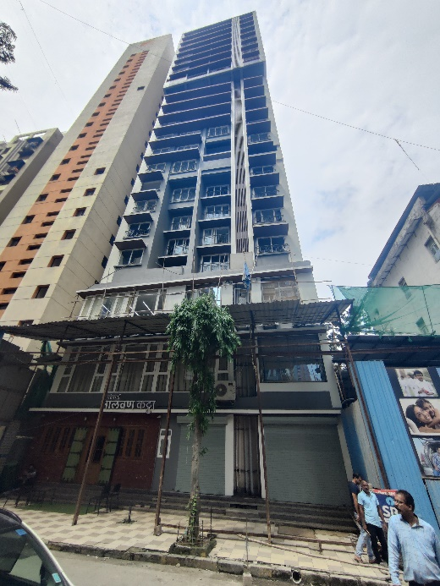
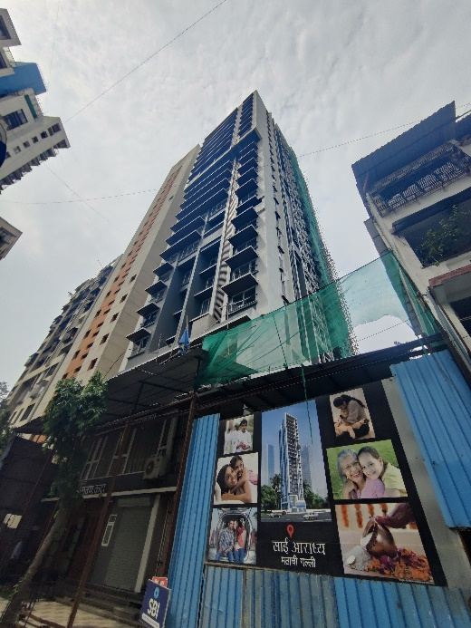
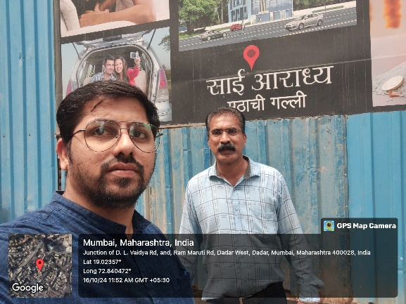
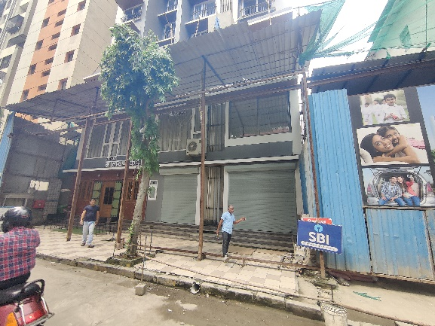
Route Map of the property
Site u/r
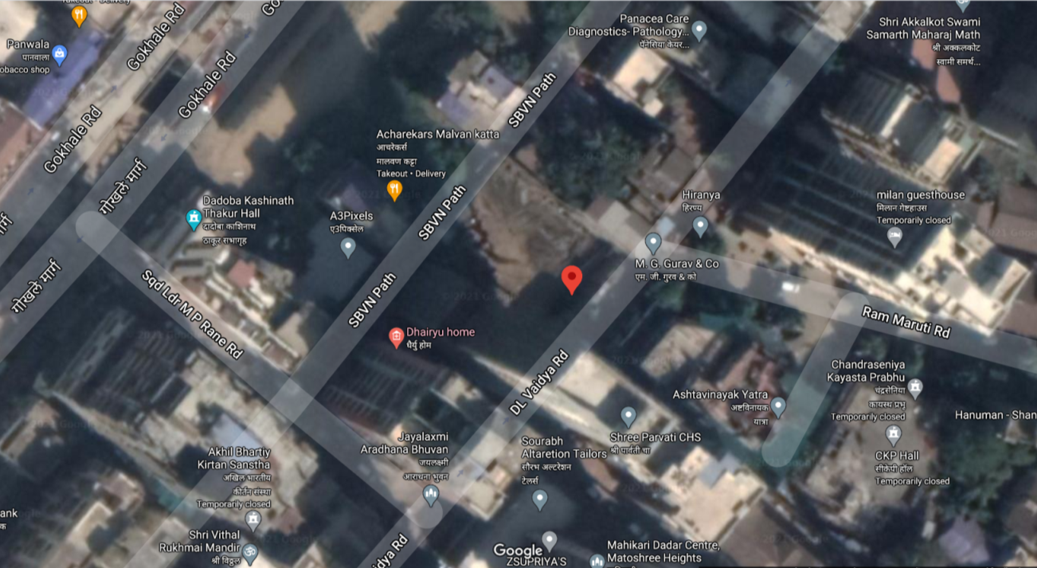

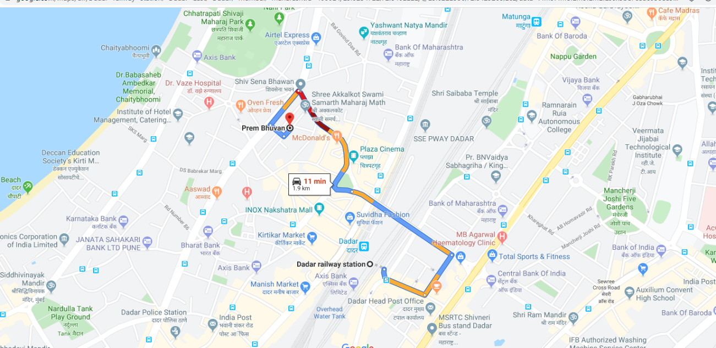

Latitude Longitude: 19°01'24.5"N 72°50'24.4"E

Note: The Blue line shows the route to site from nearest railway station (Dadar Station –1.90 Km.)
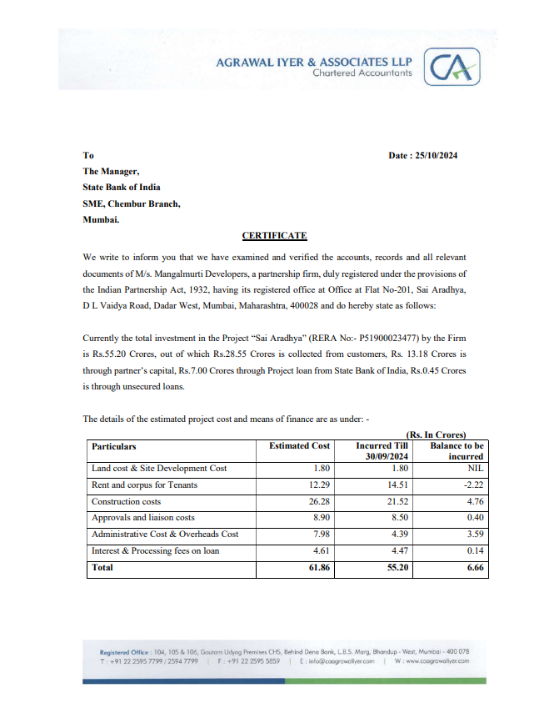
CA Certificate Dated 25.10.2024 till 30.09.2024

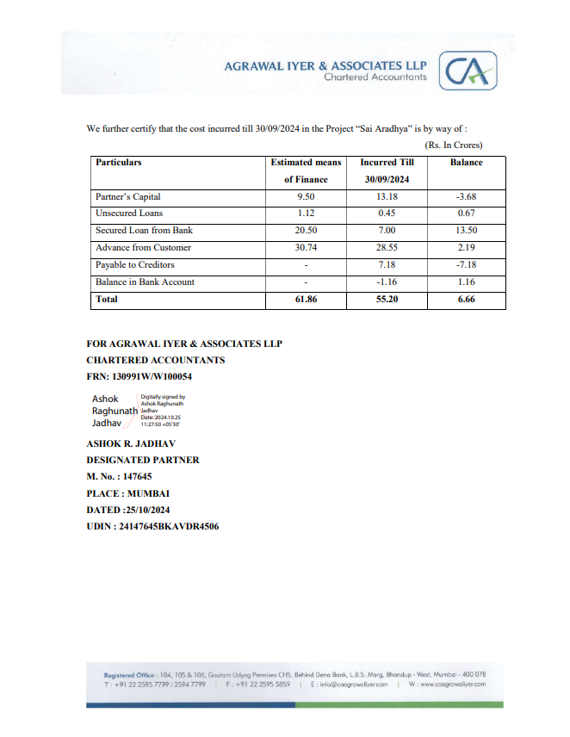
CA Certificate Dated 25.10.2024 till 30.09.2024

