Valuation Report of the Immovable Property

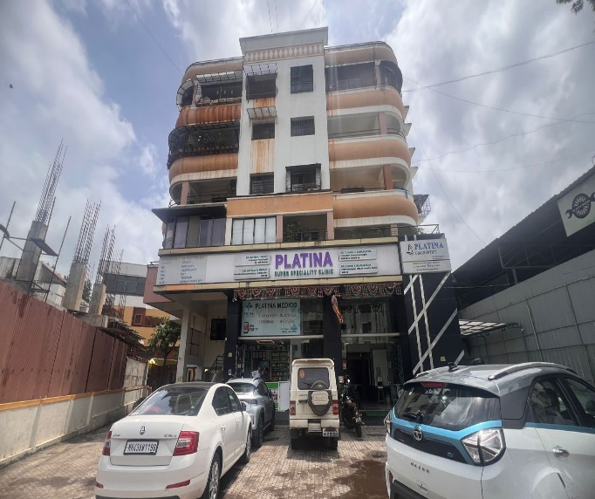

**Details of the property under consideration:**

Name of Owner: **Mr.Kapil Ashok Narang.**

Commercial Shop ( Showroom & Godown with Loft ) ,Ground Floor, " **Aditya Heights Apartment**",

Survey No.601/1/2 to 7/601/1/9 to 15/2 , C.T S No. 7296, Final Plot No.121,Plot No.2, Near

Vaishnavi Electrical, Ahilyadevi Holkar Marg , Chandak Circle,Taluka & District - Nashik,

PIN Code - 422 002, State - Maharashtra, Country - India

# **Longitude Latitude: 19°59'21.3"N 73°46'36.3"E**

**Valuation Done for:**

**Bank of India**

**Indira Nagar Branch**

Bungalow No 23, Shree Samartha Kripa, Gurukrinear Rathachakara Chowk,

Indira Nagar, Nashik-422 009, State - Maharashtra,Country - India

Vastu/Mumbai/01/2020/16759/32210

20/06-210-NIA

Date:12.11.2024

# **VALUATION OPINION REPORT**

This is to certify that the property bearing Commercial Shop ( Showroom & Godown with Loft ) ,Ground Floor, " **Aditya Heights Apartment**",Survey No.601/1/2 to 7/601/1/9 to 15/2 , C.T S No. 7296, Final Plot No.121,Plot No.2, Near Vaishnavi Electrical, Ahilyadevi Holkar Marg , Chandak Circle,Taluka & District - Nashik, PIN Code - 422 002, State - Maharashtra, Country - India. belongs to **Mr.Kapil Ashok Narang**

|  |  |  |
| --- | --- | --- |
| Boundaries of the property. | | |
| North | : | Road | |
| South | : | Building | |
| East | : | Building | |
| West | : | Building | |
|  |  |  | |

Considering various parameters recorded, existing economic scenario, and the information that is available with reference to the development of neighborhood and method selected for valuation, we are of the opinion that, the property premises can be assessed and valued for this particular purpose at **` 5,73,78,240.00 (Rupees Five Crore Seventy Three Lakh Seventy Eight Thousand Two Hundred Forty Only)**

The valuation of the property is based on the documents produced by the concern. Legal aspects have not been taken into considerations while preparing this valuation report.

Hence certified

## Sharadkumar B. Chalikwar

Govt. Reg. Valuer

Chartered Engineer (India)

Reg. No. (N) CCIT/1-14/52/2008-09

Encl: Valuation report.

|  |  |  |  |
| --- | --- | --- | --- |
|  |  |  |  |

|  |  |  |  |  |  |  |  |  |  |  |  |  |  |  |  |  |  |  |  |  |  |  |  |  |  |  |  |  |  |  |  |  |  |  |  |  |  |  |  |  |  |  |  |  |  |  |  |  |  |  |  |  |  |  |  |  |  |  |  |  |  |  |  |  |  |  |  |  |  |  |  |  |  |  |  |  |  |  |  |  |  |  |  |  |  |  |  |  |  |  |  |  |  |  |  |  |  |  |  |  |  |  |  |  |  |  |  |  |  |  |  |  |  |  |  |  |  |  |  |  |  |  |  |  |  |  |  |  |  |  |  |  |  |  |  |  |  |  |  |  |  |  |  |  |  |  |  |  |  |  |  |  |  |  |  |  |  |  |  |  |  |  |  |  |  |  |  |  |  |  |  |  |  |  |  |  |  |  |  |  |  |  |  |  |  |  |  |  |  |  |  |  |  |  |  |  |  |  |  |  |  |  |  |  |  |  |  |  |  |  |  |  |  |  |  |  |  |  |  |  |  |  |  |  |  |  |  |  |  |  |  |  |  |  |  |  |  |  |  |  |  |  |  |  |  |  |  |  |  |  |  |  |  |  |  |  |  |  |  |  |  |  |  |  |  |  |  |  |  |  |  |  |  |  |  |  |  |  |  |  |  |  |  |  |  |  |  |  |  |  |  |  |  |  |  |  |  |  |  |  |  |  |  |  |  |  |  |  |  |  |  |  |  |  |  |  |  |  |  |  |  |  |  |  |  |  |  |  |  |  |  |  |  |  |  |  |  |  |  |  |  |  |  |  |  |  |  |  |  |  |  |  |  |  |  |  |  |  |  |  |  |  |  |  |  |  |  |  |  |  |  |  |  |  |  |  |  |  |  |  |  |  |  |  |  |  |  |  |  |  |  |  |  |  |  |  |  |  |  |  |  |  |  |  |  |  |  |  |  |  |  |  |  |  |  |  |  |  |  |  |  |  |  |  |  |  |  |  |  |  |  |  |  |  |  |  |  |  |  |  |  |  |  |  |  |  |  |  |  |  |  |  |  |  |  |  |  |  |  |  |  |  |  |  |  |  |  |  |  |  |  |  |  |  |  |  |  |  |  |  |  |  |  |  |  |  |  |  |  |  |  |  |  |  |  |  |  |  |  |  |  |  |  |  |  |  |  |  |  |  |  |  |  |  |  |  |  |  |  |  |  |  |  |  |  |  |  |  |  |  |  |  |  |  |  |  |  |  |  |  |  |  |  |  |  |  |  |  |  |  |  |  |  |  |  |  |  |  |  |  |  |  |  |  |  |  |  |  |  |  |  |  |  |  |  |  |  |  |  |  |  |  |  |  |  |  |  |  |  |  |  |  |  |  |  |  |  |  |  |  |  |  |  |  |  |  |  |  |  |  |  |  |  |  |  |  |  |  |  |  |  |  |  |  |  |  |  |  |  |  |  |  |  |  |  |  |  |  |  |  |  |  |  |  |  |  |  |  |  |  |  |  |  |  |  |  |  |  |  |  |  |  |  |  |  |  |  |  |  |  |  |  |  |  |  |  |  |  |  |  |  |  |  |  |  |  |  |  |  |  |  |  |  |  |  |  |  |  |  |  |  |  |  |  |  |  |  |  |  |  |  |  |  |  |  |  |  |  |  |  |  |  |  |  |  |  |  |  |  |  |  |  |  |  |  |  |  |  |  |  |  |  |  |
| --- | --- | --- | --- | --- | --- | --- | --- | --- | --- | --- | --- | --- | --- | --- | --- | --- | --- | --- | --- | --- | --- | --- | --- | --- | --- | --- | --- | --- | --- | --- | --- | --- | --- | --- | --- | --- | --- | --- | --- | --- | --- | --- | --- | --- | --- | --- | --- | --- | --- | --- | --- | --- | --- | --- | --- | --- | --- | --- | --- | --- | --- | --- | --- | --- | --- | --- | --- | --- | --- | --- | --- | --- | --- | --- | --- | --- | --- | --- | --- | --- | --- | --- | --- | --- | --- | --- | --- | --- | --- | --- | --- | --- | --- | --- | --- | --- | --- | --- | --- | --- | --- | --- | --- | --- | --- | --- | --- | --- | --- | --- | --- | --- | --- | --- | --- | --- | --- | --- | --- | --- | --- | --- | --- | --- | --- | --- | --- | --- | --- | --- | --- | --- | --- | --- | --- | --- | --- | --- | --- | --- | --- | --- | --- | --- | --- | --- | --- | --- | --- | --- | --- | --- | --- | --- | --- | --- | --- | --- | --- | --- | --- | --- | --- | --- | --- | --- | --- | --- | --- | --- | --- | --- | --- | --- | --- | --- | --- | --- | --- | --- | --- | --- | --- | --- | --- | --- | --- | --- | --- | --- | --- | --- | --- | --- | --- | --- | --- | --- | --- | --- | --- | --- | --- | --- | --- | --- | --- | --- | --- | --- | --- | --- | --- | --- | --- | --- | --- | --- | --- | --- | --- | --- | --- | --- | --- | --- | --- | --- | --- | --- | --- | --- | --- | --- | --- | --- | --- | --- | --- | --- | --- | --- | --- | --- | --- | --- | --- | --- | --- | --- | --- | --- | --- | --- | --- | --- | --- | --- | --- | --- | --- | --- | --- | --- | --- | --- | --- | --- | --- | --- | --- | --- | --- | --- | --- | --- | --- | --- | --- | --- | --- | --- | --- | --- | --- | --- | --- | --- | --- | --- | --- | --- | --- | --- | --- | --- | --- | --- | --- | --- | --- | --- | --- | --- | --- | --- | --- | --- | --- | --- | --- | --- | --- | --- | --- | --- | --- | --- | --- | --- | --- | --- | --- | --- | --- | --- | --- | --- | --- | --- | --- | --- | --- | --- | --- | --- | --- | --- | --- | --- | --- | --- | --- | --- | --- | --- | --- | --- | --- | --- | --- | --- | --- | --- | --- | --- | --- | --- | --- | --- | --- | --- | --- | --- | --- | --- | --- | --- | --- | --- | --- | --- | --- | --- | --- | --- | --- | --- | --- | --- | --- | --- | --- | --- | --- | --- | --- | --- | --- | --- | --- | --- | --- | --- | --- | --- | --- | --- | --- | --- | --- | --- | --- | --- | --- | --- | --- | --- | --- | --- | --- | --- | --- | --- | --- | --- | --- | --- | --- | --- | --- | --- | --- | --- | --- | --- | --- | --- | --- | --- | --- | --- | --- | --- | --- | --- | --- | --- | --- | --- | --- | --- | --- | --- | --- | --- | --- | --- | --- | --- | --- | --- | --- | --- | --- | --- | --- | --- | --- | --- | --- | --- | --- | --- | --- | --- | --- | --- | --- | --- | --- | --- | --- | --- | --- | --- | --- | --- | --- | --- | --- | --- | --- | --- | --- | --- | --- | --- | --- | --- | --- | --- | --- | --- | --- | --- | --- | --- | --- | --- | --- | --- | --- | --- | --- | --- | --- | --- | --- | --- | --- | --- | --- | --- | --- | --- | --- | --- | --- | --- | --- | --- | --- | --- | --- | --- | --- | --- | --- | --- | --- | --- | --- | --- | --- | --- | --- | --- | --- | --- | --- | --- | --- | --- | --- | --- | --- | --- | --- | --- | --- | --- | --- | --- | --- | --- | --- | --- | --- | --- | --- | --- | --- | --- | --- | --- | --- | --- | --- | --- | --- | --- | --- | --- | --- | --- | --- | --- | --- | --- | --- | --- | --- | --- | --- | --- | --- | --- | --- | --- | --- | --- | --- | --- | --- | --- | --- | --- | --- | --- | --- | --- | --- | --- | --- | --- | --- | --- | --- | --- | --- | --- | --- | --- | --- | --- | --- | --- | --- | --- | --- | --- | --- | --- | --- | --- | --- | --- | --- | --- | --- | --- | --- | --- | --- | --- | --- | --- | --- | --- | --- | --- | --- | --- | --- | --- | --- | --- | --- | --- | --- | --- | --- | --- | --- | --- | --- | --- | --- | --- | --- | --- | --- | --- | --- | --- | --- | --- | --- | --- | --- | --- | --- | --- | --- | --- | --- | --- | --- | --- | --- | --- | --- | --- | --- | --- | --- | --- | --- | --- | --- | --- | --- | --- | --- | --- | --- | --- | --- | --- | --- | --- | --- | --- | --- | --- | --- | --- | --- | --- | --- | --- | --- | --- | --- | --- | --- | --- | --- | --- | --- | --- | --- | --- | --- | --- | --- | --- | --- | --- | --- | --- | --- | --- | --- | --- | --- | --- | --- | --- | --- | --- | --- |
| **Vastukala Consultants (I) Pvt. Ltd.**  4, 1st Floor, Madhusha Elite, Vrundavan Nagar, Jatra - Nandur Naka Link Road, Adgaon, Nashik - 422003  To,  **The Branch Manager,**  **Bank of India**  **Indira Nagar Branch**  Bungalow No 23, Shree Samartha Kripa, Gurukrinear  Rathachakara Chowk, Indira Nagar, Nashik-422 009,  State - Maharashtra,Country - India  **VALUATION REPORT (IN RESPECT OF SHOP)**   |  |  |  |  |  |  |  | | --- | --- | --- | --- | --- | --- | --- | | I | **General** | | | | | | | 1. | Purpose for which the valuation is made | | | : | To assess fair market value of the property for Housing Loan Purpose. | | | 2. | a) | | Date of inspection | : | 11.11.2024 | | |  | b) | | Date on which the valuation is  Made |  | 12.11.2024 | | |  | List of documents produced for perusal | | | : | 1. Copy of Saledeed Vide No.1480/2012 Dated.08.02.2012 2. Copy of Commencement Certificate No. LND / BP / NSK /A1/139/3729 dated 25.10.2011 issued by Nashik Municipal Corporation. 3. Copy of Occupancy Certificate No. Javak Number / NRV/ 10521/4440 dated 13.12.2011 issued by Nashik Municipal Corporation 4. Copy of Approved Building Plan Accompaining Occupancy Certificate No.Nashik/NSK/A1/10521/4440 dated 13.12.2011, issued by Executive Engineer Town Planning Nashik Municipal Corporation, Nashik. | | | 4. | Name of the owner(s) and his / their address (es) with Phone no. (details of share of each owner in case of joint ownership) | | | : | **Mr.Kapil Ashok Narang**  Address - Commercial Shop ( Showroom & Godown with Loft ) ,Ground Floor, " **Aditya Heights Apartment**",Survey No.601/1/2 to 7/601/1/9 to 15/2 , C.T S No. 7296, Final Plot No.121,Plot No.2, Near Vaishnavi Electrical, Ahilyadevi Holkar Marg , Chandak Circle,Taluka & District - Nashik, PIN Code - 422 002,  State - Maharashtra, Country - India  **Contact Person :**  Mr.Shivam (Mob No. +91 9850895453)  Sole Ownership | | | 5. | Brief description of the property (Including Leasehold / freehold etc.) | | | : | The property is a Commercial Shop ( Showroom & Godown with Loft ) located on Ground Floor.  The property is at 9.2 Mtr. distances from nearest railway station Nashik. | | | 6. | Location of property | | | : |  | | |  | a) | Plot No. / Survey No. | | : | Survey No.601/1/2 to 7/601/1/9 to 15/2 , C.T S No. 7296, Final Plot No.121,Plot No.2 | | |  | b) | Door No. | | : | Commercial Shop ( Showroom & Godown with Loft ) ,Ground Floor | | |  | c) | T.S. No. / Village | | : | Village – Nashik | | |  | d) | Ward / Taluka | | : | Taluka – Nashik | | |  | e) | Mandal / District | | : | District - Nashik | | |  | f) | Date of issue and validity of layout of approved map / plan | | : | Copy of Approved Building Plan Accompaining Occupancy Certificate No.Nashik/NSK/A1/10521/4440 dated 13.12.2011, issued by Executive Engineer Town Planning Nashik Municipal Corporation, Nashik | | |  | g) | Approved map / plan issuing authority | |  | Nashik Municipal Corporation, Nashik | | |  | h) | Whether genuineness or authenticity of approved map/ plan is verified | | : | Yes | | |  | i) | Any other comments by our empanelled valuers on authentic of approved plan | | : | No | | | 7. | Postal address of the property | | | : | Commercial Shop ( Showroom & Godown with Loft ) ,Ground Floor, " **Aditya Heights Apartment**",Survey No.601/1/2 to 7/601/1/9 to 15/2 , C.T S No. 7296, Final Plot No.121,Plot No.2, Near Vaishnavi Electrical, Ahilyadevi Holkar Marg , Chandak Circle,Taluka & District - Nashik, PIN Code - 422 002, State - Maharashtra, Country - India | | | 8. | City / Town | | | : | Nashik | | |  | Residential area | | | : | No | | |  | Commercial area | | | : | Yes | | |  | Industrial area | | | : | No | | | 9. | Classification of the area | | | : |  | | |  | i) High / Middle / Poor | | | : | Middle Class | | |  | ii) Urban / Semi Urban / Rural | | | : | Urban | | | 10. | Coming under Corporation limit / Village Panchayat / Municipality | | | : | Village- Nashik  Nashik Municipal Corporation, Nashik | | | 11. | Whether covered under any State / Central Govt. enactments (e.g., Urban Land Ceiling Act) or notified under agency area/ scheduled area / cantonment area | | | : | No | | | 12. | Boundaries of the property ( Building ) | | |  | As per Site | As per Deed | |  | North | | | : | Road | 24 Mtrs.Wide Road | |  | South | | | : | Building | Plot No.15,16 & 17 | |  | East | | | : | Building | Plot No.3 | |  | West | | | : | Building | Plot No.1 | | 13 | Boundaries of the property ( Shop ) | | |  |  |  | |  |  | | |  | As per Site | As per Deed | |  | North | | | : | Road | Road | |  | South | | | : | Part of Building | Part of Building | |  | East | | | : | Marginal Space | Marginal Space | |  | West | | | : | Marginal Space | Marginal Space | | 14. | Extent of the site | | | : | Carpet Area in Sq. Ft. = 2227.00  (Area as per actual site measurement)  **Built Up Area in Sq. Ft. = 2784.00**  **(As per Saledeed )** | | | 14.1 | Latitude, Longitude & Co-ordinates of Shop | | | : | 19°59'21.3"N 73°46'36.3"E | | | 15. | Extent of the site considered for Valuation (least of 13A& 13B) | | | : | **Built Up Area in Sq. Ft. = 2784.00**  **(As per Saledeed )** | | | 16 | Whether occupied by the owner / tenant? If occupied by tenant since how long? Rent received per month. | | | : | Owner Occupied | | | **II** | **APARTMENT BUILDING** | | |  |  | | |  | Nature of the Apartment | | | : | Commercial | | |  | Location | | | : |  | | |  | C.T.S. No. | | | : | Survey No.601/1/2 to 7/601/1/9 to 15/2 , C.T S No. 7296, Final Plot No.121,Plot No.2 | | |  | Block No. | | | : | - | | |  | Ward No. | | | : | - | | |  | Village / Municipality / Corporation | | | : | Village- Nashik  Nashik Municipal Corporation, Nashik | | |  | Door No., Street or Road (Pin Code) | | | : | Commercial Shop ( Showroom & Godown with Loft ) ,Ground Floor, " **Aditya Heights Apartment**",Survey No.601/1/2 to 7/601/1/9 to 15/2 , C.T S No. 7296, Final Plot No.121,Plot No.2, Near Vaishnavi Electrical, Ahilyadevi Holkar Marg , Chandak Circle,Taluka & District - Nashik, PIN Code - 422 002, State - Maharashtra, Country - India | | |  | Description of the locality Commercial / Commercial / Mixed | | | : | Commercial | | |  | Year of Construction | | | : | 2011 (As per Occupancy Certificate ) | | |  | Number of Floors | | | : | Ground Floor | | |  | Type of Structure | | | : | R.C.C. Framed Structure | | |  | Number of Dwelling units in the building | | | : | 2 Shops on Ground Floor | | |  | Quality of Construction | | | : | Excellent | | |  | Appearance of the Building | | | : | Excellent | | |  | Maintenance of the Building | | | : | Excellent | | |  | Facilities Available | | | : |  | | |  | Lift | | | : | 1 Lift | | |  | Protected Water Supply | | | : | Municipal Water supply | | |  | Underground Sewerage | | | : | Connected to Municipal sewer | | |  | Car parking - Open / Covered | | | : | Open Parking | | |  | Is Compound wall existing? | | | : | Yes | | |  | Is pavement laid around the Building | | | : | Yes | |  |  |  |  |  | | --- | --- | --- | --- | | **III** | **SHOP** |  |  | | 1 | The floor in which the Shop is situated | : | Ground Floor | | 2 | Door No. of the Shop | : | Commercial Shop ( Showroom & Godown with Loft ) | | 3 | Specifications of the Shop | : | Commercial Shop ( Showroom & Godown with Loft ) | |  | Roof | : | R.C.C. Slab | |  | Flooring | : | Vitrified tiles flooring | |  | Doors | : | Rolling Shutter | |  | Windows | : | Not Applicable | |  | Fittings | : | Electrical wiring with Concealed | |  | Finishing | : | Good | | 4 | House Tax | : |  | |  | Assessment No. | : | Details Not Available | |  | Tax paid in the name of : | : | Details Not Available | |  | Tax amount : | : | Details Not Available | | 5 | Electricity Service connection No. : | : | Details Not Available | |  | Meter Card is in the name of : | : | Details Not Available | | 6 | How is the maintenance of the Shop? | : | Good | | 7 | Sale Deed executed in the name of | : | **Mr.Kapil Ashok Narang** | | 8 | What is the undivided area of land as per Sale Deed? | : | Details not available | | 9 | What is the plinth area of the Shop? | : | **Built Up Area in Sq. Ft. = 2784.00**  **(As per Saledeed )** | | 10 | What is the floor space index (app.) | : | As per NMC norms | | 11 | What is the Carpet Area of the Shop? | : | Carpet Area in Sq. Ft. = 2227.00  (Area as per actual site measurement) | | 12 | Is it Posh / I Class / Medium / Ordinary? | : | Medium | | 13 | Is it being used for Commercial or Commercial purpose? | : | Commercial purpose | | 14 | Is it Owner-occupied or let out? | : | Owner Occupied | | 15 | If rented, what is the monthly rent? | : | ` 1,90,000.00 expected rent per month | | **IV** | **MARKETABILITY** | : |  | | 1 | How is the marketability? | : | Good | | 2 | What are the factors favoring for an extra Potential Value? | : | Located in developed area | | 3 | Any negative factors are observed which affect the market value in general? | : | No | | **V** | **Rate** | : |  | | 1 | After analyzing the comparable sale instances, what is the composite rate for a similar Shop with same specifications in the adjoining locality? - (Along with details / reference of at - least two latest deals / transactions with respect to adjacent properties in the areas) | : | ` 15,000.00 to ` 25,000.00 per Sq. Ft. on Built Up area | | 2 | Assuming it is a new construction, what is the adopted basic composite rate of the Shop under valuation after comparing with the specifications and other factors with the Shop under comparison (give details). | : | ` 21,000.00 per Sq. Ft. on Built Up area | | 3 | Break – up for the rate | : |  | |  | I. Building + Services | : | ` 2,000.00 per Sq. Ft. | |  | II. Land + others | : | ` 19,000.00 per Sq. Ft. | | 4 | Guideline rate obtained from the Registrar's office(an evidence thereof to be enclosed) | : | ` 62,870.00 per Sq. M. i.e.  ` 5,841.00 per Sq. Ft. | |  | Guideline rate obtained from the Registrar’s  office (After Depreciation) |  | ` 59,156.00 per Sq. M. i.e.  ` 5,496.00 per Sq. Ft. | | **VI** | **COMPOSITE RATE ADOPTED AFTER DEPRECIATION** |  |  | | **a** | Depreciated building rate | : | ` 1,610.00 per Sq. Ft. | |  | Replacement cost of Shop with Services (v(3)i) | : | ` 2,000.00 per Sq. Ft. | |  | Age of the building | : | 13 Year | |  | Life of the building estimated | : | 47 years Subject to proper, preventive periodic maintenance & structural repairs. | |  | Depreciation percentage assuming the salvage value as 10% | : | 19.50% | |  | Depreciated Ratio of the building | : | N.A. as the age of the property is below 5 years | | **b** | Total composite rate arrived for Valuation | : |  | |  | Depreciated building rate VI (a) | : | ` 1,610.00 per Sq. Ft. | |  | Rate for Land & other V (3) ii | : | ` 19,000.00 per Sq. Ft. | |  | **Total Composite Rate** | : | **` 20,610.00 per Sq. Ft.** | |  | **Remark :** *It is observed that, As per Reg. Sale Deed it is mentioned as Shop whereas as per approved building it is Showroom & Back side sanctioned as Godown with Loft & actual on site Showroom & Godown with Loft is amalgamated hence we have considered average market rate to entire property.* | | |   **Details of Valuation:**   |  |  |  |  |  | | --- | --- | --- | --- | --- | | **Sr. No.** | **Description** | **Qty.** | **Rate per  unit (`)** | **Estimated**  **Value (`)** | | 1 | Present value of the Shop (incl. car parking, if provided) | 2784.00  Sq. Ft. | 20,610.00 | **5,73,78,240.00** | | 2 | Wardrobes |  |  |  | | 3 | Showcases / |  |  |  | | 4 | Kitchen arrangements |  |  |  | | 5 | Superfine finish |  |  |  | | 6 | Interior Decorations |  |  |  | | 7 | Electricity deposits / electrical fittings, etc. |  |  |  | | 8 | Extra collapsible gates / grill works etc. |  |  |  | | 9 | Potential value, if any |  |  |  | | 10 | Others |  |  |  | |  | **Present Market value of the property** |  |  | **5,73,78,240.00** | |  | **The realizable value of the property** |  |  | **5,45,09,328.00** | |  | **The Distress value of the property** |  |  | **4,59,02,592.00** | |  | **Insurable value of the property (2784.00 Sq. Ft. X** ` **2,000.00)** | | | **55,68,000.00** | |  | **Guideline value of the property (2784.00 Sq. Ft. X** ` **5,496.00)** | | | **1,53,00,864.00** |   The sales comparison approach uses the market data of sale prices to estimate the value of a real estate property. Property valuation in this method is done by comparing a property to other similar properties that have been recently sold. Comparable properties, also known as comparables, or comps, must share certain features with the property in question. Some of these include physical features such as square footage, number of rooms, condition, and age of the building; however, the most important factor is no doubt the location of the property. Adjustments are usually needed to account for differences as no two properties are exactly the same. To make proper adjustments when comparing properties, real estate appraisers must know the differences between the comparable properties and how to value these differences. The sales comparison approach is commonly used for Commercial Shop, where there are typically many comparables available to analyze. As the property is a Commercial Shop, we have adopted Sale Comparison Approach Method for the purpose of valuation .The Price for similar type of property in the nearby vicinity is in the range of ` 15,000.00 to ` 25,000.00 per Sq. Ft. Considering the rate with attached report , current market conditions , demand and supply position, Shop size, location, upswing in real estate prices , sustained demand for Commercial Shop , all round development of commercial and Commercial application in the locality etc. We estimate ` 20,610.00 per Sq. Ft. for valuation.   |  |  | | --- | --- | | Impending threat of acquisition by government for road widening / publics service purposes, sub merging & applicability of CRZ provisions (Distance from sea-cost / tidal level must be incorporated) and their effect on |  | | 1. Saleability | Good | | 1. Likely rental values in future in | ` 1,90,000.00 expected rent per month | | 1. Any likely income it may generate | Rental Income |   **Sharadkumar B. Chalikwar**  Govt. Reg. Valuer  Chartered Engineer (India)  Reg. No. (N) CCIT/1-14/52/2008-09  Place : Nashik  Date : 12.11.2024 |

**Actual Site Photographs**

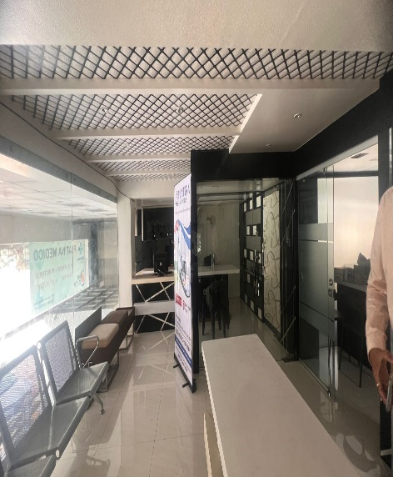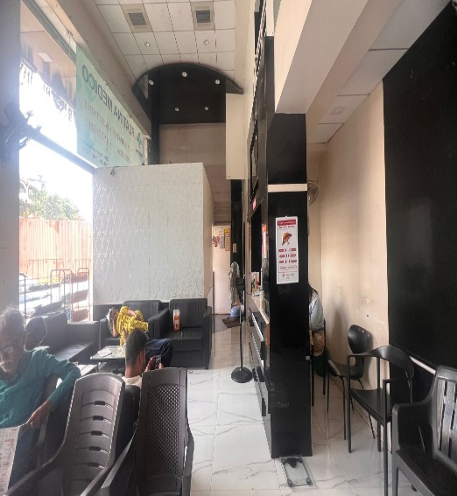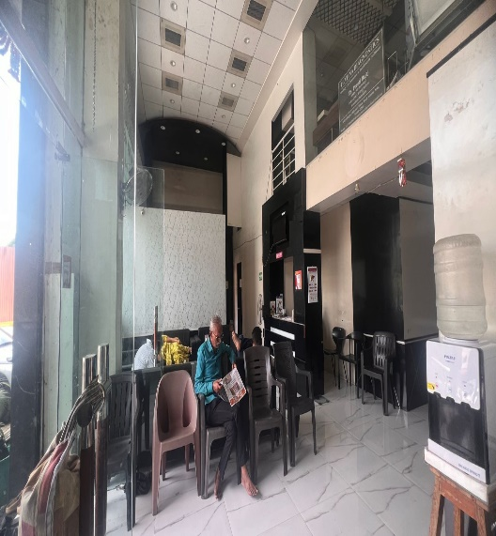

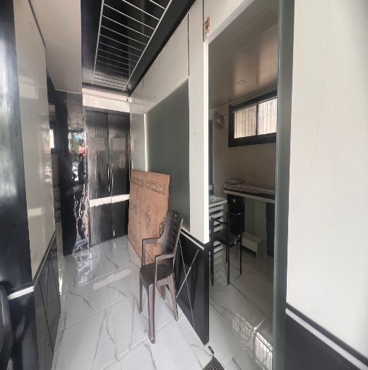

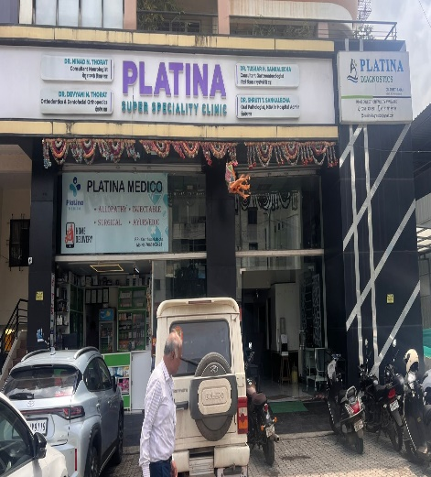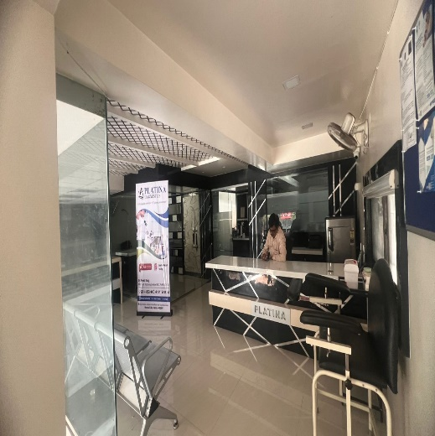

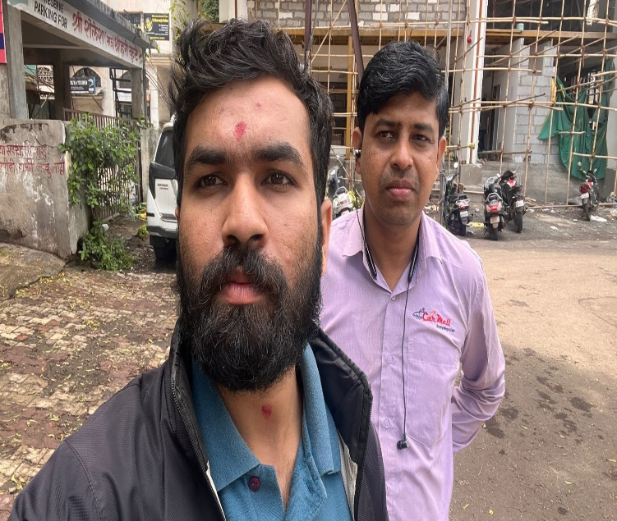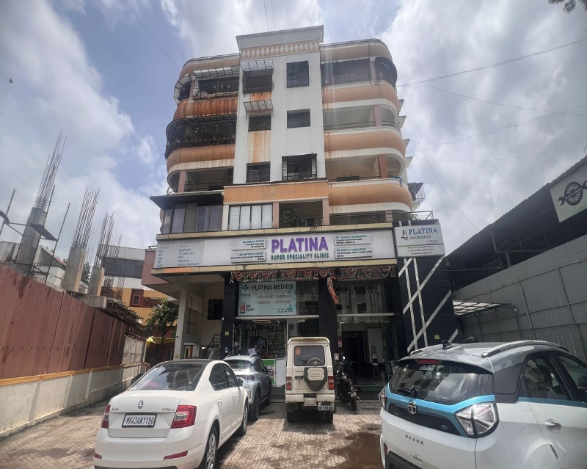

Route Map of the property

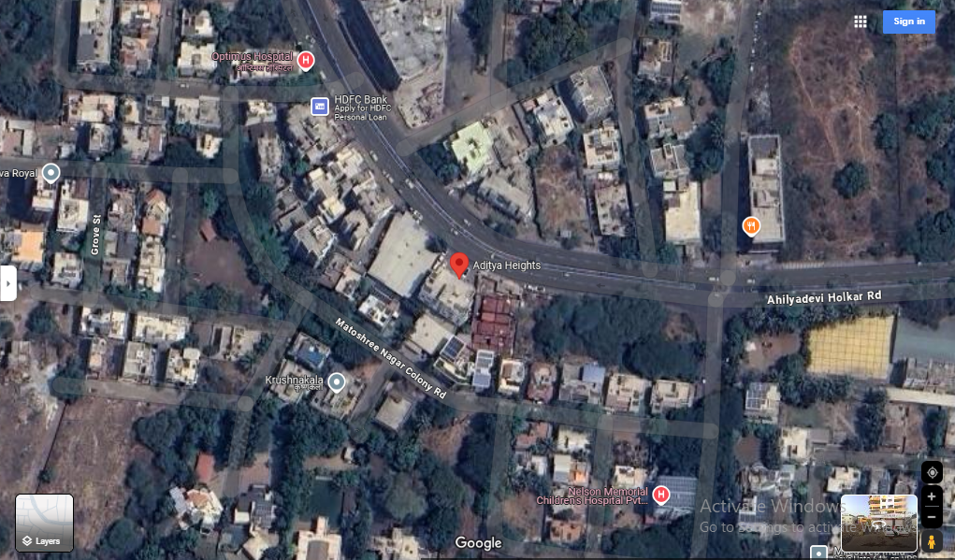

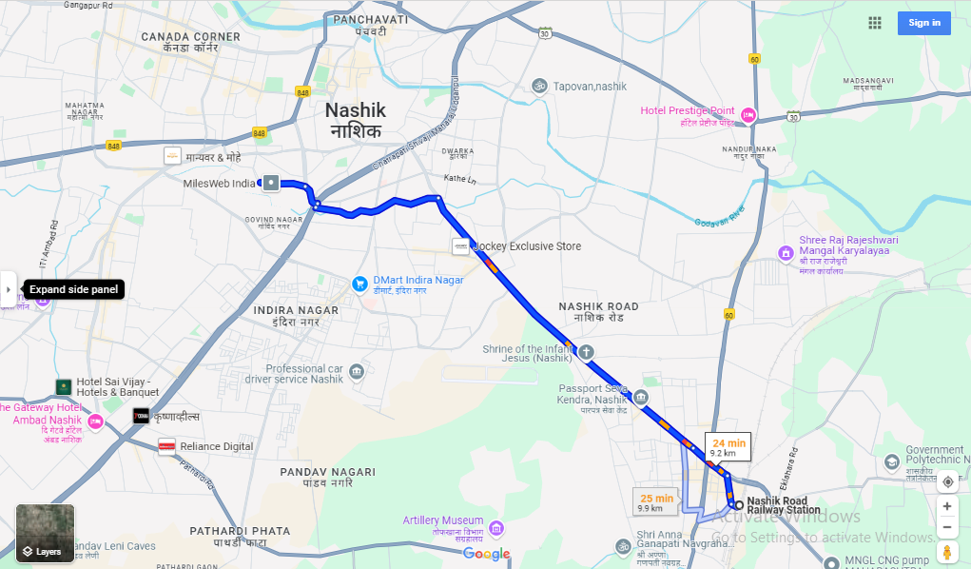

# **Longitude Latitude: 19°59'21.3"N 73°46'36.3"E**

**Note:** The Blue line shows the route to site from nearest railway station (Nashik –9.2 Km.)

**Ready Reckoner Rate**

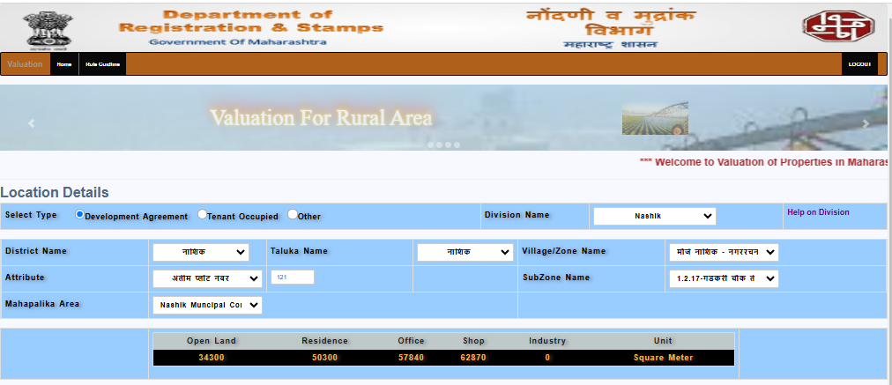

**Price Indicators**

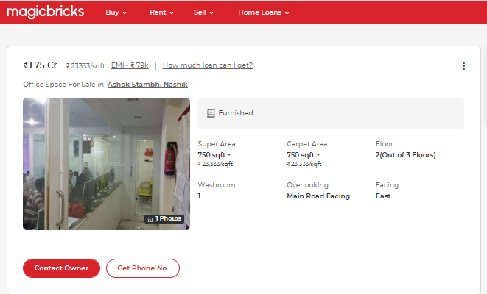

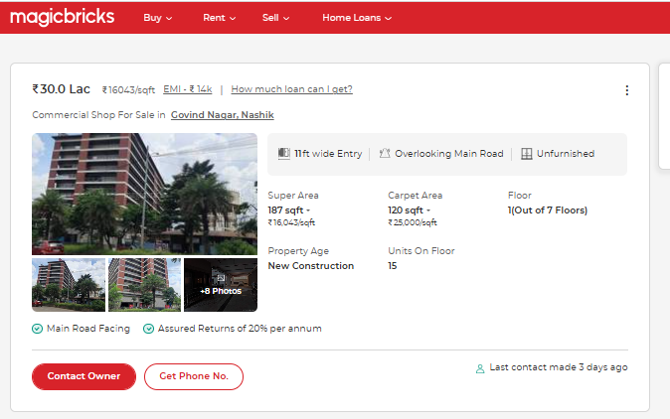

As a result of my appraisal and analysis, it is my considered opinion that the present fair market value of the above property in the prevailing condition with aforesaid specifications is **` 5,73,78,240.00 (Rupees Five Crore Seventy Three Lakh Seventy Eight Thousand Two Hundred Forty Only).** The Realizable Value of the above property is **` 5,45,09,328.00 (Rupees Five Crore Forty Five Lakh Nine Thousand Three Hundred Twenty Eight Only).** And the distress value **` 4,59,02,592.00 (Rupees Four Crore Fifty Nine Lakh Two Thousand Five Hundred Ninety Two Only).**

Place :Nashik

Date :12.11.2024

**Sharadkumar B. Chalikwar**

Govt. Reg. Valuer

Chartered Engineer (India)

Reg. No. (N) CCIT/1-14/52/2008-09

The undersigned has inspected the property detailed in the Valuation Report dated _______________________

on ____________________. We are satisfied that the fair and reasonable market value of the property is `_________________________ (Rupees ________________________________________________________

________________________________________only).

Date

Signature

(Name & Designation of the Inspecting Official/s)

Countersigned

(BRANCH MANAGER)

**Assumptions, Disclaimers, Limitations & Qualifications**

**Value Subject to Change**

The subject appraisal exercise is based on prevailing market dynamics as on **12th November 2024** and does not take into account any unforeseeable developments which could impact the same in the future.

**Our Investigations**

We are not engaged to carry out all possible investigations in relation to the subject property. Where in our report we identify certain limitations to our investigations, this is to enable the reliant party to instruct further investigations where considered appropriate or where we recommend as necessary prior to reliance. Vastukala Consultants India Pvt. Ltd. (VCIPL) is not liable for any loss occasioned by a decision not to conduct further investigations

**Assumptions**

Assumptions are a necessary part of undertaking valuations. VCIPL adopts assumptions for the purpose of providing valuation advise because some matters are not capable of accurate calculations or fall outside the scope of our expertise, or out instructions. The reliant party accepts that the valuation contains certain specific assumptions and acknowledge and accept the risk of that if any of the assumptions adopted in the valuation are incorrect, then this may have an effect on the valuation.

**Information Supplied by Others**

The appraisal is based on the information provided by the client. The same has been assumed to be correct and has been used for appraisal exercise. Where it is stated in the report that another party has supplied information to VCIPL, this information is believed to be reliable but VCIPL can accept no responsibility if this should prove not to be so.

**Future Matters**

To the extent that the valuation includes any statement as to a future matter, that statement is provided as an estimate and/or opinion based on the information known to VCIPL at the date of this document. VCIPL does not warrant that such statements are accurate or correct.

**Map and Plans**

Any sketch, plan or map in this report is included to assist the reader while visualising the property and assume no responsibility in connection with such matters.

**Site Details**

Based on inputs received from Client's representative and site visit conducted, we understand that the subject property is currently Vacant admeasuring **2784 Sq. ft. on Built Up Area** in the name of **Mr.Kapil Ashok Narang.** Further, VCIPL has assumed that the subject property is free from any encroachment and is available as on the date of the appraisal.

**Property Title**

Based on our discussion with the Client, we understand that the subject property is owned by **Mr.Kapil Ashok Narang.** For the purpose of this appraisal exercise, we have assumed that the subject property has a clear title and is free from any encumbrances, disputes and claims. VCIPL has made no further enquiries with the relevant local authorities in this regard and does not certify the property as having a clear and marketable title. Further, no legal advice regarding the title and ownership of the subject property has been obtained for the purpose of this appraisal exercise. It has been assumed that the title deeds are clear and marketable.

**Environmental Conditions**

We have assumed that the subject property is not contaminated and is not adversely affected by any existing or proposed environmental law and any processes which are carried out on the property are regulated by environmental legislation and are properly licensed by the appropriate authorities.

**Town Planning**

The permissible land use, zoning, achievable FSI, area statement adopted for purpose of this valuation is based on the information provided by the Client's representative and the same has been adopted for this valuation purpose. VCIPL has assumed the same to be correct and permissible. VCIPL has not validated the same from any authority.

**Area**

Based on the information provided by the Client's representative, we understand that the subject property is Vacant and Super Built up area is **2784 Sq. ft. on Built Up Area**.

**Condition & Repair**

In the absence of any information to the contrary, we have assumed that there are no abnormal ground conditions, nor archaeological remains present which might adversely affect the current or future occupation, development or value of the property. The property is free from rat, infestation, structural or latent defect. No currently known deleterious or hazardous materials or suspect techniques will be used in the construction of or subsequent alteration or additions to the property and comments made in the property details do not purport to express an opinion about, or advise upon, the condition of uninspected parts and should not be taken as making an implied representation or statement about such parts

**Valuation Methodology**

For the purpose of this valuation exercise, the valuation methodology used is Direct Comparison Approach Method and proposed Highest and Best Use model is used for analysing development potential.

The Direct Comparison Approach involves a comparison of the property being valued to similar properties that have actually been sold in arms - length transactions or are offered for sale. This approach demonstrates what buyers have historically been willing to pay (and sellers willing to accept) for similar properties in an open and competitive market and is particularly useful in estimating the value of the land and properties that are typically traded on a unit basis.

In case of inadequate recent transaction activity in the subject micro-market, the appraiser would collate details of older transactions. Subsequently, the appraiser would analysed rental / capital value trends in the subject micro-market in order to calculate the percentage increase / decrease in values since the date of the identified transactions. This percentage would then be adopted to project the current value of the same.

Where reliance has been placed upon external sources of information in applying the valuation methodologies, unless otherwise specifically instructed by Client and/or stated in the valuation, VCIPL has not independently verified that information and VCIPL does not advise nor accept it as reliable. The person or entity to whom the report is addressed acknowledges and accepts the risk that if any of the unverified information in the valuation is incorrect, then this may have an effect on the valuation.

**Not a Structural Survey**

We state that this is a valuation report and not a structural survey

**Other**

All measurements, areas and ages quoted in our report are approximate

**Legal**

We have not made any allowances with respect to any existing or proposed local legislation relating to taxation on realization of the sale value of the subject property. VCIPL is not required to give testimony or to appear in court by reason of this appraisal report, with reference to the property in question, unless arrangement has been made thereof. Further, no legal advice on any aspects has been obtained for the purpose of this appraisal exercise

Property specific assumptions

Based on inputs received from the client and site visit conducted, we understand that the subject property is currently Vacant and Super Built up area is **2784 Sq. ft. on Built Up Area**.

**Sharadkumar B. Chalikwar**

Govt. Reg. Valuer

Chartered Engineer (India)

Reg. No. (N) CCIT/1-14/52/2008-09

SBI Empanelment No.: SME/TCC/2017-18/942/178

**Vastukala Consultants (I) Pvt. Ltd.**

4, 1st Floor, Madhusha Elite, Vrundavan Nagar, Jatra –

Nandur Naka Link Road, Adgaon, Nashik - 422003

Date: 12.11.2024

Place: Nashik

**DEFINITION OF VALUE FOR THIS SPECIFIC PURPOSE**

This exercise is to assess **Fair Market Value** of the property under reference as on **12th November 2024.**

The term **Fair Market Value** is defined as

*“The most probable price, as of a specified date, in cash, terms equivalent to cash, or in other precisely revealed terms for which the specified property rights would sell after reasonable exposure in a competitive market under all conditions requisite to a fair sale, with the buyer and seller each acting prudently knowledgeably and for self interest assuming that neither is under undue duress”.*

Fundamental assumptions and conditions presumed in this definition are:

1. Buyer and seller are motivated by self-interest.

2. Buyer and seller are well informed and are acting prudently.

3. The property is exposed for a reasonable time on the open market.

4. Payment is made in cash or equivalent or in specified financing terms.

#### UNDER LYING ASSUMPTIONS

1. We assume no responsibility for matters of legal nature affecting the property appraised or the title thereto, nor do we render our opinion as to the title, which is assumed to be good and marketable.

2. The property is valued as though under responsible ownership.

3. It is assumed that the property is free of liens and encumbrances.

4. It is assumed that there are no hidden or unapparent conditions of the subsoil or structure that would render it more or less valuable. No responsibility is assumed for such conditions or for engineering that might be required to discover such factors.

## Sharadkumar B. Chalikwar

Govt. Reg. Valuer

Chartered Engineer (India)

Reg. No. (N) CCIT/1-14/52/2008-09

**DECLARATION OF PROFESSIONAL FEES CHARGED**

We hereby declare that, our professional fees are not contingent upon the valuation findings. However, if the statute AND/OR clients demands that, the fees should be charged on the percentage of assessed value then, with the full knowledge of the AND/OR end user, it is being charged accordingly.

# **VALUATION OF THE PROPERTY PREMISES**

Considering various parameters recorded herein above, existing economic scenario, and the information that is available with reference to the development of neighborhood and method selected for valuation, we are of the opinion that, the property premises can be assessed and valued for this particular purpose at **` 5,73,78,240.00 (Rupees Five Crore Seventy Three Lakh Seventy Eight Thousand Two Hundred Forty Only)**

## Sharadkumar B. Chalikwar

Govt. Reg. Valuer

Chartered Engineer (India)

Reg. No. (N) CCIT/1-14/52/2008-09