**Name of Owner: M/s. Welspun Home Solutions Ltd.**

**Plant Location: - Survey No. 674/P & 890/P, located in Welspun City, Village-Varsamedi, Taluka-Anjar, District- Kachchh, PIN Code-370 110, State- Gujarat, Country-India.**

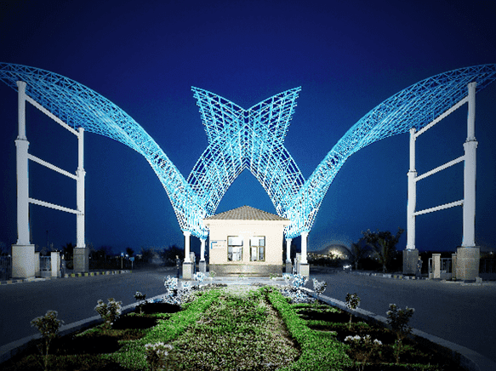

**Report Prepared For**

**Exim Bank**

**FOR THE PROJECT BEING IMPLEMENTED BY WELSPUN HOME SOLUTIONS LTD.**

**INDEX**

|  |  |  |
| --- | --- | --- |
| CHAPTER | NAME | PAGE NO. |
| 1 | **PREAMBLE** | **03** |
| 2 | **ASSIGNMENT OVERVIEW** | **04** |
| 3 | **ABOUT COMPANY & THE PROJECT** | **08** |
| 4 | **PROJECT EXECUTION** | **28** |
| 4 | **PHOTOGRAPHS** | **40** |
| 5 | **NOTES, LIMITATIONS, DISCLAIMERS & CAVEATS** | **47** |
| 6 | **SUMMARY** | **49** |
| 7 | **OPINION** | **52** |

Vastu/Exim/Thane/11/2024/12310/2309010

12/14-95-APU

Date: - 12.11.2024

1. **PREAMBLE**

**M/s. Welspun Home Solutions Ltd.** having registered office at Welspun City, P.O. Box 21, Versamedhi, Anjar, Kachchh, Anjar, Gujarat, India, 370 110 has appointed **M/s Vastukala Consultants (I) Pvt. Ltd. (VCIPL)** as Lender’s Independent Engineers for inspection and monitoring the progress of proposed Terry Towel manufacturing facility of Rs. 303.32 Crores by **M/s Welspun Home Solutions Ltd.,** (hereinafter referred to as either “WHSL” or “the borrower” or “the company”). Project cost is estimated to be approximately Rs. 303.32 crores which is proposed to be funded by way of term loan of Rs. 225.00 crores and balance Rs. 78.32 crores by way of promoter contribution.

**(Rs in Cr)**

| S. No | Particular | Proposed |
| --- | --- | --- |
| 1 | Project Cost | 303.32 |
|  | **Means of Finance** |  |
| 1 | Term Loan from Bank | 225.00 |
| 2. | Mix of promoter contribution/ Preference Shares/ Debentures/ Unsecured loan/ Convertible Instruments/ Subordinated Debt etc from WLL | 78.32 |
|  | **Total** | **303.32** |

Pursuant to instructions from **M/s. Welspun Home Solutions Ltd.** having registered office at Welspun City, P.O. Box 21, Versamedhi, Anjar, Kachchh, Anjar, Gujarat, India, 370 110, as appointment of Lender’s Independent Engineer, our Engineer visited the project site of Proposed Terry Towel manufacturing facility at Survey No. 674/P & 890/P, located in Welspun City, Village-Versamedi, Taluka-Anjar, District- Kachchh, PIN Code-370 110, State- Gujarat, Country-India 3rd time on 18.10.2024 with a view to ascertain and certify the quantity and amount of work progressively undertaken by the Company.

1. **ASSIGNMENT OVERVIEW**

#### 2.1 NATURE OF ASSIGNMENT

To review the status of the Proposed Terry Towel manufacturing facility at Survey No. 674/P & 890/P, located in Welspun City, Village-Versamedi, Taluka-Anjar, District- Kachchh, PIN Code-370 110, State- Gujarat, Country-India on behalf of **Exim Bank**, Centre One Building, Floor 21, World Trade Centre Complex, Cuffe Parade, Mumbai- 400 005 (Lender’s).

#### 2.2 SCOPE OF WORK: -

#### The scope of work is as per work order provided by the company is under: -

* Executive Summary, Brief Profile/ Basic information of the applicant Company.
* Periodic Progress Monitoring Report.
* Financial Progress.
* Validation of the Project Cost, Means of Finance details and Expenses.
* Bank related details.
* Site Visit & Physical Progress and Present Physical Status of the Project.
* Building & Civil Work
* Status of Plant & Machinery and Miscellaneous Fixed Assets.
* Verification of Invoice/ Purchase Orders received for Civil construction work.
* Details of Plant & Machinery Installed.
* Statutory Approvals for the Projects
* Monitoring of obtainment of the statutory approvals, clearances from appropriate authorities.
* Monitoring of the actuals with the timelines initially set for different stages of implementation for monitoring the time over run if any.
* Review of the production capacity (In Capacity terms and Volume) via-a-vis the original projections.
* Monitoring of the disbursement made viz-a-vis the original schedule and ensuring infusion of margins.
* Confirmation that retirement of LCs opened by WLL have been made towards purchase of Plant & Machinery for WHSL Project (Acquired/ to be acquired subsequently from WLL) and that funds from Exim Bank term loan have been utilized for WHSL project which is partially funded by Exim Bank.
* Monitoring of the original purchase cost of assets from the related parties/group companies/ promoter company (WLL) and payments made thereof confirmation and certification about markup pricing for High Seas Sale between WLL and WHSL.
* Verification of the invoices and validation of the rates/commercial terms and conditions thereof vis-a-viz the original projections.
* Monitoring of the payments made to the suppliers, contractors, vendors etc.
* Monitoring changes in the external factors vis-a-viz the original estimates- government policies, policy changes.
* Monitoring of arrangement for continuous power and water supply, availability of labour.
* Environmental Clearances.
* Monitoring of logistics and infrastructure.
* Validate any other costing, expenditure as maybe required by Exim Bank.

#### 2.3 DATE OF VISIT: -

* VCIPL’s Engineer has visited the project site 3rd time on 18.10.2024.

#### 2.4 DOCUMENTS PROVIDED: -

The following documents were perused during the said assignment:

* Revised Sanction Letter from EXIM Bank for term loan of Rs. 225.00 Crores for the proposed project vide Letter Ref. No. CBG:EOU-1197:2024-25:111 dated 26.06.2024.
* Certificate of Incorporation of WHSL.
* Land Lease Deed.
* Article of Association and Memorandum of Association.
* IEM Certificate.
* Pan Card of WHSL
* GST Certificate of WHSL
* Information memorandum dated April 2024.
* Provisional Consent Order in the name of M/s. Welspun Home Solutions Ltd. issued by Gujarat Pollution Control Board vide Application: CTE:CTE-Fresh, No. 310074 dated 02.04.2024, Granted On: 13.05.2024.
* Forwarding & Undertaking Letter vide inward no 310074 dated 02.04.2024 from WHSL submitted to The Member Secretary, Gujarat Pollution Control Board Paryavaran Bhavan, Sector-10/A, Gandhinagar – 382010 regarding Application for consent for establishing / operation the industrial plant / plants under Section 21 of the Air (prevention & Control of Pollution) Act, 1981.
* Letter and Plan showing New Factory Building along with machinery layout approved by Director, Industrial Safety & Health, Gujarat State dated 22.04.2024.
* Water Consumption & Generation details.
* Breakup of Hard Cost.
* CA Certificate regarding cost incurred toward the proposed project till 21.10.2024 dated 29.10.2024 issued by M/s. C.S Mangal & Co., Chartered Accountants, Mumbai.
* Quotation/ Proforma Invoices for Imported Plant & Machinery.
* Insurance Policy.
* Held Cover Letter for extension of EAR and Marine Policy issued by HDFC ERGO General Insurance Company Limited dated 11.11.2024 valid till 08.02.2025.
* Ledger Abstract.
* Proforma Invoice Copy.
* Application for CTE/CCA 29.10.2024.
* Approval to the drawing for the electrical installation of 4 x 11 KV Feeder Bay at WHSL-Electrical Control Room along with associated equipments for 1 I/C feeder and 3 O/G Feeders... & 3 x 2500.0 KVA 11/0.433KV KV Transformer(s) & 2 x 800.0 KVAr 0.415 KV Capacitor Bank(s) along with associated equipments issued by Office of the Chief Electrical Inspector, Gandhinagar vide No. No/CEI/Gan/Plan/124895/2024 dated 24.07.2024.
* License to work a Factory issued by Directorate Industrial Safety & Health valid till 31.12.2028.
* Certificate for Importer-Exporter Code dated 27.03.2024.
* Letter of sanction of Credit Facilities for WC- Fund Based (FB) and WC-Non-Fund Based issued by IDBI Bank Limited, LCG, Mittal Court, Nariman Point, Mumbai vide Letter Ref. No. IDBI/LCG/NPT/WHSL/2024-25/419 dated 24.10.2024.

#### 2.5 METHODOLOGY ADOPTED

* LIE visit to the project site 3rd time on 18.10.2024.
* Perusal of documents and information provided by the Company.
* Physical verification of the project site with the following executives of the Company: -
* Mr. Sandeep Galagali, A.V.P. Project (+91 98198 68583) of Welspun World.
* Mr. Rohit Bhaskar, Dy. Manage, (+91 92699 02424) of Exim Bank.
* Explanations and information given by the following executives of the Company,
* Mr. Vipul Bhatt, Sr. G. M Finance (+91 98219 67716) of Welspun World.
* Mr. Ashish Shah, D.G.M. Finance & Treasury (+91 98219 75084) of Welspun World.
* Examinations of documents provided by the Company.
* Selective photographs of the project site are enclosed.
* Finalization of LIE Report.

1. **ABOUT COMPANY & THE PROJECT**

#### 3.1. ABOUT COMPANY: -

**M/s. Welspun Home Solutions Ltd.** (“WHSL” or ‘Company”) is a Public Limited Company incorporated on 06.12.2023. It is registered at Registrar of Companies, Ahmedabad. Its authorized share capital is Rs. 10,00,00,000 and its paid-up capital is Rs. 10,00,00,000. WHSL’s Corporate Identification Number is (CIN) U13999GJ2023PLC146705 and registration number is 146705. Its registered address is Welspun City, P.O. Box 21, Versamedhi, Anjar, Kachchh, Gujarat- 370 110.

WHSL is a 100% subsidiary of Welspun Living Limited (Formerly Welspun India Limited) (“WLL”, “Sponsor”) is a part of US$ 4 billion Welspun group. The Group Promoted by Mr. B.K. Goenka and Mr. Rajesh Mandawewala has experience of more than 35 years in setting up and running a fully integrated projects in different business verticals like home textiles, Line Pipes, flooring solutions, Infrastructure, Advanced textiles, warehousing, plastic products, steel & Oil & Gas.

WLL had an existing capacity of 90,000 MTPA of Bath linen in Anjar, Gujarat. The existing plant was running at average utilization of 85% to 90%. Considering the existing capacity utilization and growing demand of the product, group has proposed to increase the capacity of terry towel facility which will be implemented in Welspun Home Solutions Limited 100% subsidiary of WLL. Executive Summary of Company is as under:-

| S. No | Particular | Details |
| --- | --- | --- |
| 1 | Company Name | Welspun Home Solutions Limited (WHSL) |
| 2 | Incorporation Date | 06.12.2023 |
| 3 | Constitution | Limited Liability Company |
| 4 | CIN | U13999GJ2023PLC146705 |
| 5 | Registered Address | Welspun City, P.O. Box 21Versamedhi,, Anjar, Kachchh, Anjar, Gujarat, India, 370 110 |
| 6 | Industry | Home Textile |
| 7 | Nature of Activity | Company is in the field of manufacturing of Terry towels, Grey Fabric and processing. |
| 8 | Company Directors | 1. Sanjay Gupta  2. Sanjay Kanungo  3. Praveen Bhansali  4. Atul Shantilal Trivedi  5. Deepak Chandrabhan Singh Chauhan |
| 9 | Shareholding | |  |  |  |  | | --- | --- | --- | --- | | **S. No.** | **Shareholder Name** | **No. of Shares held** | **Shareholding** | | 1 | Welspun Living Ltd. including nominees of WLL | 1,00,00,000 | 100% | |  | **Total** | **1,00,00,000** | **100%** | |
| 10 | Plant Location | Survey No. 674/P & 890/P, located in Welspun City, Village-Versamedi, Taluka-Anjar, District- Kachchh, PIN Code-370 110, State- Gujarat, Country-India |

**3.2) ABOUT THE PROJECT**

Welspun Home Solutions Limited, a wholly owned subsidiary of Welspun Living Limited, which is the flagship textile company of the esteemed Welspun Group, has been a prominent player in the Home textiles, Advance textile, and Flooring Solutions. Building on its market presence, the company has identified a strategic opportunity for expansion, particularly in response to the escalating demand for terry towels.

Currently, the existing production capacity of 90,000 MTPA is operating at an impressive 85%-90% utilization on average. To capitalize on this momentum and meet the surging demand for terry towels, Welspun Group is embarking on a substantial expansion initiative. This expansion involves the establishment of a terry towel manufacturing facility under the new entity, Welspun Home Solutions Limited.

The proposed expansion project entails the creation of an additional manufacturing plant with a dedicated capacity of 7,920 MTPA for the production of high-quality terry towels. Additionally, the project includes the setup of a facility with a capacity of 2,880 MTPA for the production of Grey fabric.

WHSL proposes to set-up a terry towel manufacturing facility at Survey No. 674/P & 890/P, located in Welspun City, Village-Versamedi, Taluka-Anjar, District- Kachchh, PIN Code-370 110, State- Gujarat, Country-India on a land admeasuring 36,422.00 Sq. M. The Land for the Proposed project is leased from WLL for the period of 25 years commencing from 1st April, 2024 and terminating on 31st March, 2049. Total estimated project cost is Rs. 303.32 Crores as indicated in table provided below for ready reference.

| S. No | Particular of Project | Estimated Project Cost (Rs. in Crores) |
| --- | --- | --- |
| A | Hard Cost |  |
| 1. | Land | 0* |
| 2. | Site Development and Building Cost | 42.59 |
| 3. | Plant & Machinery | 178.53 |
| 4. | Miscellaneous Fixed Asset | 44.13 |
|  | **Total (A)** | **265.24** |
| **B** | **Soft Cost** |  |
| 5. | Contingencies | 6.63 |
| 6. | IDC including Preoperative and Preliminary Expenses | 13.45 |
| 7. | Margin money for working capital | 18.00 |
|  | **Total (B)** | **38.08** |
|  | **Total (A+B)** | **303.32** |

**NOTE:-**

* *The Land admeasuring 36,422.00 m² is leased from WLL.
* Cost of Land is not considered in the project cost.

**MEANS OF FINANCE**

| S. No | Particular of Project | Estimated Project Cost (Rs. in Crores) |
| --- | --- | --- |
| 1. | Promoter Contribution | 78.32 |
| 2. | Term Loan | 225.00 |
|  | **Total** | **303.32** |

**OBSERVATIONS: -**

* EXIM Bank has revised sanctioned the term loan of Rs. 225.00 Crores for the proposed project vide Letter Ref. No. CBG:EOU-1197:2024-25:111 dated 26.06.2024.

**3.3) LAND FOR THE PROJECT: -**

WHSL proposes to set-up a terry towel manufacturing facility at Survey No. 674/P & 890/P, located in Welspun City, Village-Versamedi, Taluka-Anjar, District- Kachchh, PIN Code-370 110, State- Gujarat, Country-India on a land admeasuring 36,422.00 Sq. M. The Land for the Proposed project is leased from WLL for the period of 25 years commencing from 1st April, 2024 and terminating on 31st March, 2049.

**3.4) SITE DEVELOPMENT & BUILDINGS FOR THE PROJECT: -**

As per Letter and Plan showing New Factory Building along with machinery layout approved by Director, Industrial Safety & Health, Gujarat State dated 22.04.2024 for terry towel manufacturing facility at Survey No. 674/P & 890/P, located in Welspun City, Village-Versamedi, Taluka-Anjar, District- Kachchh, PIN Code-370 110, State- Gujarat, Country-India are as under: -

| S. No. | Description | Length (m) | Width (m) | Area (Sq. M) |
| --- | --- | --- | --- | --- |
| 1 | Ambulance Room & Ambulance Parking Shed | 23.00 | 5.20 | 119.60 |
| 2 | Creach Room | Irregular | | 203.41 |
| 3 | Canteen Building | 20.00 | 30.00 | 600.00 |
| 4 | W.C Bath Urinal (Male) | 5.66 | 10.14 | 57.39 |
| 5 | W.C Bath Urinal (Male) | 5.66 | 10.14 | 57.39 |
| 6 | W.C Bath (Female) | 5.66 | 10.14 | 57.39 |
| 7 | W.C Bath (Female) | 5.66 | 10.14 | 57.39 |
| 8 | Cloak Room (Male & Female) | 22.00 | 5.00 | 110.00 |
| 9 | Lunch Room/ Rest Room (Male/ Female) | 24.40 | 4.40 | 107.36 |
| 10 | Terry Towel Process Plant | Irregular | | 26,879.20 |
| 11 | Mezz (+4.70 M.) | Irregular | | 1,820.33 |
| 12 | Utility at (+4.70 M.) | Irregular | | 3,245.07 |
|  |  |  | **Total** | **33,314.54** |

**OBSERVATIONS: -**

* As per Plan, the total BUA is 33,314.54 m2. The Cost of Site Development and Building estimated by WHSL is Rs. 42.59 Crores i.e. Rs. 12.877 per m2. As per Industrial trends the Cost of Site Development and Building estimated by WHSL is Fair and Reasonable.
* Company has awarded the Site Development & Building work to M/s. ICC Projects Pvt Ltd, M/s. PEB360 Solutions (India) LLP, M/s. Jai Shakti Eng. & Construction and M/s. Gherzi Consulting Engineers Pvt. Ltd.
* M/s. ICC Projects Pvt Ltd, M/s. PEB360 Solutions (India) LLP, M/s. Jai Shakti Eng. & Construction and M/s. Gherzi Consulting Engineers Pvt. Ltd. has mobilized the site and commenced the construction of main plant building. The construction work is in advance stage.
* As a matter of confidentiality, the Company has not provided the WO/PO/Contract for Site Development & Building.

**3.5) PLANT & MACHINERY FOR THE PROJECT: -**

The plant & machinery includes both imported as well as indigenous machineries for proposed terry towel manufacturing project at Survey No. 674/P & 890/P, located in Welspun City, Village-Versamedi, Taluka-Anjar, District- Kachchh, PIN Code-370 110, State- Gujarat, Country-India.   
The total cost of plant & machinery is estimated at Rs. 178.53 Crores which includes core plant and machinery as well as other allied machineries. The cost of imported plant and machinery is estimated at Rs. 148.58 Crores and cost of indigenous plant and machinery is estimated around Rs. 29.95 Crores.

**Breakup of Imported Plant & Machinery is as under: -**

| S. No. | Description | Qty. | Total Cost (Rs. In Lakhs) | Other Charges 5% of Total Cost  (Rs. In Lakhs) | Total (Rs. In Lakhs) |
| --- | --- | --- | --- | --- | --- |
| A | Weaving |  |  |  |  |
| 1 | Airjet Loom with Gantry - Jacquard Looms | 36 | 2,141.71 | 107.09 | 2,248.80 |
| 2 | Jacquard for above looms | 36 | 1,868.76 | 93.44 | 1,962.20 |
| 3 | Looms with Dobby | 38 | 2,852.28 | 142.61 | 2,994.89 |
| 4 | Beam Knotting Machine | 3 | 99.35 | 4.97 | 104.31 |
| 5 | Wvg + prep MHE | 2 | 322.20 | 16.11 | 338.31 |
| 6 | Side Loader | 1 | 78.30 | 3.92 | 82.22 |
|  |  | **Total (A)** | **7,362.60** | **368.13** | **7,730.73** |
| **B** | **Yarn Dyeing** |  |  |  |  |
| 1 | 50 Kg | 2 | 106.24 | 5.31 | 111.55 |
| 2 | 100 Kg | 3 | 186.75 | 9.34 | 196.09 |
| 3 | 200 Kg | 2 | 146.91 | 7.35 | 154.26 |
| 4 | 300 Kg | 1 | 83.00 | 4.15 | 87.15 |
| 5 | 500 Kg | 2 | 209.16 | 10.46 | 219.62 |
| 6 | 750 Kg | 2 | 298.80 | 14.94 | 313.74 |
| 7 | 1050 Kg | 2 | 345.28 | 17.26 | 362.54 |
| 8 | 1200 Kg | 2 | 381.80 | 19.09 | 400.89 |
| 9 | Yarn Sampling Machine | 1 | 380.14 | 19.01 | 399.15 |
| 10 | Soft Winding Machine(84 spindles each) | 3 | 832.50 | 41.63 | 874.13 |
| 11 | Color Kitchen | 1 | 537.00 | 26.85 | 563.85 |
| 12 | Dyeing Lab | 1 | 179.00 | 8.95 | 187.95 |
| 13 | Chiller | 1 | 83.00 | 4.15 | 87.15 |
| 14 | Hydro Extractors | 3 | 112.77 | 5.64 | 118.41 |
|  |  | **Total (B)** | **3,882.35** | **194.12** | **4,076.47** |
| C | **Fabric Dyeing, Washing, Finishing** |  |  |  |  |
| 1 | Fabric Dyeing Machine - 1600 KG - washing | 2 | 340.10 | 17.01 | 357.11 |
| 2 | Fabric Dyeing Machine - 1200 Kg | 1 | 143.20 | 7.16 | 150.36 |
| 3 | Fabric Dyeing Machine - 800 Kg | 2 | 247.02 | 12.35 | 259.37 |
| 4 | Fabric Dyeing Machine - 400 Kg | 2 | 187.95 | 9.40 | 197.35 |
| 5 | Fabric Dyeing Machine - 200 Kg | 1 | 85.03 | 4.25 | 89.28 |
| 6 | Fabric Dyeing Machine - 100 Kg | 1 | 62.65 | 3.13 | 65.78 |
| 7 | Fabric Dyeing Machine - 50 Kg | 1 | 53.70 | 2.69 | 56.39 |
| 8 | Fabric Dyeing Machine - 25 Kg | 1 | 49.23 | 2.46 | 51.69 |
| 9 | Fabric Lab | 1 | 179.00 | 8.95 | 187.95 |
| 10 | Color Kitchen | 1 | 537.00 | 26.85 | 563.85 |
| 11 | Finishing Line new | 1 | 630.98 | 31.55 | 662.52 |
| 12 | Shearing Machine - Double Passage | 2 | 250.60 | 12.53 | 263.13 |
|  | **Total (C )** | | **2,766.45** | **138.32** | **2,904.77** |
| **D** | Combilift | 1 | 49.23 | 2.46 | 51.69 |
| **E** | Chiller | 1 | 89.50 | 4.48 | 93.98 |
|  | **Total (A to E)** | | **14,150.12** | **707.51** | **14,857.62** |

**OBSERVATIONS: -**

* The Cost of Imported Plant & Machinery estimated by Company is Rs. 148.58 Crores.

**Breakup of Indigenous Plant & Machinery is as under: -**

|  |  |  |  |  |  |  |
| --- | --- | --- | --- | --- | --- | --- |
| S. No. | Machine Name | Qty. | Total Cost (Rs. In Lakhs) | GST @ 18% of Total Cost (Rs. In Lakhs) | Other Charges 5% of Total Cost (Rs. In Lakhs) | Total (Rs. In Lakhs) |
| A | Weaving |  |  |  |  |  |
| 1 | Sectional Warping Machine with OHTC | 3 | 345.00 | 62.10 | 17.25 | 424.35 |
| 2 | Sizing Machine | 1 | 340.00 | 61.20 | 17.00 | 418.20 |
| 3 | Direct Warping | 1 | 88.00 | 15.84 | 4.40 | 108.24 |
| 4 | Beams - Weaving | 1 | 195.00 | 35.10 | 9.75 | 239.85 |
| 5 | Beams | 76 | 68.40 | 12.31 | 3.42 | 84.13 |
| 6 | Sizing Cooker & Vessel | 1 | 15.00 | 2.70 | 0.75 | 18.45 |
| 7 | Beam Storage system | 1 | 210.00 | 37.80 | 10.50 | 258.30 |
| 8 | Racks for Yarn Storage | 1 | 30.00 | 5.40 | 1.50 | 36.90 |
| 9 | Forklift/Stacker | 1 | 25.00 | 4.50 | 1.25 | 30.75 |
| 10 | Bottom Rewinding Machine | 1 | 50.00 | 9.00 | 2.50 | 61.50 |
|  | **Total (A)** | | **1,366.40** | **245.95** | **68.32** | **1,680.67** |
| **B** | **Yarn Dyeing, Fabric & Cut & Sew** |  |  |  |  |  |
| 1 | Post Winding Machine (120 spindles each) | 4 | 96.00 | 17.28 | 4.80 | 118.08 |
| 2 | RF Dryer 125 | 3 | 210.00 | 37.80 | 10.50 | 258.30 |
| 3 | 5 Chamber Stenter | 1 | 130.00 | 23.40 | 6.50 | 159.90 |
| 4 | OHTC | 10 | 25.00 | 4.50 | 1.25 | 30.75 |
| 5 | Bobbins | 50000 | 125.00 | 22.50 | 6.25 | 153.75 |
| 6 | Dyeing Cages | 1 | 50.00 | 9.00 | 2.50 | 61.50 |
| 7 | Cone Pressing machine | 3 | 22.50 | 4.05 | 1.13 | 27.68 |
| 8 | MHE, Pullers | 1 | 75.00 | 13.50 | 3.75 | 92.25 |
| 9 | Misc. Trollies fir Dye House, Process Etc | 1 | 200.00 | 36.00 | 10.00 | 246.00 |
|  | **Total (B)** | | **933.50** | **168.03** | **46.68** | **1,148.21** |
| **C** | **Additional** |  |  |  |  |  |
| 1 | Fabric Batching Machine | 2 | 70.00 | 12.60 | 3.50 | 86.10 |
| 2 | Inspection Machine | 2 | 40.00 | 7.20 | 2.00 | 49.20 |
| 3 | Misc. MHE - Pullers etc | 1 | 25.00 | 4.50 | 1.25 | 30.75 |
|  | **Total (C )** | | **135.00** | **24.30** | **6.75** | **166.05** |
|  | **Total (A to C)** | | **2,434.90** | **438.28** | **121.75** | **2,994.93** |

**OBSERVATIONS: -**

* The Cost of Indigenous Plant & Machinery estimated by Company is Rs. 29.95 Crores.

**3.6) MISCELLANEOUS FIXED ASSET: -**

Misc Fixed Asset Cost estimated by the company is Rs. 44.13 Crs for Water Systems, Sewage Systems, Fire & Electrical Systems, Compressor and its accessories etc. Breakup for the same is as under:-

| S. No. | Machine Name | Qty. | Total Cost | GST @ 18% of Total Cost | Other Charges 2.5% of Total Cost | Total |
| --- | --- | --- | --- | --- | --- | --- |
| A | Water |  | (Rs. In Lakhs) | | | |
| 1 | Raw Water System |  |  |  |  |  |
| 2 | Hydropneumatics System | 1 | 3.00 | 0.54 | 0.08 | 3.62 |
| 3 | Pipeline & Valves | 1 | 20.00 | 3.60 | 0.50 | 24.10 |
| 4 | Installation Charges | 1 | 5.00 | 0.90 | 0.13 | 6.03 |
|  | **Total (A)** | | **28.00** | **5.04** | **0.70** | **33.74** |
| **B** | **Soft Water System** |  |  |  |  |  |
| 1 | Hydropneumatics System | 1 | 5.00 | 0.90 | 0.13 | 6.03 |
| 2 | Pipeline & Valves - SS | 1 | 75.00 | 13.50 | 1.88 | 90.38 |
| 3 | Installation Charges | 1 | 25.00 | 4.50 | 0.63 | 30.13 |
| 4 | Soft water storage Tanks | 1 | 1,037.76 | 186.80 | 25.94 | 1,250.50 |
|  | **Total (B)** | | **1,142.76** | **205.70** | **28.58** | **1,377.03** |
| **C** | **Effluent Treatment** |  |  |  |  |  |
| 1 | ETP & STP 5000 KLD ( Only RO in Anjar) | 1 | 637.97 | 114.83 | 15.95 | 768.75 |
| 2 | SS Pipeline & Valves | 1 | 50.00 | 9.00 | 1.25 | 60.25 |
| 3 | Installation Charges | 1 | 25.00 | 4.50 | 0.63 | 30.13 |
| 4 | RO Storage(material + Shifting) | 1 | 50.00 | 9.00 | 1.25 | 60.25 |
|  | **Total (C)** | | **762.97** | **137.33** | **19.08** | **919.38** |
| **D** | **Misc Pumps & Drains (RW/SW/EFF/DRAIN)** | **1** | **25.00** | **4.50** | **0.63** | **30.13** |
| **E** | **Chilled Water System** |  |  |  |  |  |
| 1 | Cooling Towers & Pumps | 1 | 3.50 | 0.63 | 0.09 | 4.22 |
| 2 | Pipeline & Fittings | 1 | 5.00 | 0.90 | 0.13 | 6.03 |
| 3 | Insulation & Erection | 1 | 5.00 | 0.90 | 0.13 | 6.03 |
|  | **Total (E )** | | **13.50** | **2.43** | **0.34** | **16.27** |
| **F** | **Compressor, Pipeline and Accessories** |  |  |  |  |  |
| 1 | Pipeline & Accessories | 1 | 25.00 | 4.50 | 0.63 | 30.13 |
|  | **Total (F)** | | **25.00** | **4.50** | **0.63** | **30.13** |
| **G** | **Pipeline Supports/ Structure/ Fabrication etc.** | | | | |  |
| 1 | Pipeline Supports/ Structure/ Fabrication etc. | 1 | 25.00 | 4.50 | 0.63 | 30.13 |
|  | **Total (G)** | | **25.00** | **4.50** | **0.63** | **30.13** |
| **H** | **Steam System** |  |  |  |  |  |
| 1 | Condensate Recovery systems | 1 | 25.00 | 4.50 | 0.63 | 30.13 |
| 2 | PRS | 2 | 16.00 | 2.88 | 0.40 | 19.28 |
| 3 | Pipeline & Fittings | 1 | 197.95 | 35.63 | 4.95 | 238.53 |
| 4 | Insulation & Erection | 1 | 73.50 | 13.23 | 1.84 | 88.57 |
|  | **Total (H)** | | **312.45** | **56.24** | **7.81** | **376.50** |
| **I** | **Fire System** |  |  |  |  |  |
| 1 | Water Tanks | 1 | 35.00 | 6.30 | 0.88 | 42.18 |
| 2 | Fire Pumps | 1 | 20.00 | 3.60 | 0.50 | 24.10 |
| 3 | Fire System - Pipeline / Fittings/ Valves | 1 | 77.28 | 13.91 | 1.93 | 93.12 |
| 4 | Misc. Fire Alarms/ Fire Safety equipment | 1 | 15.00 | 2.70 | 0.38 | 18.08 |
| 5 | Misc Fire Signage, Exit Alarm & accessories | 1 | 7.50 | 1.35 | 0.19 | 9.04 |
|  | **Total (I)** | | **154.78** | **27.86** | **3.87** | **186.51** |
| **J** | **HVAC & Ventilation Systems** |  |  |  |  |  |
| 1 | H Plant-Wvg | 1 | 130.00 | 23.40 | 3.25 | 156.65 |
| 2 | H Plant-Prep | 1 | 55.00 | 9.90 | 1.38 | 66.28 |
| 3 | DUCTING AND INSULATION | 1 | 99.20 | 17.86 | 2.48 | 119.54 |
| 4 | Misc. Ventilation for Process | 1 | 25.00 | 4.50 | 0.63 | 30.13 |
| 5 | False Ceiling | 8245 | 90.70 | 16.33 | 2.27 | 109.29 |
|  | **Total (J)** | | **399.90** | **71.98** | **10.00** | **481.87** |
| **K** | **Electrical** |  |  |  |  |  |
| 1 | VCB/Bus Coupler/LT | 3 | 22.50 | 4.05 | 0.56 | 27.11 |
| 2 | Transformer (2.5 mva) | 2 | 52.00 | 9.36 | 1.30 | 62.66 |
| 3 | Cables HT | 1 | 30.00 | 5.40 | 0.75 | 36.15 |
| 4 | Cables LT | 1 | 50.00 | 9.00 | 1.25 | 60.25 |
| 5 | Lighting and Accessories | 1 | 25.00 | 4.50 | 0.63 | 30.13 |
| 6 | Street Ligts | 1 | 5.69 | 1.03 | 0.14 | 6.86 |
| 7 | High Mast | 2 | 8.50 | 1.53 | 0.22 | 10.25 |
| 8 | DB's & MCC's /soft starter | 1 | 35.00 | 6.30 | 0.88 | 42.18 |
| 9 | Electrical Contractor | 1 | 23.02 | 4.14 | 0.58 | 27.74 |
| 10 | OTHERS Materials (Cable Tray, Jointing Kit, Electrical Poles, High Mast) | 1 | 15.00 | 2.70 | 0.38 | 18.08 |
|  | **Total (K)** | | **266.71** | **48.01** | **6.68** | **321.40** |
| **L** | **Misc.** |  |  |  |  |  |
| 1 | EOT for Yarn Dyeing & Wvg Prep. | 2 | 70.00 | 12.60 | 1.75 | 84.35 |
| 2 | Machine Accessories like Cheese, Bobbin, Spring Bobbin, Harness, Reeds | 2 | 50.00 | 9.00 | 1.25 | 60.25 |
| 3 | FURNITURE & FIXTURE | 1 | 30.00 | 5.40 | 0.75 | 36.15 |
| 4 | High Speed Doors | 1 | 2.50 | 0.45 | 0.06 | 3.01 |
| 5 | Lift | 1 | 6.50 | 1.17 | 0.16 | 7.83 |
| 6 | IT Related Expenses + Security System | 1 | 275.00 | 49.50 | 6.88 | 331.38 |
| 7 | MHE and V Store | 1 | 50.00 | 9.00 | 1.25 | 60.25 |
| 8 | Dock Levellers | 4 | 22.00 | 3.96 | 0.55 | 26.51 |
|  | **Total (L)** | | **506.00** | **91.08** | **12.65** | **609.73** |
|  | **Total (A to L)** | | **3,662.07** | **659.17** | **91.57** | **4,412.80** |

**OBSERVATIONS: -**

* The Cost of MFA estimated by Company is Rs. 44.13 Crores.

**3.7 PRE-OPERATIVE EXPENSES**

Company has estimated the pre-operative expense Rs. 13.45 Crore. The pre-operative expense consists of Interest during Construction period & Other Finance Cost, and other Misc expenditure towards traveling expenses, training, start up and trial run expenses etc.

**3.8) CONTINGENCY**

The contingency towards proposed project estimated by Company is Rs. 6.63 Crores (i.e. 2.5 % of Project Hard Cost).

**3.9) MARGIN MONEY FOR WORKING CAPITAL**

The Working capital margin for proposed project estimated by company is Rs 18 Crores. IDBI Bank vide its letter dated 24.10.2024 sanctioned working capital limit aggregating Rs. 55.00 Crores (FB+ NFB) to the Company.

**3.10) POWER & WATER REQUIREMENT: -**

The total connected load for the company would be around 4000.00 KW and the contract demand would be 3315.74 KW. The power breakup is as given under:

| S. No. | Section | Nos. of Unit | Connected KW | Total connected KW | Loading Factor | Total KW |
| --- | --- | --- | --- | --- | --- | --- |
| A | WEAVING |  |  |  |  |  |
| 1 | Sectional Warping | 3.00 | 28.20 | 84.60 | 50% | 42.30 |
| 2 | Direct Warping | 1.00 | 18.20 | 18.20 | 50% | 9.10 |
| 3 | Cone Winding Machine | 1.00 | 12.50 | 12.50 | 65% | 8.13 |
| 4 | Sizing m/c | 1.00 | 65.00 | 65.00 | 35% | 22.75 |
| 5 | Sizing Kitchen | 1.00 | 15.00 | 15.00 | 50% | 7.50 |
| 6 | Monorail for Warping | 1.00 | 3.70 | 3.70 | 50% | 1.85 |
| 7 | EOT - Crane for Sizing | 1.00 | 5.50 | 5.50 | 50% | 2.75 |
| 8 | H-Plant for Sizing &Warping | 1.00 | 150.00 | 150.00 | 80% | 120.00 |
| 9 | Goods Lift | 1.00 | 15.00 | 15.00 | 40% | 6.00 |
| 10 | Loom with J/Q - Jumbo | 12.00 | 12.50 | 150.00 | 70% | 105.00 |
| 11 | Loom with J/Q | 24.00 | 10.90 | 261.60 | 70% | 183.12 |
| 12 | Loom with Dobby | 38.00 | 7.50 | 285.00 | 70% | 199.50 |
| 13 | Beam Racking System | 1.00 | 22.00 | 22.00 | 90% | 19.80 |
| 14 | Office / Plant Lighting / AC / Misc. | 1.00 | 75.00 | 75.00 | 100% | 75.00 |
| 15 | H-Plant for Looms | 2.00 | 165 | 330.00 | 80% | 264.00 |
| 16 | Misc | 1.00 | 100 | 100.00 | 40% | 40.00 |
|  |  |  | **Total (A)** | **1,593.10** |  | **1,106.80** |
| B | **TT Winding** |  | 0.80 |  |  |  |
| 1 | SSM Winding 60 spindles | 7.00 | 10.80 | 75.60 | 50% | 37.80 |
| 2 | Rewinding m/c 90 Spindles | 7.00 | 10.80 | 75.60 | 85% | 64.26 |
| 3 | Yarn Warehouse | 1.00 | 5.50 | 5.50 | 85% | 4.68 |
|  |  |  | **Total (B)** | **156.70** |  | **106.74** |
| C | **Yarn Dyeing** |  |  |  |  |  |
| 1 | 50 Kg sample machine | 3.00 | 7.00 | 21.00 | 80% | 16.80 |
| 2 | 162 Kg | 7.00 | 25.00 | 175.00 | 80% | 140.00 |
| 3 | 326 Kg | 2.00 | 23.00 | 46.00 | 80% | 36.80 |
| 4 | 400 Kg | 5.00 | 35.00 | 175.00 | 80% | 140.00 |
| 5 | 800 Kg | 2.00 | 59.00 | 118.00 | 80% | 94.40 |
| 6 | 1226 Kg | 2.00 | 135.00 | 270.00 | 80% | 216.00 |
| 7 | Color Service | 1.00 | 100.00 | 100.00 | 70% | 70.00 |
| 8 | Press M/c | 2.00 | 2.20 | 4.40 | 70% | 3.08 |
| 9 | Hydroextractor | 3.00 | 18.00 | 54.00 | 70% | 37.80 |
| 10 | RF Dryer/Not air dryer | 2.00 | 190.00 | 380.00 | 85% | 323.00 |
| 11 | Monorai | **2.00** | 3.75 | 7.50 | 50% | 3.75 |
|  |  |  | **Total (C)** | **1,350.90** |  | **1,081.63** |
| D | **Fabric Dyeing** |  |  |  |  |  |
| 1 | Fabric Dyeing Machine - 1600 KG – washing | 2.00 | 75.00 | 150.00 | 50% | 75.00 |
| 2 | Fabric Dyeing Machine - 800 Kg | 2.00 | 31.00 | 62.00 | 50% | 31.00 |
| 3 | Fabric Dyeing Machine - 400 Kg | 3.00 | 21.0 | 63.00 | 50% | 31.50 |
| 4 | Fabric Dyeing Machine - 200 Kg | 1.00 | 18.0 | 18.00 | 50% | 9.00 |
| 5 | Fabric Dyeing Machine Sample -50 KG | 1.00 | 12.0 | 12.00 | 50% | 6.00 |
| 6 | Padding Mangle @ 80% retention | 1.00 | 36.0 | 36.00 | 30% | 10.80 |
| 7 | Biancalani Tumble Dryer | 1.00 | 325.0 | 325.00 | 80% | 260.00 |
| 8 | Stenter Dryer 3 Chamber | 1.00 | 110.0 | 110.00 | 50% | 55.00 |
| 9 | Shearing Machine | 2.00 | 60.0 | 120.00 | 50% | 60.00 |
|  |  |  | **Total (D)** | **896.00** |  | **538.30** |
| **E** | **Utilities** |  |  |  |  |  |
| 1 | Chillers | 2.00 | 5.50 | 11.00 | 80% | 8.80 |
| 2 | Chilled water pump | 2.00 | 9.01 | 18.02 | 80% | 14.41 |
| 3 | Cooling water pump | 2.00 | 19.92 | 39.84 | 80% | 31.87 |
| 4 | ETP with RO | 1.00 | 384.00 | 384.00 | 80% | 307.20 |
| 5 | Thermic Oil & its Pumping | 1.00 | 150.00 | 150.00 | 80% | 120.00 |
|  |  |  | **Total (E)** | **602.85** |  | **482.28** |
|  |  | **Total (A to E)** | | **4,599.55** |  | **3,315.74** |

|  |  |  |
| --- | --- | --- |
| S. No. | Particular | Details |
| 1 | Total Load | 3,315.74 |
| 2 | Utilization factor | 0.8 |
| 3 | Power Required | 2,652.59 |
| 4 | KVA at 0.9 PF | 2,792.21 |
| 5 | Transformer selected | 2 X 2,000 KVA |
| 6 | Transformer total Capacity | 4,000 KVA |
| 7 | Loading of Transformer | 0.70 |

The total connected load for the company would be around 4000 KW and the contract demand would be 3315.74 KW.

The total water requirement as estimated is 2513 KL per Day and the same will be provided by WLL. Water will be required for sizing, dyeing, bleaching, processing, etc.

**OBSERVATIONS: -**

* Water will be supplied by WLL. Company required of 2513 KL of Water per day. The said requirement will be sufficient for overall activity of the company.
* Construction Power available from WLL which is promoter company of WHSL.

**3.11) APPOINTMENT OF CONSULTANT & CONTRACTORS: -**

The consultant and contractor appointed for execution of proposes to set-up a terry towel manufacturing facility at Survey No. 674/P & 890/P, located in Welspun City, Village-Versamedi, Taluka-Anjar, District- Kachchh, PIN Code-370 110, State- Gujarat, Country-India are as under:-

| S. No | Particular | Name of Contractor/ Consultant |
| --- | --- | --- |
| 1 | Soil Investigation | M/s. KBM Engineering Research Laboratory. |
| 2 | General Layout Plan | M/s. Gherzi Consulting Engineers Pvt. Ltd |
| 3 | WBM Road Work | M/s. Gherzi Consulting Engineers Pvt. Ltd |
| 4 | Civil Contractor | M/s. ICC Projects Pvt Ltd, M/s. PEB360 Solutions (India) LLP and M/s. Jai Shakti Eng. & Construction |
| 5 | PMC | Bureau Veritas (India) Private Limited, Ernst & Young LLP |
| 6 | Machinery Erection | M/s. Shree Engineering and M/s. J J Tex Mach |
| 7 | Fire Hydrant System | Mansh Firetech |
| 8 | Electrical Installation | SNC Consultant |

**OBSERVATIONS: -**

* Company has appointed the Consultants & Contractors for the proposed project.
* Project activity is going on.

**3.12) STATUTORY CLEARANCES AND APPROVALS: -**

Status of Approvals and clearances is as under: -

| S. No. | Approvals / Certifications | Approving / Sanctioning Authority | Status |
| --- | --- | --- | --- |
| 1 | Date of Incorporation | Registrar, Mumbai, Ministry of Corporate Affairs, GOI | Obtained |
| 2 | PAN Card | Income Tax, GOI | Obtained |
| 3 | GST Certificate | GOI | Obtained |
| 4 | Certificate of Importer - Exporter Code | Directorate General of Foreign Trade | Obtained |
| 5 | Land Possession |  | Lease deed executed |
| 6 | Building Plan approval | Director of Industrial Safety & Health | Obtained |
| 7 | Consent to establish | Gujarat Pollution Control Board | Consent to Establish received for the project. (the validity of CTE is for 7 years - up to 01/04/2031). |
| 8 | Provisional Fire NOC |  | N. A because the building height is less than 15 meters |
| 9 | Temporary Power Connection |  | Temporary power (for construction of project) is being supplied by WLL to WHSL, hence no approval is required from Chief Electrical Inspector. |
| 10 | Temporary Water Connection |  | MOU with WLL |
| 11 | Machinery Layout Plan | Director of Industrial Safety & Health | Obtained |
| 12 | Permanent Electricity Connection |  | After installation of all machines, drawing approval is to be submitted to Chief Electrical Inspector (CEI). After inspection, CEI will provide approval. |
| 13 | Drainage completion certificate |  | Require after Building Completed |
| 14 | Building Completion Certificate |  | Require after Building Completed |
| 15 | IBR Approvals | Directorate of Boilers | Not required as steam to be supplied by WLL. |
| 16 | Final Fire Department NOC |  | N. A because the building height is less than 15 meters |
| 17 | Consent to Operate |  | Required before commercial production |
| 18 | Factory License | Director of Industrial Safety & Health | Factory License Application will be submitted after completion of construction of the project. |

**3.13) IMPLEMENTATION SCHEDULE: -**

Implementation Schedule for Proposed Terry Towel Project of WHSL at Survey No. 674/P & 890/P, located in Welspun City, Village-Versamedi, Taluka-Anjar, District- Kachchh, PIN Code-370 110, State- Gujarat, Country-India is as under: -

| S. No. | Activity | Original Date as per Project Report | | Remark |
| --- | --- | --- | --- | --- |
| Start Date | Completion Date |
| 1 | Procurement of Land |  | Completed | Lease deed executed |
| 2 | Land Development |  | May-24 | 85% to 90% Construction work Completed. Major Civil work is completed. Final Finishing work is pending |
| 3 | Foundation of Building |  | Jun-24 |
| 4 | Construction of Building |  | Jul-24 |
| 5 | Machines Orders-Imported |  | Jul-24 | Major Imported P&M arrived at site and are under installation |
| 6 | Machines Orders-Indigenous |  | Aug-24 | Major Indigenous P&M arrived at site and are under installation |
| 7 | Machines Orders-MFA |  | Sep-24 | Few Machineries arrived at site |
| 8 | Receipt of P&M- Imported |  | Dec-24 | Major Imported P&M arrived at site and are under installation |
| 9 | Receipt of P&M- Indigenous |  | Dec-24 | Major Indigenous P&M arrived at site and are under installation |
| 10 | Receipt of P&M- MFA |  | Dec-24 | Few Machineries arrived at site |
| 11 | Installation of P&M | Jun-24 | Jan-25 | Installation work is in Progress. |
| 12 | Assembling Fittings | Jan-25 | Feb-25 | Installation work is in Progress |
| 13 | Trail Run | Feb-25 | Mar-25 |  |
| 14 | Commercial Production | April-25 |  |  |

**OBSERVATIONS: -**

* The progress of the project is as per original Implementation schedule.

**3.14) INSURANCE: -**

Company has provided the held cover letter for Marine cum Erection Policy taken the insurance policy for proposed project at Survey No. 674/P & 890/P, located in Welspun City, Village-Versamedi, Taluka-Anjar, District- Kachchh, PIN Code-370 110, State- Gujarat, Country-India is as under: -

| S. No. | Type of Policy | Policy Period | Sum Insured (₹) | Policy Issuer |
| --- | --- | --- | --- | --- |
| 1 | Marine Open Policy |  |  |  |
| I | Indigenous | 09.11.2024 to 08.02.2025 | 329,450,000 | HDFC Ergo General Insurance Co. Limited |
| II | Imported | 09.11.2024 to 08.02.2025 | 1,634,380,000 | HDFC Ergo General Insurance Co. Limited |
|  |  | **Total (1)** | **1,963,830,000** |  |
| 2 | Erection All Risk Policy | 09.11.2024 to 08.02.2025 | 2,718,800,000 | HDFC Ergo General Insurance Co. Limited |

**OBSERVATIONS: -**

* Company has taken Erection All Risk Policy and Marine Open Policy for the proposed project. Insurance Policy is endorsed to Exim Bank.

**3.15) ABOUT PRODUCT:-**

**A. TERRY TOWEL**

A terry towel is a textile product which is made with loop pile on one or both sides generally covering the entire surface or forming strips, checks or other patterns. Special type of weaving technique is required for terry towel manufacturing. Terry towels are often very complex with yarns of different types and colors, in combination with various loop pile and flat structures. The name "terry" comes from the word "tirer" which means to pull out, referring to the pulled out by hand to make absorbent traditional. Turkish toweling Latin "vellus" meaning hair has the derivation "velour" which is the toweling with cut loops.

**B. GREY FABRIC**

Grey cloth is a type of fabric that is woven from unbleached cotton or cotton blends. The fabric is called "grey" because it has a natural, undyed color that is a light shade of brown or beige. Grey cloth is used as a base fabric for many different types of finished textiles, including bed sheets, tablecloths, curtains, and clothing. The process of making grey cloth begins with the spinning of raw cotton fibers into yarn. The yarn is then woven on a loom to create the fabric. Grey cloth is typically made in large rolls or bolts, which can be several hundred meters long. The fabric is then sold to textile manufacturers who use it as a base fabric for a variety of different products. One of the main advantages of grey cloth is its versatility. Because it is a neutral color, it can be easily dyed or printed with a variety of different patterns and designs. This makes it an ideal choice for a wide range of textile applications. Grey cloth is also relatively inexpensive compared to other types of fabrics, which makes it a cost-effective choice for manufacturers.

**C. RAW MATERIALS**

The following raw materials are required for the project:

| S. No. | Raw Material | Source |
| --- | --- | --- |
| 1 | Cotton / Yarn | Domestic/Imported |
| 2 | Chemicals | Domestic |
| 3 | Packing Material | Domestic |

As informed by WHSL, the above raw material is already being procured by Welspun Living Ltd, and hence availability of raw material will not be a concern.

**3.16) MANUFACTURING PROCESS**

The process flow chart of Terry Towel is as under:-

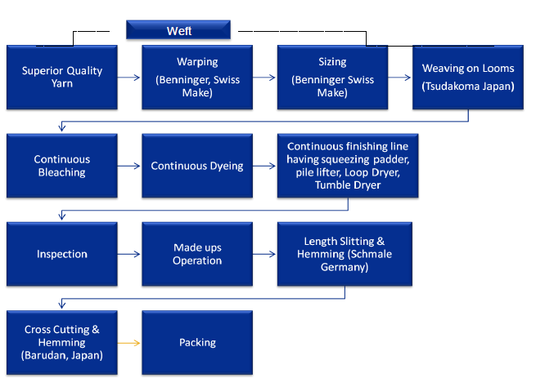

The basic manufacturing process for terry towels is fabric weaving, finishing (bleaching, dyeing, printing etc), making up and packing. The details of manufacturing process are as under:

* **Warping** : At warping the individual cones are put into creel (the number of cones depends upon fabric construction) and yarn from individual cones is pulled together in sheet form, wound on a barrel called warping beams (for Direct warping) or on weaving beams (for Sectional Warping). If warp sheet is with patterns of different colored yarns, it is processed on sectional warping machine.
* **Sizing:** Warp yarns are subject to very high tension and intensive abrasive action during weaving. Yarn needs protection for such abrasive action, otherwise frequent yarn breaks will occur in weaving. The object of sizing is to improve the strength of yarn by chemically binding the fibres with each other and to improve its friction resistance capacity by chemically coating the surface of yarn/fibres. Further, number of threads in warper beam sheet is very less against number of threads required in whole width of fabric. Hence multiplication of sheets by drawing yarns together from many warps beams and again making one sheet is also performed on sizing machine. In case the yarn sheet presented to sizing is from sectional warping machine, this multiplication is not required.
* **Drawing – in:** Weaving is basically interlacements of two sets i.e. warp and weft threads in desired sequence and pattern. To obtain this interlacement, warp yarn sheet is bifurcated & opened in form of two layers/sheet and weft thread is inserted between so opened two warp sheets. During subsequent cycle, the sheet forming upper layer is lowered and made to form lower layer and vis-à-vis for opposite sheet. Thus the interlacement is formed. In order to get this sheet separation and their up and down movement, each warp thread is to be drawn through healds, reeds and drop pins. This operation is called “Drawing - in”.
* **Beam Gaiting / Knotting on Weaving Machine:** The drawn weavers beams are fixed on weaving machines, threads are ‘tied and heald shafts are coupled. This operation is called Beam Gaiting. Further, tying-up of the undrawn warp threads to the threads of finished beams is called Knotting. These operations are essential because normally weavers beam can carry only certain length of warp sheet on it and when so woven, whole length is converted to the fabric by weaving machine. Further, warp length is required to be fed which can be done by knotting or gaiting other beams on weaving machine.
* **Weaving:** During weaving warp yarns are divided into two sheets called top shed and bottom shed and a weft is inserted inside the shed. Weft can be inserted by mechanical means, by air or by water. For sheeting fabrics, weft insertion by air jet is very common. This type of loom is known as air-jet loom. Looms producing sheeting fabrics have large width as compared to those producing apparel fabrics. Reed space of looms in sheeting division is 340 cm. Shed formation in looms are of three types : cam, dobby and jacquard. Cam shedding is used for simple structures like plain, twill, sateen, oxford, matt etc. Dobby shedding can produce little motifs. Jacquards are used to produce large motifs on fabric. Fabric woven on loom is wound on to a roll on the loom. This fabric is known as grey or greige fabric. Grey fabric rolls are sent to inspection department.
* **Processing:** The fabric woven on weaving machines is in Grey stage and needs certain chemical/mechanical treatments to get its final finished stage. Since these operations are altogether specialised and different from weaving technology, fabric is sent to process department wherein fabric is passed through the following processing stages;
* **Singeing & Desizing -** In singeing, the fabric runs on gas flame at a high speed of 80 Mtrs to 100 Mtrs/min. and the protruding fibres on the surface of fabrics are burnt during this process. After singeing, the fabric appears as clean shave look and then sent for desizing. During desizing, the fabrics are impregnated with enzyme solution to remove size chemicals (used prior to weaving during sizing process). Impregnated desized fabrics are kept on rotating batches for a period of 6 to 8 hours for effective removal of sizing chemicals.
* **Open width Scouring and Bleaching -** Desized fabrics are first washed in a bath of water and then treated for scouring and bleaching with caustic soda, good detergent /soap and peroxide with stabiliser. Fabric then passed through steamer so that reaction takes place with impurities and they are fully dissolved. The fabrics so washed are then clean and absorbent. This process is very important for obtaining good quality results in dyeing and printing.
* **Finishing -** The fabric is finished to finally keep control on width, bow and skew and its shrinkage. Further, to improve handle of fabrics special chemicals are used. Finishing is also done for obtaining stain free, soft and supple finish on fabrics. By using properly processed fabrics with appealing colors fast to washings, light, rubbing perspiration and having specialty finishes, fabrics look and value is added.
* **Length cutting -** Fabrics are cut to the desired width as per requirement on this machine. (At a time a full width fabric can be cut up to four different widths) on this machine accurately and automatically.

The terry towels are thoroughly checked for various types of defects such as uneven dyeing, quality of hemming, length and width, bleaching and dyeing defects, stitching defects, oil stains, patches /pattas. The final product is categorised quality-wise. The products then found okay are segregated and sent to packing department whereas defective ones are sent to correction.

Sets are formed as per the requirements of buyer in desired nos. and sizes and are packed together.

After inspection, the sets are wrapped in polythene bags and send for packing in suitable form as per buyer’s specifications. Sets so formed and packed are then sent for final dispatches.

1. **PROJECT EXECUTION**

#### 4.1) SITE SETUP: -

The project site setup as on LIE 3rd Visit is as under: -

| S. No | Particular | Status as on LIE 3rd Visit |
| --- | --- | --- |
| 1 | Power | Available for construction |
| 2 | Water | Available for construction |
| 3 | Project Team | Available |
| 4 | Timing | 8.00 a.m to 6.00 p.m |
| 5 | Project Office Setup | Furniture and office Equipments etc. |
| 6 | Staff | Recruitment ongoing |
| 7 | Lighting | Flood Lights |
| 8 | Labour Camp | Available |
| 9 | Canteen | Available |

**OBSERVATIONS: -**

The site setup is satisfactory. The photographs of site setup are provided for ready reference in Photograph Section.

#### 4.2) MANPOWER: -

The recruitment for the project execution is as under: -

| S. No | Particular | Nos. |
| --- | --- | --- |
| 1 | Project Head | 1 |
| 2 | Civil Engineer | 3 |
| 3 | Mechanical Engineer | 11 |
| 4 | Electrical Engineer | 3 |
| 5 | Maintenance, Operations, Total Quality Management, Product Development | 139 |
| 6 | Stores, Finance & Accounts, Training & Development | 6 |

The outsource contract staff is as under: -

| S. No | Particular | Nos. |
| --- | --- | --- |
| 1 | Security | Common Plot Security |
| 2 | Erection | 4 Teams |
| 3 | Contractor | 4 Teams |

#### OBSERVATIONS: -

The project team is experienced to handle the day-to-day operations of the project.

#### 4.3) COST OF THE PROJECT: -

WHSL is proposes to set-up a terry towel manufacturing facility at Survey No. 674/P & 890/P, located in Welspun City, Village-Versamedi, Taluka-Anjar, District- Kachchh, PIN Code-370 110, State- Gujarat, Country-India on a land admeasuring 36,422 Sq. M. Total estimated project cost is Rs. 303.32 Crores as indicated in table provided below for ready reference.

| S. No | Particular of Project | Estimated Project Cost (Rs. in Crores) |
| --- | --- | --- |
| A | Hard Cost |  |
| 1. | Land | 0* |
| 2. | Site Development and Building Cost | 42.59 |
| 3. | Plant & Machinery | 178.53 |
| 4. | Miscellaneous Fixed Asset | 44.13 |
|  | **Total (A)** | **265.24** |
| **B** | **Soft Cost** |  |
| 5. | Contingencies | 6.63 |
| 6. | IDC including Preoperative and Preliminary Expenses | 13.45 |
| 7. | Margin money for working capital | 18.00 |
|  | **Total (B)** | **38.08** |
|  | **Total (A+B)** | **303.32** |

**NOTE:-**

* *The Land admeasuring 36,422 m² is leased from WLL.
* Cost of Land is not considered in the project cost.

**MEANS OF FINANCE**

| S. No | Particular of Project | Estimated Project Cost (Rs. in Crores) |
| --- | --- | --- |
| 1. | Promoter Contribution | 78.32 |
| 2. | Term Loan | 225.00 |
|  | **Total** | **303.32** |

**OBSERVATIONS:-**

* EXIM Bank has sanctioned the term loan of Rs. 225.00 Crores for the proposed project vide revised sanction Letter Ref. No. CBG:EOU-1197:2024-25:111 dated 26.06.2024.

#### 4.4) EXPENDITURE ON PROJECT: -

The expenditure on Cost on Project as on 21.10.2024 as per CA Certificate is as under: -

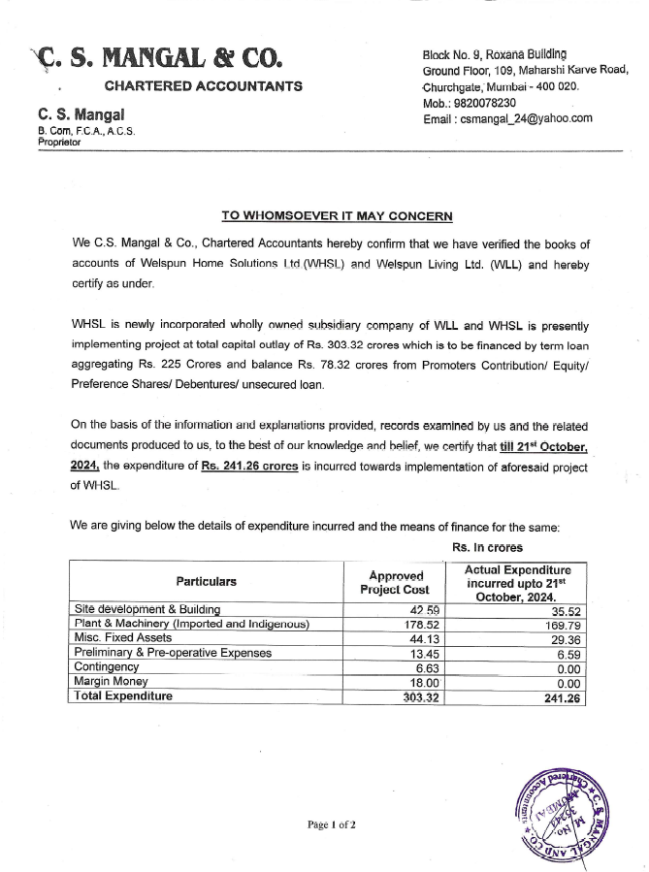

The expenditure on Cost on Project as on 21.10.2024 as per CA Certificate is as under: -

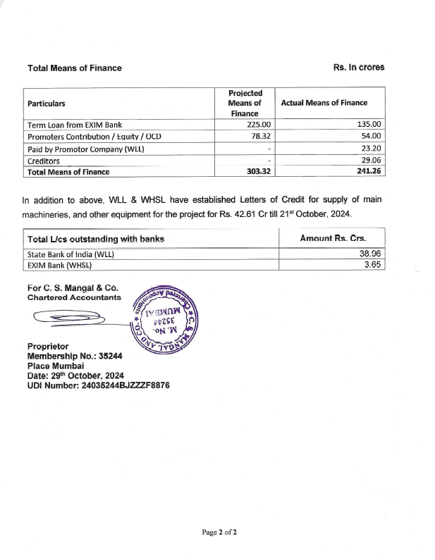

#### 4.5) COST INCURRED TOWARD SITE DEVELOPMENT & BUILDING: -

As per C.A Certificate dated 29.10.2024, the Cost incurred towards site development & Building till 21.10.2024 is Rs. 35.52 Crores and the details are as under:-

|  |  |  |  |  |
| --- | --- | --- | --- | --- |
| S. No. | WBS Description | Head | Head-2 | Cost incurred till 21.10.2024 (Rs.) |
| 1 | Site Grading & Level | Land & Site Development | Site Grading & Level | 7,92,960 |
| 2 | Horticulture | Land & Site Development | Horticulture | 5,60,650 |
| 3 | Civil & Consultant | Civil Work | Civil & Consultant | 3,00,00,000 |
| 4 | Site Grading & Level | Land & Site Development | Land & Site Development | 18,00,833 |
| 5 | Horticulture | Land & Site Development | Land & Site Development | 11,15,415 |
| 6 | Weaving Shed | Civil Work | Weaving Shed | 11,09,13,839 |
| 7 | Annex Building | Civil Work | Annex Building | 3,48,95,154 |
| 8 | Yarn Storage Area | Civil Work | Yarn Storage Area | 30,33,622 |
| 9 | Yarn Dyeing | Civil Work | Yarn Dyeing | 59,51,139 |
| 10 | Fabric Process Shed | Civil Work | Fabric Process Shed | 6,05,13,028 |
| 11 | Roads | Civil Work | Roads | 12,63,938 |
| 12 | Electrical Substation | Civil Work | Electrical Substation | 16,76,102 |
| 13 | Misc Tanks for Water | Civil Work | Misc Tanks for Water | 9,41,250 |
| 14 | Misc Foundations for | Civil Work | Misc Foundations for | 1,31,98,832 |
| 15 | Storm Water Drain, Pa | Civil Work | Storm Water Drain, Pa | 34,67,390 |
| 16 | Civil & Consultant | Civil Work | Civil & Consultant | 39,38,630 |
| 17 | Vastu Consultant | Civil Work | Vastu Consultant | 2,30,59,000 |
| 18 | PMC /Quality Consult | Civil Work | PMC /Quality Consult | 21,83,434 |
| 19 | Warping Area Trenches | Civil Work | Warping Area Trenches | 67,21,189 |
| 20 | Weaving Trenches | Civil Work | Weaving Trenches | 1,50,18,593 |
| 21 | H-Plant | Civil Work | H-Plant | 3,09,36,280 |
| 22 | Winding H-Plant | Civil Work | Winding H-Plant | 1,43,813 |
| 23 | Production Area - Fa | Civil Work | Production Area - Fa | 30,79,722 |
|  |  |  | **Total** | **35,52,04,813** |

#### 5.6) COST INCURRED TOWARDS PLANT & MACHINERY: -

As per C.A Certificate dated 29.10.2024, the Cost incurred towards Plant & Machinery till 21.10.2024 is Rs. 169.79 Crores.

| S. No. | WBS Description | Head | Head-2 | Cost incurred till 21.10.2024 (Rs.) |
| --- | --- | --- | --- | --- |
| A | Plant & Machinery Indigenous |  |  |  |
| 1 | Sectional Warping Machine | P & M -Indigenous | Weaving | 3,64,13,105 |
| 2 | Sizing Machine | P & M -Indigenous | Weaving | 4,11,05,275 |
| 3 | Direct Warping | P & M -Indigenous | Weaving | 1,64,96,026 |
| 4 | Beams - Weaving | P & M -Indigenous | Weaving | 2,35,45,908 |
| 5 | Beams | P & M -Indigenous | Weaving | 38,24,552 |
| 6 | Sizing Cooker & Vess | P & M -Indigenous | Weaving | 28,96,346 |
| 7 | Racks for Yarn Stora | P & M -Indigenous | Weaving | 1,34,91,002 |
| 8 | Forklift/Stacker | P & M -Indigenous | Weaving | 97,500 |
| 9 | Machine Erection 2 f | P & M -Indigenous | Weaving | 6,53,000 |
| 10 | Post Winding Machine | P & M -Indigenous | Yarn Dyeing, Fabric | 7,01,52,200 |
| 11 | RF Dryer 125 | P & M -Indigenous | Yarn Dyeing, Fabric | 1,33,28,000 |
| 12 | Sectional Warping Ma | P & M -Indigenous | Weaving | 24,36,000 |
| 13 | Direct Warping | P & M -Indigenous | Weaving | 9,44,000 |
| 14 | RF Dryer 125 | P & M -Indigenous | Yarn Dyeing, Fabric Dying | 24,50,000 |
|  |  |  | **Total (A)** | **22,78,32,914** |
| **B** | **Plant & Machinery-Imported** |  |  |  |
| 1 | Air jet Loom with Gan | P & M -Import | Weaving Dept. | 23,11,58,393 |
| 2 | Jacquard Loom | P & M -Import | Weaving Dept. | 19,36,85,408 |
| 3 | Dobby Loom | P & M -Import | Weaving Dept. | 28,70,48,168 |
| 4 | Beam Knotting Machin | P & M -Import | Weaving Dept. | 1,02,49,867 |
| 5 | Wvg + prep MHE | P & M -Import | Weaving Dept. | 70,000 |
| 6 | Machine Erection 1 f | P & M -Import | Weaving Dept. | 5,16,400 |
| 7 | Yarn Dyeing-50 kg | P & M -Import | Yarn Dyeing | 1,30,45,502 |
| 8 | Yarn Dyeing-100 Kg | P & M -Import | Yarn Dyeing | 1,96,65,184 |
| 9 | Yarn Dyeing-200 KG | P & M -Import | Yarn Dyeing | 1,54,47,686 |
| 10 | Yarn Dyeing-300 Kg | P & M -Import | Yarn Dyeing | 87,00,435 |
| 11 | Yarn Dyeing-500 Kg | P & M -Import | Yarn Dyeing | 2,20,20,782 |
| 12 | Yarn Dyeing-750 Kg | P & M -Import | Yarn Dyeing | 3,11,58,398 |
| 13 | Yarn Dyeing-900 Kg | P & M -Import | Yarn Dyeing | 3,62,77,736 |
| 14 | Yarn Dyeing-1200 Kg | P & M -Import | Yarn Dyeing | 4,01,68,206 |
| 15 | Soft Winding Machine | P & M -Import | Yarn Dyeing | 8,48,98,480 |
| 16 | Color Kitchen | P & M -Import | Yarn Dyeing | 8,61,93,507 |
| 17 | Hydro Extractors | P & M -Import | Yarn Dyeing | 1,19,54,610 |
| 18 | Yarn Sampling Machin | P & M -Import | Yarn Dyeing | 3,99,02,818 |
| 19 | Yarn Dyeing area- BB | P & M -Import | Yarn Dyeing | 71,31,291 |
| 20 | Fabric Dyeing M/c - | P & M -Import | Fabric Dyeing, Washing | 3,58,87,099 |
| 21 | Fabric Dyeing Machin | P & M -Import | Fabric Dyeing, Washing | 2,64,43,125 |
| 22 | Fabric Dyeing Machin | P & M -Import | Fabric Dyeing, Washing | 1,96,76,238 |
| 23 | Fabric Dyeing Machin | P & M -Import | Fabric Dyeing, Washing | 89,01,050 |
| 24 | Fabric Dyeing Machin | P & M -Import | Fabric Dyeing, Washing | 56,61,673 |
| 25 | Lab | P & M -Import | Fabric Dyeing, Washing | 12,61,030 |
| 26 | Color Kitchen | P & M -Import | Fabric Dyeing, Washing | 8,64,873 |
| 27 | Finishing Line new | P & M -Import | Fabric Dyeing, Washing | 4,39,91,913 |
| 28 | Shearing Machine - D | P & M -Import | Fabric Dyeing, Washing | 3,19,81,698 |
| 29 | Fabric Dyeing Machin | P & M -Import | Fabric Dyeing, Washing | 1,53,46,456 |
| 30 | Fabric Dyeing Machin | P & M -Import | Fabric Dyeing, Washing | 65,58,781 |
| 31 | Fabric Dyeing Machin | P & M -Import | Fabric Dyeing, Washing | 51,94,185 |
| 32 | Fabric Dyeing area-B | P & M -Import | Fabric Dyeing, Washing | 31,39,767 |
| 33 | Fabric Dyeing Machin | P & M -Import | Fabric Dyeing, Washing | 3,01,70,532 |
| 34 | Fabric Dyeing Machin | P & M -Import | Fabric Dyeing, Washing | 67,48,239 |
| 35 | Finishing Line 2 Bia | P & M -Import | Fabric Dyeing, Washing | 3,76,79,910 |
| 36 | Tow Truck EGS70 | P & M -Import | Fabric Dyeing, Washing | 2,72,000 |
| 37 | Air jet Loom with Gantry | P & M -Import | Weaving | 1,74,14,416 |
| 38 | Lab | P & M -Import | Fabric Dyeing | 1,27,71,840 |
| 39 | Finishing Line new | P & M -Import | Fabric Dyeing | 1,49,68,214 |
| 40 | Shearing Machine - D | P & M -Import | Fabric Dyeing | 58,77,427 |
|  |  |  | **Total (B)** | **1,47,01,03,337** |
|  |  |  | **Total (A+B)** | **1,69,79,36,251** |

#### 4.6. A.) LIST OF HSSA: -

List of High Seas Sale Agreements (HSSA) executed between WHSL and WLL till the date of this report for purchase of new unused machinery (having usable life of more than ten years) by WHSL from WLL for implementation of WHSL project of Rs. 303.32 crores is as under:-

| S. No. | Description | Supplier Name | Qty. | HSSA Date | HSSA Amount (Rs.) | Amount Paid in INR by WHSL to WLL (Rs.) |
| --- | --- | --- | --- | --- | --- | --- |
| 1 | Soft Winding Machines | SSM Vertriebs AG | 3 | 07-May-24 | 8,39,60,280 | 8,35,06,023 |
| 2 | Hydroextractor | Galvanin S.P.A | 3 | 30-May-24 | 73,79,619 | 73,44,076 |
| 3 | Tumbler | Biancalani S.R.L | 1 | 06-Jun-24 | 3,64,42,560 | 3,64,13,400 |
| 4 | Jacquard | Vandewiele NV | 24 | 20-Jun-24 | 14,88,67,860 | - |
| 5 | Jacquard | Vandewiele NV | 12 | 30-May-24 | 4,01,77,920 | - |
| 6 | Looms | Tsudakoma Corp | 26 | 04-Jun-24 | 18,27,39,986 | 17,98,71,217 |
| 7 | Looms | Tsudakoma Corp | 24 | 04-Jun-24 | 14,49,47,916 | 14,05,13,289 |
| 8 | Looms | Tsudakoma Corp | 24 | 30-May-24 | 13,49,69,304 | 14,11,97,703 |
| 9 | 1 No. High Performance Sizing Machine Type Prosize with All Standard Accessories | Karl Mayer Textilmaschinen Ag, | 1 | 06-Jun-24 | 3,98,59,050 | 3,93,12,481 |
| 10 | Universal Tying Machine Along with Standard Accessories | Groz-Beckert Europe Gmbh | 18 | 01-Jul-24 | 1,00,82,835 | 99,47,423 |
| 11 | Dyeing Machines | Fong's National Engineering Co Ltd | 14 | 10-Jul-24 | 9,57,06,045 | 7,51,45,854 |
| 12 | Dyeing Machines | Fong's National Engineering Co Ltd | 10 | 16-Jul-24 | 12,37,42,880 | 9,71,59,630 |
| 13 | Fully Automatic Dyes and Chemicals Dispensing | Color Service SRL | 15 | 30-Jul-24 | 8,33,62,356 | 8,29,42,646 |
| 14 | Multidirectional Reach Truck Model | Combilift ULC | 1 | 29-Jul-24 | 79,26,257 | 79,37,506 |
| 15 | Vollenweider Shearing Machine | Xetma Vollenweider Gmbh | 2 | 22-Aug-24 | 3,12,95,048 | 2,50,52,596 |
| 16 | HTHP Dyeing Machine with Standard Accessories and Spares | Brazzoli S.R.L | 11 | 22-Aug-24 | 12,29,77,150 | 9,74,49,765 |
| 17 | Weft Straightener Orthopac | Mahlo Gmbh Co.Kg | 20 | 24-Sep-24 | 1,24,26,913 | 1,14,59,339 |
| 18 | HTHP Dyeing Machine with Standard Accessories and Spares | Brazzoli S.R.L | 3 | 13-Sep-24 | 3,59,87,028 | 2,93,78,899 |
|  |  |  |  | **Total** | **1,34,28,51,007** | **1,06,46,31,847** |

**OBSERVATIONS:-**

* As informed by WHSL, Letters of Credit for import of critical machines for the project have been established by WLL. These machines are being sold by WLL to WHSL on High Seas Sale basis and WLL and WHSL have executed/ to be executed High Seas Sale Agreement (HSSA). Promoters of WHSL will have to arrange payment of additional Mark-up cost of about 2% over and above the actual machinery cost which is/ to be incurred by WLL for procurement of machines.
* The machinery cost including L/C opening charges, L/C amendment charges, L/C retirement charges and difference between High Seas Sale Agreement cost and the actual cost incurred by WLL due to change in assumed exchange rate in HSSA and actual exchange rate incurred by WLL shall be reimbursed by WHSL to WLL. Mark-up machinery value by about 2% of the actual machinery cost, in our opinion is fair and reasonable. The said mark-up machinery value is funded solely by WLL.

#### 4.7) COST INCURRED TOWARDS MISCELLANEOUS FIXED ASSET: -

As per C.A Certificate dated 29.10.2024, the Cost incurred towards MFA till 21.10.2024 is   
Rs. 29.36 Crores.

| S. No. | WBS Description | Heading | Total Rs. |
| --- | --- | --- | --- |
| 1 | Soft Water System | Misc. Fixed Assets | 1,40,60,031 |
| 2 | Effluent Treatment | Misc. Fixed Assets | 65,24,473 |
| 3 | Chilled Water System | Misc. Fixed Assets | 2,85,000 |
| 4 | Compressor, Pipeline | Misc. Fixed Assets | 77,01,713 |
| 5 | Pipeline -Supports/P | Misc. Fixed Assets | 26,48,085 |
| 6 | Steam System | Misc. Fixed Assets | 1,71,94,009 |
| 7 | Fire System | Misc. Fixed Assets | 33,71,890 |
| 8 | HVAC & Ventilation S | Misc. Fixed Assets | 3,59,63,203 |
| 9 | Electrical | Misc. Fixed Assets | 2,94,56,280 |
| 10 | IT Related Expenses | Misc. Fixed Assets | 83,38,967 |
| 11 | Soft Water System | Misc. Fixed Assets | 12,97,29,803 |
| 12 | Effluent Treatment | Misc. Fixed Assets | 6,31,990 |
| 13 | Misc Pumps & Drains | Misc. Fixed Assets | 2,42,280 |
| 14 | Chilled Water System | Misc. Fixed Assets | 12,71,437 |
| 15 | Pipeline -Supports/ | Misc. Fixed Assets | 1,49,047 |
| 16 | Steam System | Misc. Fixed Assets | 1,21,87,486 |
| 17 | Fire System | Misc. Fixed Assets | 4,40,335 |
| 18 | H Plant-Wvg | Misc. Fixed Assets | 2,25,700 |
| 19 | H Plant-Prep | Misc. Fixed Assets | 24,81,260 |
| 20 | Electrical | Misc. Fixed Assets | 1,59,73,750 |
| 21 | EOT for Yarn Dyeing | Misc. Fixed Assets | 44,61,200 |
| 22 | IT Related Expenses | Misc. Fixed Assets | 2,32,092 |
|  |  | **Total** | **29,35,70,030** |

#### 4.8) COST INCURRED TOWARDS PRELIMINARY AND PRE-OPERATIVE EXPENSES: -

As per C.A Certificate dated 29.10.2024, the Cost incurred towards preliminary and pre-operative expenses till 21.10.2024 is Rs. 6.59 Crores.

|  |  |  |
| --- | --- | --- |
| S. No. | WBS Description | Total Rs. |
| 1 | Interest During Construction & Training, Start-up expenses | 6,59,15,193 |
|  | **Total** | **6,59,15,193** |

#### 4.9) SUMMARY OF TOTAL COST INCURRED TOWARDS PROJECT: -

Summary for Cost incurred toward project till 21.10.2024 is as under:-

| S. No | Particular of Project | Estimated Project Cost (Rs. in Crores) | Cost incurred till 21.10.2024 (Rs. In Crores) |
| --- | --- | --- | --- |
| A | Hard Cost |  |  |
| 1. | Land | 0* | 0 |
| 2. | Site Development and Building Cost | 42.59 | 35.52 |
| 3. | Plant & Machinery | 178.53 | 169.79 |
| 4. | Miscellaneous Fixed Asset | 44.13 | 29.36 |
|  | **Total (A)** | **265.24** | **234.67** |
| **B** | **Soft Cost** |  |  |
| 5. | Contingencies | 6.63 | 0.00 |
| 6. | IDC including Preoperative and Preliminary Expenses | 13.45 | 6.59 |
| 7. | Margin money for working capital | 18.00 | 0.00 |
|  | **Total (B)** | **38.08** | **6.59** |
|  | **Total (A+B)** | **303.32** | **241.26** |

**OBSERVATIONS: -**

* Land is Leasehold, therefore land cost is not considered for the Project.
* Cost incurred toward total project is Rs. 241.26 Crores.

1. **PHOTOGRAPHS**

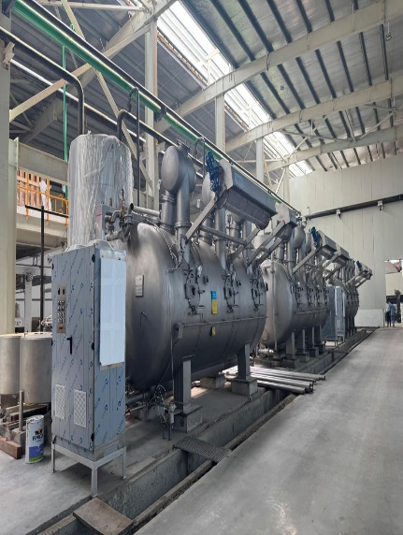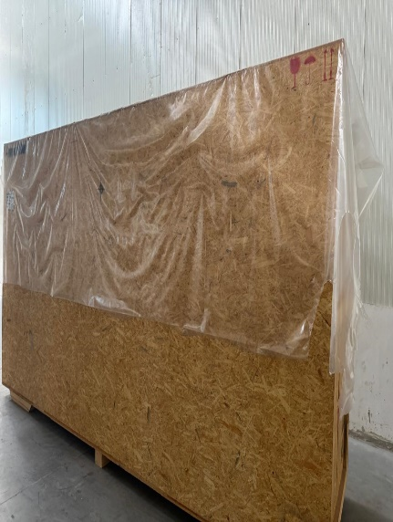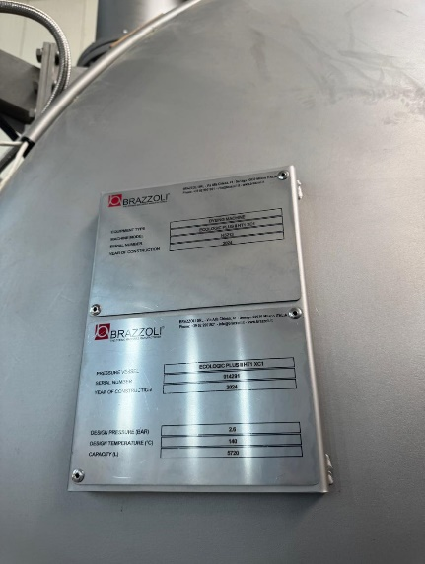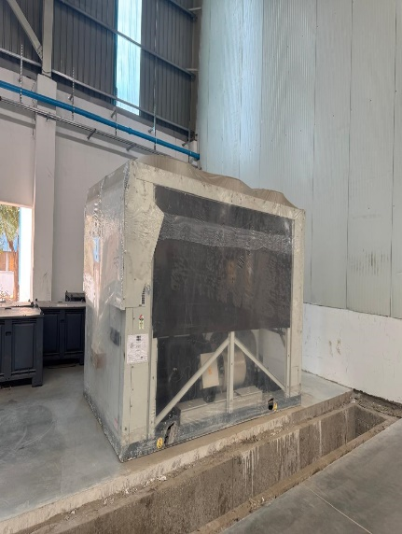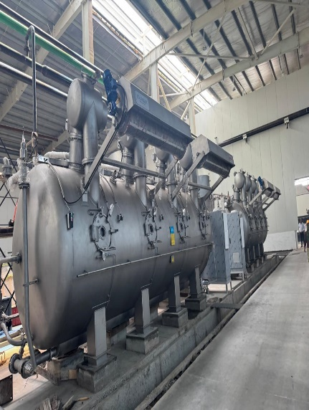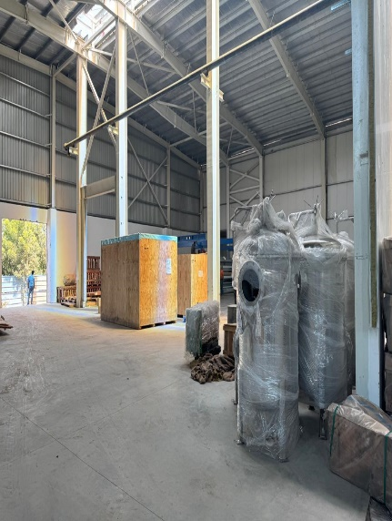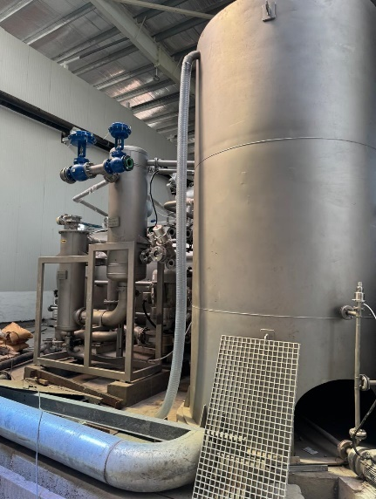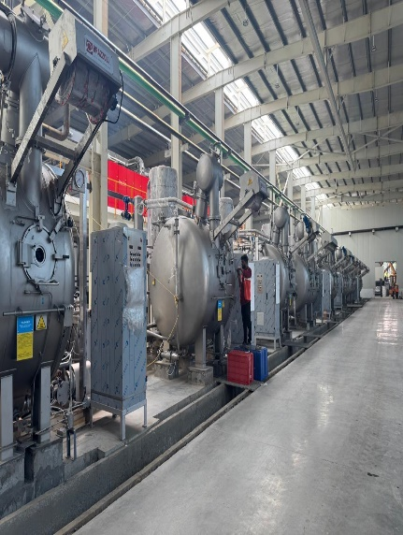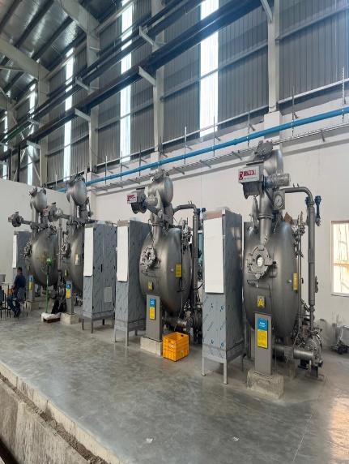

**PHOTOGRAPHS**

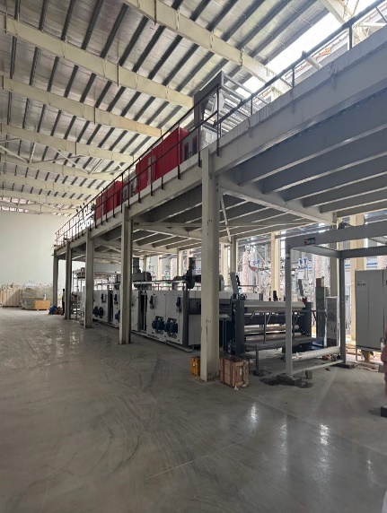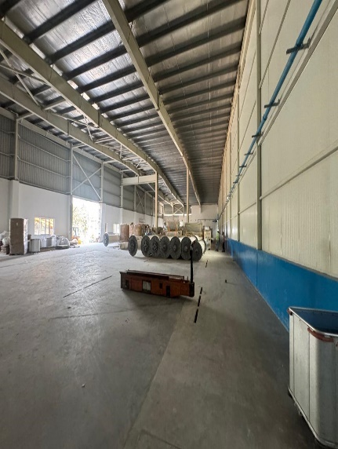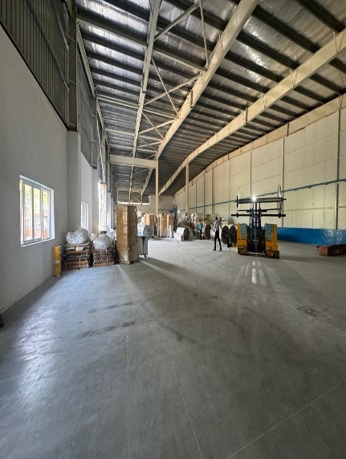

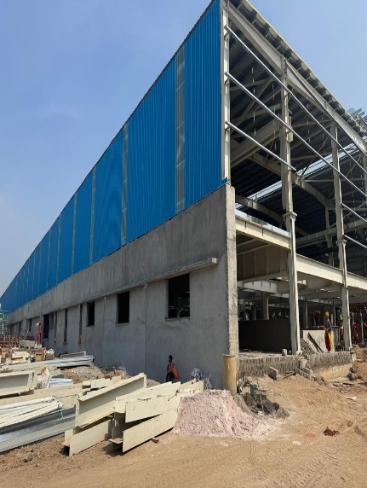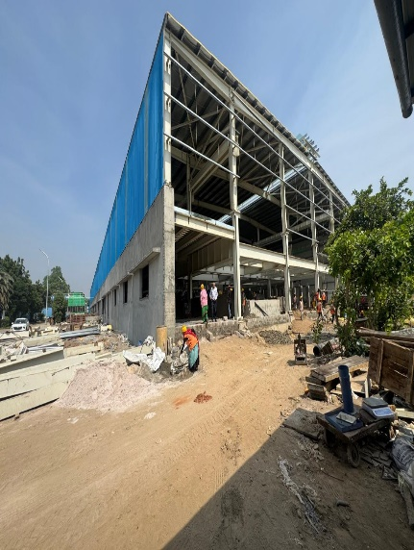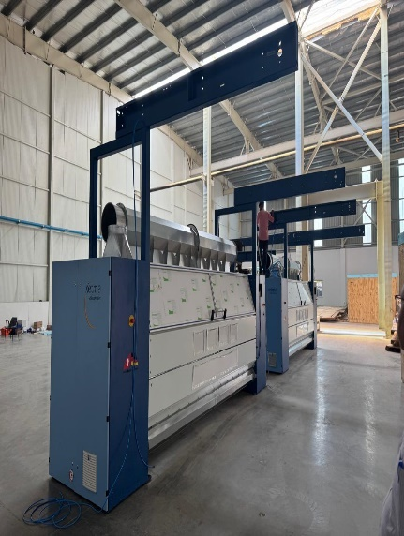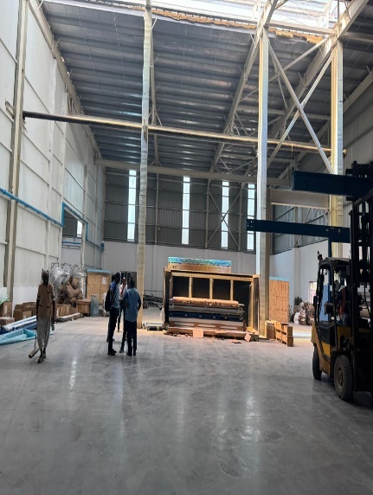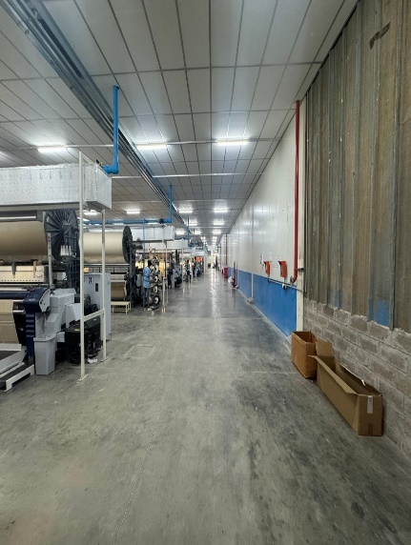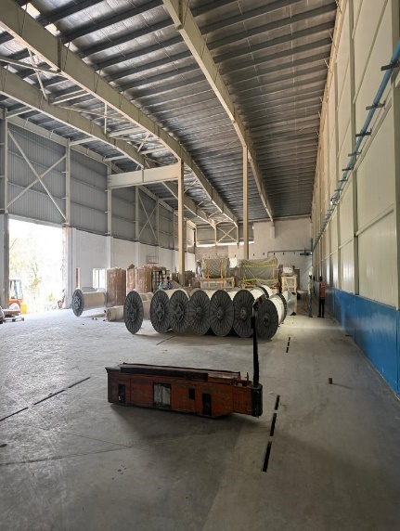

**PHOTOGRAPHS**

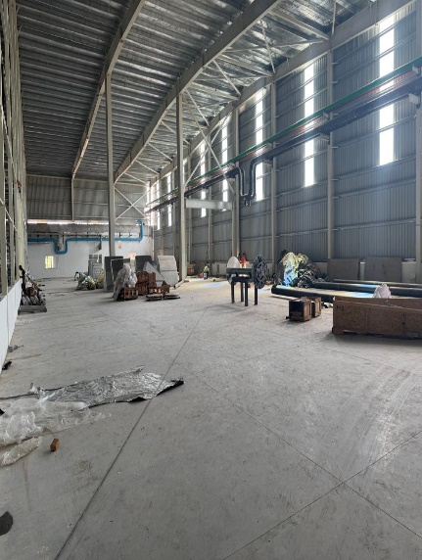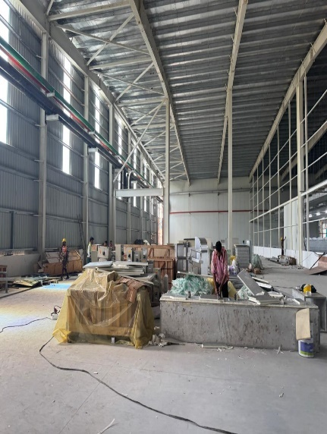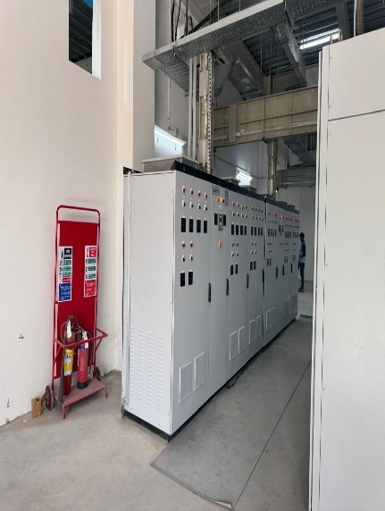

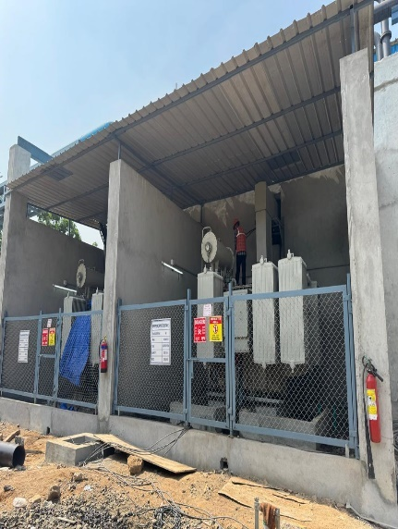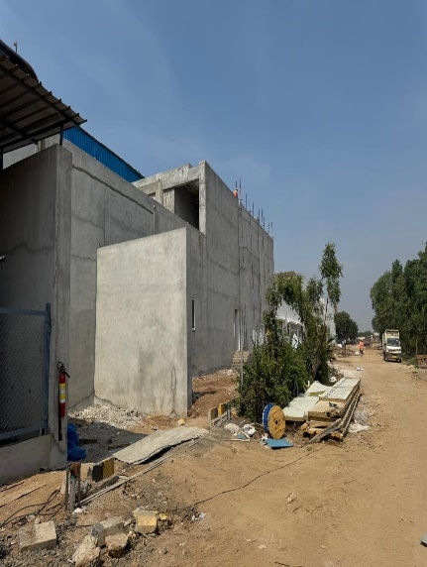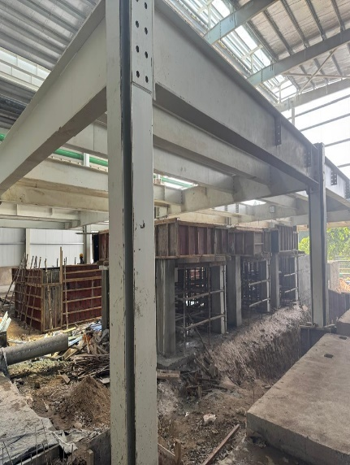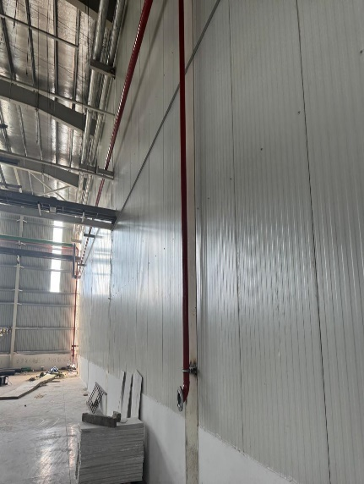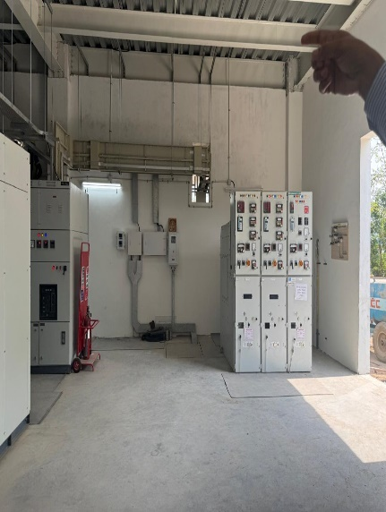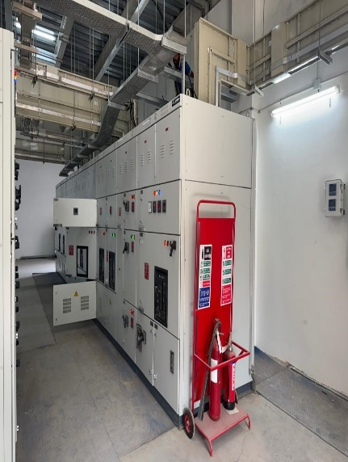

**PHOTOGRAPHS**

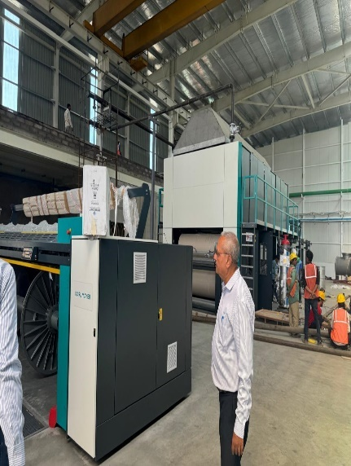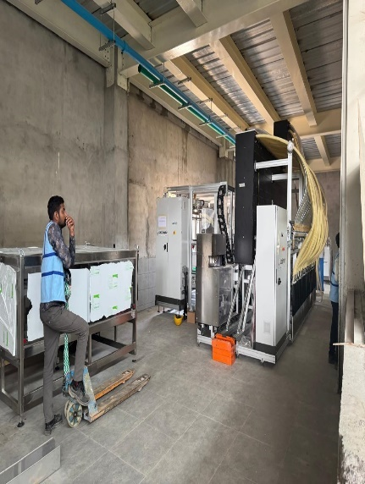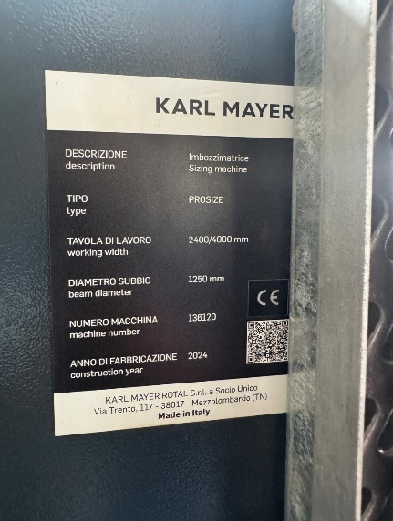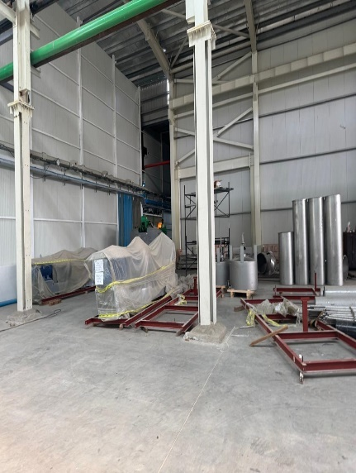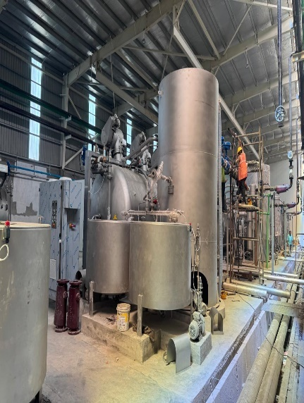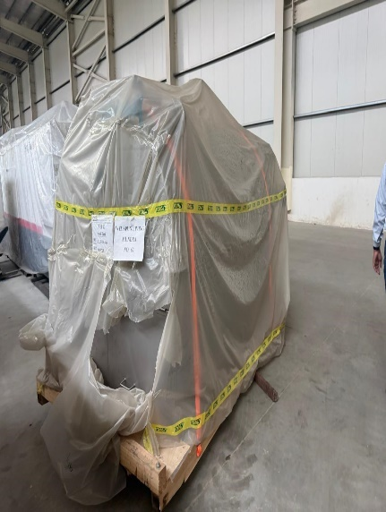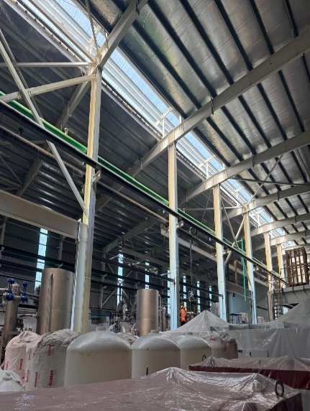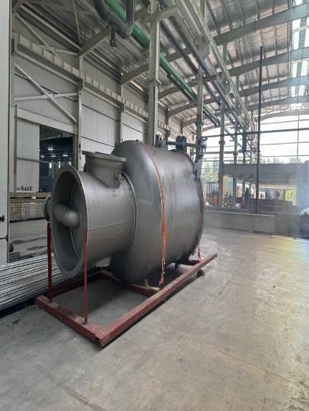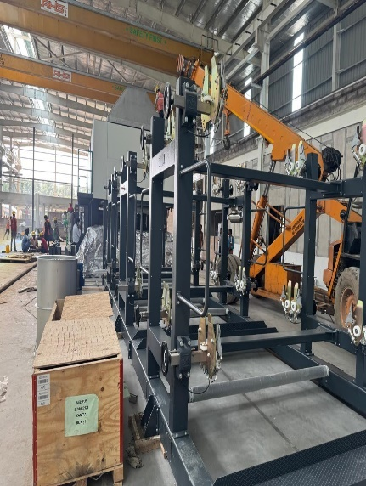

**PHOTOGRAPHS**

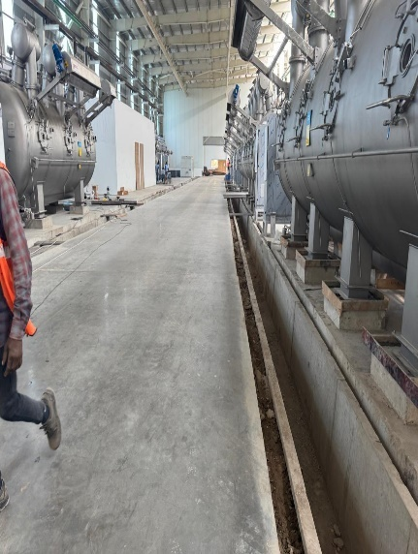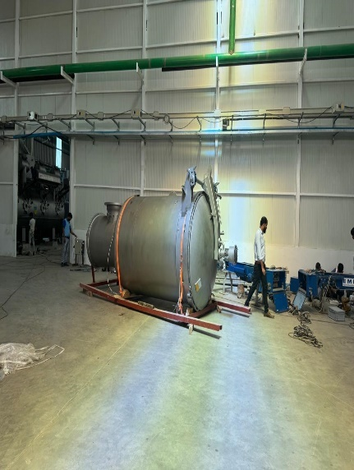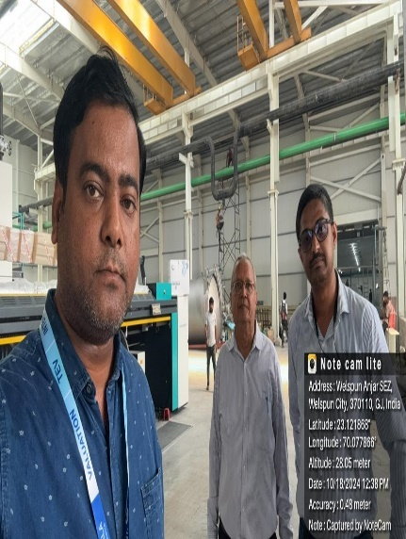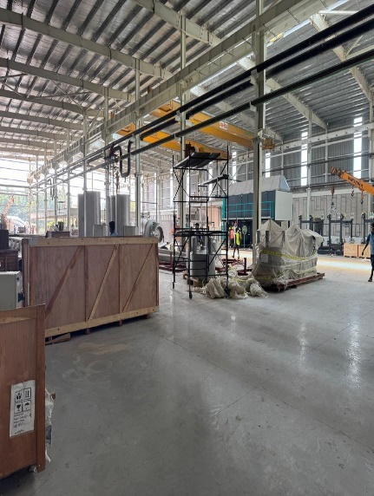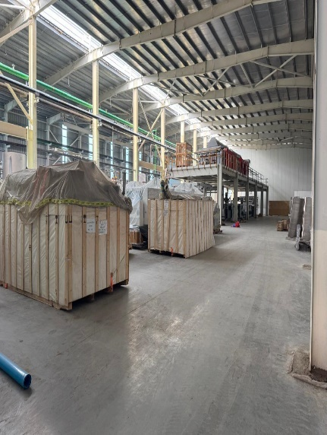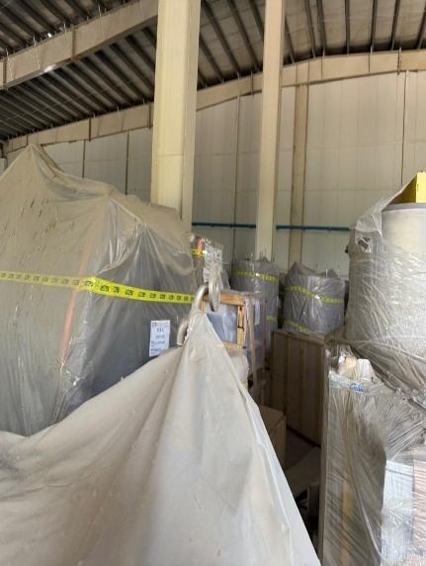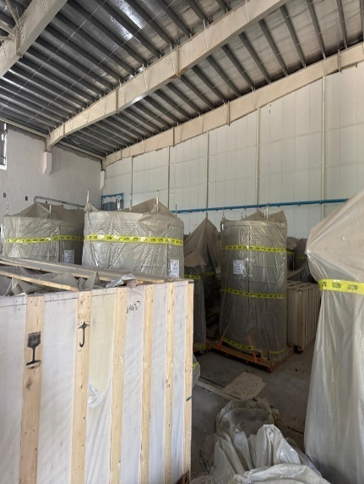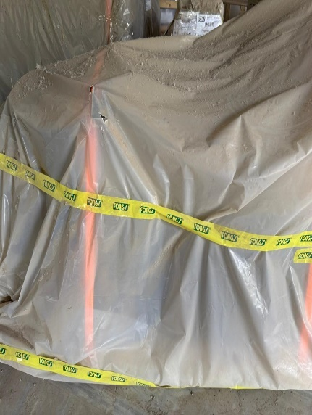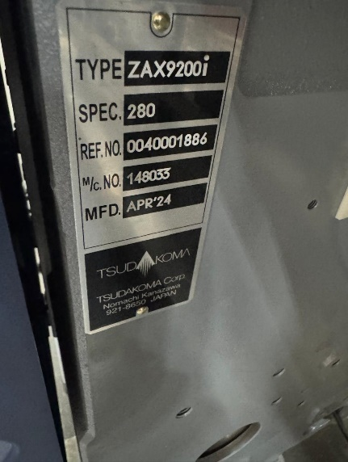

**PHOTOGRAPHS**

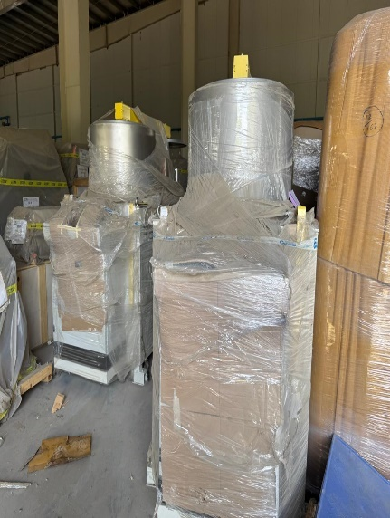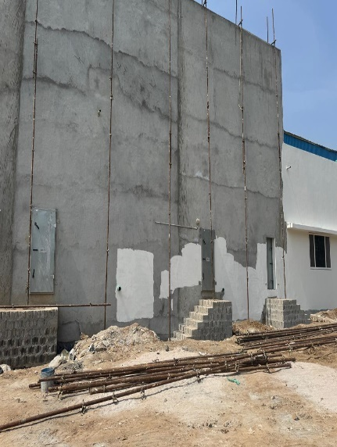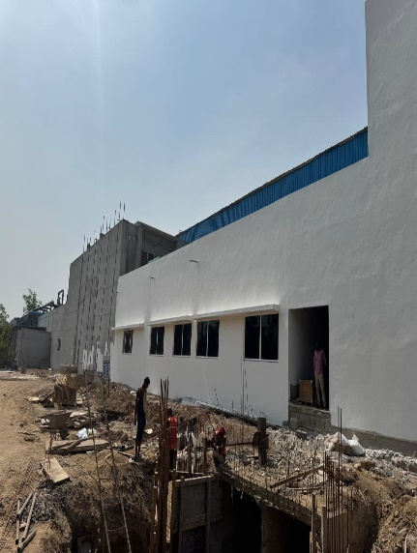

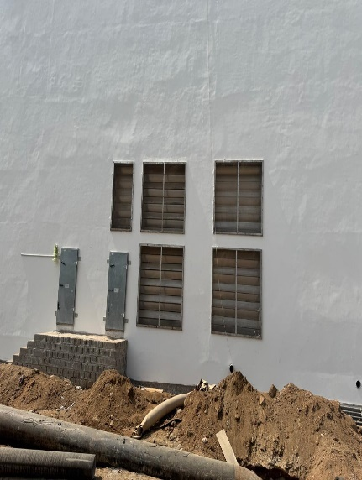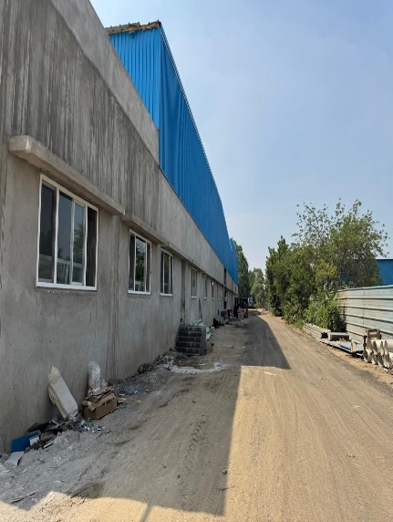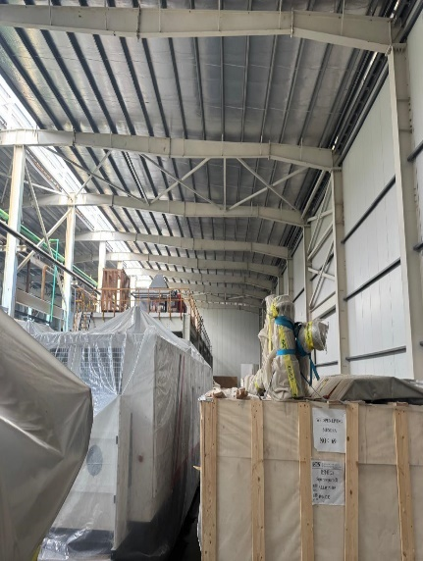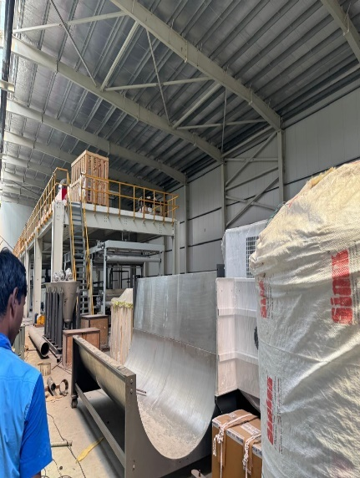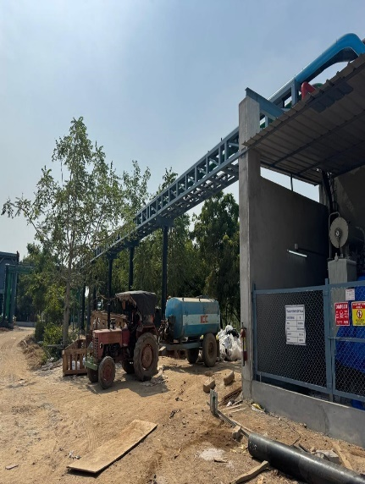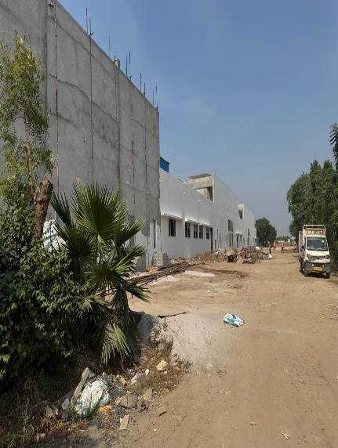

**PHOTOGRAPHS**

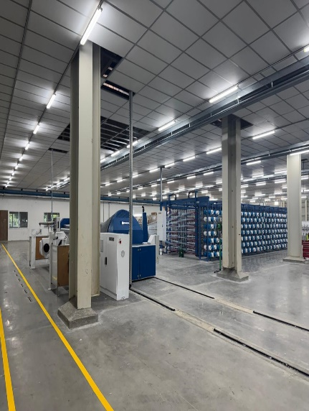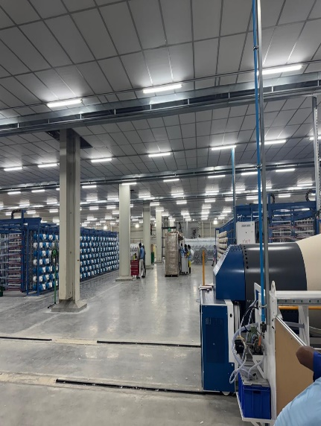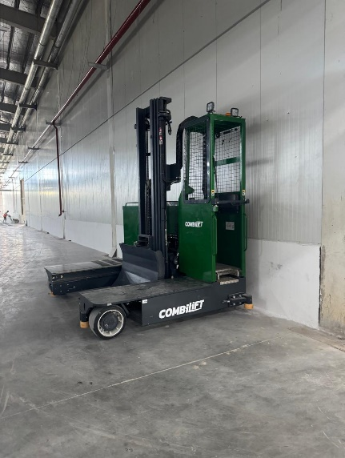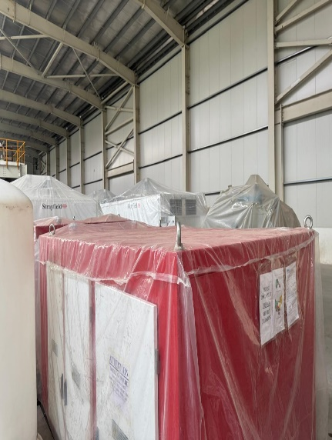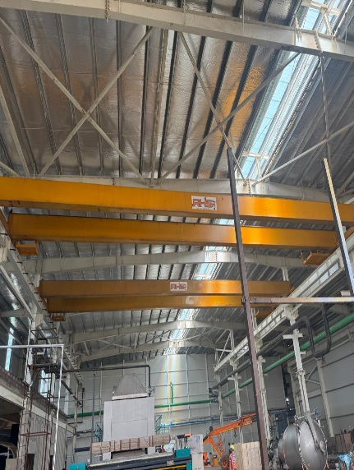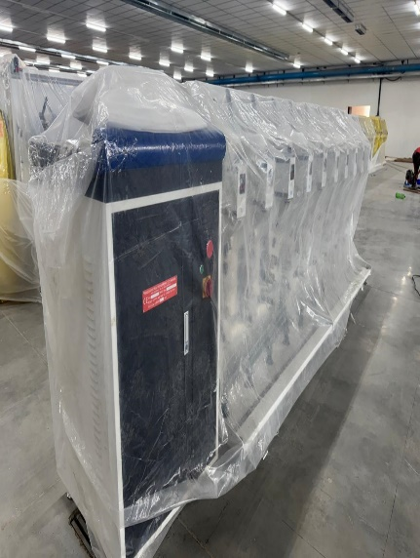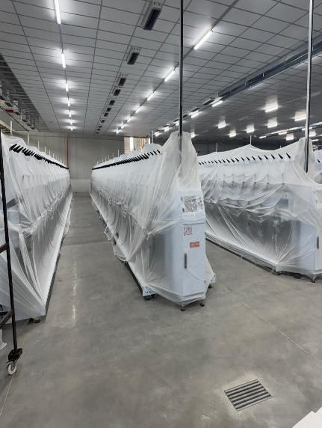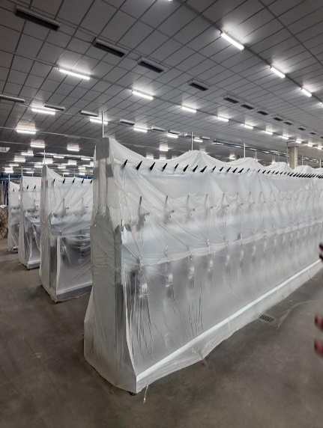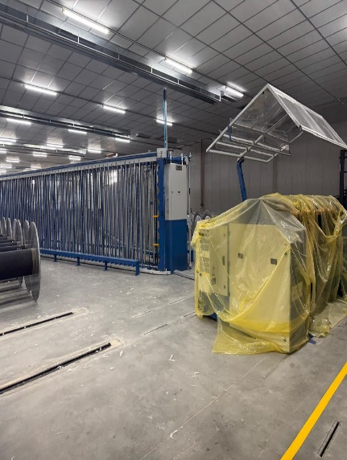

1. **NOTES, LIMITATIONS, DISCLAIMERS & CAVEATS**

#### Notes, Limitations, Disclaimers & Caveats forms important part of the report.

* The Lender’s independent engineer report is made to review the progress of project activities and to prepare the detail report outlining all activities completed along with the status.
* Our Engineer has visited the project site on 18.10.2024 with a view to ascertain and certify the quantity and amount of work progressively undertaken by the borrower.
* LIE progress report is based on the physical verification of the site on 18.10.2024, invoices provided, discussions held with the Company Officials and information and explanation given & documents provided. Accordingly, the percentage of work of completion of project activities is worked out. The photographs are enclosed.
* The progress of the project is as per our site visit and further information and documents provided by Company.
* The Company has provided the necessary documents. LIE has referred the same for preparation of report.
* During the date and time of our visit to the project site, the execution of project activities like final finishing of Main Plant Building, Installation of Plant & Machinery, Piping work, Electrical work is going on and it can be clearly seen from the photographs enclosed.
* The Credit details in other bank accounts are not verified by us and we have relied on CA Certificate and other documents provided by the party.
* Our report does not cover verification of ownership, title clearance, or legality and subject to adequacy of engineering / structural design.
* It should be noted that VCIPL’s project progress assessments are based upon the facts and evidence available at the time of assessment and the documents provided. The lenders should do the progress assessment from time to time.
* The legal documents pertaining to the ownership of the properties has been referred to on its face value and that is presumed that Bank /financer have got the same verified through its legal counsel. We do not certify the veracity of the documents. This report does not certify valid or legal or marketable title of any of the parties over the property. Our report does not cover verification of ownership, title clearance, or legality and subject to adequacy of engineering / structural design.
* Our report is only for the use of the party to whom it is addressed and no responsibility is accepted to any third party for the whole or any part of its contents.
* It is presumed that the soft copies of documents are taken from the originals duly tested and verified at the party’s end.
* The progress report is made based on our visit, information furnished, discussions, documents made available at the time of visit. We presume optimistically that the project assessed by us will be a top success project. In case on a future date if the project does not come up to an expectation of the lenders and borrowers, due to various factors i.e., socio, economic and political factors in this region and country, any decrease in projections, profits, non-repayment of regular installments of loan and interest thereon, the VCIPL should not be held responsible on a future date. The market scenario in India at particular and the whole world at large is at volatile trend since last many months and future cannot be anticipated as of date.
* Our report should be read along with disclaimers. We have given our opinion as the percentage of work completion of the project as on date of visit to the project site.

1. **SUMMARY**

#### 7.1) WORK COMPLETION FOR THE PROJECT: -

Activity wise progress of the project is as under: -

| S. No. | Activities | % of Work Completion |
| --- | --- | --- |
|  | **Project Documentation** |  |
| 1 | Detailed Project Report | 100% |
|  | **Statutory Clearances** |  |
| 2 | Building Plan (initial approval) | 100% |
| 3 | Pollution Control Board - Consent to establish | 100% |
| 4 | Pollution Control Board - Consent to operate | 0% |
| 5 | Power Sanction | 0% |
| 6 | Insurance | 100% |
| 7 | Bank Loan Sanction | 100% |
| 8 | Disbursement – Term loan (Fund + non-Fund) | 60% |
|  | **Site Setup** |  |
| 9 | Start of Payments | 100% |
| 10 | Registrations PAN Card, GST, IEC, IEM, etc. | 100% |
| 11 | Power –for construction purpose | 100% |
| 12 | Water - for construction purpose | 100% |
| 13 | Office setup at Site | 60% |
| 14 | Recruitment | 20% |
|  | **Civil Work** |  |
| 15 | Foundation | 100% |
| 16 | Flooring Work | 85% |
| 17 | Brick Work | 85% |
| 18 | Roof | 90% |
| 19 | Finishing | 50% |
| 20 | Road | 60% |
| 21 | Infrastructure | 60% |
| 22 | Drainage | 60% |
|  | **Plant & Machinery** |  |
|  | **Imported Plant & Machinery** |  |
| 23 | Vendor Selection | 95% |
| 24 | Purchase Order/ Contract/PI | 90% |
| 25 | Delivery | 80% |
| 26 | Erection | 60% |
| 27 | Installation | 60% |
| 28 | Electrification | 60% |
| 29 | Trials & Commissioning | 0% |
|  | **Indigenous Plant & Machinery** |  |
| 30 | Vendor Selection | 90% |
| 31 | Purchase Order/ Contract/PI | 80% |
| 32 | Delivery | 70% |
| 33 | Erection | 60% |
| 34 | Installation | 60% |
| 35 | Electrification | 60% |
| 36 | Trials & Commissioning | 0% |
|  | **Miscellaneous Fixed Asset** |  |
| 37 | Vendor Selection | 70% |
| 38 | Purchase Order/ Contract/PI | 70% |
| 39 | Delivery | 65% |
| 40 | Erection | 50% |
| 41 | Installation | 50% |
| 42 | Electrification | 50% |
| 43 | Trials & Commissioning | 0% |
|  | **Electrical Fittings** |  |
| 44 | Vendor Selection | 70% |
| 45 | Purchase Order/ Contract | 70% |
| 46 | Delivery | 65% |
| 47 | Erection | 60% |
| 48 | Installation | 60% |
| 49 | Electrification | 60% |
| 50 | Trials & Commissioning | 0% |
|  | **Total Work Completed** | **60%** |

#### 7.2) DRAW DOWN SCHEDULE: -

The estimated draw down schedule is as under: -

**(Rs. in Crores)**

|  |  |  |
| --- | --- | --- |
| S. No. | Quarter Ended | Term Loan Disbursement  (Rs. in Crores) |
| 1 | 30.06.2024 | 91.50 |
| 2 | 30.09.2024 | 46.94 |
| 3 | 31.12.2024 | 43.28 |
| 4 | 31.03.2025 | 43.28 |
|  | **Total** | **225.00** |

**NOTE: -**

* The above draw down schedule is tentative; however, the company is confident about achieving COD as estimated.

1. **OPINION**

Based on the physical inspection and verification of project site, information and explanation given to us and the documents referred by us; we are of the opinion that the progress of proposed Towel and Grey Fabric manufacturing facility at Survey No. 674/P & 890/P, located in Welspun City, Village-Versamedi, Taluka-Anjar, District- Kachchh, PIN Code-370 110, State- Gujarat, Country-India belonging to **M/s. Welspun Home Solutions Ltd.** is 60 % completed as per our information provided by the party, observation made during LIE 3rd visit to the project site on 18.10.2024 subject to observations made in the main report.

**Date:-12.11.2024**

**Place:- Thane**

**For Vastukala Consultants (I) Pvt. Ltd.**

|  |
| --- |
| **Umang A Patel** |
| **Registered Valuer**  **Chartered Engineer (India)**  **Reg. No. IBBI/RV/04/2019/10803** |