Vastu/Nashik/07/2024/0010070/2307330
22/7-334-RPBS
Date: 12.11.2024

To, `
The Branch Manager,
Bank of Baroda
Regional Office Nashik Road Branch2
BSNL Building, Datta Mandir Road, Nashik Road,
Nashik -422 101, State - Maharashtra, Country - India.

Sub: Vetting of Extra Amenities

Sir,

With reference to above subject, we have evaluated the Extra Amenities for Residential Flat No. 304, 3rd Floor, "Shiv Vandana Heights", Om Sai Hospital, Pawar Mala, Ashwemedh Nagar, Plot No. 4, Off Rto Road, Village - Makhamalabad, Taluka - Nashik, District - Nashik, Nashik , PIN Code - 422 003, State - Maharashtra, Country - India belongs to Tejal Bhavansing Solanke (Alias) Sau. Tejal Prashant Pawar. Name of Proposed Purchaser is Shri. Nagraj Subhash Sonawane & Sau. Shubhangi Nagraj Sonawane.

We have verified the rates quoted as per current market rates. Details of Extra Work considered as per copy of Agreement for Extra Amenities issued by to Shri. Nagraj Subhash Sonawane & Sau. Shubhangi Nagraj Sonawane (First Party) and Shri. Pavan Bhavansingh Solanke (Second Party) received on dated 24.10.2024. The Extra Amenities amount is Rs.4,00,000/- (Rupees Four Lakh Only.)

The said Cost Vetting Certificate is valid upto next 6 months Only.

Thanking you

Sincerely yours

Manoj B. Chalikwar
Registered Valuer
Chartered Engineer (India)
Reg. No. CAT-I-F-1763
Reg. No. IBBI/RV/07/2018/10366
BOB Empanelment No.: ZO:MZ:ADV:46:941
Encl: Valuation report.

Agreement of Extra Amenities
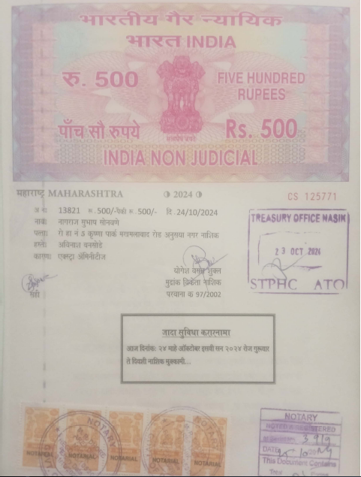
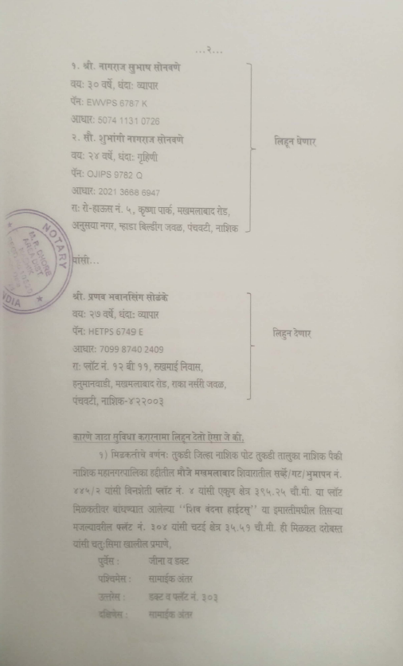

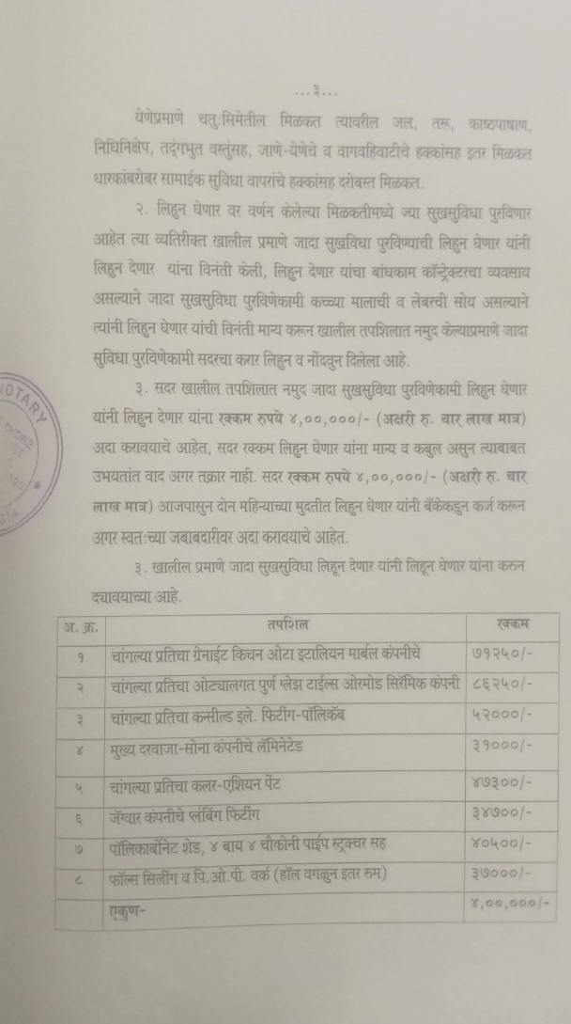
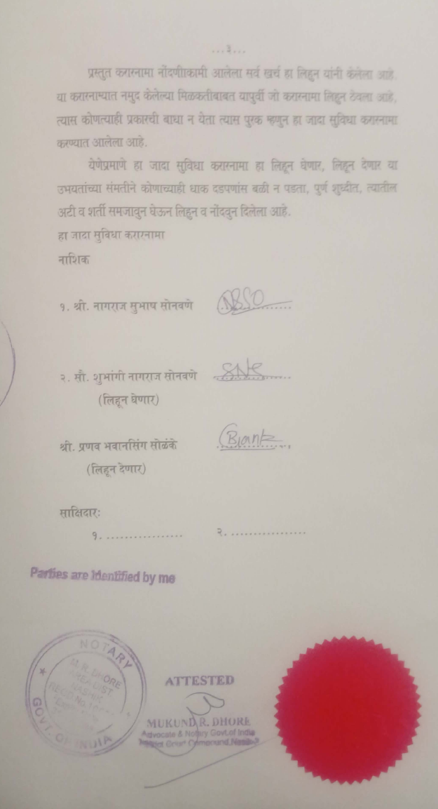

The Extra Work amount is Rs.4,00,000/- (Rupees Four Lakh Only.)

