VALUATION REPORT OF IMMOVEABLE PROPERTY
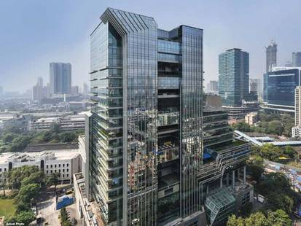

Details of the property under consideration:

NAME OF CLIENT / DEVELOPER: M/s. Marathon Nextgen Realty Ltd.

Commercial Office No. 303 & 304, A Wing, Marathon Futurex, IT / BFSI Commercial project on
C. S. No. 166, Lower Parel Division, N. M. Joshi Marg, Lower Parel, Mumbai – 400 013, Maharashtra, India.

Latitude Longitude - 18°59'40.7"N 72°49'52.6"E

Intended User:

STCI FINANCE LIMITED
A/B 1-802, A Wing, 8th Floor, Marathon Innova, Marathon Nextgen Compound,
Off. Ganpatrao Kadam Marg, Lower Parel (West), Mumbai – 400 013,
Maharashtra, India

Vastu/STCI/Mumabi/11/2024/12240/2309535
10/29-233-SSPPY
Date – 10.12.2024

VALUATION REPORT OF IMMOVABLE PROPERTY
OF
"Marathon Futurex"

Commercial Office No. 303 & 304, A Wing, IT / BFSI Commercial project on C. S. No. 166,
Lower Parel Division, N. M. Joshi Marg, Lower Parel, Mumbai – 400 013, Maharashtra, India

Latitude Longitude - 18°59'40.7"N 72°49'52.6"E

NAME OF CLIENT / DEVELOPER: M/s. Marathon Nextgen Realty Ltd.

Pursuant to instructions from SCTI finance, we have duly visited, inspected, surveyed & assessed the above said property to determine the fair & reasonable market value of the said property as on 09th November 2024 for banking purpose.

1. Location Details:
The property is situated at "Marathon Futurex", Commercial Office No. 303 & 304, A Wing, IT / BFSI Commercial project on C. S. No. 166, Lower Parel Division, N. M. Joshi Marg, Lower Parel, Mumbai – 400 013, Maharashtra, India. It is about 350 M. walking distance from Lower Parel Railway Station. Surface transport to the property is by buses, autos, taxis & private vehicles. The property is in developed locality. All the amenities like shops, banks, hotels, markets, schools, hospitals, etc. are all available in the surrounding locality.

2. Developer Details:

Name of Client / Developer | M/s. Marathon Nextgen Realty Ltd.
Register office address | Marathon Futurex, N. M. Joshi Marg, Lower Parel, Mumbai – 400 013, Maharashtra, India.
Contact Numbers | Contact Person:  Mrs. Sharavi Joshi  Mb. No. 8097616974  Mr. Rohit Jadhav (Office Boy)  Mb. No. 9594101959
E – mail ID and Website | sharvari.joshi@marathonrealty.com

3. Boundaries of the Property:

Direction | Particulars
On or towards North | BDD Chawl & Western Railway Track
On or towards South | Mafatlal Mills
On or towards East | N. M. Joshi Road
On or towards West | Western Railway Track

Vastukala Consultants (I) Pvt. Ltd.
1 B1-001, U/B Floor, Boomerang, Chandivali Farm Road, Powai, Andheri (East), Mumbai – 400 072

To,
The Branch Manager,
STCI FINANCE LIMITED
A/B 1-802, A Wing, 8th Floor, Marathon Innova,
Marathon Nextgen Compound, off. Ganpatrao Kadam Marg,
Lower Parel (West), Mumbai – 400 013, State – Maharashtra, Country – India

VALUATION REPORT (IN RESPECT OF COMMERCIAL OFFICE)
I | General
1. | Purpose for which the valuation is made |  |  | : | As per request from STCI Finance Limited, Lower Parel (West) to assess fair market value of the property for lending purpose.
2. | a) | Date of inspection |  | : | 09.11.2024
 | b) | Date on which the valuation is made |  | : | 10.12.2024
3. | List of documents produced for perusal
- Copy of Approved Plan No. EB/9927/GS/A/OCC/8/New dated 01.06.2023 issued by Municipal Corporation of Greater Mumbai
Approved Upto: 3 Basement Floors + Ground Floor + 1st to 38th Upper Floors
- Copy of Commencement Certificate No. EB/9927/GS/A/FCC/6/Amend dated 19.01.2022 issued by Municipal Corporation of Greater Mumbai
This CC is endorsed for the work upto 38th Floor + OHT + Staircase as per approved plan dated 06.12.2021
- Copy of Part Occupancy Certificate No. EB/9927/GS/A/OCC/8/New dated 01.06.2023 issued by Municipal Corporation of Greater Mumbai.
Approved for 36th Floor to 38 (part) upper floor of building C
 | - Copy of Developer Agreement dated 22.09.2004 between Mafatlal Industries Ltd. (The Owners) and M/s. Marathon Realty Ltd. (The Developers) through vide Reg. No. BBE/2/7533/2004 dated 23.09.2004
 | - Copy of Property Card
 | - Copy of Self Declaration Letter issued by M/s. Marathon Nextgen Realty Ltd.
4a. | Property Under Consideration |  |  | : | Commercial Office No. 303 & 304, Marathon Futurex, A Wing, IT / BFSI Commercial project on C. S. No. 166, Lower Parel Division, N. M. Joshi Marg, Lower Parel, Mumbai – 400 013, Maharashtra, India.
4b. | Name of the clients / developers and his / their address (es) with Phone no. (details of share of each owner in case of joint ownership) |  |  | : | M/s. Marathon Nextgen Realty Ltd.  Address:  Marathon Futurex, N. M. Joshi Marg, Lower Parel, Mumbai – 400 013, Maharashtra, India.  Contact Person:  Mrs. Sharavi Joshi  Mb. No. 8097616974  Mr. Rohit Jadhav (Office Boy)  Mb. No. 9594101959
5. | Brief description of the property (Including Leasehold / freehold etc.):
About Galaxy Marathon Futurex Project:
Marathon Futurex is a well-structured and strategically planned project that is preferably placed in a very good location - Lower Parel, Mumbai. The units in this project come at a reasonable price. Marathon Futurex makes sure to provide all the contemporary requirements of all the residents. This skillfully crafted project has ready-to-move units. The project offers an array of property choices such as a commercial office space to suit every individual's need. This project was launched in January 2019 and is now ready to move. Moreover, the certificate of occupancy was granted to this project. A well-known builder Marathon Realty Pvt. Ltd., has constructed Marathon Futurex with sophistication and perfection.

TYPE OF THE BUILDING:
Wing | Number of Floors
A, B & C | 3 Basement Floors + Ground Floor + 1st to 38th Upper Floors

LEVEL OF COMPLETEION:
Present stage of Construction | Percentage of work completion
The units are sold as bare shell units. Internal walls and final finishing will be done while giving the possession to the client  (Occupancy Received dated 2011 to 2023) | 100%

6. | Location of property |  |  | :
 | a) | Plot No. / Survey No. |  | : | -
 | b) | Door No. |  | : | Not applicable
 | c) | C. T.S. No. / Village |  | : | C. S. No. 166, Lower Parel Division
 | d) | Ward / Taluka |  | : | Taluka – Dadar
 | e) | Mandal / District |  | : | District – Mumbai
7. | Postal address of the property / Property Under Consideration |  |  | : | Commercial Office No. 303 & 304, Marathon Futurex, A Wing, IT / BFSI Commercial project on C. S. No. 166, Lower Parel Division, N. M. Joshi Marg, Lower Parel, Mumbai – 400 013, Maharashtra, India.
8. | City / Town |  |  | : | Lower Parel, Mumbai
 | Residential area |  |  | : | No
 | Commercial area |  |  | : | Yes
 | Industrial area |  |  | : | No
9. | Classification of the area |  |  | :
 | i) High / Middle / Poor |  |  | : | Higher Middle Class
 | ii) Urban / Semi Urban / Rural |  |  | : | Urban
10. | Coming under Corporation limit / Village Panchayat / Municipality |  |  | : | Municipal Corporation of Greater Mumbai (MCGM).
11. | Whether covered under any State / Central Govt. enactments (e.g., Urban Land Ceiling Act) or notified under agency area/ scheduled area / cantonment area |  |  | : | No
12. | In Case it is Agricultural land, any conversion to house site plots is contemplated |  |  | : | N.A.
13. | Boundaries of the property |  | As per Documents |  |  | As per Site
 | North |  | Property of CB Gorwala |  |  | BDD Chawl & Western Railway Track
 | South |  | Partly by the property Municipal land and partly by Bombay Development Chawls |  |  | Mafatlal Mills
 | East |  | De Lisle Road (Now Know as N. M. Joshi Road) |  |  | N. M. Joshi Road
 | West |  | Railway Lines of Western Railway |  |  | Western Railway Track
14.1 | Dimensions of the site |  |  |  | N. A. as the land is irregular in shape
14.2 | Latitude, Longitude & Co-ordinates of property |  |  | : | 18°59'40.7"N 72°49'52.6"E
14.3 | Extent of the site |  |  | : | Unit wise area - As per table attached to the report
15. | Extent of the site considered for Valuation (least of 14A& 14B) |  |  | : | As per table attached to the report
16 | Whether occupied by the owner / tenant? If occupied by tenant since how long? Rent received per month. |  |  | : | Vacant and in bare shell condition
II | CHARACTERSTICS OF THE SITE
 | Classification of locality |  |  | : | Higher Middle class
 | Development of surrounding areas |  |  | : | Good
 | Possibility of frequent flooding/ sub-merging |  |  | : | No
 | Feasibility to the Civic amenities like School, Hospital, Bus Stop, Market etc. |  |  | : | All available near by
 | Level of land with topographical conditions |  |  | : | Plain
 | Shape of land |  |  | : | Irregular
 | Type of use to which it can be put |  |  | : | For Commercial purpose
 | Any usage restriction |  |  | : | Commercial
 | Is plot in town planning approved layout? |  |  | : | Yes, MCGM Approved Layout
 | Corner plot or intermittent plot? |  |  | : | Intermittent
 | Road facilities |  |  | : | Yes
 | Type of road available at present |  |  | : | B.T. Road
 | Width of road – is it below 20 ft. or more than 20 ft. |  |  | : | 30.00 M. wide Road
 | Is it a Land – Locked land? |  |  | : | No
 | Water potentiality |  |  | : | Municipal Water supply
 | Underground sewerage system |  |  | : | Connected to Municipal sewer
 | Is Power supply is available in the site |  |  | : | Yes
 | Advantages of the site |  |  | : | Located in developed area near to both suburban railway stations i.e., Lower Parel on Western Railway Line and Curry Road on Central Railway line.
 | Special remarks, if any like threat of acquisition of land for publics service purposes, road widening or applicability of CRZ provisions etc., (Distance from sea-cost / tidal level must be incorporated) |  |  | : | No
Part – A
1 | Size of plot |  |  | : | Land Area – 17,033.00 Sq. M. (As per Plan)
 | North & South |  |  | : | -
 | East & West |  |  | : | -
2 | Area of Units considered for valuation |  |  | : | As per table attached to the report.
3 | Prevailing market rate (Along With details / reference of at least two latest deals / transactions with respect to adjacent properties in the areas) |  |  | : | As per table attached to the report.  Details of recent online listings are attached with the report.
4 | Guideline rate obtained from the Registrar’s Office (evidence thereof to be enclosed) |  |  | : | Commercial Unit - ` 3,52,900.00 per Sq. M i.e., ` 32,785.00 per Sq. Ft. on Built-up Area
Part – B (Valuation of Building)
1 | Technical details of the building |  |  | :
 | - Type of Building (Residential / Commercial / Industrial) |  |  | : | Commercial
 | - Type of construction (Load bearing / RCC / Steel Framed) |  |  | : | R.C.C. Framed structure
 | - Year of construction |  |  | : | 2011 to 2023 (As per Occupancy Certificate)
 | - Number of floors and height of each floor including basement, if any |  |  | : | 3 Basement Floor + Ground Floor + 1st to 38th Upper Floor
 | - Plinth area floor-wise |  |  | : | As per table attached to the report
 | - Condition of the building |  |  | :
 | - Exterior – Excellent, Good, Normal, Poor |  |  | : | Excellent
 | - Interior – Excellent, Good, Normal, Poor |  |  | : | Excellent
 | - Date of issue and validity of layout of approved map |  |  | : | - Copy of Approved Plan No. EB/9927/GS/A/OCC/8/New dated 01.06.2023 issued by Municipal Corporation of Greater Mumbai  Approved Upto: Wing C: 3 Basement Floor + Ground Floor + 1st to 38th Upper Floor  - Copy of Commencement Certificate No. EB/9927/GS/A/FCC/6/Amend dated 19.01.2022 issued by Municipal Corporation of Greater Mumbai  This CC is endorsed for the work upto 38th Floor + OHT + Staircase as per approved plan dated 06.12.2021  - Copy of Part Occupancy Certificate No. EB/9927/GS/A/OCC/8/New dated 01.06.2023 issued by Municipal Corporation of Greater Mumbai.  Approved for 36th Floor to 38 (part) upper floor of building C
 | - Approved map / plan issuing authority |  |  | :
 | - Whether genuineness or authenticity of approved map / plan is verified |  |  | : | Yes
 | - Any other comments by our empanelled valuers on authentic of approved plan |  |  | : | No.

Specifications of construction (floor-wise) in respect of
Sr. No. | Description
 | Foundation | : | R.C.C. Footing
 | Basement | : | Yes
 | Superstructure | : | As per IS Code requirements
 | Joinery / Doors & Windows (Please furnish details about size of frames, shutters, glazing, fitting etc. and specify the species of timber | : | Glass Door at main entrance of office premises
 | RCC Works | : | Yes
 | Plastering | : | Yes
 | Flooring, Skirting, dado | : | Units are in Bare shell Condition
 | Special finish as marble, granite, wooden paneling, grills etc. | : | Glass Cladding for building exteriors
 | Roofing including weather proof course | : | Provided
 | Drainage | : | Connected to municipal line
2. | Compound Wall | :
 | Height | : | RCC Framed Structure with plastered B.B. Masonry wall
 | Length | : | RCC Framed Structure with plastered B.B. Masonry wall
 | Type of construction | : | RCC Framed Structure with plastered B.B. Masonry wall
3. | Electrical installation | : | Concealed
 | Type of wiring | : | Concealed
 | Class of fittings (superior / ordinary / poor) | : | Concealed
 | Number of light points | : | Basic points provided as per requirement. Interior electrical works to be done by unit owner.
 | Fan points | :
 | Spare plug points | :
 | Any other item | : | -
4. | Plumbing installation
 | - No. of water closets and their type | : | Concealed
 | - No. of wash basins | : | Concealed
 | - No. of urinals | : | Concealed
 | - No. of bath tubs | : | Concealed
 | - Water meters, taps etc. | : | Concealed
 | - Any other fixtures | : | Concealed

Part – C (Extra Items) |  | : | Amount in `
 | Portico | : | Included in the Rate per Sq. Ft. on Carpet Area
 | Ornamental front door | : | Included in the Rate per Sq. Ft. on Carpet Area
 | Sit out / Verandah with steel grills | : | Included in the Rate per Sq. Ft. on Carpet Area
 | Overhead water tank | : | Included in the Rate per Sq. Ft. on Carpet Area
 | Extra steel / collapsible gates | : | Included in the Rate per Sq. Ft. on Carpet Area
 | Total

Part – D (Amenities) |  | : | Amount in `
 | Wardrobes | : | Included in the Rate per Sq. Ft. on Carpet Area
 | Glazed tiles | : | Included in the Rate per Sq. Ft. on Carpet Area
 | Extra sinks and bath tub | : | Included in the Rate per Sq. Ft. on Carpet Area
 | Marble / ceramic tiles flooring | : | Included in the Rate per Sq. Ft. on Carpet Area
 | Interior decorations | : | Included in the Rate per Sq. Ft. on Carpet Area
 | Architectural elevation works |  | Included in the Rate per Sq. Ft. on Carpet Area
 | Paneling works |  | Included in the Rate per Sq. Ft. on Carpet Area
 | Aluminum works |  | Included in the Rate per Sq. Ft. on Carpet Area
 | Aluminum hand rails |  | Included in the Rate per Sq. Ft. on Carpet Area
 | False ceiling |  | Included in the Rate per Sq. Ft. on Carpet Area
 | Total

Part – E (Miscellaneous) |  | : | Amount in `
 | Separate toilet room | : | Included in the Rate per Sq. Ft. on Carpet Area
 | Separate lumber room | : | Included in the Rate per Sq. Ft. on Carpet Area
 | Separate water tank / sump | : | Included in the Rate per Sq. Ft. on Carpet Area
 | Trees, gardening | : | Included in the Rate per Sq. Ft. on Carpet Area
 | Total

Part – F (Services) |  | : | Amount in `
 | Water supply arrangements | : | Included in the Rate per Sq. Ft. on Carpet Area
 | Drainage arrangements | : | Included in the Rate per Sq. Ft. on Carpet Area
 | Compound wall | : | Included in the Rate per Sq. Ft. on Carpet Area
 | C.B. deposits, fittings etc. | : | Included in the Rate per Sq. Ft. on Carpet Area
 | Pavement |  | Included in the Rate per Sq. Ft. on Carpet Area
 | Total |  | -

CONFIGURATION OF UNITS TO BE AS PER INFORMATION PROVIDED BY DEVELOPER:

Government Value of Property:
Sr. No. | Office No. | Floor | Wing | Carpet Area in Sq. Ft. | Built up Area in Sq. Ft. | RR Rate per Sq. M. on Built Up Area in ` | RR Rate per Sq. Ft. on Built Up Area in ` | Government Value in `
1 | 303 | 3rd Floor | A | 4,730.00 | 5,676.00 | 3,52,900.00 | 32,785.00 | 18,60,88,852.00
2 | 304 | 3rd Floor | A | 10,299.00 | 12,359.00 | 3,52,900.00 | 32,785.00 | 40,51,85,853.00
TOTAL |  |  |  | 15,029.00 | 18,035.00 |  |  | 59,12,74,705.00

Fair Market Value of Property:
Sr. No. | Office No. | Floor | Wing | Saleable Area in Sq. Ft. | Carpet Area in Sq. Ft. | Built up Area in Sq. Ft. | Rate per Sq. Ft. on Carpet Area in ` | Value in `
1 | 303 | 3rd Floor | A | 7,277.00 | 4,730.00 | 5,676.00 | 43,000.00 | 20,33,90,000.00
2 | 304 | 3rd Floor | A | 15,845.00 | 10,299.00 | 12,359.00 | 43,000.00 | 44,28,57,000.00
TOTAL |  |  |  | 23,122.00 | 15,029.00 | 18,035.00 |  | 64,62,47,000.00

Summary of the Project:
Particulars | Value in ` | Value in ` Cr.
Fair Market Value of the Property | 64,62,47,000.00 | 64.62
Realizable Value of the Property | 58,16,22,300.00 | 58.16
Distress Value of the Property | 51,69,97,600.00 | 51.69
Government value of the Property | 59,12,74,705.00 | 59.12
Insurable Value  (Total Built Up Area X Rate) = (23,122.00 X 2,500.00) | 5,78,05,000.00 | 5.78

VALUATION METHODOLGY:
The sales comparison approach uses the market data of sale prices to estimate the value of a real estate property. Property valuation in this method is done by comparing a property to other similar properties that have been recently sold. Comparable properties, also known as comparable, or comps, must share certain features with the property in question. Some of these include physical features such as square footage, number of rooms, condition, and age of the building; however, the most important factor is no doubt the location of the property. Adjustments are usually needed to account for differences as no two properties are exactly the same. To make proper adjustments when comparing properties, real estate appraisers must know the differences between the comparable properties and how to value these differences. The sales comparison approach is commonly used for Residential Flat & Commercial Shop where there are typically many comparable available to analyze. As the property is a residential flat, we have adopted Sale Comparison Approach Method for the purpose of valuation. The Price for similar type of property in the nearby vicinity is in the range of ` 40,000.00 to ` 50,000.00 per Sq. Ft. on Carpet area for commercial property Considering the rate with attached report, current market conditions, demand and supply position, office size, location, upswing in real estate prices, sustained demand for Commercial Unit, all-round development of commercial and residential application in the locality etc. We estimate ` 43,000.00 per Sq. Ft. on Carpet Area for valuation.
Actual Site Photographs
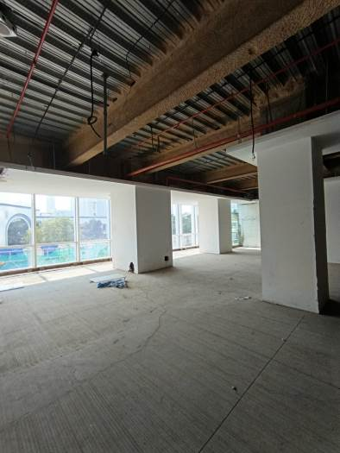
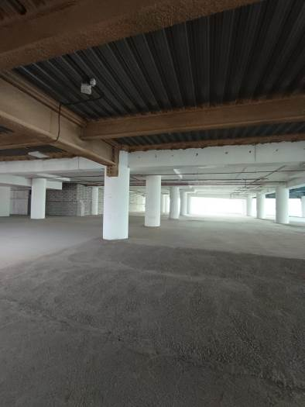
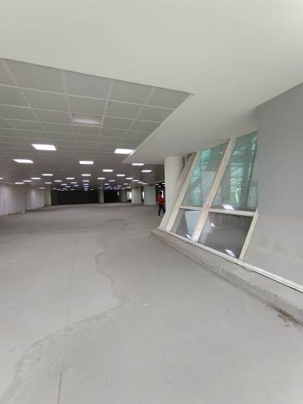
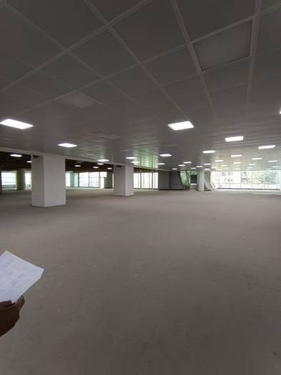
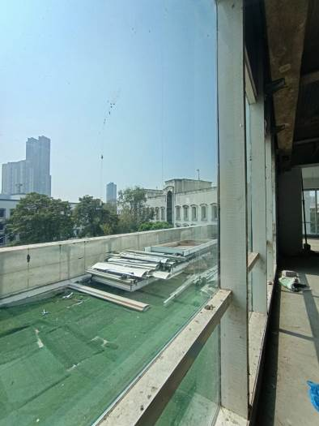
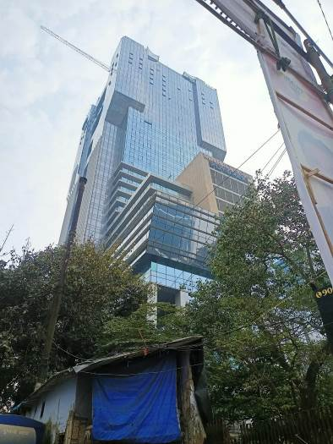

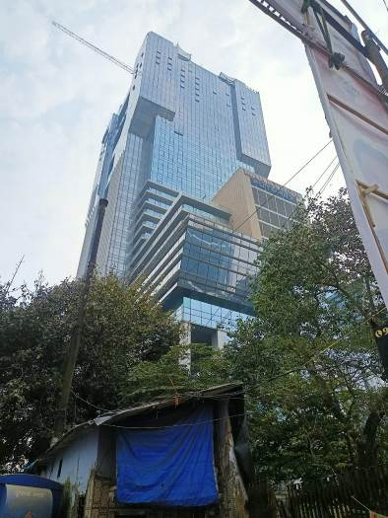

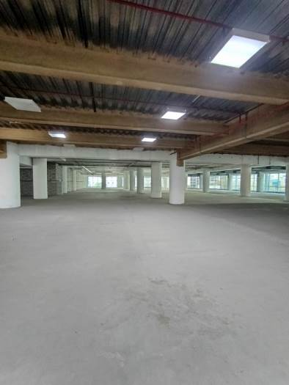
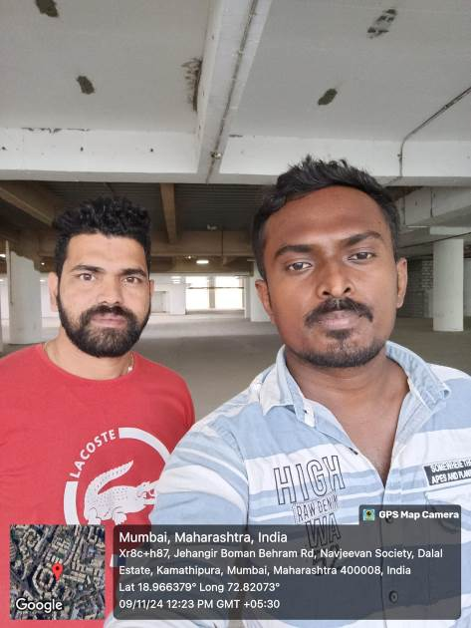
Layout Plan
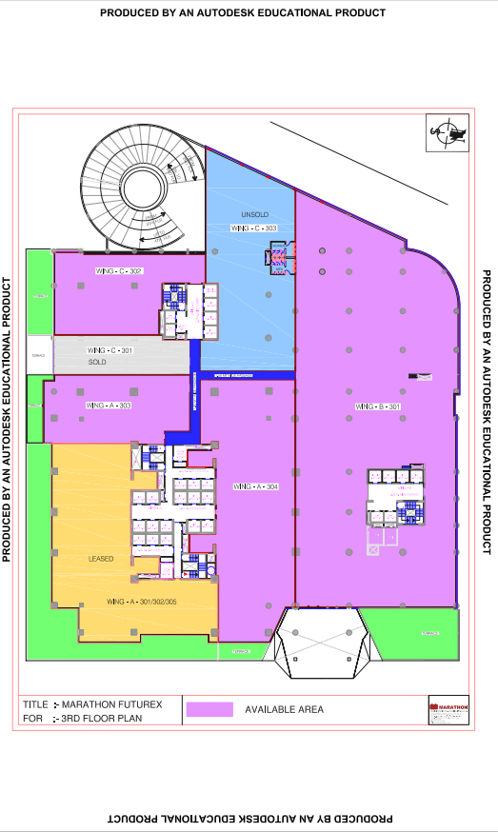
Self-Declaration Letter
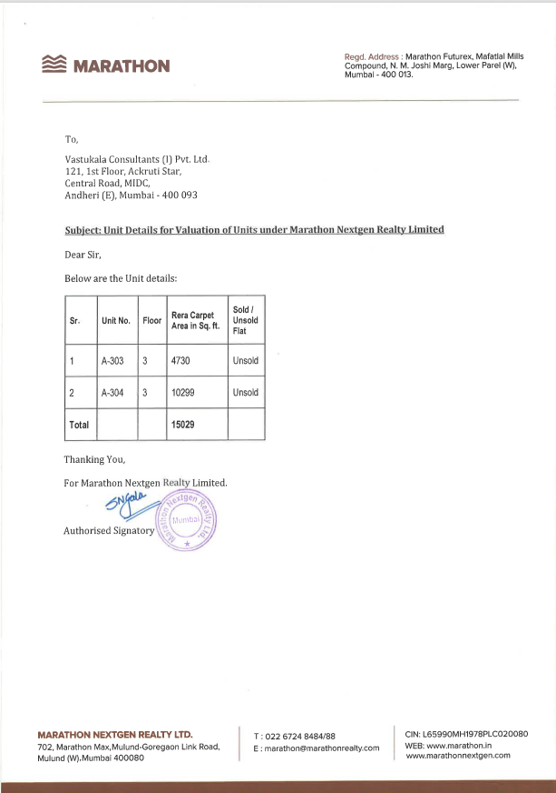
Route Map of the property
Site u/r
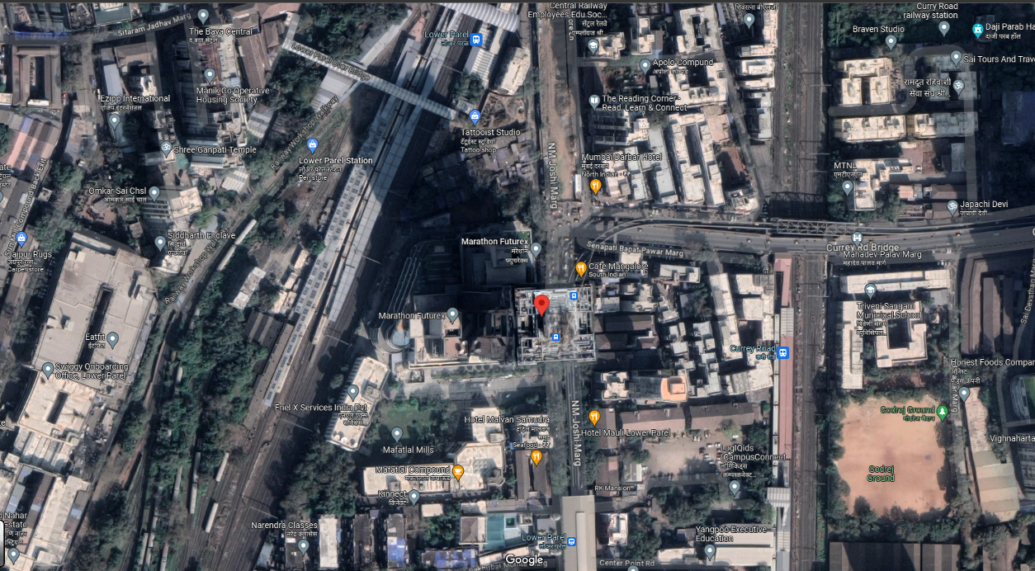

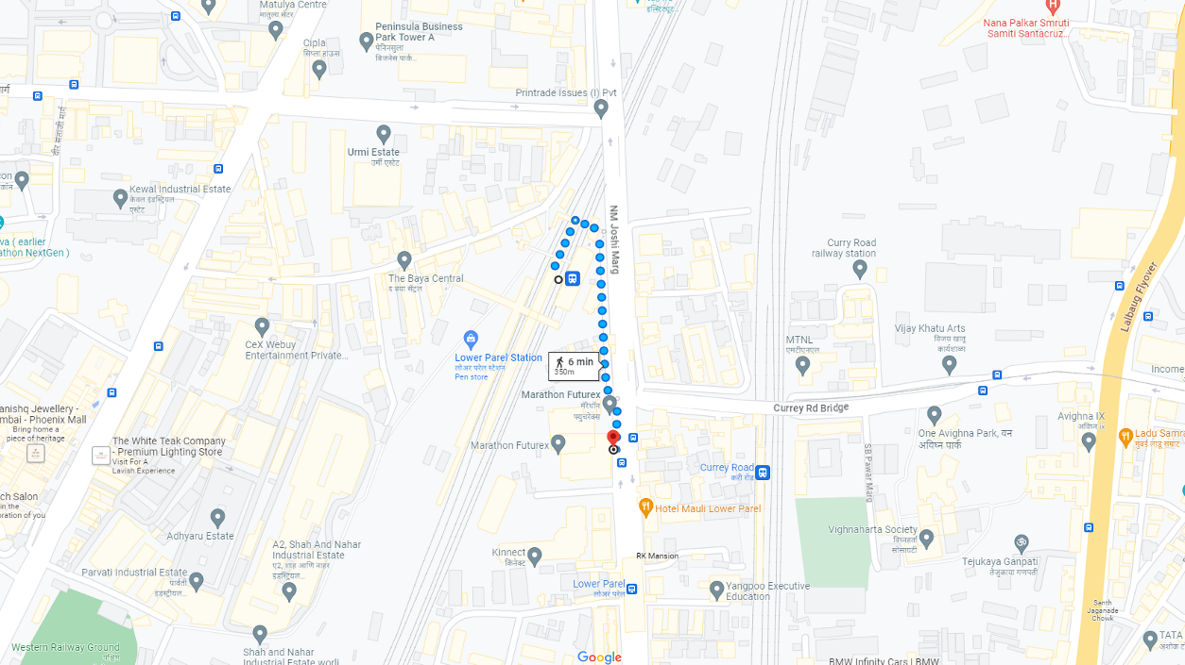

Latitude Longitude - 18°59'40.7"N 72°49'52.6"E

Note: The Blue line shows the route to site from nearest railway station (Lower Parel – 350 M.)

Ready Reckoner Rate
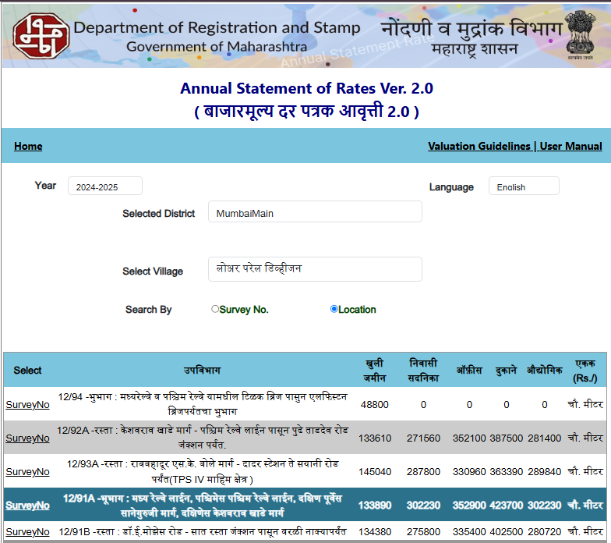

Multi-Storied building with Lift
For residential premises / commercial unit / office on above floor in multistoried building, the rate mentioned in the ready reckoner will be increased as under:

 | Location of Flat / Commercial Unit in the building | Rate
a) | On Ground to 4 Floors | No increase for all floors from ground to 4 floors
b) | 5 Floors to 10 Floors | Increase by 5% on units located between 5 to 10 floors
c) | 11 Floors to 20 Floors | Increase by 10% on units located between 11 to 20 floors
d) | 21 Floors to 30 Floors | Increase by 15% on units located between 21 to 30 floors
e) | 31 Floors and above | Increase by 20% on units located on 31 and above floors

Table – D: Depreciation Percentage Table

Completed Age of Building in Years | Value in percent after depreciation
 | R.C.C. Structure / other Pukka Structure | Cessed Building, Half or Semi – Pukka Structure & Kaccha Structure.
0 to 2 Years | 100% | 100%
Above 2 & up to 5 Years | 95% | 95%
Above 5 Years | After initial 5 year for every year 1% depreciation is to be considered. However maximum deduction available as per this shall be 70% of Market Value rate | After initial 5 year for every year 1.5% depreciation is to be considered. However maximum deduction available as per this shall be 85% of Market Value rate

Registered Sale Instances
Regd. Doc. No. | Date | Agreement Value in ` | Carpet Area in Sq. M. | Carpet Area in Sq. Ft. | Rate / Sq. Ft. on Carpet Area
23848 / 2024 | 06.10.2024 | 2,93,87,690.00 | 65.31 | 703.00 | 41,803.00
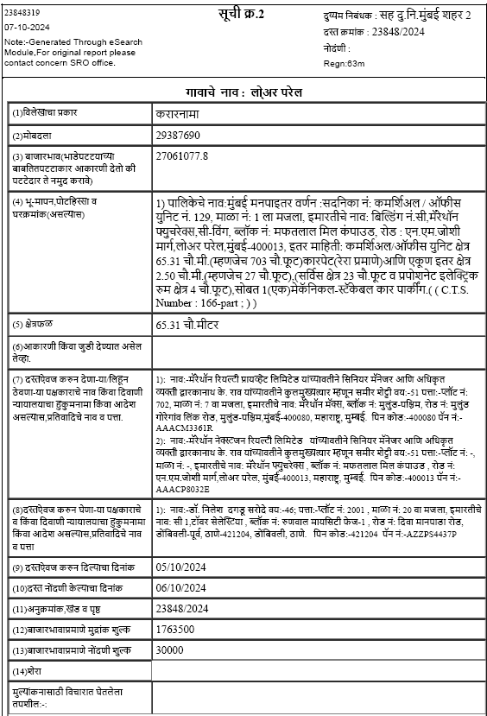

Registered Sale Instances
Regd. Doc. No. | Date | Agreement Value in ` | Carpet Area in Sq. M. | Carpet Area in Sq. Ft. | Rate / Sq. Ft. on Carpet Area
9749 / 2024 | 15.06.2024 | 22,18,06,250.00 | - | 5527.14 | 40,130.38
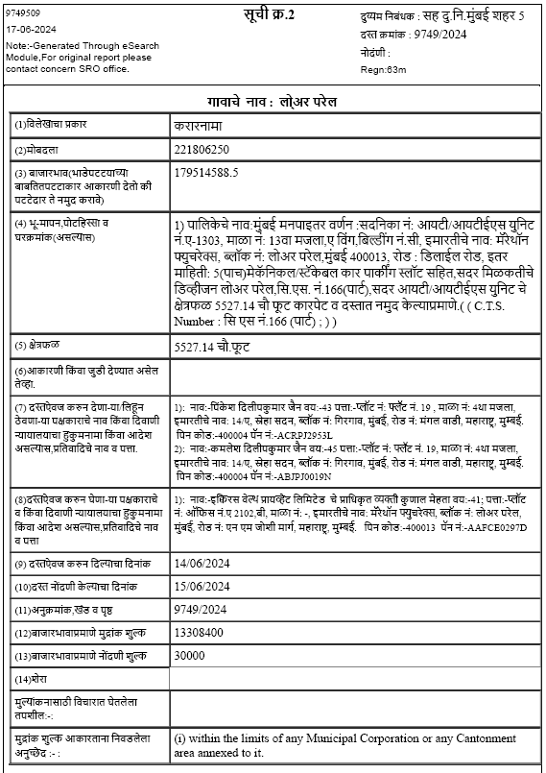

Price Indicators

Floor | Source | Carpet Area in Sq. Ft. | Value in ` | Rate / Sq. Ft. on Carpet Area
13 | Magicbricks.com | 4,961.00 | 22,26,00,000.00 | 44,870.00
36 | Magicbricks.com | 800.00 | 3,60,00,000.00 | 45,000.00
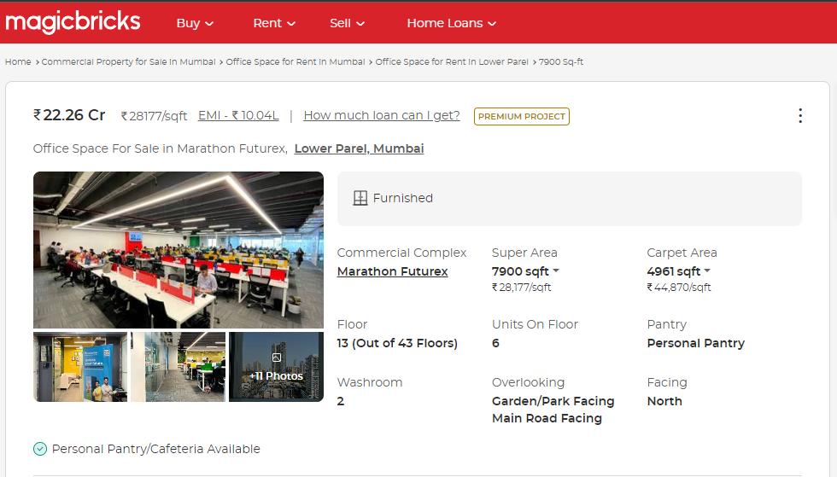

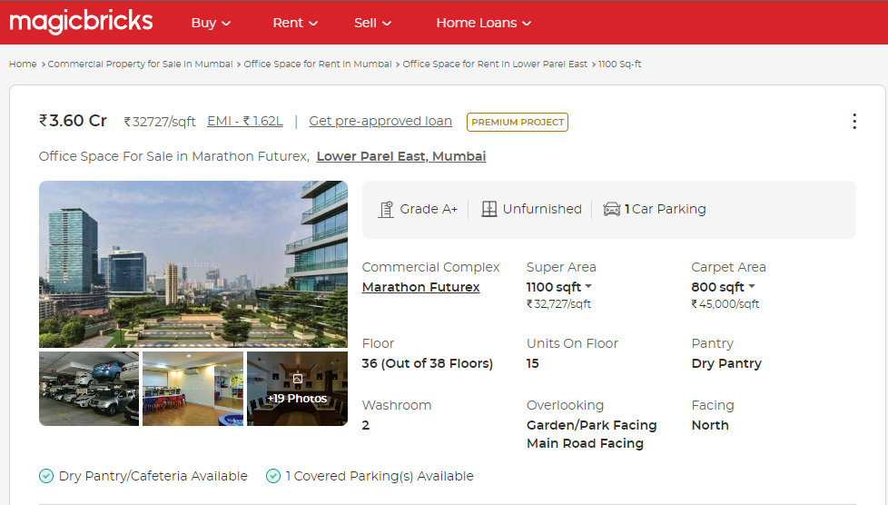

Price Indicators

Floor | Source | Carpet Area in Sq. Ft. | Value in ` | Rate / Sq. Ft. on Carpet Area
31 | 99acres.com | 1,676.57 | 7,00,00,000.00 | 41,752.00
1 | 99acres.com | 500.00 | 2,20,00,000.00 | 44,000.00
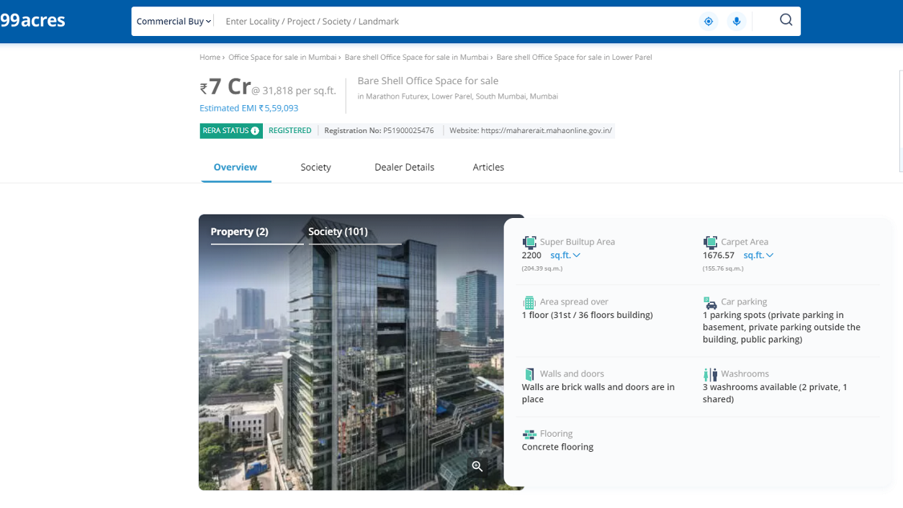

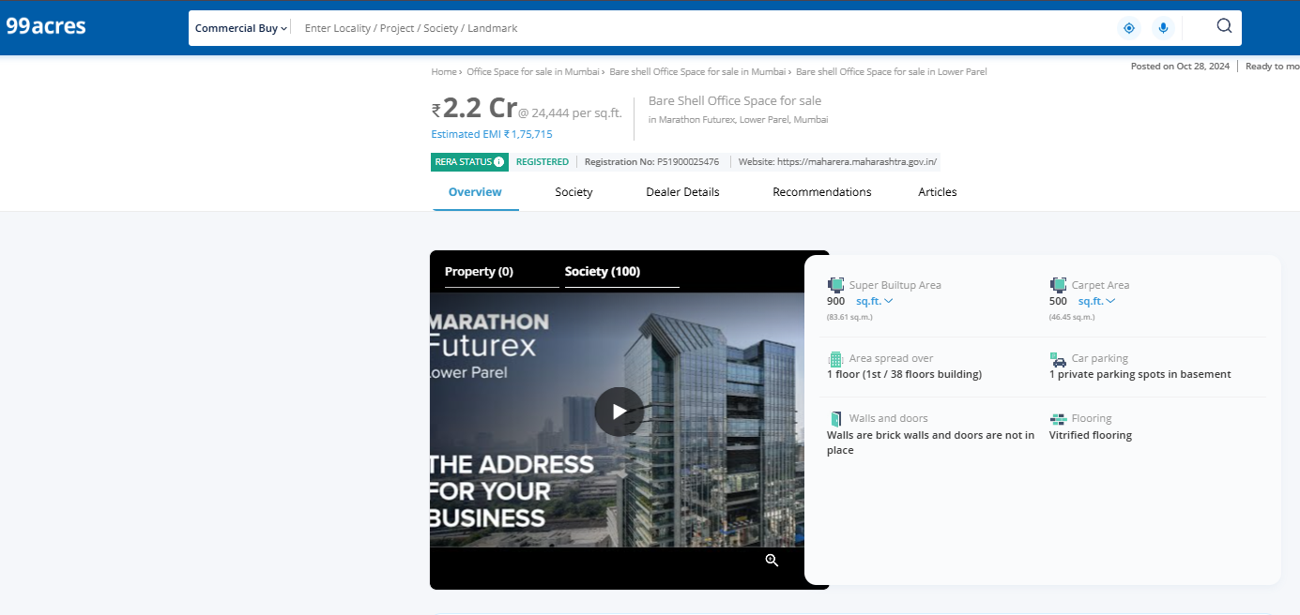
As a result of my appraisal and analysis, it is my considered opinion that the Fair Market Value of the above property in the prevailing condition with aforesaid specification is as follows
Particulars | Value in ` | Value in ` Cr.
Fair Market Value of the Property | 64,62,47,000.00 | 64.62
Realizable Value of the Property | 58,16,22,300.00 | 58.16
Distress Value of the Property | 51,69,97,600.00 | 51.69
Government value of the Property | 59,12,74,705.00 | 59.12
Insurable Value  (Total Built Up Area X Rate) = (23,122.00 X 2,500.00) | 5,78,05,000.00 | 5.78

Place: Mumbai
Date: 10.12.2024

Manoj B. Chalikwar
Registered Valuer
Chartered Engineer (India)
Reg. IBBI/RV/07/2018/10366
Reg. No. CAT-I-F-1763

Enclosures
 | Declaration-cum-undertaking from the valuer (Annexure- I) | Attached
(Annexure-I)
DECLARATION-CUM-UNDERTAKING

I, Manoj Chalikwar son of Shri. Baburao Chalikwar do hereby solemnly affirm and state that:

- I am a citizen of India.
- I will not undertake valuation of any assets in which I have a direct or indirect interest or become so interested at any time during a period of three years prior to my appointment as valuer or three years after the valuation of assets was conducted by me.
- The information furnished in my valuation report dated 10.12.2024 is true and correct to the best of my knowledge and belief and I have made an impartial and true valuation of the property.
- I/ my authorized representative have personally inspected the property on 09.11.2024. The work is not sub - contracted to any other valuer and carried out by myself.
- Valuation report is submitted in the format as prescribed by the bank.
- I have not been depanelled / delisted by any other bank and in case any such depanelment by other banks during my empanelment with you, I will inform you within 3 days of such depanelment.
- I have not been removed / dismissed from service / employment earlier.
- I have not been convicted of any offence and sentenced to a term of imprisonment
- I have not been found guilty of misconduct in my professional capacity.
- I have not been declared to be unsound mind
- I am not an undischarged bankrupt, or has not applied to be adjudicated as a bankrupt;
- I am not an undischarged insolvent.
- I have not been levied a penalty under section 271J of Income-tax Act, 1961 (43 of 1961) and time limit for filing appeal before Commissioner of Income-tax (Appeals) or Income-tax Appellate Tribunal, as the case may be having expired, or such penalty has been confirmed by Income-tax Appellate Tribunal, and five years have not elapsed after levy of such penalty
- I have not been convicted of an offence connected with any proceeding under the Income Tax Act 1961, Wealth Tax Act 1957 or Gift Tax Act 1958 and
- My PAN Card number as applicable is AERPC9086P
- I undertake to keep you informed of any events or happenings which would make me ineligible for empanelment as a valuer
- I have not concealed or suppressed any material information, facts and records and I have made a complete and full disclosure
- I have read the Handbook on Policy, Standards and procedure for Real Estate Valuation, 2011 of the IBA and this report is in conformity to the "Standards" enshrined for valuation in the Part - B of the above handbook to the best of my ability.
- I have read the International Valuation Standards (IVS) and the report submitted to the Bank for the respective asset class is in conformity to the "Standards" as enshrined for valuation in the IVS in "General Standards" and "Asset Standards" as applicable. The valuation report is submitted in the prescribed format of the bank.
- I am valuer registered with Insolvency & Bankruptcy Board of India (IBBI)
- My CIBIL Score and credit worthiness is as per Bank's guidelines.
- I am Chairman & Managing Director of the company, who is competent to sign this valuation report.
- I will undertake the valuation work on receipt of Letter of Engagement generated from the system (i.e., LLMS / LOS) only.
- Further, I hereby provide the following information.

 | Particulars | Valuer comment
 | Background information of the asset being valued; | The property under consideration is developed by M/s. Marathon Realty Pvt. Ltd. and unit consideration are 303 & 304 in A Wing
 | Purpose of valuation and appointing authority | As per request from STCI Finance Limited, Lower Parel (West) to assess fair market value of the property for lending purpose.
 | Identity of the Valuer and any other experts involved in the valuation; | Manoj B. Chalikwar – Regd. Valuer  Prayush P. Parekh – Senior Valuation Engineer  Saiprasad Patil & Chandan Singh – Valuation Engineer
 | Disclosure of Valuer interest or conflict, if any; | We have no interest, either direct or indirect, in the property valued. Further to state that we do not have relation or any connection with property owner / applicant directly or indirectly. Further to state that we are an independent Valuer and in no way related to property owner / applicant
 | Date of appointment, valuation date and date of report; | Date of Appointment – 08.11.2024  Valuation Date – 10.12.2024  Date of Report – 10.12.2024
 | Inspections and/or investigations undertaken; | Physical Inspection done on date 09.11.2024
 | Nature and sources of the information used or relied upon; | - Market Survey at the time of site visit  - Ready Reckoner rates / Circle rates  - Online search for Registered Transactions  - Online Price Indicators on real estate portals  - Enquiries with Real estate consultants  - Existing data of Valuation assignments carried out by us
 | Procedures adopted in carrying out the valuation and valuation standards followed; | Comparable Sales Method
 | Restrictions on use of the report, if any; | This valuation is for the use of the party to whom it is addressed and for no other purpose. No responsibility is accepted to any third party who may use or rely on the whole or any part of this valuation. The valuer has no pecuniary interest that would conflict with the proper valuation of the property.
- . | Major factors that were taken into account during the valuation; | Current market conditions, demand and supply position, industrial land size, location, sustained demand for residential land, all round development of residential projects in the locality etc.
 | Caveats, limitations and disclaimers to the extent they explain or elucidate the limitations faced by valuer, which shall not be for the purpose of limiting his responsibility for the valuation report. | Attached

Assumptions, Disclaimers, Limitations & Qualifications
Value Subject to Change
The subject appraisal exercise is based on prevailing market dynamics as on 10th December 2024 and does not take into account any unforeseeable developments which could impact the same in the future.

Our Investigations
We are not engaged to carry out all possible investigations in relation to the subject property. Where in our report we identify certain limitations to our investigations, this is to enable the reliant party to instruct further investigations where considered appropriate or where we recommend as necessary prior to reliance. Vastukala Consultants India Pvt. Ltd. (VCIPL) is not liable for any loss occasioned by a decision not to conduct further investigations

Assumptions
Assumptions are a necessary part of undertaking valuations. VCIPL adopts assumptions for the purpose of providing valuation advise because some matters are not capable of accurate calculations or fall outside the scope of our expertise, or out instructions. The reliant party accepts that the valuation contains certain specific assumptions and acknowledge and accept the risk of that if any of the assumptions adopted in the valuation are incorrect, then this may have an effect on the valuation.

Information Supplied by Others
The appraisal is based on the information provided by the client. The same has been assumed to be correct and has been used for appraisal exercise. Where it is stated in the report that another party has supplied information to VCIPL, this information is believed to be reliable but VCIPL can accept no responsibility if this should prove not to be so.

Future Matters
To the extent that the valuation includes any statement as to a future matter, that statement is provided as an estimate and/or opinion based on the information known to VCIPL at the date of this document. VCIPL does not warrant that such statements are accurate or correct.

Map and Plans
Any sketch, plan or map in this report is included to assist the reader while visualising the property and assume no responsibility in connection with such matters.

Site Details
Based on inputs received from Client's representative and site visit conducted, we understand that the subject property is currently a Building Under Construction work is in progress contiguous and non-agricultural land parcel admeasuring as per table attached to the report and in the name of Developer M/s. Marathon Nextgen Realty Ltd. Further, VCIPL has assumed that the subject property is free from any encroachment and is available as on the date of the appraisal.

Property Title
Based on our discussion with the Client, we understand that the subject property is developed by M/s. Marathon Nextgen Realty Ltd. For the purpose of this appraisal exercise, we have assumed that the subject property has a clear title and is free from any encumbrances, disputes and claims. VCIPL has made no further enquiries with the relevant local authorities in this regard and does not certify the property as having a clear and marketable title. Further, no legal advice regarding the title and ownership of the subject property has been obtained for the purpose of this appraisal exercise. It has been assumed that the title deeds are clear and marketable.

Environmental Conditions
We have assumed that the subject property is not contaminated and is not adversely affected by any existing or proposed environmental law and any processes which are carried out on the property are regulated by environmental legislation and are properly licensed by the appropriate authorities.

Town Planning
The permissible land use, zoning, achievable FSI, area statement adopted for purpose of this valuation is based on the documents provided by the Client's representative and the same has been adopted for this valuation purpose. VCIPL has assumed the same to be correct and permissible. VCIPL has not validated the same from any authority.

Area
Based on the information provided by the Client's representative, we understand that the subject property is a Building Under Construction work is in progress, contiguous and non-agricultural land parcel admeasuring as per table attached to the report.

Condition & Repair
In the absence of any information to the contrary, we have assumed that there are no abnormal ground conditions, nor archaeological remains present which might adversely affect the current or future occupation, development or value of the property. The property is free from rat, infestation, structural or latent defect. No currently known deleterious or hazardous materials or suspect techniques will be used in the construction of or subsequent alteration or additions to the property and comments made in the property details do not purport to express an opinion about, or advise upon, the condition of uninspected parts and should not be taken as making an implied representation or statement about such parts

Valuation Methodology
For the purpose of this valuation exercise, the valuation methodology used is Direct Comparison Approach Method and proposed Highest and Best Use model is used for analysing development potential.
The Direct Comparison Approach involves a comparison of the property being valued to similar properties that have actually been sold in arms - length transactions or are offered for sale. This approach demonstrates what buyers have historically been willing to pay (and sellers willing to accept) for similar properties in an open and competitive market and is particularly useful in estimating the value of the land and properties that are typically traded on a unit basis.
In case of inadequate recent transaction activity in the subject micro-market, the appraiser would collate details of older transactions. Subsequently, the appraiser would analyse rental / capital value trends in the subject micro-market in order to calculate the percentage increase / decrease in values since the date of the identified transactions. This percentage would then be adopted to project the current value of the same.
Where reliance has been placed upon external sources of information in applying the valuation methodologies, unless otherwise specifically instructed by Client and/or stated in the valuation, VCIPL has not independently verified that information and VCIPL does not advise nor accept it as reliable. The person or entity to whom the report is addressed acknowledges and accepts the risk that if any of the unverified information in the valuation is incorrect, then this may have an effect on the valuation.

Not a Structural Survey
We state that this is a valuation report and not a structural survey

Other
All measurements, areas and ages quoted in our report are approximate

Legal
We have not made any allowances with respect to any existing or proposed local legislation relating to taxation on realization of the sale value of the subject property. VCIPL is not required to give testimony or to appear in court by reason of this appraisal report, with reference to the property in question, unless arrangement has been made thereof. Further, no legal advice on any aspects has been obtained for the purpose of this appraisal exercise

Property specific assumptions
Based on inputs received from the client and site visit conducted, we understand that the subject property is currently Building Under Construction work is in progress, contiguous and non-agricultural land parcel admeasuring area as per table attached to the report.

ASSUMPTIONS, CAVEATS, LIMITATION AND DISCLAIMERS
- We assume no responsibility for matters of legal nature affecting the property appraised or the title thereto, nor do we render our opinion as to the title, which is assumed to be good and marketable.
- The property is valued as though under responsible ownership.
- It is assumed that the property is free of liens and encumbrances.
- It is assumed that there are no hidden or unapparent conditions of the subsoil or structure that would render it more or less valuable. No responsibility is assumed for such conditions or for engineering that might be required to discover such factors.
- There is no direct/ indirect interest in the property valued.
- The rates for valuation of the property are in accordance with the Govt. approved rates and prevailing market rates.
DEFINITION OF VALUE FOR THIS SPECIFIC PURPOSE

This exercise is to assess Fair Market Valuation of the property under reference as on 10th December 2024.

The term Fair Market Value is defined as

“The most probable price, as of a specified date, in cash, terms equivalent to cash, or in other precisely revealed terms for which the specified property rights would sell after reasonable exposure in a competitive market under all conditions requisite to a fair sale, with the buyer and seller each acting prudently knowledgeably and for self interest assuming that neither is under undue duress”.

Fundamental assumptions and conditions presumed in this definition are:

1. Buyer and seller are motivated by self-interest.
2. Buyer and seller are well informed and are acting prudently.
3. The property is exposed for a reasonable time on the open market.
4. Payment is made in cash or equivalent or in specified financing terms.
DECLARATION OF PROFESSIONAL FEES CHARGED

We hereby declare that, our professional fees are not contingent upon the valuation findings. However, if the statute AND/OR clients demands that, the fees should be charged on the percentage of assessed value then, with the full knowledge of the AND/OR end user, it is being charged accordingly.

VALUATION OF THE PROPERTY PREMISES

Considering various parameters recorded herein above, existing economic scenario, and the information that is available with reference to the development of neighborhood and method selected for valuation, we are of the opinion that, the property premises can be assessed and valued for this particular purpose as per the details provided.

Manoj B. Chalikwar
Registered Valuer
Chartered Engineer (India)
Reg. No. IBBI/RV/07/2018/10366
Reg. No. CAT-I-F-1763

