Valuation Report of the Immovable Property

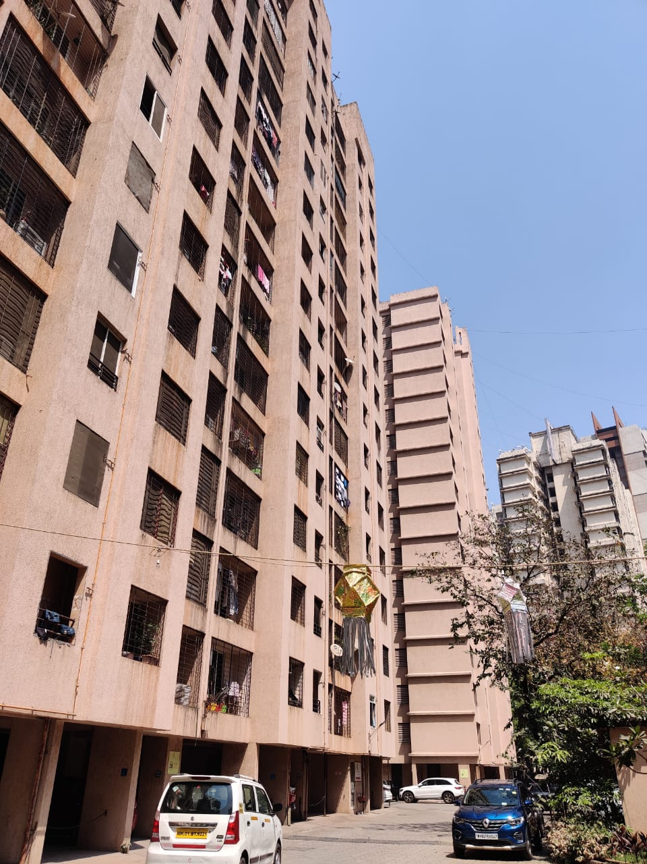

Details of the property under consideration:
Name of Owner: Mrs. Beena Bipin Pitroda & Mr. Bipin Laxmidas Pitroda

Residential Flat No. 1002, 10th Floor, “Cedar Building”, Mahavir Kalpvruksha Complex, Ghodbunder Road, Village – Ovale, Thane (West), PIN – 400601, State – Maharashtra, Country – India.

Longitude Latitude: 19°16’06.8”N 72°57’44.8”E

Valuation Done for:
Bank of Baroda
Kapurbawadi Branch
Shop No. 4 to 8, Jangid Heights, Near CIne Wonder Mall, Kapurbawadi, Thane West,
PIN – 400601, State – Maharashtra, Country – India.

Vastukala Consultants (I) Pvt. Ltd.
Mumbai • Delhi NCR • Indore • Aurangabad • Nanded• Pune
Raipur • Jaipur • Ahmedabad • Rajkot • Thane • Nashik
INDEX
Particulars Page No.
1. VALUATION OPINION REPORT 3
2. VALUATION REPORT (IN RESPECT OF FLAT) 4
3. TOTAL ABSTRACT VALUATION OF THE ENTIRE PROPERTY 10
4. METHOD OF VALUATION: SALES COMPARISON APPROACH METHOD 10
5. SOURCE OF DATA COLLECTION 11
6. IMPORTANT NOTES 11
7. ASSUMPTIONS, DISCLAIMERS, LIMITATIONS & QUALIFICATIONS 11
8. DECLARATION-CUM-UNDERTAKING 15
9. ACTUAL SITE PHOTOGRAPHS 19
10. GOOGLE MAP OF THE PROPERTY 21
10. READYRECKONER RATE 22
11. PRICE INDICATORS 23
12. JUSTIFICATION FOR PRICE /RATE 26
13. VALUATION OF THE PROPERTY PREMISES 27

Vastu/Mumbai/03/2022/23606/397968919
19/20-327-SKVS
Date: 19.03.2022

VALUATION OPINION REPORT

This is to certify that the property bearing Residential Flat No. 1002, 10th Floor, “Cedar Building”, Mahavir Kalpvruksha Complex, Ghodbunder Road, Village – Ovale, Thane (West), PIN – 400601, State – Maharashtra, Country – India belongs to Mrs. Beena Bipin Pitroda & Mr. Bipin Laxmidas Pitroda.

Boundaries of the property.
North | : | Puranik Hometown City Road
South | : | Seven Square Academy
East | : | Parijat Garden
West | : | Internal Road
Considering various parameters recorded, existing economic scenario, and the information that is available with reference to the development of neighbourhood and method selected for valuation, we are of the opinion that, the property premises can be assessed and valued for SARFAESI Securitisation and Reconstruction of Financial Assets and Enforcement of Security Interest Act, 2002 purpose at
Particulars | Fair Market Value In (`) | Realizable Value In (`) | Distress Sale Value In (`) | Insurable Value In  (`)
Residential Flat | ` 86,16,888.00 | ` 73,24,355.00 | ` 60,31,822.00 | ` 19,92,600.00
The valuation of the property is based on the documents produced by the concern. Legal aspects have not been taken into considerations while preparing this valuation report.
Hence certified

Sharadkumar B. Chalikwar
Govt. Reg. Valuer
Chartered Engineer (India)
Reg. No. (N) CCIT/1-14/52/2008-09

Vastukala Consultants (I) Pvt. Ltd.
121, 1st Floor, Ackruti Star, Central Road, MIDC, Andheri (E), Mumbai – 400 093.

To,
The Chief Manager,
Bank Of Baroda
Kapurbawadi, MMSR Branch
Shop No. 4 to 8, Jangid Heights, Near CIne wonder Mall,
Kapurbawadi, Thane West, PIN – 400601, State – Maharashtra, Country – India.

VALUATION REPORT (IN RESPECT OF FLAT)

 | Ref No & Date | : | -
1 | Purpose for which the valuation is made | : | As per the request from Bank of Baroda, Kapurbawadi Branch to assess market value of the property for SARFAESI Securitisation and Reconstruction of Financial Assets and Enforcement of Security Interest Act, 2002 purpose
2 | Type of Property | : | Residential
 | If the property is industrial state: | : | N.A.
 | - for what type of activity industry, the premises is well suited: | : | N.A.
 | - Sanctioned/connected power load: | : | N.A.
 | - Type of activity presently going on at the premises: | : | N.A.
3 | Date of visit |  | 16.03.2022
4 | Documents produced for scrutiny:
 | Description of the document | : | Document number | Document date
 | - Copy of Agreement for sale |  | TNN2-11646-2015 | 29.09.2015
 | - Copy of Index II |  | 11646/2015 | 29.09.2015
 | - Copy of Occupancy Certificate issued by Thane Municipal Corporation |  | V.P. No. 2007 / 22 / TMC / TDD / 90 | 31.07.2014
 | - Copy of Commencement Certificate issued by Thane Municipal Corporation |  | V.P. No. 2007 / 22 / TMC / TDD / 807 | 17.032.010
 | Name of the owner(s) | : | Mrs. Beena Bipin Pitroda & Mr. Bipin Laxmidas Pitroda
5 | Property Details:
 | House/Flat No/Door No. |  | Residential Flat No. 1002
 | Plot No. |  | -
 | Survey No |  | Survey No. 86/1A+2+3A, 86/3C and others of Village – Ovale
 | Ward & Block No. |  | -
 | Location |  | Ghodbunder Road, Village – Ovale, Thane (West)
 | Property is situated in (Gram Panchayat, Municipality, Municipal corporation) |  | Thane Municipal Corporation
 | LANDMARK (Mandatory) |  | Seven Square Academy
 | Full postal address of the property (FULL ADDRESS AND PINCODE MANDATORY) |  | Residential Flat No. 1002, 10th Floor, “Cedar Building”, Mahavir Kalpvruksha Complex, Ghodbunder Road, Village – Ovale, Thane (West), PIN – 400601, State – Maharashtra, Country – India
6 | Brief Description/Specification of the property with comments on Right of Way and other Easementary Rights: | :
 | The property is a Residential Flat located on 10th Floor. The composition of Flat is having 2 Bedrooms + Living Room + Dining + Kitchen + 2 Toilets + Balcony (i.e. 2 BHK + 2 Toilets). The property is at 10.1 6 KM. distance from nearest railway station Thane.
 | Right of Way and other Easementary Rights – N.A.

7.1 | Dimensions of the Plot of land (larger Extent)
 | Direction | As per the document Plan/title deed | Actual  (As per the measurement of site during visit)
 | North | N.A., the property under consideration is Residential Flat.
 | East
 | South
 | West
7.2 | Boundaries of the property (larger extent):
 | Direction | As per the document Plan/title deed | Actual  (As per the measurement of site during visit)
 | North | N.A. | N.A.
 | East | N.A. | N.A.
 | South | N.A. | N.A.
 | West | N.A. | N.A.
7.3 | Shape of the plot of land and remarks | N.A., the property under consideration is Residential Flat.
7.4 | Boundaries of the property (Flat)
 | Direction | As per the document Plan/title deed | Actual  (As per the measurement of site during visit)
 | North | Details not available | Compound Area
 | East | Details not available | Lift
 | South | Details not available | Compound Area
 | West | Details not available | Flat No. 1001

8.0 | Flat marking are available (Yes / No) | No
 | Dimensions of the Structure
 | Area of the unit | As per approved plan | As per the actual construction
 | Built up area | Not Provided | Carpet Area in Sq. Ft. = 587.00  Balcony Area in Sq. Ft. = 35.00  Total Area in Sq. Ft. = 622.00  (Area as per actual site measurement)  Carpet Area in Sq. Ft. = 615.00  (Area as per Index II)  Built Up Area in Sq. Ft. = 738.00  (Carpet + 20%)
 | Common areas | - | -
 | Car Parking | - | 1 Podium with Puzzle Car parking

8.1 Specification of Construction:

S. No. | Particulars | Comment
8.1.1 | Foundation | R.C.C.
8.1.2 | Basement | No
8.1.3 | Superstructure | RCC Framed Structure with Stilt + 15 Upper Floor.  R.C.C. frame work with 9 inch thick B. B. Masonry for external walls & 6 inch thick B.B. Masonry for internal walls
8.1.4 | Joinery/Doors Windows | Powder coated aluminum sliding windows
8.1.5 | Walls and roof | 6" thick B.B. Masonry internal walls with Cement and Neeru finish and 9" thick B. B. Masonry external walls with sand faced plaster finish, R.C.C. slab
8.1.6 | Doors | Wooden door frame with flush shutters
8.1.7 | Windows | Powder coated aluminum sliding windows
8.1.8 | Plastering | Cement plastering + sand faced plaster externally
8.1.9 | Flooring | All rooms are finished with Vitrified tiles flooring. Toilets are finished with ceramic tiles flooring & full height glazed tiles dado.
8.1.10 | Any special finishing | No
8.1.11 | Compound wall. | 5'6" High, R.C.C. columns with B. B. Masonry wall
8.1.12 | Water and sump | Municipal Water Supply and sewerage line.

9. | Details of Approval:
9.1 | Whether plan approval and required permission are issued by the competent authority (Yes/No) | As Occupancy Certificate is available it may be assumed that the construction is as per Sanctioned Plan.
9.2 | Any other additional permissions / approval is required to be obtained. (Yes/No)  If yes please mention the details of permissions/approvals to be obtained. | N.A.
 | Whether building tax/land revenue has been paid up to date (Yes/No) | Information not available
 | If building tax/land revenue tax is not required to be paid, state the reason for the same.: | N.A.
 | Details of approvals/permissions/ electricity connection/property tax/ (please include or delete any document as per applicability) | Issuing authority | Number of the document | Date of the document
 | a) Non agriculture land conversion order/  Data Bank Details of converted property | N.A., as the land is Residential
 | b) Lay out approval/Regularization order of the plot.  b) Lay out approval/Regularization order of the plot issued by Govt.  If regularization of the plot is not required as per the aforesaid GO, reason for the same | Copy of Approved building plan is not provided for verification.
 | c) Building construction approval Certificate from the competent authority  (Applicable to MC where building is  constructed before ………….. without  approved sanction plan) | N.A.
 | d) BPS/BRS/LRS order | Details Not Provided
 | e) Land use certificate | Details Not Provided
 | f) Commencement certificate | Details Not Provided
 | g) Occupancy certificate | Details Not Provided
 | h) Patta Details: Type: Natham  Patta/Manaivari Patta etc  Patta No: (Applicable to TN) | Not Applicable as the property is located in the Maharashtra State.
 | Restrictive Clauses as to uses, if any (whether Building use Certificate from the competent authority has been obtained etc.) | As per TMC norms

9.4 | Description of the locality (Residential/commercial/mixed residential and commercial/industrial) | Residential
9.5 | Classification of the Locality as per Municipal records | Middle
9.6 | Classification of locality (Higher class/Middle Class etc.) | Middle Class
 | Classification of area (Metro/Urban/Semi Urban / Rural) | Urban
9.7 | Title of the property (free hold, lease hold etc.) | Freehold
 | If not free hold, what is the unexpired Period of contract in force? | N.A.
 | Please mention the details of the contract in force (for eg: name  of the tenant, date of effect of the lease/rental agreement, expiry date, monthly rent etc) | N.A.
9.8 | Presently used for (Residential / Commercial / Godown etc.) | Residential
 | Type of the use to which it can be put to (in case of under construction / construction yet to be started units) | N.A.
9.9 | Building is vacant / occupied by owner/tenant | Owner Occupied
9.10 | Tentative monthly rent if let out. | Expected rental income per month - ` 18,000.00
9.11 | Name of the present Owner | Mrs. Beena Bipin Pitroda & Mr. Bipin Laxmidas Pitroda
 | Whether joint/co-ownership/others (specify) | Joint Ownership
 | In case of joint ownership please furnish shares of each owner and also whether the shares are undivided? | Details of ownership share is not available
9.12 | Year of acquisition | 29.09.2015
9.13 | Purchase price | ` 72,37,500.00
9.14 | Name of the person accompanied for inspection and contact number. | Mr. Bipin Laxmidas Pitroda (Owner)  Contact No.: 9082374811
9.15 | Name of the Bank Official accompanied for inspection and Branch name. | -
9.16 | Has the whole or part of the land been notified for acquisition by Government or Statutory Body? If so, give details | N.A.
9.17 | General remarks:
 | - Development of the surrounding areas. | Residential
 | - Proximity of CIVIC amenities like schools, hospitals, offices, markets, entertainment centres, Commercial Malls etc. | All Available near by
 | - Level of land with topographical conditions. | Plain
 | - Means and proximity of transportation facilities. | Bus, Auto, Taxi & Private vehicles etc.
 | - Maintenance of the Flat. | Good
 | - Disadvantages if any. | No

9.2 Details of Previous Valuation:
Whether the subject property was valued earlier (Yes/No) | Details Not provided
Date of earlier valuation | Details Not provided
Name and address of the valuer | Details Not provided
Purpose of earlier valuation | To ascertain Fair Market Value
Basis of valuation (enclose a copy of the same) | Details Not provided
Reason for increase or decrease in the valuation of the property | N.A.

PART-2 | VALUATION OF THE PROPERTY | (STRUCTURE)
10.2.1 | Type of building  (Residential / Commercial / Industrial) | Residential
10.2.2 | Year of construction | 2014 (As per Occupancy Certificate)
10.2.3 | Age of property | 8 Years
10.2.4 | Residual life of the property | 52 Years (Subject to proper, preventive periodic maintenance and structural repairs.)
10.2.5 | Type of structure (RCC/Load Bearing/Steel Framed) | RCC Framed Structure
10.2.6 | No. of floors and height of each floor | Stilt + 15 Upper Floor  10th Floor is having 4 Residential Flats.  The building is having 2 Lifts.
10.2.7 | Floor in which the subject flat is located | 10th Floor
 | Configuration of the unit | Residential Flat
 | Extent of UDS portion | -
 | Carpet Area | Carpet Area in Sq. Ft. = 587.00  Balcony Area in Sq. Ft. = 35.00  Total Area in Sq. Ft. = 622.00  (Area as per actual site measurement)  Carpet Area in Sq. Ft. = 615.00  (Area as per Index II)
 | Plinth area | Built Up Area in Sq. Ft. = 738.00  (Carpet + 20%)
10.2.8 | Deviation observed in construction (Yes/No) | N.A, as the copy of approved building plan is not provided for verification.
 | Percentage of deviation
 | Risk of demolition (Yes/No) | No
10.2.9 | Adverse effect of bank’s interest if any on accepting the property as security | No
10.2.10 | Mortgage stipulation if any as per building approval | Information not available
10.2.11 | Carpet Area of Residential Flat | 615.00 Sq. Ft.
 | Rate per Sq. Ft. | ` 14,400.00 per Sq. Ft. including parking
 | Value of Residential Flat | ` 88,56,000.00
10.2.12 | Total | ` 88,56,000.00
10.2.13 | Remark
10.2.14 | Any addition of interiors/extension/addition is proposed (Yes/No) |  | No

PART 3: Item wise Valuation of other amenities/extra items/ miscellaneous (including proposed) which are not considered in Part-1/ Part-2 above.
Government Value
10.3 | Item | Unit of Measurement | Quantity | Value
 | Included in the Part - 2 above |  |  | -
 | Total value of the amenities/extra items/ miscellaneous |  |  | -

Guideline rate obtained from the Registrar's Office  (New Property) | 71,715.00 Sq. Mt.
Guideline rate (After Depreciation) | 66,164.00 Sq. Mt.

 | Rate in Sq. Mt. | Rate in Sq. Ft.
Guideline Rate | 68,300.00
Increased 5% Floor wise | 3,415.00
Guideline Rate (New Property) | 71,715.00 | 6,662.49
(-) Land Cost | 16,200.00
 | 55,515.00
Depreciation 30% | 49,963.50
Guideline Rate (After Depreciation) | 66,163.50 | 6,146.74  Say 6,147/-

Particulars | Built Up Area in Sq. Ft. | Rate in ` | Value in `
Flat | 738.00 | 6,147.00 | 45,36,486.00
Total |  |  | 45,36,486.00

TOTAL ABSTRACT VALUATION OF THE ENTIRE PROPERTY

Part 1 | Land / UDS Portion | -
Part 2 | Flat | ` 88,56,000.00
 | Cost of Construction (738.00 X 2,700/-) | ` 19,92,600.00
 | Depreciation {(100-10) X 8/60} | 12.00%
 | Less: Depreciation if any (mention the percentage of salvage value) | 2,39,112.00
Part 3 | Interiors/amenities | -
 | Total | ` 86,16,888.00
 | Present Market Value of the property | ` 86,16,888.00
 | Realizable Value of the property | ` 73,24,355.00
 | Distress sale value of the property | ` 60,31,822.00
 | Marketability (Very Good/Good/Moderate/no  demand) | Moderate
 | What are the factors favouring for an extra potential value | Not Applicable

METHOD OF VALUATION: SALES COMPARISON APPROACH METHOD

- The sales comparison approach uses the market data of sale prices to estimate the value of a real estate property. Property valuation in this method is done by comparing a property to other similar properties that have been recently sold. Comparable properties, also known as comparable, or comps, must share certain features with the property in question. Some of these include physical features such as square footage, number of rooms, condition, and age of the building; however, the most important factor is no doubt the location of the property.
- Adjustments are usually needed to account for differences as no two properties are exactly the same. To make proper adjustments when comparing properties, real estate appraisers must know the differences between the comparable properties and how to value these differences.
- The sales comparison approach is commonly used for Residential Flat, Commercial office, Industrial Gala, Godowns where there are typically many comparable available to analyze.
- As the property is a Residential Flat, we have adopted Sale Comparison Approach Method for the purpose of valuation
- The Price for similar type of property in the nearby vicinity is in the range of ` 13,000/- to ` 15,000/- per Sq. Ft. on Carpet Area Considering the rate with attached report, current market conditions, demand and supply position, Flat size, location, upswing in real estate prices, sustained demand for such property, all round development of residential & commercial application in the locality etc. We estimate ` 14,400/- per Sq. Ft. on Carpet Area for valuation.

SOURCE OF DATA COLLECTION
Please mention the sources of data collection for present market value and the guideline value.
- For Present Market Value- Source for Data Collection is Subject property Area Market Survey, Local Inquires from Estate Agents & Online Portals.
- For Guideline Value: https://igrmaharashtra.gov.in/eASR/eASRCommon.aspx?hDistName=Thane

As a result of my appraisal and analysis, it is my considered opinion that the present market Value of the above property in the prevailing condition with aforesaid specification is ` 86,16,888.00 (Rupees Eighty Six Lakh Sixteen Thousand Eight Hundred Eighty Eight Only).
Date: 19.03.2022
Place: Mumbai

Sharadkumar B. Chalikwar
Govt. Reg. Valuer
Chartered Engineer (India)
Reg. No. (N) CCIT/1-14/52/2008-09
For Valuation Certificate: Please refer page No. 3 for the same.

IMPORTANT NOTES

Important Notes

ASSUMPTIONS, DISCLAIMERS, LIMITATIONS & QUALIFICATIONS

Value Subject to Change
The subject appraisal exercise is based on prevailing market dynamics as on 19th March 2022 and does not take into account any unforeseeable developments which could impact the same in the future.
Our Investigations
We are not engaged to carry out all possible investigations in relation to the subject property. Where in our report we identify certain limitations to our investigations, this is to enable the reliant party to instruct further investigations where considered appropriate or where we recommend as necessary prior to reliance. Vastukala Consultants India Pvt. Ltd. (VCIPL) is not liable for any loss occasioned by a decision not to conduct further investigations
Assumptions
Assumptions are a necessary part of undertaking valuations. VCIPL adopts assumptions for the purpose of providing valuation advise because some matters are not capable of accurate calculations or fall outside the scope of our expertise, or out instructions. The reliant party accepts that the valuation contains certain specific assumptions and acknowledge and accept the risk of that if any of the assumptions adopted in the valuation are incorrect, then this may have an effect on the valuation.
- The property is valued as though under responsible ownership.
- It is assumed that the property is free of liens and encumbrances.
- It is assumed that there are no hidden or unapparent conditions of the subsoil or structure that would render it more or less valuable. No responsibility is assumed for such conditions or for engineering that might be required to discover such factors.
- There is no direct/ indirect interest in the property valued.
- The rates for valuation of the property are in accordance with the Govt. approved rates and prevailing market rates
Information Supplied by Others
The appraisal is based on the information provided by the client. The same has been assumed to be correct and has been used for appraisal exercise. Where it is stated in the report that another party has supplied information to VCIPL, this information is believed to be reliable but VCIPL can accept no responsibility if this should prove not to be so.
Future Matters
To the extent that the valuation includes any statement as to a future matter, that statement is provided as an estimate and/or opinion based on the information known to VCIPL at the date of this document. VCIPL does not warrant that such statements are accurate or correct.

Map and Plans
Any sketch, plan or map in this report is included to assist the reader while visualizing the property and assume no responsibility in connection with such matters.
Site Details
Based on inputs received from Client's representative and site visit conducted, we understand that the subject property is a Residential Flat. The property is owned by Mrs. Beena Bipin Pitroda & Mr. Bipin Laxmidas Pitroda. At present, the property is Owner occupied. Further, VCIPL has assumed that the subject property is free from any encroachment and is available as on the date of the appraisal.

Property Title
Based on our discussion with the Client, we understand that the property is owned by Mrs. Beena Bipin Pitroda & Mr. Bipin Laxmidas Pitroda. For the purpose of this appraisal exercise, we have assumed that the subject property has a clear title and is free from any encumbrances, disputes and claims. VCIPL has made no further enquiries with the relevant local authorities in this regard and does not certify the property as having a clear and marketable title. Further, no legal advice regarding the title and ownership of the subject property has been obtained for the purpose of this appraisal exercise. It has been assumed that the title deeds are clear and marketable.
Environmental Conditions
We have assumed that the subject property is not contaminated and is not adversely affected by any existing or proposed environmental law and any processes which are carried out on the property are regulated by environmental legislation and are properly licensed by the appropriate authorities.
Town Planning
The permissible land use, zoning, achievable FSI, area statement adopted for purpose of this valuation is based on the information provided by the Client's representative and the same has been adopted for this valuation purpose. VCIPL has assumed the same to be correct and permissible. VCIPL has not validated the same from any authority.
Area
Based on the documents, we understand that the subject property is a Residential Flat, admeasuring 615.00 Sq. Ft. Carpet Area.
Condition & Repair
In the absence of any information to the contrary, we have assumed that there are no abnormal ground conditions, nor archaeological remains present which might adversely affect the current or future occupation, development or value of the property. The property is free from rat, infestation, structural or latent defect. No currently known deleterious or hazardous materials or suspect techniques will be used in the construction of or subsequent alteration or additions to the property and comments made in the property details do not purport to express an opinion about, or advise upon, the condition of uninspected parts and should not be taken as making an implied representation or statement about such parts.

Valuation Methodology
For the purpose of this valuation exercise, the valuation methodology used is Direct Comparison Approach Method and proposed Current use / Exiting use premise is considered for this assignment.
The Direct Comparison Approach involves a comparison of the property being valued to similar properties that have actually been sold in arms - length transactions or are offered for sale. This approach demonstrates what buyers have historically been willing to pay (and sellers willing to accept) for similar properties in an open and competitive market and is particularly useful in estimating the value of the land and properties that are typically traded on a unit basis.
In case of inadequate recent transaction activity in the subject micro-market, the appraiser would collate details of older transactions. Subsequently, the appraiser would analyse rental / capital value trends in the subject micro-market in order to calculate the percentage increase / decrease in values since the date of the identified transactions. This percentage would then be adopted to project the current value of the same.
Where reliance has been placed upon external sources of information in applying the valuation methodologies, unless otherwise specifically instructed by Client and/or stated in the valuation, VCIPL has not independently verified that information and VCIPL does not advise nor accept it as reliable. The person or entity to whom the report is addressed acknowledges and accepts the risk that if any of the unverified information in the valuation is incorrect, then this may have an effect on the valuation.
Not a Structural Survey
We state that this is a valuation report and not a structural survey
Other
All measurements, areas and ages quoted in our report are approximate
Legal
We have not made any allowances with respect to any existing or proposed local legislation relating to taxation on realization of the sale value of the subject property. VCIPL is not required to give testimony or to appear in court by reason of this appraisal report, with reference to the property in question, unless arrangement has been made thereof. Further, no legal advice on any aspects has been obtained for the purpose of this appraisal exercise
We assume no responsibility for matters of legal nature affecting the property appraised or the title thereto, nor do we render our opinion as to the title, which is assumed to be good and marketable.
Property specific assumptions
Based on inputs received from the client and site visit conducted, we understand that the subject property a Residential Flat, admeasuring 615.00 Sq. Ft. Carpet Area Currently it is owner occupied.

The term Fair Market Value is defined as
“The most probable price, as of a specified date, in cash, terms equivalent to cash, or in other precisely revealed terms for which the specified property rights would sell after reasonable exposure in a competitive market under all conditions requisite to a fair sale, with the buyer and seller each acting prudently knowledgeably and for self interest assuming that neither is under undue duress”.

DECLARATION-CUM-UNDERTAKING

I, Sharadkumar Chalikwar son of Shri. Baburao Chalikwar do hereby solemnly affirm and state that:

- I am a citizen of India.
- I will not undertake valuation of any assets in which I have a direct or indirect interest or become so interested at any time during a period of three years prior to my appointment as valuer or three years after the valuation of assets was conducted by me.
- The information furnished in my valuation report dated 19.03.2022 is true and correct to the best of my knowledge and belief and I have made an impartial and true valuation of the property.
- I/ my authorized representative has personally inspected the property on 16.03.2022. The work is not sub - contracted to any other valuer and carried out by myself.
- Valuation report is submitted in the format as prescribed by the bank.
- I have not been depanelled / delisted by any other bank and in case any such depanelment by other banks during my empanelment with you, I will inform you within 3 days of such depanelment.
- I have not been removed / dismissed from service / employment earlier.
- I have not been convicted of any offence and sentenced to a term of imprisonment
- I have not been found guilty of misconduct in my professional capacity.
- I have not been declared to be unsound mind
- I am not an undischarged bankrupt, or has not applied to be adjudicated as a bankrupt;
- I am not an undischarged insolvent.
- I have not been levied a penalty under section 271J of Income-tax Act, 1961 (43 of 1961) and time limit for filing appeal before Commissioner of Income-tax (Appeals) or Income-tax Appellate Tribunal, as the case may be has expired, or such penalty has been confirmed by Income-tax Appellate Tribunal, and five years have not elapsed after levy of such penalty
- I have not been convicted of an offence connected with any proceeding under the Income Tax Act 1961, Wealth Tax Act 1957 or Gift Tax Act 1958 and
- My PAN Card number as applicable is AEAPC0117Q
- I undertake to keep you informed of any events or happenings which would make me ineligible for empanelment as a valuer
- I have not concealed or suppressed any material information, facts and records and I have made a complete and full disclosure
- I have read the Handbook on Policy, Standards and procedure for Real Estate Valuation, 2011 of the IBA and this report is in conformity to the "Standards" enshrined for valuation in the Part - B of the above handbook to the best of my ability.
- I have read the International Valuation Standards (IVS) and the report submitted to the Bank for the respective asset class is in conformity to the "Standards" as enshrined for valuation in the IVS in "General Standards" and "Asset Standards" as applicable. The valuation report is submitted in the prescribed format of the bank.
- I abide by the Model Code of Conduct for empanelment of valuer in the Bank. (Annexure V - A signed copy of same to be taken and kept along with this declaration)
- I am registered under Section 34 AB of the Wealth Tax Act, 1957.
- I am valuer registered with Insolvency & Bankruptcy Board of India (IBBI)
- My CIBIL Score and credit worthiness is as per Bank's guidelines.
- I am Chairman & Managing Director of the company, who is competent to sign this valuation report.
- I will undertake the valuation work on receipt of Letter of Engagement generated from the system (i.e. LLMS / LOS) only.
- Further, I hereby provide the following information.

- We hereby declare that, our professional fees are not contingent upon the valuation findings. However, if the statute AND/OR clients demands that, the fees should be charged on the percentage of assessed value then, with the full knowledge of the AND/OR end user, it is being charged accordingly.

Sr. No. | Particulars | Valuer comment
1 | Background information of the asset being valued; | As per documents, the property is acquired by Mrs. Beena Bipin Pitroda & Mr. Bipin Laxmidas Pitroda vide Agreement for Sale dated 29.09.2015.
2 | Purpose of valuation and appointing authority | As per the request from Bank of Baroda, Kapurbawadi Branch to assess market value of the property for SARFAESI Securitisation and Reconstruction of Financial Assets and Enforcement of Security Interest Act, 2002 purpose
3 | Identity of the Valuer and any other experts involved in the valuation; | Sharadkumar B. Chalikwar – Regd. Valuer  Manoj B. Chalikwar – Regd. Valuer  Umang Patel – Regd. Valuer & Valuation Engineer  Kashinath Ugale – Valuation Engineer  Vaishali Sarmalkar – Technical Manager  Shyam Kajvilkar – TechnicalOfficer
4 | Disclosure of Valuer interest or conflict, if any; | We have no interest, either direct or indirect, in the property valued. Further to state that we do not have relation or any connection with property owner / applicant directly or indirectly. Further to state that we are an independent Valuer and in no way related to property owner / applicant
5 | Date of appointment, valuation date and date of report; | Date of Appointment – 16.03.2022  Valuation Date – 19.03.2022  Date of Report – 19.03.2022
6 | Inspections and/or investigations undertaken; | Physical Inspection done on date 16.03.2022
7 | Nature and sources of the information used or relied upon; | - Market Survey at the time of site visit  - Ready Reckoner rates / Circle rates  - Online search for Registered Transactions  - Online Price Indicators on real estate portals  - Enquiries with Real estate consultants  - Existing data of Valuation assignments carried out by us
8 | Procedures adopted in carrying out the valuation and valuation standards followed; | Sales Comparison Method
9 | Restrictions on use of the report, if any; | This valuation is for the use of the party to whom it is addressed and for no other purpose. No responsibility is accepted to any third party who may use or rely on the whole or any part of this valuation. The valuer has no pecuniary interest that would conflict with the proper valuation of the property.
10 | Major factors that were taken into account during the valuation. | current market conditions, demand and supply position, Residential Flat size, location, upswing in real estate prices, sustained demand for Residential Flat, all round development of commercial and residential application in the locality etc.
11 | Caveats, limitations, and disclaimers to the extent they explain or elucidate the limitations faced by valuer, which shall not be for the purpose of limiting his responsibility for the valuation report. | Attached

For Branch Use

The undersigned has inspected the property detailed in the valuation report dt. ________, we are satisfied that the fair and reasonable value of the property is Rs. ____________ (___________________________________ in words).
Name of the inspecting officer:
Signature of the inspecting officer:
Designation of the inspecting officer:
Employee code:
Branch:
Seen and Noted
Name of the branch head/unit head:
Signature of the Branch head/Unit head:
Designation:
Employee code:
Branch:

ACTUAL SITE PHOTOGRAPHS
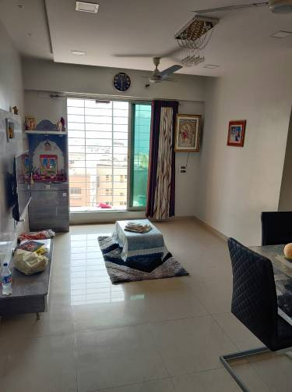
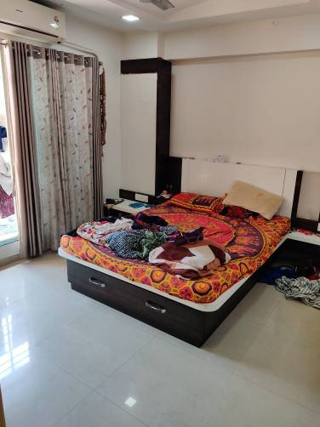
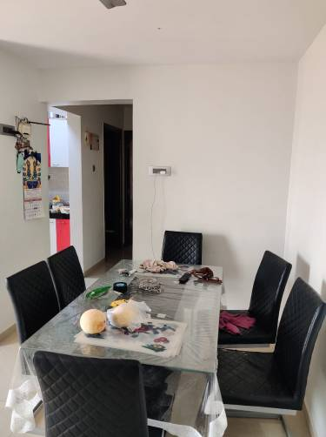

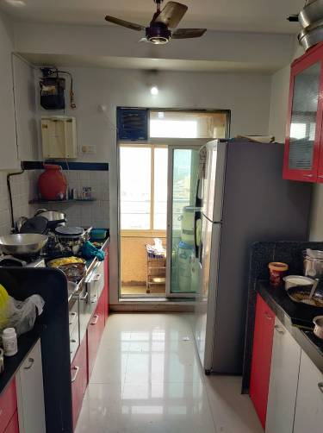
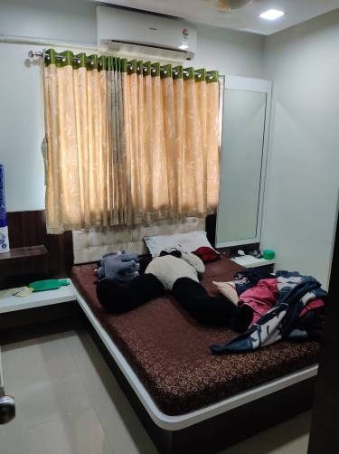
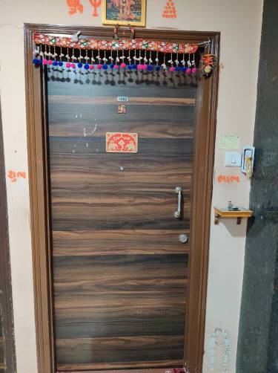

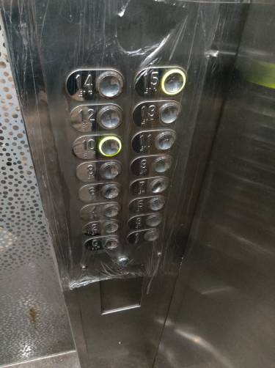
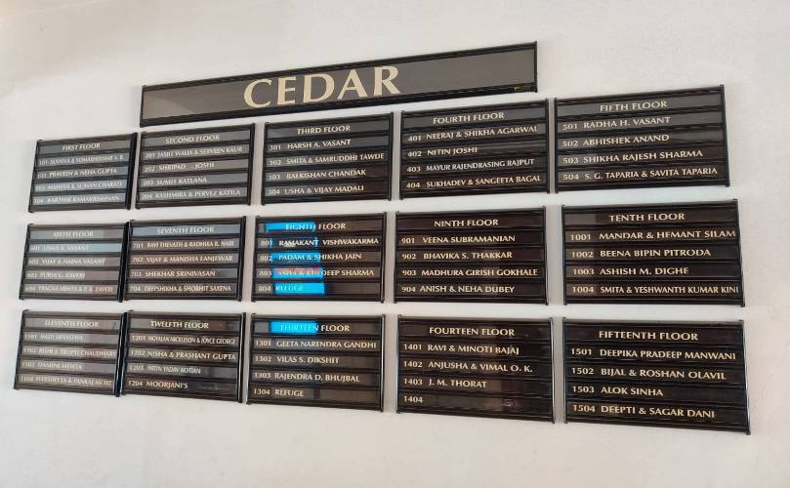

ACTUAL SITE PH OTOGRAPHS

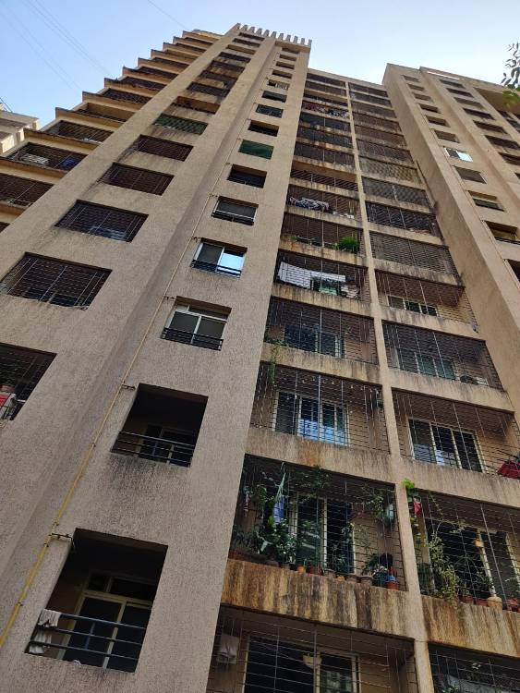
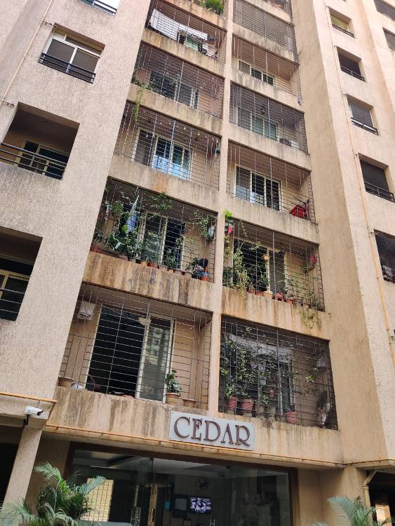
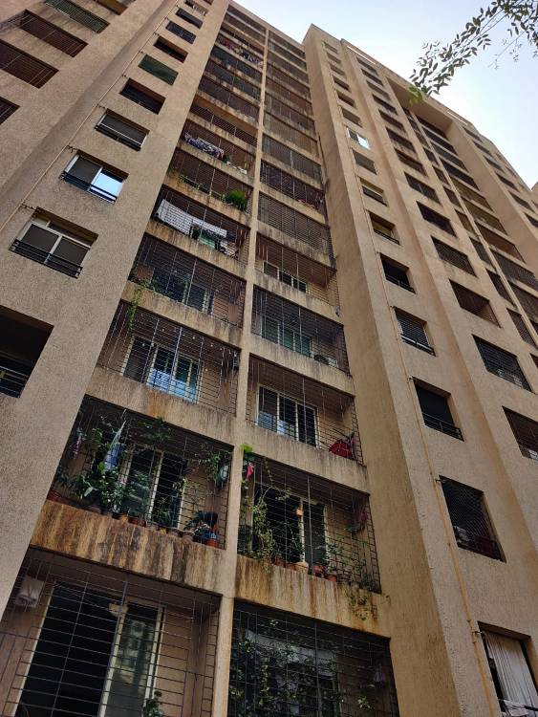

10. GOOGLE MAP OF THE PROPERTY
Site u/r
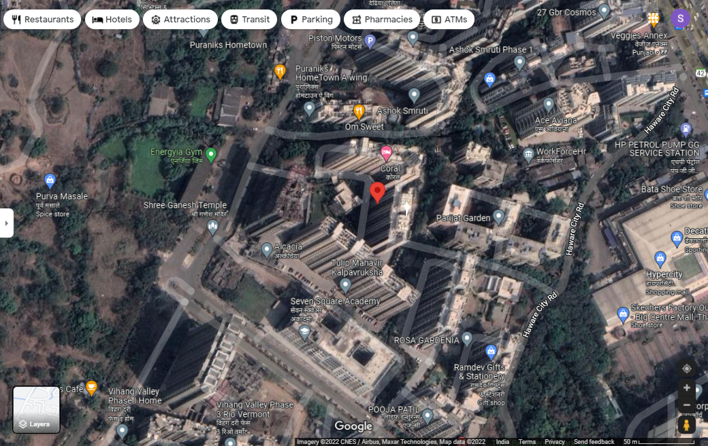

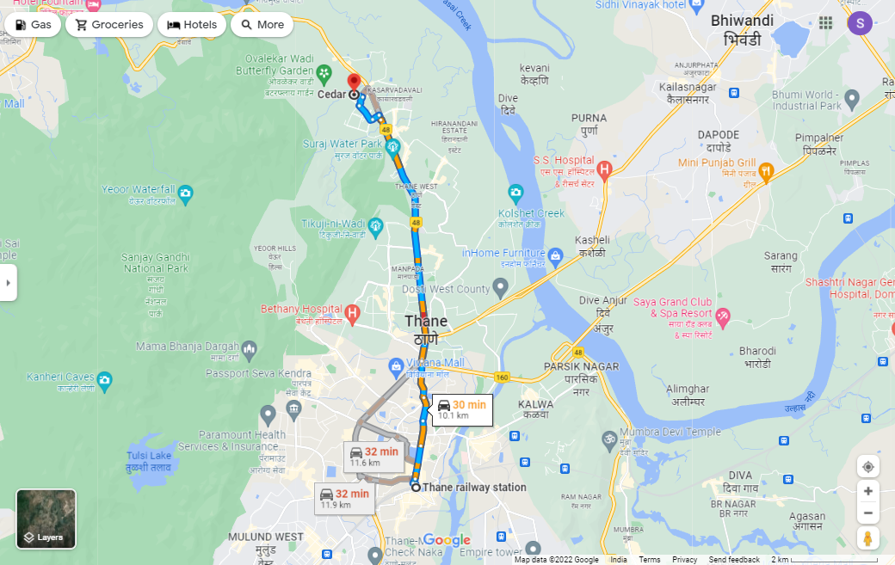

Latitude Longitude - 19°16’06.8”N 72°57’44.8”E
Note: The Blue line shows the route to site from nearest railway station (Thane – 10.1 Km.)

READYRECKONER RATE

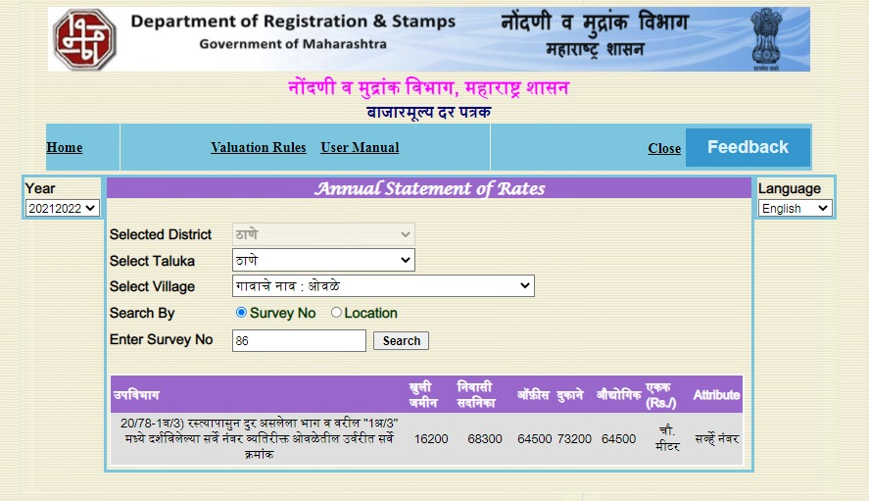

PRICE INDICATORS

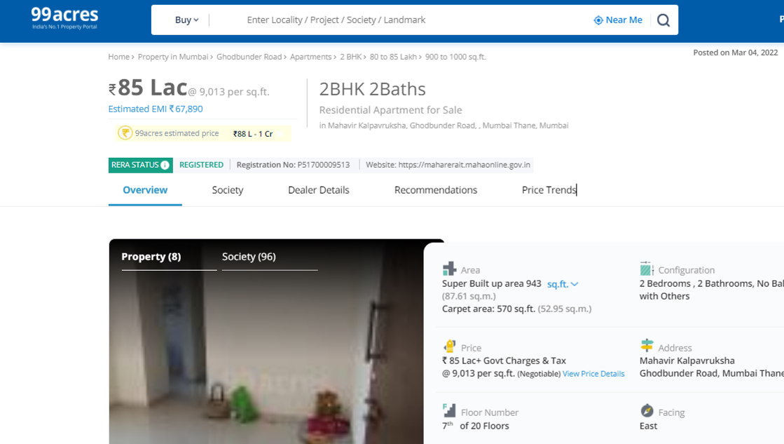

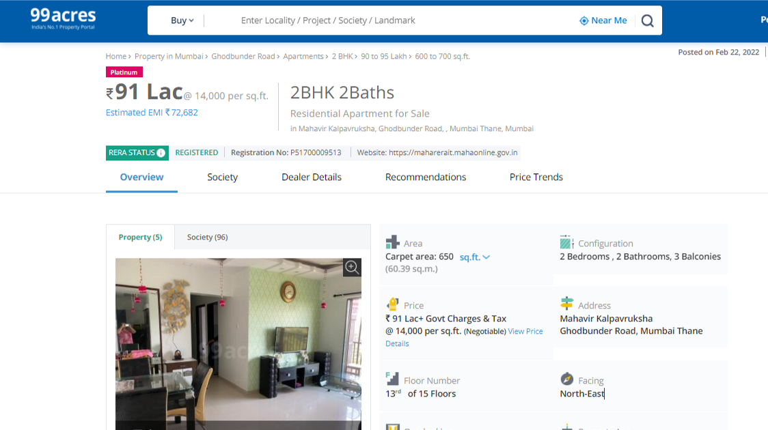

PRICE INDICATORS

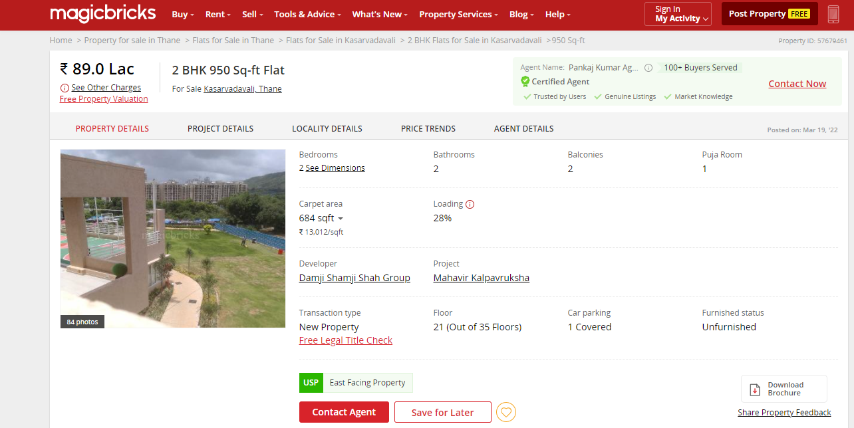

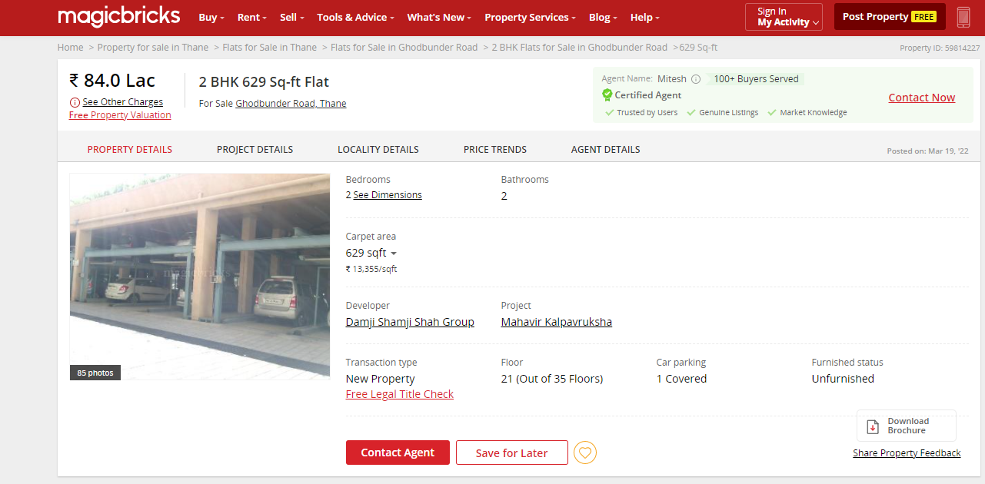

SALES INSTANCES
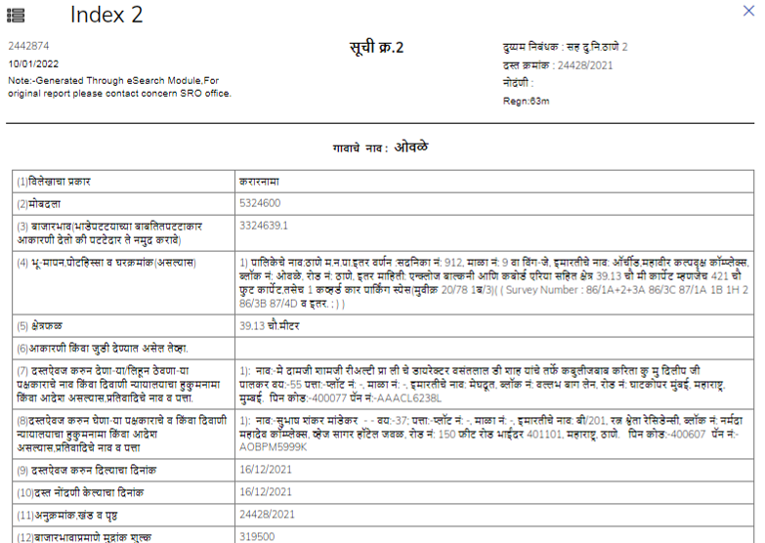
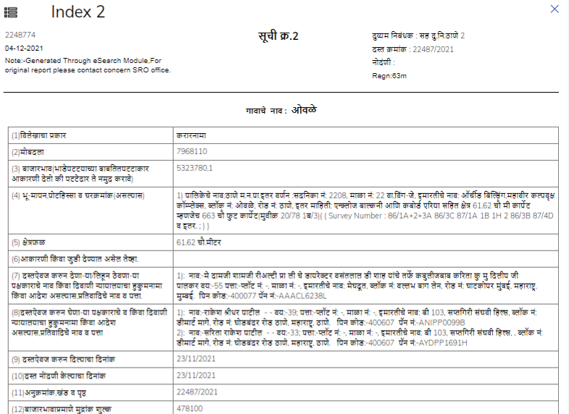

12. JUSTIFICATION FOR PRICE /RATE

The Market Value of the property is based on facts of markets discovered by us during our enquiries, however the government rate value in this case is less than the market value arrived by us. We are of the opinion that the value arrive by us will prove to be correct if an Auction of the subject property is carried out. As far as Market Value in Index II / Property Documents is concerned, it is not possible to comment on same, may be government rates are fixed by sampling during same point of time in part and whereas, Market values change every month.
In most of the cases the actual deal amount or Transaction value is not reflected in Index II / Property Documents because of various Market practices. As Valuer, we always try to give a value which is correct reflection of actual transaction value irrespective of any factors in market.
We hope this will satisfy your requirements.

VALUATION OF THE PROPERTY PREMISES

Considering various parameters recorded, existing economic scenario, and the information that is available with reference to the development of neighbourhood and method selected for valuation, we are of the opinion that, the property premises can be assessed and valued for SARFAESI Securitisation and Reconstruction of Financial Assets and Enforcement of Security Interest Act, 2002 purpose at
Particulars | Fair Market Value In (`) | Realizable Value In (`) | Distress Sale Value In (`) | Insurable Value In  (`)
Residential Flat | ` 86,16,888.00 | ` 73,24,355.00 | ` 60,31,822.00 | ` 19,92,600.00

Sharadkumar B. Chalikwar
Govt. Reg. Valuer
Chartered Engineer (India)
Reg. No. (N) CCIT/1-14/52/2008-09

