7th LENDERS INDEPENDENT ENGINEER REPORT
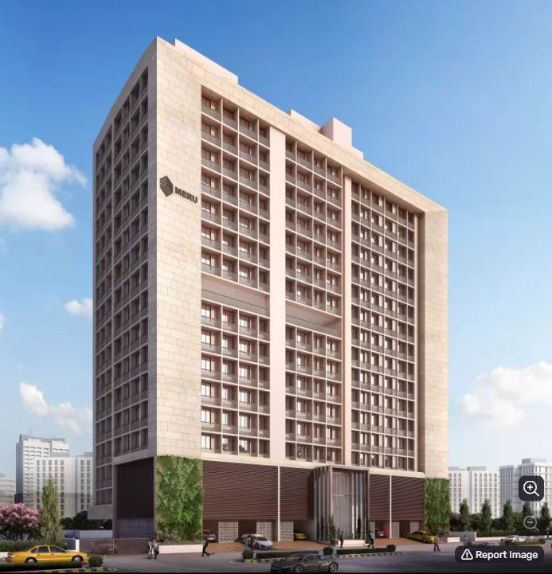

Details of the property under consideration:

Name of Project: Yojan One

"Yojan One", Proposed Slum Rehabilitation Scheme Residential Building on plot bearing on
C.T.S. No.131 (pt),131/1 to 131/50, 131/52 to 131/84, Match Factory Lane, H.P.K Marg,
Village – Kurla (IV), Kurla (West), Mumbai, Pin Code – 400 070, State - Maharashtra, Country – India

Latitude Longitude: 19°04'08.2"N 72°52'33.2"E

Valuation Prepared for:

State Bank of India
SME Chembur Branch
Unit No. 11, Building No. 11, Ground Floor, Corporate Park, Sion Trombay Road,
Chembur, Mumbai, Pin Code – 400 071, State - Maharashtra, Country – India

Vastu/SBI/Mumbai/11/2024/12176/2307397
25/08-401-PY
Date: - 05.11.2024

SEVENTH LENDERS INDEPENDENT ENGINEER REPORT

To,
State Bank of India
SME Chembur Branch
Unit No. 11, Building No. 11,
Ground Floor, Corporate Park,
Sion Trombay Road, Chembur,
Mumbai, Pin Code – 400 071,
State - Maharashtra, Country – India

Subject: Construction of Proposed Slum Rehabilitation Scheme - Residential Building on plot bearing on C.T.S. No.131,131/1 to 131/50, 131/52 to 131/84 Match Factory Lane, H.P.K Marg, Village – Kurla (IV), Kurla (West), Mumbai, Pin Code – 400 070, State - Maharashtra, Country – India.

Ref: You’re Request for Lenders Independent Engineer Report of under Construction Building.
Dear Sir,
- As per your instruction, we have inspected the under-construction Rehab and Sale Building project situated on plot bearing C.T.S. No.131,131/1 to 131/50, 131/52 to 131/84 Match Factory Lane, H.P.K Marg, Village – Kurla (IV), Kurla (West), Mumbai, Pin Code – 400 070, State - Maharashtra, Country – India which is being developed by M/s. Meru Realty LLP in order to give the physical progress at site and to certify cost incurred towards project as on 30/09/2024.
- The Construction work as per approved plan was in progress during the site visit on 16th October 2024.
- Status of work:
- For Rehab Building: Slab work, blockwork, plaster work, flooring, kitchen platform, kitchen & toilet tiling, waterproofing, firefighting, Gypsum work, plumbing & electrical concealed work are completed, Doors & Windows & Lift are installed & Internal Painting, Sanitary fitting & final finishing work is in progress.
Rehab building work is delay by 1 year.

- For Sale Building: 14th Floor Slab work, 1st & 10th floor block work is completed, 15th floor shuttering work is in progress & 11th floor block work is in progress.
Sale building work is delay by 6 months.

- As per cost incurred certificate issued by CA Certificate actual total expenditure occurred as on 30/09/2024 is ` 69.20 Cr. for Rehab & Sale Building (Wing A & B) & overall financial progress is 60.41% estimated cost of project.
- As per bills actual total expenditure occurred as on 30/09/2024 is ` 71.17 Cr. for Residential of Rehab & Sale Building (Wing A & B) & overall financial progress is 62.13% estimated cost of project.
- Overall Physical progress of the rehab building construction as on 16/10/2024 is 84.39% as per physical site inspection.

- Overall Physical progress of the sale building construction as on 16/10/2024 is 52.54% as per physical site inspection.

- Overall Physical progress of the rehab & sale building construction as on 16/10/2024 is 62.73% as per physical site inspection.

DECLARATION
- The information furnished in the report is based on our 7th site visit Dated 16/10/2024 & Document Provided by Client.
- Vastukala 6th LIE Report dated 25.07.2024.
- I have no direct and indirect interest in the property examined for report.
- I have not been found guilty of misconduct in my professional capacity.

Manoj B. Chalikwar
Registered Valuer
Chartered Engineer (India)
Reg. No. IBBI/RV/07/2018/10366
Encl.: LIE report

Purpose & Methodology
- State Bank of India Banks and financial institutions require monitoring & an independent review of the progress of the sanctioned projects
- VCIPL undertakes such study to independently review the progress of the project and put forward a comprehensive analysis

Advantages:
- Assurance on present practices
- Identification of risk
- Analyzing the performance of third parties
- Recommendations

The Methodology
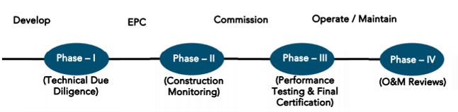
SEVENTH LENDERS INDEPENDENT ENGINEER REPORT
OF
"YOJAN ONE"

"Yojan One", Proposed Slum Rehabilitation Scheme Residential Building on plot bearing on C.T.S. No.131 (pt),131/1 to 131/50, 131/52 to 131/84, Match Factory Lane, H.P.K Marg, Village – Kurla (IV), Kurla (West),
Mumbai, Pin Code – 400 070, State - Maharashtra, Country – India

Latitude Longitude: 19°04'08.2"N 72°52'33.2"E

NAME OF DEVELOPER: M/s. Meru Realty LLP
Pursuant to instructions from State of India, SME Chembur Branch, we have duly visited, inspected, surveyed & assessed the above said property on 16th October 2024 to determine the fair & reasonable market value of the said property/project as on Quarter ending 30th September 2024 for LIE purpose.

1. Location Details:
Proposed Residential Building on plot bearing on C.T.S. No.131,131/1 to 131/50, 131/52 to 131/84 Match Factory Lane, H.P.K Marg, Village – Kurla (IV), Kurla (West), Mumbai, Pin Code – 400 070 It is about 850 M. tarvelling distance from Kurla Railway station. Surface transport to the property is by buses, taxis & private vehicles. The property is in developed locality. All the amenities like shops, banks, hotels, markets, schools, hospitals, etc. are all available in the surrounding locality. The area is higher middle class & developed.
2. Developer Details:
Name of builder | M/s. Meru Realty LLP
Project Rera Registration Number | P51800028864
Registered office address | Office No. 243, Behind Akshaya Jewellers, Opp. Kurla Police Staion, Sarveshwar Mandir Marg, Kurla (West), Mumbai, Pin Code – 400070, State - Maharashtra, Country – India
Contact details | Contact Person:  Mr. Arnik A. Shah (Director)  Mobile No. 9930084006
E – mail ID and website | merurealtyllp@gmail.com  www.merurealty.in
3. Boundaries of the Property:
Direction | Particulars
On or towards North | Manraj Heights
On or towards South | Slum Area
On or towards East | HP Keluskar Marg
On or towards West | Slum Area

Introduction
As per Information on site M/s. Meru Realty LLP has acquired land by Conveyance Deed dated 10.10.2017 admeasuring area is 3,674.10 Sq. M. bearing C.T.S. No.131,131/1 to 131/50, 131/52 to 131/84 & 132. For the Proposed Residential Building.

Area Statement:

Land:
Date | Particular | Area in Sq. M.
10.10.2017 | C.T.S. No.131,131/1 to 131/50, 131/52 to 131/84 & 132 | 3,674.10
TOTAL |  | 3,674.10

- Copy of Conveyance Deed dated 10.10.2017 b/w M/s. A. H. Wadia Trust (The Vendors) & M/s. Meru Realty LLP (The Purchasers)

Building Area As per Approved Plan:
Sr. No. | Area Statement | Area in Sq. M.
1 | Area of Plot | 3,248.10
a | Area of Reservation in Plot
b | Area of Road Set Back | 261.19
c | Area of DP Road | -
2 | Ductions For
A | For Reservation / Road Area | -
a | Road Set Back Area to Be Handed Over (100%) (Regulation No. (16) | 261.19
b | Proposed DP Road to Be Handed Over (100%)  (Regulation No. (16) | -
c | i) Reservation Area to Be Handed Over (100%) (Regulation No. (17)
 | ii) Reservation Area to Be Handed Over as Per AR (Regulation No. (17) | -
B | For Amenity Area | -
a | Area of Amenity Plots / Plots to Be Handed Over as Per DSR 14 A | -
b | Area of Amenity Plots / Plots to Be Handed Over as Per DSR 14 B | -
c | Area of Amenity Plots / Plots to Be Handed Over as Per DSR 35 (Abeyance) | -
C | Deduction For Existing BUA to Be Retained If Any / Land Component of Existing BUA/ Existing BUA as Per Regulation Under which the Development Was Allowed | -
3 | Total Deduction [(2(A) +2(B)+2(C)] and when Applicable | 2,986.91
4 | Balance Area of Plot (1 Minus 3) | -
5 | Plot Area Under Development After Area to Be Handed Over to MCGM / Applicable Authority as Per SR No. 4 Above | -
6 | Zonal (Basic FSI (0.50 or 0.75 or 0.33) | -
SR 1.1 | Minimum FSI to Be Attained as Per Clouse Use 3.8 of 33 (10) of DCPR 2034 | -
SR 1.2 | Permissible FSI as Per 33(11)A | -
7 | Built Up Area as Per Zonal (Basic) FSI (5X6) (In Case of Mill Land Permissible BUA / Keep in Abeyance
8 | Built Up Equal to Area of Land Handed Over as Per Regulation 30 (A)
 | i) As Per 2(A) And 2 (B) Except 2(A) (C) ii) Above with In Cap of Permissible TDR as Column 6 of Table-12 On Remaining/ Balance Plot
 | ii) In Case of 2 (A)(C) ii) Permissible Over and Above Permissible BUA on Remaining/ Balance Plot.
9 | Built Up Area In Lieu of Cost of Construction of Built-Up Amenity to Be Handed Over (Within the Limit of Premises BUA On Remaining Plot)
10 | Built Up Area Due to Additional FSI on Payment of Premium as per Table No. 12 of Regulation No. 30 (A) On Remaining / Balance Plot
11 | Built Up Area Due to Admissible TDR as Per Table No. 12 of Regulation NC 30 (A) And 32 On remaining / Balance Plot
12 | Permissible Built-Up Area (As the Case May Be with / without BUA as Per 2 (C)
SR 2.1 | Proposed Built Up Area of Rehab | 4,903.76
 | Rehab Component | 5,945.47
 | Permissible Sale Component (Incentive x Rehab Component) 5945.64 X 1.10 | 5945.64 X 1.10
SR 2.2 | Permissible Built-Up Transit Tenements for SRA / of Total Additional BUA
 | Permissible BUA for Sale Components of Total Additional BUA | 6,540.02
SR 3 | Total BUA Sanctioned for The Project | 11,443.78
13 | Proposed BUA (As the Case May Be with / Without BUA as Per 2C
SR 4.1 | Total BUA Proposed to Be Consumed In Situ
SR 4.1 | Proposed BUA for Transit Tenements For SRA/Of Total Additional BUA
 | Proposed BUA for Sale Component of Total Additional BUA | 6,540.02
14 | TDR Generate If Any as Per Regulation No. 30 (A) And 32
SR 5 | TDR Generate in Schedule
15 | Fungible Compensatory Area as Per Regulation No. 31(3)
a | i) Permissible Fungible Compensatory Area for Rehab Component Without Charging Premium | 1,716.52
 | ii) Fungible Compensatory Area Availed for Rehab Component Without Charging Premium | 155.52
b | i) Permissible Fungible Compensatory Area by Charging Premium for Sale | 2,289.00
 | ii) Fungible Compensatory Area Availed on Payment of Premium for Sale | 2,283.29
16 | i) Total BUA Including Fungible for Rehab Component
SR 6 | ii) Total BUA Including Fungible for Sale Component | 8,823.31
 | Total Built Up Area Proposed Including Fungible Compensatory Area [13 + 15 (a) (ii) + 15 (b)(ii)]
17 | FSI Consumed on Net Plot 13 SR 4.1 / 4

List of Approvals:
- Copy of IOD Plan for Rehab Building No. L/PVT/0076/20180604/LOI dated 28.08.2020 issued by Slum Rehabilitation Authority (SRA).
- Copy of Approved Plan for Rehab Building No. L/PVT/0076/20180604/AP/R dated 15.09.2020 issued by Slum Rehabilitation Authority (SRA).
Approval Up to: Basement + Ground Floor + 1st to 15th Upper Floors
- Copy of Amended Approved Plan for Rehab Building No. SRA/ENG/L/PVT/0076/20180604/AP/R dated 24.08.2023 issued by Slum Rehabilitation Authority (SRA).
Approval Up to: Basement + Ground Floor + 1st to 17th Upper Floors
- Copy of 1st Commencement Certificate for Rehab Building No. L/PVT/0076/20180604/AP/R dated 29.01.2021 issued by Slum Rehabilitation Authority (SRA).
(This CC is now endorsed for the work of Plinth Level)
- Copy of 2nd Commencement Certificate for Rehab Building No. L/PVT/0076/20180604/AP/R dated 29.06.2021 issued by Slum Rehabilitation Authority (SRA).
(This CC is now endorsed for the work of Basement + Ground Floor + 1st to 15th Upper Floors including OHT& LMR)
- Copy of IOD Plan for Sale Building No. L/PVT/0076/20180604/AP/S dated 15.09.2020 issued by Slum Rehabilitation Authority (SRA).
- Copy of Approved Plan for Sale Building No. L/PVT/0076/20180604/AP/LAY dated 24.11.2020 issued by Slum Rehabilitation Authority (SRA).
Approval Up to: Ground Floor + 1st to 11th Upper Floors
- Copy of 1st Amended Approved Plan for Sale Building No. L/PVT/0076/20180604/AP/S dated 14.10.2021 issued by Slum Rehabilitation Authority (SRA).
Approval Up to: Ground Floor + 1st to 16th Upper Floors
- Copy of 2nd Amended Approved Plan for Sale Building No. SRA/ENG/L/PVT/0076/2018/0604/AP/S dated 23.01.2023 issued by Slum Rehabilitation Authority (SRA).
Approval Up to: Ground Floor + 1st to 16th Upper Floors
- Copy of 3rd Amended Approved Plan for Sale Building No. L/PVT/0076/20180604/AP/S dated 24.08.2023 issued by Slum Rehabilitation Authority (SRA).
Approval Up to: Ground Floor + 1st to 14th Upper Floors
- Copy of Concession Plan for Sale dated 23.01.2023 issued by Slum Rehabilitation Authority (SRA).
Approval Up to: Ground Floor + 1st to 16th Upper Floors
- Copy of 1st Commencement Certificate for Sale Building No. L/PVT/0076/20180604/AP/S dated 10.02.2021 issued by Slum Rehabilitation Authority (SRA).
(This CC is now endorsed for the work of Plinth level)
- Copy of 2nd Commencement Certificate for Sale Building No. L/PVT/0076/20180604/AP/S dated 25.10.2021 issued by Slum Rehabilitation Authority (SRA).
(This CC is now endorsed for the work of Ground Floor + 1st to 3rd Upper Floors)
- Copy of 3rd Commencement Certificate for Sale Building No. L/PVT/0076/20180604/AP/S dated 23.01.2023 issued by Slum Rehabilitation Authority (SRA).
(This CC is now endorsed for the work of Ground Floor + 1st to 6th Upper Floors)
- Copy of 4th Commencement Certificate for Sale Building No. L/PVT/0076/20180604/AP/S dated 05.09.2023 issued by Slum Rehabilitation Authority (SRA).
(This CC is now endorsed for the work of Ground Floor + 1st to 10th Upper Floors)
- Copy of 5th Commencement Certificate for Sale Building No. L/PVT/0076/20180604/AP/S dated 07.03.2024 issued by Slum Rehabilitation Authority (SRA).
(This CC is now endorsed for the work of Ground Floor + 1st to 14th Upper Floors + OWH Tank + LMR room as per amended approved plans 24.08.2023)

LEVEL OF COMPLETION:

REHAB BUILDING
Sr. No | Floor Nos. | Construction Area  in Sq. M. | Completed Area in Sq. M. | Work Completion as on 6th LIE Report | Work Completion as on 16.10.2024
1 | Deep Excavation  & Piling Work |  |  | Excavation & Piling work is completed | Excavation & Piling work is completed
2 | Basement | 508.14 | 508.14 | Slab work, Block work Plaster work & Electrical conducting work are completed | Slab work, blockwork, Plasterwork, Gypsum work, Firefighting, Waterproofing, Kitchen Platform, Flooring, Kitchen & Toilet tiling, Doors & Windows are installed Plumbing work, Electrical concealed work, Passage & Staircase flooring work is completed, Lift are installed
3 | Ground Floor | 458.54 | 458.54 | Slab work, Block work Plaster work & Electrical conducting work are completed | Slab work, blockwork, Plasterwork, Gypsum work, Firefighting, Waterproofing, Kitchen Platform, Flooring, Kitchen & Toilet tiling, Doors & Windows are installed Plumbing work, Electrical concealed work, Passage & Staircase flooring work is completed, Lift are installed
4 | 1st Floor | 464.21 | 464.21 | Slab work, blockwork, Plasterwork, Firefighting, Waterproofing, Kitchen Platform, Flooring, Kitchen & Toilet tiling, Doors & Windows are installed Plumbing work, Electrical concealed work is completed | Slab work, blockwork, Plasterwork, Gypsum work, Firefighting, Waterproofing, Kitchen Platform, Flooring, Kitchen & Toilet tiling, Doors & Windows are installed Plumbing work, Electrical concealed work, Passage & Staircase flooring work is completed, Lift are installed
5 | 2nd Floor | 457.14 | 457.14 | Slab work, blockwork, Plasterwork, Firefighting, Waterproofing, Kitchen Platform, Flooring, Kitchen & Toilet tiling, Doors & Windows are installed Plumbing work, Electrical concealed work is completed | Slab work, blockwork, Plasterwork, Gypsum work, Firefighting, Waterproofing, Kitchen Platform, Flooring, Kitchen & Toilet tiling, Doors & Windows are installed Plumbing work, Electrical concealed work, Passage & Staircase flooring work is completed, Lift are installed
6 | 3rd Floor | 453.64 | 453.64 | Slab work, blockwork, Plasterwork, Firefighting, Waterproofing, Kitchen Platform, Flooring, Kitchen & Toilet tiling, Doors & Windows are installed Plumbing work, Electrical concealed work is completed | Slab work, blockwork, Plasterwork, Gypsum work, Firefighting, Waterproofing, Kitchen Platform, Flooring, Kitchen & Toilet tiling, Doors & Windows are installed Plumbing work, Electrical concealed work, Passage & Staircase flooring work is completed, Lift are installed
7 | 4th Floor | 453.64 | 453.64 | Slab work, blockwork, Plasterwork, Firefighting, Waterproofing, Kitchen Platform, Flooring, Kitchen & Toilet tiling, Doors & Windows are installed Plumbing work, Electrical concealed work is completed | Slab work, blockwork, Plasterwork, Gypsum work, Firefighting, Waterproofing, Kitchen Platform, Flooring, Kitchen & Toilet tiling, Doors & Windows are installed Plumbing work, Electrical concealed work, Passage & Staircase flooring work is completed, Lift are installed
8 | 5th Floor | 453.64 | 453.64 | Slab work, blockwork, Plasterwork, Firefighting, Waterproofing, Kitchen Platform, Flooring, Kitchen & Toilet tiling, Doors & Windows are installed Plumbing work, Electrical concealed work is completed | Slab work, blockwork, Plasterwork, Gypsum work, Firefighting, Waterproofing, Kitchen Platform, Flooring, Kitchen & Toilet tiling, Doors & Windows are installed Plumbing work, Electrical concealed work, Passage & Staircase flooring work is completed, Lift are installed
9 | 6th Floor | 453.64 | 453.64 | Slab work, blockwork, Plasterwork, Firefighting, Waterproofing, Kitchen Platform, Flooring, Kitchen & Toilet tiling, Doors & Windows are installed Plumbing work, Electrical concealed work is completed | Slab work, blockwork, Plasterwork, Gypsum work, Firefighting, Waterproofing, Kitchen Platform, Flooring, Kitchen & Toilet tiling, Doors & Windows are installed Plumbing work, Electrical concealed work, Passage & Staircase flooring work is completed, Lift are installed
10 | 7th Floor | 453.64 | 453.64 | Slab work, blockwork, Plasterwork, Firefighting, Waterproofing, Kitchen Platform, Flooring, Kitchen & Toilet tiling, Doors & Windows are installed Plumbing work, Electrical concealed work is completed | Slab work, blockwork, Plasterwork, Gypsum work, Firefighting, Waterproofing, Kitchen Platform, Flooring, Kitchen & Toilet tiling, Doors & Windows are installed Plumbing work, Electrical concealed work, Passage & Staircase flooring work is completed, Lift are installed
11 | 8th Floor | 456.64 | 456.64 | Slab work, blockwork, Plasterwork, Firefighting, Waterproofing, Kitchen Platform, Flooring, Kitchen & Toilet tiling, Doors & Windows are installed Plumbing work, Electrical concealed work is completed | Slab work, blockwork, Plasterwork, Gypsum work, Firefighting, Waterproofing, Kitchen Platform, Flooring, Kitchen & Toilet tiling, Doors & Windows are installed Plumbing work, Electrical concealed work, Passage & Staircase flooring work is completed, Lift are installed
12 | 9th Floor | 453.64 | 453.64 | Slab work, blockwork, Plasterwork, Firefighting, Waterproofing, Kitchen Platform, Flooring, Kitchen & Toilet tiling, Doors & Windows are installed Plumbing work, Electrical concealed work is completed | Slab work, blockwork, Plasterwork, Gypsum work, Firefighting, Waterproofing, Kitchen Platform, Flooring, Kitchen & Toilet tiling, Doors & Windows are installed Plumbing work, Electrical concealed work, Passage & Staircase flooring work is completed, Lift are installed
13 | 10th Floor | 453.64 | 453.64 | Slab work, blockwork, Plasterwork, Firefighting, Waterproofing, Kitchen Platform, Flooring, Kitchen & Toilet tiling, Doors & Windows are installed Plumbing work, Electrical concealed work is completed | Slab work, blockwork, Plasterwork, Gypsum work, Firefighting, Waterproofing, Kitchen Platform, Flooring, Kitchen & Toilet tiling, Doors & Windows are installed Plumbing work, Electrical concealed work, Passage & Staircase flooring work is completed, Lift are installed
14 | 11th Floor | 453.64 | 453.64 | Slab work, blockwork, Plasterwork, Firefighting, Waterproofing, Kitchen Platform, Flooring, Kitchen & Toilet tiling, Doors & Windows are installed Plumbing work, Electrical concealed work is completed | Slab work, blockwork, Plasterwork, Gypsum work, Firefighting, Waterproofing, Kitchen Platform, Flooring, Kitchen & Toilet tiling, Doors & Windows are installed Plumbing work, Electrical concealed work, Passage & Staircase flooring work is completed, Lift are installed
15 | 12th Floor | 453.64 | 453.64 | Slab work, blockwork, Plasterwork, Firefighting, Waterproofing, Kitchen Platform, Flooring, Kitchen & Toilet tiling, Doors & Windows are installed Plumbing work, Electrical concealed work is completed | Slab work, blockwork, Plasterwork, Gypsum work, Firefighting, Waterproofing, Kitchen Platform, Flooring, Kitchen & Toilet tiling, Doors & Windows are installed Plumbing work, Electrical concealed work, Passage & Staircase flooring work is completed, Lift are installed
16 | 13th Floor | 453.64 | 453.64 | Slab work, blockwork, Plasterwork, Firefighting, Waterproofing, Kitchen Platform, Flooring, Kitchen & Toilet tiling, Doors & Windows are installed Plumbing work, Electrical concealed work is completed | Slab work, blockwork, Plasterwork, Gypsum work, Firefighting, Waterproofing, Kitchen Platform, Flooring, Kitchen & Toilet tiling, Doors & Windows are installed Plumbing work, Electrical concealed work, Passage & Staircase flooring work is completed, Lift are installed
17 | 14th Floor | 453.64 | 453.64 | Slab work, blockwork, Plasterwork, Firefighting, Waterproofing, Kitchen Platform, Flooring, Kitchen & Toilet tiling, Doors & Windows are installed Plumbing work, Electrical concealed work is completed | Slab work, blockwork, Plasterwork, Gypsum work, Firefighting, Waterproofing, Kitchen Platform, Flooring, Kitchen & Toilet tiling, Doors & Windows are installed Plumbing work, Electrical concealed work, Passage & Staircase flooring work is completed, Lift are installed
18 | 15th Floor | 306.54 | 306.54 | Slab work, blockwork, Plasterwork, Firefighting, Waterproofing, Kitchen Platform, Flooring, Kitchen & Toilet tiling, Doors & Windows are installed Plumbing work, Electrical concealed work is completed | Slab work, blockwork, Plasterwork, Gypsum work, Firefighting, Waterproofing, Kitchen Platform, Flooring, Kitchen & Toilet tiling, Doors & Windows are installed Plumbing work, Electrical concealed work, Passage & Staircase flooring work is completed, Lift are installed
19 | 16th Floor | - | - | Slab work, blockwork, Plasterwork, Firefighting, Waterproofing, Kitchen Platform, Flooring, Kitchen & Toilet tiling, Doors & Windows are installed Plumbing work, Electrical concealed work is completed | Slab work, blockwork, Plasterwork, Gypsum work, Firefighting, Waterproofing, Kitchen Platform, Flooring, Kitchen & Toilet tiling, Doors & Windows are installed Plumbing work, Electrical concealed work, Passage & Staircase flooring work is completed, Lift are installed
20 | 17th Floor | - | - | Slab work, blockwork, Plasterwork, Firefighting, Waterproofing, Kitchen Platform, Flooring, Kitchen & Toilet tiling, Doors & Windows are installed Plumbing work, Electrical concealed work is completed | Slab work, blockwork, Plasterwork, Gypsum work, Firefighting, Waterproofing, Kitchen Platform, Flooring, Kitchen & Toilet tiling, Doors & Windows are installed Plumbing work, Electrical concealed work, Passage & Staircase flooring work is completed, Lift are installed
21 | Terrace | 39.15 | 39.15 | Slab work, Blockwork, Plasterwork, waterproofing, parapet wall, flooring work is completed, Tank material is available at site. | Slab work, blockwork, Plasterwork, Gypsum work, Firefighting, Waterproofing, Kitchen Platform, Flooring, Kitchen & Toilet tiling, Doors & Windows are installed Plumbing work, Electrical concealed work, Passage & Staircase flooring work is completed, Lift are installed
22 | No. Parking | 24.00
 | Total | 7,680.40 | 7,680.40

SALE BUILDING
Sr. No | Floor Nos. | Construction Area in Sq. M. | Completed Area in Sq. M. | Work Completion as on 6th LIE Report | Work Completion as on 16.10.2024
1 | Deep Excavation  & Piling Work |  |  | Excavation & Piling work is completed | Excavation & Piling work is completed
2 | Ground Floor | 948.93 | 948.93 | Slab work is completed | Slab work is completed
3 | 1st Floor | 943.22 | 943.22 | Slab work, Block work, Plaster work is completed, Gypsum work is in progress | Slab work, Block work, plaster work, gypsum work & waterproofing work is completed & 1 flat is uses as sales offices
4 | 2nd Floor | 915.04 | 915.04 | Slab work, Block work is completed | Slab work, Block work, plaster work, gypsum work, Flooring, Kitchen tiling & platform, toilet dadoing & waterproofing work is completed
5 | 3rd Floor | 813.76 | 813.76 | Slab work, Block work is completed | Slab work, 75% Block work, is completed
6 | 4th Floor | 813.76 | 813.76 | Slab work, Block work is completed | Slab work, Block work, plaster work is completed
7 | 5th Floor | 813.76 | 813.76 | Slab work is completed | Slab work, 75% Block work, 75% plaster work, 75% gypsum work is completed
8 | 6th Floor | 813.76 | 813.76 | Slab work is completed | Slab work, Block work, plaster work, 75% gypsum work & waterproofing work is completed
9 | 7th Floor | 813.76 | 813.76 | Slab work is completed, 95% block work is completed | Slab work, Block work, 85% plaster work & 50% gypsum work is completed
10 | 8th Floor | 813.76 | 813.76 | Slab work is completed, Block work is in progress | Slab work, Block work & 75% plaster work is completed
11 | 9th Floor | 813.76 | 813.76 | Slab work is completed, Block work is in progress | Slab work & 75% Block work is completed
12 | 10th Floor | 813.76 | 813.76 | Slab work is completed, Block work is in progress | Slab work & 90% Block work is completed
13 | 11th Floor | 813.76 | 813.76 | Slab work is completed, Block work is in progress | Slab work is completed, Block work is in progress
14 | 12th Floor | 813.76 | 813.76 | Slab work is completed | Slab work is completed
15 | 13th Floor | 813.76 | 813.76 | Slab work is completed | Slab work is completed
16 | 14th Floor | 813.76 | 813.76 | Slab work is completed | Slab work is completed
17 | 15th Floor | 813.76 |  | Shuttering work is in progress | Shuttering work is in progress
18 | 16th floor | 831.79
19 | Terrace | 137.84
20 | No. Parking | 92
 | Total | 14,355.69 | 10,944.79
- As per site inspection, rehab building slab work is completed upto 17th Floors and sale building slab work is completed upto 14th floors.
- Revised building approval drawings for rehab building was submitted to us and has building permission upto 17th Floor only.
- Revised building approval drawings for sale building was submitted to us and has building permission upto 14th Floor only and after the OC of rehab building & sale building 15th & 16th floor LOI & CC we be sanctioned by SRA authority.
- As bank has sanctioned the loan upto 15th floor of rehab building & upto 16th floor of sale building.
- Hence for the LIE Report we have considered as following for Plinth Calculation.
Rehab Building – Basement (Part) + Ground Floor + 1st to 15th floor
Sale Building – Ground Floor + 1st to 16th floor.

Details of the Project as Financed By SBI:

Project Cost: (as per C.A. Certificate)
Particulars | Estimated Cost (in Cr.) | Incurred Cost (In Cr.) dated 30.09.2024 by M/s H L Jain & Associates | Incurred Cost (In Cr.) dated 30.06.2024 by M/s H L Jain & Associates | Net
Land Cost | 8.07 | 8.07 | 8.07 | -
Payment payable to Rehab Tenants Alter Accommodation | 6.77 | 6.97 | 6.42 | 0.55
Construction Cost of Rehab Building | 22.44 | 17.29 | 33.84 | 3.63
Construction Cost of Sale Building | 47.70 | 20.18
Approval Cost of Fungible Cost & Development cess premium & Stamp Duty | 9.33 | 5.14 | 5.13 | 0.01
Architect Cost, RCC & other Professional fees | 3.51 | 2.28 | 2.08 | 0.20
On- site expenditure for development / Advance for Project/ Administrative Cost / Fixed Assets | 2.81 | 2.77 | 2.75 | 0.02
Marketing Expenses | 3.81 | 3.34 | 2.55 | 0.79
Interest Cost | 8.00 | 1.70 | 1.21 | 0.49
Contingency | 2.10 | 1.46 | 1.42 | 0.04
Total | 114.54 | 69.20 | 63.47 | 5.73

- The Builder has incurred about 6.97 Cr. for Rent Cost, 17.29 Cr. for rehab building construction cost, 20.18 Cr. for sale building construction cost, 5.14 Cr. for approval cost, 2.28 Cr. for professional cost, 2.77 Cr. for Admin Cost, 3.34 Cr. for marketing cost, 1.70 Cr. For Interest Cost, 1.46 for contingency cost in last quarter till 30.09.2024 as per C.A. certificate issued by M/s. H L Jain & Associates dated 29.10.2024.

Project Cost: (as per Bills):
Particulars | Incurred Cost (in Cr.)
 | 30.09.2024 as per Bill (Inclusive GST) | 30.06.2024 as per Bill (Inclusive GST) | Net
Land Cost | 8.07 | 8.07 | -
Payment payable to Rehab Tenants Alter Accommodation | 6.97 | 6.42 | 0.55
Construction cost of Rehab Building | 36.50 | 33.15 | 3.35
Construction cost of Sale Building
Premium Cost / FSI / GOM Charges / fees / security Deposits | 5.14 | 5.14 | 0.01
Architect Cost, RCC & Professional Cost | 2.34 | 2.14 | 0.20
On- site expenditure for development / Advance for Project/ Administrative Cost / Fixed Assets | 5.23 | 4.00 | 1.23
Marketing Cost | 5.21 | 4.57 | 0.65
Interest Cost | 1.69 | 1.21 | 0.49
Contingency Cost | - | - | -
Total | 71.17 | 64.70 | 6.47
Note:

Land Cost:
Sr. No. | Date | Description | Total Cost in ` | Incurred Cost in `
1 | 06.10.2017 | Land Cost | 7,40,71,573.00 | 7,40,71,573.00
2 |  | Stamp Duty | 66,28,427.00 | 66,28,427.00
3 |  | Reg. Fees | 30,000.00 | 30,000.00
5 |  |  | 100.00 | 100.00
Total |  |  | 8,07,30,100.00 | 8,07,30,100.00
As per Sale Agreement.

Summary of Bills
Sr. No. | Particulars | Amount in `  (Till 30.09.2024) | Amount in ` (in Cr.) | Amount in `  (Till 30.06.2024) | Amount in ` (in Cr.) | Net in ` (in Cr.)
1 | Payment payable to Rehab Tenants Alter Accommodation | 6,97,20,556.00 | 6.97 | 6,42,49,125.00 | 6.42 | 0.55
2 | Construction Cost of Rehab & Sale Building | 36,50,15,549.00 | 36.50 | 33,15,17,788.00 | 33.15 | 3.35
3 | Premium Cost / FSI / GOM Charges / fees / security Deposits | 5,14,28,506.00 | 5.14 | 5,13,50,806.00 | 5.14 | 0.01
4 | Professional Cost | 2,33,90,904.00 | 2.34 | 2,14,21,536.00 | 2.14 | 0.20
5 | Administrative Cost | 5,23,49,891.00 | 5.23 | 4,00,05,266.00 | 4.00 | 1.23
6 | Marketing Cost | 5,21,22,990.00 | 5.21 | 4,56,52,457.00 | 4.57 | 0.65
TOTAL |  | 61,40,28,396.00 | 61.40 | 55,41,96,978.00 | 55.42 | 6.00
Note: Bills were provided by the client up to 30.09.2024.
Sr. No | Particulars | Estimate Amount in ` | Incurred Amount in ` (till 30.09.2024) | Incurred Amount in ` (till 30.06.2024) | Difference in ` | Balance to be incurred in `
1 | Interest Cost | 8,00,00,000.00 | 1,69,33,377.00 | 1,20,73,707.00 | 48,59,670.00 | 6,30,66,623.00
TOTAL |  | 8,00,00,000.00 | 1,69,33,377.00 | 1,20,73,707.00 | 48,59,670.00 | 6,30,66,623.00

Interest Cost:

Cost of Construction as on 16th October 2024:

REHAB BUILDING
PLINTH AREA CALCULATION
Sr. No | Floor Nos. | Construction Area in Sq. M. | Completed Area in Sq. M. | Rate per Sq. M. | Full Value after completion | % of work completed | Actual Expenditure till date in `
1 | Deep Excavation & Piling Work |  |  |  | 2,04,01,000.00 | 100% | 2,04,01,000.00
2 | Basement | 508.14 | 508.14 | 25,000.00 | 1,27,03,500.00 | 88% | 1,11,79,080.00
3 | Ground Floor | 458.54 | 458.54 | 25,000.00 | 1,14,63,500.00 | 88% | 1,00,87,880.00
4 | 1st Floor | 464.21 | 464.21 | 25,000.00 | 1,16,05,250.00 | 88% | 1,02,12,620.00
5 | 2nd Floor | 457.14 | 457.14 | 25,000.00 | 1,14,28,500.00 | 88% | 1,00,57,080.00
6 | 3rd Floor | 453.64 | 453.64 | 25,000.00 | 1,13,41,000.00 | 88% | 99,80,080.00
7 | 4th Floor | 453.64 | 453.64 | 25,000.00 | 1,13,41,000.00 | 88% | 99,80,080.00
8 | 5th Floor | 453.64 | 453.64 | 25,000.00 | 1,13,41,000.00 | 88% | 99,80,080.00
9 | 6th Floor | 453.64 | 453.64 | 25,000.00 | 1,13,41,000.00 | 88% | 99,80,080.00
10 | 7th Floor | 453.64 | 453.64 | 25,000.00 | 1,13,41,000.00 | 88% | 99,80,080.00
11 | 8th Floor | 456.64 | 456.64 | 25,000.00 | 1,14,16,000.00 | 88% | 1,00,46,080.00
12 | 9th Floor | 453.64 | 453.64 | 25,000.00 | 1,13,41,000.00 | 88% | 99,80,080.00
13 | 10th Floor | 453.64 | 453.64 | 25,000.00 | 1,13,41,000.00 | 88% | 99,80,080.00
14 | 11th Floor | 453.64 | 453.64 | 25,000.00 | 1,13,41,000.00 | 88% | 99,80,080.00
15 | 12th Floor | 453.64 | 453.64 | 25,000.00 | 1,13,41,000.00 | 88% | 99,80,080.00
16 | 13th Floor | 453.64 | 453.64 | 25,000.00 | 1,13,41,000.00 | 88% | 99,80,080.00
17 | 14th Floor | 453.64 | 453.64 | 25,000.00 | 1,13,41,000.00 | 88% | 99,80,080.00
18 | 15th Floor | 306.54 | 306.54 | 25,000.00 | 76,63,500.00 | 88% | 67,43,880.00
19 | Terrace | 39.15 | 39.15 | 25,000.00 | 9,78,750.00 | 88% | 8,61,300.00
20 | No. Parking | 24.00 |  | 5,00,000.00 | 1,20,00,000.00 | 0% | -
 | Total | 7,680.40 | 7,680.40 |  | 22,44,11,000.00 | 84.39% | 18,93,69,800.00

Note: Details of work completed is as per site visit dated 16.10.2024 but report is prepared for 30th September quarter 2024.

SALE BUILDING
Sr. No | Floor Nos. | Construction Area in Sq. M. | Completed Area in Sq. M. | Rate per Sq. M. | Full Value after completion | % of work completed | Actual Expenditure till date in `
1 | Deep Excavation & Piling Work |  |  |  | 4,33,08,885.00 | 100% | 4,33,08,885.00
2 | Ground Floor | 948.93 | 948.93 | 27,000.00 | 2,56,21,110.00 | 50% | 1,28,10,555.00
3 | 1st Floor | 943.22 | 943.22 | 27,000.00 | 2,54,66,950.80 | 78% | 1,98,64,221.62
4 | 2nd Floor | 915.04 | 915.04 | 27,000.00 | 2,47,06,169.10 | 78% | 1,92,70,811.90
5 | 3rd Floor | 813.76 | 813.76 | 27,000.00 | 2,19,71,503.80 | 60% | 1,31,82,902.28
6 | 4th Floor | 813.76 | 813.76 | 27,000.00 | 2,19,71,503.80 | 70% | 1,53,80,052.66
7 | 5th Floor | 813.76 | 813.76 | 27,000.00 | 2,19,71,503.80 | 65% | 1,42,81,477.47
8 | 6th Floor | 813.76 | 813.76 | 27,000.00 | 2,19,71,503.80 | 70% | 1,53,80,052.66
9 | 7th Floor | 813.76 | 813.76 | 27,000.00 | 2,19,71,503.80 | 67% | 1,47,20,907.55
10 | 8th Floor | 813.76 | 813.76 | 27,000.00 | 2,19,71,503.80 | 65% | 1,42,81,477.47
11 | 9th Floor | 813.76 | 813.76 | 27,000.00 | 2,19,71,503.80 | 58% | 1,27,43,472.20
12 | 10th Floor | 813.76 | 813.76 | 27,000.00 | 2,19,71,503.80 | 62% | 1,36,22,332.36
13 | 11th Floor | 813.76 | 813.76 | 27,000.00 | 2,19,71,503.80 | 50% | 1,09,85,751.90
14 | 12th Floor | 813.76 | 813.76 | 27,000.00 | 2,19,71,503.80 | 50% | 1,09,85,751.90
15 | 13th Floor | 813.76 | 813.76 | 27,000.00 | 2,19,71,503.80 | 50% | 1,09,85,751.90
16 | 14th Floor | 813.76 | 813.76 | 27,000.00 | 2,19,71,503.80 | 40% | 87,88,601.52
17 | 15th Floor | 813.76 |  | 27,000.00 | 2,19,71,503.80 | 0% | -
18 | 16th floor | 831.79 |  | 27,000.00 | 2,24,58,278.70 | 0% | -
19 | Terrace | 137.84 |  | 27,000.00 | 37,21,680.00 | 0% | -
20 | No. Parking | 92 |  | 5,00,000.00 | 4,60,00,000.00 | 0% | -
 | Total | 14,355.69 | 12,572.31 |  | 47,69,12,623.00 | 52.54% | 25,05,93,005.39

Note: Details of work completed is as per site visit dated 16.10.2024 but report is prepared for 30th September quarter 2024.

SUMMARY
Sr. No. | Building | Total Construction Area in Sq. M. | Cost of Construction | % of work completed | Actual Expenditure till date in `
1 | Rehab Building No. 1 | 7,680.40 | 21,24,11,000.00 | 89.15% | 18,93,69,800.00
2 | Sale Building | 14,355.69 | 43,09,12,623.00 | 58.15% | 25,05,93,005.39
 | Sub Total (A) | 22,036.09 | 64,33,23,623.00 | 68.39% | 43,99,62,805.39
3 | Puzzle Parking of Rehab Building in No. | 24.00 | 1,20,00,000.00 | 0% | -
4 | Puzzle Parking of Sale Building in No. | 92.00 | 4,60,00,000.00 | 0% | -
 | Sub Total (B) | 116.00 | 5,80,00,000.00 | 0% | -
Total Cost of Construction (A + B) |  |  | 70,13,23,623.00 | 62.73% | 43,99,62,805.39

Particulars | Estimated Cost  (In Cr.) | Incurred Cost (in Cr.)
 |  | Issued dated 29.10.2024 till 30.09.2024 as per CA | As per Bills upto 30.09.2024 | As per Bills upto 30.06.2024 | Net
Land Cost | 8.07 | 8.07 | 8.07 | 8.07 | -
Payment payable to Rehab Tenants Alter Accommodation | 6.77 | 6.97 | 6.97 | 6.42 | 0.55
Construction cost of Rehab Building | 22.44 | 17.29 | 36.50 | 33.15 | 3.35
Construction cost of Sale Building | 47.70 | 20.18
Premium Cost / FSI / GOM Charges / fees / security Deposits | 9.33 | 5.14 | 5.14 | 5.14 | 0.01
Architect, RCC & Other Professional Cost | 3.51 | 2.28 | 2.34 | 2.14 | 0.20
On- site expenditure for development / Advance for Project/ Administrative Cost/ Fixed Assets | 2.81 | 2.77 | 5.23 | 4.00 | 1.23
Marketing Cost | 3.81 | 3.34 | 5.21 | 4.57 | 0.65
Interest Cost | 8.00 | 1.70 | 1.69 | 1.21 | 0.49
Contingency Cost | 2.10 | 1.46 | - | - | -
Total | 114.54 | 69.20 | 71.17 | 64.70 | 6.47
Note:
In CA Certificate, TDS Amount & Tax Amount is not calculated but for the LIE report we have considered the same amount as per there heads.
As per plinth area, calculation the total work completed is up to 62.73% of total work, which comes to ` 44.00 Cr. However, company has incurred cost of ` 36.50 Cr. till 30.09.2024 as per bill .
As per site inspection, rehab building slab work is completed upto 17th Floors and sale building slab work is completed upto 14th floors.
Revised building approval drawings for rehab building was submitted to us and has building permission upto 17th Floor only.
Revised building approval drawings for sale building was submitted to us and has building permission upto 14th Floor only and after the OC of rehab building 15th & 16th floor LOI & CC we be sanctioned by SRA authority.
As bank has sanctioned the loan upto 15th floor of rehab building & upto 16th floor of sale building.
Hence for the LIE Report we have considered as following for Plinth Calculation.
- Rehab Building – Basement (Part) + Ground Floor + 1st to 15th floor
- Sale Building – Ground Floor + 1st to 16th floor.

Comparison of Cost incurred on dated 30.09.2024 & 30.06.2024
Particulars | 30.09.2024 as per Bill | 30.06.2024 as per Bill | Net | % of net amount
Land Cost | 8.07 | 8.07 | - | 0.00%
Payment payable to Rehab Tenants Alter Accommodation | 6.97 | 6.42 | 0.55 | 0.77%
Construction cost of Rehab Building | 36.50 | 33.15 | 3.35 | 4.71%
Construction cost of Sale Building
Premium Cost / FSI / GOM Charges / fees / security Deposits | 5.14 | 5.14 | 0.01 | 0.01%
Architect, RCC & Other Professional Cost | 2.34 | 2.14 | 0.20 | 0.28%
On- site expenditure for development / Advance for Project/ Administrative Cost/ Fixed Assets | 5.23 | 4.00 | 1.23 | 1.73%
Marketing Cost | 5.21 | 4.57 | 0.65 | 0.91%
Interest Cost | 1.69 | 1.21 | 0.49 | 0.69%
Contingency Cost | - | - | - | 0.00%
Total | 71.17 | 64.70 | 6.47 | 9.11%

% of Fund Utilised till 30th September 2024
Particulars | Estimated Project Cost  (in Cr.) | Incurred cost as on 30.09.2024 | % of Incurred Cost | % of Estimated Project Cost
Land Cost | 8.07 | 8.07 | 100.00% | 7.05%
Payment payable to Rehab Tenants Alter Accommodation | 6.77 | 6.97 | 102.98% | 6.09%
Construction cost of Rehab Building | 22.44 | 36.50 | 52.04% | 31.87%
Construction cost of Sale Building | 47.70
Premium Cost / FSI / GOM Charges / fees / security Deposits | 9.33 | 5.14 | 55.13% | 4.49%
Architect, RCC & Other Professional Cost | 3.51 | 2.34 | 66.64% | 2.04%
On- site expenditure for development / Advance for Project/ Administrative Cost/ Fixed Assets | 2.81 | 5.23 | 186.30% | 4.57%
Marketing Cost | 3.81 | 5.21 | 136.81% | 4.55%
Interest Cost | 8.00 | 1.69 | 21.17% | 1.48%
Contingency Cost | 2.10 | - | 0.00% | 0.00%
Total | 114.54 | 71.17 | 62.13% | 62.13%
Based on above Calculation it is found that total Project cost incurred is 62.13% of the Total Project Cost.

Means of Finance:
Sr. No. | Particulars | Exp. Cumulative (Cr.)
 | Equity share capital / Quassi Loan from Promoter | 23.66
 | Sales (Advance from customer) | 26.00
 | Bank Laon Amount | 16.93
 | Unsecured Loan | 2.59
 | Total | 69.18
The Details of the Means of Finance are provided by Client as on 30.09.2024.

Mandatory Arrangements:
Sr. No. | Particulars | Status
 | Rainwater Harvesting | To be executed after RCC Structure
 | Firefighting System | To be executed after RCC Structure
 | Solid Waste Management | To be executed after RCC Structure

Quality of Construction:
Sr. No. | Particulars | Status
 | Soundness of Structures | Executing as per approved Structural Design
 | Look of Structures | Good
 | Quality of Material Used | Good
 | Safety Measures for Construction/labour | Taken Care by Contractor

Schedule V/s. Actual Progress:

REHAB BUILDING
Activity | Date of Implementation | Date of Completion | Status
Land | April 2017 | September 2017 | Completed
Development of Land | November 2019 | July 2020 | Completed
Foundation Work |  |  | Completed
Basement |  | September 2021 | Slab work is Completed
Ground Floor Slab | 01.10.2021 | 20.10.2021 | Slab work is Completed
1st Floor Slab | 21.10.2021 | 10.11.2021 | Slab work is Completed
2nd Floor Slab | 11.11.2021 | 30.11.2021 | Slab work is Completed
3rd Floor Slab | 1.12.2021 | 31.12.2021 | Slab work is Completed
4th Floor Slab | 01.01.2022 | 20.01.2022 | Slab work is Completed
5th Floor Slab | 21.01.2022 | 10.02.2022 | Slab work is Completed
6th Floor Slab | 11.02.2022 | 28.02.2022 | Slab work is Completed
7th Floor Slab | 01.03.2022 | 31.03.2022 | Slab work is Completed
8th Floor Slab | 01.04.2022 | 30.06.2022 | Slab work is Completed
9th Floor Slab | 01.07.2022 | 30.09.2022 | Slab work is Completed
10th Floor Slab | 01.10.2022 | 15.11.2022 | Slab work is Completed
11th Floor Slab | 15.11.2022 | 31.12.2022 | Slab work is Completed
12th Floor Slab | 01.01.2023 | 31.01.2023 | Slab work is Completed
13th Floor Slab | 01.02.2023 | 28.02.2023 | Slab work is Completed
14th Floor Slab | 01.03.2023 | 31.03.2023 | Slab work is Completed
15th Floor Slab | 01.04.2023 | 30.04.2023 | Slab work is Completed
Block work / Internal Plaster work | 01.01.2022 | 31.10.2023 | Block work & Plaster work is completed
Terrace Parapet wall / Overhead water tank / Lift Machine room / compound wall / External Plaster work | 01.11.2022 | 31.12.2023 | Terrace Parapet wall, Overhead water tank work, Lift machine room & External Plaster work is completed
Electric Work | 01.11.2022 | 31.12.2023 | Work is completed
Water Proofing |  |  | Work is completed
Plumbing Work |  |  | Work is completed
Tiling / Marble Flooring |  |  | Work is completed
Door Frames |  |  | Work is completed
Window Installation |  |  | Work is completed
Staircase Flooring |  |  | Work is completed
Staircase Railing |  |  | Work is completed
Refuge Area Flooring |  |  | Work is in progress & Delay 1 year
Internal Painting |  |  | Work is in progress & Delay 1 year
External Painting |  |  | Delay 1 year
Lift Work |  |  | Work is completed
Fire Fighting Installation |  |  | Work is completed
Stack Parking |  |  | Delay 1 year
CP Fitting & Sanitary Work |  |  | Work is in progress & Delay 1 year
Final Finishing & Fitting |  | December 2023 | Work is in progress & Delay 1 year
Rehab building work is delay by 1 year.

SALE BUILDING
Activity | Date of Implementation | Date of Completion | Status
Land | April 2017 | September 2017 | Completed
Development of Land | November 2019 | July 2020 | Completed
Foundation Work | 01.10.2021 | 31.12.2022 | Completed
Ground Floor Slab | 01.01.2023 | 31.03.2023 | Slab work is Completed
1st Floor Slab | 01.04.2023 | 30.04.2023 | Slab work is Completed
2nd Floor Slab | 01.05.2023 | 31.05.2023 | Slab work is Completed
3rd Floor Slab | 01.06.2023 | 20.07.2023 | Slab work is Completed
4th Floor Slab | 21.07.2023 | 31.08.2023 | Slab work is Completed
5th Floor Slab | 01.09.2023 | 30.09.2023 | Slab work is Completed
6th Floor Slab | 01.10.2023 | 31.10.2023 | Slab work is Completed
7th Floor Slab | 01.11.2023 | 30.11.2023 | Slab work is Completed
8th Floor Slab | 01.12.2023 | 31.12.2023 | Slab work is Completed
9th Floor Slab | 01.01.2024 | 31.01.2024 | Slab work is Completed
10th Floor Slab | 01.02.2024 | 29.02.2024 | Slab work is Completed
11th Floor Slab | 01.03.2024 | 31.03.2024 | Slab work is Completed
12th Floor Slab | 01.04.2024 | 30.04.2024 | Slab work is Completed
13th Floor Slab | 01.05.2024 | 31.05.2024 | Slab work is Completed
14th Floor Slab | 01.06.2024 | 30.06.2024 | Slab work is Completed
15th Floor Slab | 01.07.2024 | 31.07.2024 | Delay by 6 months & Shuttering work is in progress
16th Floor Slab | 01.08.2024 | 31.08.2024 | Delay by 6 months
Block work / Internal Plaster work | 01.10.2023 | 31.03.2025 | 1st to 10th Floor Block work is completed, 11th floor block work is in progress  1st , 2^{nd,} 4th to 8th floor internal plaster work is completed
Terrace Parapet wall / Overhead water tank / Lift Machine room / compound wall / External Plaster work | 01.01.2024 | 31.03.2025
Electric Work | 01.10.2023 | 31.12.2025
Water Proofing |  |  | 1st & 2nd floor water proofing is completed
Plumbing Work
Tiling / Marble Flooring | 01.08.2024 | 31.12.2025 | Partly 1st & 2nd floor water proofing is completed
Door Frames | 01.01.2025 | 31.12.2025
Window Installation
Staircase Flooring | 01.08.2024 | 31.12.2025
Staircase Railing
Refuge Area Flooring
Internal Painting | 01.04.2025 | 31.12.2025
External Painting
Lift Work
Fire Fighting Installation
Stack Parking
CP Fitting & Sanitary Work | 01.10.2023 | 31.12.2025
Final Finishing & Fitting
Sale building work is delay by 6 months.

Action initiated to complete the project in time:
For Rehab Building: Slab work, blockwork, plaster work, flooring, kitchen platform, kitchen & toilet tiling, waterproofing, firefighting, Gypsum work, plumbing & electrical concealed work are completed, Doors & Windows & Lift are installed & Internal Painting, Sanitary fitting & final finishing work is in progress.
Rehab building work is delay by 1 year.
For Sale Building: 14th Floor Slab work, 1st & 10th floor block work is completed, 15th floor shuttering work is in progress & 11th floor block work is in progress.
Sale building work is delay by 6 months.

The developers have Major work on themselves only hence (all Manpower (Labour Contractor) and material resources) shall be enhanced by the Developer to meet the TimeLine. Detailed periodic progress report needs to be checked for timely completion of project.

Multiple activists to be done for achieving the timely progress & detailed periodic bar chart, is to be submitted for the further next quarter.

Comments related to cost overrun if any:
The cost of Rehab cum Sales Building is ` 114.54 Cr., project cost will overrun as two additional floors are added in rehab building and Rent cost, Admin cost & Marketing cost has been overrun in this quarter.
- As per site inspection, rehab building slab work is completed upto 17th Floors and sale building slab work is completed upto 14th floors.
- Revised building approval drawings for rehab building was submitted to us and has building permission upto 17th Floor only.
- Revised building approval drawings for sale building was submitted to us and has building permission upto 14th Floor only and after the OC of rehab building 15th & 16th floor LOI & CC we be sanctioned by SRA authority.
- As bank has sanctioned the loan upto 15th floor of rehab building & upto 16th floor of sale building.
- Hence for the LIE Report we have considered as following for Plinth Calculation.
Rehab Building – Basement (Part) + Ground Floor + 1st to 15th floor
Sale Building – Ground Floor + 1st to 16th floor.

Balance investment required for completion of project:
We opinion amount of ` 43.38 Cr. Will be required to complete the Project.

Mandatory Approval Status:
Sr. No. | Particulars | Name of Department | Status | Order Details
1A | IOD of Rehab Building | Slum Rehabilitation Authority (SRA). | Obtained and available at site | L/PVT/0076/20180604/LOI dated 28.08.2020
1B | Approved Plan of Rehab Building | Slum Rehabilitation Authority (SRA). | Obtained and available at site | L/PVT/0076/20180604/AP/R dated 15.09.2020
1C | 1st Amended Approved plan of Rehab Building | Slum Rehabilitation Authority (SRA). | Obtained and available at site | L/PVT/0076/20180604/AP/R dated 24.08.2023
1D | IOD of Sale Building | Slum Rehabilitation Authority (SRA). | Obtained and available at site | L/PVT/0076/20180604/AP/S dated 15.09.2020
1E | Approved Plan of Sale Building | Slum Rehabilitation Authority (SRA). | Obtained and available at site | L/PVT/0076/20180604/AP/LAY dated 24.11.2020
1F | 1st Amended Approved plan of Sale Building | Slum Rehabilitation Authority (SRA). | Obtained and available at site | L/PVT/0076/20180604/AP/S dated 14.10.2021
1G | 2nd Amended Approved plan of Sale Building | Slum Rehabilitation Authority (SRA). | Obtained and available at site | SRA/ENG/L/PVT/0076/2018/0604/AP/S dated 23.01.2023
1H | 3rd Amended Approved plan of Sale Building | Slum Rehabilitation Authority (SRA). | Obtained and available at site | SRA/ENG/L/PVT/0076/20180604/AP/S dated 24.08.2023
2A | First C.C. for Rehab Building | Slum Rehabilitation Authority (SRA). | Obtained and available at site | V.P. No. S02/0021/08TMC/TDD/4217/22 dated 10.10.2022. This CC is endorsed for the work for Plinth level
2B | Second C.C. for Rehab Building | Slum Rehabilitation Authority (SRA). | Obtained and available at site | L/PVT/0076/20180604/AP/R dated 29.06.2021. This CC is endorsed for the work for Basement + Ground Floor + 1st to 15th Upper Floors including OHT& LMR
2C | First C.C. for Sale Building | Slum Rehabilitation Authority (SRA). | Obtained and available at site | L/PVT/0076/20180604/AP/S dated 10.02.2021. This CC is endorsed for the work for Plinth Level
2D | Second C.C. for Sale Building | Slum Rehabilitation Authority (SRA). | Obtained and available at site | L/PVT/0076/20180604/AP/S dated 25.10.2021. This CC is endorsed for the work for Ground Floor + 1st to 3rd Upper Floors
2E | Third C. C. for Sale Building | Slum Rehabilitation Authority (SRA). | Obtained and available at site | L/PVT/0076/20180604/AP/S dated 23.01.2023. This CC is endorsed for the work for Ground Floor + 1st to 6th Upper Floors
2F | Fourth C. C. for Sale Building | Slum Rehabilitation Authority (SRA). | Obtained and available at site | L/PVT/0076/20180604/AP/S dated 05.09.2023. This CC is endorsed for the work for Ground Floor + 1st to 10th Upper Floors
2G | Fifth C. C. for Sale Building | Slum Rehabilitation Authority (SRA). | Obtained and available at site | L/PVT/0076/20180604/AP/S dated 07.03.2024. This CC is endorsed for the work for Ground Floor + 1st to 14th Upper Floors as per amended approved plan 24.08.2023.
2H | Sixth C. C. for Sale Building | Slum Rehabilitation Authority (SRA). | Pending
3A | Occupancy of Rehab Building | Slum Rehabilitation Authority (SRA). | Pending (Project is not completed)
3B | Occupancy of Sale Building | Slum Rehabilitation Authority (SRA).

Status Insurance Coverage:
Particulars | Descriptions | Particulars | Descriptions
Policy No. | 0000000034415663 | Policy Issued Date | 31.07.2023
Period of Insurance | From 28.07.2023 to 31.12.2025 | Total Sum Insured | ` 63,59,00,000.00
Insurance Policy Name | Contractors All Risk Policy | Issued By | SBI General Insurance
Type of Cover / Benefit | 1. Material Damage / Contract Price  2. Third Party Liabilities/ All accidents during policy period

Assumptions & Remarks:
- The adequacy of Engineering / Structural design is beyond the scope of our assignment.
- As per Bank sanctioned letter Rehab building estimated completion dated is 31st December 2023 & sale building estimated project completion date is 31st December 2025.
- Rehab building work is delay by 1 year & Sale building work is delay by 6 months as per schedule mentioned in the bank sanctioned letter.
- We opinion that the project is will be completed as per estimated completion date mentioned in RERA Certificate as 31.05.2027.
- As per RERA Certificate estimated project completion date is 31/05/2027.
- The cost is certified based on the assumptions that the project will be completed within period. Few assumptions were made regarding inflation & cost rise etc. during construction period.

Manoj B. Chalikwar
Registered Valuer
Chartered Engineer (India)
Reg. No. IBBI/RV/07/2018/10366

About the Project:
1. Introduction
a) | Project Name  (With Address & Phone Nos.) | "Yojan One", Proposed Slum Rehabilitation Scheme Residential Building on plot bearing on C.T.S. No.131 (pt),131/1 to 131/50, 131/52 to 131/84, Match Factory Lane, H.P.K Marg, Village – Kurla (IV), Kurla (West), Mumbai, Pin Code – 400 070, State - Maharashtra, Country – India  Contact Person:  Mr. Arnik A. Shah (Director)  Mobile No. 9930084006
b) | Purpose of Valuation | As per request from State Bank of India, SME Chembur Branch to give the physical progress at site and to certify cost incurred towards project as on 30/09/2024 of the Project for LIE purpose.
c) | Date of Inspection of Property | 16.10.2024
d) | Date of LIE Report | 05.11.2024
e) | Name of the Developer of Property  (in case of developer built properties) | M/s. Meru Realty LLP  Office No. 243, Behind Akshaya Jewellers, Opp. Kurla Police Staion, Sarveshwar Mandir Marg, Kurla (West), Mumbai, Pin Code – 400070, State - Maharashtra, Country – India
2. Physical Characteristics of the Property
a) | Location of the Property | "Yojan One", Proposed Slum Rehabilitation Scheme Residential Building on plot bearing on C.T.S. No.131 (pt),131/1 to 131/50, 131/52 to 131/84, Match Factory Lane, H.P.K Marg, Village – Kurla (IV), Kurla (West), Mumbai, Pin Code – 400 070, State - Maharashtra, Country – India
 | Brief description of the property
About "Yojan One" Project:
Yojan One is strategically located in Kurla West and is a well-planned project. A location so convenient, a project so viable, a home so cozy. A life so secure, peaceful and comfortable; everything so perfect. The promise of lifestyle that is at the very heart of the city. A life so full of cheer, it will put a smile one everyone's face. The property units offer a comfortable space, and vary in size from 1 BHK Flat (369.00 to 416.00 Sq. Ft.), 2 BHK Flat (572.00 Sq. Ft. to 591.00 Sq. Ft.).
At Yojan One you get to enjoy the best of facilities and amenities, such as Lift, Landscape Garden, Children Play Area, Mediation Deck, Banquet Hall, Jogging Track.

TYPE OF THE BUILDING
Project Name | Building | Number of Floors
"Yojan One" | REHAB | Basement + Ground Floor + 1st to 15th Upper Floor + Terrace Floor
 | SALE | Ground Floor + 1st to 16th Upper Floor + Terrace Floor

Building work is given on contract based for RCC contract. Developer has grant to the contractor do the work of construction and completion includes Concrete work, Reinforcement work, Masonry, Internal Plaster, External Plaster and other miscellaneous work such as repairing, joints b/w concrete and masonry surface, etc. Bill must be paid on measurement of construction area exclusive of Steel, Cement & other construction material.
Lift & lift installation contract is not finalized till now.
Firefighting work contract is finalized.

PROPOSED DATE OF COMPLETION & FUTURE LIFE:
Expected completion date as per RERA is 30th September 2026
 | Nearby landmark | Kurla Station
 | Postal Address of the Property | "Yojan One", Proposed Slum Rehabilitation Scheme Residential Building on plot bearing on C.T.S. No.131 (pt),131/1 to 131/50, 131/52 to 131/84, Match Factory Lane, H.P.K Marg, Village – Kurla (IV), Kurla (West), Mumbai, Pin Code – 400 070, State - Maharashtra, Country – India
 | Area of the plot/land  (Supported by a plan) | Plot Area: 2,986.91 Sq. M.
 | Type of Land: Solid, Rocky, Marsh land, reclaimed land, Water-logged, Land locked. | Solid land
 | Independent access/approach to the property etc. | Yes
 | Google Map Location of the Property with a neighborhood layout map | Provided
 | Details of roads abutting the property | 30.00 Mt. wide Road
 | Description of adjoining property | Located in Higher Middle-class locality
 | Plot No. Survey No. | C.T.S. No.131,131/1 to 131/50, 131/52 to 131/84
 | Ward/Village/Taluka | Village – Kurla (IV), Taluka – Kurla
 | Sub-Registry/Block | Mumbai Suburban
 | District | District – Mumbai Suburban
b) | Boundaries of the Plot
 | As per Agreement | As per RERA Certificate | Actual
North | CTS No. 131pt | CTS No. 131pt & 132 | Manraj Heights
South | CTS No 177 &181 | CTS No 177 &181 | Slum Area
East | HP Keluskar Marg | 13.40 M. D P Road | HP Keluskar Marg
West | CTS No 131pt, 133, 134, 135 & 136 | CTS No 132, 135 & 136 | Slum Area

4. Document Details and Legal Aspects of Property:
a) | Ownership Documents (Building Permission, Commencement Certificate & Status of Plan)
 | Sale Deed, Gift Deed, Lease Deed
 | - Copy of Conveyance Deed dated 10.10.2017 b/w M/s. A. H. Wadia Trust (The Vendors) & M/s. Meru Realty LLP (The Purchasers)
 | - Copy of Limited Liability Partnership Agreement dated 06.07.2019.
- Copy of Amended Approved Plan for Sale Building No. SRA/ENG/L/PVT/0076/2018/0604/AP/S dated 23.01.2023 issued by Slum Rehabilitation Authority (SRA).
Approval Up to: Ground Floor + 1st to 16th Upper Floors
- Copy of Amended Approved Plan for Sale Building No. L/PVT/0076/20180604/AP/S dated 14.10.2021 issued by Slum Rehabilitation Authority (SRA).
Approval Up to: Ground Floor + 1st to 16th Upper Floors
- Copy of Approved Plan for Sale Building No. L/PVT/0076/20180604/AP/LAY dated 24.11.2020 issued by Slum Rehabilitation Authority (SRA).
Approval Up to: Ground Floor + 1st to 11th Upper Floors
- Copy of Approved Plan for Rehab Building No. L/PVT/0076/20180604/AP/R dated 15.09.2020 issued by Slum Rehabilitation Authority (SRA).
Approval Up to: Basement + Ground Floor + 1st to 15th Upper Floors
 | - Copy of IOD Plan for Sale Building No. L/PVT/0076/20180604/AP/S dated 15.09.2020 issued by Slum Rehabilitation Authority (SRA).
 | - Copy of IOD Plan for Rehab Building No. L/PVT/0076/20180604/LOI dated 28.08.2020 issued by Slum Rehabilitation Authority (SRA).
- Copy of Commencement Certificate for Rehab Building No. L/PVT/0076/20180604/AP/R dated 29.06.2021 issued by Slum Rehabilitation Authority (SRA).
(This CC is now endorsed for the work of Basement + Ground Floor + 1st to 15th Upper Floors including OHT& LMR)
- Copy of Commencement Certificate for Sale Building No. L/PVT/0076/20180604/AP/S dated 23.01.2023 issued by Slum Rehabilitation Authority (SRA).
(This CC is now endorsed for the work of Ground Floor + 1st to 6th Upper Floors)
- Copy of Commencement Certificate for Sale Building No. L/PVT/0076/20180604/AP/S dated 10.02.2021 issued by Slum Rehabilitation Authority (SRA).
(This CC is now endorsed for the work of Plinth level)
- Copy of No Objection Certificate for Height Clearance No. SNCR/WEST/B/031919/378819 dated 05.04.2019 valid upto 04.04.2027 issued by Airports Authority of India.
(Permissible Top Elevation of the building above Mean Sea Level (AMSL) should be 57.13 M)
 | - Copy of CA Certificate dated 18.04.2023 issued by M/s. H. L. Jain & Associates.
 | - Copy of CA Certificate (Form 3) dated 14.04.2023 issued by M/s. H. L. Jain & Associates.
 | - Copy of CA Certificate dated 15.12.2021 issued by M/s. H. L. Jain & Associates.
 | - Copy of Title Report dated 25.03.2021 issued by Mr. G.S. Bhat
 | - Copy of Title Report dated 18.06.2021 issued by M/s. R. K. Consultant
 | - Copy of Search Report dated 21.02.2017 issued by R.K Consultant
 | - Copy of RERA Certificate No. P51800028864 dated 08.09.2021 issued by Maharashtra Real Estate Regulatory Authority (MAHRERA).
 | - Copy of Architect Certificate dated 31.12.2022 issued by Consultants Combined Architects
 | - Copy of Architect Certificate dated 11.02.2021 issued by Consultants Combined Architects
 | - Copy of Architect Certificate dated 08.12.2021 issued by Consultants Combined Architects
 | - Copy of Engineer Certificate dated 30.01.2023 issued by Mr. Sailesh R. Mahimtura.
 | - Copy of Engineer Certificate dated 03.03.2021 issued by M/s. Mahimtura Consultants Pvt. Ltd.
 | - Copy of Engineer Certificate dated 30.09.2021 issued by Mr. Sailesh R. Mahimtura.
 | - Bills till 31.03.2023
 | - Copy of Architect Certificate dated 04.07.2023 issued by M/s. Consultants Combined Architects.
 | - Copy of Engineer Certificate dated 30.06.2022 issued by Mr. Shailendra Talekar
 | - Copy of CA Certificate dated 18.07.2023 issued by M/s. H. L. Jain & Associates.
 | - Copy of CA Certificate Form 3 dated 10.07.2023 issued by M/s. H. L. Jain & Associates
 | - Copy of Bills From 01.04.2023 to 30.06.2023
 | - Copy of Architect Certificate dated 27.10.2023 issued by M/s. Consultants Combined Architects.
 | - Copy of Engineer Certificate dated 30.09.2023 issued by Mr. Shailendra Talekar
 | - Copy of CA Certificate dated 21.10.2023 issued by M/s. H. L. Jain & Associates.
 | - Copy of CA Certificate Form 3 dated 19.10.2023 issued by M/s. H. L. Jain & Associates
 | - Copy of Bills From 01.07.2023 to 30.09.2023
- Copy of Amended Approved Plan for Rehab Building No. L/PVT/0076/20180604/AP/R dated 24.08.2023 issued by Slum Rehabilitation Authority (SRA).
Approval Up to: Basement + Ground Floor + 1st to 17th Upper Floors.
 | - Copy of CA Certificate dated 30.01.2024 issued by M/s. H. L. Jain & Associates.
 | - Copy of CA Certificate Form 3 dated 30.01.2024 issued by M/s. H. L. Jain & Associates
 | - Copy of Bills From 01.10.2023 to 31.12.2023
- Copy of 4th Commencement Certificate for Sale Building No. L/PVT/0076/20180604/AP/S dated 05.09.2023 issued by Slum Rehabilitation Authority (SRA).
(This CC is now endorsed for the work of Ground Floor + 1st to 10th Upper Floors)
 | - Copy of CA Certificate dated 15.05.2024 issued by M/s. H. L. Jain & Associates.
 | - Copy of CA Certificate Form 3 dated 30.05.2024 issued by M/s. Ashish S Agarwal & Associates
 | - Copy of Bills From 01.01.2024 to 31.03.2024
 | - Copy of Architect Certificate dated 04.04.2024 issued by M/s. Consultants Combined Architects.
 | - Copy of Engineer Certificate dated 31.03.2024 issued by Mr. Shailendra Talekar
 | - Copy of CA Certificate dated 10.07.2024 issued by M/s. H. L. Jain & Associates.
 | - Copy of CA Certificate Form 3 dated 23.07.2024 issued by M/s. Ashish S Agarwal & Associates
 | - Copy of Bills From 01.04.2024 to 30.06.2024
 | - Copy of Engineer Certificate dated 23.07.2024 issued by Mr. Shailendra U. Talekar.
- Copy of 3rd Amended Approved Plan for Sale Building No. L/PVT/0076/20180604/AP/S dated 24.08.2023 issued by Slum Rehabilitation Authority (SRA).
Approval Up to: Ground Floor + 1st to 14th Upper Floors
- Copy of 5th Commencement Certificate for Sale Building No. L/PVT/0076/20180604/AP/S dated 07.03.2024 issued by Slum Rehabilitation Authority (SRA).
(This CC is now endorsed for the work of Ground Floor + 1st to 14th Upper Floors + OWH Tank + LMR room as per amended approved plans 24.08.2023)

b) | Documents verified for present LIE report
 | - Copy of CA Certificate dated 29.10.2024 issued by M/s. H. L. Jain & Associates.
 | - Copy of CA Certificate Form 3 dated 26.10.2024 issued by M/s. Ashish S Agarwal & Associates
 | - Copy of Bills From 01.07.2024 to 30.09.2024
 | - Copy of Insurance Policy No. 0000000034415663 dated 31.07.2023 issued by SBI General Insurance.

Actual Site Photographs
Rehab Building
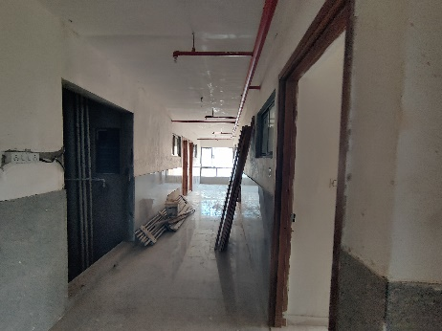
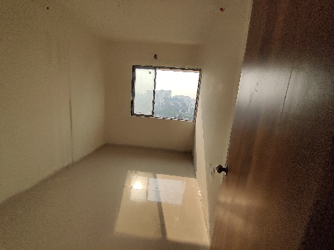
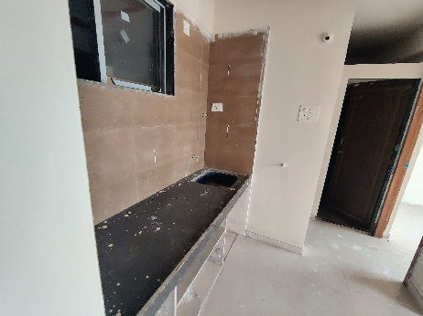

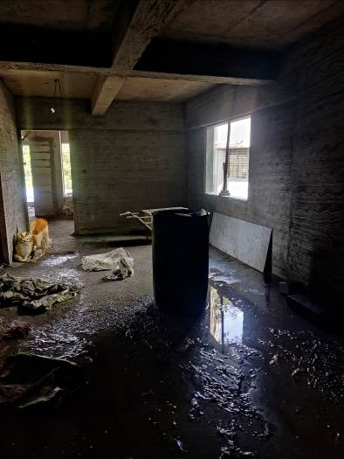
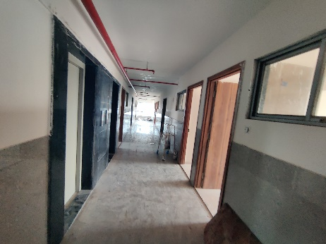
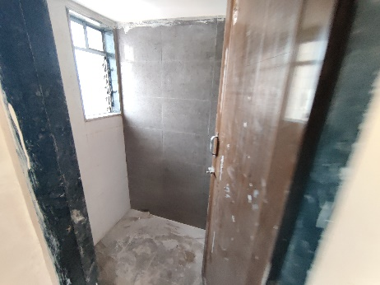
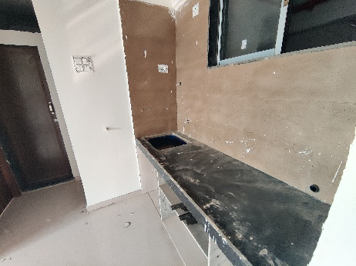

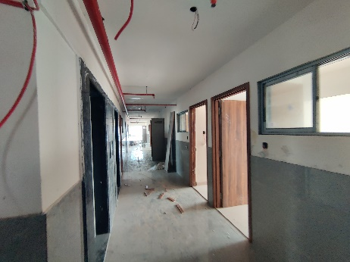
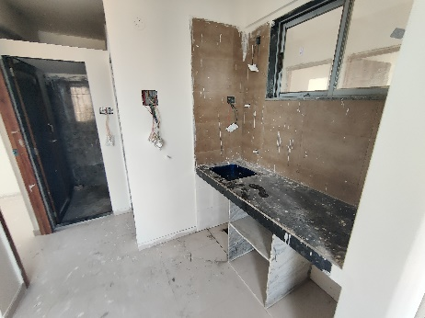
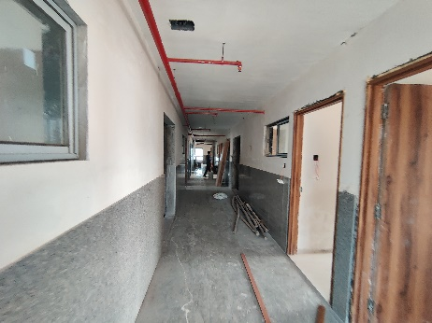

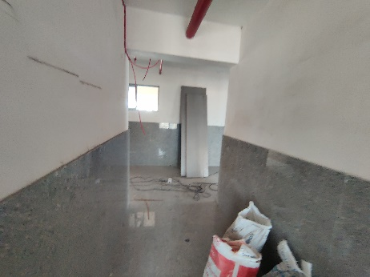
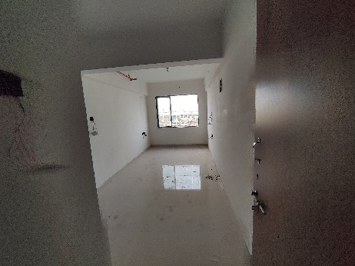
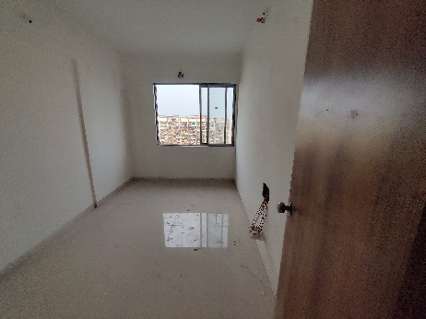

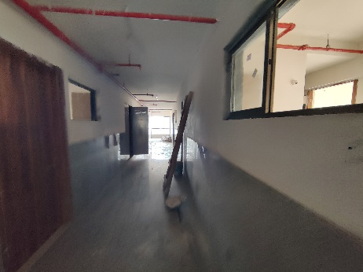
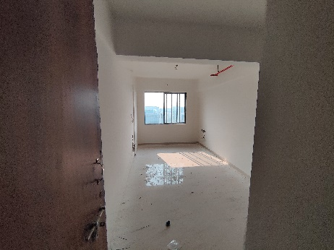
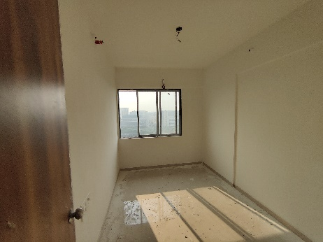
Actual Site Photographs
Rehab Building
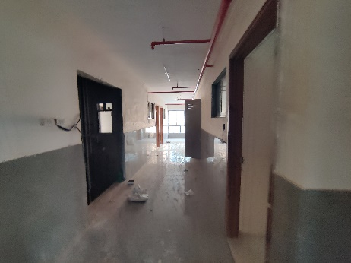
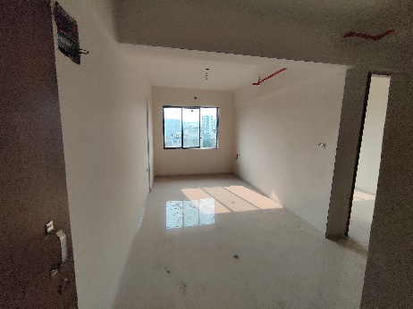
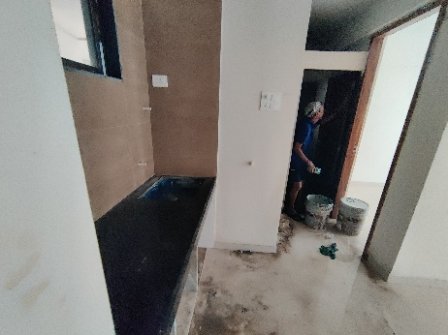

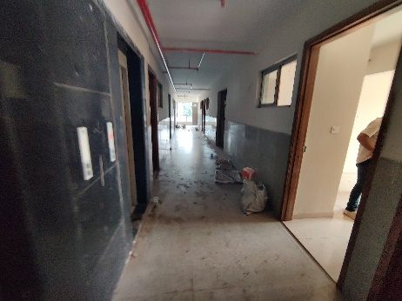
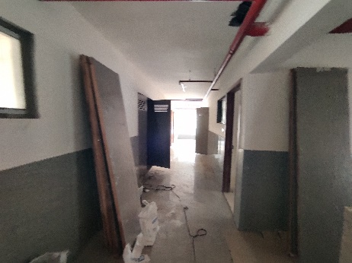
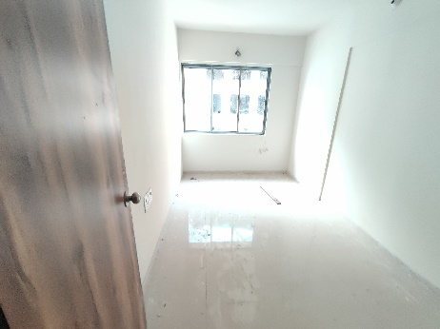
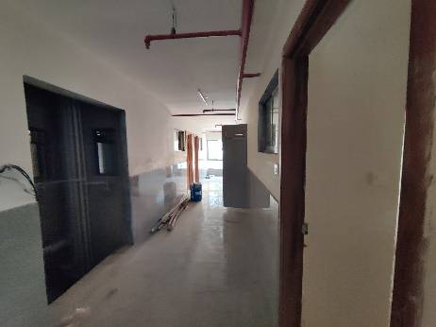
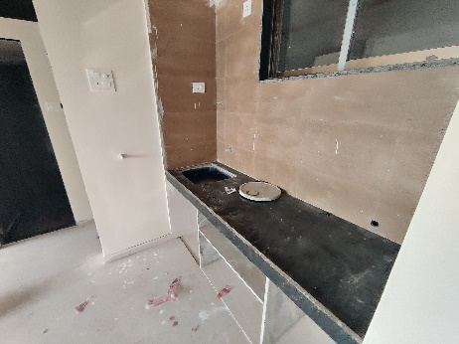
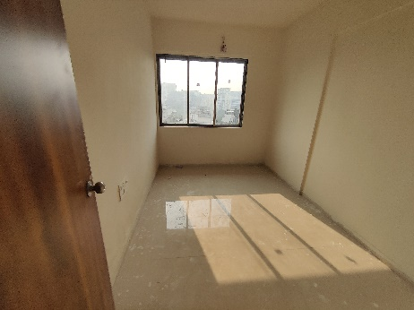
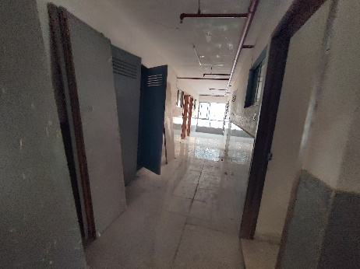
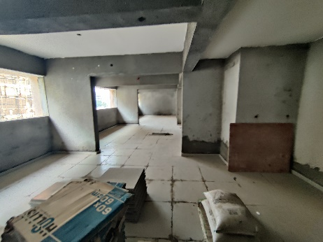
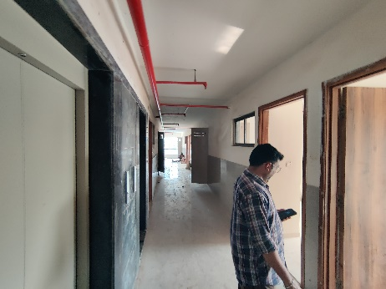
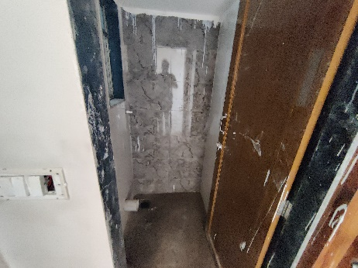
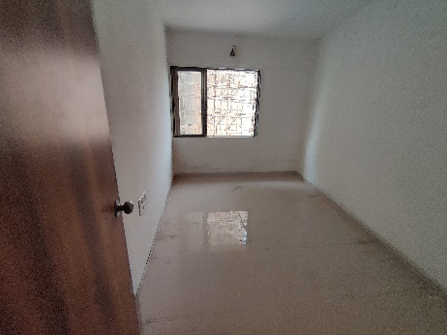
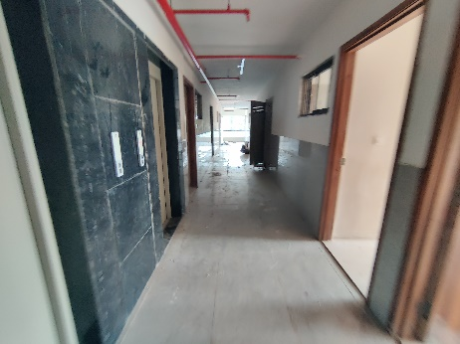
Actual Site Photographs
Rehab Building
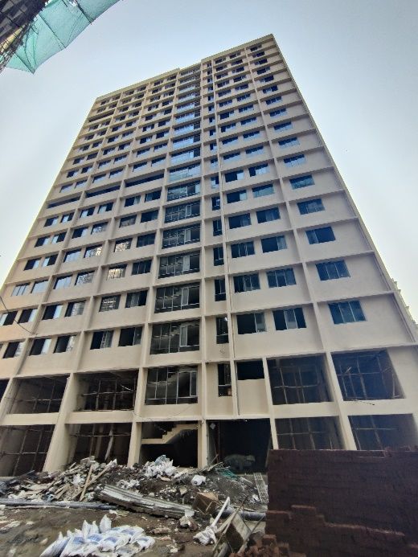
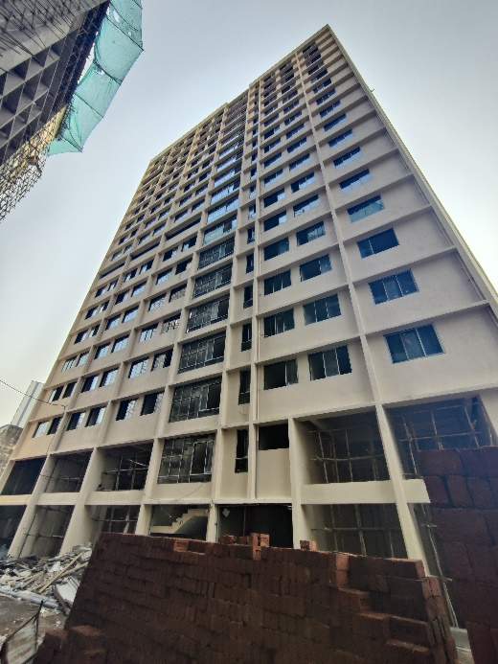
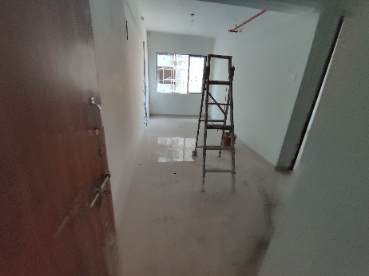
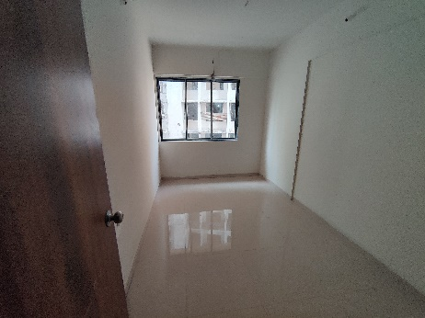
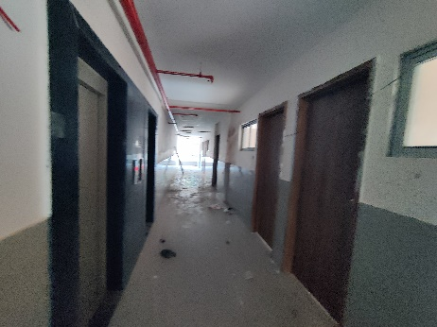
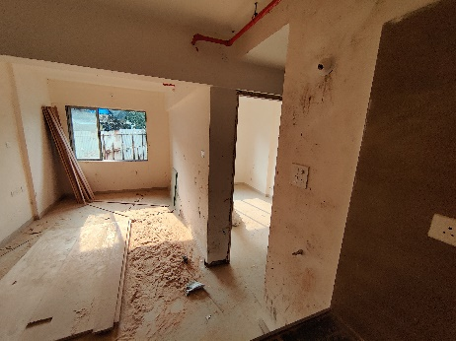
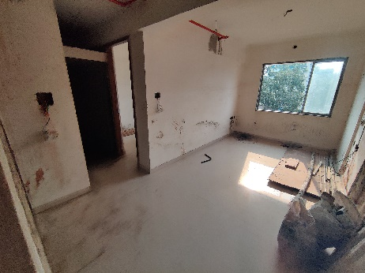
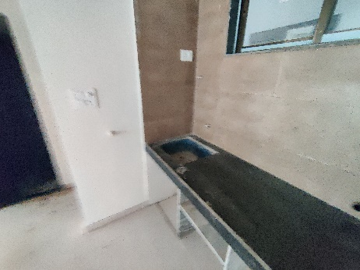

Actual Site Photographs
Sale Building
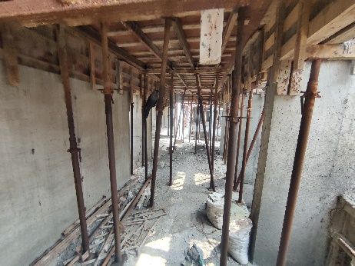
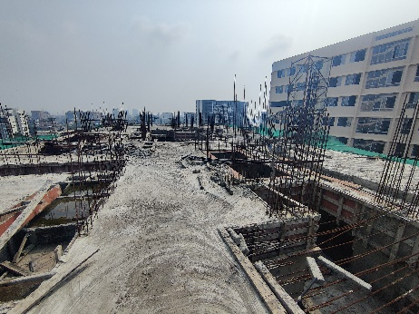
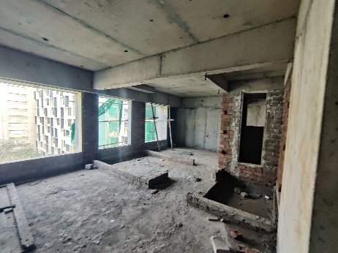
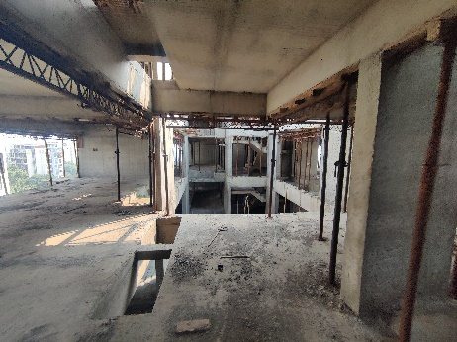
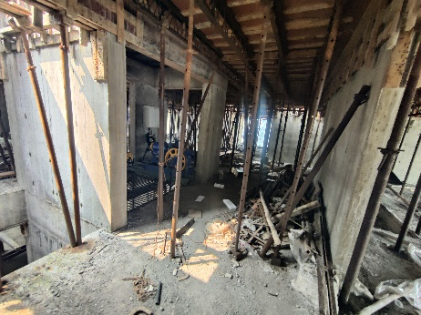
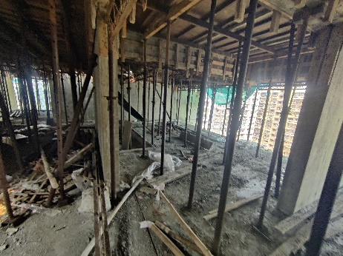
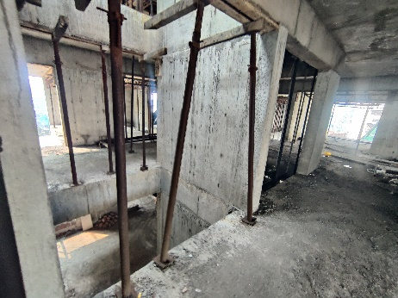
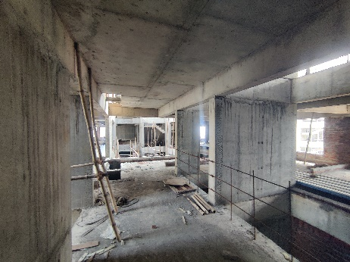
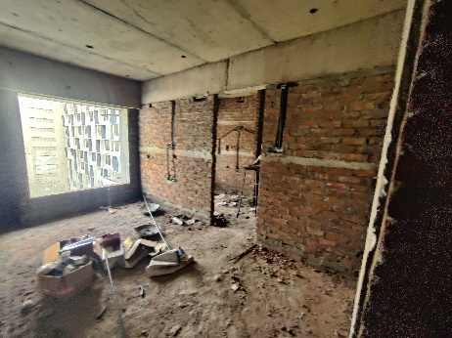
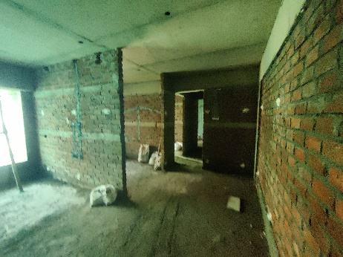
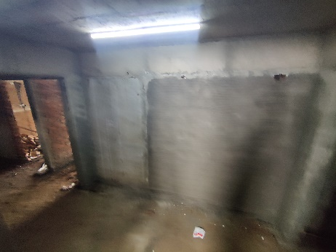
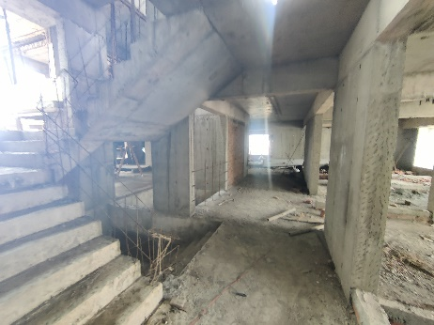
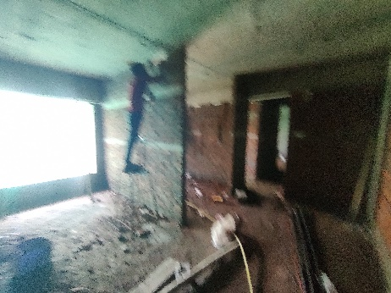
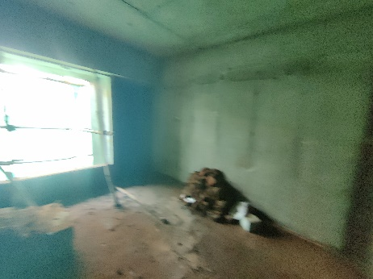
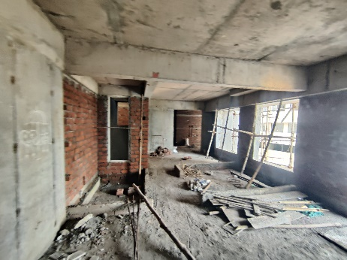

Actual Site Photographs

Sale Building
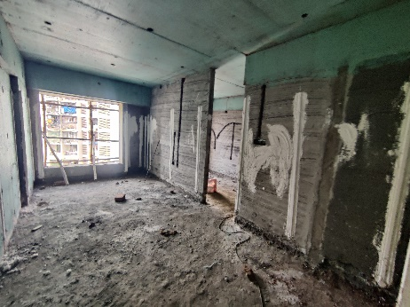
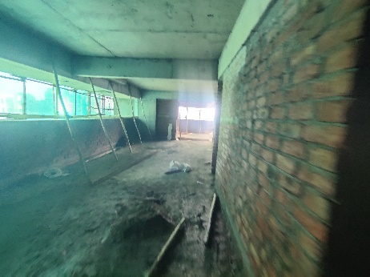
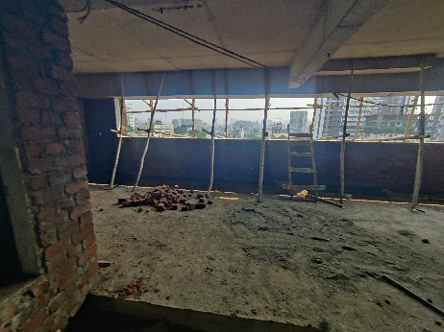
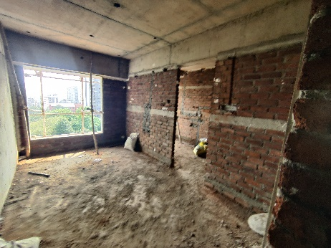
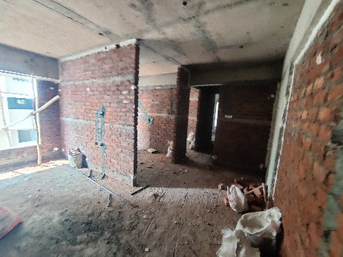
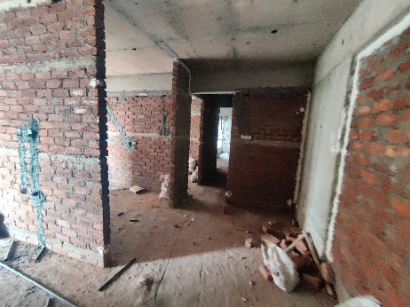
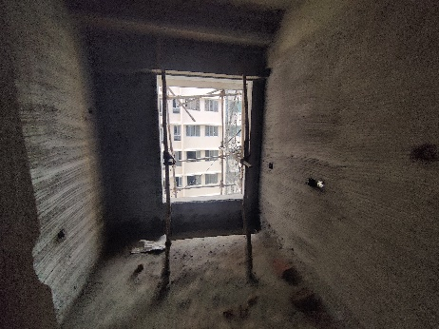
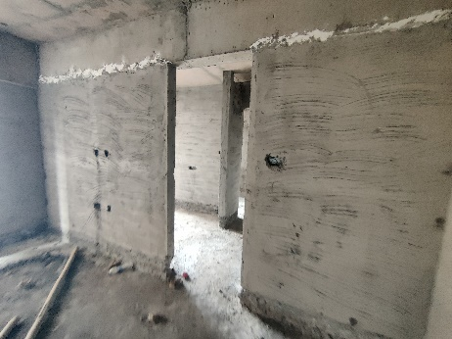
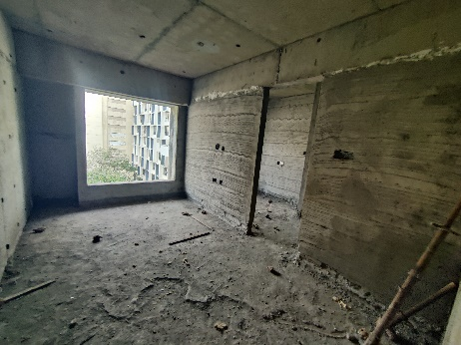
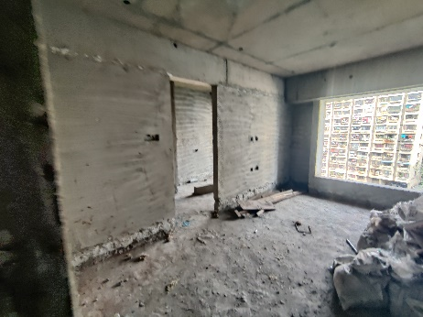
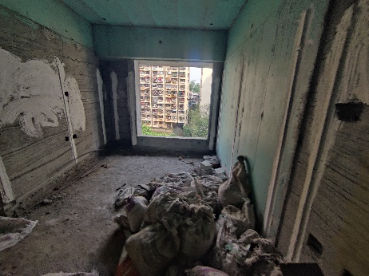
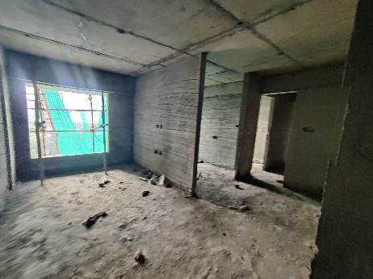
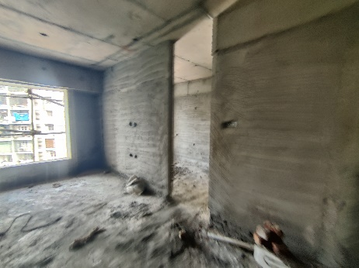
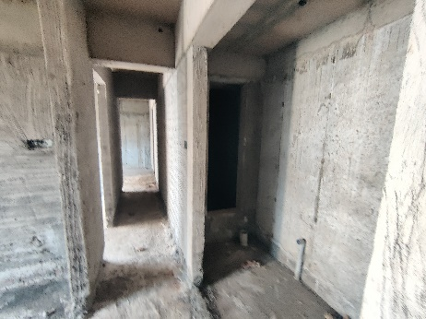
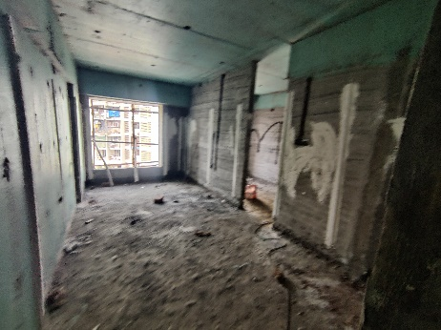

Actual Site Photographs

Sale Building
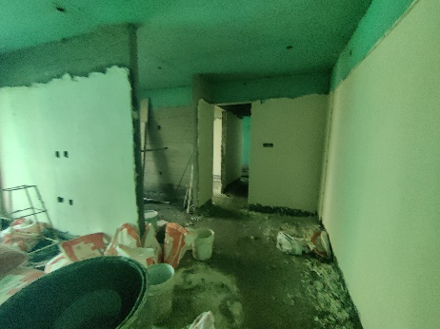
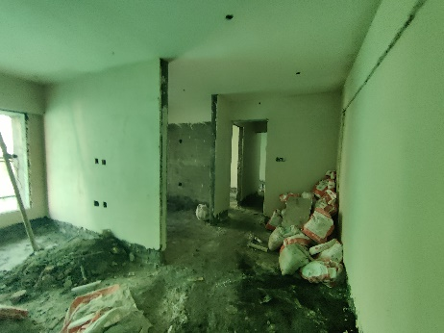
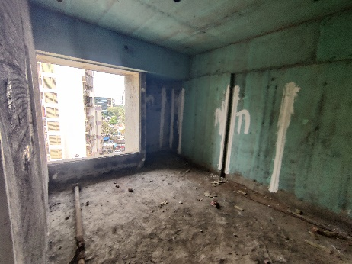
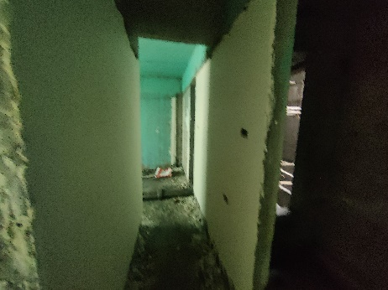
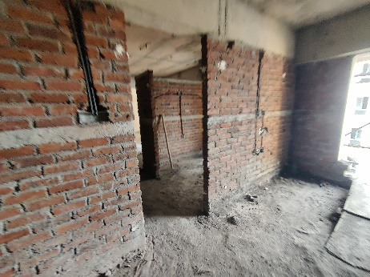
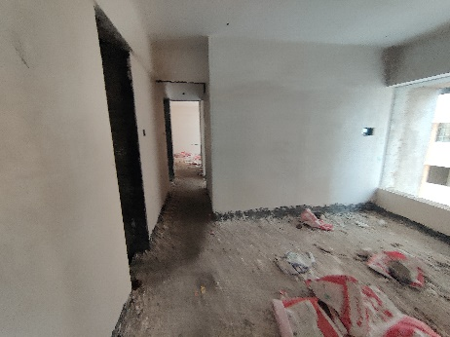
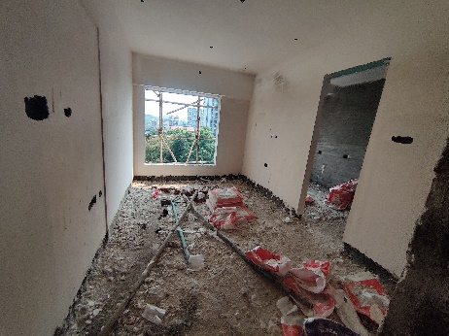
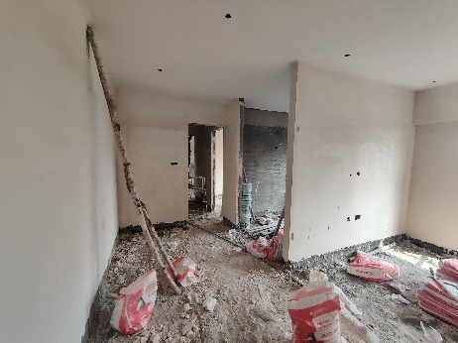
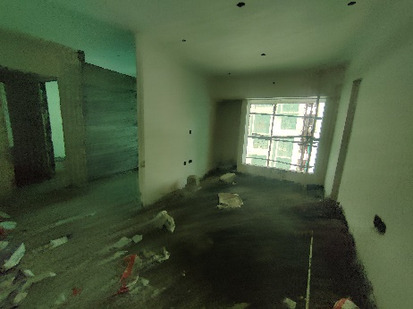
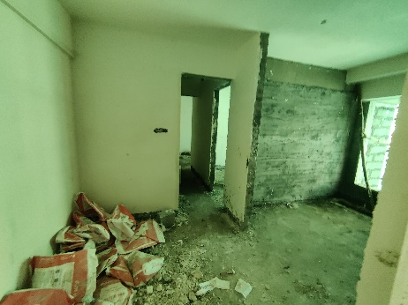
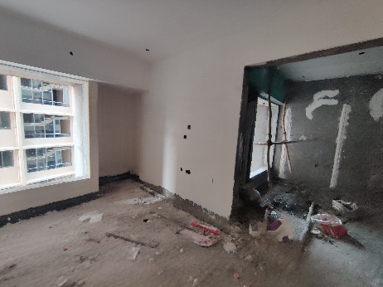
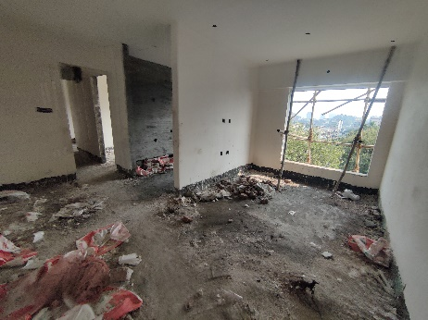
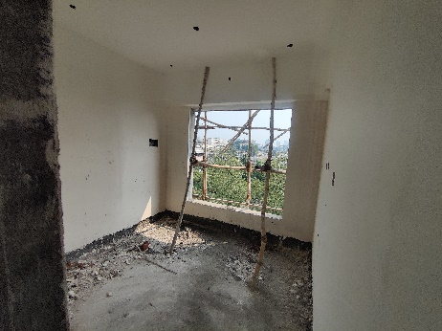
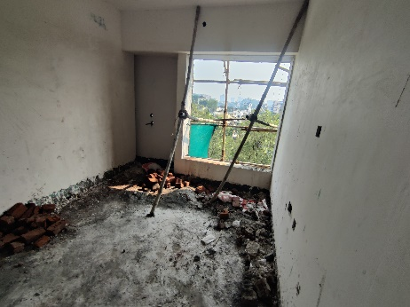
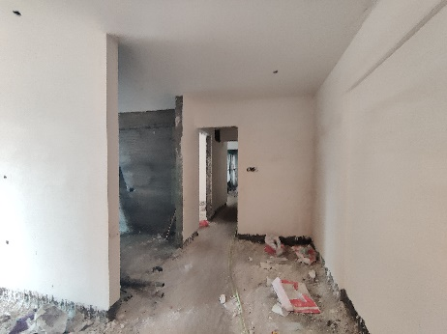

Actual Site Photographs

Sale Building
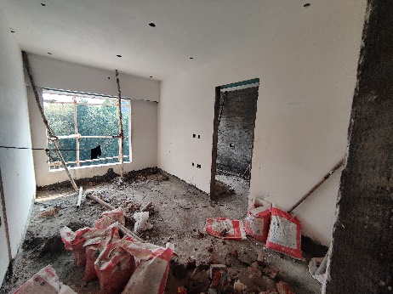
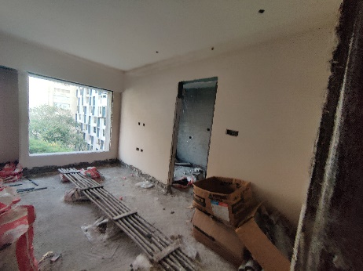
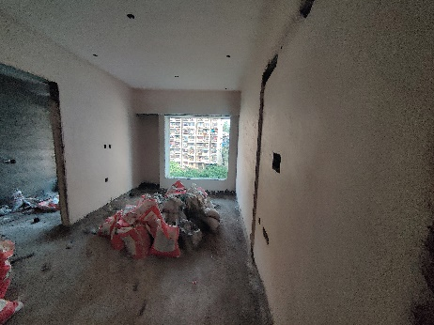
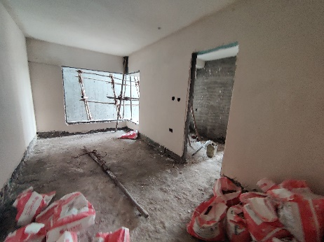
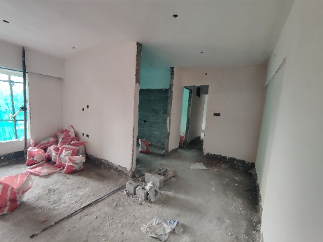
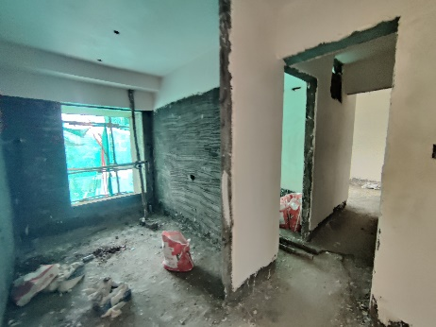
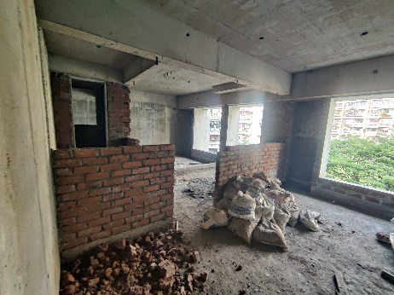
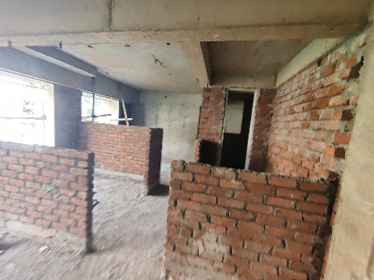
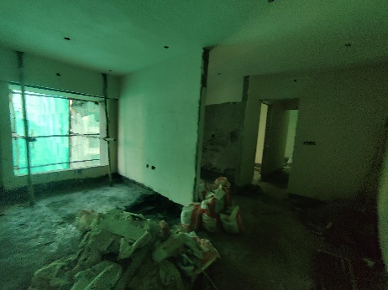
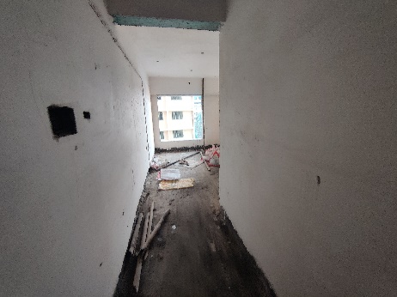
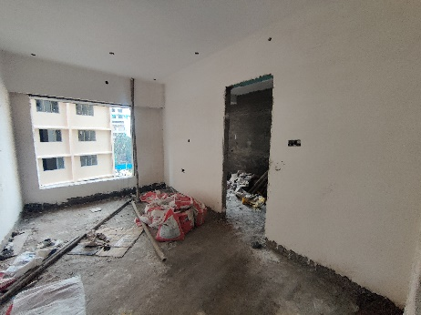
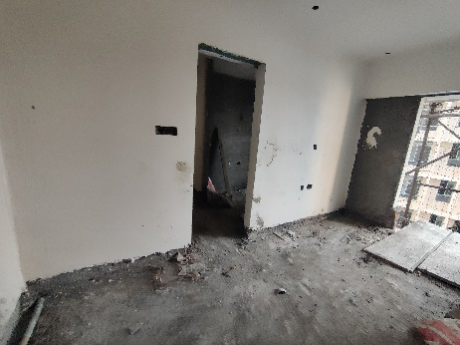
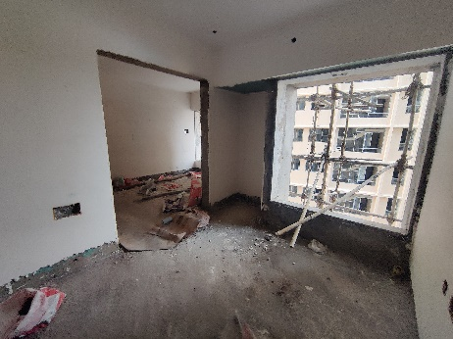
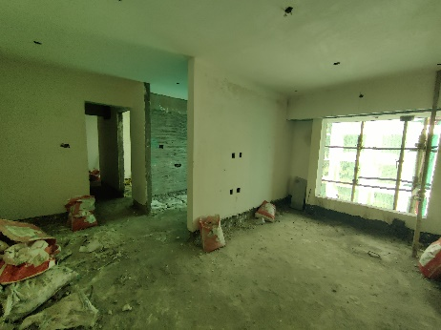
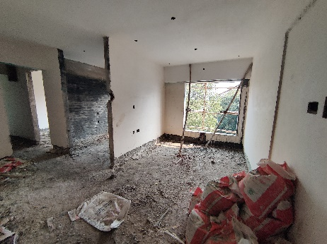

Actual Site Photographs

Sale Building
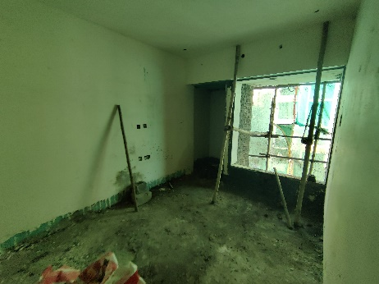
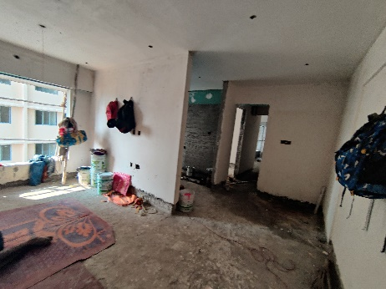
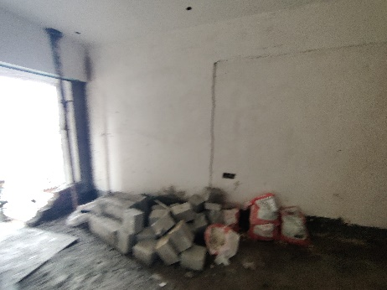
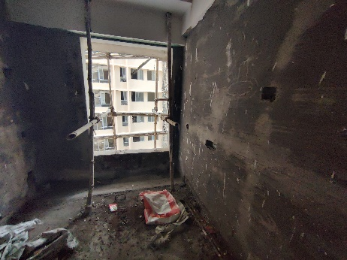
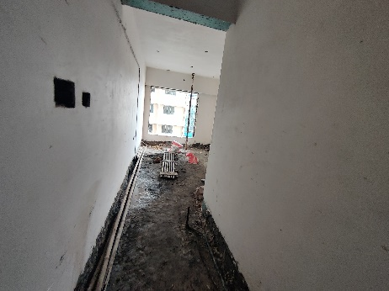
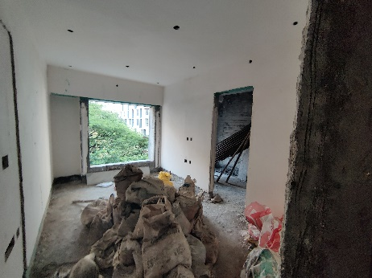
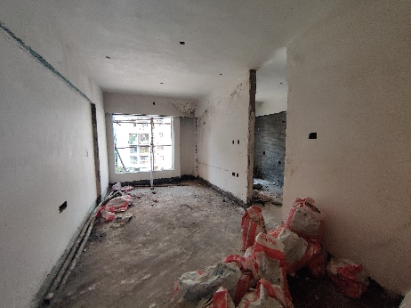
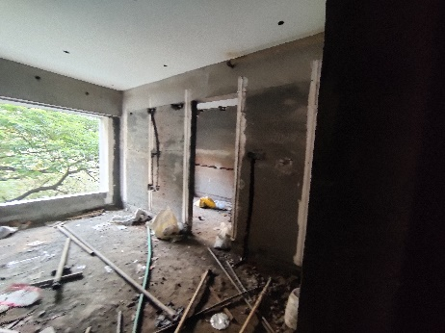
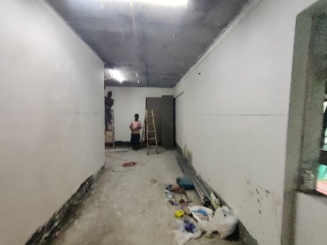
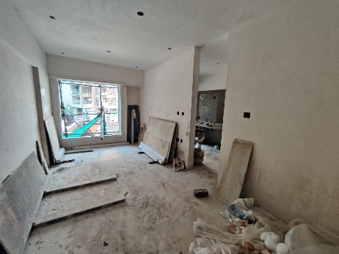
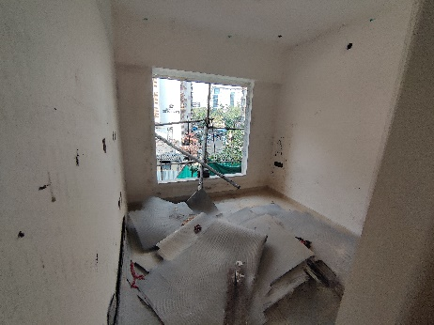
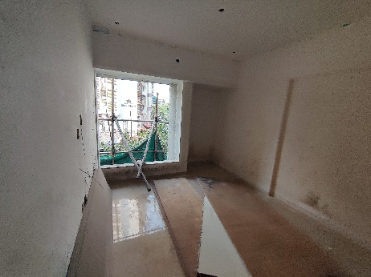
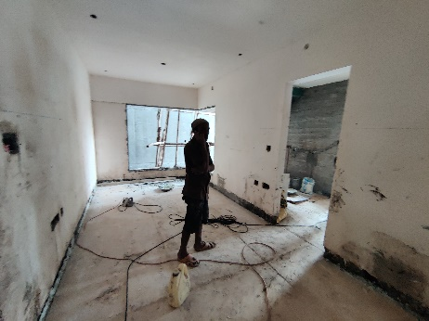
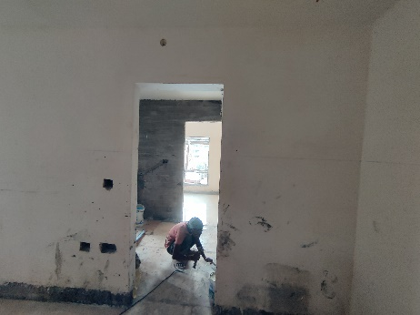
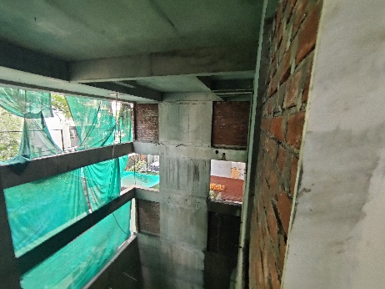

Actual Site Photographs

Sale Building
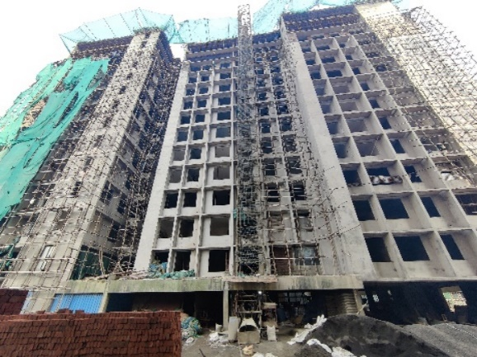
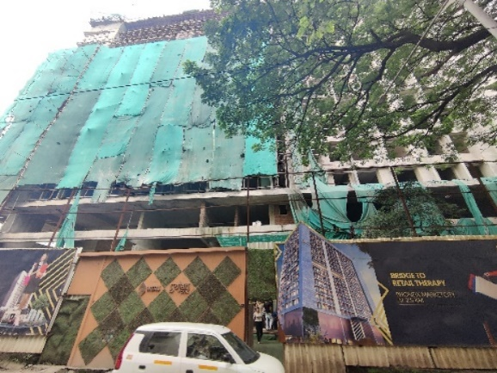
.
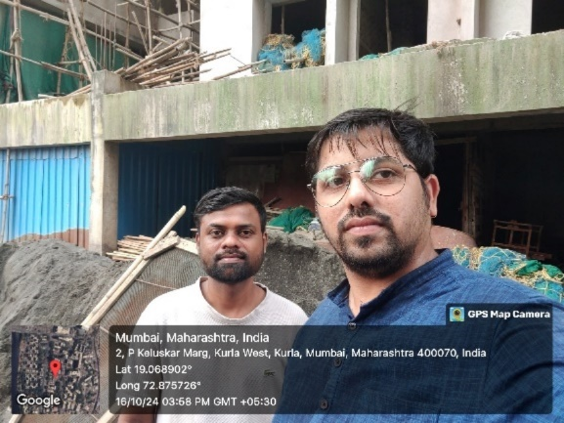
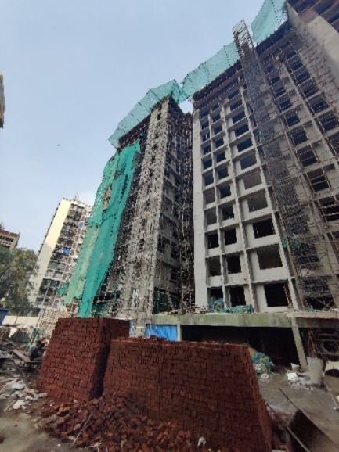
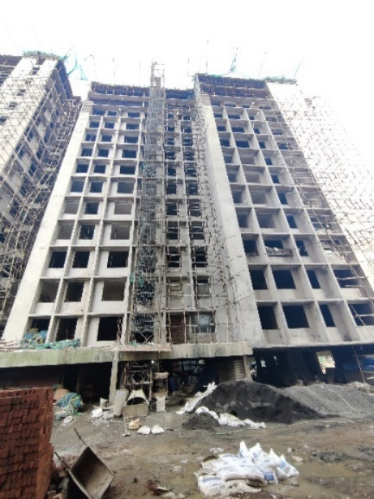
Route Map of the property
Site u/r
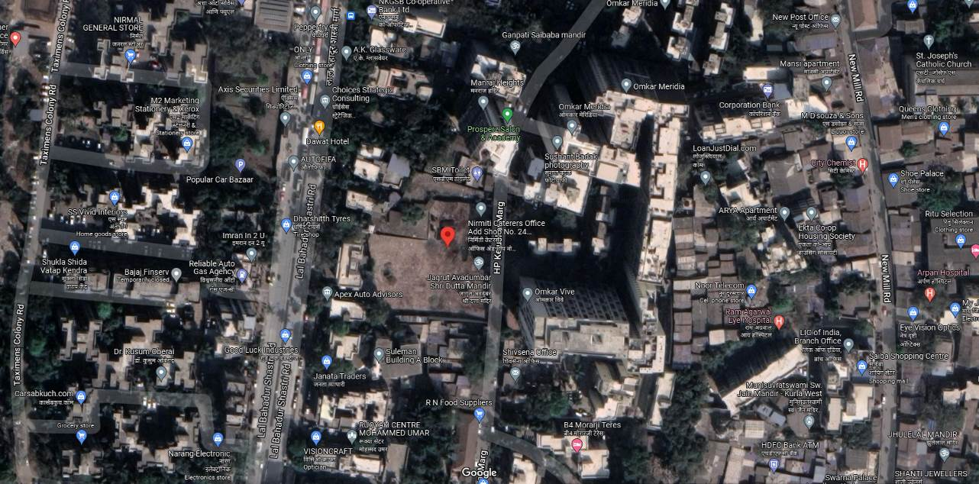

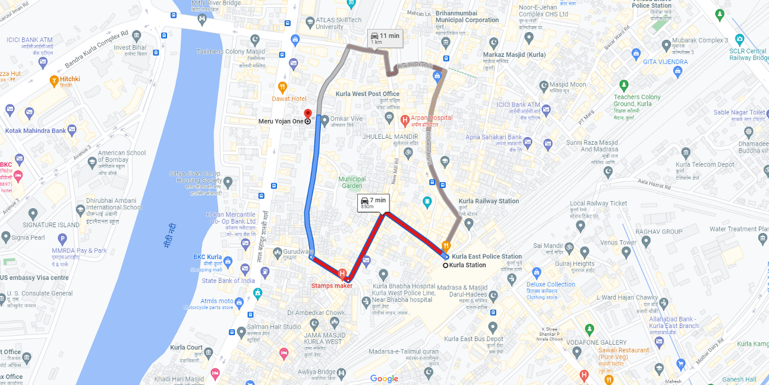

Latitude Longitude: 19°04'08.2"N 72°52'33.2"E

Note: The Blue line shows the route to site from nearest railway station (Kurla – 850 M.)
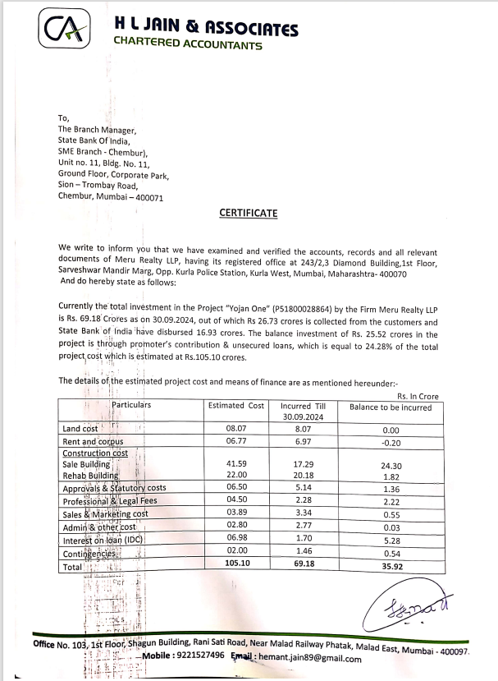
CA Certificate Dated 29.10.2024 incurred cost till 30.09.2024

CA Certificate Dated 29.10.2024 incurred cost till 30.09.2024
