Valuation Report of the Immovable Property
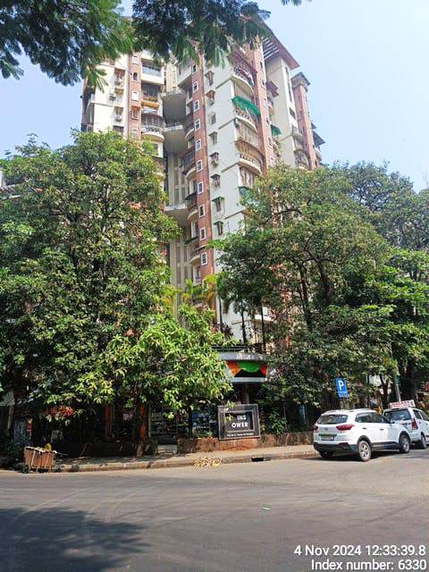

Details of the property under consideration:

Name of Owner: Mr. Anoop Naidu & Mrs. Radhika Naidu

Residential Pent House No. 1503, 15th & 16th Floor, ‘A’ Wing, “Twins Co-op. Hsg. Soc. Ltd.”
Plot No. 57, Sector 20, Kharghar, Navi Mumbai - 410 210
State - Maharashtra, Country - India.

Longitude Latitude: 19°03'03.0"N 73°04'23.1"E

Valuation Done for:
Bank of India
Kalbadevi Branch
Round Building, Shamaldas Gandhi Marg, Mumbai – 400 002
State – Maharashtra, Country – India.

Vastu/Mumbai/11/2024/012160/2301261
26/03-362-JARJ
Date: 21.11.2024

VALUATION OPINION REPORT

This is to certify that the property bearing Residential Pent House No. 1503, 15th & 16th Floor, ‘A’ Wing, “Twins Co-op. Hsg. Soc. Ltd.”, Plot No. 57, Sector 20, Kharghar, Navi Mumbai - 410 210, State – Maharashtra, Country – India belongs to Mr. Anoop Naidu & Mrs. Radhika Naidu.

Boundaries of the property.

North | : | ‘B’ Wing of Twins Tower
South | : | Haware Splendor Road
East | : | Internal Road & Haware Splendor
West | : | Jalvayu Phase II Road
Considering various parameters recorded, existing economic scenario, and the information that is available with
reference to the development of neighbourhood and method selected for valuation, we are of the opinion that, the property premises can be assessed for this particular purpose at ` 3,85,44,896.00 (Rupees Three Crore Eighty Five Lakhs Forty Four Thousand Eighty Hundred Ninety Six Only).

The valuation of the property is based on the documents produced by the concern. Legal aspects have not been taken into considerations while preparing this valuation report.

Hence certified

Sharadkumar B. Chalikwar
Govt. Reg. Valuer
Chartered Engineer (India)
Reg. No. [N]C.C.I.T/I -14/52/2008-09
Bank of India Empanelment No.: KZO/CR/19-20/582

Encl: Valuation report.
Vastukala Consultants (I) Pvt. Ltd.
B1-001, U/B Floor, Boomerang, Chandivali Farm Road, Powai, Andheri (East), Mumbai – 400 072.

To,
The Branch Manager
Bank of India
Kalbadevi Branch
Round Building
Shamaldas Gandhi Marg
Mumbai - 400 002
State - Maharashtra, Country - India.

VALUATION REPORT (IN RESPECT OF PENT HOUSE)
I | General
1. | Purpose for which the valuation is made |  |  | : | To assess Fair Market Value of the property for Bank Loan Purpose.
2. | a) |  | Date of inspection | : | 30.10.2024
 | b) |  | Date on which the valuation is made |  | 21.11.2024
3. | List of documents produced for perusal:  - Copy of Agreement for Sale dated 31/12/2009 between M/s. Creative Enterprises (the Developer) AND Mr. Anoop Naidu & Mrs. Radhika Naidu (the Purchasers).  - Copy of Occupancy Certificate No. CIDCO/BP/ATPO/670 dated 29/03/2007 issued by CIDCO.  - Copy of Commencement Certificate No. CIDCO/ATPO/166 issued by CIDCO.  - Copy of Supplementary Agreement in Continuation to Agreement for Sale DTD 31st December, 2009 Cum Rectification Deed dated 09/09/2010 between M/s. Creative Enterprises (the Developer) AND Mr. Anoop Naidu & Mrs. Radhika Naidu (the Purchasers).  - Copy of Deed of Assignment dated 12/01/2011 between M/s. Creative Enterprises (the Assignor) AND The Twins Co-op. Hsg. Soc. Ltd. (the Assignees)
4. | Name of the owner(s) and his / their address (es) with Phone no. (details of share of each owner in case of joint ownership) |  |  | : | Mr. Anoop Naidu & Mrs. Radhika Naidu  Address: Residential Pent House No. 1503, 15th & 16th Floor, ‘A’ Wing, “Twins Co-op. Hsg. Soc. Ltd.”, Plot No. 57, Sector 20, Kharghar, Navi Mumbai - 410 210, State – Maharashtra, Country – India.  Contact Person:  Mr. Anoop Naidu (Owner)  Contact No.: 9769996785  Joint Ownership  Details of ownership share is not available
5. | Brief description of the property (Including Leasehold / freehold etc.) |  |  | : | The property is a Residential Pent House located on 15th & 16th Floor. The composition of Residential Pent House is  The property is at 4.2 km. travelling distance from nearest railway station Kharghar.
  Floor | Composition
  15th | Living Room + Kitchen + Pooja Room + Passage + Bedroom + Toilet + Terrace Area
  16th | Staircase Area + 2 Bedrooms + Store + 2 Toilets + Passage + Terrace
6. | Location of property |  |  | :
 | a) | Plot No. / Survey No. |  | : | Plot No. 57
 | b) | Door No. |  | : | Residential Pent House No. 1503
 | c) | C. T.S. No. / Village |  | : | Village - Kharghar
 | d) | Ward / Taluka |  | : | Taluka - Panvel
 | e) | Mandal / District |  | : | District - Raigad
 | f) | Date of issue and validity of layout of approved map / plan |  | : | As Occupancy Certificate is received it may be assumed that the construction is as per Sanctioned Plan.
 | g) | Approved map / plan issuing authority |  | :
 | h) | Whether genuineness or authenticity of approved map/ plan is verified |  | :
 | i) | Any other comments by our empanelled valuers on authentic of approved plan |  |  | No
7. | Postal address of the property |  |  | : | Residential Pent House No. 1503, 15th & 16th Floor, ‘A’ Wing, “Twins Co-op. Hsg. Soc. Ltd.”, Plot No. 57, Sector 20, Kharghar, Navi Mumbai - 410 210, State – Maharashtra, Country – India.
8. | City / Town |  |  | : | Kharghar, Navi Mumbai
 | Residential area |  |  | : | Yes
 | Commercial area |  |  | : | No
 | Industrial area |  |  | : | No
9. | Classification of the area |  |  | :
 | i) High / Middle / Poor |  |  | : | Middle Class
 | ii) Urban / Semi Urban / Rural |  |  | : | Urban
10. | Coming under Corporation limit / Village Panchayat / Municipality |  |  | : | Village - Kharghar  CIDCO
11. | Whether covered under any State / Central Govt. enactments (e.g., Urban Land Ceiling Act) or notified under agency area/ scheduled area / cantonment area |  |  | : | No
12. | Boundaries of the property |  |  |  | As per Site | As per Documents
 | North |  |  | : | ‘B’ Wing of Twins Tower | 15.00 Mtrs. Wide Road
 | South |  |  | : | Haware Splendor Road | 15.00 Mtrs. Wide Road
 | East |  |  | : | Internal Road & Haware Splendor | Plot No. 56
 | West |  |  | : | Jalvayu Phase II Road | 15.00 Mtrs. Wide Road
13 | Dimensions of the site |  |  |  | N. A. as property under consideration is a Residential Pent House in a building.
 |  |  |  |  | A  As per the Deed | B Actuals
 | North |  |  | : | - | -
 | South |  |  | : | - | -
 | East |  |  | : | - | -
 | West |  |  | : | - | -
14. | Extent of the site |  |  | : | Area as per Actual Site Measurement:  Area as per Supplementary Agreement in Continuation to Agreement for Sale dated 31st December, 2009 Cum Rectification Deed:
  Floor | Carpet Area in Sq. Ft. | Terrace Area in Sq. Ft.
  15th | 811.00 | 270.00
  16th | 803.00 | 156.00
  Total | 1,614.00 | 426.00
  Particulars | Area in Sq. Ft.
  Carpet | 1,387.40
  Built-up | 1,665.00
  Terrace Area | 318.00
14.1 | Latitude, Longitude & Co-ordinates of Pent House |  |  | : | 19°03'03.0"N 73°04'23.1"E
15. | Extent of the site considered for Valuation (least of 13A& 13B) |  |  | : | (Area asper Supplementary Agreement in Continuation to Agreement for Sale dated 31st December, 2009 Cum Rectification Deed)
  Particulars | Area in Sq. Ft.
  Built-up | 1,665.00
  Terrace Area | 127.00 (40% of total area of Chargeable Terrace area considered)
  Total | 1,792.00
16 | Whether occupied by the owner / tenant? If occupied by tenant since how long? Rent received per month. |  |  | : | Owner Occupied
II | APARTMENT BUILDING
 | Nature of the Apartment |  |  | : | Residential
 | Location |  |  | :
 | C. T.S. No. |  |  | : | -
 | Block No. |  |  | : | -
 | Ward No. |  |  | : | -
 | Village / Municipality / Corporation |  |  | : | Village - Kharghar  CIDCO
 | Door No., Street or Road (Pin Code) |  |  | : | Residential Pent House No. 1503, 15th & 16th Floor, ‘A’ Wing, “Twins Co-op. Hsg. Soc. Ltd.”, Plot No. 57, Sector 20, Kharghar, Navi Mumbai - 410 210, State – Maharashtra, Country – India.
 | Description of the locality Residential / Commercial / Mixed |  |  | : | Residential
 | Year of Construction |  |  | : | 2007 (As per Occupancy Certificate)
 | Number of Floors |  |  | : | Ground (pt) + Stilt (pt) + 15 Upper Floors
 | Type of Structure |  |  | : | R.C.C. Framed Structure
 | Number of Dwelling units in the building |  |  | : | 05 Flats on 15th Floor
 | Quality of Construction |  |  | : | Good
 | Appearance of the Building |  |  | : | Good
 | Maintenance of the Building |  |  | : | Good
 | Facilities Available |  |  | :
 | Lift |  |  | : | 2 lifts
 | Protected Water Supply |  |  | : | Municipal Water Supply
 | Underground Sewerage |  |  | : | Connected to Municipal Sewer System
 | Car parking - Open / Covered |  |  | : | Covered / Open Parking Space
 | Is Compound wall existing? |  |  | : | Yes
 | Is pavement laid around the building |  |  | : | Yes
III | Pent House
1 | The floor in which the pen house is situated |  |  | : | 15th & 16th Floor
2 | Door No. of the pent house |  |  | : | Residential Pent House No. 1503
3 | Specifications of the pent house |  |  | :
 | Roof |  |  | : | R.C.C. Slab
 | Flooring |  |  | : | Vitrified tiles flooring
 | Doors |  |  | : | Teak Wood door frame with flush doors
 | Windows |  |  | : | Powder coated Aluminum sliding windows
 | Fittings |  |  |  | Concealed plumbing with C.P. fittings.  Electrical wiring with Concealed
 | Finishing |  |  |  | Cement Plastering with POP false ceiling
4 | House Tax |  |  | :
 | Assessment No. |  |  | : | Details not available
 | Tax paid in the name of: |  |  | : | Details not available
 | Tax amount: |  |  | : | Details not available
5 | Electricity Service connection No.: |  |  | : | Details not available
 | Meter Card is in the name of: |  |  | : | Details not available
6 | How is the maintenance of the pent house? |  |  | : | Good
7 | Sale Deed executed in the name of |  |  | : | Mr. Anoop Naidu &  Mrs. Radhika Naidu
8 | What is the undivided area of land as per Sale Deed? |  |  | : | Details not available
9 | What is the plinth area of the pent house? |  |  | : | (Area asper Supplementary Agreement in Continuation to Agreement for Sale dated 31st December, 2009 Cum Rectification Deed)
  Particulars | Area in Sq. Ft.
  Built-up | 1,665.00
  Terrace Area | 127.00 (40% of total area of Chargeable Terrace area considered)
  Total | 1,792.00
10 | What is the floor space index (app.) |  |  | : | As per CIDCO norms
11 | What is the Carpet Area of the pent house? |  |  | : | Area as per Actual Site Measurement:
  Floor | Carpet Area in Sq. Ft. | Terrace Area in Sq. Ft.
  15th | 811.00 | 270.00
  16th | 803.00 | 156.00
  Total | 1,614.00 | 426.00
12 | Is it Posh / I Class / Medium / Ordinary? |  |  | : | Middle Class
13 | Is it being used for Residential or Commercial purpose? |  |  | : | Residential
14 | Is it Owner-occupied or let out? |  |  | : | Owner Occupied
15 | If rented, what is the monthly rent? |  |  | : | ` 80,000.00 Expected rental income per month
IV | MARKETABILITY |  |  | :
1 | How is the marketability? |  |  | : | Good
2 | What are the factors favoring for an extra Potential Value? |  |  | : | Located in developed area
3 | Any negative factors are observed which affect the market value in general? |  |  | : | No
V | Rate |  |  | :
1 | After analyzing the comparable sale instances, what is the composite rate for a similar pent house with same specifications in the adjoining locality? - (Along with details / reference of at - least two latest deals / transactions with respect to adjacent properties in the areas) |  |  | : | ` 18,000.00 to ` 20,000.00 per Sq. Ft. on Built-up Area
2 | Assuming it is a new construction, what is the adopted basic composite rate of the [pent hoiuse under valuation after comparing with the specifications and other factors with the pent house under comparison (give details). |  |  | : | ` 19,200.00 per Sq. Ft. on Built-up Area  ` 18,563.00 per Sq. Ft. on Built-up Area after depreciation
3 | Break – up for the rate |  |  | :
 | I. Building + Services |  |  | : | ` 2,500.00 per Sq. Ft.
 | II. Land + others |  |  | : | ` 16,700.00 per Sq. Ft.
4 | Guideline rate obtained from the Registrar's office (an evidence thereof to be enclosed) |  |  | : | ` 1,17,810.00 per Sq. M. i.e. ` 10,945.00 per Sq. Ft.
 | Guideline rate (after deprecation) |  |  |  | ` 1,05,330.00 per Sq. M. i.e.,  ` 9,785.00 per Sq. Ft.
 | In case of variation of 20% or more in the valuation proposed by the valuer and the Guideline value provided in the State Govt. notification or Income Tax Gazette justification on variation has to be given. |  |  |  | It is a foregone conclusion that market value is always more than RR prices. As the RR rates are fixed by respective state governments for computing stamp duty / Regn. Fees. Thus the rates differs from place to place and location. amenities per se as evident from the fact that even RR rates decided by Govt. differs.
VI | COMPOSITE RATE ADOPTED AFTER DEPRECIATION
a | Depreciated building rate |  |  | :
 | Replacement cost of pent house with Services (v(3)i) |  |  | : | ` 2,500.00 per Sq. Ft.
 | Age of the building |  |  | : | 17 years
 | Life of the building estimated |  |  | : | 43 years Subject to proper, preventive periodic maintenance & structural repairs.
 | Depreciation percentage assuming the salvage value as 10% |  |  | : | 25.50%
 | Depreciated Ratio of the building |  |  | : | -
b | Total composite rate arrived for Valuation |  |  | :
 | Depreciated building rate VI (a) |  |  | : | ` 1,863.00per Sq. Ft.
 | Rate for Land & other V (3) ii |  |  | : | ` 16,700.00 per Sq. Ft.
 | Total Composite Rate |  |  | : | ` 18,563.00 per Sq. Ft.
 | Remark:

Details of Valuation:

Sr. No. | Description | Qty. | Rate per  unit (`) | Estimated  Value (`)
1 | Present value of the pent house | 1,792.00 Sq. Ft. | 18,563.00 | 3,32,64,896.00
2 | Wardrobes
3 | Showcases
4 | Kitchen arrangements
5 | Superfine finish
6 | Interior Decorations | 1,792.00 Sq. Ft. | 2,500.00 | 44,80,000.00
7 | Electricity deposits / electrical fittings, etc.
8 | Extra collapsible gates / grill works etc.
9 | Potential value, if any
10 | Others / Car Parking | 2 | 4,00,000.00 | 8,00,000.00
 | Present market value of the property |  |  | 3,85,44,896.00
 | The Realizable value of the property |  |  | 3,46,90,406.00
 | The Distress value of the property |  |  | 3,08,35,917.00
 | Insurable value of the property (1,792.00 X 2,500.00) |  |  | 44,80,000.00
 | Govt. Value of the property (1,792.00 X 9,785.00) |  |  | 1,75,34,720.00

Justification for price / rate

The Market Value of the property is based on facts of markets discovered by us during our enquiries, however the government rate value in this case is less than the market value arrived by us. We are of the opinion that the value arrive by us will prove to be correct if an Auction of the subject property is carried out. As far as Market Value in Index II is concerned, it is not possible to comment on same, may be government rates are fixed by sampling during same point of time in part and whereas, Market values change every month.
In most of the cases the actual deal amount or Transaction value is not reflected in Index II because of various Market
practices. As Valuer, we always try to give a value which is correct reflection of actual transaction value irrespective of any factors in market.
Method of Valuation / Approach
The sales comparison approach uses the market data of sale prices to estimate the value of a real estate property. Property valuation in this method is done by comparing a property to other similar properties that have been recently sold. Comparable properties, also known as comparables, or comps, must share certain features with the property in question. Some of these include physical features such as square footage, number of rooms, condition, and age of the building; however, the most important factor is no doubt the location of the property. Adjustments are usually needed to account for differences as no two properties are exactly the same. To make proper adjustments when comparing properties, real estate appraisers must know the differences between the comparable properties and how to value these differences. The sales comparison approach is commonly used for Residential Pent House, where there are typically many comparables available to analyze. As the property is a Residential Pent House, we have adopted Sale Comparison Approach Method for the purpose of valuation. The Price for similar type of property in the nearby vicinity is in the range of ` 19,000.00 to ` 20,000.00 per Sq. Ft. on Built-up Area. Considering the rate with attached report, current market conditions, demand and supply position, Pent House size, location, upswing in real estate prices, sustained demand for Residential Pent House, all round development of Residential and Commercial application in the locality etc. We estimate ` 18,563.00 per Sq. Ft. on Built-up Area (after depreciation) for valuation.
Impending threat of acquisition by government for road widening / publics service purposes, sub merging & applicability of CRZ provisions (Distance from sea-cost / tidal level must be incorporated) and their effect on
- Saleability | Good
- Likely rental values in future in | ` 80,000.00 Expected rental income per month
- Any likely income it may generate | Rental Income

Actual Site Photographs
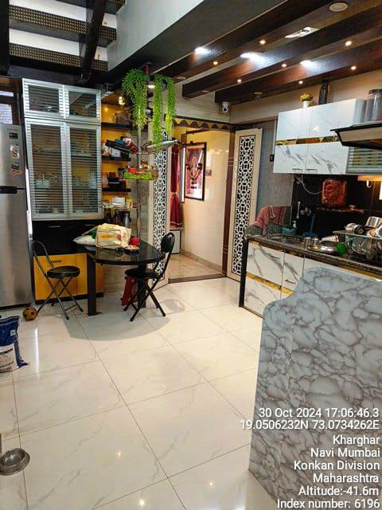
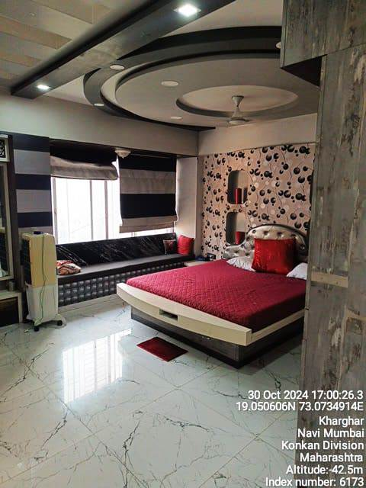
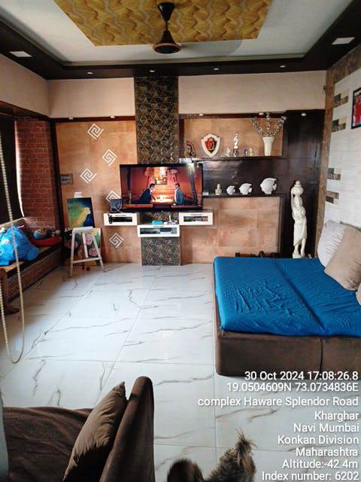

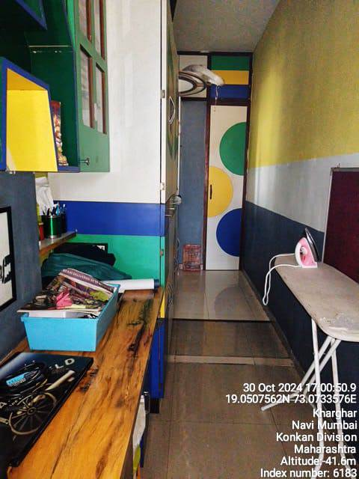
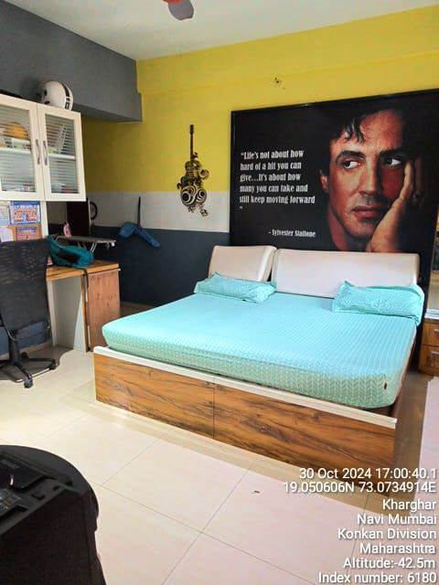
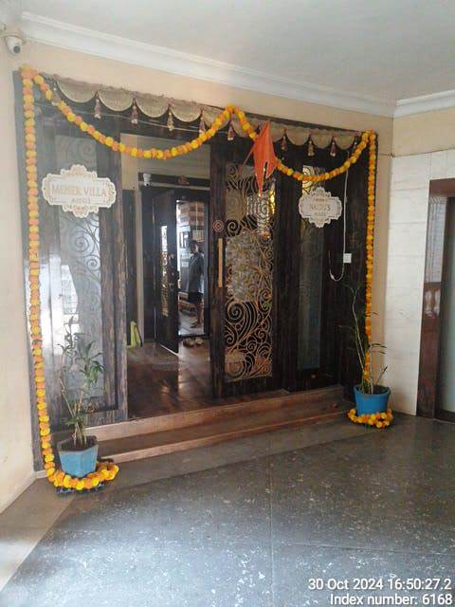

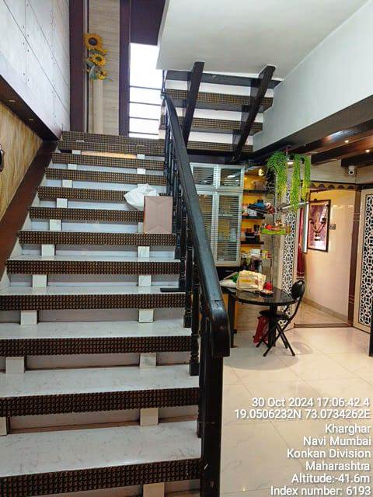
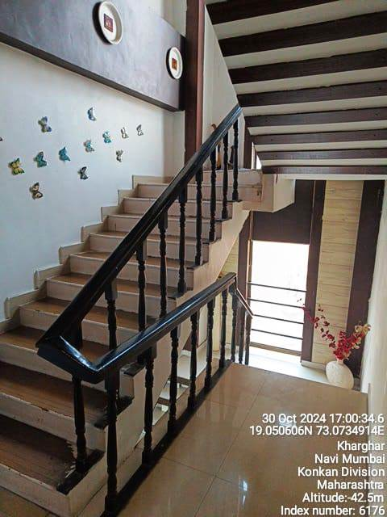
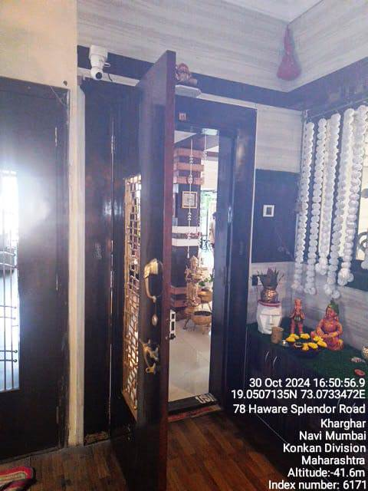

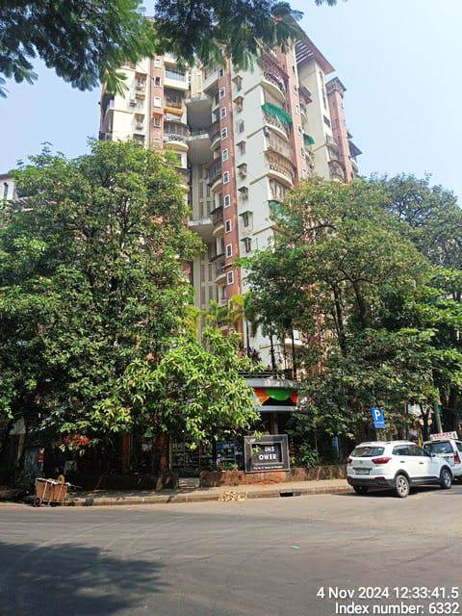
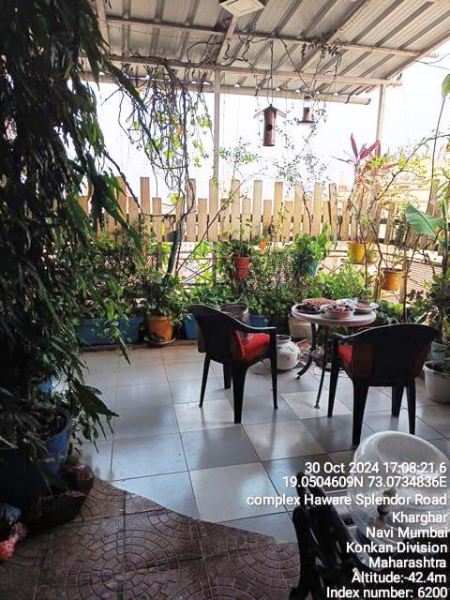
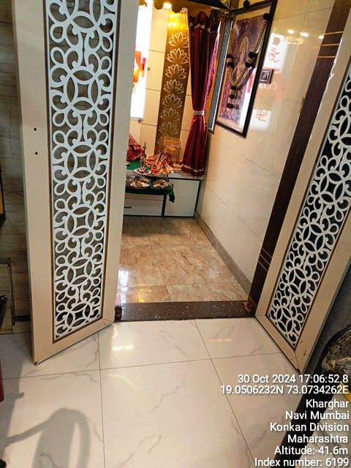
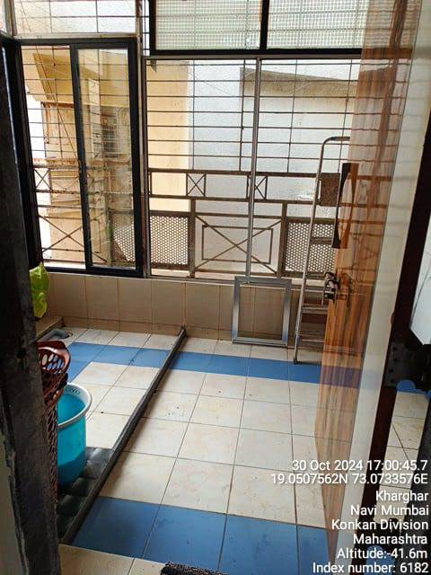
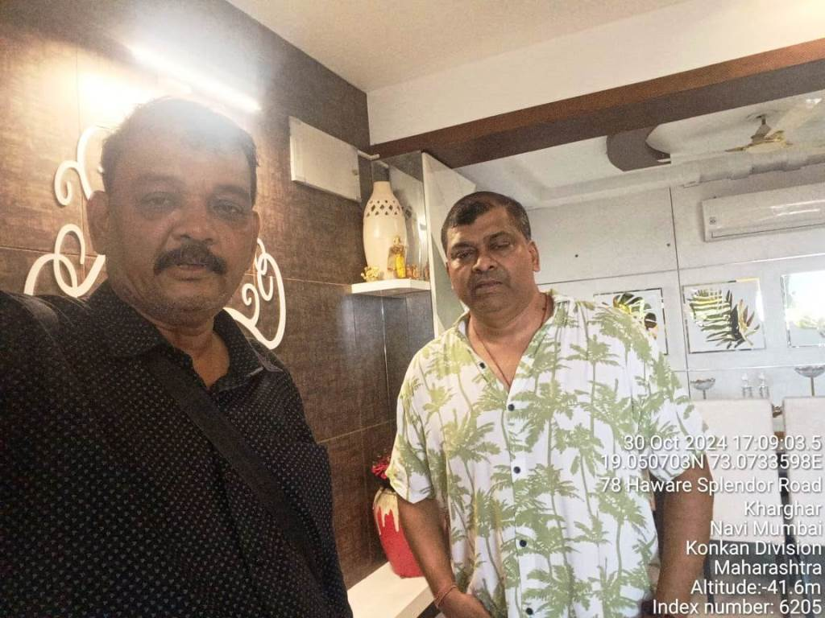
Actual Site Photographs
Route Map of the property
Site u/r
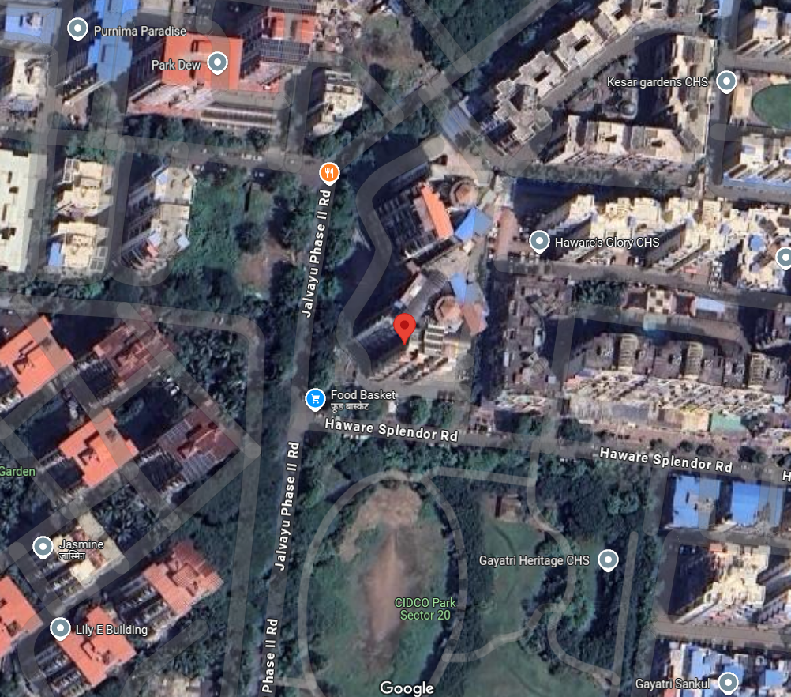

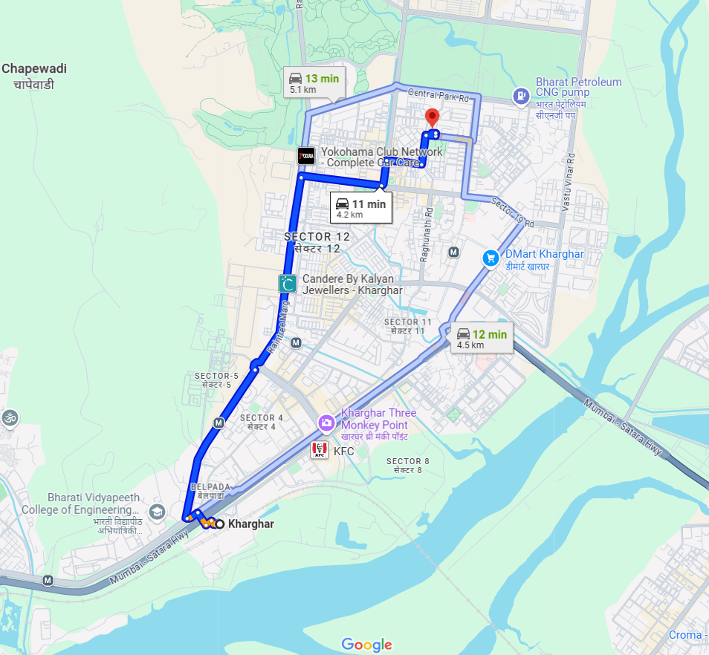

Longitude Latitude: 19°03'03.0"N 73°04'23.1"E

Note: The Blue line shows the route to site from nearest railway station (Kharghar – 4.2 KM.)

Ready Reckoner Rate
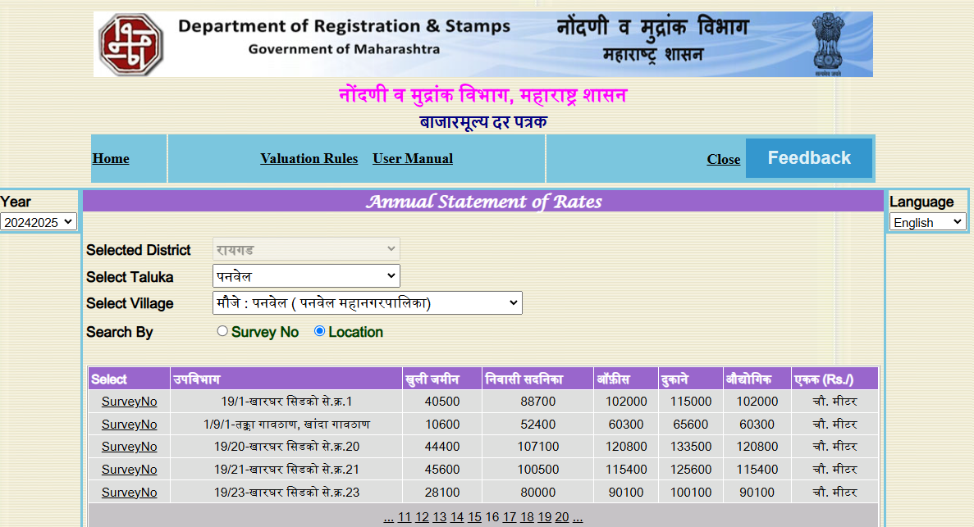

Stamp Duty Ready Reckoner Market Value Rate for Pent House | 1,07,100.00
10% Increase on pent house Located on 15th & 16th Floor | 10,710.00
Stamp Duty Ready Reckoner Market Value Rate (After Increase) (A) | 1,17,810.00 | Sq. Mt. | 10,945.00 | Sq. Ft.
Stamp Duty Ready Reckoner Market Value Rate for Land (B) | 44,400.00
The difference between land rate and building rate (A – B = C) | 73,410.00
Depreciation Percentage as per table (D) [100% - 17%]  (Age of the Building – 17 Years) | 83%
Rate to be adopted after considering depreciation [B + (C x D)] | 1,05,330.00 | Sq. Mt. | 9,785.00 | Sq. Ft.

Multi-Storied building with Lift
For residential premises / commercial unit / office on above floor in multistoried building, the rate mentioned in the ready reckoner will be increased as under:

 | Location of Pent House / Commercial Unit in the building | Rate
a) | On Ground to 4 Floors | No increase for all floors from ground to 4 floors
b) | 5 Floors to 10 Floors | Increase by 5% on units located between 5 to 10 floors
c) | 11 Floors to 20 Floors | Increase by 10% on units located between 11 to 20 floors
d) | 21 Floors to 30 Floors | Increase by 15% on units located between 21 to 30 floors
e) | 31 Floors and above | Increase by 20% on units located on 31 and above floors

Table – D: Depreciation Percentage Table

Completed Age of Building in Years | Value in percent after depreciation
 | R.C.C. Structure / other Pukka Structure | Cessed Building, Half or Semi – Pukka Structure & Kaccha Structure.
0 to 2 Years | 100% | 100%
Above 2 & up to 5 Years | 95% | 95%
Above 5 Years | After initial 5 year for every year 1% depreciation is to be considered. However maximum deduction available as per this shall be 70% of Market Value rate | After initial 5 year for every year 1.5% depreciation is to be considered. However maximum deduction available as per this shall be 85% of Market Value rate

Price Indicators
Property | 3 BHK Flat in Unique Twins Tower CHS, Sector 20, Kharghar
Source | 99acres
Floor | -
 | Carpet | Built Up | Saleable
Area | 1000.00 | 1200.00 | -
Percentage | - | 20% | -
Rate Per Sq. Ft. | ₹ 24,000.00 | ₹ 20,000.00 | -
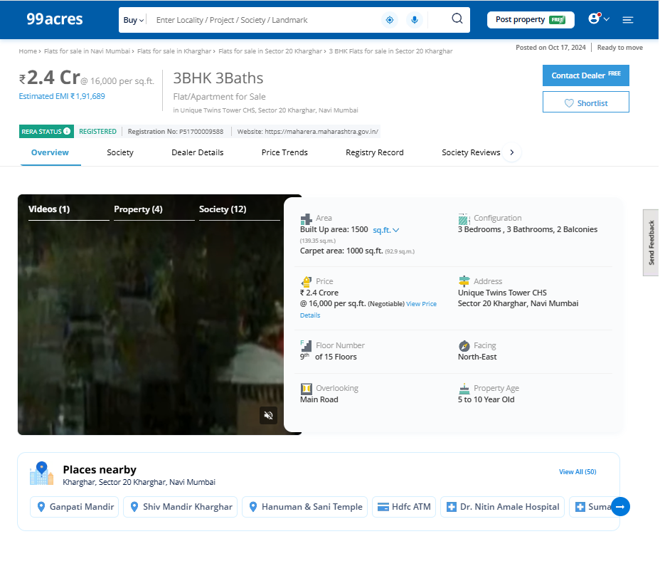

Price Indicators
Property | 3 BHK Flat in Unique Twins Tower CHS, Sector 20, Kharghar
Source | 99acres
Floor | -
 | Carpet | Built Up | Saleable
Area | 1,365.00 | 1,638.00 | -
Percentage | - | 20% | -
Rate Per Sq. Ft. | ₹ 24,176.00 | ₹ 20,147.00 | -
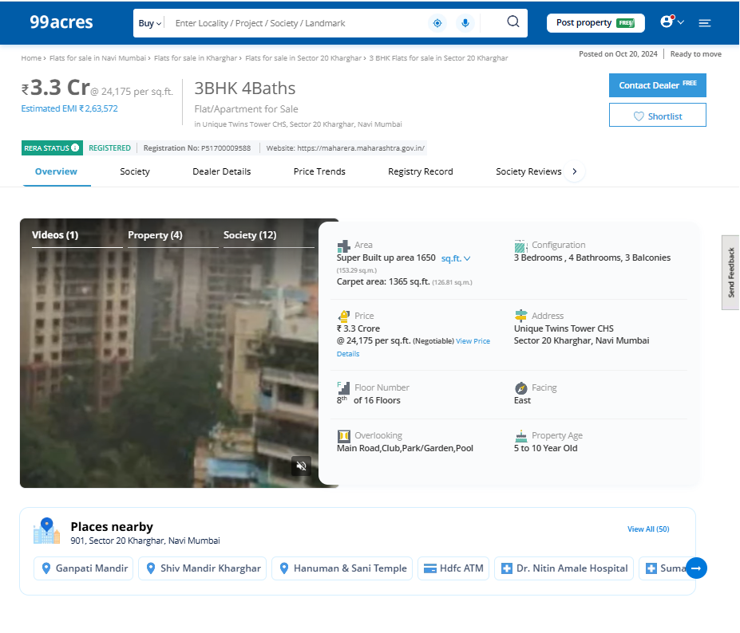

Sales Instance
Property | Flat
Source | Index II
Floor | -
 | Carpet | Built Up | Saleable
Area | 815.00 | 978.00 | -
Percentage | - | 20% | -
Rate Per Sq. Ft. | ₹ 19,205.00 | ₹ 16,004.00 | -
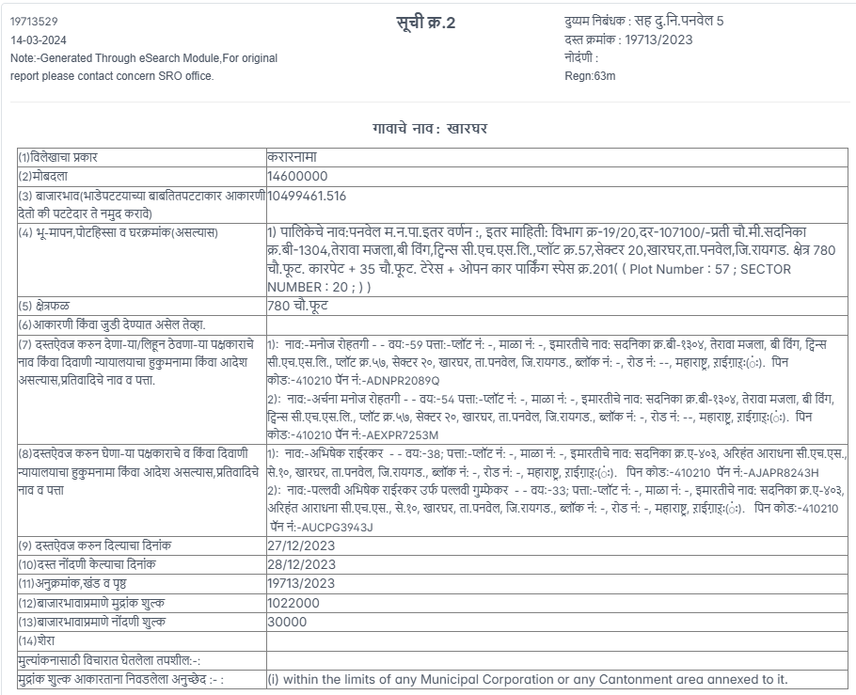
Sales Instance
Property | Flat
Source | Index II
Floor | -
 | Carpet | Built Up | Saleable
Area | 1624.17 | 1,949.00 | -
Percentage | - | 20% | -
Rate Per Sq. Ft. | ₹ 19,782.00 | ₹ 16,485.00 | -
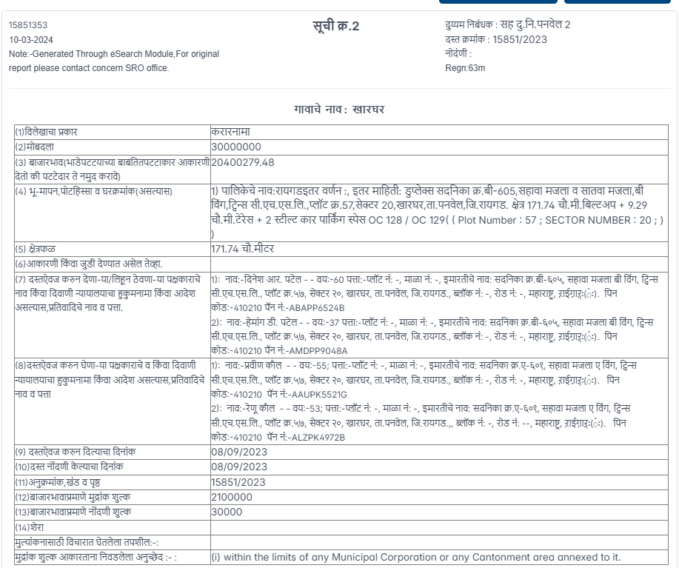

As a result of my appraisal and analysis, it is my considered opinion that the present fair market value of the above property in the prevailing condition with aforesaid specifications is ` 3,85,44,896.00 (Rupees Three Crore Eighty Five Lakhs Forty Four Thousand Eighty Hundred Ninety Six Only). The Realizable Value of the above property is ` 3,46,90,406.00 (Rupees Three Crore Forty Six Lakhs Ninety Thousand Four Hundred and Six Only). The Distress Value is ` 3,08,35,917.00 (Rupees Three Crore Eight Lakhs Thirty Five Thousand Nine Hundred Seventeen Only).

Place: Mumbai
Date: 21.11.2024

Sharadkumar B. Chalikwar
Govt. Reg. Valuer
Chartered Engineer (India)
Reg. No. [N]C.C.I.T/I -14/52/2008-09
Bank of India Empanelment No.: KZO/CR/19-20/582

The undersigned has inspected the property detailed in the Valuation Report dated _______________________

on ____________________. We are satisfied that the fair and reasonable market value of the property is `_________________________ (Rupees ________________________________________________________

________________________________________only).

Date
Signature
(Name & Designation of the Inspecting Official/s)

Countersigned
(BRANCH MANAGER)

Enclosures
Declaration-cum-undertaking from the valuer (Annexure-IV) | Attached
Model code of conduct for valuer - (Annexure V) | Attached

(Annexure-IV)
DECLARATION-CUM-UNDERTAKING

I, Sharadkumar Chalikwar do hereby solemnly affirm and state that:

- I am a citizen of India.

- I will not undertake valuation of any assets in which I have a direct or indirect interest or become so interested at any time during a period of three years prior to my appointment as valuer or three years after the valuation of assets was conducted by me.

- The information furnished in my valuation report dated 21.11.2024 is true and correct to the best of my knowledge and belief and I have made an impartial and true valuation of the property.

- My engineer Anwar Shaikh has personally inspected the property on 30.10.2024. The work is not sub - contracted to any other valuer and carried out by myself.

- Valuation report is submitted in the format as prescribed by the bank.

- I have not been depanelled / delisted by any other bank and in case any such depanelment by other banks during my empanelment with you, I will inform you within 3 days of such depanelment.

- I have not been removed / dismissed from service / employment earlier.

- I have not been convicted of any offence and sentenced to a term of imprisonment

- I have not been found guilty of misconduct in my professional capacity.

- I have not been declared to be unsound mind

- I am not an undischarged bankrupt, or has not applied to be adjudicated as a bankrupt;

- I am not an undischarged insolvent.

- I have not been levied a penalty under section 271J of Income-tax Act, 1961 (43 of 1961) and time limit for filing appeal before Commissioner of Income-tax (Appeals) or Income-tax Appellate Tribunal, as the case may be has expired, or such penalty has been confirmed by Income-tax Appellate Tribunal, and five years have not elapsed after levy of such penalty

- I have not been convicted of an offence connected with any proceeding under the Income Tax Act 1961, Wealth Tax Act 1957 or Gift Tax Act 1958 and

- My PAN Card number as applicable is EAPC7114Q

- I undertake to keep you informed of any events or happenings which would make me ineligible for empanelment as a valuer

- I have not concealed or suppressed any material information, facts and records and I have made a complete and full disclosure

- I have read the Handbook on Policy, Standards and procedure for Real Estate Valuation, 2011 of the IBA and this report is in conformity to the "Standards" enshrined for valuation in the Part - B of the above handbook to the best of my ability.

- I have read the International Valuation Standards (IVS) and the report submitted to the Bank for the respective asset class is in conformity to the "Standards" as enshrined for valuation in the IVS in "General Standards" and "Asset Standards" as applicable. The valuation report is submitted in the prescribed format of the bank.

- I abide by the Model Code of Conduct for empanelment of valuer in the Bank. (Annexure V - A signed copy of same to be taken and kept along with this declaration)

- am registered under Section 34 AB of the Wealth Tax Act, 1957

- My CIBIL Score and credit worthiness is as per Bank's guidelines.

- I am Director of the company, who is competent to sign this valuation report.

- I will undertake the valuation work on receipt of Letter of Engagement generated from the system (i.e. LLMS / LOS) only.

- Further, I hereby provide the following information.

Sr.  No. | Particulars | Valuer comment
 | background information of the asset being valued; | The property under consideration is purchased by Mr. Anoop Naidu & Mrs. Radhika Naidu from M/s. Creative Enterprises, as per Agreement for Sale dated 31/12/2009.
 | purpose of valuation and appointing authority | As per the request from Bank of India, Kalbadevi Branch to assess Fair Market Value of the property for Bank Loan purpose
 | identity of the valuer and any other experts involved in the valuation; | Sharadkumar Chalikwar – Govt. Regd. Valuer  Rajesh Ghadi – Valuation Engineer  Rashmi Jadhav – Technical Manger  Jayaraja Acharya – Technical Officer
 | disclosure of valuer interest or conflict, if any; | We have no interest, either direct or indirect, in the property valued. Further to state that we do not have relation or any connection with property owner / applicant directly or indirectly. Further to state that we are an independent Valuer and in no way related to property owner / applicant
 | date of appointment, valuation date and date of  report; | Date of Appointment – 30.10.2024  Valuation Date – 21.11.2024  Date of Report – 21.11.2024
 | inspections and/or investigations undertaken; | Physical Inspection done on 30.10.2024
 | nature and sources of the information used or relied upon; | - Market Survey at the time of site visit  - Ready Reckoner rates / Circle rates  - Online search for Registered Transactions  - Online Price Indicators on real estate portals  - Enquiries with Real estate consultants  - Existing data of Valuation assignments carried out by us
 | Procedures adopted in carrying out the valuation and valuation standards followed; | Sales Comparison Method
 | restrictions on use of the report, if any; | This valuation is for the use of the party to whom it is addressed and for no other purpose. No responsibility is accepted to any third party who may use or rely on the whole or any part of this valuation. The valuer has no pecuniary interest that would conflict with the proper valuation of the property.
 | major factors that were taken into account during the valuation; | Current market conditions, demand and supply position, Residential Pent House size, location, upswing in real estate prices, sustained demand for Residential Pent House, all-round development of commercial and Commercial application in the locality etc.
 | Caveats, limitations and disclaimers to the extent they explain or elucidate the limitations faced by valuer, which shall not be for the purpose of limiting his responsibility for the valuation report. | Attached

Assumptions, Disclaimers, Limitations & Qualifications

Value Subject to Change
The subject appraisal exercise is based on prevailing market dynamics as on 21st November 2024 and does not take into account any unforeseeable developments which could impact the same in the future.
Our Investigations
We are not engaged to carry out all possible investigations in relation to the subject property. Where in our report we identify certain limitations to our investigations, this is to enable the reliant party to instruct further investigations where considered appropriate or where we recommend as necessary prior to reliance. Vastukala Consultants India Pvt. Ltd. (VCIPL) is not liable for any loss occasioned by a decision not to conduct further investigations
Assumptions
Assumptions are a necessary part of undertaking valuations. VCIPL adopts assumptions for the purpose of providing valuation advise because some matters are not capable of accurate calculations or fall outside the scope of our expertise, or out instructions. The reliant party accepts that the valuation contains certain specific assumptions and acknowledge and accept the risk of that if any of the assumptions adopted in the valuation are incorrect, then this may have an effect on the valuation.
Information Supplied by Others
The appraisal is based on the information provided by the client. The same has been assumed to be correct and has been used for appraisal exercise. Where it is stated in the report that another party has supplied information to VCIPL, this information is believed to be reliable but VCIPL can accept no responsibility if this should prove not to be so.
Future Matters
To the extent that the valuation includes any statement as to a future matter, that statement is provided as an estimate and/or opinion based on the information known to VCIPL at the date of this document. VCIPL does not warrant that such statements are accurate or correct.
Map and Plans
Any sketch, plan or map in this report is included to assist the reader while visualising the property and assume no responsibility in connection with such matters.
Site Details
Based on inputs received from Client's representative and site visit conducted, we understand that the subject property is Residential Pent House, admeasuring 1,792.00 Sq. Ft. Built-up Area (including 40% area of Terrace) in the name of Mr. Anoop Naidu & Mrs. Radhika Naidu. Further, VCIPL has assumed that the subject property is free from any encroachment and is available as on the date of the appraisal.

Property Title
Based on our discussion with the Client's representative, we understand that the subject property is owned by Mr. Anoop Naidu & Mrs. Radhika Naidu. For the purpose of this appraisal exercise, we have assumed that the subject property has a clear title and is free from any encumbrances, disputes and claims. VCIPL has made no further enquiries with the relevant local authorities in this regard and does not certify the property as having a clear and marketable title. Further, no legal advice regarding the title and ownership of the subject property has been obtained for the purpose of this appraisal exercise. It has been assumed that the title deeds are clear and marketable.
Environmental Conditions
We have assumed that the subject property is not contaminated and is not adversely affected by any existing or proposed environmental law and any processes which are carried out on the property are regulated by environmental legislation and are properly licensed by the appropriate authorities.
Town Planning
The permissible land use, zoning, achievable FSI, area statement adopted for purpose of this valuation is based on the information provided by the Client's representative and the same has been adopted for this valuation purpose. VCIPL has assumed the same to be correct and permissible. VCIPL has not validated the same from any authority.
Area
Based on the information provided by the Client's representative, we understand that the subject property is Residential Pent House, admeasuring 1,792.00 Sq. Ft. Built-up Area (including 40% area of Terrace).
Condition & Repair
In the absence of any information to the contrary, we have assumed that there are no abnormal ground conditions, nor archaeological remains present which might adversely affect the current or future occupation, development or value of the property. The property is free from rat, infestation, structural or latent defect. No currently known deleterious or hazardous materials or suspect techniques will be used in the construction of or subsequent alteration or additions to the property and comments made in the property details do not purport to express an opinion about, or advise upon, the condition of uninspected parts and should not be taken as making an implied representation or statement about such parts
Valuation Methodology
For the purpose of this valuation exercise, the valuation methodology used is Direct Comparison Approach Method and proposed Current use / Exiting use premise is considered for this assignment.
The Direct Comparison Approach involves a comparison of the property being valued to similar properties that have actually been sold in arms - length transactions or are offered for sale. This approach demonstrates what buyers have historically been willing to pay (and sellers willing to accept) for similar properties in an open and competitive market and is particularly useful in estimating the value of the land and properties that are typically traded on a unit basis.
In case of inadequate recent transaction activity in the subject micro-market, the appraiser would collate details of older transactions. Subsequently, the appraiser would analyse rental / capital value trends in the subject micro-market in order to calculate the percentage increase / decrease in values since the date of the identified transactions. This percentage would then be adopted to project the current value of the same.
Where reliance has been placed upon external sources of information in applying the valuation methodologies, unless otherwise specifically instructed by Client and/or stated in the valuation, VCIPL has not independently verified that information and VCIPL does not advise nor accept it as reliable. The person or entity to whom the report is addressed acknowledges and accepts the risk that if any of the unverified information in the valuation is incorrect, then this may have an effect on the valuation.
Not a Structural Survey
We state that this is a valuation report and not a structural survey
Other
All measurements, areas and ages quoted in our report are approximate
Legal
We have not made any allowances with respect to any existing or proposed local legislation relating to taxation on realization of the sale value of the subject property. VCIPL is not required to give testimony or to appear in court by reason of this appraisal report, with reference to the property in question, unless arrangement has been made thereof. Further, no legal advice on any aspects has been obtained for the purpose of this appraisal exercise
Property specific assumptions
Based on inputs received from the client's representative and site visit conducted, we understand that the subject property is Residential Pent House, admeasuring 1,792.00 Sq. Ft. Built-up Area (including 40% area of Terrace).
ASSUMPTIONS, CAVEATS, LIMITATION AND DISCLAIMERS
- We assume no responsibility for matters of legal nature affecting 1. the property appraised or the title thereto, nor do we render our opinion as to the title, which is assumed to be good and marketable.
- The property is valued as though under responsible ownership.
- It is assumed that the property is free of liens and encumbrances
- It is assumed that there are no hidden or unapparent conditions of the subsoil or structure that would render it more or less valuable. No responsibility is assumed for such conditions or for engineering that might be required to discover such factors.
- There is no direct/ indirect interest in the property valued.
- The rates for valuation of the property are in accordance with the Govt. approved rates and prevailing market rates.

MODEL CODE OF CONDUCT FOR VALUERS
Integrity and Fairness
- A valuer shall, in the conduct of his/its business, follow high standards of integrity and fairness in all his/its dealings with his/its clients and other valuers.
- A valuer shall maintain integrity by being honest, straightforward, and forthright in all professional relationships.
- A valuer shall endeavour to ensure that he/it provides true and adequate information and shall not misrepresent any facts or situations.
- A valuer shall refrain from being involved in any action that would bring disrepute to the profession.
- A valuer shall keep public interest foremost while delivering his services.

Professional Competence and Due Care
- A valuer shall render at all times high standards of service, exercise due diligence, ensure proper care and exercise independent professional judgment.
- A valuer shall carry out professional services in accordance with the relevant technical and professional standards that may be specified from time to time.
- A valuer shall continuously maintain professional knowledge and skill to provide competent professional service based on up-to-date developments in practice, prevailing regulations / guidelines and techniques.
- In the preparation of a valuation report, the valuer shall not disclaim liability for his/its expertise or deny his/its duty of care, except to the extent that the assumptions are based on statements of fact provided by the company or its auditors or consultants or information available in public domain and not generated by the valuer.
- A valuer shall not carry out any instruction of the client insofar as they are incompatible with the requirements of integrity, objectivity and independence.
- A valuer shall clearly state to his client the services that he would be competent to provide and the services for which he would be relying on other valuers or professionals or for which the client can have a separate arrangement with other valuers.

Independence and Disclosure of Interest
- A valuer shall act with objectivity in his/its professional dealings by ensuring that his/its decisions are made without the presence of any bias, conflict of interest, coercion, or undue influence of any party, whether directly connected to the valuation assignment or not.
- A valuer shall not take up an assignment if he/it or any of his/its relatives or associates is not independent in terms of association to the company.
- A valuer shall maintain complete independence in his/its professional relationships and shall conduct the valuation independent of external influences.
- A valuer shall wherever necessary disclose to the clients, possible sources of conflicts of duties and interests, while providing unbiased services.
- A valuer shall not deal in securities of any subject company after any time when he/it first becomes aware of the possibility of his / its association with the valuation, and in accordance with the Securities and Exchange Board of India (Prohibition of Insider Trading)Regulations,2015 or till the time the valuation report becomes public, whichever is earlier.
- A valuer shall not indulge in "mandate snatching" or offering "convenience valuations" in order to cater to a company or client's needs.
- As an independent valuer, the valuer shall not charge success fee.
- In any fairness opinion or independent expert opinion submitted by a valuer, if there has been a prior engagement in an unconnected transaction, the valuer shall declare the association with the company during the last five years.

Confidentiality
- A valuer shall not use or divulge to other clients or any other party any confidential information about the subject company, which has come to his / its knowledge without proper and specific authority or unless there is a legal or professional right or duty to disclose.

Information Management

- A valuer shall ensure that he/ it maintains written contemporaneous records for any decision taken, the reasons for taking the decision, and the information and evidence in support of such decision. This shall be maintained so as to sufficiently enable a reasonable person to take a view on the appropriateness of his /its decisions and actions.
- A valuer shall appear, co-operate and be available for inspections and investigations carried out by the authority, any person authorised by the authority, the registered valuers organisation with which he/it is registered or any other statutory regulatory body.
- A valuer shall provide all information and records as may be required by the authority, the Tribunal, Appellate Tribunal, the registered valuers organisation with which he/it is registered, or any other statutory regulatory body.
- A valuer while respecting the confidentiality of information acquired during the course of performing professional services, shall maintain proper working papers for a period of three years or such longer period as required in its contract for a specific valuation, for production before a regulatory authority or for a peer review. In the event of a pending case before the Tribunal or Appellate Tribunal, the record shall be maintained till the disposal of the case.

Gifts and hospitality:
- A valuer or his / its relative shall not accept gifts or hospitality which undermines or affects his independence as a valuer.
Explanation: For the purposes of this code the term 'relative' shall have the same meaning as defined in clause (77) of Section 2 of the Companies Act, 2013 (18 of 2013).
- A valuer shall not offer gifts or hospitality or a financial or any other advantage to a public servant or any other person with a view to obtain or retain work for himself / itself, or to obtain or retain an advantage in the conduct of profession for himself / itself.

Remuneration and Costs.
- A valuer shall provide services for remuneration which is charged in a transparent manner, is a reasonable reflection of the work necessarily and properly undertaken, and is not inconsistent with the applicable rules.
- A valuer shall not accept any fees or charges other than those which are disclosed in a written contract with the person to whom he would be rendering service.

Occupation, employability and restrictions.
- A valuer shall refrain from accepting too many assignments, if he/it is unlikely to be able to devote adequate time to each of his/ its assignments.
- A valuer shall not conduct business which in the opinion of the authority or the registered valuer organisation discredits the profession.
Miscellaneous
- A valuer shall refrain from undertaking to review the work of another valuer of the same client except under written orders from the bank or housing finance institutions and with knowledge of the concerned valuer.
- A valuer shall follow this code as amended or revised from time to time.

Sharadkumar B. Chalikwar
Govt. Reg. Valuer
Chartered Engineer (India)
Reg. No. [N]C.C.I.T/I -14/52/2008-09
Bank of India Empanelment No.: KZO/CR/19-20/582

