COST VETTING REPORT
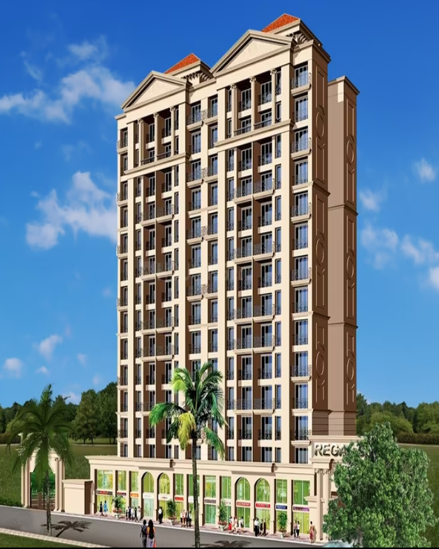

Details of the property under consideration:

Name of Project: "Regal Square Phase 4 Tower 8 And 1"

"Regal Square Phase 4 Tower 8 And 1", Proposed residential building no. 8 & 6 on plot bearing S. No. 5/1(P) & 5/2 (P), Village – Bhadwad, Taluka – Bhiwandi, District – Thane, Pin Code – 421 302, State – Maharashtra, Country – India.

Latitude Longitude: 19°17'18.3"N 73°05'00.4"E

Valuation Done for:
State Bank of India
SME Chembur Branch
Unit No. 11, Building No. 11, Ground Floor, Corporate Park, Sion Trombay Road,
Chembur, Mumbai, Pin Code – 400 071, State - Maharashtra, Country – India.

Vastu/SBI/Mumbai/10/2024/12150/2308492
03/09-32-PY
Date: 29.10.2024

To,
The Branch Manager,
State Bank of India
SME Chembur Branch
Unit No. 11, Building No. 11,
Ground Floor, Corporate Park,
Sion Trombay Road, Chembur,
Mumbai, Pin Code – 400 071,
State - Maharashtra, Country – India.

Sub: Cost Vetting Report for "Regal Square Phase 4 Tower 8 And 1" at Bhiwandi, Pin Code – 421 302

Dear Sir,
In accordance with your letter of engagement as stated above, we enclose our Report on Cost Vetting for "Regal Square Phase 4 Tower 8 And 1", Proposed residential building no. 8 & 6 on plot bearing S. No. 5/1(P) & 5/2 (P), Village – Bhadwad, Taluka – Bhiwandi, District – Thane, Pin Code – 421 302, State – Maharashtra, Country – India.
M/s. Dev Drashti Realty Pvt Ltd is Proposed residential building no. 8 & 6 on plot bearing S. No. 5/1(P) & 5/2 (P), Village – Bhadwad, Taluka – Bhiwandi, District – Thane, Pin Code – 421 302, State – Maharashtra, Country – India. Project is comprising of Sale Building.
Residential Sale Building No. 8 as per Sale Plan (Building No. 6 as per Approved Plan) & Sale Building No. 1 as per Sale Plan (Building No. 8 as per Approved Plan) are proposed of Ground Floor + 1st to 15th Upper Floors with total RERA carpet area of 1,24,348.56 Sq. Ft. which consists 1 BHK & 2 BHK with 242 nos. of Sell flats, 31 Landowner Flats providing with Society Office & Other Amenities.
Our analysis of the cost vetting is enclosed in this report. This Report forms an integral whole and cannot be split in parts. The outcome of the report/ study can only lead to proper conclusions if the Report as a whole is taken into account.
The information used by Vastukala Consultants (I) Pvt. Ltd. (VCIPL) in preparing this report has been obtained from a variety of sources and other relevant documents provided by the client & bank. As agreed, we have performed our cost vetting exercise with the data available related to the business, considering the market prospects and projections. Our results are dependent on documents provided by client & bank, the underlying assumptions, which has been analyzed at a broader level by VCIPL while assessing their reasonableness.

Total Project Cost for the completion of Project will be ` 65.81 Cr.

For Vastukala Consultants (I) Pvt. Ltd.

Manoj B. Chalikwar
Registered Valuer
Chartered Engineer (India)
Reg. No. IBBI / RV / 07/2018/10366
Reg. No. CAT-I-F-1763
SBI Empanelment No.: SME/TCC/38/IBBI/3
About the Project:
Proposed residential building no. 8 & 6 on plot bearing S. No. 5/1(P) & 5/2 (P), Village – Bhadwad, Taluka – Bhiwandi, District – Thane, Pin Code – 421 302, It is about 4.9 KM travelling distance from Bhiwandi Railway station.

Area Statement as per Approved Plan
 |  | Proforma | Sq. M.
 |  | Area Statement
 | A. | Area of Plot
1 |  | Area of plot as per 7/12 S. No 5/1(P) | 5280.00
 |  | Area of plot as per 7/12 S. No 5/2(P) | 4270.00
 |  | Area of plot as per 7/12 S. No 5/2(P) | 4730.00
 | a. | As per ownership Document (7/12 C.T.S. Extract) | 14,280.00
 | b. | Area of plot as per triangulation Method | 14,634.87
 | c. | Safe Plot Area | 14,279.14
 | d. | Plot not in Possession | 821.58
 | e. | As per Site | 13,458.14
2 |  | Deduction For
 | a. | 18 M W.D.P. Road Area | 330.00
 | b. | Any Reservation | 1147.29
 | c. | Total a + b | 1477.29
3 | a. | Balance area of plot (1-2) | 11980.65
 | b. | Add Library Reservation Under Accommodation Policy | 1147.29
 | c. | Total (a + b) | 12727.94
4 |  | Amenity Space if Applicable
 | a. | Required
 | b. | Adjustment of 2a if any
 | c. | Balance Proposed
5 |  | Net Plot Area | 13126.14
6 |  | Recreational open space (if Applicable)
 | a. | Required 10% | 1312.81
 | b. | Proposed | 2274.5
7 |  | Internal Road Area
8 |  | Plottable Area (If Applicable)
9 |  | Built up Area with Ref. to basic FSI as per front road width | 14440.95
 |  | (Sr.NO. 6 x Basic FSI) 13128.14 x 1.10= 14440.95
10 |  | Addition of FSI on payment premium
 | a. | Maximum permissible premium FSI based on Road width
 | b. | Proposed FSI on payment of premium (13458.14 x 0.50 = 6729.07) | 3200
11 |  | In-Situ FSI/TDR Loading
 | a. | In-situ area against D.P. Road, If Any | 680
 | b. | In-Situ Area against Amenity Space if Handed Over
 |  | (2.00 Or 1.85 x Sr. No. 4/ and / Or C
 | c. | TDR Area | 6401.1
 | d. | Total In-Situ (TDR Loading Proposed (11a + b+ c) | 7061.1
12 |  | Additional FSI Area Under Chapter NO 7
13 |  | Total Entitlement of FSI in the proposal
 | a. | Whichever is Applicable | 26702.05
 | b. | Ancillary Area FSI upto 60% or 10% with payment of Charges | 6273.58
 | c. | Total Entitlement (a + b) | 30975.9
14 |  | Maximum Utilization limit of FSI (Building Potential)
 |  | Permissible As per Road Width
 |  | As per Regulation No 6.1 or 6.2 or 6.3 or 6.4 as applicable x1.6 or 1.8
15 |  | Total Built up Area in Proposal (Excluding Area at Sr. No. 17b)
 | a. | Existing Built Up Area | 11651.6
 | b. | Proposed Built up Area (As per P Line) | 10008.21
 | c. | Total (a + b) | 30536.87
16 |  | FSI Consumed (15/13) (Should Not be more than Serial No 14 Above) | 0.5
17 |  | Area for Inclusive housing if Any
 | a. | Required (20% of Sr. No. 5)
 | b. | Proposed

Construction Area as per Approved Plan for Sale Building

- Building No. 8 as per Sale Plan (Building No. 6 as per Approved Plan)

Sr. No. | Floor | Built Up Area in Sq. M. | Lift & Fire Duct Area in Sq. M. | Refuge Area in Sq. M. | Other Area in Sq. M. | Total Area in Sq. M. | Total Area in Sq. Ft.
1 | Stilt Floor | 122.13 | 20.45 | - | 832.08 | 974.66 | 10,491.24
2 | 1st Floor | 710.03 | 20.45 | - | - | 730.48 | 7,862.89
3 | 2nd Floor | 710.03 | 20.45 | - | - | 730.48 | 7,862.89
4 | 3rd Floor | 710.03 | 20.45 | - | - | 730.48 | 7,862.89
5 | 4th Floor | 710.03 | 20.45 | - | - | 730.48 | 7,862.89
6 | 5th Floor | 710.03 | 20.45 | - | - | 730.48 | 7,862.89
7 | 6th Floor | 710.03 | 20.45 | - | - | 730.48 | 7,862.89
8 | 7th Floor | 710.03 | 20.45 | - | - | 730.48 | 7,862.89
9 | 8th Floor | 675.95 | 20.45 | 34.08 | - | 730.48 | 7,862.89
10 | 9th Floor | 710.03 | 20.45 | - | - | 730.48 | 7,862.89
11 | 10th Floor | 710.03 | 20.45 | - | - | 730.48 | 7,862.89
12 | 11th Floor | 710.03 | 20.45 | - | - | 730.48 | 7,862.89
13 | 12th Floor | 710.03 | 20.45 | - | - | 730.48 | 7,862.89
14 | 13th Floor | 675.95 | 20.45 | 34.08 | - | 730.48 | 7,862.89
15 | 14th Floor | 710.03 | 20.45 | - | - | 730.48 | 7,862.89
16 | 15th Floor | 710.03 | 20.45 | - | - | 730.48 | 7,862.89
17 | Terrace | - | - | - | 80.63 | 80.63 | 867.88
TOTAL |  | 10,704.42 | 327.20 | 68.16 | 912.71 | 12,012.49 | 1,29,302.42

- Building No. 1 as per Sale Plan (Building No. 8 as per Approved Plan)

Sr. No. | Floor | Built Up Area in Sq. M. | Lift & Fire Duct Area in Sq. M. | Refuge Area in Sq. M. | Other Area in Sq. M. | Total Area in Sq. M. | Total Area in Sq. Ft.
1 | Stilt Floor | 308.17 | 12.79 | - | 83.47 | 404.43 | 4,353.28
2 | 1st Floor | 215.28 | 12.79 | - | 176.36 | 404.43 | 4,353.28
3 | 2nd Floor | 391.64 | 12.79 | - | - | 404.43 | 4,353.28
4 | 3rd Floor | 391.64 | 12.79 | - | - | 404.43 | 4,353.28
5 | 4th Floor | 391.64 | 12.79 | - | - | 404.43 | 4,353.28
6 | 5th Floor | 391.64 | 12.79 | - | - | 404.43 | 4,353.28
7 | 6th Floor | 391.64 | 12.79 | - | - | 404.43 | 4,353.28
8 | 7th Floor | 391.64 | 12.79 | - | - | 404.43 | 4,353.28
9 | 8th Floor | 372.85 | 12.79 | 18.79 | - | 404.43 | 4,353.28
10 | 9th Floor | 391.64 | 12.79 | - | - | 404.43 | 4,353.28
11 | 10th Floor | 391.64 | 12.79 | - | - | 404.43 | 4,353.28
12 | 11th Floor | 391.64 | 12.79 | - | - | 404.43 | 4,353.28
13 | 12th Floor | 391.64 | 12.79 | - | - | 404.43 | 4,353.28
14 | 13th Floor | 372.85 | 12.79 | 18.79 | - | 404.43 | 4,353.28
15 | 14th Floor | 391.64 | 12.79 | - | - | 404.43 | 4,353.28
16 | 15th Floor | 391.64 | 12.79 | - | - | 404.43 | 4,353.28
17 | Terrace | - | - | - | 48.94 | 48.94 | 526.75
TOTAL |  | 5,968.83 | 204.64 | 37.58 | 308.77 | 6,519.82 | 70,179.30

- Total Construction Area

Sr. No. | Floor | Built Up Area in Sq. M. | Lift & Fire Duct Area in Sq. M. | Refuge Area in Sq. M. | Other Area in Sq. M. | Total Area in Sq. M. | Total Area in Sq. Ft.
1 | Stilt Floor | 430.30 | 33.24 | - | 915.55 | 1,379.09 | 14,844.52
2 | 1st Floor | 925.31 | 33.24 | - | 176.36 | 1,134.91 | 12,216.17
3 | 2nd Floor | 1,101.67 | 33.24 | - | - | 1,134.91 | 12,216.17
4 | 3rd Floor | 1,101.67 | 33.24 | - | - | 1,134.91 | 12,216.17
5 | 4th Floor | 1,101.67 | 33.24 | - | - | 1,134.91 | 12,216.17
6 | 5th Floor | 1,101.67 | 33.24 | - | - | 1,134.91 | 12,216.17
7 | 6th Floor | 1,101.67 | 33.24 | - | - | 1,134.91 | 12,216.17
8 | 7th Floor | 1,101.67 | 33.24 | - | - | 1,134.91 | 12,216.17
9 | 8th Floor | 1,048.80 | 33.24 | 52.87 | - | 1,134.91 | 12,216.17
10 | 9th Floor | 1,101.67 | 33.24 | - | - | 1,134.91 | 12,216.17
11 | 10th Floor | 1,101.67 | 33.24 | - | - | 1,134.91 | 12,216.17
12 | 11th Floor | 1,101.67 | 33.24 | - | - | 1,134.91 | 12,216.17
13 | 12th Floor | 1,101.67 | 33.24 | - | - | 1,134.91 | 12,216.17
14 | 13th Floor | 1,048.80 | 33.24 | 52.87 | - | 1,134.91 | 12,216.17
15 | 14th Floor | 1,101.67 | 33.24 | - | - | 1,134.91 | 12,216.17
16 | 15th Floor | 1,101.67 | 33.24 | - | - | 1,134.91 | 12,216.17
17 | Terrace | - | - | - | 129.56 | 129.56 | 1,394.62
TOTAL |  | 16,673.25 | 531.84 | 105.74 | 1,221.47 | 18,532.30 | 1,99,481.72

Project Cost
Sr. No. | Particulars | Total Estimated Amount in ` | Total Estimated Amount  in ` Cr.
1 | Land Cost
 | Acquisition Cost of Land or Development Rights, and Legal Cost. | 7,81,76,040.00 | 7.82
 | Rent to Tenants, Lease premium, Lease Rent, interest cost incurred or payable on Land Cost | - | -
 | Amount of Premium payable to obtain development rights, FSI, additional FSI, fungible area, and any other incentive under DCR from Local Authority or State Government or any Statutory Authority. | 50,00,000.00 | 0.50
 | Acquisition cost of TDR (if any) | - | -
2 | Cost of Construction
 | Estimated construction cost of rehab cum sale building including site development and infrastructure for the same. | 46,33,07,590.00 | 46.33
 | On site expenditure for development of entire project excluding cost of construction as per(i) above,
a. | Architect Fees & Consultant fees | 1,38,99,228.00 | 1.39
b. | Admin Cost includes salaries, site overheads, development works, cost of services (including water, electricity, sewerage, drainage, layout roads etc.), cost of machineries and equipment including its hire and maintenance cost, consumables etc. All costs directly incurred to complete the construction of the entire phase of the project registered. | 2,31,65,380.00 | 2.32
c. | Marketing Cost | 1,66,35,652.00 | 1.66
3 | Interest during the Project | 4,40,00,000.00 | 4.40
4. | Contingency Charges | 1,38,99,228.00 | 1.39
 | GRAND TOTAL: | 65,80,83,118.00 | 65.81

Manoj B. Chalikwar
Registered Valuer
Chartered Engineer (India)
Reg. No. IBBI / RV / 07/2018/10366
Reg. No. CAT-I-F-1763
SBI Empanelment No.: SME/TCC/38/IBBI/3
Comments on each element of Cost of Project: -
- Land Cost:
As per Present Ready Reckoner rate the Project Land Value is ` 0.88 Cr. considering Land Rate @ ` 8,000.00 per Sq. M. & Plot Area of 1,101.67 Sq. M.
As per developer agreement land stamp duty cost is ` 7,81,76,040.00 i.e., ` 7.82 Cr. which is 11.88% of Total Project Cost.
Sr. | Date | Document Name | Description | Total Cost in ` | Incurred Cost in `
1 | 14/09/2024 | Development Agreement | Purchase Cost | 7,20,00,000.00 | 7,20,00,000.00
2 | 14/09/2024 | Development Agreement | Stamp Duty | 61,37,800.00 | 61,37,800.00
3 | 14/09/2024 | Development Agreement | Reg. Fees | 30,000.00 | 30,000.00
4 | 14/09/2024 | Development Agreement | Reg. Fees | 2,740.00 | 2,740.00
5 | 21/09/2024 | Supplementary Development Agreement | Stamp Duty | 500.00 | 500.00
6 | 21/09/2024 | Supplementary Development Agreement | Reg. Fees | 3,100.00 | 3,100.00
7 | 21/09/2024 | Supplementary Development Agreement | Reg. Fees | 100.00 | 100.00
8 | 21/09/2024 | Power of Attorney | Stamp Duty | 500.00 | 500.00
9 | 21/09/2024 | Power of Attorney | Reg. Fees | 1,200.00 | 1,200.00
10 | 21/09/2024 | Power of Attorney | Reg. Fees | 100.00 | 100.00
Total |  |  |  | 7,81,76,040.00 | 7,81,76,040.00

- Building Cost of Construction for Sale Building:
Construction Area of Sale Building No. 1 as per Sale Plan (Building No. 8 as per Approved Plan) =
6,519.82 Sq. M. i.e., 70,179.30 Sq. Ft.
Construction Area of Sale Building No. 8 as per Sale Plan (Building No. 6 as per Approved Plan) =
12,012.49 Sq. M. i.e., 1,29,302.42 Sq. Ft.
Total Construction Area of Sale Building = 18,532.30 Sq. M. i.e., 1,99,481.72 Sq. Ft.
Total estimated cost for construction of Building (includes cost of RCC work, manpower, lift, material, painting, finishing work, site development, etc.) is ` 46,33,07,590.00 i.e., ` 46.33 Cr. which comes ` 25,000.00 per Sq. M. on construction area for building,
The total construction area is 18,532.30 Sq. M. i.e.,1,99,481.72 Sq. Ft., projected cost of ` 46.33 Cr is 70.40% of total project cost
VCIPL opinion the construction cost of 25,000/- Per Sq. Ft. which is in line with Market-Trend.
Particulars | Rate per Sq. M.
Excavation Work | 2,000.00
Total RCC Work | 12,000.00
Final Finishing Work | 6,000.00
Other Work | 5,000.00
Cost of Construction | 25,000.00

- Approval Charges:
The Total Approval Cost (Fungible Cost & Development Cess Premium & TDR Cost) as per challan provided by the developer will be ` 50,00,00.00 i.e., `0.50 Cr. which is 0.76% of Total Project Cost.
As per information provided by developer.

- Architect Cost, RCC & Other Professional Charges:
The total Architect charges of ` 1,38,99,228.00 i.e., ` 1.39 Cr. Is 3% of total construction cost building & it is line up with Market trend.
The professional charge consists of Architect & Legal which in market is in the range of 2% - 5% of Total Construction cost of the project.

- Administrative Expenses:
Salaries, site overheads, development works, cost of services (including water, electricity, sewerage, drainage, layout roads etc.), cost of machineries and equipment including its hire and maintenance cost, consumables etc. All costs directly incurred to complete the construction of the entire phase of the project registered is estimated 5% of total construction cost Building which comes to ` 2,31,65,380.00 i.e., ` 2.32 Cr.
The admin charges which in market is in the range of 4% - 6% of Total Construction cost of the project.

- Marketing Expenses:
Marketing costs directly incurred to complete the construction of the entire phase of the project registered is estimated at 2% of total Sale income from the project which comes to ` 1,66,35,652.00 i.e., ` 1.66 Cr.
The marketing charge consists of brokerage & commission which in market is in the range of 1% - 3% of Total Sale income of the property.

- Interest Costs:
The Interest cost for the term loan is ` 4,40,00,000.00 i.e., ` 4.40 Cr., which is 6.69% of total project cost.
As per information provided by the client.

- Contingency Costs:
The contingency charges estimated at 3% of total cost of construction which comes to ` 1,38,99,228.00 i.e., ` 1.39 Cr.
Observation and Construction: -
Total estimated cost of project i.e., ` 65,80,83,118.00 (Rupees Sixty – Five Crore Eighty Lakh Eighty – Three Thousand One Hundred Eighteen Only) i.e., ` 65.81 Cr. is fair & reasonable.
The project cost is including land premium payable to concern authorities, Fungible FSI Premium, Cost of Construction of Sale Building, professional charges on site expenses including admin & marketing expenses, premiums / charges to be paid to competent authority and Bank interest, etc. we have not independently verified interest cost hence not consider in cost vetting.
As per present sanctioned building plan, permissible built-up area on the said plot is 16,673.25 Sq. M. sale building is presently approved for Residential Sale Building No. 8 as per Sale Plan (Building No. 6 as per Approved Plan) & Sale Building No. 1 as per Sale Plan (Building No. 8 as per Approved Plan) are proposed of Ground Floor + 1st to 15th Upper Floors. Estimated cost of entire project of 15th upper floors are considered.
Total estimated cost of construction of Sales building is ` 46,33,07,590.00 i.e., ` 46.33 Cr. which comes ` 25,000.00 per Sq. M. on construction area for building which is fair & reasonable considering the present status of project, type & quality of construction & specification of the building materials to be used, height of the structure, amenities to be provided in proposed building.

Assumptions & Remarks-
- The adequacy of Engineering / Structural design is beyond the scope of our assignment.
- Estimated project completion date is 31/12/2026. The cost is certified based on the assumptions that the project will be completed within time frame. Few assumptions are made regarding inflation & cost rise etc. during construction period.

Photo copy of following document is provided to us & this report should be read along with it:
- Copy Development agreement between Dev Drashti Realty Pvt Ltd (The Owner) & M/s. Drashti Realty Pvt. Ltd. (The Developers) through registered agreement No. BVD3/8186/2024 dated 05.10.2024.
- Copy of Power of Attorney from Mr. Sachin C. Mirani & Partner (The Owner – Squarefeet Infrastructure LLP.) To M/s. Dev Drashti Realty Pvt Ltd (The Developers) through register agreement No. BVD3/8375/2024 dated 21.09.2024.
- Copy of Supplementary Agreement between Dev Drashti Realty Pvt Ltd (The Owner) & M/s. Drashti Realty Pvt. Ltd. (The Developers) through registered agreement No. BVD3/8374/2024 dated 21.09.2024.
- Copy of Architect Certificate issued by Navrachana Architect & Interior Designers dated 24.09.2024.
- Copy of Title Certificate issued by O. R. Maurya (Advocate High Court) dated 25.11.2013.
- Copy of Legal Title Report issued by M. A. Ansari (Advocate High Court) dated 24.02.2022.
- Copy of Search Report issued by Sachin Patil (Search Clerk) dated 30.06.2021.
- Copy of N.A. Order dated 01.09.2014.
- Copy of Fire NOC registered No. J.K./BNSMNP/Fire/395/2022, issued by Bhiwandi Nizampur City Municipal Corporation, Fire Brigade & Emergency Services dated 06.06.2022.
- Copy of Certificate of Incorporation issued by Government of India Ministry of Corporate Affairs dated 03.10.2023.
- Copy of Approved Plan No. BPK/32/2021-2022/JKNRV/3004 dated 29.10.2021 issued by Bhiwandi Nizampur City Municipal Corporation.
Approved Upto: Stilt Floor + 1st Floor to 15th Upper Floor
- Copy of Commencement Certificate No. BPK/32/2021-2022/JKNRV/3004 dated 29.10.2021, issued by Bhiwandi Nizampur City Municipal Corporation
Approved Upto: (This CC is endorsed for the work from Stilt Floor + 1st floor to 15th Upper Floor)
- Copy of RERA Certificate No. P51700033625 issued by Maharashtra Real Estate Regulatory Authority dated 02.03.2022.
Actual Site Photographs
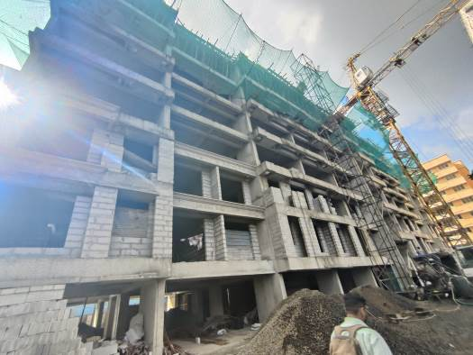
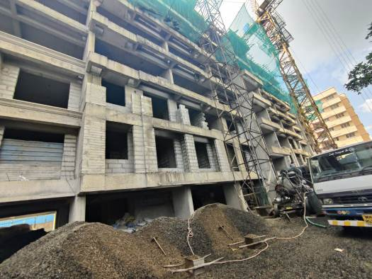
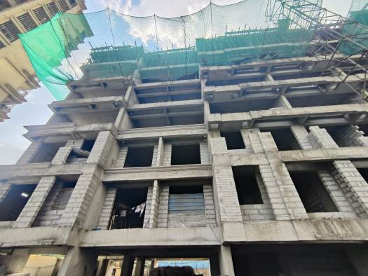
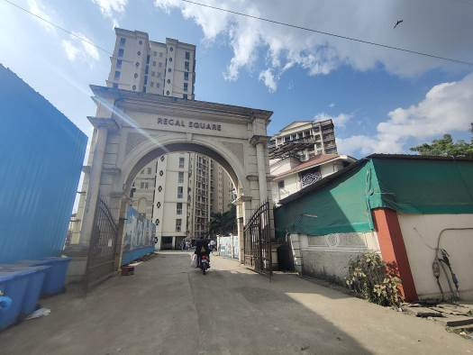
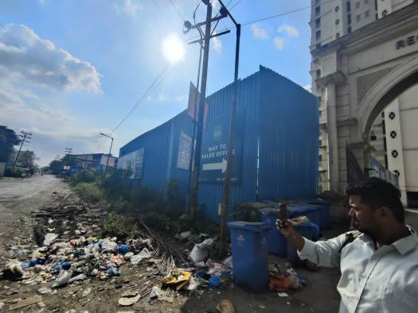

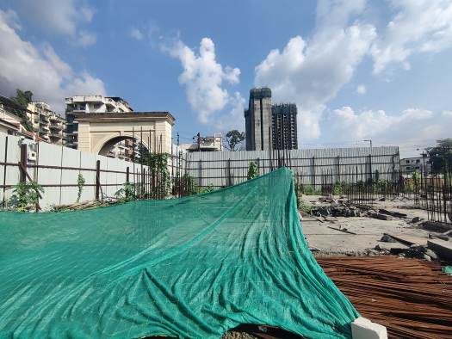

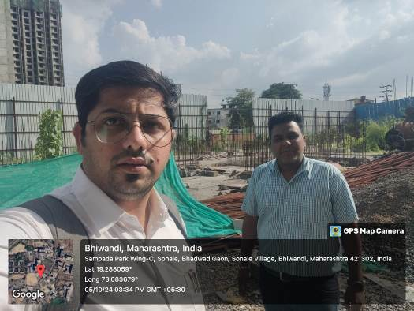
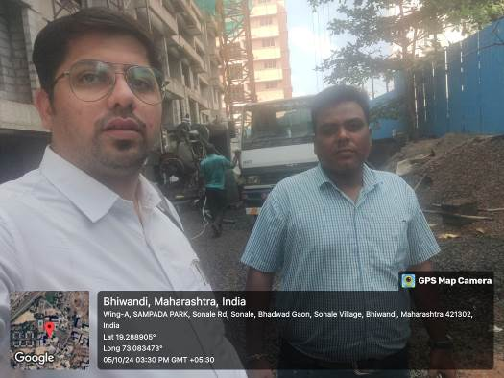

Route Map of the property
Site u/r
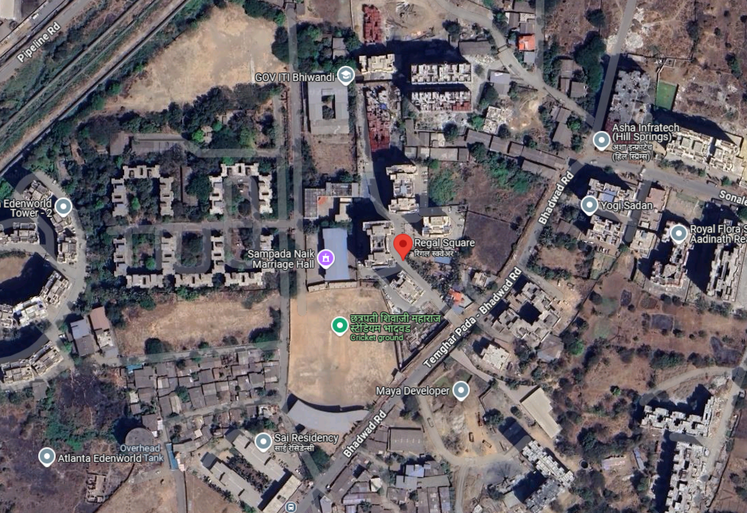

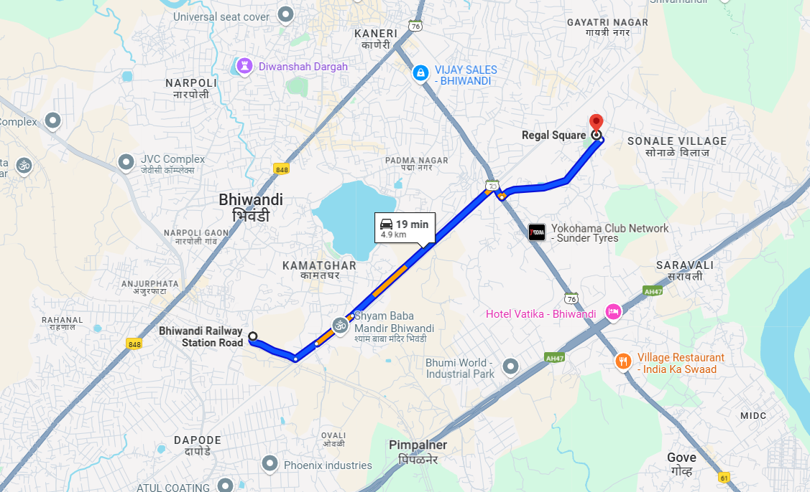

Latitude Longitude: 19°17’18.3” N 73°05’00.4” E
Note: The Blue line shows the route to site from nearest railway station (Bhiwandi – 4.9 Km)

