Valuation Report of the Immovable Property

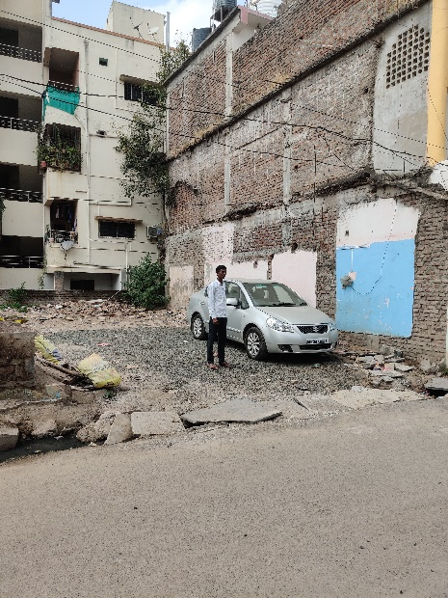

## Details of the property under consideration:

Name of Owner:

**Mr. Bhimesh S/o Vitthalrao Kotgire**

Residential Plot bearing M. H. No. 4643, Line Galli, (Pethamrapur), Village – Degloor,

Taluka – Degloor, District – Nanded, Maharashtra, India

**Longitude Latitude: 18.549009,77.572007**

# Intended User:

# Axis Bank

Nanded Main Branch

Nikhil Heights, Vazirabad Bus Stand Road, Kalamandir, Nanded,

PIN Code – 431602, Maharashtra, India.

Vastu/Axis Bank/Nanded/12/2024/012141/2309496

09/28-190-VCAS

Date: 09.12.2024

# VALUER’S OPINION REPORT

This is to certify that the property bearing Residential Plot bearing M. H. No. 4643, Line Galli, (Pethamrapur), Village – Degloor, Taluka – Degloor, District – Nanded, Maharashtra, India belongs to **Mr. Bhimesh S/o Vitthalrao Kotgire.**

|  |  |  |
| --- | --- | --- |
| **Boundaries of the property.** |  |  |
| On or towards the North by | : | House of Mr. Pravin Venkatarao Achintalwar |
| On or towards the South by | : | House of Mr. Ram Narayan Mariwar |
| On or towards the East by | : | Line Galli Road |
| On or towards the West by | : | Sheri & Shri. Padamwar’s Apartment |

Considering various parameters recorded, existing economic scenario, and the information that is available with reference to the development of neighborhood and method selected for valuation, we are of the opinion that, the property premises can be assessed are as under:

|  |  |
| --- | --- |
| **Fair Market Value of the Property** | **Rs. 48,79,000.00** |
| **Realizable Value of the Property** | **Rs. 43,91,100.00** |
| **Forced/ Distress Sale value of the Property** | **Rs. 39,03,200.00** |
| **Guideline Value of the Property** | **Rs. 2,77,134.00** |

The valuation of the property is based on the documents produced by the concern. Legal aspects have not been taken into considerations while preparing this valuation report.

Hence certified

For, **Vastukala Consultants (I) Pvt. Ltd.**

**Sharadkumar B. Chalikwar**

B.E. (Civil), M.E. (Civil), M.Sc. (Real Estate Valuation), M.Sc. (P&M Valuation), FIE (I),

FIV, FIWRS Chairman & Managing Director

Govt. Reg. Valuer Chartered Engineer (India)

Reg. No. (N) CCIT/1-14/52/2008-09 IBBI

Reg. No. IBBI/RV/07/2019/11744

Encl: Valuation report.

## VALUATION REPORT (IN RESPECT OF RESIDENTIAL LAND)

|  |  |  |  |  |  |  |  |  |  |
| --- | --- | --- | --- | --- | --- | --- | --- | --- | --- |
| 1. | **CBB/CCMC/CCSU** | |  | | **Request No** | | - | | |
| **Proposal No.** | | - | | |
|  | Authorization Letter of Bank | | | | Telephonic discussion with Mr. Shivkumar Chandsure, Manager, Axis Bank, Nanded Main Branch dated 19.10.2024.  Email Id: 295942@axisbank.com  Cell # 9145702020 | | | | |
| 2. | Name of Owner & Address: | | | | **Mr. Bhimesh S/o Vitthalrao Kotgire**  R/o. Line Galli, Degloor, Tq. Degloor, Dist. Nanded.  Cell # 9422185107 | | | | |
| 3. | Name of the Bank Official Present | | | | No. | | | | |
| Name of the Representative & Mobile No. | | | | Siddappa bogdewar (Owner’s Representative)  Cell # 9949044561 | | | | |
| **4.** | **Details of the Property Being Valued** | | | | | | | | |
| 4.1 | Description of the Property | | | | * The Subject Property under valuation is Freehold Residential Plot Bearing M. H. No. 4643, Line Galli, (Pethamrapur), Village – Degloor, Taluka – Degloor, District – Nanded, Maharashtra, India. * There is no demarcation of layout. * Plot Size as per Sale Deed: 12.80 Mx 7.62 M. = 97.58 Sqm. * Plot Area as per Mortgage Deed: 97.58 Sqm.   **Plot area of 97.58 Sqm. as per Sale Deed & Mortgage Deed is considered for valuation.** | | | | |
| 4.2 | Location of Property | | | | Residential Plot bearing M. H. No. 4643, Line Galli, (Pethamrapur), Village – Degloor, Taluka – Degloor, District – Nanded, Maharashtra, India | | | | |
| (Rural / Semi Urban / Urban) | | | | Urban | | | | |
| 4.3 | Documents Provided: | | | | | | | | |
| 1 | Photo Copy of Sale Deed No.497/2014, dated 28.03.2014, Sub Registered, Degloor. | | | | | | | |
| 2 | Photo Copy of Gaothan Certificate vide No. N.P./6101 / 2021 dated 21.10.201 issued by Chief Officer, Degloor, Municipal Council. | | | | | | | |
| 3 | Photo Copy of property Register Certificate vide No. N.P./6101 / 2021 dated 21.10.201 issued by Chief Officer, Degloor, Municipal Council. | | | | | | | |
| 4 | Photo Copy of Namuna No.43 Rule (74) Tax Assessment dated 22.10.2021, Chief Officer, Degloor Municipal Council. | | | | | | | |
| 5 | Photo Copy of Paid Receipt No. 87, Book No. 856dated 18.10.2021, Degloor Municipal Council. | | | | | | | |
| 6 | Photo Copy of Mortgage Deed No. 952/2020 dated 26.06.2020 issued by Sub – Registrar, Degloor - 2. | | | | | | | |
| 4.4 | Plot No / Survey No. / Gut No. / Khasra No: | | | Residential Plot bearing M. H. No. 4643 | | | | | |
| Road | | | Line Galli Road | | | | | |
| 4.5 | Colony / Nagar / Sector | | | Venkatesh Nagar. | | Locality / Landmark | | | Degaon Road |
| 4.6 | Village/Town/City | | | Nanded | | District: | | | Nanded |
| 4.7 | State | | | Maharashtra | | Pin code: | | | 431 717 |
| 4.8 | Distance from Area Office | | | | | @ 81.2 Km from Nanded Branch to Degloor | | | |
| **5.** | **Type of Property** | | | | | | | | |
|  | (A) Plot: (Residential / Commercial / Industrial) | | | | | | | Residential. | |
| Level of land with topographical conditions | | | | | | | Levelled. | |
| Whether situated in Municipal / Corporation Limit | | | | | | | Municipal Limit | |
| Any construction observed on plot | | | | | | | No. | |
| **(B) Residential Property: (**Independent house / Bungalow / Row House / Flat) | | | | | | | Open Plot. | |
| Civic Amenities like school, hospital, market, etc. (Available, within the radius of Km./ Not Available) | | | | | | | All available nearby. | |
| **(C) Commercial / Industrial Property :** (Office / Shop / Unit in a Mall / Gowdown) | | | | | | | No. | |
| **6.** | **Accessibility / Boundaries / Others** | | | | | | | | |

,

|  |  |  |  |  |  |  |  |  |  |  |  |  |  |  |
| --- | --- | --- | --- | --- | --- | --- | --- | --- | --- | --- | --- | --- | --- | --- |
| 6.1 | Availability of local transport (Metro / Local Train / Bus / Personal Transport) | | | | | | | Local Transport, Bus Stand, Personal Transport | | | | | | |
| 6.2 | Distance from Nanded Railway station @ 82.40 Km. | | | | | | | Bus stop/ Taxi/ Auto Stand @ 1.00 Km | | | | | | |
| 6.3 | Does the approach road to the Property / Building is independent and accessible | | | | | Yes. | | Will it be able to accommodate a fire extinguisher | | | | | | No. |
| 6.4 | Does the property falls under land locked  area | | | | | No. | | Does the property fall in a community  dominated area | | | | | | No. |
| 6.5 | Cornered / Intermittent Plot | | | | | | | Intermittent | | | | | | |
| 6.6 | Plot No. 37/1 | | | | | | | | | | | | | |
|  | Boundaries | As Per Site | | | | | | As Per Sale Deed | | | | | | |
| North | House of Mr. Pravin Venkatarao Achintalwar | | | | | | House of Mr. Pravin Venkatarao Achintalwar | | | | | | |
| South | House of Mr. Ram Narayan Mariwar | | | | | | House of Mr. Ram Narayan Mariwar | | | | | | |
| East | Line Galli Road | | | | | | Line Galli Road | | | | | | |
| West | Sheri & Shri. Padamwar’s Apartment | | | | | | Sheri & Shri. Padamwar’s Apartment | | | | | | |
| 6.7 | Class of locality (Posh / Higher Middle Class / Middle Class / Lower Middle Class / Poor) | | | | | | | Middle Class | | | | | | |
| 6.8 | Quality of Infrastructure in the vicinity (Excellent / Good / Average / Poor) | | | | | | | Developing | | | | | | |
| 6.9 | Ownership Status of the Property (Free Hold / Reg. Lease / Govt. Authority) | | | | | | | Freehold. | | | | | | |
| 6.10 | Approved usage of property (Industrial / Commercial / Residencial / Mix) | | | | Residential | | | Actual usage of property (Industrial / Commercial / Residential / Mix) | | | | Residential | | |
| 6.11 | Restrictive covenants in regards to Land Use, (if any) | | | | | | | Residential | | | | | | |
| 6.12 | Type of Structure (Load Bearing / RCC / Aluform shuttering) | | | | | | | Not applicable being open plot | | | | | | |
| 6.13 | Number of floors | | | | | | | Not applicable being open plot | | | | | | |
| 6.14 | Occupancy Details (Self-Occupied / Rented / Vacant) | | | | | | | Not applicable being open plot | | | | | | |
| **7.** | **If the property is on rent:** | | | | | | | | | | | | | |
| 7.1 | Name of tenant / lease & Number of years in tenancy | | | | | | | | N.A. | | | | | |
| 7.2 | Was there any resistance for valuation: No | | | | | | If yes, from the current occupants: N.A. | | | | | | | |
| 7.3 | Does property have basic amenities | | | No. | | | Development of surrounding area Underdeveloped / Developing / Developed | | | | | | Developing. | |
| **8.** | **If the property is Leasehold** | | | | | | | | | | | | | |
| 8.1 | Name of Lesser: | | N.A. | Nature of Lease: | | | | | | | N.A. | | | |
| 8.2 | Total Period of Lease: | | N.A. | If yes, from the current occupants: | | | | | | | N.A. | | | |
| 8.3 | Does property have basic amenities | | No. | Development of surrounding area Underdeveloped / Developing / Developed. | | | | | | | Developing | | | |
| **9.** | **Approval Details** | | | | | | | | | | | | | |
| 9.1 | RERA Registration Number | | | | | Not applicable being open plot | | | | | | | | |
| 9.2 | Layout Approval Number: | | | | | - | | | | | | | | |
| Date of Approval | | | | | - | | | | | | | | |
| Expiry Date | | | | | - | | | | | | | | |
| 9.3 | Building Plan Approval Number & Occupancy Certificate | | | | | Not applicable being open plot | | | | | | | | |
| Date of Approval | | | | | - | | | | | | | | |
| Expiry Date | | | | | - | | | | | | | | |
| **10.00** | **Plot Area Details.** | | | | | | | | | | | | | |
| **10.01** | **Plot Area** | | | | | | | | | **Area in Sqm.** | | | | |
| **10.02** | **Plot Area As per Sale Deed** | | | | | | | | | 12.80 m. X 7.62 m. | | | | |
|  | **a) Plot No. 27** | | | | | | | | | 97.58 Sq. m. | | | | |

|  |  |  |  |  |  |  |  |  |  |  |  |  |  |  |  |  |  |  |
| --- | --- | --- | --- | --- | --- | --- | --- | --- | --- | --- | --- | --- | --- | --- | --- | --- | --- | --- |
|  | **Total Area as per Sale Deed** | | | | | | | | | | | | | **97.58 Sq. m.** | | | |  |
| 10.03 | Demarcation at Site | | | | | | | | | | | | | No. | | | |
| 10.04 | Plot Area Considered for Valuation | | | | | | | | | | | | | 97.58 Sq. m. | | | |
| **10.05** | **Construction Area Details** | | | | | | | | | | | | | N.A. | | | |
| **10.06** | **Floor wise break up as follows** | | | | | | | | | **Current Usage**  (Storage / Parking / Commercial /Residential) | | | | | | | |
|  | N.A. | | | | | | | | | N.A. | | | | | | | |
| 10.07 | Amenities Details (if any): | | | | | | | | | No. | | | | | | | |
| 10.08 | FSI Utilized | | | | | | | | | N.A. | | | | | | | |
| 10.09 | Whether the construction is as per approved building plan and / or local building bye laws: | | | | | | | | | N.A. | | | | | | | |
| 10.10 | Details of Extra Construction | | | | | | | | | N.A. | | | | | | | |
| 10.11 | Percentage of Extra Construction | | | | | | | | | N.A. | | | | | | | |
| 10.12 | Whether the extra construction is Compoundable OR Non-Compoundable? | | | | | | | | | N.A. | | | | | | | |
| 10.13 | Quality of construction | | | | | | | | | N.A. | | | | | | | |
| 10.14 | Maintenance of the Property | | | | | | | | | N.A. | | | | | | | |
| 10.15 | Condition of Building | | | | | | | | | N.A. | | | | | | | |
| 10.16 | Current Life of the structure | | | N.A. | | | Projected Future Life of the Structure | | | | | N.A. | | | | | |
| 10.17 | Land Revenue / Taxes Paid upto (for Land) | | | Details not available | | | Municipal Taxes Paid  upto (for Building) | | | | | Details not available. | | | | | |
| **11.** | **Details of Valuation:** | | | | | | | | | | | | | | | | |
|  | **S.L** | **Particulars of Item** | **Plinth / Built up Area In Sq. M.** | | | **Age of Building** | | **Estimated Replacement Rate Of Construction** | | | **Replacement cost** | | | | **Depreciation Nil** | | **Net Value after Depreciation** |
| **Nil** | | | | | | | | | | | | | | | | |
| **12.** | Details of Amenities | | | | | | | | | | | | | | | | N.A. |
| **13.** | **Government Guideline value** | | | | | | | | | | | | | | | | |
|  | **Particulars** | | | | **Area in Sqm.** | | | | **Rate in Rs.** | | | | | | | **Value in Rs.** | |
| 1 | Land | | | | 97.58 | | | | 2,130.00 | | | | | | | 2,77,134.00 | |
|  | **TOTAL** | | | | | | | | | | | | | | | **2,77,134.00** | |
| 14. | **Market Value of Land** | | | | | | | | | | | | | | | | |
|  | **Particulars** | | | | **Area in Sqm.** | | | | **Rate in Rs.** | | | | | | | **Value in Rs.** | |
| **Land** | | | | 97.58 | | | | 50,000.00 | | | | | | | **48,79,000.00** | |
| 15. | **Value of the Property** | | | | | | | | | | | | | | | | |
|  |  | | | | **Land** | | | | **Building** | | | | **Amenities** | | | **Total** | |
| **Market Value** | | | | **48,79,000.00** | | | | Nil | | | | Nil | | | **Rs. 48,79,000.00** | |
| **Realizable Value** | | | |  | | | | | | | | | | | **Rs. 43,91,100.00** | |
| **Distressed/Forced Sale Value** | | | |  | | | | | | | | | | | **Rs. 39,03,200.00** | |
| **Government Guideline value** | | | |  | | | | | | | | | | | **Rs. 2,77,134.00** | |
| **Insurable Value** | | | |  | | | | | | | | | | | **Nil** | |
| **Remarks** | | | | | | | | | | | | | | | | |  |
| * No infrastructure is developed. | | | | | | | | | | | | | | | | |

### Undertaking:

* 1. I have / our / representative Md. Shareq Salim Md. Jilani Pasha (Technical Assistant) has inspected the subject property on 23.10.2024 along with Owner's Representative Gansesh Achintalwar identified the same based on the documents provided.
  2. I/We have no direct or Indirect interest in the property being valued.
  3. The information furnished above is true and correct to my/our knowledge
  4. I/ we have not been dismissed or removed from govt. Service or convicted of an offence connected with any proceedings of income tax act, wealth tax act or gift tax act or have been blacklisted by any bank/ financial institution/ govt. Department/ public sector enterprise/ body corporate etc.
  5. This valuation is prepared without any prejudice or bias to any person or institution.
  6. The value of land is taken into account by making due enquires in the locality and ascertaining the sales value of the properties in the locality.
  7. Any additions/alterations made to the property after the date of valuations shall not fall under the scope of this report.

## For, Vastukala Consultants (I) Pvt. Ltd.

**Sharadkumar B. Chalikwar**

B.E. (Civil), M.E. (Civil), M.Sc. (Real Estate Valuation), M.Sc. (P&M Valuation), FIE (I),

FIV, FIWRS Chairman & Managing Director

Govt. Reg. Valuer Chartered Engineer (India)

Reg. No. (N) CCIT/1-14/52/2008-09 IBBI

Reg. No. IBBI/RV/07/2019/11744

Date: 09.12.2024

Place: Nanded

|  |  |  |
| --- | --- | --- |
| **Attachments** | | |
| Photographs of the Property from inside & outside | : | Attached |
| Location sketch for the property: | : | Attached |
| Geo Tagging | : | Attached |
| Topography | : | Leveled Land |
| Government Value Document | : | Attached |

**Actual Site Photographs**

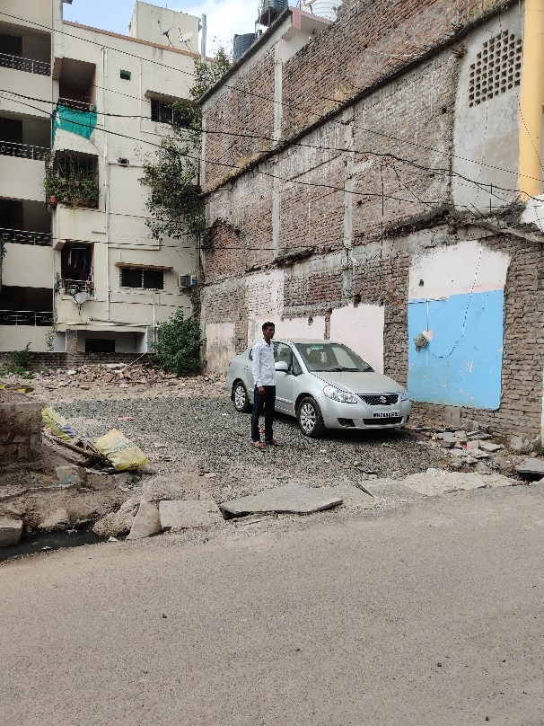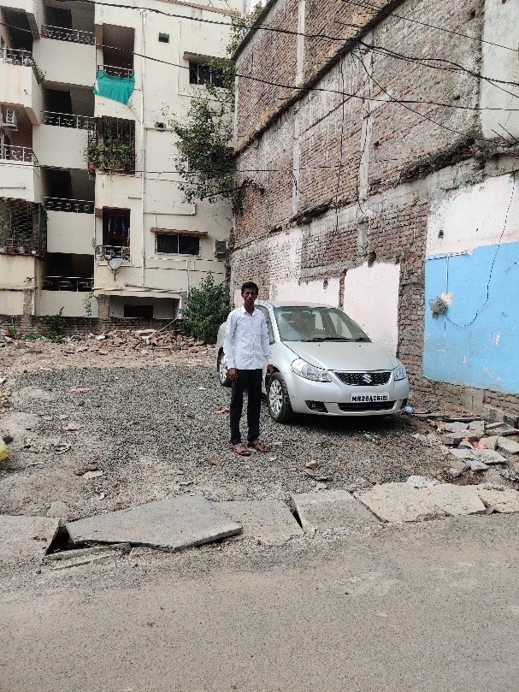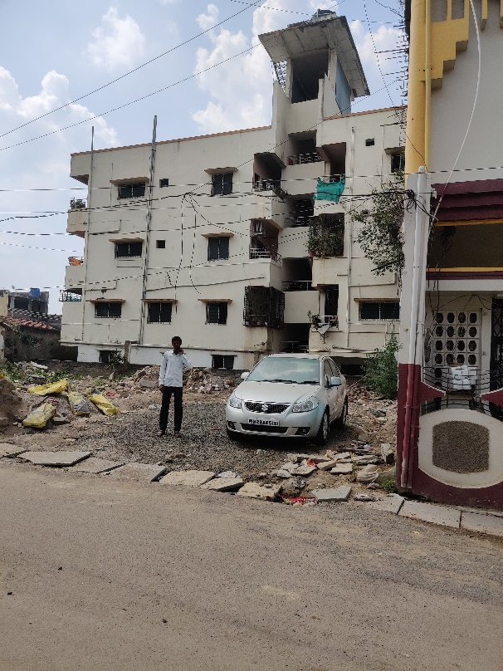

**Route Map of the Property**

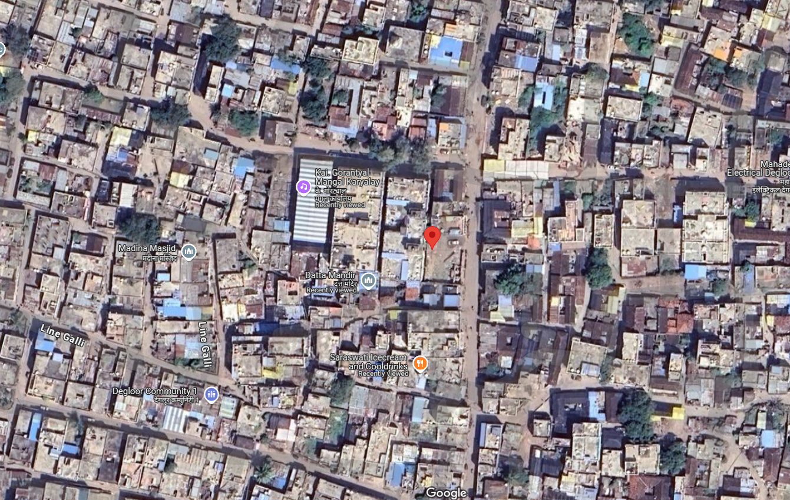

### 

### 

### Longitude Latitude: 18.549009,77.572007

**Note**:

* Red Pointer shows Approx. Property Location.
* Blue line shows Route from Nanded Railway Station @ 82.4 Km.

**Price Indicator**

|  |  |
| --- | --- |
| Plot area | 2100.00 Sq. Ft. |
| Rate per Sq. Ft. | 6, 714.00 |
| Rate Per Sq. M. | 72,273.00 |

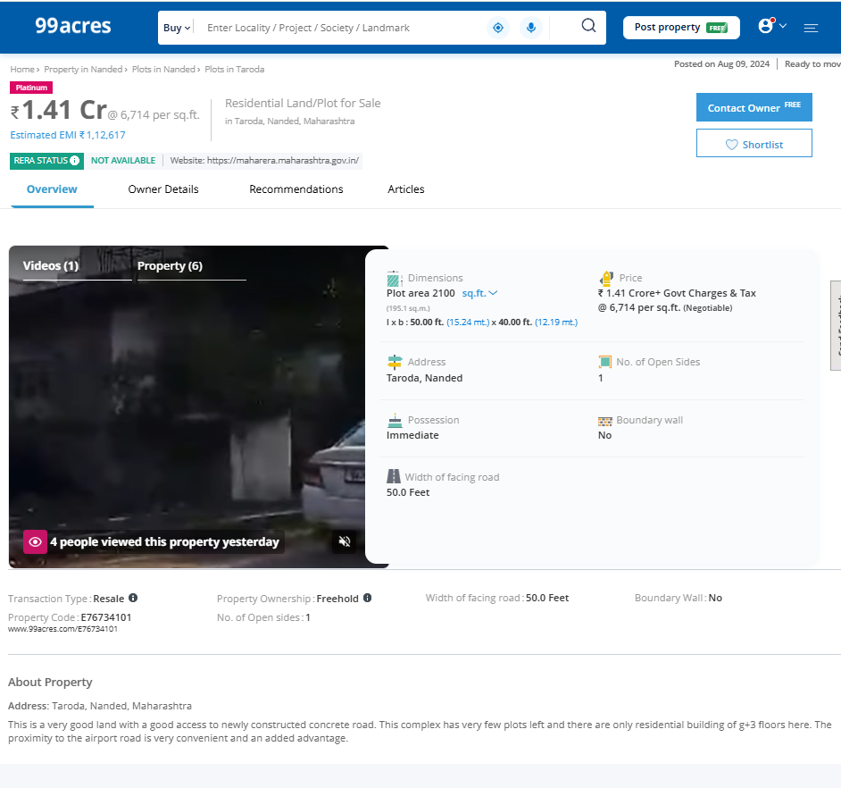

|  |  |
| --- | --- |
| Plot area | 1,454.00 Sq. Ft. |
| Rate per Sq. Ft. | 6, 877.00 |
| Rate Per Sq. M. | 74,030.00 |

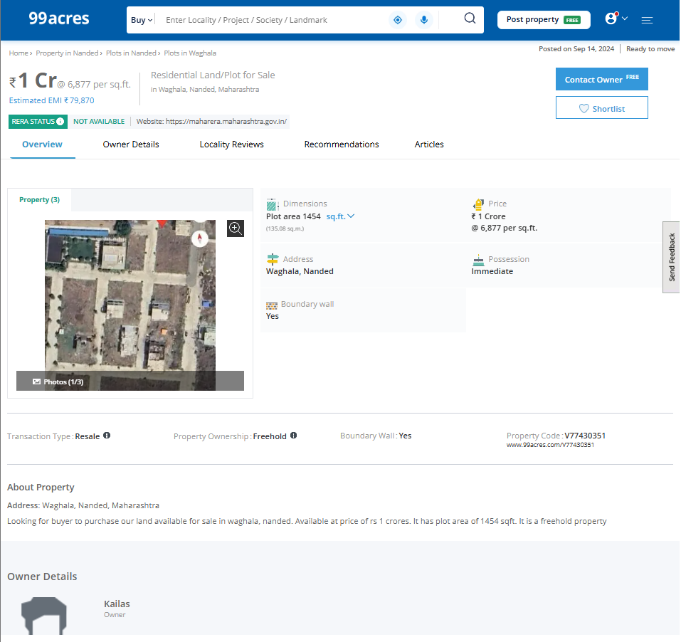

**Price Indicator**

|  |  |
| --- | --- |
| Plot area | 1,200.00 Sq. Ft. |
| Rate per Sq. Ft. | 6,000.00 |
| Rate Per Sq. M. | 64,584.00 |

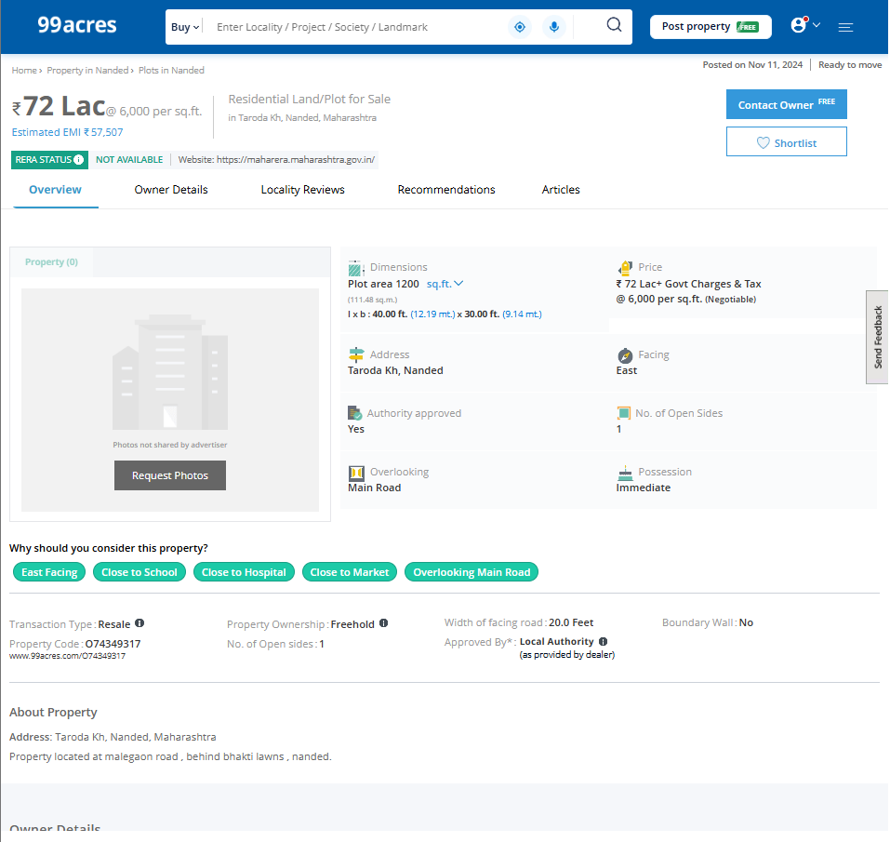

**Ready Reckoner Rate**

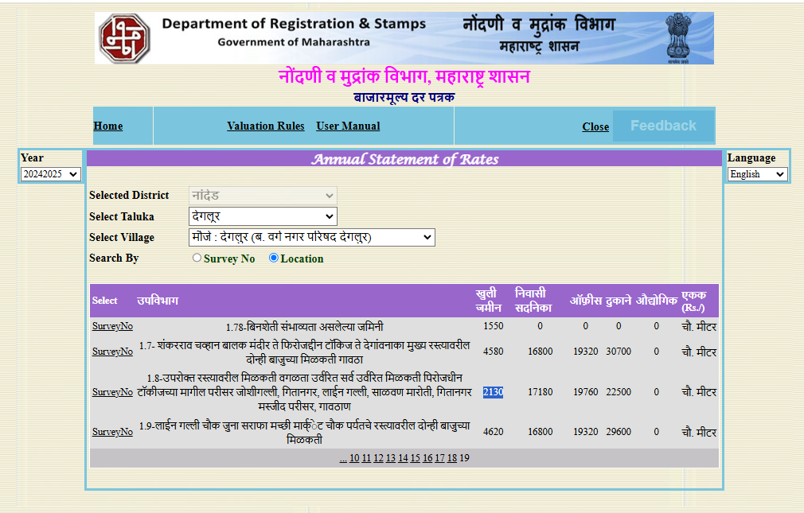

**ASSUMPTIONS, CAVEATS, LIMITATION AND DISCLAIMERS**

1. We assume no responsibility for matters of legal nature affecting the property appraised or the title thereto, nor do we render our opinion as to the title, which is assumed to be good and marketable.
2. The property is valued as though under responsible ownership.
3. It is assumed that the property is free of liens and encumbrances.
4. It is assumed that there are no hidden or unapparent conditions of the subsoil or structure that would render it more or less valuable. No responsibility is assumed for such conditions or for engineering that might be required to discover such factors.
5. The rates for valuation of the property are in accordance with the Govt. approved rates and prevailing market rates

## For, Vastukala Consultants (I) Pvt. Ltd.

**Sharadkumar B. Chalikwar**

B.E. (Civil), M.E. (Civil), M.Sc. (Real Estate Valuation), M.Sc. (P&M Valuation), FIE (I),

FIV, FIWRS Chairman & Managing Director

Govt. Reg. Valuer Chartered Engineer (India)

Reg. No. (N) CCIT/1-14/52/2008-09 IBBI

Reg. No. IBBI/RV/07/2019/11744

Date: 09.12.2024

Place: Nanded