Valuation Report of the Immovable Property

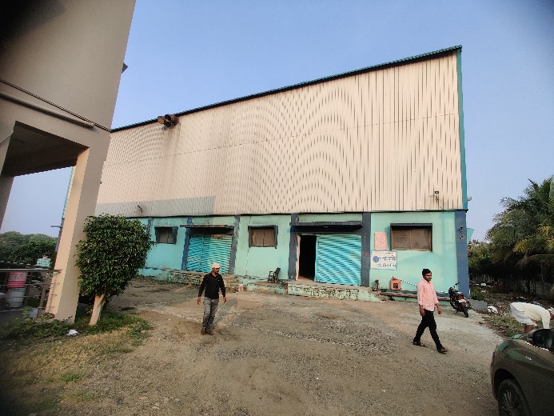

**Details of the property under consideration:**

Name of Lessor: **Maharashtra Industrial Development Corporation**

Name of Lessee / Client – **M/s. Ganesh Agro Industries Pvt. Ltd.**

**Industrial Land and Building** on Plot No. C-33, Degloor Industrial Area, M.I.D.C., Village Khanapur,

Taluka Degloor, District Nanded, PIN – 431717, Maharashtra, India.

# **Longitude Latitude: 18°36'35.5"N 77°34'28.1"E**

**Valuation Done for:**

**Axis Bank**

**Nanded Main Branch**

Nikhil Heights, Vazirabad Bus Stand Road, Kalamandir, Nanded,

PIN Code – 431602, Maharashtra, India.

Vastu/Axis Bank/Nanded/11/2024/012140/2308826

25/9-366-BHBS

Date: 15.11.2024

# **VALUER’S OPINION REPORT**

**Address of the property:** **Industrial Land and Building** on Plot No. C-33, Degloor Industrial Area, M.I.D.C., Village Khanapur, Taluka Degloor, District Nanded, PIN – 431717, Maharashtra, India.

Name of Lessor: **Maharashtra Industrial Development Corporation**

Name of Lessee / Client – **M/s. Ganesh Agro Industries Pvt. Ltd.**

|  |  |  |
| --- | --- | --- |
| Boundaries of the property. | | |
| North | : | 25.0 M. MIDC Road | |
| South | : | Plot No. C-36 | |
| East | : | Open Space No.3 | |
| West | : | Plot No. C-32 and C-37 | |

Considering various parameters recorded, existing economic scenario, and the information that is available with reference to the development of neighborhood and method selected for valuation, we are of the opinion that, the property premises can be assessed are as under:

|  |  |
| --- | --- |
| **Guideline Value of the Property** | **Rs. 2,17,74,052.00** |
| **Fair Market Value of the Property** | **Rs. 3,03,82,652.00** |
| **Realizable Value of the Property** | **Rs. 2,73,44,387.00** |
| **Forced/ Distress Sale value of the Property.** | **Rs. 2,43,06,122.00** |

The valuation of the property is based on the documents produced by the concern. Legal aspects have not been taken into considerations while preparing this valuation report.

Hence certified

For, **Vastukala Consultants (I) Pvt. Ltd.**

**Sharadkumar B. Chalikwar**

B.E. (Civil), M.E. (Civil), M.Sc. (Real Estate Valuation), M.Sc. (P&M Valuation), FIE (I), FIV, FIWRS

Chairman & Managing Director

Govt. Reg. Valuer

Chartered Engineer (India)

Reg. No. (N) CCIT/1-14/52/2008-09

IBBI Reg.No. IBBI/RV/07/2019/11744

|  |  |  |  |  |  |  |  |  |  |  |  |  |  |  |  |  |  |  |  |  |  |  |  |  |  |  |  |  |  |  |  |  |  |  |  |  |  |  |  |  |  |  |  |  |  |  |  |  |  |  |  |  |  |  |  |  |  |  |  |  |  |  |  |  |  |  |  |  |  |  |  |  |  |  |  |  |  |  |  |  |  |  |  |  |  |  |  |  |  |  |  |  |  |  |  |  |  |  |  |  |  |  |  |  |  |  |  |  |  |  |  |  |  |  |  |  |  |  |  |  |  |  |  |  |  |  |  |  |  |  |  |  |  |  |  |  |  |  |  |  |  |  |  |  |  |  |  |  |  |  |  |  |  |  |  |  |  |  |  |  |  |  |  |  |  |  |  |  |  |  |  |  |  |  |  |  |  |  |  |  |  |  |  |  |  |  |  |  |  |  |  |  |  |  |  |  |  |  |  |  |  |  |  |  |  |  |  |  |  |  |  |  |  |  |  |  |  |  |  |  |  |  |  |  |  |  |  |  |  |  |  |  |  |  |  |  |  |  |  |  |  |  |  |  |  |  |  |  |  |  |  |  |  |  |  |  |  |  |  |  |  |  |  |  |  |  |  |  |  |  |  |  |  |  |  |  |  |  |  |  |  |  |  |  |  |  |  |  |  |  |  |  |  |  |  |  |  |  |  |  |  |  |  |  |  |  |  |  |  |  |  |  |  |  |  |  |  |  |  |  |  |  |  |  |  |  |  |  |  |  |  |  |  |  |  |  |  |  |  |  |  |  |  |  |  |  |  |  |  |  |  |  |  |  |  |  |  |  |  |  |  |  |  |  |  |  |  |  |  |  |  |  |  |  |  |  |  |  |  |  |  |  |  |  |  |  |  |  |  |  |  |  |  |  |  |  |  |  |  |  |  |  |  |  |  |  |  |  |  |  |  |  |  |  |  |  |  |  |  |  |  |  |  |  |  |  |  |  |  |  |  |  |  |  |  |  |  |  |  |  |  |  |  |  |  |  |  |  |  |  |  |  |  |  |  |  |  |  |  |  |  |  |  |  |  |  |  |  |  |  |  |  |  |  |  |  |  |  |  |  |  |  |  |  |  |  |  |  |  |  |  |  |  |  |  |  |  |  |  |  |  |  |  |  |  |  |  |  |  |  |  |  |  |  |  |  |  |  |  |  |  |  |  |  |  |  |  |  |  |  |  |  |  |  |  |  |  |  |  |  |  |  |  |  |  |  |  |  |  |  |  |  |  |  |  |  |  |  |  |  |  |  |  |  |  |  |  |  |  |  |  |  |  |  |  |  |  |  |  |  |  |  |  |  |  |  |  |  |  |  |  |  |  |  |  |  |  |  |  |  |  |  |  |  |  |  |  |  |  |  |  |  |  |  |  |  |  |  |  |  |  |  |  |  |  |  |  |  |  |  |  |  |  |  |  |  |  |  |  |  |  |  |  |  |  |  |  |  |  |  |  |  |  |  |  |  |  |  |  |  |  |  |  |  |  |  |  |  |  |  |  |  |  |  |  |  |  |  |  |  |  |  |  |  |  |  |  |  |  |  |  |  |  |  |  |  |  |  |  |  |  |  |  |  |  |  |  |  |  |  |  |  |  |  |  |  |  |  |  |  |  |  |  |  |  |  |  |  |  |  |  |  |  |  |  |  |  |  |  |  |  |  |  |  |  |  |  |  |  |  |  |  |  |  |  |  |  |  |  |  |  |  |  |  |  |  |  |  |  |  |  |  |  |  |  |  |  |  |  |  |  |  |  |  |  |  |  |  |  |  |  |  |  |  |  |  |  |  |  |  |  |  |  |  |  |  |  |  |  |  |  |  |  |  |  |  |  |  |  |  |  |  |  |  |  |  |  |  |  |  |  |  |  |  |  |  |  |  |  |  |  |  |  |  |  |  |  |  |  |  |  |  |  |  |  |  |  |  |  |  |  |  |  |  |  |  |  |  |  |  |  |  |  |  |  |  |  |  |  |  |  |  |  |  |  |  |  |  |  |  |  |  |  |  |  |  |  |  |  |  |  |  |  |  |  |  |  |  |  |  |  |  |  |  |  |  |  |  |  |  |  |  |  |  |  |  |  |  |  |  |  |  |  |  |  |  |  |  |  |  |  |  |  |  |  |  |  |  |  |  |  |  |  |  |  |  |  |  |  |  |  |  |  |  |  |  |  |  |  |  |  |  |  |  |  |  |  |  |  |  |  |  |  |  |  |  |  |  |  |  |  |  |  |  |  |  |  |  |  |  |  |  |  |  |  |  |  |  |  |  |  |  |  |  |  |  |  |  |  |  |  |  |  |  |  |  |  |  |  |  |  |  |  |  |  |  |  |  |  |  |  |  |  |  |  |  |  |  |  |  |  |  |  |  |  |  |  |  |  |  |  |  |  |  |  |  |  |  |  |  |  |  |  |  |  |  |  |  |  |  |  |  |  |  |  |  |  |  |  |  |  |  |  |  |  |  |  |  |  |  |  |  |  |  |  |  |  |  |  |  |  |  |  |  |  |  |  |  |  |  |  |  |  |  |  |  |  |  |  |  |  |  |  |  |  |  |  |  |  |  |  |  |  |  |  |  |  |  |  |  |  |  |  |  |  |  |  |  |  |  |  |  |  |  |  |  |  |  |  |  |  |  |  |  |  |  |  |  |  |  |  |  |  |  |  |  |  |  |  |  |  |  |  |  |  |  |  |  |  |  |  |  |  |  |  |  |  |  |  |  |  |  |  |  |  |  |  |  |  |  |  |  |  |  |  |  |  |  |  |  |  |  |  |  |  |  |  |  |  |  |  |  |  |  |  |  |  |  |  |  |  |  |  |  |  |  |  |  |  |  |  |  |  |  |  |  |  |  |  |  |  |  |  |  |  |  |  |  |  |  |  |  |  |  |  |  |  |  |  |  |  |  |  |  |  |  |  |  |  |  |  |  |  |  |  |  |  |  |  |  |  |  |  |  |  |  |  |  |  |  |  |  |  |  |  |  |  |  |  |  |  |  |  |  |  |  |  |  |  |  |  |  |  |  |  |  |  |  |  |  |  |  |  |  |  |  |  |  |  |  |  |  |  |  |  |  |  |  |  |  |  |  |  |  |  |  |  |  |  |  |  |  |  |  |  |  |  |  |  |  |  |  |  |  |  |  |  |  |  |  |  |  |  |  |  |  |  |  |  |  |  |  |  |  |  |  |  |  |  |  |  |  |  |  |  |  |  |  |  |  |  |  |  |  |  |  |  |  |  |  |  |  |  |  |  |  |  |  |  |  |  |  |  |  |  |  |  |  |  |  |  |  |  |  |  |  |  |  |  |  |  |  |  |  |  |  |  |  |  |  |  |  |  |  |  |  |  |  |  |  |  |  |  |  |  |  |  |  |  |  |  |  |  |  |  |  |  |  |  |  |  |  |  |  |  |  |  |  |  |  |  |  |  |  |  |  |  |  |  |  |  |  |  |  |  |  |  |  |  |  |  |  |  |  |  |  |  |  |  |  |  |  |  |  |  |  |  |  |  |  |  |  |  |  |  |  |  |  |  |  |  |  |  |  |  |  |  |  |  |  |  |  |  |  |  |  |  |  |  |  |  |  |  |  |  |  |  |  |  |  |  |  |  |  |  |  |  |  |  |  |  |  |  |  |  |  |  |  |  |  |  |  |  |  |  |  |  |  |  |  |  |  |  |  |  |  |  |  |  |  |  |  |  |  |  |  |  |  |  |  |  |  |  |  |  |  |  |  |  |  |  |  |  |  |  |  |  |  |  |  |  |  |  |  |  |  |  |  |  |  |  |  |  |  |  |  |  |  |  |  |  |  |  |  |  |  |  |  |  |  |  |  |  |  |  |  |  |  |  |  |  |  |  |  |  |  |  |  |  |  |  |  |  |  |  |  |  |  |  |  |  |  |  |  |  |  |  |  |  |  |  |  |  |  |  |  |  |  |  |  |  |  |  |  |  |  |  |  |  |  |  |  |  |  |  |  |  |  |  |  |  |  |  |  |  |  |  |  |  |  |  |  |  |  |  |  |  |  |  |  |  |  |  |  |  |  |  |  |  |  |  |  |  |  |  |  |  |  |  |  |  |  |  |  |  |  |  |  |  |  |  |  |  |  |  |  |  |  |  |  |  |  |  |  |  |  |  |  |  |  |  |  |  |  |  |  |  |  |  |  |  |  |  |  |  |  |  |  |  |  |  |  |  |  |  |  |  |  |  |  |  |  |  |  |  |  |  |  |  |  |  |  |  |  |  |  |  |  |  |  |  |  |  |  |  |  |  |  |  |  |  |  |  |  |  |  |  |  |  |  |  |  |  |  |  |  |  |  |  |  |  |  |  |  |  |  |  |  |  |  |  |  |  |  |  |  |  |  |  |  |  |  |  |  |  |  |  |  |  |  |  |  |  |  |  |  |  |  |  |  |  |  |  |  |  |  |  |  |  |  |  |  |  |  |  |  |  |  |  |  |  |  |  |  |  |  |  |  |  |  |  |  |  |  |  |  |  |  |  |  |  |  |  |  |  |  |  |  |  |  |  |  |  |  |  |  |  |  |  |  |  |  |  |  |  |  |  |  |  |  |  |  |  |  |  |  |  |  |  |  |  |  |  |  |  |  |  |  |  |  |  |  |  |  |  |  |  |  |  |  |  |  |  |  |  |  |  |  |  |  |  |  |  |  |  |  |  |  |  |  |  |  |  |  |  |  |  |  |  |  |  |  |  |  |  |  |  |  |  |  |  |  |  |  |  |  |  |  |  |  |  |  |  |  |  |  |  |  |  |  |  |  |  |  |  |  |  |  |  |  |  |  |  |  |  |  |  |  |  |  |  |  |  |  |  |  |  |  |  |  |  |  |  |  |  |  |  |  |  |  |  |  |  |  |  |  |  |  |  |  |  |  |  |  |  |  |  |  |  |  |  |  |  |  |  |  |  |  |  |  |  |  |  |  |  |  |  |  |  |  |  |  |  |  |  |  |  |  |  |  |  |  |  |  |  |  |  |  |  |  |  |  |  |  |  |  |  |  |  |  |  |  |  |  |  |  |  |  |  |  |  |  |  |  |  |  |  |  |  |  |  |  |  |  |  |  |  |  |  |  |  |  |  |  |  |  |  |  |  |  |  |  |  |  |  |  |  |  |  |  |  |  |  |  |  |  |  |  |  |  |  |  |  |  |  |  |  |  |  |  |  |  |  |  |  |  |  |  |  |  |  |  |  |  |  |  |  |  |  |  |  |  |  |  |  |  |  |  |  |  |  |  |  |  |  |  |  |  |  |  |  |  |  |  |  |  |  |  |  |  |  |  |  |  |  |  |  |  |  |  |  |  |  |  |  |  |  |  |  |  |  |  |  |  |  |  |  |  |  |  |  |  |  |  |  |  |  |  |  |  |  |  |  |  |  |  |  |  |  |  |  |  |  |  |  |  |  |  |  |  |  |  |  |  |  |  |  |  |  |  |  |  |  |  |  |  |  |  |  |  |  |  |  |  |  |  |  |  |  |  |  |  |  |  |  |  |  |  |  |  |  |  |  |  |  |  |  |  |  |  |  |  |  |  |  |  |  |  |  |  |  |  |  |  |  |  |  |  |  |  |  |  |  |  |  |  |  |  |  |  |  |  |  |  |  |  |  |  |  |  |  |  |  |  |  |  |  |  |  |  |  |  |  |  |  |  |  |  |  |  |  |  |  |  |  |  |  |  |  |  |  |  |  |  |  |  |  |  |  |  |  |  |  |  |  |  |  |  |  |  |  |  |  |  |  |  |  |  |  |  |  |  |  |  |  |  |  |  |  |  |  |  |  |  |  |  |  |  |  |  |  |  |  |  |  |  |  |  |  |  |  |  |  |  |  |  |  |  |  |  |  |  |  |  |  |  |  |  |  |  |  |  |  |  |  |  |  |  |  |  |  |  |  |  |  |  |  |  |  |  |  |  |  |  |  |  |  |  |  |  |  |  |  |  |  |  |  |  |  |  |  |  |  |  |  |  |  |  |  |  |  |  |  |  |  |  |  |  |  |  |  |  |  |  |  |  |  |  |  |  |  |  |  |  |  |  |  |  |  |  |  |  |  |  |  |  |  |  |  |  |  |  |  |  |  |  |  |  |  |  |  |  |  |  |  |  |  |  |  |  |  |  |  |  |  |  |  |  |  |  |  |  |  |  |  |  |  |  |  |  |  |  |  |  |  |  |  |  |  |  |  |  |  |  |  |  |  |  |  |  |  |  |  |  |  |  |  |  |  |  |  |  |  |  |  |  |  |  |  |  |  |  |  |  |  |  |  |  |  |  |  |  |  |  |  |  |  |  |  |  |  |  |  |  |  |  |  |  |  |  |  |  |  |  |  |  |  |  |  |  |  |  |  |  |  |  |  |  |  |  |  |  |  |  |  |  |  |  |  |  |  |  |  |  |  |  |  |  |  |  |  |  |  |  |  |  |  |  |  |  |  |  |  |  |  |  |  |  |  |  |  |  |  |  |  |  |  |  |  |  |  |  |  |  |  |  |  |  |  |  |  |  |  |  |  |  |  |  |  |  |  |  |  |  |  |  |  |  |  |  |  |  |  |  |  |  |  |  |  |  |  |  |  |  |  |  |  |  |  |  |  |  |  |  |  |  |  |  |  |  |  |  |  |  |  |  |  |  |  |  |  |  |  |  |  |  |  |  |  |  |  |  |  |  |  |  |  |  |  |  |  |  |  |
| --- | --- | --- | --- | --- | --- | --- | --- | --- | --- | --- | --- | --- | --- | --- | --- | --- | --- | --- | --- | --- | --- | --- | --- | --- | --- | --- | --- | --- | --- | --- | --- | --- | --- | --- | --- | --- | --- | --- | --- | --- | --- | --- | --- | --- | --- | --- | --- | --- | --- | --- | --- | --- | --- | --- | --- | --- | --- | --- | --- | --- | --- | --- | --- | --- | --- | --- | --- | --- | --- | --- | --- | --- | --- | --- | --- | --- | --- | --- | --- | --- | --- | --- | --- | --- | --- | --- | --- | --- | --- | --- | --- | --- | --- | --- | --- | --- | --- | --- | --- | --- | --- | --- | --- | --- | --- | --- | --- | --- | --- | --- | --- | --- | --- | --- | --- | --- | --- | --- | --- | --- | --- | --- | --- | --- | --- | --- | --- | --- | --- | --- | --- | --- | --- | --- | --- | --- | --- | --- | --- | --- | --- | --- | --- | --- | --- | --- | --- | --- | --- | --- | --- | --- | --- | --- | --- | --- | --- | --- | --- | --- | --- | --- | --- | --- | --- | --- | --- | --- | --- | --- | --- | --- | --- | --- | --- | --- | --- | --- | --- | --- | --- | --- | --- | --- | --- | --- | --- | --- | --- | --- | --- | --- | --- | --- | --- | --- | --- | --- | --- | --- | --- | --- | --- | --- | --- | --- | --- | --- | --- | --- | --- | --- | --- | --- | --- | --- | --- | --- | --- | --- | --- | --- | --- | --- | --- | --- | --- | --- | --- | --- | --- | --- | --- | --- | --- | --- | --- | --- | --- | --- | --- | --- | --- | --- | --- | --- | --- | --- | --- | --- | --- | --- | --- | --- | --- | --- | --- | --- | --- | --- | --- | --- | --- | --- | --- | --- | --- | --- | --- | --- | --- | --- | --- | --- | --- | --- | --- | --- | --- | --- | --- | --- | --- | --- | --- | --- | --- | --- | --- | --- | --- | --- | --- | --- | --- | --- | --- | --- | --- | --- | --- | --- | --- | --- | --- | --- | --- | --- | --- | --- | --- | --- | --- | --- | --- | --- | --- | --- | --- | --- | --- | --- | --- | --- | --- | --- | --- | --- | --- | --- | --- | --- | --- | --- | --- | --- | --- | --- | --- | --- | --- | --- | --- | --- | --- | --- | --- | --- | --- | --- | --- | --- | --- | --- | --- | --- | --- | --- | --- | --- | --- | --- | --- | --- | --- | --- | --- | --- | --- | --- | --- | --- | --- | --- | --- | --- | --- | --- | --- | --- | --- | --- | --- | --- | --- | --- | --- | --- | --- | --- | --- | --- | --- | --- | --- | --- | --- | --- | --- | --- | --- | --- | --- | --- | --- | --- | --- | --- | --- | --- | --- | --- | --- | --- | --- | --- | --- | --- | --- | --- | --- | --- | --- | --- | --- | --- | --- | --- | --- | --- | --- | --- | --- | --- | --- | --- | --- | --- | --- | --- | --- | --- | --- | --- | --- | --- | --- | --- | --- | --- | --- | --- | --- | --- | --- | --- | --- | --- | --- | --- | --- | --- | --- | --- | --- | --- | --- | --- | --- | --- | --- | --- | --- | --- | --- | --- | --- | --- | --- | --- | --- | --- | --- | --- | --- | --- | --- | --- | --- | --- | --- | --- | --- | --- | --- | --- | --- | --- | --- | --- | --- | --- | --- | --- | --- | --- | --- | --- | --- | --- | --- | --- | --- | --- | --- | --- | --- | --- | --- | --- | --- | --- | --- | --- | --- | --- | --- | --- | --- | --- | --- | --- | --- | --- | --- | --- | --- | --- | --- | --- | --- | --- | --- | --- | --- | --- | --- | --- | --- | --- | --- | --- | --- | --- | --- | --- | --- | --- | --- | --- | --- | --- | --- | --- | --- | --- | --- | --- | --- | --- | --- | --- | --- | --- | --- | --- | --- | --- | --- | --- | --- | --- | --- | --- | --- | --- | --- | --- | --- | --- | --- | --- | --- | --- | --- | --- | --- | --- | --- | --- | --- | --- | --- | --- | --- | --- | --- | --- | --- | --- | --- | --- | --- | --- | --- | --- | --- | --- | --- | --- | --- | --- | --- | --- | --- | --- | --- | --- | --- | --- | --- | --- | --- | --- | --- | --- | --- | --- | --- | --- | --- | --- | --- | --- | --- | --- | --- | --- | --- | --- | --- | --- | --- | --- | --- | --- | --- | --- | --- | --- | --- | --- | --- | --- | --- | --- | --- | --- | --- | --- | --- | --- | --- | --- | --- | --- | --- | --- | --- | --- | --- | --- | --- | --- | --- | --- | --- | --- | --- | --- | --- | --- | --- | --- | --- | --- | --- | --- | --- | --- | --- | --- | --- | --- | --- | --- | --- | --- | --- | --- | --- | --- | --- | --- | --- | --- | --- | --- | --- | --- | --- | --- | --- | --- | --- | --- | --- | --- | --- | --- | --- | --- | --- | --- | --- | --- | --- | --- | --- | --- | --- | --- | --- | --- | --- | --- | --- | --- | --- | --- | --- | --- | --- | --- | --- | --- | --- | --- | --- | --- | --- | --- | --- | --- | --- | --- | --- | --- | --- | --- | --- | --- | --- | --- | --- | --- | --- | --- | --- | --- | --- | --- | --- | --- | --- | --- | --- | --- | --- | --- | --- | --- | --- | --- | --- | --- | --- | --- | --- | --- | --- | --- | --- | --- | --- | --- | --- | --- | --- | --- | --- | --- | --- | --- | --- | --- | --- | --- | --- | --- | --- | --- | --- | --- | --- | --- | --- | --- | --- | --- | --- | --- | --- | --- | --- | --- | --- | --- | --- | --- | --- | --- | --- | --- | --- | --- | --- | --- | --- | --- | --- | --- | --- | --- | --- | --- | --- | --- | --- | --- | --- | --- | --- | --- | --- | --- | --- | --- | --- | --- | --- | --- | --- | --- | --- | --- | --- | --- | --- | --- | --- | --- | --- | --- | --- | --- | --- | --- | --- | --- | --- | --- | --- | --- | --- | --- | --- | --- | --- | --- | --- | --- | --- | --- | --- | --- | --- | --- | --- | --- | --- | --- | --- | --- | --- | --- | --- | --- | --- | --- | --- | --- | --- | --- | --- | --- | --- | --- | --- | --- | --- | --- | --- | --- | --- | --- | --- | --- | --- | --- | --- | --- | --- | --- | --- | --- | --- | --- | --- | --- | --- | --- | --- | --- | --- | --- | --- | --- | --- | --- | --- | --- | --- | --- | --- | --- | --- | --- | --- | --- | --- | --- | --- | --- | --- | --- | --- | --- | --- | --- | --- | --- | --- | --- | --- | --- | --- | --- | --- | --- | --- | --- | --- | --- | --- | --- | --- | --- | --- | --- | --- | --- | --- | --- | --- | --- | --- | --- | --- | --- | --- | --- | --- | --- | --- | --- | --- | --- | --- | --- | --- | --- | --- | --- | --- | --- | --- | --- | --- | --- | --- | --- | --- | --- | --- | --- | --- | --- | --- | --- | --- | --- | --- | --- | --- | --- | --- | --- | --- | --- | --- | --- | --- | --- | --- | --- | --- | --- | --- | --- | --- | --- | --- | --- | --- | --- | --- | --- | --- | --- | --- | --- | --- | --- | --- | --- | --- | --- | --- | --- | --- | --- | --- | --- | --- | --- | --- | --- | --- | --- | --- | --- | --- | --- | --- | --- | --- | --- | --- | --- | --- | --- | --- | --- | --- | --- | --- | --- | --- | --- | --- | --- | --- | --- | --- | --- | --- | --- | --- | --- | --- | --- | --- | --- | --- | --- | --- | --- | --- | --- | --- | --- | --- | --- | --- | --- | --- | --- | --- | --- | --- | --- | --- | --- | --- | --- | --- | --- | --- | --- | --- | --- | --- | --- | --- | --- | --- | --- | --- | --- | --- | --- | --- | --- | --- | --- | --- | --- | --- | --- | --- | --- | --- | --- | --- | --- | --- | --- | --- | --- | --- | --- | --- | --- | --- | --- | --- | --- | --- | --- | --- | --- | --- | --- | --- | --- | --- | --- | --- | --- | --- | --- | --- | --- | --- | --- | --- | --- | --- | --- | --- | --- | --- | --- | --- | --- | --- | --- | --- | --- | --- | --- | --- | --- | --- | --- | --- | --- | --- | --- | --- | --- | --- | --- | --- | --- | --- | --- | --- | --- | --- | --- | --- | --- | --- | --- | --- | --- | --- | --- | --- | --- | --- | --- | --- | --- | --- | --- | --- | --- | --- | --- | --- | --- | --- | --- | --- | --- | --- | --- | --- | --- | --- | --- | --- | --- | --- | --- | --- | --- | --- | --- | --- | --- | --- | --- | --- | --- | --- | --- | --- | --- | --- | --- | --- | --- | --- | --- | --- | --- | --- | --- | --- | --- | --- | --- | --- | --- | --- | --- | --- | --- | --- | --- | --- | --- | --- | --- | --- | --- | --- | --- | --- | --- | --- | --- | --- | --- | --- | --- | --- | --- | --- | --- | --- | --- | --- | --- | --- | --- | --- | --- | --- | --- | --- | --- | --- | --- | --- | --- | --- | --- | --- | --- | --- | --- | --- | --- | --- | --- | --- | --- | --- | --- | --- | --- | --- | --- | --- | --- | --- | --- | --- | --- | --- | --- | --- | --- | --- | --- | --- | --- | --- | --- | --- | --- | --- | --- | --- | --- | --- | --- | --- | --- | --- | --- | --- | --- | --- | --- | --- | --- | --- | --- | --- | --- | --- | --- | --- | --- | --- | --- | --- | --- | --- | --- | --- | --- | --- | --- | --- | --- | --- | --- | --- | --- | --- | --- | --- | --- | --- | --- | --- | --- | --- | --- | --- | --- | --- | --- | --- | --- | --- | --- | --- | --- | --- | --- | --- | --- | --- | --- | --- | --- | --- | --- | --- | --- | --- | --- | --- | --- | --- | --- | --- | --- | --- | --- | --- | --- | --- | --- | --- | --- | --- | --- | --- | --- | --- | --- | --- | --- | --- | --- | --- | --- | --- | --- | --- | --- | --- | --- | --- | --- | --- | --- | --- | --- | --- | --- | --- | --- | --- | --- | --- | --- | --- | --- | --- | --- | --- | --- | --- | --- | --- | --- | --- | --- | --- | --- | --- | --- | --- | --- | --- | --- | --- | --- | --- | --- | --- | --- | --- | --- | --- | --- | --- | --- | --- | --- | --- | --- | --- | --- | --- | --- | --- | --- | --- | --- | --- | --- | --- | --- | --- | --- | --- | --- | --- | --- | --- | --- | --- | --- | --- | --- | --- | --- | --- | --- | --- | --- | --- | --- | --- | --- | --- | --- | --- | --- | --- | --- | --- | --- | --- | --- | --- | --- | --- | --- | --- | --- | --- | --- | --- | --- | --- | --- | --- | --- | --- | --- | --- | --- | --- | --- | --- | --- | --- | --- | --- | --- | --- | --- | --- | --- | --- | --- | --- | --- | --- | --- | --- | --- | --- | --- | --- | --- | --- | --- | --- | --- | --- | --- | --- | --- | --- | --- | --- | --- | --- | --- | --- | --- | --- | --- | --- | --- | --- | --- | --- | --- | --- | --- | --- | --- | --- | --- | --- | --- | --- | --- | --- | --- | --- | --- | --- | --- | --- | --- | --- | --- | --- | --- | --- | --- | --- | --- | --- | --- | --- | --- | --- | --- | --- | --- | --- | --- | --- | --- | --- | --- | --- | --- | --- | --- | --- | --- | --- | --- | --- | --- | --- | --- | --- | --- | --- | --- | --- | --- | --- | --- | --- | --- | --- | --- | --- | --- | --- | --- | --- | --- | --- | --- | --- | --- | --- | --- | --- | --- | --- | --- | --- | --- | --- | --- | --- | --- | --- | --- | --- | --- | --- | --- | --- | --- | --- | --- | --- | --- | --- | --- | --- | --- | --- | --- | --- | --- | --- | --- | --- | --- | --- | --- | --- | --- | --- | --- | --- | --- | --- | --- | --- | --- | --- | --- | --- | --- | --- | --- | --- | --- | --- | --- | --- | --- | --- | --- | --- | --- | --- | --- | --- | --- | --- | --- | --- | --- | --- | --- | --- | --- | --- | --- | --- | --- | --- | --- | --- | --- | --- | --- | --- | --- | --- | --- | --- | --- | --- | --- | --- | --- | --- | --- | --- | --- | --- | --- | --- | --- | --- | --- | --- | --- | --- | --- | --- | --- | --- | --- | --- | --- | --- | --- | --- | --- | --- | --- | --- | --- | --- | --- | --- | --- | --- | --- | --- | --- | --- | --- | --- | --- | --- | --- | --- | --- | --- | --- | --- | --- | --- | --- | --- | --- | --- | --- | --- | --- | --- | --- | --- | --- | --- | --- | --- | --- | --- | --- | --- | --- | --- | --- | --- | --- | --- | --- | --- | --- | --- | --- | --- | --- | --- | --- | --- | --- | --- | --- | --- | --- | --- | --- | --- | --- | --- | --- | --- | --- | --- | --- | --- | --- | --- | --- | --- | --- | --- | --- | --- | --- | --- | --- | --- | --- | --- | --- | --- | --- | --- | --- | --- | --- | --- | --- | --- | --- | --- | --- | --- | --- | --- | --- | --- | --- | --- | --- | --- | --- | --- | --- | --- | --- | --- | --- | --- | --- | --- | --- | --- | --- | --- | --- | --- | --- | --- | --- | --- | --- | --- | --- | --- | --- | --- | --- | --- | --- | --- | --- | --- | --- | --- | --- | --- | --- | --- | --- | --- | --- | --- | --- | --- | --- | --- | --- | --- | --- | --- | --- | --- | --- | --- | --- | --- | --- | --- | --- | --- | --- | --- | --- | --- | --- | --- | --- | --- | --- | --- | --- | --- | --- | --- | --- | --- | --- | --- | --- | --- | --- | --- | --- | --- | --- | --- | --- | --- | --- | --- | --- | --- | --- | --- | --- | --- | --- | --- | --- | --- | --- | --- | --- | --- | --- | --- | --- | --- | --- | --- | --- | --- | --- | --- | --- | --- | --- | --- | --- | --- | --- | --- | --- | --- | --- | --- | --- | --- | --- | --- | --- | --- | --- | --- | --- | --- | --- | --- | --- | --- | --- | --- | --- | --- | --- | --- | --- | --- | --- | --- | --- | --- | --- | --- | --- | --- | --- | --- | --- | --- | --- | --- | --- | --- | --- | --- | --- | --- | --- | --- | --- | --- | --- | --- | --- | --- | --- | --- | --- | --- | --- | --- | --- | --- | --- | --- | --- | --- | --- | --- | --- | --- | --- | --- | --- | --- | --- | --- | --- | --- | --- | --- | --- | --- | --- | --- | --- | --- | --- | --- | --- | --- | --- | --- | --- | --- | --- | --- | --- | --- | --- | --- | --- | --- | --- | --- | --- | --- | --- | --- | --- | --- | --- | --- | --- | --- | --- | --- | --- | --- | --- | --- | --- | --- | --- | --- | --- | --- | --- | --- | --- | --- | --- | --- | --- | --- | --- | --- | --- | --- | --- | --- | --- | --- | --- | --- | --- | --- | --- | --- | --- | --- | --- | --- | --- | --- | --- | --- | --- | --- | --- | --- | --- | --- | --- | --- | --- | --- | --- | --- | --- | --- | --- | --- | --- | --- | --- | --- | --- | --- | --- | --- | --- | --- | --- | --- | --- | --- | --- | --- | --- | --- | --- | --- | --- | --- | --- | --- | --- | --- | --- | --- | --- | --- | --- | --- | --- | --- | --- | --- | --- | --- | --- | --- | --- | --- | --- | --- | --- | --- | --- | --- | --- | --- | --- | --- | --- | --- | --- | --- | --- | --- | --- | --- | --- | --- | --- | --- | --- | --- | --- | --- | --- | --- | --- | --- | --- | --- | --- | --- | --- | --- | --- | --- | --- | --- | --- | --- | --- | --- | --- | --- | --- | --- | --- | --- | --- | --- | --- | --- | --- | --- | --- | --- | --- | --- | --- | --- | --- | --- | --- | --- | --- | --- | --- | --- | --- | --- | --- | --- | --- | --- | --- | --- | --- | --- | --- | --- | --- | --- | --- | --- | --- | --- | --- | --- | --- | --- | --- | --- | --- | --- | --- | --- | --- | --- | --- | --- | --- | --- | --- | --- | --- | --- | --- | --- | --- | --- | --- | --- | --- | --- | --- | --- | --- | --- | --- | --- | --- | --- | --- | --- | --- | --- | --- | --- | --- | --- | --- | --- | --- | --- | --- | --- | --- | --- | --- | --- | --- | --- | --- | --- | --- | --- | --- | --- | --- | --- | --- | --- | --- | --- | --- | --- | --- | --- | --- | --- | --- | --- | --- | --- | --- | --- | --- | --- | --- | --- | --- | --- | --- | --- | --- | --- | --- | --- | --- | --- | --- | --- | --- | --- | --- | --- | --- | --- | --- | --- | --- | --- | --- | --- | --- | --- | --- | --- | --- | --- | --- | --- | --- | --- | --- | --- | --- | --- | --- | --- | --- | --- | --- | --- | --- | --- | --- | --- | --- | --- | --- | --- | --- | --- | --- | --- | --- | --- | --- | --- | --- | --- | --- | --- | --- | --- | --- | --- | --- | --- | --- | --- | --- | --- | --- | --- | --- | --- | --- | --- | --- | --- | --- | --- | --- | --- | --- | --- | --- | --- | --- | --- | --- | --- | --- | --- | --- | --- | --- | --- | --- | --- | --- | --- | --- | --- | --- | --- | --- | --- | --- | --- | --- | --- | --- | --- | --- | --- | --- | --- | --- | --- | --- | --- | --- | --- | --- | --- | --- | --- | --- | --- | --- | --- | --- | --- | --- | --- | --- | --- | --- | --- | --- | --- | --- | --- | --- | --- | --- | --- | --- | --- | --- | --- | --- | --- | --- | --- | --- | --- | --- | --- | --- | --- | --- | --- | --- | --- | --- | --- | --- | --- | --- | --- | --- | --- | --- | --- | --- | --- | --- | --- | --- | --- | --- | --- | --- | --- | --- | --- | --- | --- | --- | --- | --- | --- | --- | --- | --- | --- | --- | --- | --- | --- | --- | --- | --- | --- | --- | --- | --- | --- | --- | --- | --- | --- | --- | --- | --- | --- | --- | --- | --- | --- | --- | --- | --- | --- | --- | --- | --- | --- | --- | --- | --- | --- | --- | --- | --- | --- | --- | --- | --- | --- | --- | --- | --- | --- | --- | --- | --- | --- | --- | --- | --- | --- | --- | --- | --- | --- | --- | --- | --- | --- | --- | --- | --- | --- | --- | --- | --- | --- | --- | --- | --- | --- | --- | --- | --- | --- | --- | --- | --- | --- | --- | --- | --- | --- | --- | --- | --- | --- | --- | --- | --- | --- | --- | --- | --- | --- | --- | --- | --- | --- | --- | --- | --- | --- | --- | --- | --- | --- | --- | --- | --- | --- | --- | --- | --- | --- | --- | --- | --- | --- | --- | --- | --- | --- | --- | --- | --- | --- | --- | --- | --- | --- | --- | --- | --- | --- | --- | --- | --- | --- | --- | --- | --- | --- | --- | --- | --- | --- | --- | --- | --- | --- | --- | --- | --- | --- | --- | --- | --- | --- | --- | --- | --- | --- | --- | --- | --- | --- | --- | --- | --- | --- | --- | --- | --- | --- | --- | --- | --- | --- | --- | --- | --- | --- | --- | --- | --- | --- | --- | --- | --- | --- | --- | --- | --- | --- | --- | --- | --- | --- | --- | --- | --- | --- | --- | --- | --- | --- | --- | --- | --- | --- | --- | --- | --- | --- | --- | --- | --- | --- | --- | --- | --- | --- | --- | --- | --- | --- | --- | --- | --- | --- | --- | --- | --- | --- | --- | --- | --- | --- | --- | --- | --- | --- | --- | --- | --- | --- | --- | --- | --- | --- | --- | --- | --- | --- | --- | --- | --- | --- | --- | --- | --- | --- | --- | --- | --- | --- | --- | --- | --- | --- | --- | --- | --- | --- | --- | --- | --- | --- | --- | --- | --- | --- | --- | --- | --- | --- | --- | --- | --- | --- | --- | --- | --- | --- | --- | --- | --- | --- | --- | --- | --- | --- |
| **VALUATION REPORT (IN RESPECT OF INDUSTRIAL LAND AND BUILDING)**   |  |  |  |  |  |  |  |  |  |  |  |  |  |  |  |  |  |  |  |  |  |  |  | | --- | --- | --- | --- | --- | --- | --- | --- | --- | --- | --- | --- | --- | --- | --- | --- | --- | --- | --- | --- | --- | --- | --- | | 1. | CBB/CCMC/CCSU | | | | |  | | | | | - | | | | | | - | | | | | | | - | | | | | | - | | | | | | |  | Authorization Letter of Bank | | | | | | | | | | Telephonic discussion with Mr. Shivkumar Chandsure, Manager, Axis Bank, Nanded Main Branch dated 19.10.2024.  Email Id: 295942@axisbank.com  Cell # 9145702020 | | | | | | | | | | | | | 2. | Name of Owner & Address: | | | | | | | | | | **Name of Lessee / Client:**  **M/s. Ganesh Agro Industries Pvt. Ltd.**  **R/o.** Line Galli, Degloor, Taluka Degloor, District Nanded, State – Maharashtra, Country – India.  Mob. No. +91 94221 85107 | | | | | | | | | | | | | Name of Borrower & Address | | | | | | | | | | **Name of Lessee / Client:**  **M/s. Ganesh Agro Industries Pvt. Ltd.**  **R/o.** Line Galli, Degloor, Taluka Degloor, District Nanded, State – Maharashtra, Country – India. Mob. No. +91 94221 85107 | | | | | | | | | | | | | 3. | Name of the Bank Official Present | | | | | | | | | | No | | | | | | | | | | | | | Name of the Representative & Mobile No. | | | | | | | | | | **Mr. Ganesh Achintalwar** (Owner’s Representative)  Contact No.+ 91 9422185107 | | | | | | | | | | | | | **4.** | **Details of the Property Being Valued** | | | | | | | | | | | | | | | | | | | | | | | 4.1 | Description of the Property | | | | | | | | | | **Ground + Mezzanine + First Floor** | | | | | | | | | | | | | 4.2 | Location of Property | | | | | | | | | | **Industrial Land and Building** on Plot No. C-33, Degloor Industrial Area, M.I.D.C., Village Khanapur, Taluka Degloor, District Nanded, PIN – 431717, Maharashtra, India. | | | | | | | | | | | | | (Rural / Semi Urban / Urban) | | | | | | | | | | Urban. | | | | | | | | | | | | | 4.3 | Documents Provided: | | | | | | | | | | | | | | | | | | | | | | | 1 | | Photo Copy of MIDC registered Lease Deed No. DGL-1886-2014 dated 13.11.2014 between MIDC and M/s. Ganesh Agro Industries Pvt. Ltd | | | | | | | | | | | | | | | | | | | | | 2 | | Photo Copy of Building Completion Certificate approved by Executive Engineer, MIDC, Nanded vide letter IFMS No. EE/DB/A39422 of 2016 dated 04.02.2016. | | | | | | | | | | | | | | | | | | | | | 3 | | Photo Copy of Revised Building Plans approved by Executive Engineer, MIDC, Nanded vide letter IFMS No. EEN/DB/A38660 of 2016 dated 04.02.2016 | | | | | | | | | | | | | | | | | | | | |  | 4 | | Photo Copy of MIDC Possession Letter for handover of physical possession of Plot No. C-33 dated 31/10/2013 | | | | | | | | | | | | | | | | | | | | |  | 5 | | Photo Copy of Water Bill payment M/s. Ganesh Agro Industries Pvt. Ltd. by receipt No. DEG18_X000068 dated 20.10.2021 | | | | | | | | | | | | | | | | | | | | |  | 6 | | Photo Copy of Electricity Bill for consumer No. 555139007360 dated 03.12.2021 | | | | | | | | | | | | | | | | | | | | | 4.4 | Plot No / Survey No. / Gut No./ Khasra No: | | | | | Plot No. C-33 | | | | Road | | | | | | | Above 20 ft. road | | | | | | | 4.5 | Colony / Nagar / Sector | | | | | Khanapur | | | | Locality / Landmark | | | | | | | Near 32 KV Sub-Station Degloor | | | | | | | 4.6 | Village/Town/City | | | | | Khanapur | | | | District: | | | | | | | Nanded | | | | | | | 4.7 | State | | | | | Maharashtra | | | | Pin code: | | | | | | | 431 717 | | | | | | | 4.8 | Distance from Area Office (Nanded Branch) | | | | | | | | | @ 75.5 Km. from Nanded Main Branch | | | | | | | | | | | | | | **5.** | **Type of Property** | | | | | | | | | | | | | | | | | | | | | | |  | **(A) Plot: (**Residential / Commercial / Industrial) | | | | | | | | | | | | | | Industrial | | | | | | | | | Level of land with topographical conditions | | | | | | | | | | | | | | Leveled | | | | | | | | | Whether situated in Municipal / Corporation Limit | | | | | | | | | | | | | | M.I.D.C Limit | | | | | | | | | Any construction observed on plot | | | | | | | | | | | | | | Yes, Ground + Mezzanine + First Floor | | | | | | | | | **(B) Residential Property: (**Independent house / Bungalow / Row House / Flat) | | | | | | | | | | | | | | Yes, Industrial building | | | | | | | | | Civic Amenities like school, hospital, market, etc. (Available, within the radius of Km./ Not Available) | | | | | | | | | | | | | | All available nearby. | | | | | | | | | **(C) Commercial / Industrial Property: (**Office / Shop / Unit in a Mall / Gowdown) | | | | | | | | | | | | | | Industrial Property. | | | | | | | | | **6.0** | **Accessibility / Boundaries / Others** | | | | | | | | | | | | | | | | | | | | | | | 6.1 | Availability of local transport (Metro / Local Train / Bus / Personal Transport) | | | | | | | | | | | | Local Transport, Bus Stand, Railway Station, Personal Transport. | | | | | | | | | | | 6.2 | Distance from Nanded Railway station @ 74.90 Km | | | | | | | | | | | | Bus stop/ Taxi/ Auto Stand nearby | | | | | | | | | | | 6.3 | Does the approach road to the Property / Building is independent and accessible | | | | | | | | Yes. | | | | Will it be able to accommodate a fire extinguisher | | | | | | | | | Yes | | 6.4 | Does the property fall under land locked area | | | | | | | | No. | | | | Does the property fall in a community dominated area | | | | | | | | | No | | 6.5 | Cornered / Intermittent Plot | | | | | | | | | | | | Intermittent Plot. | | | | | | | | | | | **6.6** | **Boundaries** | | | | | | | | | | | | | | | | | | | | | | | **Boundaries** | | | | **As Per Lease Deed** | | | | | | | | | **As Per Site** | | | | | | | | | |  | **North** | | | | 25.0 M. MIDC Road | | | | | | | | | 25.0 M. MIDC Road | | | | | | | | | | **South** | | | | Plot No. C-36 | | | | | | | | | Plot No. C-36 | | | | | | | | | | **East** | | | | Open Space No.3 | | | | | | | | | Open Space No.3 | | | | | | | | | | **West** | | | | Plot No. C-32 and C-37 | | | | | | | | | Plot No. C-32 and C-37 | | | | | | | | | | 6.7 | Class of locality (Posh / Higher Middle Class / Middle Class / Lower Middle Class / Poor) | | | | | | | | | | | | | Middle Class | | | | | | | | | | 6.8 | Quality of Infrastructure in the vicinity (Excellent / Good / Average / Poor) | | | | | | | | | | | | | Good | | | | | | | | | | 6.9 | Ownership Status of the Property (Free Hold / Reg. Lease / Govt. Authority) | | | | | | | | | | | | | Leasehold from M.I.D.C. | | | | | | | | | | 6.10 | Approved usage of property (Industrial / Commercial / Residential / Mix) | | | | | | Industrial | | | | | | | Actual usage of property (Industrial / Commercial / Residential / Mix) | | | | | Mix | | | | | 6.11 | Restrictive covenants in regards to Land Use, (if any) | | | | | | | | | | | | | Industrial | | | | | | | | | | 6.12 | Type of Structure (Load Bearing / RCC / Alu form shuttering) | | | | | | | | | | | | | RCC Framed Structure with G.I. Sheet roofing | | | | | | | | | | 6.13 | Number of floors | | | | | As per Actual | | | | | | | | As per below mentioned table | | | | | | | | | | As per Sanctioned Plan | | | | | | | | As per below mentioned table | | | | | | | | | |  | Ground Floor | | | | | Drying Platform and Covered Platform | | | | | | | | | | | | | | | | | |  | Ground + Mezzanine | | | | | Main Factory Shed, M/C Shed, Chunni Godown, Finish Goods Shed, R/M Godown | | | | | | | | | | | | | | | | | |  | Ground + First Floor | | | | | Office room, Ladies Staff, Common Staff Room and M. D. Cabin | | | | | | | | | | | | | | | | | | 6.14 | Occupancy Details (Self-Occupied / Rented / Vacant) | | | | | | | | | | | | | Lessee Occupied. | | | | | | | | | | **7.** | **If the property is on rent** | | | | | | | | | | | | | | | | | | | | | | | 7.1 | Name of tenant / lease & Number of years in tenancy | | | | | | | | | | | | | No. | | | | | | | | | | 7.2 | Was there any resistance for valuation | | | | | | No. | | | | | | | If yes, from the current occupants | | | | | | N.A. | | | | 7.3 | Does property have basic amenities | | | | | | Yes. | | | | | | | Development of surrounding area Underdeveloped / Developing / Developed | | | | | | Developed. | | | | **8.** | **If the property is Leasehold** | | | | | | | | | | | | | | | | | | | | | | | 8.1 | Name of Lesser | | | | | M.I.D.C. | Nature of Lease: | | | | | | | | | | | | | M/s. Ganesh Agro Industries Pvt. Ltd. | | | | 8.2 | Total Period of Lease | | | | | 95 Years | If yes, from the current occupants | | | | | | | | | | | | | 84 Years | | | | 8.3 | Does property have basic amenities | | | | | Yes | Development of surrounding area Underdeveloped / Developing / Developed | | | | | | | | | | | | | Developed | | | | **9.** | **Approval Details** | | | | | | | | | | | | | | | | | | | | | | | 9.1 | RERA Registration Number | | | | | | | | | | Not Applicable | | | | | | | | | | | | | 9.2 | Layout Approval Number: | | | | | | | | | | Not Available. | | | | | | | | | | | | | Date of Approval | | | | | | | | | | Not Available. | | | | | | | | | | | | | Expiry Date | | | | | | | | | | Not Available. | | | | | | | | | | | | | 9.3 | Building Plan Approval Number: | | | | | | | | | | Photo Copy of Revised Building Plans approved by Executive Engineer, MIDC, Nanded vide letter IFMS No. EEN/DB/A38660 of 2016 dated 04.02.2016 (Building Built up Plan) | | | | | | | | | | | | | Date of Approval | | | | | | | | | | 04.02.2016 | | | | | | | | | | | | | Expiry Date | | | | | | | | | | Photo Copy of Revised Building Plans approved by Executive Engineer, MIDC, Nanded vide letter IFMS No. EEN/DB/A38660 of 2016 dated 04.02.2016 | | | | | | | | | | | | | 9.4 | Occupancy Certificate | | | | | | | | | | Photo Copy of Building Completion Certificate approved by Executive Engineer, MIDC, Nanded vide letter IFMS No. EE/DB/A39422 of 2016 dated 04.02.2016. | | | | | | | | | | | | | **10.00** | **Plot Area Details.** | | | | | | | | | | | | | | | | | | | | | | | **10.01** | **Plot Area** | | | | | | | | | | | | | | | | **Area in Sq. M.** | | | | | | | 10.02 | Plot Area As per Sale Deed (**A)** | | | | | | | | | | | | | | | | 7,700.00 | | | | | | | 10.03 | Plot Area as per sanctioned Plan (**B)** | | | | | | | | | | | | | | | | 7,700.00 | | | | | | | 10.04 | **Plot Area Considered for Valuation (Minimum of A & B)** | | | | | | | | | | | | | | | | **7,700.00** | | | | | | | **10.05** | **Construction Area Details** | | | | | | | | | | | | | | | | | | | | | | |  | **Floor** | | | | | **Built up area as per Sanctioned Plan in Sq. M.** | | | | | **Floor** | | | | | | **Built up area as per Actual in Sq. M.** | | | | | | | As per table mentioned below | | | | | | | | | | | | | | | | | | | | | | |  | **Sr. No.** | | | **Name of Units** | | | | **Ground Floor** | | | | **Mezzanine Floor** | | | | **First Floor** | | | | | **Built up area in Sq. M.** | | | 1 | | | Main Factory Shed, M/C Shed, Chunni Godown, Finish Goods Shed, R/M Godown | | | | 909.56 | | | | 694.92 | | | | -- | | | | | 1604.48 | | | 2 | | | Office room, Ladies Staff, Common Staff Room and M. D. Cabin | | | | 87.72 | | | | -- | | | | 109.44 | | | | | 197.16 | | | 3 | | | Drying Platform and Covered Platform | | | | 1864.06 | | | | -- | | | | -- | | | | | 1864.06 | | |  | | | **Total** | | | | **1887.80** | | | | **694.92** | | | | **109.44** | | | | | **3665.70** | | | 10.06 | **Built up area considered for Valuation.** | | | | | | | | | | | | | | | |  | | | | | | | **10.07** | **Floor wise break up as follows** | | | | | | | | | |  | | | | | | | **Current Usage** | | | | | |  | **Floor** | | | | | **Built up area as per Sanctioned Plan in Sqm** | | | | | **Floor** | | | | **Actual Built-up area in Sqm** | | | (Storage / Parking / Commercial /Residential) | | | | | | Main Factory Shed (Mezzanine Floor) | | | | | 694.92 | | | | | Main Factory Shed (Mezzanine Floor) | | | | 694.92 | | | Main Factory Shed (Mezzanine Floor) | | | | | | M/C Shed (Ground Floor) | | | | | 333.94 | | | | | M/C Shed (Ground Floor) | | | | 333.94 | | | M/C Shed (Ground Floor) | | | | | | Godown (Raw Material, Chuni Godown, Finished Good Shed)  Ground Floor | | | | | 575.62 | | | | | Godown (Raw Material, Chuni Godown, Finished Good Shed)  Ground Floor | | | | 575.62 | | | Godown (Raw Material, Chuni Godown, Finished Good Shed)  Ground Floor | | | | | | Office Building-Ground Floor | | | | | 87.72 | | | | | Office Building-Ground Floor | | | | 87.72 | | | Office Building-Ground Floor | | | | | | Office Building-  First Floor | | | | | 109.44 | | | | | Office Building-  First Floor | | | | 109.44 | | | Office Building-  First Floor | | | | | | Drying Platform and Covered Platform -  Ground Floor | | | | | 1,864.07 | | | | | Drying Platform and Covered Platform -  Ground Floor | | | | 1,864.07 | | | Drying Platform and Covered Platform -  Ground Floor | | | | | |  | | | | | **3,665.71** | | | | |  | | | | **3,665.71** | | |  | | | | | | 10.08 | Amenities Details (if any): | | | | | | | | | | Available as per requirement | | | | | | | | | | | | | 10.9 | Floor Space Index permissible | | | | | | | | | | As per M.I.D.C. rules | | | | | | | | | | | | | 10.10 | FSI Utilized | | | | | | | | | | As per M.I.D.C. rules | | | | | | | | | | | | | 10.11 | Whether the construction is as per approved building plan and / or local building bye laws: | | | | | | | | | | * Yes. As per approved building plan. * Hence Cost of Construction as per the Sanctioned Planisconsidered for Valuation. | | | | | | | | | | | | | 10.12 | Details of Extra Construction | | | | | | | | | | Refer Sr. No. 10.05 & 10.07 | | | | | | | | | | | | | 10.13 | Percentage of Extra Construction | | | | | | | | | | Not Applicable | | | | | | | | | | | | | 10.14 | Whether the extra construction is Compoundable OR Non-Compoundable? | | | | | | | | | | Not Applicable | | | | | | | | | | | | | 10.15 | Quality of construction | | | | | | | | | | Good. | | | | | | | | | | | | | 10.16 | Maintenance of the Property | | | | | | | | | | Good | | | | | | | | | | | | | 10.17 | Condition of Building | | | | | | | | | | Good. | | | | | | | | | | | | | 10.18 | Current Life of the structure | | | | | 8 years old | | | | | Projected Future Life of the Structure | | | | | | 42 Years | | | | | | | 10.19 | Land Revenue / Taxes Paid upto (for Land) | | | | | Details not available | | | | | Municipal Taxes Paid up to (for Building) | | | | | | - | | | | | | | **11.** | **Details of Valuation:** | | | | | | | | | | | | | | | | | | | | | | |  | **S. L** | **Particulars of Item** | | | | **Plinth / Built up Area In Sq. M.** | | | | | **Estimated Replacement Rate of Construction** | | | | | | **Replacement cost** | | | **Net Value** | | | | As per table mentioned below | | | | | | | | | | | | | | | | | | | | | | |  | |  |  |  |  |  |  |  |  |  |  | | --- | --- | --- | --- | --- | --- | --- | --- | --- | --- | | **Structure**  **Name** | **Built Up Area** | **Year**  **of Const.** | **Valuation Year** | **Total**  **Life of Structure** | **Estimated Replacement Rate** | **Balance Life** | **Final Depreciated Rate to be considered** | **Final Depreciated Value to be considered** | **Estimated Replacement Cost** | |  | **(Sq. M.)** |  |  | **(Yrs.)** | **(`)** | **(Yrs.)** | **(`)** | **(`)** | **(`)** | | Main Factory Shed | 694.92 | 2016 | 2024 | 50 | 12,000 | 8 | 10,272 | 71,38,218 | 83,39,040 | | M/C Shed | 333.94 | 2016 | 2024 | 50 | 10,000 | 8 | 8,560 | 28,58,526 | 33,39,400 | | Godown  (Raw Material, Chuni Godown, Finished Good Shed) | 575.62 | 2016 | 2024 | 50 | 10,000 | 8 | 8,560 | 49,27,307 | 57,56,200 | | Office Building-Gr Floor | 87.72 | 2016 | 2024 | 50 | 15,000 | 8 | 12,840 | 11,26,325 | 13,15,800 | | Office Building-First Floor | 109.44 | 2016 | 2024 | 50 | 15,000 | 8 | 12,840 | 14,05,210 | 16,41,600 | | Drying Platform and Covered Platform | 1,864.07 | 2016 | 2024 | 50 | 1,500 | 8 | 1,284 | 23,93,466 | 27,96,105 | | **Total** | **3,665.71** |  |  |  |  |  | **-** | **1,98,49,052** | **2,31,88,145** | | | | | | | | | | | | | | | | | | | | | | | | **12.** | **Government Guideline value** | | | | | | | | | | | | | | | | | | | | | | |  | **Particulars** | | | | | | **Area in Sq. M.** | | | | **Rate in Rs.** | | | | | | | **Value in Rs.** | | | | | | 1 | **Land** | | | | | | **7,700.00** | | | | 250.00 | | | | | | | 19,25,000.00 | | | | | | 2 | **Construction** | | | | | |  | | | | | | | | | | | 1,98,49,052.00 | | | | | |  | **TOTAL** | | | | | | | | | | | | | | | | | **2,17,74,052.00** | | | | | | 13. | **Market Value of Land** | | | | | | | | | | | | | | | | | | | | | | |  | **Particulars** | | | | | | **Area in Sq. M.** | | | | **Rate in Rs.** | | | | | | | **Value in Rs.** | | | | | | **Land** | | | | | | **7,700.00** | | | | 1,368.00 | | | | | | | **1,05,33,600.00** | | | | | | 14. | **Value of the Property** | | | | | | | | | | | | | | | | | | | | | | |  |  | | | | | | **Land** | | | | **Building** | | | | | | | **Total** | | | | | | Market Value | | | | | | **1,05,33,600.00** | | | | **1,98,49,052.00** | | | | | | | **3,03,82,652.00** | | | | | |  | | | | | |  | | | | **Say** | | | | | | | **3,03,83,000.00** | | | | | | Total Market Value | | | | | | | | | | | | | | | | | **3,03,83,000.00** | | | | | | Realizable Value | | | | | | | | | | | | | | | | | **2,73,45,000.00** | | | | | | Distressed/Forced Sale Value | | | | | | | | | | | | | | | | | **2,43,06,000.00** | | | | | | Insurable Value | | | | | | | | | | | | | | | | | **2,31,88,145.00** | | | | |  |   **Undertaking:**   1. Our representative Mr. Md. Shareq has inspected the subject property on 23.10.2024 along Mr. Ganesh Achintalwar identified the same based on the documents provided. 2. I/We have no direct or Indirect interest in the property being valued. 3. The information furnished above is true and correct to my/our knowledge 4. I/ we have not been dismissed or removed from govt. Service or convicted of an offence connected with any proceedings of income tax act, wealth tax act or gift tax act or have been blacklisted by any bank/ financial institution/ govt. Department/ public sector enterprise/ body corporate etc. 5. This valuation is prepared without any prejudice or bias to any person or institution. 6. The value of land is taken into account by making due enquires in the locality and ascertaining the sales value of the properties in the locality. 7. Any additions/alterations made to the property after the date of valuations shall not fall under the scope of this report.   For, **Vastukala Consultants (I) Pvt. Ltd.**  **Sharadkumar B. Chalikwar**  B.E. (Civil), M.E. (Civil), M.Sc. (Real Estate Valuation), M.Sc. (P&M Valuation), FIE (I), FIV, FIWRS  Chairman & Managing Director  Govt. Reg. Valuer  Chartered Engineer (India)  Reg. No. (N) CCIT/1-14/52/2008-09  IBBI Reg.No. IBBI/RV/07/2019/11744  Date: 09.12.2024     |  |  |  | | --- | --- | --- | | **Attachments** | | | | Photographs of the Property from inside & outside | : | Attached | | Location sketch for the property: | : | Attached | | Geo Tagging | : | Attached | | Topography | : | Leveled Land | | Government Value | : | Attached | |

**Actual Site Photographs**

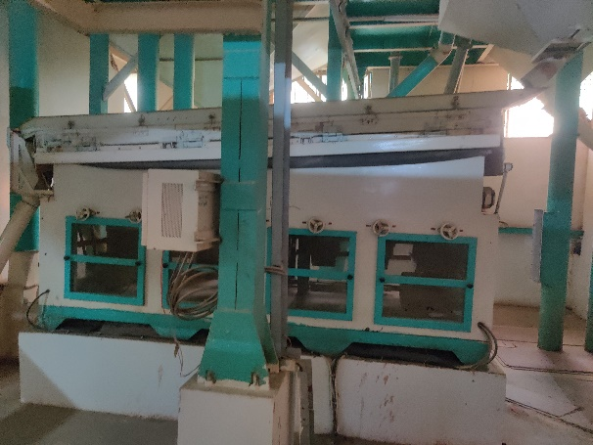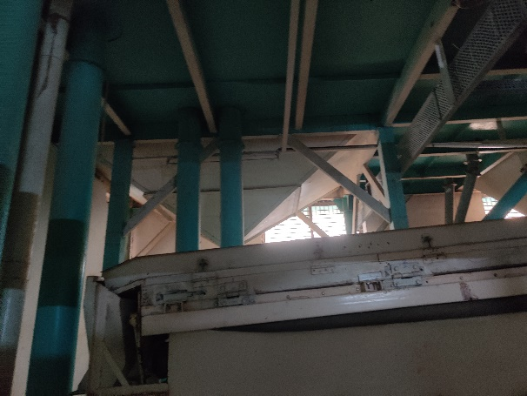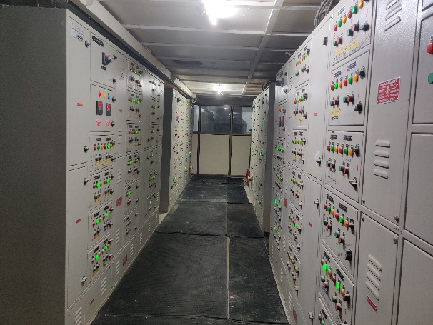

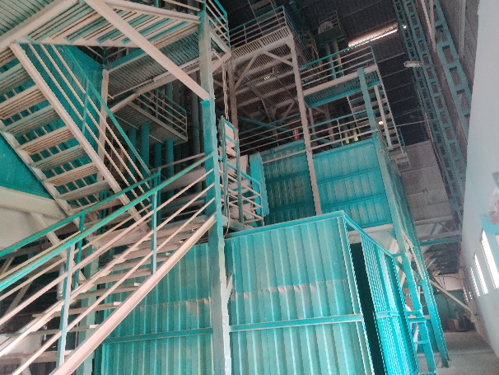

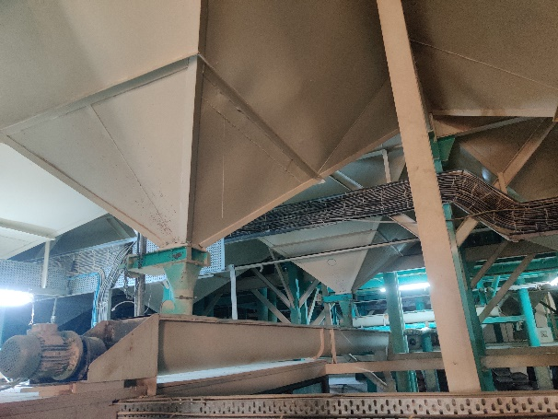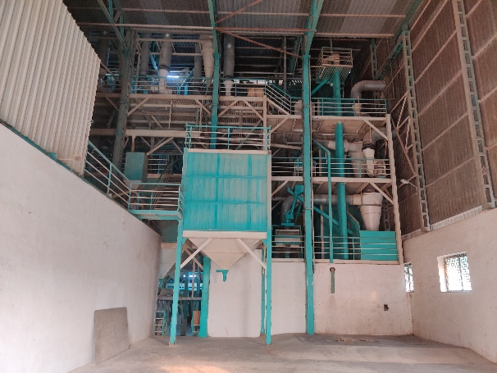

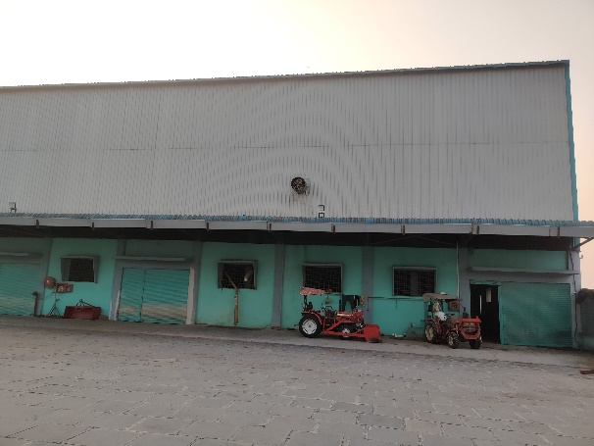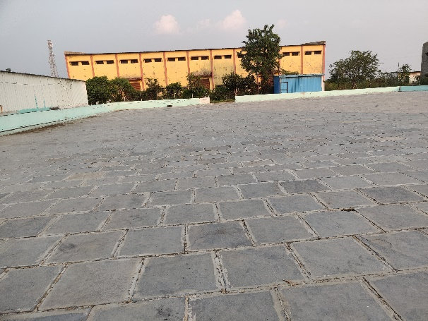

**Actual Site Photographs**

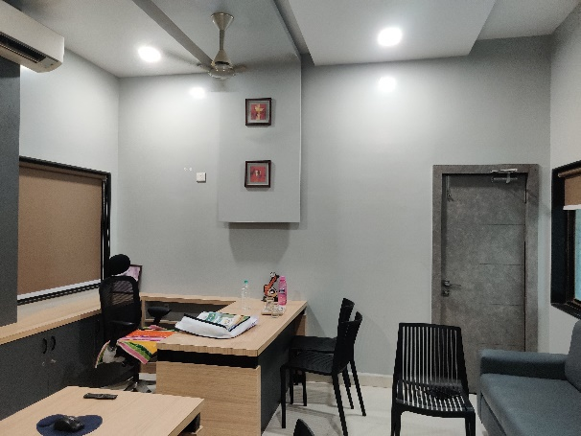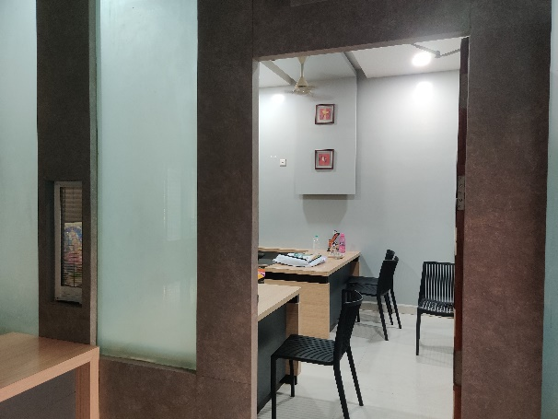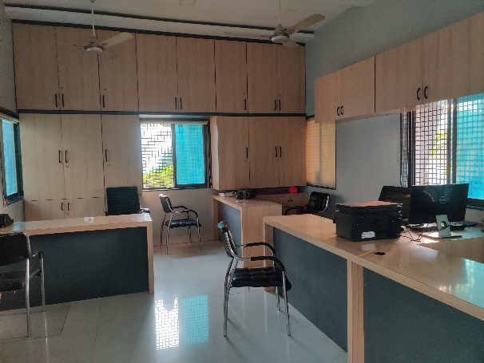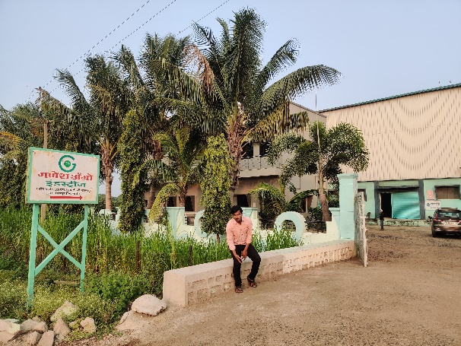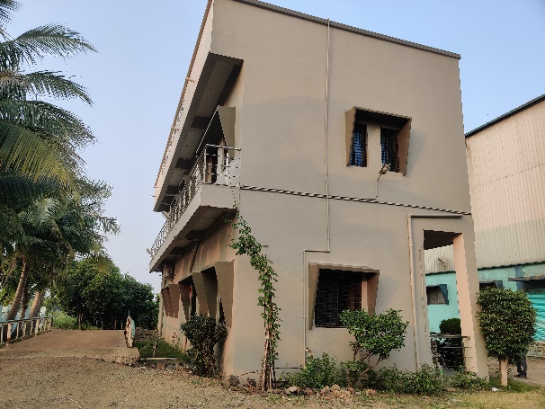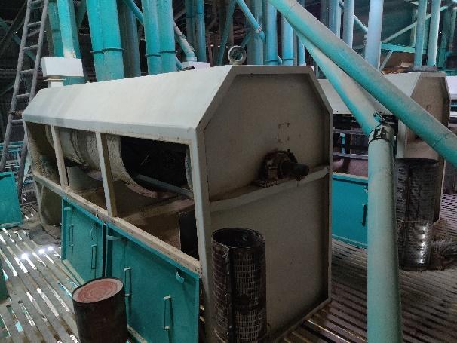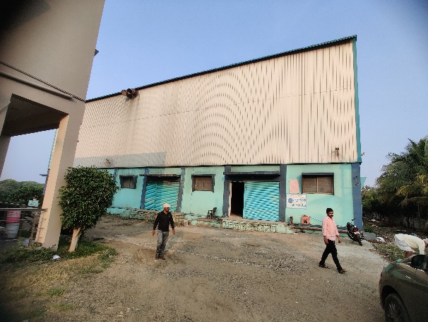

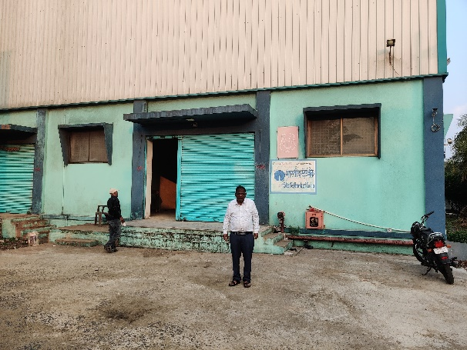

**Route Map of the property**

**Site u/r**

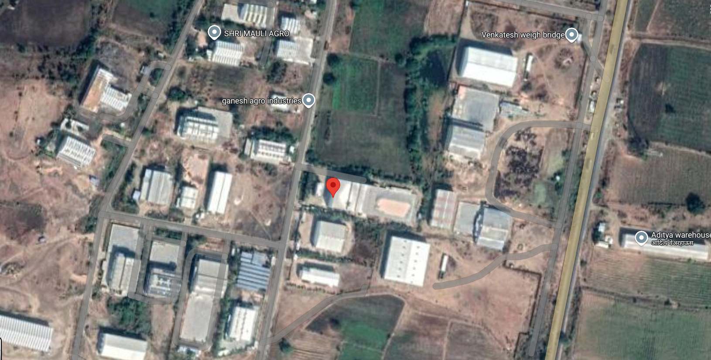

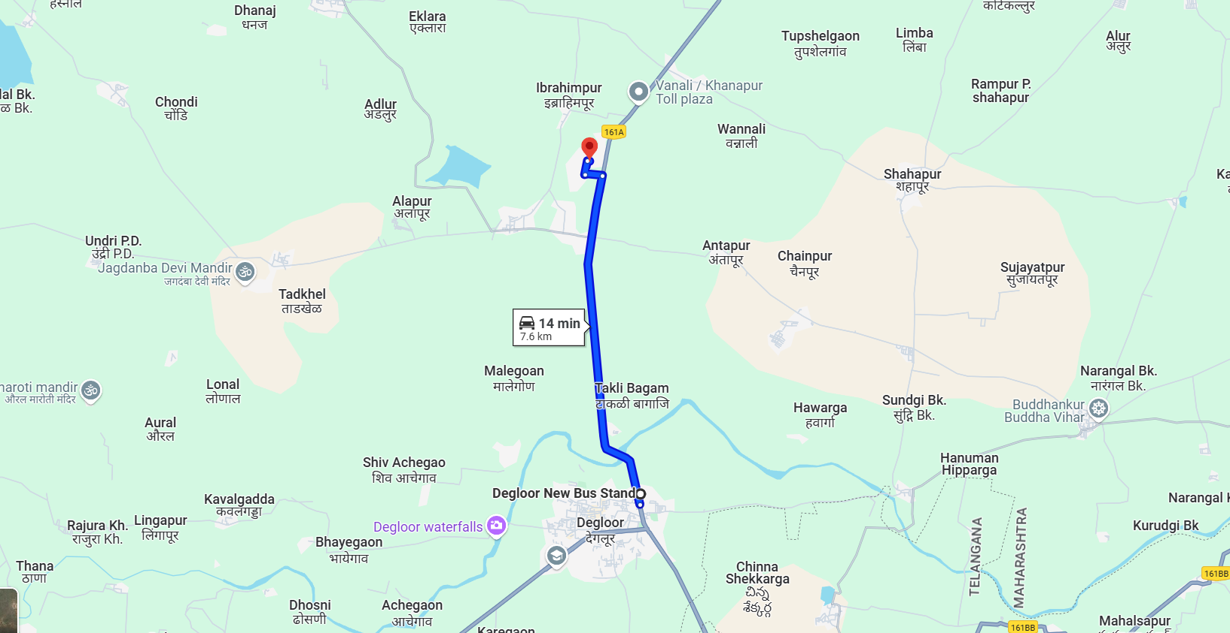

**Latitude Longitude: 18°36'35.5"N 77°34'28.1"E**

Note: The Blue line shows the route to site from nearest Bus Stand (Degloor – 7.6 KM.)

**MIDC MAP**

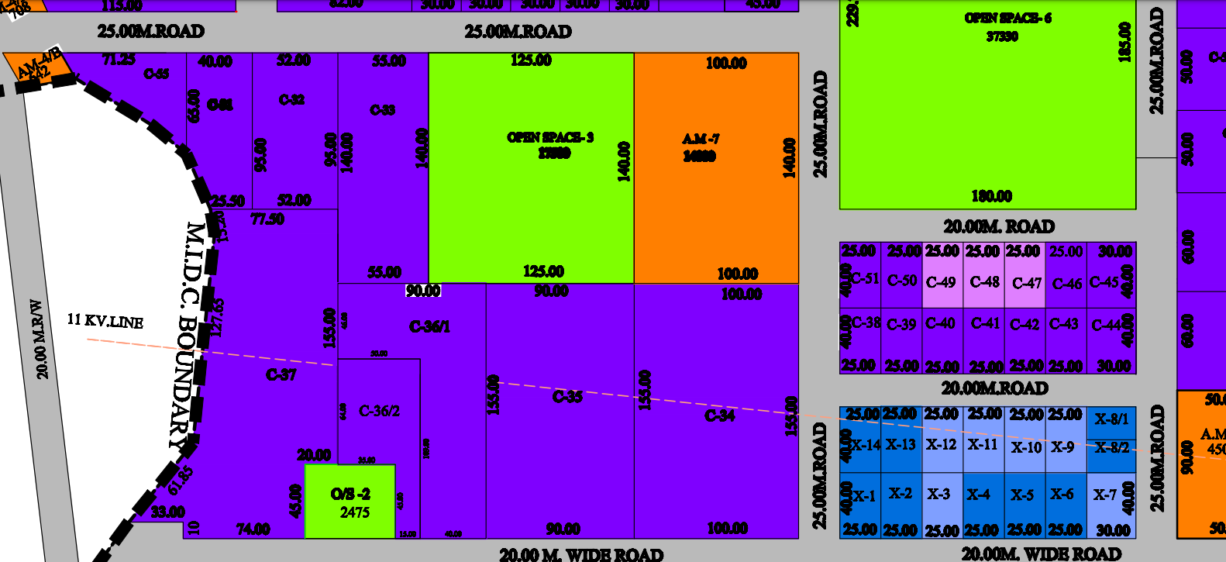

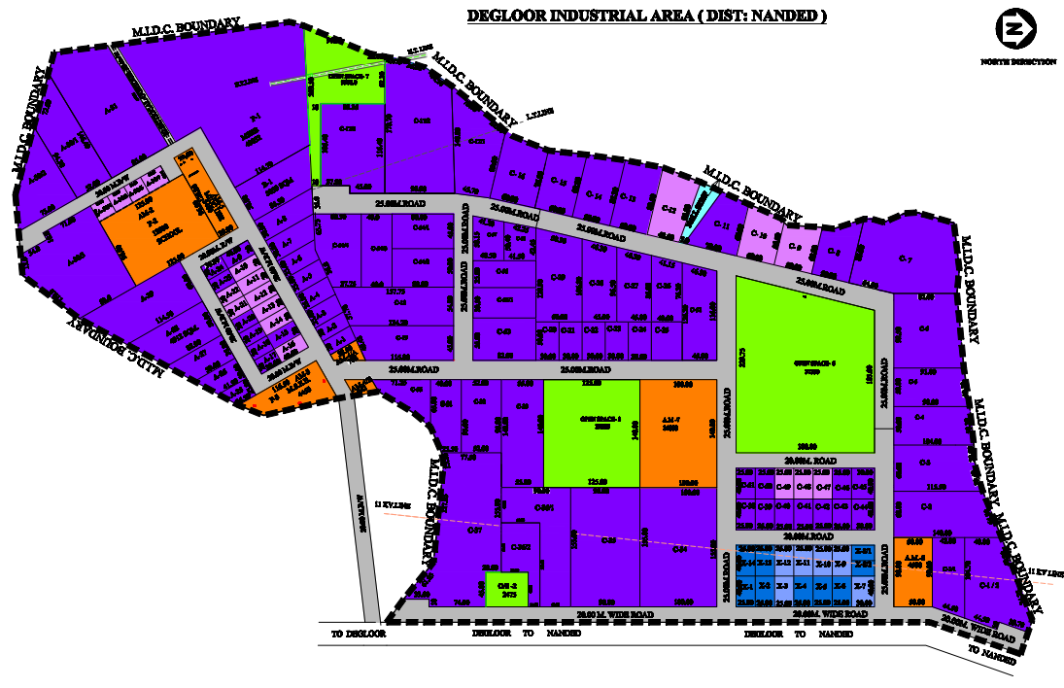

**MIDC CIRCLE RATE**

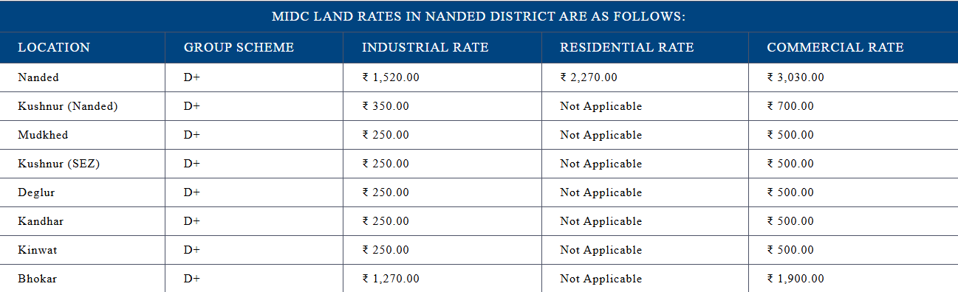

**READY RECKONER RATE**

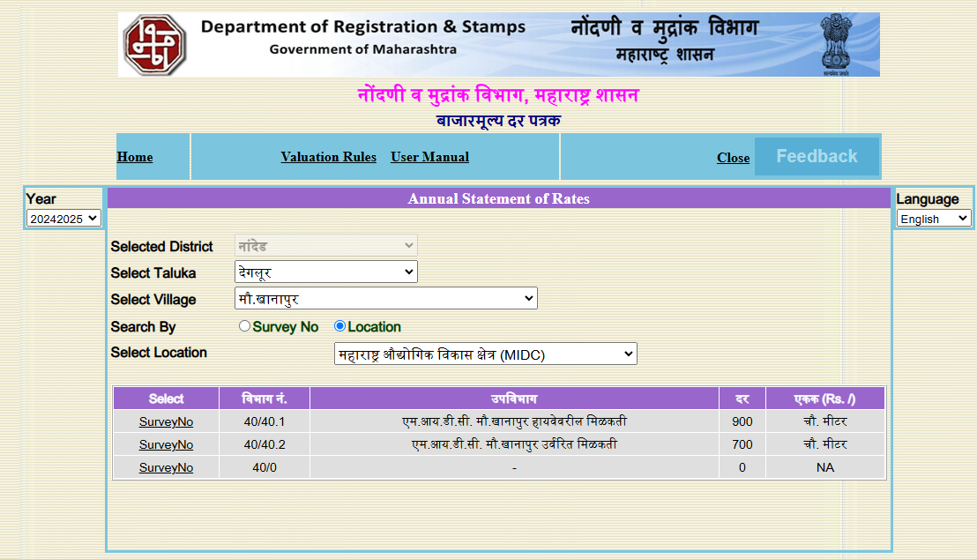

**M.I.D.C. AUCTION RATE**

|  |  |
| --- | --- |
| **Date of Auction** | **May 2022** |
| Kandhar | 1,331/- per Sqm. |
| Krushnoor | 888/- per Sqm. |
| Degloor | 1,368/- per Sqm. |

There is no big size plot in auction in Nanded, MIDC. For small size plot like 16 Sqm. Auction rate ranges from Rs.1500/- to Rs.2000/- before 2 years back.

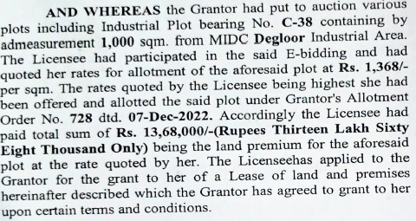

**ASSUMPTIONS, CAVEATS, LIMITATION AND DISCLAIMERS**

1. We assume no responsibility for matters of legal nature affecting the property appraised or the title thereto, nor do we render our opinion as to the title, which is assumed to be good and marketable.
2. The property is valued as though under responsible ownership.
3. It is assumed that the property is free of liens and encumbrances.
4. It is assumed that there are no hidden or unapparent conditions of the subsoil or structure that would render it more or less valuable. No responsibility is assumed for such conditions or for engineering that might be required to discover such factors.
5. The rates for valuation of the property are in accordance with the Govt. approved rates and prevailing market rates

For, **Vastukala Consultants (I) Pvt. Ltd.**

**Sharadkumar B. Chalikwar**

B.E. (Civil), M.E. (Civil), M.Sc. (Real Estate Valuation), M.Sc. (P&M Valuation), FIE (I), FIV, FIWRS

Chairman & Managing Director

Govt. Reg. Valuer

Chartered Engineer (India)

Reg. No. (N) CCIT/1-14/52/2008-09

IBBI Reg.No. IBBI/RV/07/2019/11744

Date: 09.12.2024

Place: Nanded.