**Valuation Report of the Immovable Property**

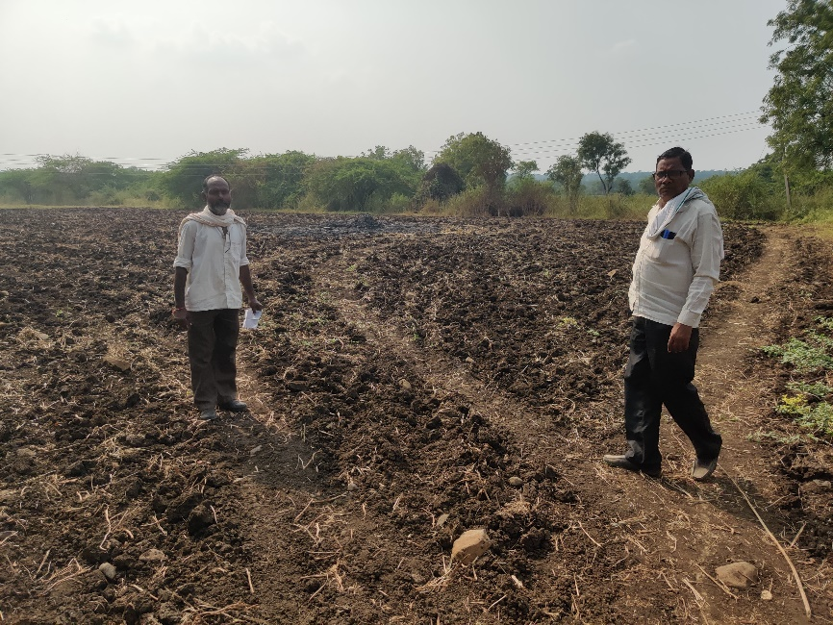

## Details of the property under consideration:

## Name of Owner:

## Mr. Ganesh S/o Venkatrao Achintalwar, Mr. Pravin S/o Venkatrao Achintalwar & Mr. Raju S/o Venkatrao Achintalwar

## Gut No.367, Opp. To Unit – 2, Venkateshwara Dall Industries, Degloor Karadkhed Road, Mouje – Karadkhed, Taluka – Degloor,

## District – Nanded, Maharashtra, India.

**Longitude Latitude: 18.487684, 77.503117**

# Intended User:

# Axis Bank

Nanded Main Branch

Nikhil Heights, Vazirabad Bus Stand Road, Kalamandir, Nanded,

PIN Code – 431601, Maharashtra, India

Vastu/Nanded/12/2024/012121/2309473

09/9-171-SKAS

Date: 09.12.2024

# VALUER’S OPINION REPORT

This is to certify that the property situated on Gut No.367, Opp. To Unit – 2, Venkateshwara Dall Industries, Degloor Karadkhed Road, Mouje – Karadkhed, Taluka – Degloor, District – Nanded, Maharashtra, India belongs to **Mr. Ganesh S/o Venkatrao Achintalwar, Mr. Pravin S/o Venkatrao Achintalwar & Mr. Raju S/o Venkatrao Achintalwar.**

|  |  |  |
| --- | --- | --- |
| **Boundaries of the property.** |  |  |
| On or towards the North by | : | Gut No. 369 |
| On or towards the South by | : | Gut No. 368 |
| On or towards the East by | : | Gut No. 365 |
| On or towards the West by | : | Gut No. 366 |

Considering various parameters recorded, existing economic scenario, and the information that is available with reference to the development of neighborhood and method selected for valuation, we are of the opinion that, the property premises can be assessed are as under:

|  |  |
| --- | --- |
| **Guideline Value of the Property** | **Rs. 7,17,692.00** |
| **Fair Market Value of the Property** | **Rs. 58,00,000.00** |
| **Realizable Value of the Property** | **Rs. 52,20,000.00** |
| **Forced/ Distress Sale value of the Property** | **Rs. 46,40,000.00** |

The valuation of the property is based on the documents produced by the concern. Legal aspects have not been taken into considerations while preparing this valuation report.

Hence certified

**Sharadkumar B. Chalikwar Nagendra Kalegore**

B.E. (Civil), M.E. (Civil), M.Sc. (Real Estate Valuation), M.Sc (Agri)

M.Sc. (P&M Valuation), FIE (I), FIV, FIWRS Ex. Professor & Agriculture Valuer

Chairman & Managing Director PVAI Reg. No. LM-3459

Govt. Reg. Valuer

Chartered Engineer (India)

Reg. No. (N) CCIT/1-14/52/2008-09

IBBI Reg. No. IBBI/RV/07/2019/11744

Encl: Valuation report.

## VALUATION REPORT (IN RESPECT OF AGRICULTURE LAND)

|  |  |  |  |  |  |  |  |  |  |  |  |  |  |  |  |  |  |  |  |  |  |  |  |  |  |  |  |  |  |  |  |  |  |  |  |  |  |
| --- | --- | --- | --- | --- | --- | --- | --- | --- | --- | --- | --- | --- | --- | --- | --- | --- | --- | --- | --- | --- | --- | --- | --- | --- | --- | --- | --- | --- | --- | --- | --- | --- | --- | --- | --- | --- | --- |
| 1. | **CBB/CCMC/CCSU** | | | | |  | | | | | | | | **Request No** | | | | | | | | | - | | | | | | | | | | | | | | |
| **Proposal No.** | | | | | | | | | - | | | | | | | | | | | | | | |
|  | Authorization Letter of Bank | | | | | | | | | | | | | Telephonic discussion with Mr. Shivkumar Chandsure, Manager, Axis Bank, Nanded Main Branch dated 19.10.2024.  Email Id: 295942@axisbank.com  Cell # 9145702020 | | | | | | | | | | | | | | | | | | | | | | | |
| 2. | Name of Owner & Address: | | | | | | | | | | | | | **Mr. Ganesh S/o Venkatrao Achintalwar.**  R/o. Laine Galli, Shivaji Chowk, Tq. Degloor, Dist. Hingoli.  Cell # 9422185107  **Mr. Pravin S/o Venkatrao Achintalwar.**  R/o. Laine Galli, Shivaji Chowk, Tq. Degloor, Dist. Hingoli.  Cell # 9503468080  **Mr. Raju S/o Venkatrao Achintalwar.**  R/o. Laine Galli, Shivaji Chowk, Tq. Degloor, Dist. Hingoli.  Cell # 9168204105  Joint Ownership  (Details of ownership share not available) | | | | | | | | | | | | | | | | | | | | | | | |
| Name of Borrower & Address | | | | | | | | | | | | | **Mr. Ganesh S/o Venkatrao Achintalwar.**  R/o. Laine Galli, Shivaji Chowk, Tq. Degloor, Dist. Hingoli.  Cell # 9422185107  **Mr. Pravin S/o Venkatrao Achintalwar.**  R/o. Laine Galli, Shivaji Chowk, Tq. Degloor, Dist. Hingoli.  Cell # 9503468080  **Mr. Raju S/o Venkatrao Achintalwar.**  R/o. Laine Galli, Shivaji Chowk, Tq. Degloor, Dist. Hingoli.  Cell # 9168204105  Joint Ownership  (Details of ownership share not available) | | | | | | | | | | | | | | | | | | | | | | | |
| 3. | Name of the Bank Official Present | | | | | | | | | | | | | No. | | | | | | | | | | | | | | | | | | | | | | | |
| Name of the Representative & Mobile No. | | | | | | | | | | | | | 1. Siddappa  (Owner’s Representative)  Mob. # 9949044561  2. Md Shareq Salim  (Technical Assistant)  Mob. # 7020555018 | | | | | | | | | | | | | | | | | | | | | | | |
| **4.** | **Details of the Property Being Valued** | | | | | | | | | | | | | | | | | | | | | | | | | | | | | | | | | | | | |
| 4.1 | Description of the Property | | | | | | | | | | | | | * The Subject Property under valuation is Freehold Gut No.367, Opp. To Unit – 2, Venkateshwara Dall Industries, Degloor Karadkhed Road, Mouje – Karadkhed, Taluka – Degloor, District – Nanded, Maharashtra, India. * Land area as per 7/12 Extract & As per Mortgaged Deed is 1.16 Ha. Same is considered for valuation. * Property is not SARFAESI compliant. | | | | | | | | | | | | | | | | | | | | | | | |
| 4.2 | Location of Property | | | | | | | | | | | | | Gut No.367, Opp. To Unit – 2, Venkateshwara Dall Industries, Degloor Karadkhed Road, Mouje – Karadkhed, Taluka – Degloor, District – Nanded, Maharashtra, India. | | | | | | | | | | | | | | | | | | | | | | | |
| (Rural / Semi Urban / Urban) | | | | | | | | | | | | | Rural | | | | | | | | | | | | | | | | | | | | | | | |
| 4.3 | Documents Provided: | | | | | | | | | | | | | | | | | | | | | | | | | | | | | | | | | | | | |
| 1 | | Photo Copy of Digitally Signed 7/12 Extract of Gat No. 367, dated 22.12.2024 | | | | | | | | | | | | | | | | | | | | | | | | | | | | | | | | | | |
| 2 | | Photo Copy of Mortgaged Deed No. 952/2020, dated 26.06.2020 issued by Sub – Registrar, Degloor – 2. | | | | | | | | | | | | | | | | | | | | | | | | | | | | | | | | | | |
| 3 | | Photo Copy of Valuation Report prepared by Ar. Achyut P. Mahajan, Nanded, dated 22.11.2021. | | | | | | | | | | | | | | | | | | | | | | | | | | | | | | | | | | |
| 4.4 | Plot No / Survey No. / Gut No. / Khasra No: | | | | | | Gut No.367, Opp. To Unit – 2, Venkateshwara Dall Industries, Degloor Karadkhed Road, Mouje – Karadkhed, Taluka – Degloor, District – Nanded, Maharashtra, India. | | | | | | | | | | | | | | | | | | | | | | | | | | | | | | |
| Road | | | | | | Degloor Karadkhed Road | | | | | | | | | | | | | | | | | | | | | | | | | | | | | | |
| 4.5 | Colony / Nagar / Sector | | | | | | Karadkhed | | | | | | | | | | | | | Locality / Landmark | | | | | | | Venkateshwara Dall Industries | | | | | | | | | | |
| 4.6 | Village/Town/City | | | | | | Degloor | | | | | | | | | | | | | District: | | | | | | | Nanded | | | | | | | | | | |
| 4.7 | State | | | | | | Maharashtra | | | | | | | | | | | | | Pin code: | | | | | | | 431718 | | | | | | | | | | |
| 4.8 | Distance from Area Office | | | | | | | | | | | | | | | | | | | @ 92.9 Km. from Nanded Branch to Degloor | | | | | | | | | | | | | | | | | |
| **5.** | **Type of Property** | | | | | | | | | | | | | | | | | | | | | | | | | | | | | | | | | | | | |
|  | **(A) Plot:** (Residential / Commercial / Industrial) | | | | | | | | | | | | | | | | | | | | | | | Agricultural Land | | | | | | | | | | | | | |
| Level of land with topographical conditions | | | | | | | | | | | | | | | | | | | | | | | Perennial | | | | | | | | | | | | | |
| Whether situated in Municipal / Corporation Limit | | | | | | | | | | | | | | | | | | | | | | | Village Panchayat. | | | | | | | | | | | | | |
| Any construction observed on plot | | | | | | | | | | | | | | | | | | | | | | | No. | | | | | | | | | | | | | |
| **(B) Residential Property: (**Independent house / Bungalow / Row House / Flat) | | | | | | | | | | | | | | | | | | | | | | | Agricultural Land | | | | | | | | | | | | | |
| Civic Amenities like school, hospital, market, etc. (Available, within the radius of Km./ Not Available) | | | | | | | | | | | | | | | | | | | | | | | All available nearby. | | | | | | | | | | | | | |
| **(C) Commercial / Industrial Property:** (Office / Shop / Unit in a Mall / Gowdown) | | | | | | | | | | | | | | | | | | | | | | | No. | | | | | | | | | | | | | |
| **6.** | **Accessibility / Boundaries / Others** | | | | | | | | | | | | | | | | | | | | | | | | | | | | | | | | | | | | |
| 6.1 | | Availability of local transport (Metro / Local Train / Bus / Personal Transport) | | | | | | | | | | | | | | | | | | | | | | | Local Transport, Bus Stand, Personal Transport | | | | | | | | | | | |
| 6.2 | | Distance from Nanded Railway station @ 92.9 Km | | | | | | | | | | | | | | | | | | | | | | | Bus stop/ Taxi/ Auto Stand @ 1.5 Km | | | | | | | | | | | |
| 6.3 | | Does the approach road to the Property / Building is independent and accessible | | | | | | | | | | | | | | | | Yes | | | | | | | Will it be able to accommodate a fire extinguisher | | | | | | | | | | | No. |
| 6.4 | | Does the property falls under land locked  area | | | | | | | | | | | | | | | | No | | | | | | | Does the property falls in a community  dominated area | | | | | | | | | | | No. |
| 6.5 | | Cornered / Intermittent Plot | | | | | | | | | | | | | | | | | | | | | | | Intermittent | | | | | | | | | | | |
| **6.6** | | **Gut No.367** | | | | | | | | | | | | | | | | | | | | | | | | | | | | | | | | | | |
|  | | Boundaries | | | As Per Site | | | | | | | | | | | | | | | | | | | | As Per Documents | | | | | | | | | | | |
| North | | | Gut No. 369 | | | | | | | | | | | | | | | | | | | | Gut No. 369 | | | | | | | | | | | |
| South | | | Gut No. 368 | | | | | | | | | | | | | | | | | | | | Gut No. 368 | | | | | | | | | | | |
| East | | | Gut No. 365 | | | | | | | | | | | | | | | | | | | | Gut No. 365 | | | | | | | | | | | |
| West | | | Gut No. 366 | | | | | | | | | | | | | | | | | | | | Gut No. 366 | | | | | | | | | | | |
| 6.7 | | Class of locality (Posh / Higher Middle Class / Middle Class / Lower Middle Class / Poor) | | | | | | | | | | | | | | | | | | | | | | | Middle Class | | | | | | | | | | | |
| 6.8 | | Quality of Infrastructure in the vicinity (Excellent / Good / Average / Poor) | | | | | | | | | | | | | | | | | | | | | | | No infrastructure developed. | | | | | | | | | | | |
| 6.9 | | Ownership Status of the Property (Free Hold / Reg. Lease / Govt. Authority) | | | | | | | | | | | | | | | | | | | | | | | Freehold. | | | | | | | | | | | |
| 6.10 | | Approved usage of property (Industrial / Commercial / Residential / Mix) | | | | | | | | | | | | | Agricultural Land | | | | | | | | | | Actual usage of property (Industrial / Commercial / Residential / Mix) | | | | | | | | Agricultural Land | | | |
| 6.11 | | Restrictive covenants in regards to Land Use, (if any) | | | | | | | | | | | | | | | | | | | | | | | Agricultural Land | | | | | | | | | | | |
| 6.12 | | Type of Structure (Load Bearing / RCC / Aluform shuttering) | | | | | | | | | | | | | | | | | | | | | | | Not applicable being open plot | | | | | | | | | | | |
| 6.13 | | Number of floors | | | | | | | | | | | | | | | | | | | | | | | Not applicable being open plot | | | | | | | | | | | |
| 6.14 | | Occupancy Details (Self-Occupied / Rented / Vacant) | | | | | | | | | | | | | | | | | | | | | | | Not applicable being open plot | | | | | | | | | | | |
| **7.** | | **If the property is on rent:** | | | | | | | | | | | | | | | | | | | | | | | | | | | | | | | | | | |
| 7.1 | | Name of tenant / lease & Number of years in tenancy | | | | | | | | | | | | | | | | | | | | | | | Not applicable being open plot | | | | | | | | | | | |
| 7.2 | | Was there any resistance for valuation: No | | | | | | | | | | | | | | | | | | | If yes, from the current occupants: N.A. | | | | | | | | | | | | | | | |
| 7.3 | | Does property have basic amenities | | | | | | | | | | No. | | | | | | | | | Development of surrounding area Underdeveloped / Developing / Developed | | | | | | | | | | | | | | Developing. | |
| **8.** | | **If the property is Leasehold** | | | | | | | | | | | | | | | | | | | | | | | | | | | | | | | | | | |
| 8.1 | | Name of Lesser: | | | | | | | N.A. | | | Nature of Lease: | | | | | | | | | | | | | | | | | | | N.A. | | | | | |
| 8.2 | | Total Period of Lease: | | | | | | | N.A. | | | If yes, from the current occupants: | | | | | | | | | | | | | | | | | | | N.A. | | | | | |
| 8.3 | | Does property have basic amenities | | | | | | | No. | | | Development of surrounding area Underdeveloped / Developing / Developed. | | | | | | | | | | | | | | | | | | | Developing | | | | | |
| **9.** | | **Approval Details** | | | | | | | | | | | | | | | | | | | | | | | | | | | | | | | | | | |
| 9.1 | | RERA Registration Number | | | | | | | | | | | | | | | | Not applicable being open plot | | | | | | | | | | | | | | | | | | |
| 9.2 | | Layout Approval Number: | | | | | | | | | | | | | | | | - | | | | | | | | | | | | | | | | | | |
| Date of Approval | | | | | | | | | | | | | | | | - | | | | | | | | | | | | | | | | | | |
| Expiry Date | | | | | | | | | | | | | | | | - | | | | | | | | | | | | | | | | | | |
| 9.3 | | Building Plan Approval Number & Occupancy Certificate | | | | | | | | | | | | | | | | Not applicable being open plot | | | | | | | | | | | | | | | | | | |
| Date of Approval | | | | | | | | | | | | | | | | - | | | | | | | | | | | | | | | | | | |
| Expiry Date | | | | | | | | | | | | | | | | - | | | | | | | | | | | | | | | | | | |
| **10.00** | | **Plot Area Details.** | | | | | | | | | | | | | | | | | | | | | | | | | | | | | | | | | | |
| **10.01** | | **Plot Area** | | | | | | | | | | | | | | | | | | | | | | | | | | | **Area in Ha.** | | | | | | | |
| **10.02** | | **Plot Area As per 7/12 Extract** | | | | | | | | | | | | | | | | | | | | | | | | | | | **1.16 Ha.** | | | | | | | |
|  | | **Total Area as per 7/12 Extract** | | | | | | | | | | | | | | | | | | | | | | | | | | | **1.16 Ha.** | | | | | | | |
| 10.03 | | Demarcation at Site | | | | | | | | | | | | | | | | | | | | | | | | | | | No. | | | | | | | |
| 10.04 | | Plot Area Considered for Valuation | | | | | | | | | | | | | | | | | | | | | | | | | | | **1.16 Ha.** | | | | | | | |
| **10.05** | | **Construction Area Details** | | | | | | | | | | | | | | | | | | | | | | | | | | | Not applicable being open plot | | | | | | | |
| **10.06** | | **Floor wise break up as follows** | | | | | | | | | | | | | | | | | | | | **Current Usage**  (Storage / Parking / Commercial /Residential) | | | | | | | | | | | | | | |
|  | | N.A. | | | | | | | | | | | | | | | | | | | | N.A. | | | | | | | | | | | | | | |
| 10.07 | | Amenities Details (if any): | | | | | | | | | | | | | | | | | | | | Not applicable being open plot | | | | | | | | | | | | | | |
| 10.08 | | FSI Utilized | | | | | | | | | | | | | | | | | | | | Not applicable being open plot | | | | | | | | | | | | | | |
| 10.09 | | Whether the construction is as per approved building plan and / or local building bye laws: | | | | | | | | | | | | | | | | | | | | Not applicable being open plot | | | | | | | | | | | | | | |
| 10.10 | | Details of Extra Construction | | | | | | | | | | | | | | | | | | | | Not applicable being open plot | | | | | | | | | | | | | | |
| 10.11 | | Percentage of Extra Construction | | | | | | | | | | | | | | | | | | | | Not applicable being open plot | | | | | | | | | | | | | | |
| 10.12 | | Whether the extra construction is Compoundable OR Non-Compoundable? | | | | | | | | | | | | | | | | | | | | Not applicable being open plot | | | | | | | | | | | | | | |
| 10.13 | | Quality of construction | | | | | | | | | | | | | | | | | | | | Not applicable being open plot | | | | | | | | | | | | | | |
| 10.14 | | Maintenance of the Property | | | | | | | | | | | | | | | | | | | | Not applicable being open plot | | | | | | | | | | | | | | |
| 10.15 | | Condition of Building | | | | | | | | | | | | | | | | | | | | Not applicable being open plot | | | | | | | | | | | | | | |
| 10.16 | | Current Life of the structure | | | | | | | | Not applicable being open plot | | | | | | Projected Future Life of the Structure | | | | | | | | | | | Not applicable being open plot | | | | | | | | | |
| 10.17 | | Land Revenue / Taxes Paid upto (for Land) | | | | | | | | Not applicable being open plot | | | | | | Municipal Taxes Paid up to (for Building) | | | | | | | | | | | Not applicable being open plot | | | | | | | | | |
| **11.** | | **Details of Valuation:** | | | | | | | | | | | | | | | | | | | | | | | | | | | | | | | | | | |
|  | | **S.L** | | **Particulars of Item** | | | | **Plinth / Built up Area In Ha.** | | | | | **Age of Building** | | | | **Estimated Replacement Rate Of Construction** | | | | | | | | | **Replacement cost** | | | | **Depreciation Nil** | | | | **Net Value after Depreciation** | | |
| **Nil** | | | | | | | | | | | | | | | | | | | | | | | | | | | | | | | | | | |
| **12.** | | Details of Amenities | | | | | | | | | | | | | | | | | | | | | | | | | | | | | | | | N.A. | | |
| **13.** | | **Government Guideline value** | | | | | | | | | | | | | | | | | | | | | | | | | | | | | | | | | | |
|  | | **Particulars** | | | | | | | | | **Area in Ha.** | | | | | | | | **Rate in Rs.** | | | | | | | | | | | | | **Value in Rs.** | | | | |
| 1 | | Land | | | | | | | | | 1.16 | | | | | | | | 6,18,700.00 | | | | | | | | | | | | | **7,17,692.00** | | | | |
|  | | **TOTAL** | | | | | | | | | | | | | | | | | | | | | | | | | | | | | | **7,17,692.00** | | | | |
| 14. | | **Market Value of Land** | | | | | | | | | | | | | | | | | | | | | | | | | | | | | | | | | | |
|  | | **Particulars** | | | | | | | | | **Area in Ha.** | | | | | | | | **Rate in Rs.** | | | | | | | | | | | | | **Value in Rs.** | | | | |
| **Land** | | | | | | | | | 1.16 | | | | | | | | 50,00,000.00 | | | | | | | | | | | | | **Rs. 58,00,000.00** | | | | |
| 15. | | **Value of the Property** | | | | | | | | | | | | | | | | | | | | | | | | | | | | | | | | | | |
|  | |  | | | | | | | | | **Land** | | | | | | | | **Building** | | | | | | | | | **Amenities** | | | | **Total** | | | | |
| Government Guideline value | | | | | | | | | **7,17,692.00** | | | | | | | | Nil | | | | | | | | | Nil | | | | **7,17,692.00** | | | | |
| Market Value | | | | | | | | | **58,00,000.00** | | | | | | | | Nil | | | | | | | | | Nil | | | | **Rs. 58,00,000.00** | | | | |
| Realizable Value | | | | | | | | |  | | | | | | | | | | | | | | | | | | | | | **Rs. 52,20,000.00** | | | | |
| Distressed/Forced Sale Value | | | | | | | | |  | | | | | | | | | | | | | | | | | | | | | **Rs. 46,40,000.00** | | | | |
| Insurable Value | | | | | | | | |  | | | | | | | | | | | | | | | | | | | | | **Nil** | | | | |
| **Remarks** | | | | | | | | | | | | | | | | | | | | | | | | | | | | | | | | | | |
| * No infrastructure is developed. | | | | | | | | | | | | | | | | | | | | | | | | | | | | | | | | | | |

### Undertaking:

* 1. I have / our / representative Md. Shareq Salim Md. Jilani Pasha (Technical Assistant) has inspected the subject property on 23.10.2024 along with Owner's Representative Mr.Siddappa identified the same based on the documents provided.
  2. I/We have no direct or Indirect interest in the property being valued.
  3. The information furnished above is true and correct to my/our knowledge
  4. I/ we have not been dismissed or removed from govt. Service or convicted of an offence connected with any proceedings of income tax act, wealth tax act or gift tax act or have been blacklisted by any bank/ financial institution/ govt. Department/ public sector enterprise/ body corporate etc.
  5. This valuation is prepared without any prejudice or bias to any person or institution.
  6. The value of land is taken into account by making due enquires in the locality and ascertaining the sales value of the properties in the locality.
  7. Any additions/alterations made to the property after the date of valuations shall not fall under the scope of this report.

## For, Vastukala Consultants (I) Pvt. Ltd.

**Sharadkumar B. Chalikwar Nagendra Kalegore**

B.E. (Civil), M.E. (Civil), M.Sc. (Real Estate Valuation), M.Sc (Agri)

M.Sc. (P&M Valuation), FIE (I), FIV, FIWRS Ex. Professor & Agriculture Valuer

Chairman & Managing Director PVAI Reg. No. LM-3459

Govt. Reg. Valuer

Chartered Engineer (India)

Reg. No. (N) CCIT/1-14/52/2008-09

IBBI Reg. No. IBBI/RV/07/2019/11744

Date: 09.12.2024

|  |  |  |
| --- | --- | --- |
| **Attachments** | | |
| Photographs of the Property from inside & outside | : | Attached |
| Location sketch for the property: | : | Attached |
| Geo Tagging | : | Attached |
| Topography | : | Leveled Land |
| Government Value Document | : | Attached |

**Actual Site Photographs**

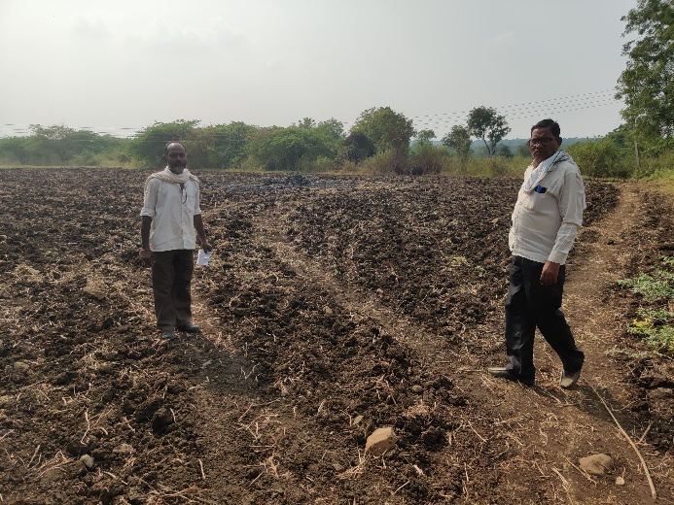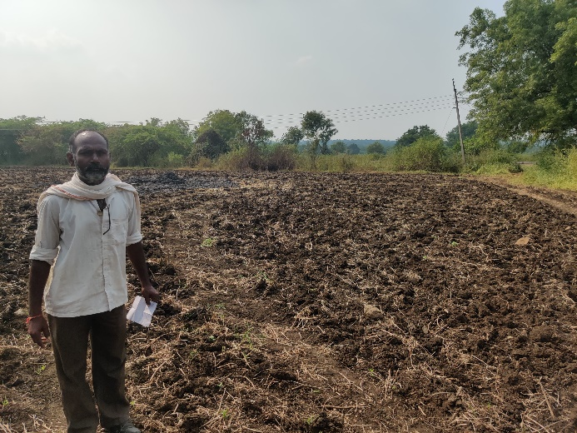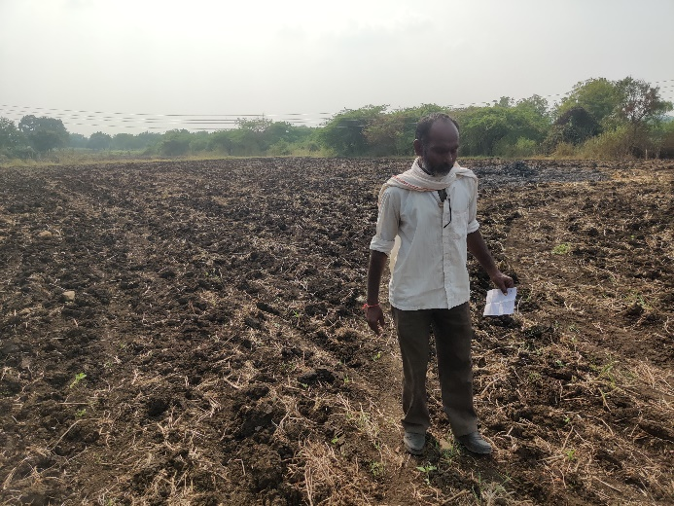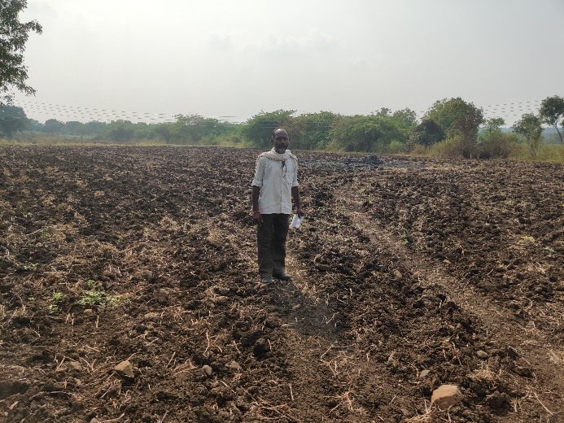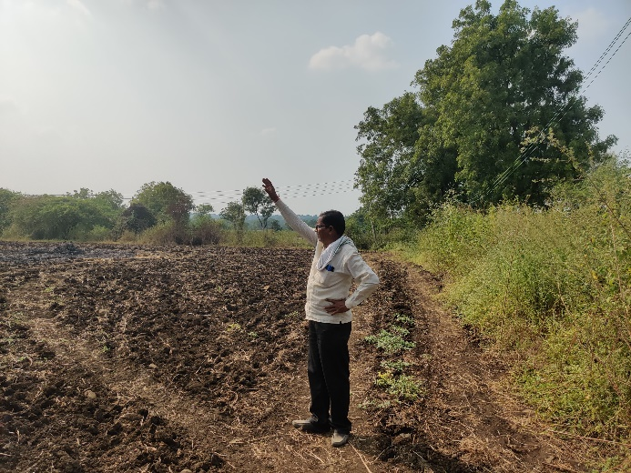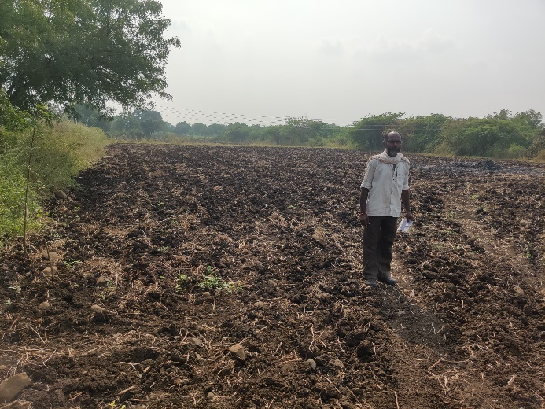

**Route Map of the Property**

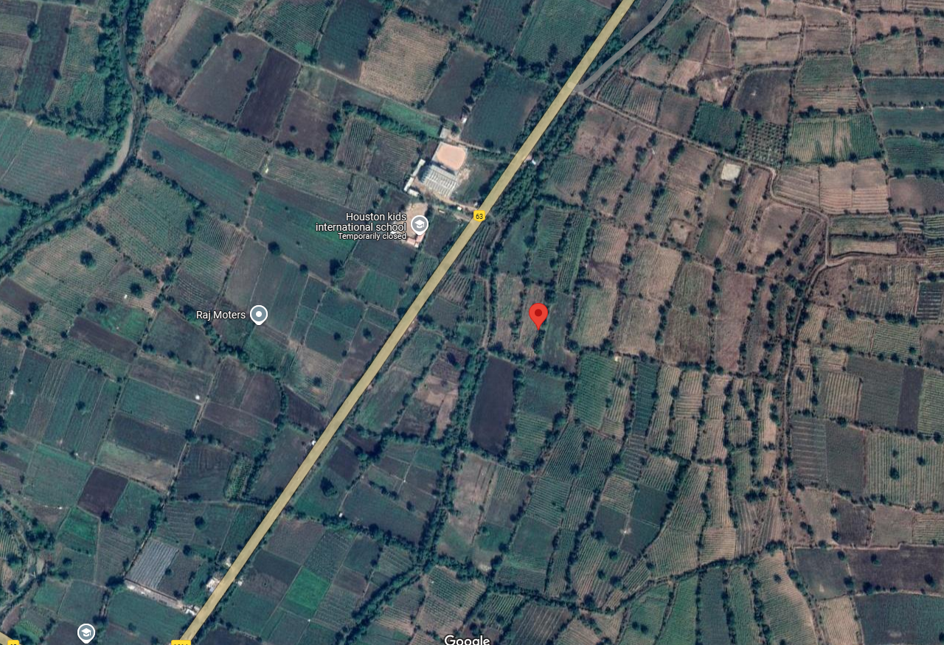

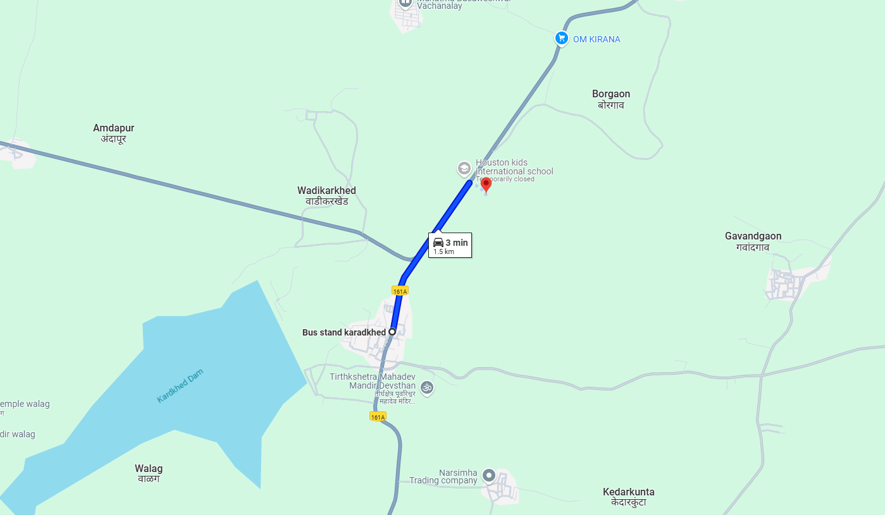

### Longitude Latitude: 18.487684, 77.503117

**Note**:

* Red Pointer shows Approx. Property Location.
* Blue line shows Route from Karadkhed Bus Stand @ 1.5 Km.

**Ready Reckoner Rate**

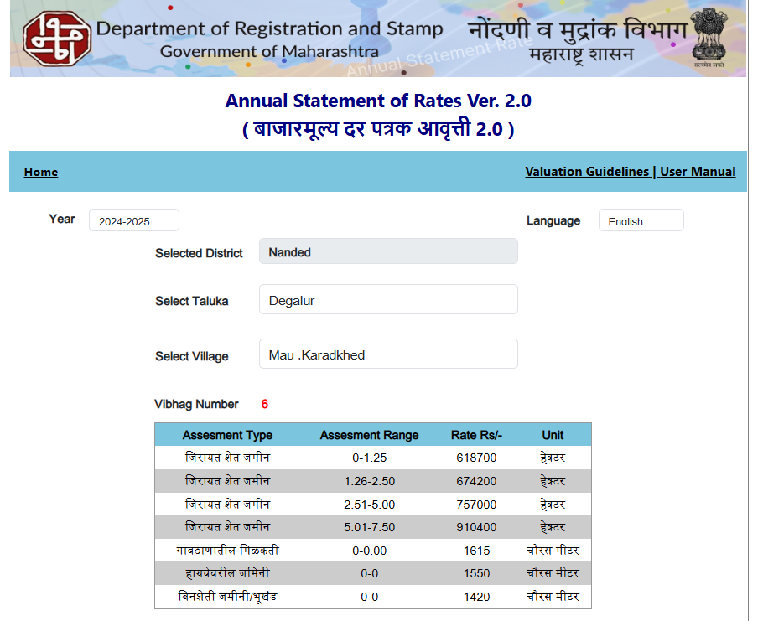

**Price Indicators**

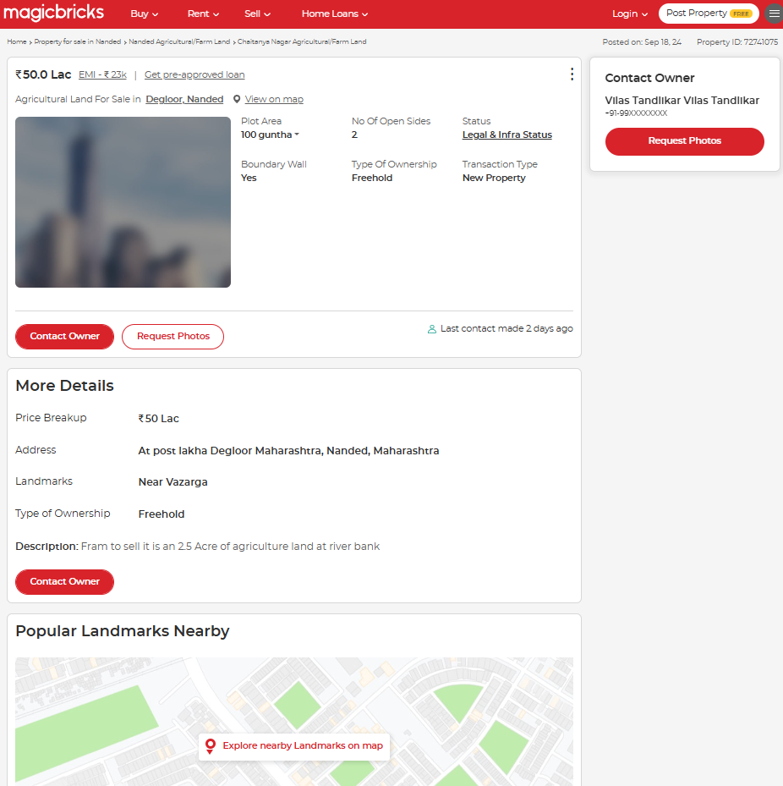

**Price Indicators**

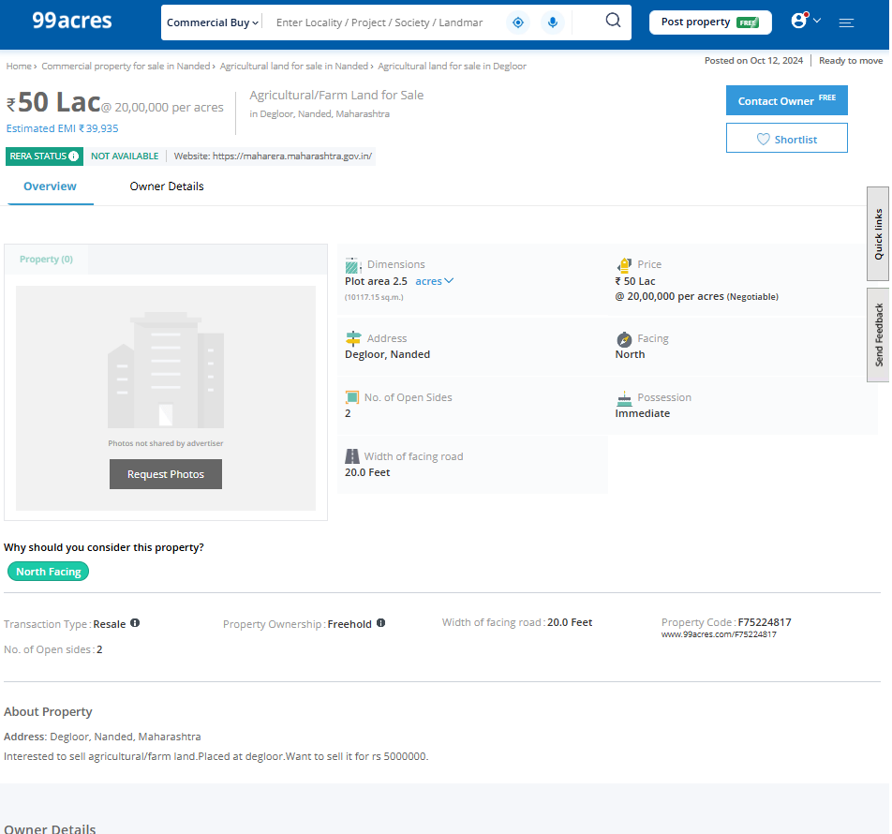

**ASSUMPTIONS, CAVEATS, LIMITATION AND DISCLAIMERS**

1. We assume no responsibility for matters of legal nature affecting the property appraised or the title thereto, nor do we render our opinion as to the title, which is assumed to be good and marketable.
2. The property is valued as though under responsible ownership.
3. It is assumed that the property is free of liens and encumbrances.
4. It is assumed that there are no hidden or unapparent conditions of the subsoil or structure that would render it more or less valuable. No responsibility is assumed for such conditions or for engineering that might be required to discover such factors.
5. The rates for valuation of the property are in accordance with the Govt. approved rates and prevailing market rates

## For, Vastukala Consultants (I) Pvt. Ltd.

**Sharadkumar B. Chalikwar Nagendra Kalegore**

B.E. (Civil), M.E. (Civil), M.Sc. (Real Estate Valuation), M.Sc (Agri)

M.Sc. (P&M Valuation), FIE (I), FIV, FIWRS Ex. Professor & Agriculture Valuer

Chairman & Managing Director PVAI Reg. No. LM-3459

Govt. Reg. Valuer

Chartered Engineer (India)

Reg. No. (N) CCIT/1-14/52/2008-09

IBBI Reg. No. IBBI/RV/07/2019/11744

Date: 09.12.2024

Place: Nanded.