**Valuation Report of the Immovable Property**

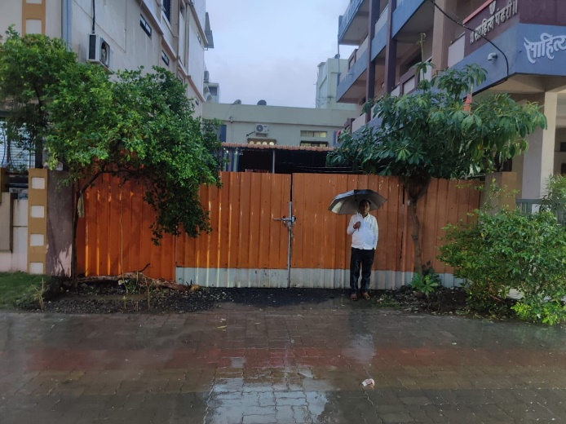

**Details of the property under consideration:**

Name of Client: **Shri. Suryakant Digambar Gutte & Smt. Shakuntla Suryakant Gutte**

Open Land Bering on Plot No. 45 (West Side Part), Gut No. 7/A/2, M.H. Pin No. 40101110003, Deep Nagar, Behind BSNL Office, Jangamwadi, Taluka & District – Nanded, PIN – 431 710,

State – Maharashtra, Country – India.

**Latitude: 19.184471, Longitude: 77.297512**

**Intended User for:**

**THE AKOLA URBAN CO-OPERATIVE BANK LTD.**

**Br. Nanded.**

Vastu/AUCB/10/2024/12114/2308887

28/6-427-BHA Date: 26.10.2024

**VALUER’S OPINION REPORT**

**Address of the Property:** Open Land Bering on Plot No. 45 (West Side Part), Gut No. 7/A/2, M.H. Pin No. 40101110003, Deep Nagar, Behind BSNL Office, Jangamwadi, Taluka & District – Nanded, PIN – 431 710, State – Maharashtra, Country – India.

Name of Client: **Shri. Suryakant Digambar Gutte & Smt. Shakuntla Suryakant Gutte.**

|  |  |  |
| --- | --- | --- |
| Boundaries of the property | | |
| North | : | 30 Feet wide Road | |
| South | : | House of Mr. Madhavrao Wamanrao Powde | |
| East | : | Remaining Part of plot No.45 of Mr. Govindraj Suryakant Gutte | |
| West | : | Remaining Part of plot No. 45 | |

Considering various parameters recorded, existing economic scenario, and the information that is available with reference to the development of neighbourhood and method selected for valuation, we are of the opinion that, the property premises can be assessed and valued for banking purpose is as under.

|  |  |
| --- | --- |
| **Guideline value of the property.** | **Rs. 26,05,500.00** |
| **Fair Market value of the property** | **Rs. 1,05,00,000.00** |
| **Realizable Value of the property.** | **Rs. 94,50,000.00** |
| **Distress / Forced Sale Value of the property.** | **Rs. 84,00,000.00** |

The valuation of the property is based on the documents produced by the concern. Legal aspects have not been taken into considerations while preparing this report.

Hence certified.

For, **Vastukala Consultants (I) Pvt. Ltd.**

**Sharadkumar B. Chalikwar**

B.E. (Civil), M.E. (Civil), M.Sc. (Real Estate Valuation), M.Sc. (P&M Valuation), FIE (I), FIV, FIWRS

Chairman & Managing Director

Govt. Reg. Valuer

Chartered Engineer (India)

Reg. No. (N) CCIT/1-14/52/2008-09

IBBI Reg.No. IBBI/RV/07/2019/11744

Encl.: Valuation report

**Valuation Report of Immovable Property**

|  |  |  |  |  |  |  |  |  |  |  |  |  |  |  |  |  |  |  |  |  |  |  |  |  |  |  |  |  |  |
| --- | --- | --- | --- | --- | --- | --- | --- | --- | --- | --- | --- | --- | --- | --- | --- | --- | --- | --- | --- | --- | --- | --- | --- | --- | --- | --- | --- | --- | --- |
| **1.00** | **Customer Details** | | | | | | | | | | | | | | | | | | | | | | | | | | | | |
| 1.01 | Name(s) of the Customer. | | | | | | | | | | | | **Shri. Suryakant Digambar Gutte & Smt. Shakuntla Suryakant Gutte**  R/O: Nandkishor Nagar, Purna road, Dist. Nanded.  **Cell No.** 9423614721 | | | | | | | | | | | | | | | | |
| 1.02 | Name(s) of the Owners | | | | | | | | | | | | **Shri. Suryakant Digambar Gutte & Smt. Shakuntla Suryakant Gutte**  R/O: At Post. Mondha Tq. Mukhed & Dist. Nanded.  **Cell No.** 9423614721 | | | | | | | | | | | | | | | | |
| 1.03 | Application No./Purpose of valuation | | | | | | | | | | | | **To Assess the Fair Market Value.** | | | | | | | | | | | | | | | | |
| 1.04 | Authorization letter of Bank | | | | | | | | | | | | Telephonic instruction From the Akola Urban Co-op. Bank Ltd., Akola, Br. Nanded, dated 12.02.2024. | | | | | | | | | | | | | | | | |
| 1.05 | Date of Appointment | | | | | | | | | | | | 03.10.2024 | | | | | | | | | | | | | | | | |
| 1.06 | Date of Inspection | | | | | | | | | | | | 05.10.2024 | | | | | | | | | | | | | | | | |
| 1.07 | Date of Report | | | | | | | | | | | | 26.10.2024 | | | | | | | | | | | | | | | | |
| 1.08 | Persons present at the time of Inspection | | | | | | | | | | | | Property inspected in presence of Owner’s Representative  **Cell No.** + 91 75880 86318 | | | | | | | | | | | | | | | | |
| **2** | **Property Details** | | | | | | | | | | | | | | | | | | | | | | | | | | | | |
|  | Address | | | | | | | | | | | | Open Land Bering on Plot No. 45 (West Side Part), Gut No. 7/A/2, M.H. Pin No. 40101110003, Deep Nagar, Behind BSNL Office, Jangamwadi, Taluka & District – Nanded, PIN – 431 710, State – Maharashtra, Country – India | | | | | | | | | | | | | | | | |
| Nearby Landmark / Google Map Independent access to the property | | | | | | | | | | | | * Google Map is attached. | | | | | | | | | | | | | | | | |
| **3** | **Document Details** | | | | | | | | | | | | | | | | | | | | | | | | | | | | |
|  | **Legal Documents:** | | | | | | | | | | | | | | | | | | | | | | | | | | | | |
| 1 | | Photo Copy of Agreement for Sale Dated 30.08.2018 between Shree. Rajaguod P. Vitthalguod Lahukar (Seller) AND Shri. Suryakant Digambar Gutte (East Portion of West Side Part)) | | | | | | | | | | | | | | | | | | | | | | | | | | |
| 2 | | Photo Copy of Agreement for Sale Dated 30.08.2018 between Shree. Rajaguod P. Vitthalguod Lahukar (Seller) AND Smt. Shakuntla Suryankant Gutte (Purchaser) (Balance West Portion of West Side Part) | | | | | | | | | | | | | | | | | | | | | | | | | | |
| 2 | | Photo Copy 7/12 Extract | | | | | | | | | | | | | | | | | | | | | | | | | | |
| **4.00** | **Physical Details** | | | | | | | | | | | | | | | | | | | | | | | | | | | | |
|  | **Adjoining Properties** | | | | | | | **As Per Actual** | | | | | | | | | | | | | | | **As Per Document** | | | | | | |
|  | | | | | | |  | | | | | | | | | | | | | | | Shri. Suryakant Digambar Gutte | | | | | Smt. Shakuntla Suryankant Gutte | |
| **On or towards North** | | | | | | | 30 Feet wide Road | | | | | | | | | | | | | | | 30 Feet wide Road | | | | | 30 Feet wide Road | |
| **On or towards South** | | | | | | | House of Mr. Madhavrao Wamanrao Powde | | | | | | | | | | | | | | | House of Mr. Madhavrao Wamanrao Powde | | | | | House of Mr. Madhavrao Wamanrao Powde | |
| **On or towards East** | | | | | | | Remaining Part of plot No.45 of Mr. Govindraj Suryakant Gutte | | | | | | | | | | | | | | | Remaining Part of plot No.45 of Mr. Govindraj Suryakant Gutte | | | | | Remaining part of Plot No. 45 | |
| **On or towards West** | | | | | | | Remaining Part of plot No. 45 | | | | | | | | | | | | | | | Remaining Part of plot No. 45 | | | | | Plot No. 44 Shri. Gyaneshwar Pandarinath Digode | |
| **Matching of Boundaries** | | | | | | | | | Yes. | | | | | | | | | | | | | | | | | | | |
| **Plot Demarcated** | | | | Yes | | | | **Approved Land use** | | | | | - | | | | | | | **Type of Property** | | | | | - | | | |
| **No. of Rooms** | | | | | | | | | | | | | | | | | | | | | | | | | | | | |
| - | | | | | | - | | | | | | | | | | | | | | | | | | | | | | |
| 4.01 | **Composition of the property** | | | | | | | | | | | | | | | | | | | | | | | | | | | | |
|  | The Subject property under valuation of Plot No. 45 (West Side Part), Gut No. 7/A/2 M.H. Pin No. 40101110003, Deep Nagar, Behind BSNL Office, Jangamwadi, Taluka & District – Nanded, PIN – 431 710, State – Maharashtra, Country – India. | | | | | | | | | | | | | | | | | | | | | | | | | | | | |
| **Sr. No.** | | | **Particulars** | | | | | | | **Plot Size** | | | | | | | | | | | | | | **Plot Area.** | | | | |
| **In Feet** | | | | | | | | | | | | | | **In Sq. Ft.** | | | | |
| **1.** | | | **As per Documents** | | | | | | | 25 Ft. x 60 Ft. | | | | | | | | | | | | | | **1,500.00** | | | | |
|  | **Extent of the site considered for Valuation: 1,500.00 Sq. Ft i.e. 139.00 Sq. Mts.**  **(As per Agreement for sale)** | | | | | | | | | | | | | | | | | | | | | | | | | | | |
| **5** | **Occupancy Details - Tenant(s)** | | | | | | | | | | | | | | | | | | | | | | | | | | | | |
|  | Status of Tenure | | | | | Open Plot | | | | | | Relationship of tenant with owner | | | | | | | | | | | | | | | N.A. | | |
| **6** | **Stage of Construction** | | | | | | | | | | | | | | | | | | | | | | | | | | | | |
|  | Stage of construction | | | | | | | | | | | | | | | | Open Plot | | | | | | | | | | | | |
| **If under construction, extent of completion** | | | | | | | | | | | | | | | | Open Plot | | | | | | | | | | | | |
| **Engineering and Technology Aspects of the Property** | | | | | | | | | | | | | | | | | | | | | | | | | | | | |
| a) | Type of construction | | | | | | | | | | | | | | | Open Plot | | | | | | | | | | | | | |
| b) | Material & technology used | | | | | | | | | | | | | | | Open Plot | | | | | | | | | | | | | |
| **c)** | **Specifications.** | | | | | | | | | | | | | | | | | | | | | | | | | | | | |
| **Sr. No.** | **Description** | | | | | | | | | | | | | | | **Ground Floor** | | | | | | | | | | | | | |
| 1 | Foundation. | | | | | | | | | | | | | | | Open Plot | | | | | | | | | | | | | |
| 2 | Basement. | | | | | | | | | | | | | | | Open Plot | | | | | | | | | | | | | |
| 3 | Superstructure. | | | | | | | | | | | | | | | Open Plot | | | | | | | | | | | | | |
| 4 | Joinery/ Doors & Windows. | | | | | | | | | | | | | | | Open Plot | | | | | | | | | | | | | |
| 5 | RCC work. | | | | | | | | | | | | | | | Open Plot | | | | | | | | | | | | | |
| 6 | Plastering. | | | | | | | | | | | | | | | Open Plot | | | | | | | | | | | | | |
| 7 | Flooring, Skirting. | | | | | | | | | | | | | | | Open Plot | | | | | | | | | | | | | |
| 8 | Kitchen Pantry Platform | | | | | | | | | | | | | | | Open Plot | | | | | | | | | | | | | |
| 9 | Whether any weather proof course is provided. | | | | | | | | | | | | | | | Open Plot | | | | | | | | | | | | | |
| 10 | Drainage. | | | | | | | | | | | | | | | Open Plot | | | | | | | | | | | | | |
| 11 | Compound wall  (Height, length and type of construction). | | | | | | | | | | | | | | | Open Plot | | | | | | | | | | | | | |
| 12 | Electric installation  (Type of wire, Class of fittings) | | | | | | | | | | | | | | | Open Plot | | | | | | | | | | | | | |
| 13 | Plumbing installation  (No. of water closets & wash basins etc.) | | | | | | | | | | | | | | | Open Plot | | | | | | | | | | | | | |
| 14 | Bore well. | | | | | | | | | | | | | | | Open Plot | | | | | | | | | | | | | |
| 15 | Wardrobes, if any. | | | | | | | | | | | | | | | Open Plot | | | | | | | | | | | | | |
| 16 | Development of open area | | | | | | | | | | | | | | | Open Plot | | | | | | | | | | | | | |
| d) | Maintenance issues | | | | | | | | | | | | | | | Open Plot | | | | | | | | | | | | | |
| e) | Age of the building | | | | | | | | | | | | | | | Open Plot | | | | | | | | | | | | | |
| f) | Future life of the building | | | | | | | | | | | | | | | Open Plot | | | | | | | | | | | | | |
| g) | Extent of deterioration | | | | | | | | | | | | | | | Open Plot | | | | | | | | | | | | | |
| h) | Structural safety | | | | | | | | | | | | | | | Open Plot | | | | | | | | | | | | | |
| i) | Protection against natural disaster viz. earthquakes, | | | | | | | | | | | | | | | Open Plot | | | | | | | | | | | | | |
| j) | Visible damage in the building | | | | | | | | | | | | | | | Open Plot | | | | | | | | | | | | | |
| k) | System of air-conditioning | | | | | | | | | | | | | | | Open Plot | | | | | | | | | | | | | |
| l) | Provision of firefighting | | | | | | | | | | | | | | | Open Plot | | | | | | | | | | | | | |
| n) | Copies of the plan and elevation of the building to be included. | | | | | | | | | | | | | | | Open Plot. | | | | | | | | | | | | | |
| **7.00** | **Violations if any observed:** | | | | | | | | | | | | | | | | | | | | | | | | | | | | |
| 7.01 | Nature and extent of violations | | | | | | | | | | | | | | **Refer 4.01** | | | | | | | | | | | | | | |
| **8.00** | **Area Details of the Property** | | | | | | | | | | | | | | **Refer 4.01** | | | | | | | | | | | | | | |
| 8.01 | **Remarks:** | | | | | | | | | | | | | | | | | | | | | | | | | | | | |
|  |  | | | | | | | | | | | | | | | | | | | | | | | | | | | | |
| **9** | **Valuation** | | | | | | | | | | | | | | | | | | | | | | | | | | | | |
|  | i. Mention the land value as per Government Approved Rates also  Guideline rate by Sub-Registrar, RR rate for plot is Zone No. 1.8 Rs**. 1,500.00** per Sq. Ft**. i.e Rs. 1,737.00** per Sq. Ft.  ii. In case of variation of 20% or more in the valuation proposed by the Valuer and Guideline value in the State Govt. notification or Income Tax Gazette justification on variation has to be given.   * Subject property is situated in " Plot No. 45 (West Side Part), Gut No. 7/A/2 M.H. Pin No. 40101110003, Deep Nagar, Behind BSNL Office, Jangamwadi, Taluka & District – Nanded, PIN – 431 710, State – Maharashtra, Country – India There is scarcity of lands in the vicinity. * The Market value of the subject property is based on facts of Market prices, Construction specification, amenities provided, Approach Road, front road width, purpose of Industrial unit, demand & Supply. However Ready Reckoner prices has proclaimed in Guideline by the Government is for stamp duty collection. * As per the Supreme Court judgement (Jawaji Nagnathan vs. REV. DIV Office (1994) SCC – 4 page 595 SC) the Guideline rate is purpose of the collecting Stamp Duty and not the Fair Market Value. * Social Forces, Economic forces, Government / Legal and Physical / Environmental factors influence the value of the Real Estate. * The market rate in the vicinity as per specification & Location is ranging **from Rs. 5,000/- to 8,000/- per Sq. Ft.** * The Cost approach and Market approach method are adopted to arrive the fair market value. * After giving due consideration for various factors influencing the value of the property with respect to physical Legal, Social and Economic aspects, Location, Development in the vicinity, Road Frontage, the Land rate of **Rs. 7,000.00 Per Sq. Ft.** is considered Fair and Reasonable and hence adopted to arrive the Fair Market Value of the Property. | | | | | | | | | | | | | | | | | | | | | | | | | | | | |
|  | | | | | | | | | | | | | | | | | | | | | | | | | | | | |
| 1. **Guideline** Value | | | | | | | | | | | | | | | | | | | | | **Area in Sq. Ft.** | | **Rate in Rs.** | | | | | **Value in Rs.** |
| 1. Land | | | | | | | | | | | | | | | | | | | | | **1,500.00** | | 1,737.00 | | | | | 26,05,500.00 |
| **Total Guideline value.** | | | | | | | | | | | | | | | | | | | | | | | | | | | | **26,05,500.00** |
| **Fair Market Value of the Property** | | | | | | | | | | | | | | | | | | | | | **Area in Sq. Ft.** | | **Rate in Rs.** | | | | | **Value in Rs.** |
| **v. Land** | | | | | | | | | | | | | | | | | | | | | **1,500.00** | | 7,000.00 | | | | | 1,05,00,000.00 |
| **Total Fair Market value** | | | | | | | | | | | | | | | | | | | | | | | | | | | | **1,05,00,000.00** |
| **c. Summary of Value of the property** | | | | | | | | | | | | | | | | | | | | | | | | | | | | |
| **Guideline value of the property.** | | | | | | | | | | | | | | | | | | | **Rs. 26,05,500.00** | | | | | | | | | |
| **Fair Market value of the property** | | | | | | | | | | | | | | | | | | | **Rs. 1,05,00,000.00** | | | | | | | | | |
| **Realizable Value of the property.** | | | | | | | | | | | | | | | | | | | **Rs 94,50,000.00** | | | | | | | | | |
| **Distress / Forced Sale Value of the property.** | | | | | | | | | | | | | | | | | | | **Rs. 84,00,000.00** | | | | | | | | | |
| **10** | **Assumptions /Remarks:** | | | | | | | | | | | | | | | | | | | | | | | | | | | | |
|  | Qualification in TIR / Mitigation Suggested, if any | | | | | | | | | | | | | | | | | | No. | | | | | | | | | | |
| Property is SARFAESI compliant. | | | | | | | | | | | | | | | | | | Yes. | | | | | | | | | | |
| Whether property belongs to social infrastructure like hospital, school, old age home etc. | | | | | | | | | | | | | | | | | | No. | | | | | | | | | | |
| Whether entire piece of land on which the unit is set up/property is situated has been mortgaged or to be mortgaged. | | | | | | | | | | | | | | | | | | Entire property is mortgaged with The Akola Urban Co-operative Bank Ltd. | | | | | | | | | | |
| Details of last two transaction in the locality / area to be provided, if available. | | | | | | | | | | | | | | | | | | Not Available. | | | | | | | | | | |
| 1. Any other aspect which has relevance on the value or marketability of the property. | | | | | | | | | | | | | | | | | | Location, development of surrounding area, and its prevailing market rate. | | | | | | | | | | |
|  | **Declaration** | | | | | | | | | | | | | | | | | | | | | | | | | | | | |
|  | 1. I/ my authorized me / our representative, has inspected the subject property on 05.10.2024 2. The undersigned does not have any direct / indirect interest in the above property. 3. The information furnished herein is true and correct to the best of our knowledge. | | | | | | | | | | | | | | | | | | | | | | | | | | | | |
| **12** | **Name, address & signature of valuer** | | | | | | | | | | | | | | | | | | | | | | | | | | | | |
|  | **Vastukala Consultants (I) Pvt. Ltd.** | | | | | | | | | | | | | | | | | |  | | --- | | For, **Vastukala Consultants (I) Pvt. Ltd.**  **Sharadkumar B. Chalikwar**  B.E.(Civil), M.E.(Civil), M.Sc. (Real Estate Valuation),  M.Sc. (P&M Valuation), FIE(I), FIV, FIWRS  Chairman & Managing Director  Govt. Reg. Valuer  Chartered Engineer (India)  Reg. No. (N) CCIT/1-14/52/2008-09 |   IBBI Reg. No. IBBI/RV/07/2019/11744 | | | | | | | | | | | |
| ***Nanded Office :***  28,SGGS Stadium Complex,  Gokul Nagar, Nanded-431 602.  Email : [sbchalikwar@gmail.com](mailto:sbchalikwar@gmail.com)  nanded@vastukala.org  Web : [www.vastukala.org](http://www.vastukala.org)  Mobile No.: 9422171100  9167204051  Tel.No.+91 2462 244288  Fax No.+91 2462 239909 | | | | | | | | | | | | | | | | |
| ***Regd.Office :***  121, 1st Floor, Ackruti Star, Central Road, MIDC, Andheri (E), Mumbai - 400 093  Email :[Mumbai@vastukala.org](mailto:Mumbai@vastukala.org) | | | | | | | | | | | | | | | | |
| 1. **Date of valuation: 26.10.2024** | | | | | | | | | | | |
| **13** | **Enclosures Documents & Photographs** | | | | | | | | | | | | | | | | | 1. Valuation Report.  2. Satellite Location Map.  3. Location cum Route Map.  4. Ready Reckoner.  5. Photographs of the property. | | | | | | | | | | | |

Actual site photographs

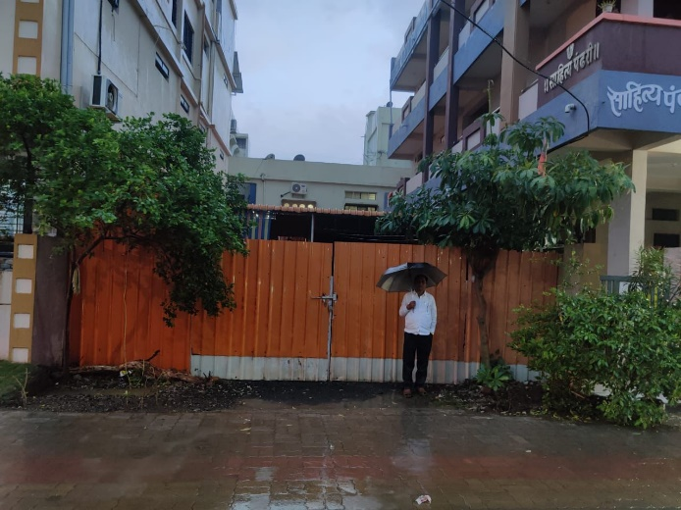

`

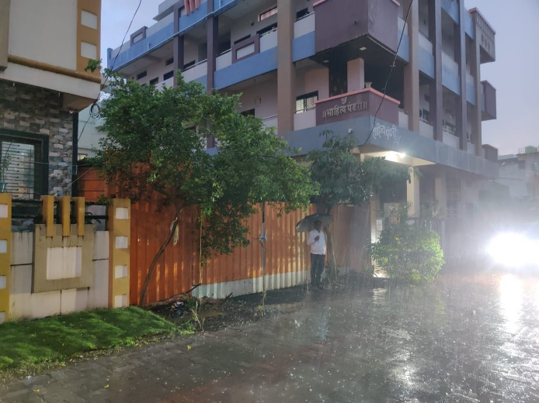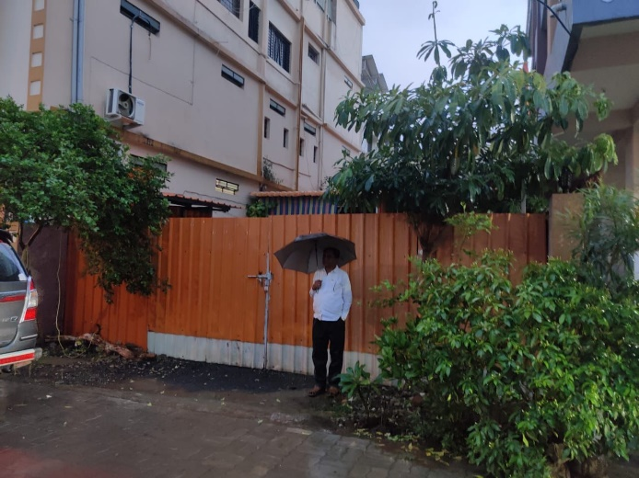

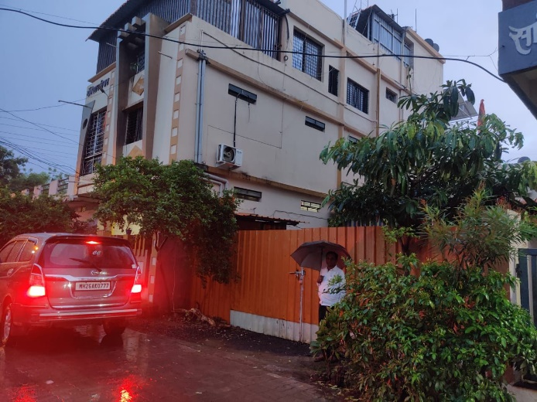

**Route Map of the property**

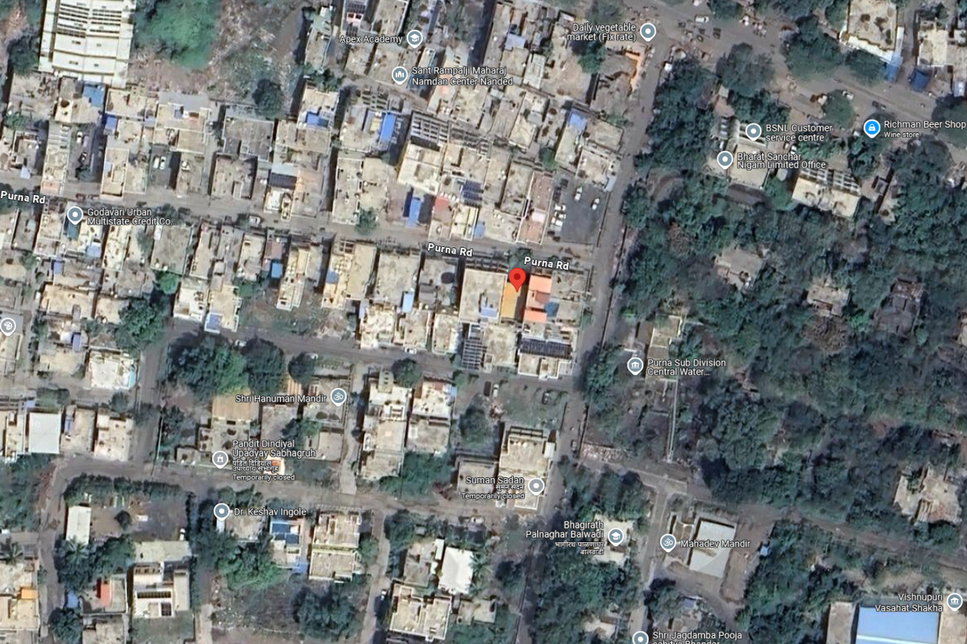

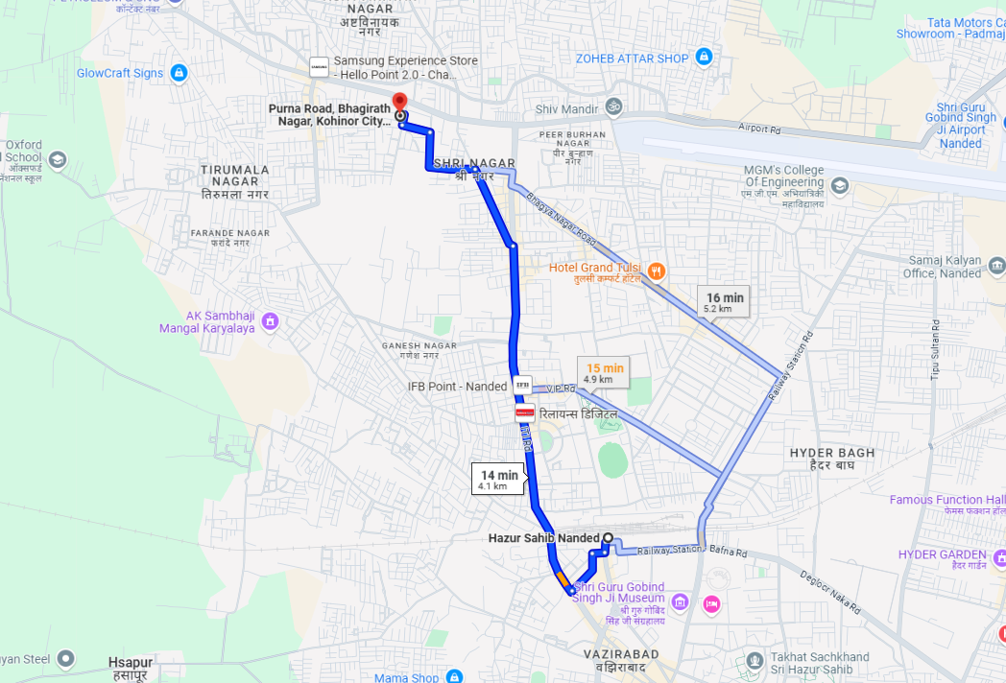

**Latitude: 19.184471, Longitude: 77.297512**

**Note**:

* Red Pointer shows Approx. Property Location
* Blue line shows Route from Nanded Railway Stationat 4.1 Km.

**Ready Reckoner Rate**

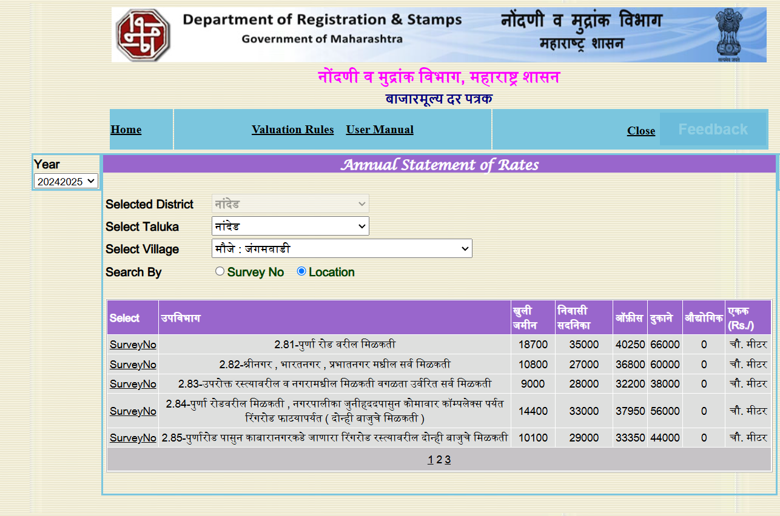

**Price Indicators**

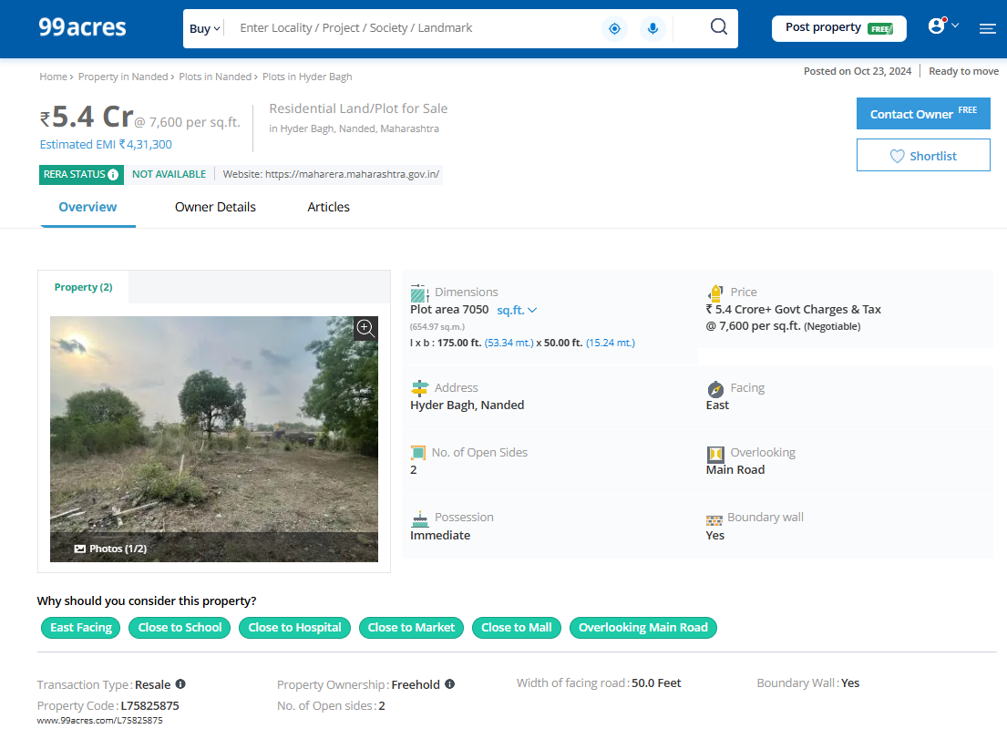

**Price Indicators**

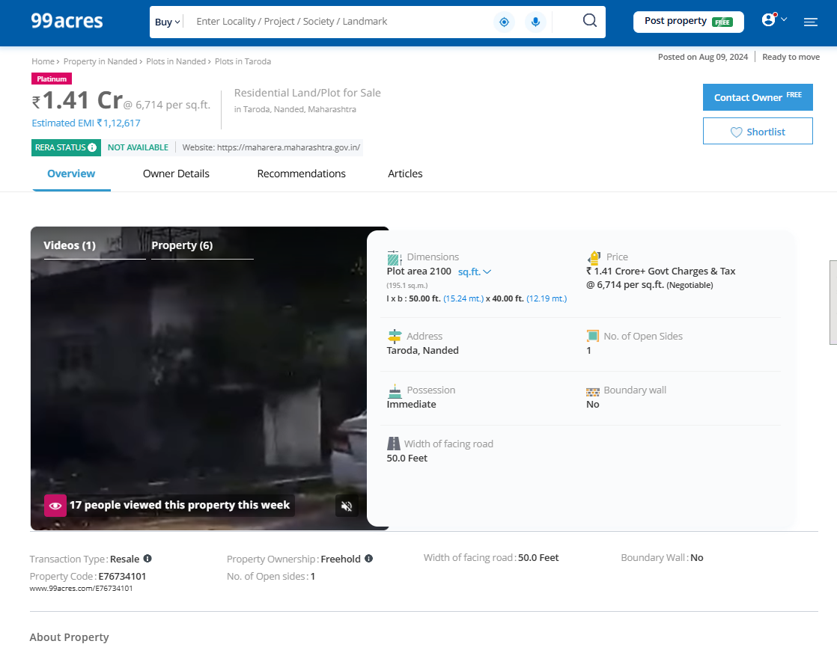

**DEFINITION OF VALUE FOR THIS SPECIFIC PURPOSE**

This exercise is to assess **Fair Market Value** of the property under reference as on dated **26th October, 2024.**

The term Fair Market Value is defined as

*"The most probable price, as of a specified date, in cash, terms equivalent to cash, or in other precisely revealed terms for which the specified property rights would sell after reasonable exposure in a competitive market under all conditions requisite to a fair sale, with the buyer and seller each acting prudently knowledgeably and for self-interest assuming that neither is under undue duress"*

Fundamental assumptions and conditions presumed in this definition are:

1. Buyer and seller are motivated by self-interest.
2. Buyer and seller are well informed and are acting prudently.
3. The property is exposed for a reasonable time on the open market.
4. Payment is made in cash or equivalent or in specified financing terms.

**UNDER LYING ASSUMPTIONS**

1. We assume no responsibility for matters of legal nature affecting the property appraised or the title thereto, nor do we render our opinion as to the title, which is assumed to be good and marketable
2. The property is valued as though under responsible ownership.
3. It is assumed that the property is free of liens and encumbrances.
4. It is assumed that there are no hidden or unapparent conditions of the subsoil or structure that would render it more or less valuable. No responsibility is assumed for such conditions or for engineering that might be required to discover such factors.

For, **Vastukala Consultants (I) Pvt. Ltd.**

**Sharadkumar B. Chalikwar**

B.E.(Civil), M.E.(Civil), M.Sc. (Real Estate Valuation), M.Sc. (P&M Valuation),FIE(I), FIV, FIWRS

Chairman & Managing Director

Govt. Reg. Valuer

Chartered Engineer (India)

Reg. No. (N) CCIT/1-14/52/2008-09

IBBI Reg.No. IBBI/RV/07/2019/11744