Vastu/Nashik/06/32014/2301224
22/20-325-RYBS
Date: 26.10.2024

To,
The Branch Manager,
State Bank of India
RACC Nashik Branch
RBO.2, The Wave Building, 1 st Floor, Opposite Shell Petrol Pump, Pathardi Road,
Nashik – 422 010, State – Maharashtra, Country – India.

Sub: Vetting of Extra Amenities

Sir,

With reference to above subject, we have evaluated the Extra Amenities for Residential Flat No. 201, 2nd Floor, " Laxmi Niwas Apartment ", Survey No. 431/ 1/ 2, Plot No. 03, Near Cambridge School, Konark Nagar, off Jatra - Nandur Road, Village - Adgaon, Taluka - Nashik, District -Nashik, Nashik, PIN Code - 422 003, State - Maharashtra, Country - India belongs to Shri. Harsh Suresh Senghani. Name of Proposed Purchaser is Taibai Vaman Ahire (Alias) Shaila Dilip Bachhav.

We have verified the rates quoted as per current market rates. Details of Extra Amenitiesconsidered as per copy of Extra AmenitiesAgreement between Taibai Vaman Ahire (Alias) Shaila Dilip Bachhav (First Party). Shri. Deepak Devshi Velani (Second Party) received on dated 18.10.2024. The Extra Amenities amount is Rs. 4,00,000/- (Rupees Four Lakh Only)

The said Cost Vetting Certificate is valid upto next 6 months Only.

Thanking you

Sincerely yours

Manoj B. Chalikwar
Registered Valuer
Chartered Engineer (India)
Reg. No. CAT-I-F-1763
SBI Empanelment No.: SME/TCC/2021-22/86/3
Encl. Valuation Report

Agreement for Extra Amenities
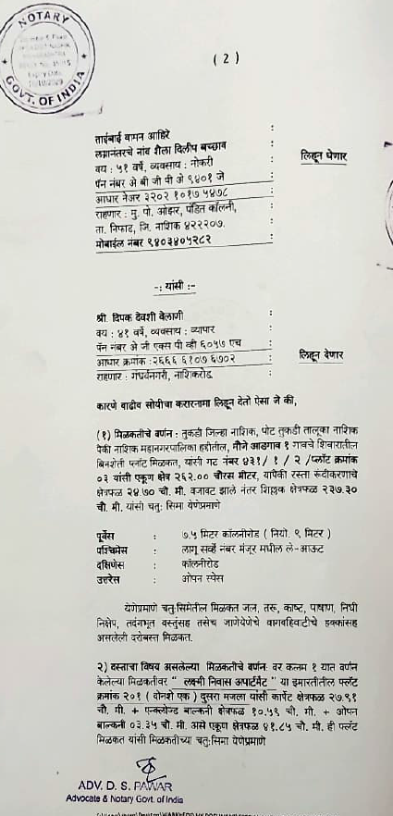
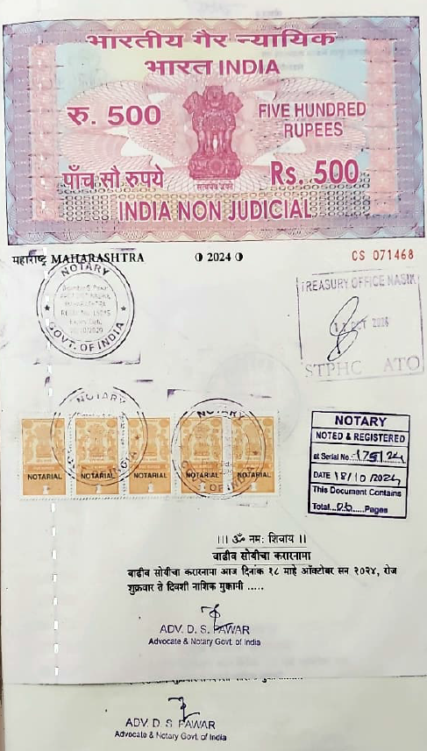

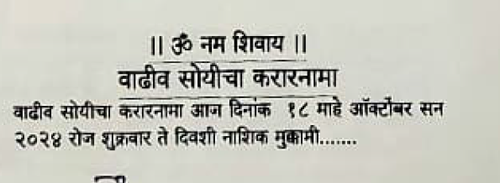

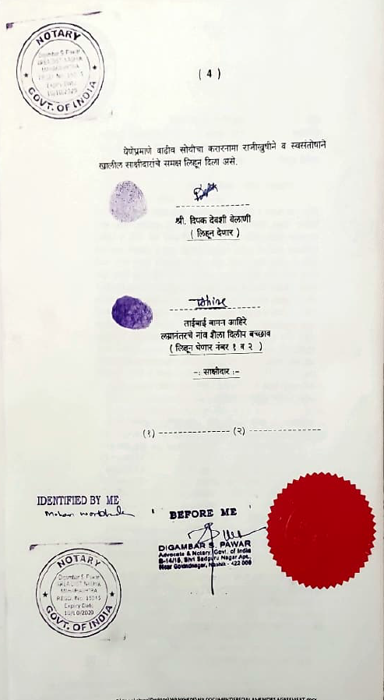
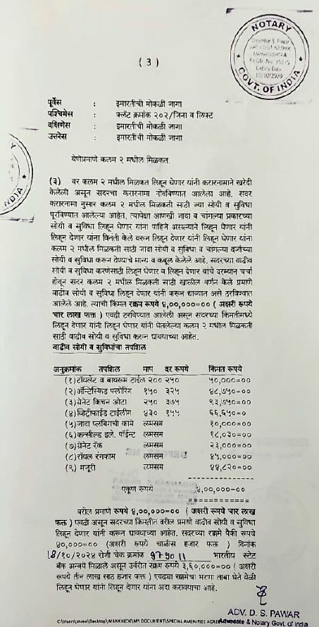

The Extra Amenities amount is Rs. 4,00,000/- (Rupees Four Lakh Only)

