Vastu/Nashik/07/2024/0010070/2307330
22/7-334-RPBS
Date: 26.10.2024

To, `
The Branch Manager,
RACPC Adgaon,
RACPC Adgaon, Nashik Branch, Nashik,
State – Maharashtra, Country – India.

Sub: Vetting of Extra Work

Sir,

With reference to above subject, we have evaluated the Extra Work for Residential Flat No. 1201, 12th Floor, "IMPERIAL TOWER", Near Dalimb Market, Kailash Nagar, Plot No. 1+2 , Sambhaji Nagar Road, Village - Dasak Shiwar, Taluka - Nashik, District - Nashik, Nashik, 422 003, State - Maharashtra, India belongs to Shri. Vikram Balu Pagare & Sau. Madhuri Vikram Pagare.

We have verified the rates quoted as per current market rates. Details of Extra Work considered as per copy of for Extra Work Agreement issued by to Mr. Vikram Balu Pagare & Mrs. Madhuri Vikram Pagare. (First Party) and Mr. Pramod Dattatray Dusane (Second Party) received on dated 25.10.2024. The Extra Work amount is Rs.7,00,000/- (Rupees Seven Lakh Only.)

The said Cost Vetting Certificate is valid upto next 6 months Only.

Thanking you

Sincerely yours

Manoj B. Chalikwar
Registered Valuer
Chartered Engineer (India)
Reg. No. CAT-I-F-1763
Reg. No. IBBI/RV/07/2018/10366
BOB Empanelment No.: ZO:MZ:ADV:46:941
Encl: Valuation report.

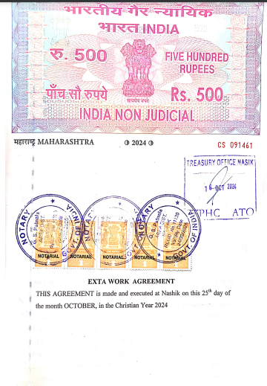
Agreement of Extra Work
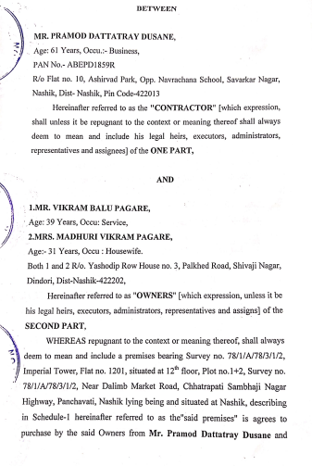

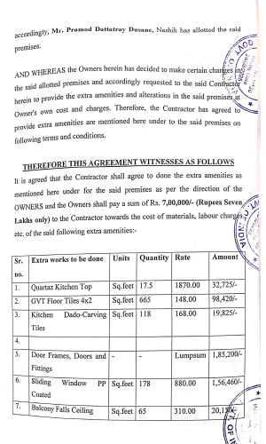
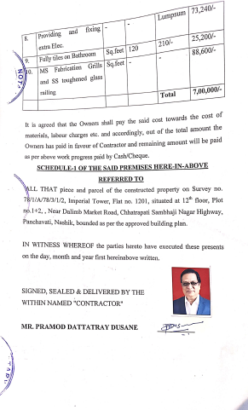

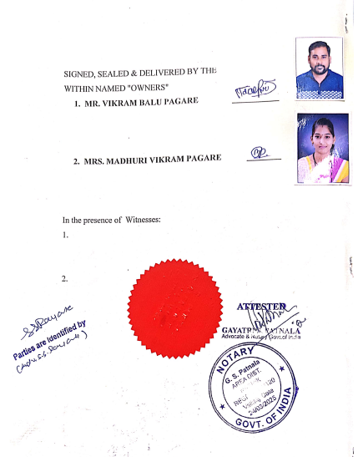

The Extra Work amount is Rs.7,00,000/- (Rupees Seven Lakh Only.)

