Vastu/Nashik/10/2024/012094 /2308843
25/26-383-RYBS
Date: 25.10.2024
To,
The Branch Manager,
Bank of Baroda
Regional Office
BSNL Building, Datta Mandir Road, Nashik Road,
Nashik, PIN – 422 101, State - Maharashtra, Country - India.

Sub: Vetting of Extra Amenities

Sir,

With reference to above subject, we have evaluated the Extra Amenities For Residential Flat No. 602, 6th Floor, "Rivera Sky Garden", Survey No. 49/ 3, Behind Serene Meadows, Near Shri Shani Maharaj Mandir, Dhruv Nagar, Someshwar-Satpur Link Road, Right Canal Road, Village - Gangapur, Taluka - Nashik, District - Nashik, Nashik, PIN Code - 422 012, State - Maharashtra, Country - India belongs to Mrs. Sangeeta Rajesh Pandit & Mr. Rajesh Shrichandrika Pandit.

We have verified the rates quoted as per current market rates. Details of Extra Amenities considered as per copy of Extra Amenities Agreement between Mrs. Sangeeta Rajesh Pandit & Mr. Rajesh Shrichandrika Pandit. (First Party). Shri. Manohar Gulab Patil (Second Party) received on dated. 22.10.2024. The Extra Amenities amount is Rs. 3,50,000/- (Rupees Three Lakh Fifty Thousand Only)

The said Cost Vetting Certificate is valid upto next 6 months Only.

Thanking you

Sincerely yours

Manoj B. Chalikwar
Registered Valuer
Chartered Engineer (India)
Reg. No. CAT-I-F-1763
Reg. No. IBBI/RV/07/2018/10366
BOB Empanelment No.: ZO:MZ:ADV:46:941
Encl: Valuation report.

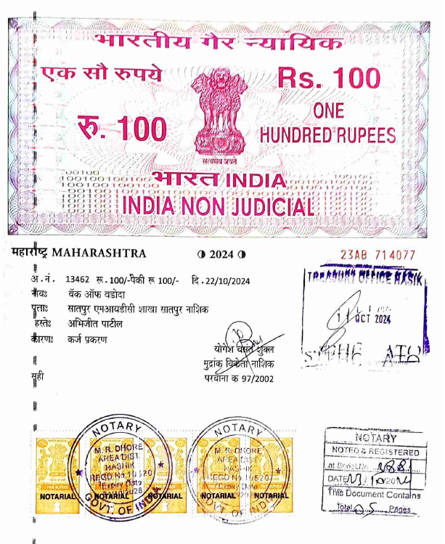
Agreement for Extra Amenities
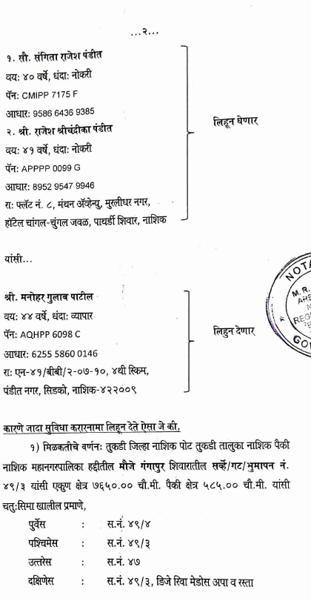

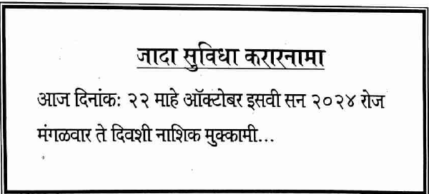

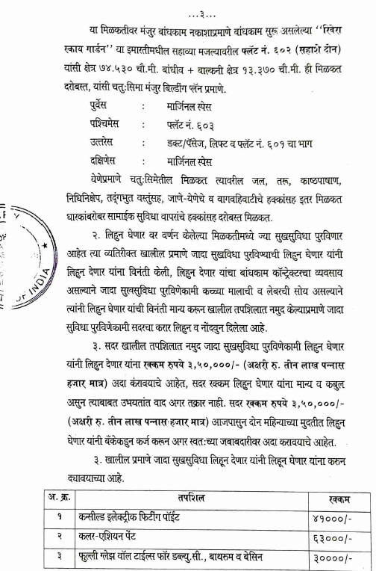
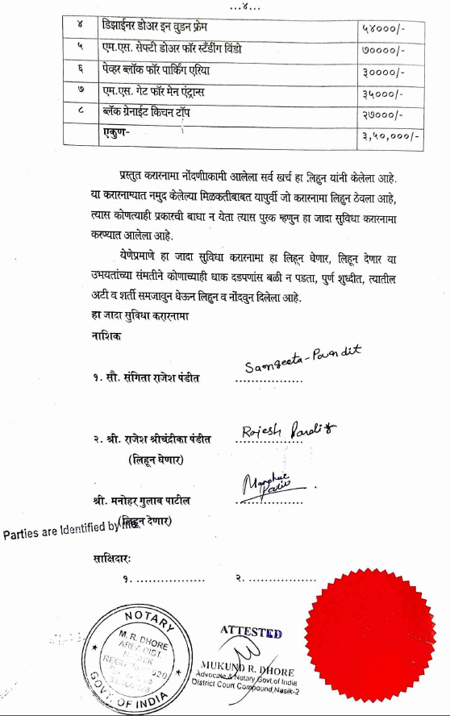

The Extra Amenities amount is Rs. 3,50,000/- (Rupees Three Lakh Fifty Thousand Only)

