Vastu/Nashik/06/32014/2301224
22/20-325-RYBS
Date: 24.10.2024

To,
The Branch Manager,
Bank of Baroda
Regional Office
BSNL Building, Datta Mandir Road, Nashik Road,
Nashik, PIN – 422 101, State - Maharashtra, Country - India.

Sub: Vetting of Extra Work

Sir,

With reference to above subject, we have evaluated the Extra Work For Residential Flat No. 201, 2nd Floor, " Ashirwad Heights ", S. No. 62/ 2, Plot No. 04, Opp. To Saundarya Beauty Parlor, Dhruv Nagar, Right Canal Road, Village - Gangapur, Taluka - Nashik, Dstrict - Nashik, PIN Code - 422 222, State - Maharashtra, Country - lndia. belongs to Shri. Sampat Santu Chumbhale. Name of Proposed Purchaser is Shri. Rahul Bapu Nikam & Sau. Yogita Rahul Nikam.

We have verified the rates quoted as per current market rates. Details of Extra Work considered as per copy of Extra Work Agreement between Shri. Rahul Bapu Nikam & Sau. Yogita Rahul Nikam (First Party). Shri. Samadhan Bapu Sonawane (Second Party) received on dated. 24.10.2024. The Extra Work amount is Rs. 4,50,000/- (Rupees Four Lakh Fifty Thousand Only)

The said Cost Vetting Certificate is valid upto next 6 months Only.

Thanking you

Sincerely yours

Manoj B. Chalikwar
Registered Valuer
Chartered Engineer (India)
Reg. No. CAT-I-F-1763
Reg. No. IBBI/RV/07/2018/10366
BOB Empanelment No.: ZO:MZ:ADV:46:941
Encl: Valuation report.

Agreement for Extra Work
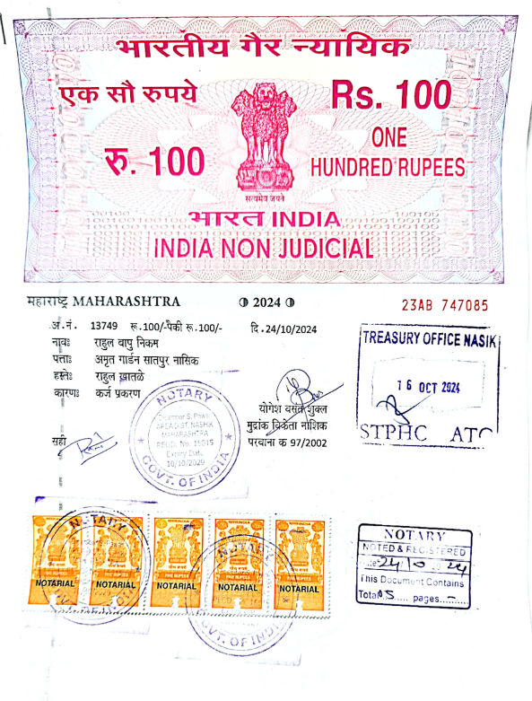
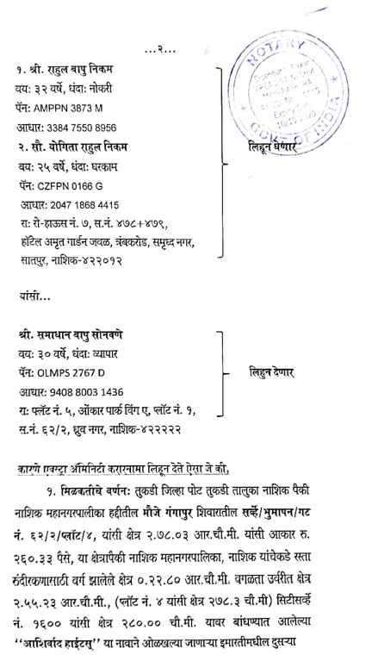

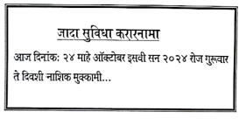

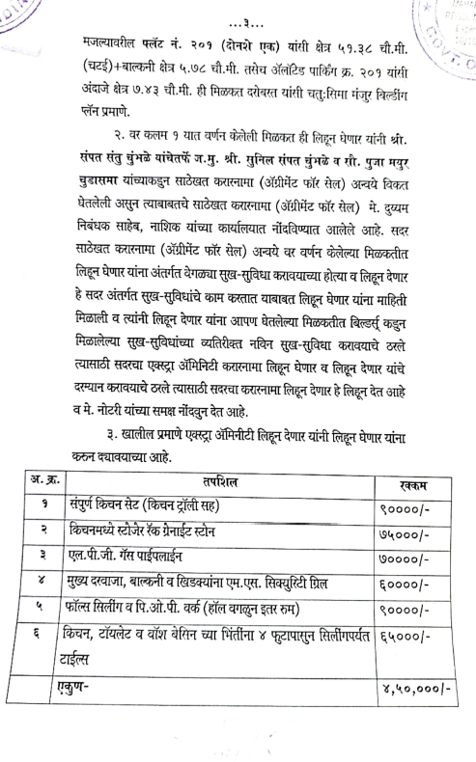
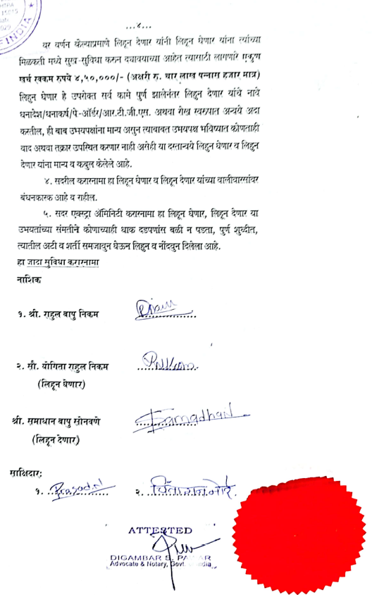

The Extra Work amount is Rs. 4,50,000/- (Rupees Four Lakh Fifty Thousand Only)

