Valuation Report of the Immovable Property
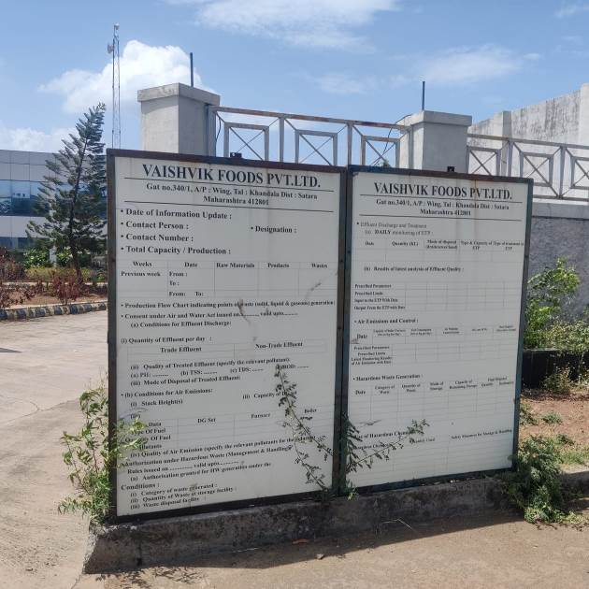

Details of the property under consideration:

Name of Owner: M/s. Vaishvik Foods Pvt. Ltd.

Industrial Land & Building located on Gut No. 340/1 & 340/2, Village Wing, Taluka – Khandala,
District – Satara, Pin Code – 412 801, State – Maharashtra, Country - India

Longitude Latitude: 18°09'50.7"N 73°55'21.3"E

Intended User:

Union Bank of India
SAMB Fort Branch
Bharat House, Ground Floor, 104, M. S. Marg Fort, Mumbai - 400 001,
State - Maharashtra, Country - India

Vastu/Mumbai/10/2024/12051/2308831
25/14-371- SPPPY
Date: 25.10.2024

VALUATION OPINION REPORT
This is to certify that the property bearing Industrial Land & Building located on Gut No. 340/1 & 340/2, Village Wing, Taluka – Khandala, District – Satara, Pin Code – 412 801, State – Maharashtra, Country - India belongs to M/s. Vaishvik Foods Pvt. Ltd.

Boundaries of the property.
North | : | Open Plot
South | : | Internal Road
East | : | Open Plot
West | : | Agripure Natural Foods Pvt. Ltd.
Considering various parameters recorded, existing economic scenario, and the information that is available with reference to the development of neighborhood and method selected for valuation, we are of the opinion that, the property premises can be assessed and Fair market value for SARFAESI Securitization and Reconstruction of Financial Assets and Enforcement of Security Interest Act, 2002,
Particulars | Fair Market Value In (`) | Realizable Value In (`) | Distress Sale Value In (`)
Land and Building | 14,30,24,110.00 | 12,15,70,494.00 | 10,01,16,877.00
The valuation of the property is based on the documents produced by the concern. Legal aspects have not been taken into considerations while preparing this valuation report.
Hence certified

Sharadkumar B. Chalikwar
Govt. Reg. Valuer &
Chartered Engineer (India)
Reg. No. (N) CCIT/1-14/52/2008-09

Encl: Valuation report.

Vastukala Consultants (I) Pvt. Ltd.
B1-001, U/B Floor, Boomerang, Chandivali Farm Road, Powai, Andheri (East), Mumbai – 400 072

To,
The Branch Manager,
Union Bank of India
SAMB Fort Branch,
Bharat House, Ground Floor, 104,
M. S. Marg Fort, Mumbai - 400 001
State - Maharashtra, Country – India

VALUATION REPORT (IN RESPECT OF LAND AND BUILDING)
I |  | General
1. |  | Purpose for which the valuation is made |  |  | : |  | As per the request from Union Bank of India, SAMB Fort to assess Market value of the property for SARFAESI (Securitisation and Reconstruction of Financial Assets and Enforcement of Security Interest Act, 2002) purpose.
2. |  | a) | Date of inspection |  | : |  | 14.10.2024
 |  | b) | Date on which the valuation is made |  | : |  | 25.10.2024
3 |  | List of documents produced for perusal: |  |  | :
- Copy of Sale Agreement dated 25.02.2008 Doc. No. KDL/480 between Mr. Amarali G. Chamadia (The Vendor) and M/s. Vaishvik Foods Pvt. Ltd. (The Purchaser).
- Copy of Sale Agreement dated 27.02.2008 Doc. No. KDL/510 between Mr. Aajj Amarali Chamadia (The Vendor) and M/s. Vaishvik Foods Pvt. Ltd. (The Purchaser).
- Copy of Sale Agreement dated 24.03.2008 Doc. No. KDL/695 between Mr. Aajj Amarali Chamadia (The Vendor) and M/s. Vaishvik Foods Pvt. Ltd. (The Purchaser).
- Copy of Sale Agreement dated 24.03.2008 Doc. No. KDL/6963 between Mr. Amarali G. Chamadia (The Vendor) and M/s. Vaishvik Foods Pvt. Ltd. (The Purchaser).
- Copy of Sale Agreement dated 29.04.2011 Doc. No. KDL/1732 between Vidula Dattatraya Ghodke (The Vendor) and M/s. Vaishvik Foods Pvt. Ltd. (The Purchaser).
- Copy of Sale Agreement dated 01.09.2007 Doc. No. KDL/6963 between Mr. Ramchandra Namdev Mandra (The Vendor) and Mr. Aajj Amarali Chamadia (The Purchaser).
- Copy of Sale Agreement dated 14.12.2009 Doc. No. KDL/2725 between Uday Gujar & 5 others (The Vendor) and Vidula Dattatraya Ghodke (The Purchaser).
- Copy of Sale Agreement dated 05.02.2010 Doc. No. KDL/351 between Uday Gujar & 5 others (The Vendor) and Vidula Dattatraya Ghodke (The Purchaser).
- Copy of Sale Agreement dated 19.03.2008 Doc. No. KDL/690 between Mr. Amarali G. Chamadia & 5 others (The Vendor) and M/s. Ultra-Engineering (The Purchaser).
- Copy of N.A. Order No. N.A./SR/33/2011 dated 03.11.2011 issued by Collector of Office, Wani.
- Copy of Approved Plan No. Building Permission/Village – Wing/Tal – Khandala/Gut No. 340/1 & 340/2/SS/2781 dated 15.10.2011 issued by Town Planning Department, Satara.
4. |  | Name of the owner(s) and his / their address (es) with Phone no. (details of share of each owner in case of joint ownership) |  |  | : |  | M/s. Vaishvik Foods Pvt. Ltd.  Address: Industrial Land & Building located on Gut No. 340/1 & 340/2, Village Wing, Taluka – Khandala, District – Satara, Pin Code – 412 801, State – Maharashtra, Country - India  Contact Person:  Mr. Hitesh Patel (Sr. Manger of UBI)  Mb. No. +91 – 90509 88881  Mr. Pranav Dangat (Owner)  Mob.: +91 – 98600 99090  Company Ownership
5. |  | Brief description of the property (Including Leasehold / freehold etc.):
The property under consideration is freehold industrial land and building connected with road and train. The property is at 7.40 Km. from Sheriwal Bus station.
At present the property is occupied by tenant.

Land Details:
As per Sale Deed land area as follows:
Sr. No. | Gut No. | Land Area in Sq. M.
1 | 340/1 | 10,838.00
2 | 340/2 | 3,500.00
TOTAL LAND AREA IN SQ. M. |  | 14,338.00

As per Approved Plan Land Area are as follows:
Sr. No. | Particulars | Area in Sq. M.
1 | Area of Gut No. 340 | 75,720.00
2 | Applicants Area of Gut No. 340/1 | 10,838.00
3 | Applicants Area of Gut No. 340/2 | 3,500.00
4 | Applicants Total Area | 14,338.00
5 | Applicants Area as MEA Plan | 13,060.50
6 | Area Under Road Widening (15 M wide) | 210.0
7 | Net Area Under Layout | 12,850.50

Net Land Area as per Approved Plan is 12,850.50 Sq. M. and same is considered for valuation.

Structure Description are as following:
Floor | Description Of Structure | Specification
Ground Floor | RCC framed structure with Ceramic Stone Flooring, Aluminum Glass Window, Open Plumbing & Electrical Fitting | Reception Area + Production Area + Lab Area + Working Area + Storage Area + Cabin + Toilet Block
First Floor |  | M.D. Cabin + Director Cabin + Accounts Section + Conference + Canteen + Toilet Block
Security Cabin | RCC framed structure with Ceramic Stone Flooring, Aluminum Glass Window, Open Plumbing & Electrical Fitting | Security Cabin

Structure area as Approved Plan and same is considered for valuation are as under:
Structure | Built Up Area in Sq. M.
Main Building
Ground Floor | 4,450.50
First Floor | 623.75
Security Cabin | 75.00
TOTAL | 5,149.25

Note: - At time of site inspection, Unit was partly operated and land of M/s. Vaishvik Foods Pvt. Ltd. and M/s. Agripure Natural Foods Pvt. Ltd. are internally connected with separate entrance gate.
6. |  | Location of property |  |  | :
 |  | a) |  | Plot No. / Survey No. | : |  | Gut No. 340/1 & 340/2
 |  | b) |  | Door No. | : |  | -
 |  | c) |  | T.S. No. / Village | : |  | Village – Wing
 |  | d) |  | Ward / Taluka | : |  | Taluka – Khandala
 |  | e) |  | Mandal / District | : |  | District – Satara
7. |  | Postal address of the property |  |  | : |  | Industrial Land & Building located on Gut No. 340/1 & 340/2, Village Wing, Taluka – Khandala, District – Satara, Pin Code – 412 801, State – Maharashtra, Country - India
8. |  | City / Town |  |  | :
 |  | Residential area |  |  | : |  | No
 |  | Commercial area |  |  | : |  | No
 |  | Industrial area |  |  | : |  | Yes
9. |  | Classification of the area |  |  | :
 |  | i) High / Middle / Poor |  |  | : |  | Middle Class
 |  | ii) Urban / Semi Urban / Rural |  |  | : |  | Semi Urban
10. |  | Coming under Corporation limit / Village Panchayat / Municipality |  |  | : |  | Wing Gram Panchayat
11. |  | Whether covered under any State / Central Govt. enactments (e.g., Urban Land Ceiling Act) or notified under agency area/ scheduled area / cantonment area |  |  | : |  | No
12. |  | In Case it is Agricultural land, any conversion to house site plots is contemplated |  |  | : |  | N.A.
13. |  | Boundaries of the property |  |  |  |  | As per the Deed |  | As per Site
 |  | North |  |  | : |  | Information not available |  | Open Plot
 |  | South |  |  | : |  | Information not available |  | Internal Road
 |  | East |  |  | : |  | Information not available |  | Open Plot
 |  | West |  |  | : |  | Information not available |  | Agripure Natural Foods Pvt. Ltd.
14.1 |  | Dimensions of the site
 |  |  |  |  |  |  | A (As per the Deed) |  | B (Actuals)
 |  | North |  |  | : |  | N.A, as the property is irregular in Shape.
 |  | South |  |  | :
 |  | East |  |  | :
 |  | West |  |  | :
14.2 |  | Latitude, Longitude & Co-ordinates of Property |  |  | : |  | 18°09'50.7"N 73°55'21.3"E
15. |  | Extent of the site |  |  | : |  | Total Plot Area = 12,850.50 Sq. M.  Structure Area –  (Area as per Approved Plan)
  Structure | Built Up Area in Sq. M.
  Main Building
  Ground Floor | 4,450.50
  First Floor | 623.75
  Security Cabin | 75.00
  TOTAL | 5,149.25
16. |  | Extent of the site considered for Valuation (least of 14A& 14B) |  |  | : |  | Total Plot Area = 12,850.50 Sq. M.  Structure Area –  (Area as per Approved Plan)
  Structure | Built Up Area in Sq. M.
  Main Building
  Ground Floor | 4,450.50
  First Floor | 623.75
  Security Cabin | 75.00
  TOTAL | 5,149.25
17. |  | Whether occupied by the owner / tenant? If occupied by tenant since how long? Rent received per month. |  |  | : |  | Owner Occupied
II |  | CHARACTERSTICS OF THE SITE
 |  | Classification of locality |  |  |  | : |  | Located in Middle class locality
 |  | Development of surrounding areas |  |  |  | : |  | Developed
 |  | Possibility of frequent flooding/ sub-merging |  |  |  | : |  | Altitude is below the front road level
 |  | Feasibility to the Civic amenities like School, Hospital, Bus Stop, Market etc. |  |  |  | : |  | Available within a distance of 5-10 Km
 |  | Level of land with topographical conditions |  |  |  | : |  | Plain
 |  | Shape of land |  |  |  | : |  | Irregular
 |  | Type of use to which it can be put |  |  |  | : |  | For Industrial purpose
 |  | Any usage restriction |  |  |  | : |  | Industrial
 |  | Is plot in town planning approved layout? |  |  |  | : |  | Yes
 |  | Corner plot or intermittent plot? |  |  |  | : |  | Intermittent
 |  | Road facilities |  |  |  | : |  | Yes
 |  | Type of road available at present |  |  |  | : |  | C.C. road
 |  | Width of road – is it below 20 ft. or more than 20 ft. |  |  |  | : |  | More than 20 ft.
 |  | Is it a Land – Locked land? |  |  |  | : |  | No
 |  | Water potentiality |  |  |  | : |  | Available
 |  | Underground sewerage system |  |  |  | : |  | Not available
 |  | Is Power supply being available in the site |  |  |  | : |  | Presently not available
 |  | Advantages of the site |  |  |  | : |  | -
 |  | Special remarks, if any like threat of acquisition of land for publics service purposes, road widening or applicability of CRZ provisions etc. (Distance from sea-cost / tidal level must be incorporated) |  |  |  | : |  | No
Part – A (Valuation of land)
1 | Size of plot |  |  |  | : |  | Total Plot Area = 12,850.50 Sq. M.  Structure Area –  (Area as per Approved Plan)
  Structure | Built Up Area in Sq. M.
  Main Building
  Ground Floor | 4,450.50
  First Floor | 623.75
  Security Cabin | 75.00
  TOTAL | 5,149.25
 | North & South |  |  |  | : |  | -
 | East & West |  |  |  | : |  | -
2 | Total extent of the plot |  |  |  | : |  | Total Plot Area = 12,850.50 Sq. M.  Structure Area –  (Area as per Approved Plan)
  Structure | Built Up Area in Sq. M.
  Main Building
  Ground Floor | 4,450.50
  First Floor | 623.75
  Security Cabin | 75.00
  TOTAL | 5,149.25
3 | Prevailing market rate (Along With details / reference of at least two latest deals / transactions with respect to adjacent properties in the areas) |  |  |  | : |  | ` 4,000.00 to ` 5,500.00 per Sq. M. for Industrial Land
4 | Ready Reckoner Government rate obtained from the Register’s Office |  |  |  | : |  | ` 1,650.00 per Sq. M.
5 | Assessed / adopted rate of valuation |  |  |  | : |  | ` 5,000.00 per Sq. M.
6 | Estimated value of land |  |  |  | : |  | ` 6,42,52,500.00
Part – B (Valuation of Building)
1 |  | Technical details of the building |  |  |  | :
 |  | - Type of Building (Residential / Commercial / Industrial) |  |  |  | : |  | Industrial
 |  | - Type of construction (Load bearing / RCC / Steel Framed) |  |  |  | : |  | RCC framed structure
 |  | - Year of construction |  |  |  | : |  | 2011 (As per Information from Client)
 |  | - Number of floors and height of each floor including basement if any |  |  |  | : |  | As per brief description
 |  | - Plinth area floor-wise |  |  |  | : |  | As per area statement
 |  | - Condition of the building |  |  |  | :
 |  | - Exterior – Excellent, Good, Normal, Poor |  |  |  | : |  | Good condition
 |  | - Interior – Excellent, Good, Normal, Poor |  |  |  | : |  | Good condition
 |  | - Date of issue and validity of layout of approved map |  |  |  | :
 |  | - Approved map / plan issuing authority |  |  |  | :
 |  | - Whether genuineness or authenticity of approved map / plan is verified |  |  |  | : |  | Yes
 |  | - Any other comments by our empanelled valuers on authentic of approved plan |  |  |  | : |  | -

Specifications of construction (floor-wise) in respect of
Sr. No. |  | Description
 |  | Foundation |  | : | RCC
 |  | Basement |  | : | N.A.
 |  | Superstructure |  | : | B. B. Masonry
 |  | Joinery / Doors & Windows (Please furnish details about size of frames, shutters, glazing, fitting etc. and specify the species of timber |  | : | Wooden Glass Door & Aluminum Glass Window
 |  | RCC Works |  | : | As per brief description
 |  | Plastering |  | : | Cement plastering to few structures and many structures are unflustered.
 |  | Flooring, Skirting, dado |  | : | Cemented
 |  | Special finish as marble, granite, wooden paneling, grills etc. |  | : | Nil
 |  | Roofing including weatherproof course |  | : | AC Sheet roofing
 |  | Drainage |  | : | Connected to public sewer
2. | Compound Wall |  |  | : | Yes
 | Height |  |  | : | 6 ft. height
 | Length |  |  | :
 | Type of construction |  |  | : | Stone masonry
3. | Electrical installation |  |  | : | Provided as per requirement
 | Type of wiring |  |  | : | Provided as per requirement
 | Class of fittings (superior / ordinary / poor) |  |  | :
 | Number of light points |  |  | :
 | Fan points |  |  | :
 | Spare plug points |  |  | :
 | Any other item |  |  | :
4. | Plumbing installation |  |  |  | Provided as per requirement
 | - No. of water closets and their type |  |  | : | Provided as per requirement
 | - No. of wash basins |  |  | :
 | - No. of urinals |  |  | :
 | - No. of bathtubs |  |  | :
 | - Water meters, taps etc. |  |  | :
 | - Any other fixtures |  |  | :
Part – C (Extra Items) |  |  | : |  | Amount in `
 | Portico |  | : |  | Including in cost of construction
 | Ornamental front door |  | : |  | Including in cost of construction
 | Sit out / Verandah with steel grills |  | : |  | Including in cost of construction
 | Overhead water tank |  | : |  | Including in cost of construction
 | Extra steel / collapsible gates |  | : |  | Including in cost of construction
 | Total |  |  |  | Including in cost of construction
Part – D (Amenities) |  |  | : |  | Amount in `
 | Wardrobes |  | : |  | Including in cost of construction
 | Glazed tiles |  | : |  | Including in cost of construction
 | Extra sinks and bathtub |  | : |  | Including in cost of construction
 | Marble / ceramic tiles flooring |  | : |  | Including in cost of construction
 | Interior decorations |  | : |  | Including in cost of construction
 | Architectural elevation works |  |  |  | Including in cost of construction
 | Paneling works |  |  |  | Including in cost of construction
 | Aluminum works |  |  |  | Including in cost of construction
 | Aluminum handrails |  |  |  | Including in cost of construction
 | False ceiling |  |  |  | Including in cost of construction
 | Total |  |  |  | Including in cost of construction
Part – E (Miscellaneous) |  |  | : |  | Amount in `
 | Separate toilet room |  | : |  | Including in cost of construction
 | Separate lumber room |  | : |  | Including in cost of construction
 | Separate water tank / sump |  | : |  | Including in cost of construction
 | Trees, gardening |  | : |  | Including in cost of construction
 | Total |  |  |  | Including in cost of construction
Part – F (Services) |  |  | : |  | Amount in `
 | Water supply arrangements |  | : |  | Including in cost of construction
 | Drainage arrangements |  | : |  | Including in cost of construction
 | Tar Fencing with RCC Footing |  | : |  | Including in cost of construction
 | Land Leveling, Murum Filling, & Compaction, WBM Road & Site Development |  | : |  | Including in cost of construction
 | Pavement |  |  |  | Including in cost of construction
 | Total |  |  |  | Including in cost of construction

Government Value
Particulars | Area in Sq. M. | Rate in ` | Value in `
Land | 12,850.50 | 1,650.00 | 2,12,03,325.00
Structure | As per valuation table |  | 7,87,71,610.00
Total |  |  | 9,99,74,935.00

Structure Value: -
Structure No. | Built Up Area | Year Of Const. | Estimated Replacement Rate | Age Of Build. | Final Depreciated Rate to be considered | Final Depreciated Value to be considered | Estimated Replacement Cost / Insurable Value
 | (Sq. M.) |  | (`) | Years | (`) | (`) | (`)
Ground Floor | 4,450.50 | 2011 | 20,000.00 | 13.00 | 15,320.00 | 6,81,81,660.00 | 8,90,10,000.00
First Floor | 623.75 | 2011 | 20,000.00 | 13.00 | 15,320.00 | 95,55,850.00 | 1,24,75,000.00
Security Cabin | 75.00 | 2011 | 18,000.00 | 13.00 | 13,788.00 | 10,34,100.00 | 13,50,000.00
Total | 5,149.25 |  |  |  |  | 7,87,71,610.00 | 10,28,35,000.00

TOTAL ABSTRACT OF THE ENTIRE PROPERTY
Part - A | Land | ` 6,42,52,500/-
Part - B | Buildings | ` 7,87,71,610/-
Part – C | Compound Wall | -
Part – D | Amenities | -
Part - E | Pavement | -
Part - F | Services | -
 | Fair Market Value In (`) | ` 14,30,24,110/-
 | Realizable Value In (`) | ` 12,15,70,494/-
 | Distress Sale Value In (`) | ` 10,01,16,877/-
 | Insurable Value In (`) | ` 10,28,35,000/-
Remarks | - At time of site inspection, Unit was partly operated and land of M/s. Vaishvik Foods Pvt. Ltd. and M/s. Agripure Natural Foods Pvt. Ltd. are internally connected with separate entrance gate.  - We have considered land area & structure area as per approved plan only.
- The cost approach is a Real Property Valuation method which considers the value of a property as the cost of the land plus the replacement cost of the building (construction costs) minus the physical and functional depreciation.
- This approach is most commonly used for real estate properties that are not easily sold like schools, hospitals, government buildings and above type of property.
- Land cost can be estimated using the Sales Comparison Approach by studying recent sales of land close to the subject property, and these sales should be comparable in size and location with subject property.
- There are different ways to estimate replacement costs, the most common being finding out the cost to build a square foot of comparable properties multiplied by the total square footage of the building. The cost approach is commonly used for Residential Bungalow, Industrial Building and properties mentioned above.
- As the property is an industrial land and building thereof, we have adopted Cost approach / Land and Building Method for the purpose of valuation. The Price for similar type of property in the nearby vicinity is in the range of ` 4,000/- to ` 5,500/- per Sq. M. for land Considering the rate with attached report, current market conditions, demand and supply position, Land size, location, sustained demand for industrial building / Plot, all round development of commercial and industrial application in the locality etc.
- We estimate ` 5,000/- per Sq. M. for Land with appropriate cost of construction for valuation.
ACTUAL SITE PHOTOGRAPHS
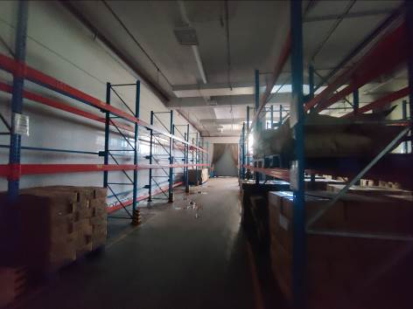
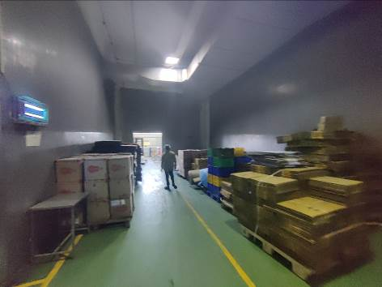
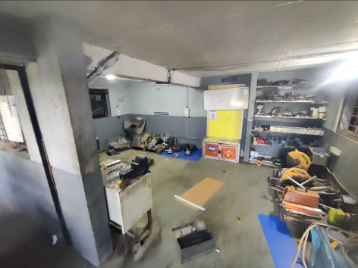
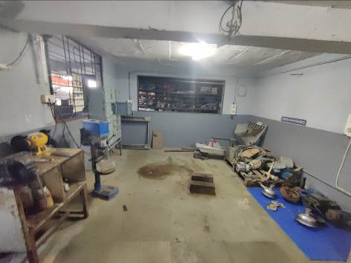
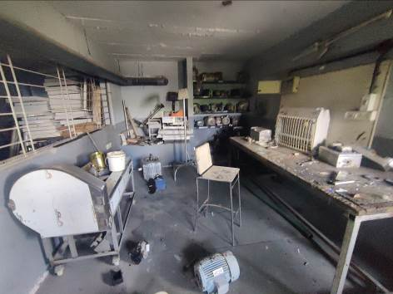
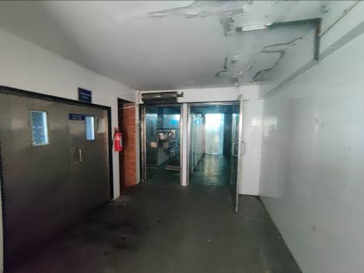
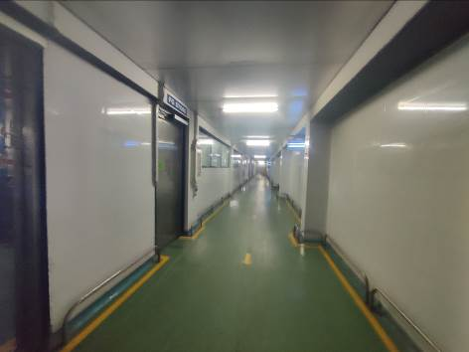
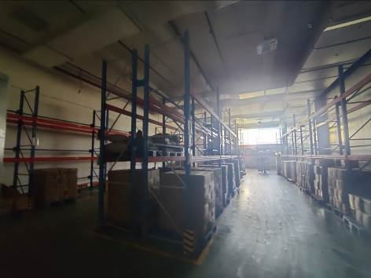
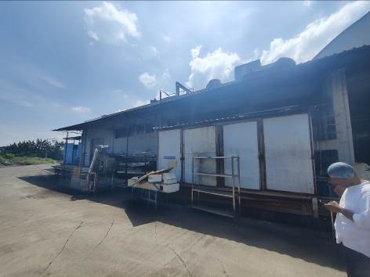
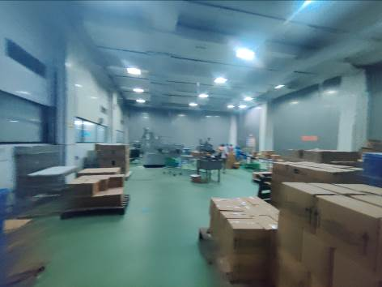
ACTUAL SITE PHOTOGRAPHS
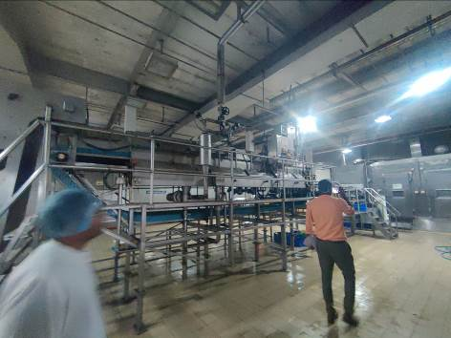
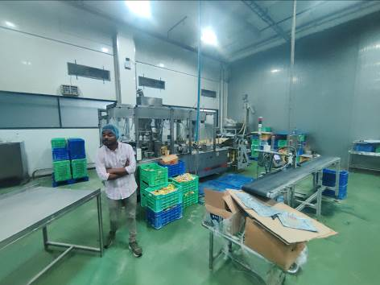
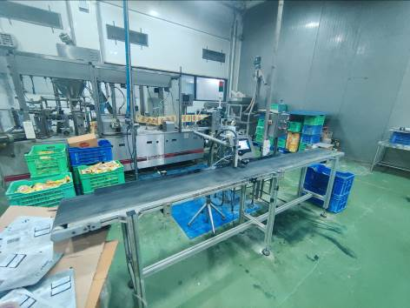
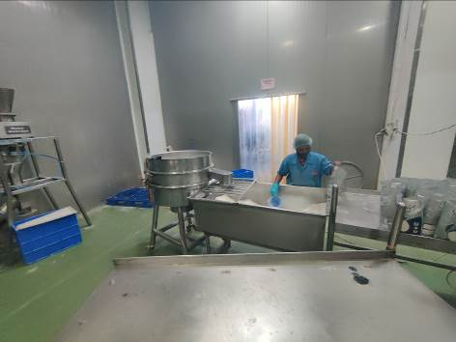
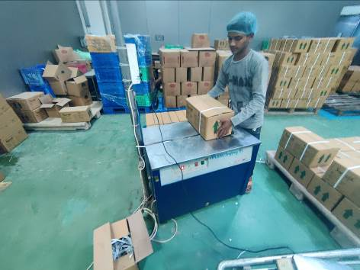
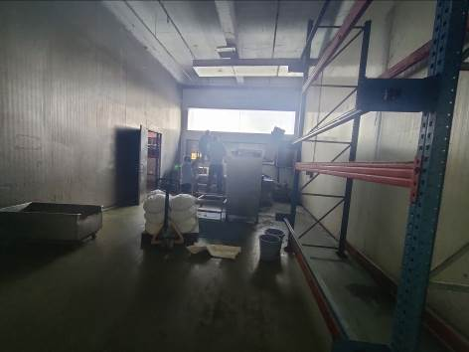
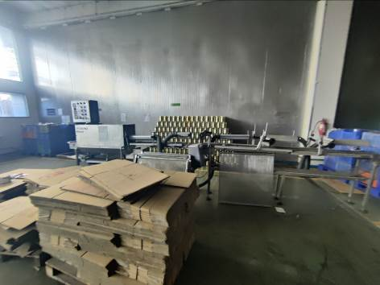
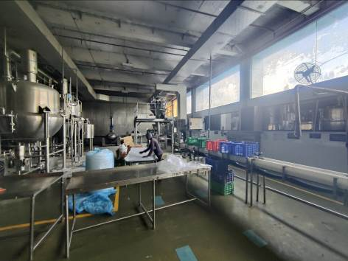
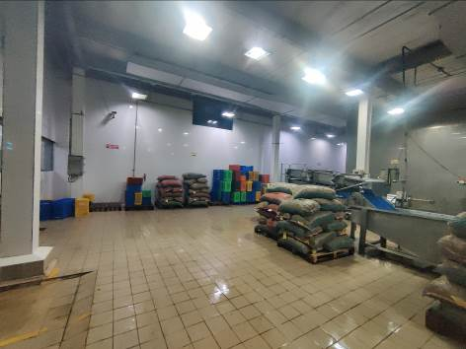
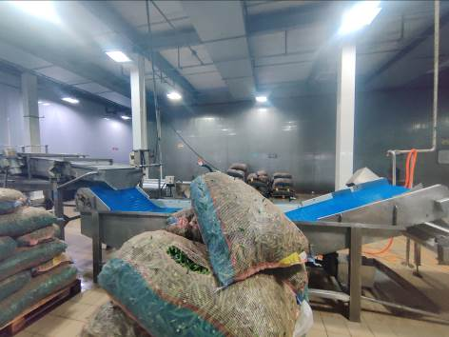
ACTUAL SITE PHOTOGRAPHS
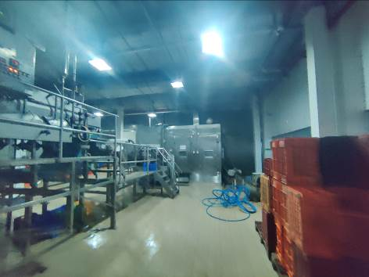
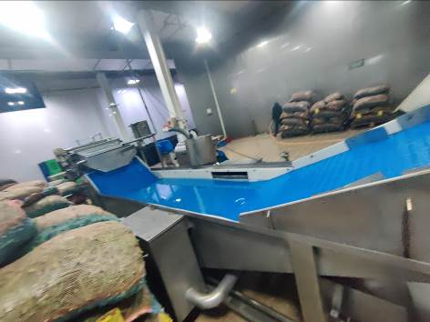
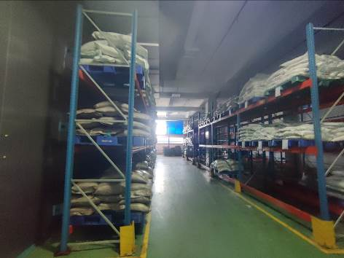
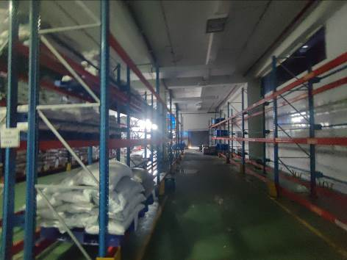
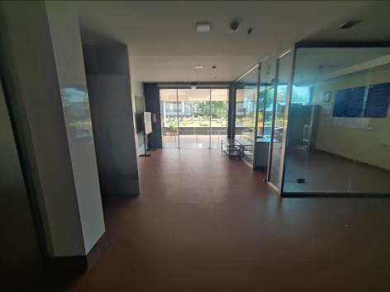
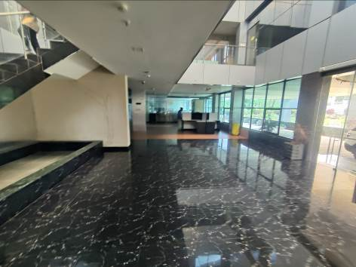
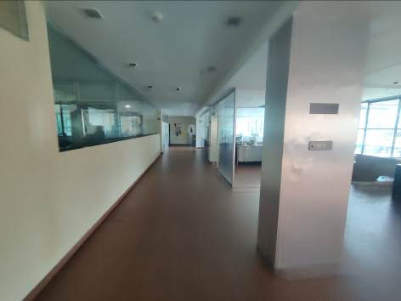
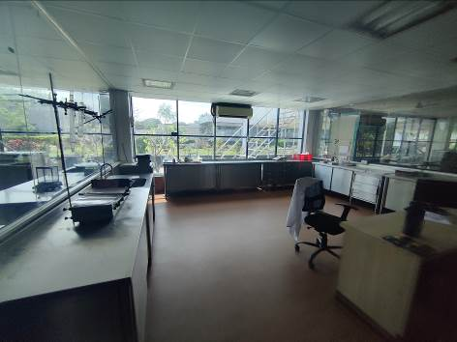
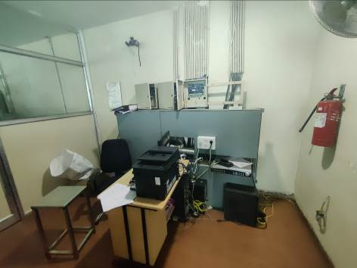
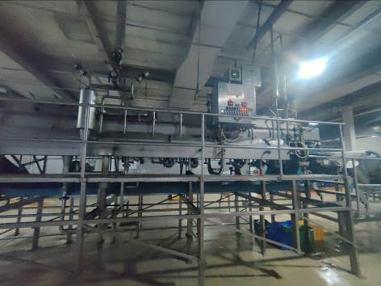
ACTUAL SITE PHOTOGRAPHS
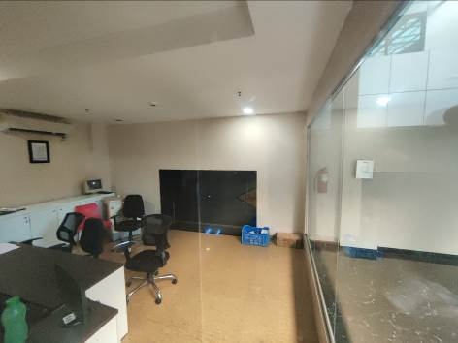
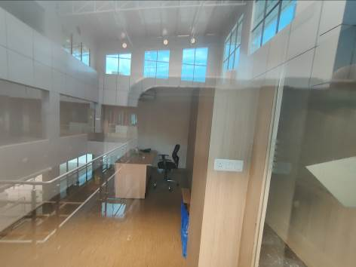
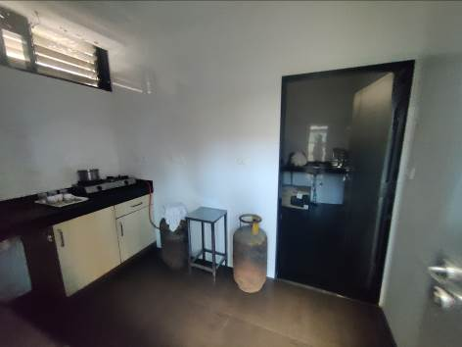
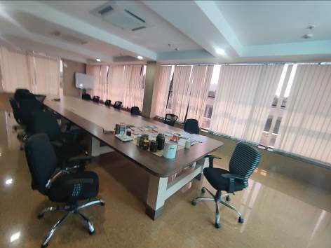
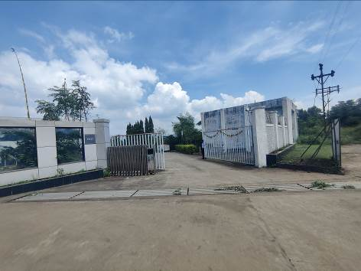
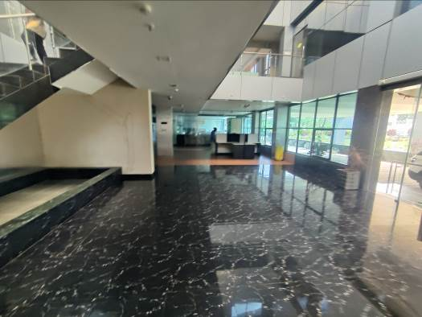
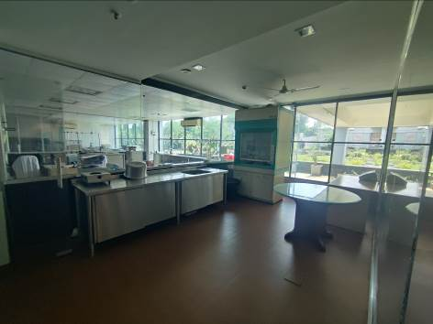
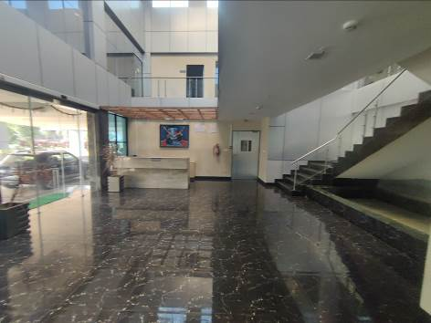
ACTUAL SITE PHOTOGRAPHS
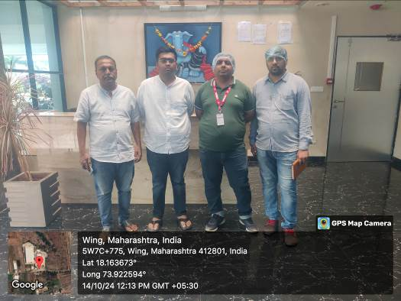
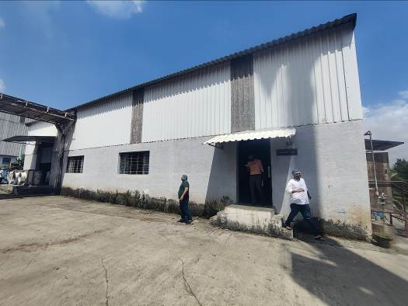
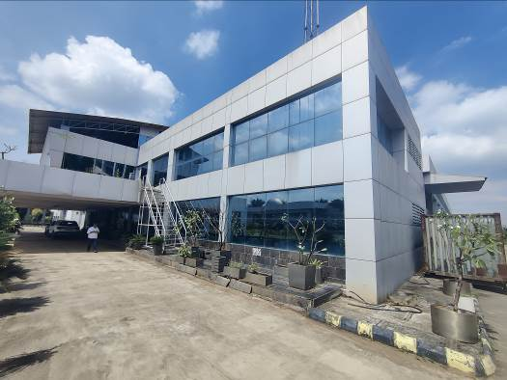
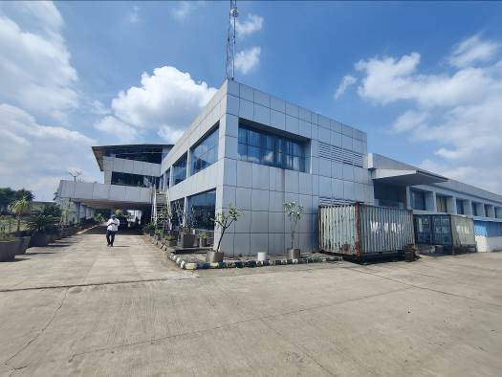
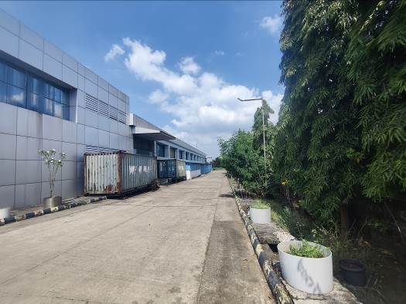
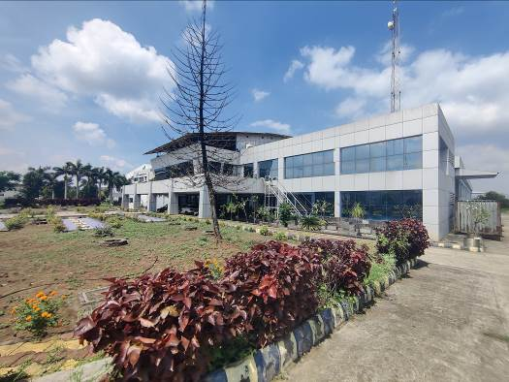
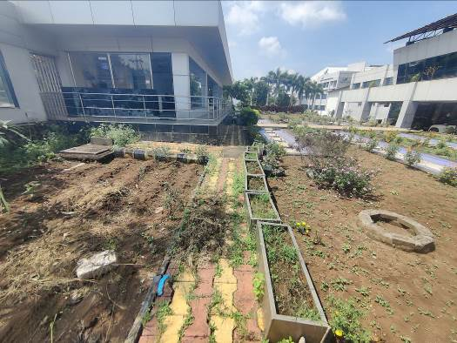
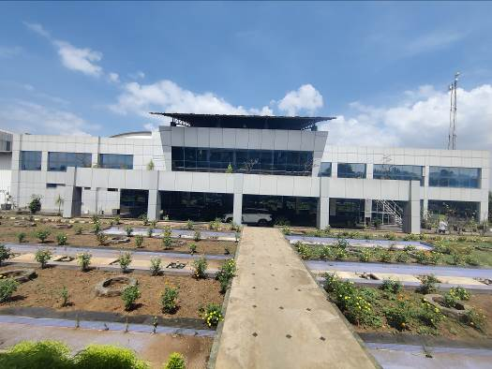
ROUTE MAP OF THE PROPERTY
Site u/r
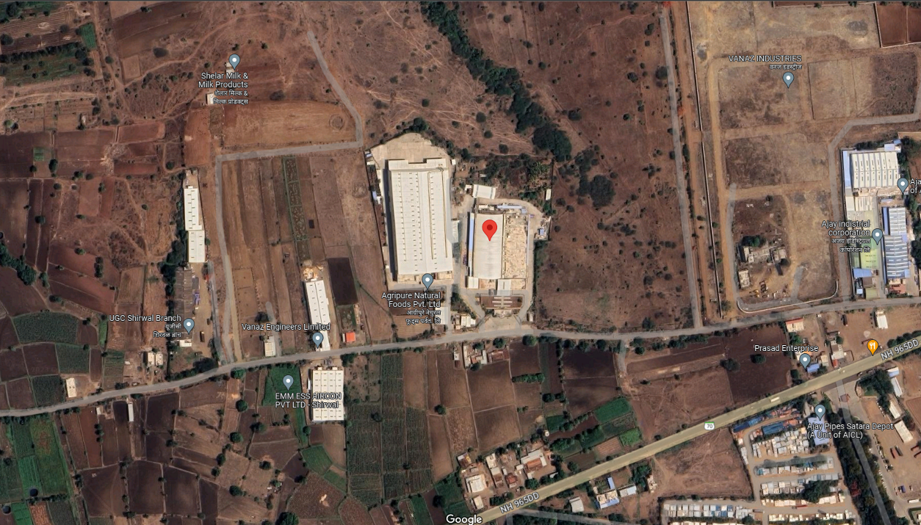

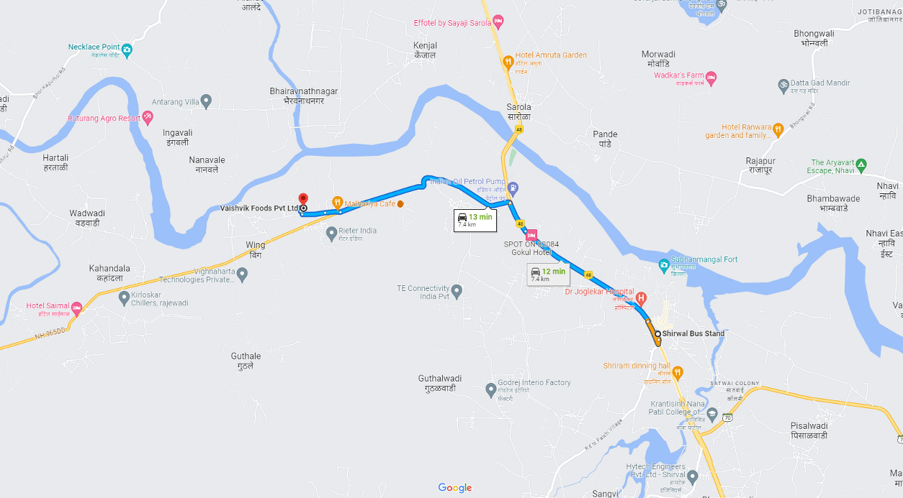

Longitude Latitude: 18°09'50.7"N 73°55'21.3"E
Note: The Blue line shows the route to site from nearest bus station (Shirwal – 7.40 Km.)

READY RECKONER RATE
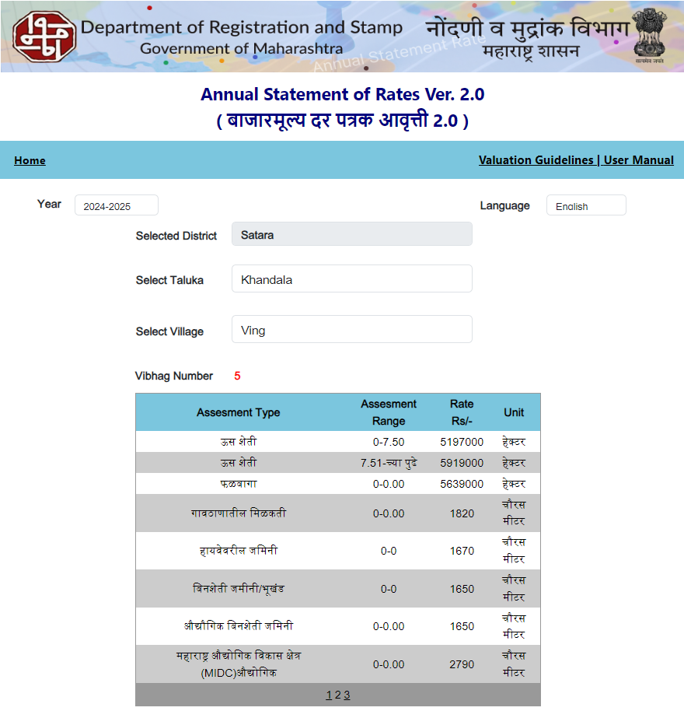

PRICE INDICATOR

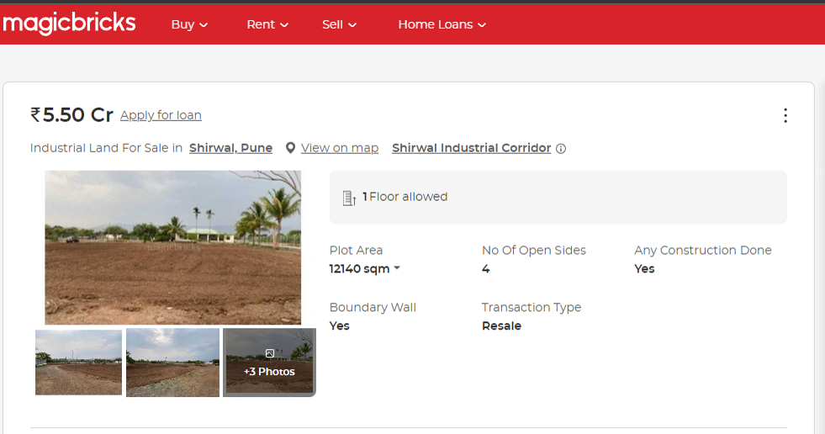
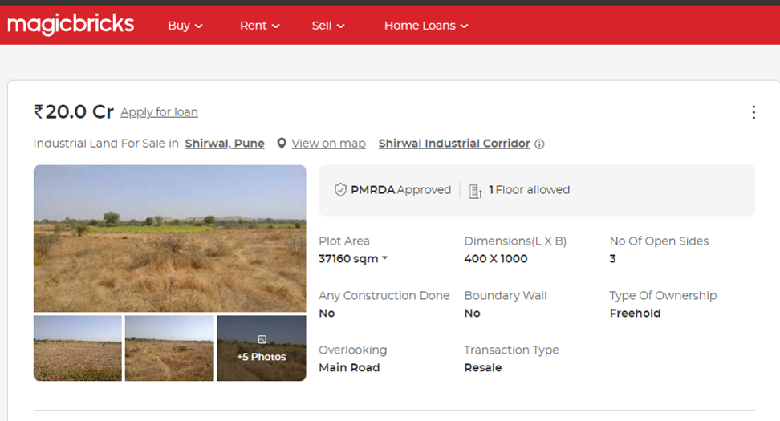
PRICE INDICATOR

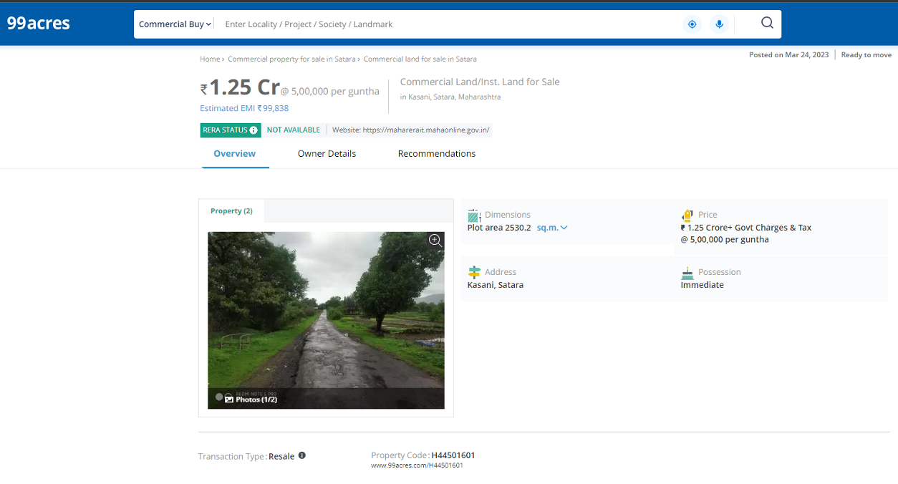
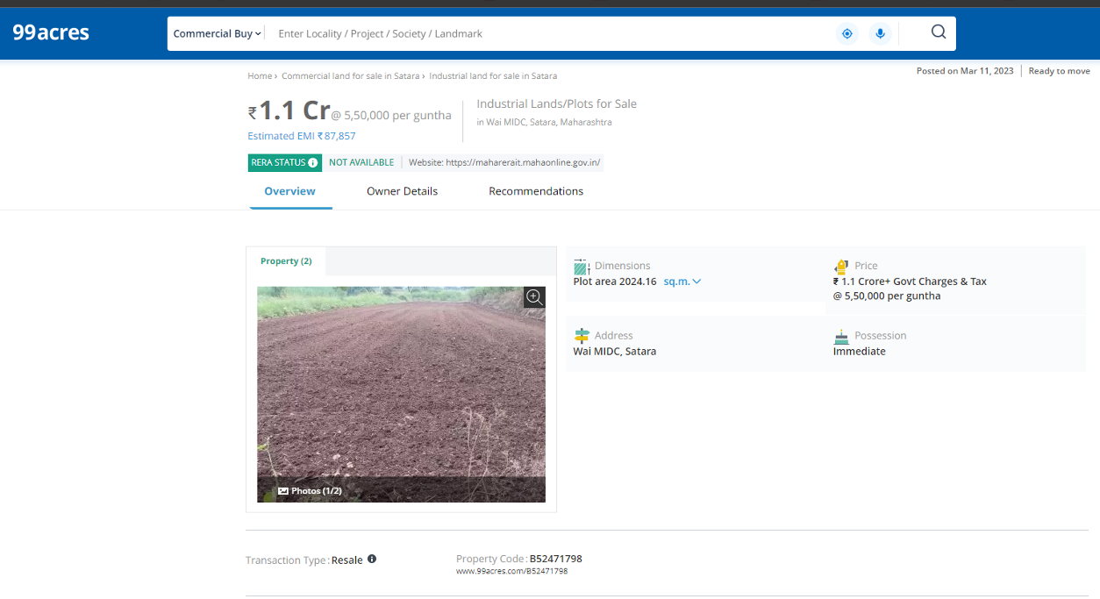
JUSTIFICATION FOR PRICE /RATE

The Market Value of the property is based on facts of markets discovered by us during our enquiries, however the government rate value in this case is less than the market value arrived by us. We are of the opinion that the value arrive by us will prove to be correct if an Auction of the subject property is carried out. As far as Market Value in Index II / Property Documents is concerned, it is not possible to comment on same, may be government rates are fixed by sampling during same point of time in part and whereas, Market values change every month.
In most of the cases the actual deal amount or Transaction value is not reflected in Index II / Property Documents because of various Market practices. As Valuer, we always try to give a value which is correct reflection of actual transaction value irrespective of any factors in market.
We Hope this will satisfy your requirements.

As a result of my appraisal and analysis, it is my considered opinion that of the above property in the prevailing condition with aforesaid specifications is assessed for SARFAESI Securitization and Reconstruction of Financial Assets and Enforcement of Security Interest Act, 2002 ` 14,30,24,110.00 (Rupees Fourteen Crores Thirty Lakh Twenty Four Thousand One Hundred Ten Only). The Realizable Value of the above property is ` 12,15,70,494.00 (Rupees Twelve Crores Fifteen Lakh Seventy Thousand Four Hundred Ninety Four Only). The Distress Value ` 10,01,16,877.00 (Rupees Ten Crores One Lakh Sixteen Thousand Eight Hundred Seventy Seven Only).

Date: 25.10.2024
Place: Mumbai

Sharadkumar B. Chalikwar
Govt. Reg. Valuer &
Chartered Engineer (India)
Reg. No. (N) CCIT/1-14/52/2008-09

The undersigned has inspected the property detailed in the Valuation Report dated _______________________

on ____________________. We are satisfied that the fair and reasonable market value of the property is

`_________________________ (Rupees ________________________________________________________

________________________________________only).

Date
Signature
(Name & Designation of the Inspecting Official/s)

Countersigned
(BRANCH MANAGER)

Enclosures
 | Declaration-cum-undertaking from the valuer (Annexure- II) | Attached
 | Model code of conduct for valuer - (Annexure - III) | Attached
(Annexure-II)

DECLARATION FROM VALUERS

I, hereby declare that:
- The information furnished in my valuation report dated 25.10.2024 is true and correct to the best of my knowledge and belief and I have made an impartial and true valuation of the property.

- I have no direct or indirect interest in the property valued;

- I/ my authorized representative have personally inspected the property on 14.10.2024. The work is not sub - contracted to any other valuer and carried out by myself.

- I have not been convicted of any offence and sentenced to a term of Imprisonment;

- I have not been found guilty of misconduct in my professional capacity.

- I have read the Handbook on Policy, Standards and procedure for Real Estate Valuation, 2011 of the IBA and this report is in conformity to the "Standards" enshrined for valuation in the Part - B of the above handbook to the best of my ability.

- I have read the International Valuation Standards (IVS) and the report submitted to the Bank for the respective asset class is in conformity to the "Standards" as enshrined for valuation in the IVS in "General Standards" and "Asset Standards" as applicable. The valuation report is submitted in the prescribed format of the bank.

- I abide by the Model Code of Conduct for empanelment of valuer in the Bank. (Annexure III - A signed copy of same to be taken and kept along with this declaration)

- I am registered under Section 34 AB of the Wealth Tax Act, 1957.

- I am Chairman & Managing Director of the company, who is competent to sign this valuation report.

- Further, I hereby provide the following information

Sr. | Particulars | Valuer comment
 | Background information of the asset being valued; | The property under consideration is owned by M/s. Vaishvik Foods Pvt. Ltd.
 | Purpose of valuation and appointing authority | As per the request from Union Bank of India, SAMB Fort to assess Market value of the property for SARFAESI (Securitisation and Reconstruction of Financial Assets and Enforcement of Security Interest Act, 2002) purpose.
 | Identity of the valuer and any other experts involved in the valuation; | Sharadkumar B. Chalikwar – Regd. Valuer  Manoj B. Chalikwar – Regd. Valuer  Umang Patel – Regd. Valuer  Prayush Parekh – Senior Valuation Engineer  Saiprasad Patil – Valuation Engineer
 | Disclosure of valuer interest or conflict, if any; | We have no interest, either direct or indirect, in the property valued. Further to state that we do not have relation or any connection with property owner / applicant directly or indirectly. Further to state that we are an independent Valuer and in no way related to property owner / applicant
 | Date of appointment, valuation date and date of report; | Date of Appointment – 10.10.2024  Valuation Date – 25.10.2024  Date of Report – 25.10.2024
 | Inspections and/or investigations undertaken; | Physical Inspection done on 14.10.2024
 | Nature and sources of the information used or relied upon; | - Market Survey at the time of site visit  - Ready Reckoner rates / Circle rates  - Online search for Registered Transactions  - Online Price Indicators on real estate portals  - Enquiries with Real estate consultants  - Existing data of Valuation assignments carried out by us
 | Procedures adopted in carrying out the valuation and valuation standards followed; | Land and Building Method
 | Restrictions on use of the report, if any; | This valuation is for the use of the party to whom it is addressed and for no other purpose. No responsibility is accepted to any third party who may use or rely on the whole or any part of this valuation. The valuer has no pecuniary interest that would conflict with the proper valuation of the property.
 | Major factors that were taken into account during the valuation; | current market conditions, demand and supply position, Commercial shop size, location, upswing in real estate prices, sustained demand for Commercial shop, all round development of commercial and residential application in the locality etc.
 | Caveats, limitations and disclaimers to the extent they explain or elucidate the limitations faced by valuer, which shall not be for the purpose of limiting his responsibility for the valuation report. | Attached

ASSUMPTIONS, DISCLAIMERS, LIMITATIONS & QUALIFICATIONS

Value Subject to Change
The subject appraisal exercise is based on prevailing market dynamics as on 25th October 2024 and does not take into account any unforeseeable developments which could impact the same in the future.
Our Investigations
We are not engaged to carry out all possible investigations in relation to the subject property. Where in our report we identify certain limitations to our investigations, this is to enable the reliant party to instruct further investigations where considered appropriate or where we recommend as necessary prior to reliance. Vastukala Consultants India Pvt. Ltd. (VCIPL) is not liable for any loss occasioned by a decision not to conduct further investigations
Assumptions
Assumptions are a necessary part of undertaking valuations. VCIPL adopts assumptions for the purpose of providing valuation advise because some matters are not capable of accurate calculations or fall outside the scope of our expertise, or out instructions. The reliant party accepts that the valuation contains certain specific assumptions and acknowledge and accept the risk of that if any of the assumptions adopted in the valuation are incorrect, then this may have an effect on the valuation.
Information Supplied by Others
The appraisal is based on the information provided by the client. The same has been assumed to be correct and has been used for appraisal exercise. Where it is stated in the report that another party has supplied information to VCIPL, this information is believed to be reliable but VCIPL can accept no responsibility if this should prove not to be so.
Future Matters
To the extent that the valuation includes any statement as to a future matter, that statement is provided as an estimate and/or opinion based on the information known to VCIPL at the date of this document. VCIPL does not warrant that such statements are accurate or correct.
Map and Plans
Any sketch, plan or map in this report is included to assist the reader while visualizing the property and assume no responsibility in connection with such matters.
Site Details
Based on inputs received from Client's representative and site visit conducted, we understand that the subject property is currently a contiguous and industrial land parcel admeasuring 12,850.50 Sq. M. and structures thereof. The property is owned by M/s. Vaishvik Foods Pvt. Ltd. At present, the property is Owner Occupied. Further, VCIPL has assumed that the subject property is free from any encroachment and is available as on the date of the appraisal.
Property Title
Based on our discussion with the banker we understand that the property is owned by M/s. Vaishvik Foods Pvt. Ltd. For the purpose of this appraisal exercise, we have assumed that the subject property has a clear title and is free from any encumbrances, disputes and claims. VCIPL has made no further enquiries with the relevant local authorities in this regard and does not certify the property as having a clear and marketable title. Further, no legal advice regarding the title and ownership of the subject property has been obtained for the purpose of this appraisal exercise. It has been assumed that the title deeds are clear and marketable.
Environmental Conditions
We have assumed that the subject property is not contaminated and is not adversely affected by any existing or proposed environmental law and any processes which are carried out on the property are regulated by environmental legislation and are properly licensed by the appropriate authorities.
Town Planning
The permissible land use, zoning, achievable FSI, area statement adopted for purpose of this valuation is based on the information provided by the Client's representative and the same has been adopted for this valuation purpose. VCIPL has assumed the same to be correct and permissible. VCIPL has not validated the same from any authority.
Area
Based on the documents, we understand that the subject property is contiguous and industrial land parcel admeasuring 12,850.50 Sq. M. and structure thereof.
Condition & Repair
In the absence of any information to the contrary, we have assumed that there are no abnormal ground conditions, nor archaeological remains present which might adversely affect the current or future occupation, development or value of the property. The property is free from rat, infestation, structural or latent defect. No currently known deleterious or hazardous materials or suspect techniques will be used in the construction of or subsequent alteration or additions to the property and comments made in the property details do not purport to express an opinion about, or advise upon, the condition of uninspected parts and should not be taken as making an implied representation or statement about such parts

Valuation Methodology
For the purpose of this valuation exercise, the valuation methodology used is Direct Comparison Approach Method and proposed Highest and Best Use model is used for analysing development potential.
The Direct Comparison Approach involves a comparison of the property being valued to similar properties that have actually been sold in arms - length transactions or are offered for sale. This approach demonstrates what buyers have historically been willing to pay (and sellers willing to accept) for similar properties in an open and competitive market and is particularly useful in estimating the value of the land and properties that are typically traded on a unit basis.
In case of inadequate recent transaction activity in the subject micro-market, the appraiser would collate details of older transactions. Subsequently, the appraiser would analyse rental / capital value trends in the subject micro-market in order to calculate the percentage increase / decrease in values since the date of the identified transactions. This percentage would then be adopted to project the current value of the same.
Where reliance has been placed upon external sources of information in applying the valuation methodologies, unless otherwise specifically instructed by Client and/or stated in the valuation, VCIPL has not independently verified that information and VCIPL does not advise nor accept it as reliable. The person or entity to whom the report is addressed acknowledges and accepts the risk that if any of the unverified information in the valuation is incorrect, then this may have an effect on the valuation.
Not a Structural Survey
We state that this is a valuation report and not a structural survey
Other
All measurements, areas and ages quoted in our report are approximate
Legal
We have not made any allowances with respect to any existing or proposed local legislation relating to taxation on realization of the sale value of the subject property. VCIPL is not required to give testimony or to appear in court by reason of this appraisal report, with reference to the property in question, unless arrangement has been made thereof. Further, no legal advice on any aspects has been obtained for the purpose of this appraisal exercise
Property specific assumptions
Based on inputs received from the client and site visit conducted, we understand that the subject property is currently vacant and under Bank Possession, contiguous and industrial land parcel admeasuring 12,850.50 Sq. M. and structure thereof.

(Annexure - III)
MODEL CODE OF CONDUCT FOR VALUERS
{Adopted in line with Companies (Registered Valuers and Valuation Rules, 2017)}
All valuers empanelled with bank shall strictly adhere to the following code of conduct:
Integrity and Fairness
- A valuer shall, in the conduct of his/its business, follow high standards of integrity and fairness in all his/its dealings with his/its clients and other valuers.
- A valuer shall maintain integrity by being honest, straightforward, and forthright in all professional relationships.
- A valuer shall endeavour to ensure that he/it provides true and adequate information and shall not misrepresent any facts or situations.
- A valuer shall refrain from being involved in any action that would bring disrepute to the profession.
- A valuer shall keep public interest foremost while delivering his services.
Professional Competence and Due Care
- A valuer shall render at all times high standards of service, exercise due diligence, ensure proper care and exercise independent professional judgment.
- A valuer shall carry out professional services in accordance with the relevant technical and professional standards that may be specified from time to time.
- A valuer shall continuously maintain professional knowledge and skill to provide competent professional service based on up-to-date developments in practice, prevailing regulations / guidelines and techniques.
- In the preparation of a valuation report, the valuer shall not disclaim liability for his/its expertise or deny his/its duty of care, except to the extent that the assumptions are based on statements of fact provided by the company or its auditors or consultants or information available in public domain and not generated by the valuer.
- A valuer shall not carry out any instruction of the client insofar as they are incompatible with the requirements of integrity, objectivity and independence.
- A valuer shall clearly state to his client the services that he would be competent to provide and the services for which he would be relying on other valuers or professionals or for which the client can have a separate arrangement with other valuers.
Independence and Disclosure of Interest
- A valuer shall act with objectivity in his/its professional dealings by ensuring that his/its decisions are made without the presence of any bias, conflict of interest, coercion, or undue influence of any party, whether directly connected to the valuation assignment or not.
- A valuer shall not take up an assignment if he/it or any of his/its relatives or associates is not independent in terms of association to the company.
- A valuer shall maintain complete independence in his/its professional relationships and shall conduct the valuation independent of external influences.
- A valuer shall wherever necessary disclose to the clients, possible sources of conflicts of duties and interests, while providing unbiased services.
- A valuer shall not deal in securities of any subject company after any time when he/it first becomes aware of the possibility of his / its association with the valuation, and in accordance with the Securities and Exchange Board of India (Prohibition of Insider Trading)Regulations,2015 or till the time the valuation report becomes public, whichever is earlier.
- A valuer shall not indulge in "mandate snatching" or offering "convenience valuations" in order to cater to a company or client's needs.
- As an independent valuer, the valuer shall not charge success fee. (Success fees may be defined as a compensation / incentive paid to any third party for successful closure of transaction. In this case, approval of credit proposals).
- In any fairness opinion or independent expert opinion submitted by a valuer, if there has been a prior engagement in an unconnected transaction, the valuer shall declare the association with the company during the last five years.
Confidentiality
- A valuer shall not use or divulge to other clients or any other party any confidential information about the subject company, which has come to his / its knowledge without proper and specific authority or unless there is a legal or professional right or duty to disclose.
Information Management
- A valuer shall ensure that he/ it maintains written contemporaneous records for any decision taken, the reasons for taking the decision, and the information and evidence in support of such decision. This shall be maintained so as to sufficiently enable a reasonable person to take a view on the appropriateness of his /its decisions and actions.
- A valuer shall appear, co-operate and be available for inspections and investigations carried out by the authority, any person authorised by the authority, the registered valuers organisation with which he/it is registered or any other statutory regulatory body.
- A valuer shall provide all information and records as may be required by the authority, the Tribunal, Appellate Tribunal, the registered valuers organisation with which he/it is registered, or any other statutory regulatory body.
- A valuer while respecting the confidentiality of information acquired during the course of performing professional services, shall maintain proper working papers for a period of three years or such longer period as required in its contract for a specific valuation, for production before a regulatory authority or for a peer review. In the event of a pending case before the Tribunal or Appellate Tribunal, the record shall be maintained till the disposal of the case.
Gifts and hospitality:
- A valuer or his / its relative shall not accept gifts or hospitality which undermines or affects his independence as a valuer.
Explanation: For the purposes of this code the term 'relative' shall have the same meaning as defined in clause (77) of Section 2 of the Companies Act, 2013 (18 of 2013).
- A valuer shall not offer gifts or hospitality or a financial or any other advantage to a public servant or any other person with a view to obtain or retain work for himself / itself, or to obtain or retain an advantage in the conduct of profession for himself / itself.
Remuneration and Costs.
- A valuer shall provide services for remuneration which is charged in a transparent manner, is a reasonable reflection of the work necessarily and properly undertaken, and is not inconsistent with the applicable rules.
- A valuer shall not accept any fees or charges other than those which are disclosed in a written contract with the person to whom he would be rendering service.
Occupation, employability and restrictions.
- A valuer shall refrain from accepting too many assignments, if he/it is unlikely to be able to devote adequate time to each of his/ its assignments.
- A valuer shall not conduct business which in the opinion of the authority or the registered valuer organisation discredits the profession.

DEFINITION OF VALUE FOR THIS SPECIFIC PURPOSE

This exercise is to assess Fair Market Value of the property under reference as on 17th July 2023.

The term Fair Market Value is defined as

“The most probable price, as of a specified date, in cash, terms equivalent to cash, or in other precisely revealed terms for which the specified property rights would sell after reasonable exposure in a competitive market under all conditions requisite to a fair sale, with the buyer and seller each acting prudently knowledgeably and for self interest assuming that neither is under undue duress”.
Fundamental assumptions and conditions presumed in this definition are:

1. Buyer and seller are motivated by self-interest.
2. Buyer and seller are well informed and are acting prudently.
3. The property is exposed for a reasonable time on the open market.
4. Payment is made in cash or equivalent or in specified financing terms.
DECLARATION OF PROFESSIONAL FEES CHARGED

We hereby declare that, our professional fees are not contingent upon the valuation findings. However, if the statute AND/OR clients demands that, the fees should be charged on the percentage of assessed value then, with the full knowledge of the AND/OR end user, it is being charged accordingly.
VALUATION OF THE PROPERTY PREMISES
Considering various parameters recorded, existing economic scenario, and the information that is available with reference to the development of neighborhood and method selected for valuation, we are of the opinion that, the property premises can be assessed and Fair market value for SARFAESI Securitization and Reconstruction of Financial Assets and Enforcement of Security Interest Act, 2002,
Particulars | Fair Market Value In (`) | Realizable Value In (`) | Distress Sale Value In (`)
Land and Building | 14,30,24,110.00 | 12,15,70,494.00 | 10,01,16,877.00

Sharadkumar B. Chalikwar
Govt. Reg. Valuer &
Chartered Engineer (India)
Reg. No. (N) CCIT/1-14/52/2008-09

