Vastu/Nashik/07/2024/0010070/2307330
22/7-334-RPBS
Date: 23.10.2024

To, `
The Branch Manager,
Bank of Baroda
Regional Office Nashik Road Branch
BSNL Building, Datta Mandir Road, Nashik Road,
Nashik -422 101, State - Maharashtra, Country - India.

Sub: Vetting of Extra Work

Sir,

With reference to above subject, we have evaluated the Extra Work for Residential Bungalow No.2, Ground + First Floor, Gat No.2460, Plot No.37, Behind Shinde Lawns, Shivaji Nagar , At - Ozar, Taluka- Niphad & District - Nashik,PIN Code – 422 207, State – Maharashtra, Country – India belongs to Mahesh Manohar Bharati & Dipa Mahesh Bharati Dipa Vitthal Puri (Before Marriage)

We have verified the rates quoted as per current market rates. Details of Extra Work considered as per Vetting of Extra Work issued by to Mahesh Manohar Bharati (First Party) and Vishwakarma Furniture (Second Party) received on dated 12.09.2024. The Extra Work amount is Rs.20,98,000/- (Rupees Twenty Lakh Ninety Eight Thousand Only.)

The said Cost Vetting Certificate is valid upto next 6 months Only.

Thanking you

Sincerely yours

Manoj B. Chalikwar
Registered Valuer
Chartered Engineer (India)
Reg. No. CAT-I-F-1763
Reg. No. IBBI/RV/07/2018/10366
BOB Empanelment No.: ZO:MZ:ADV:46:941
Encl: Valuation report.

Vetting of Extra Work
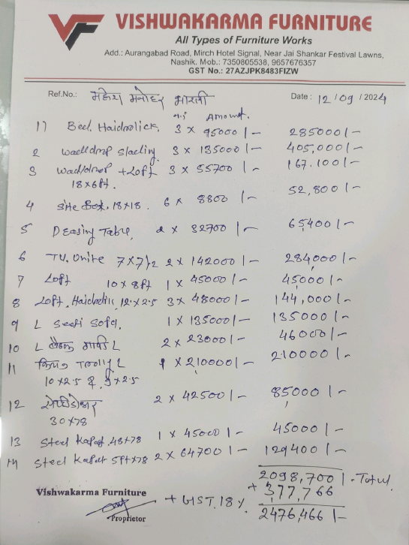

The Extra Work amount is Rs.20,98,000/- (Rupees Twenty Lakh Ninety Eight Thousand Only.)

