3rd LENDERS INDEPENDENT ENGINEER REPORT
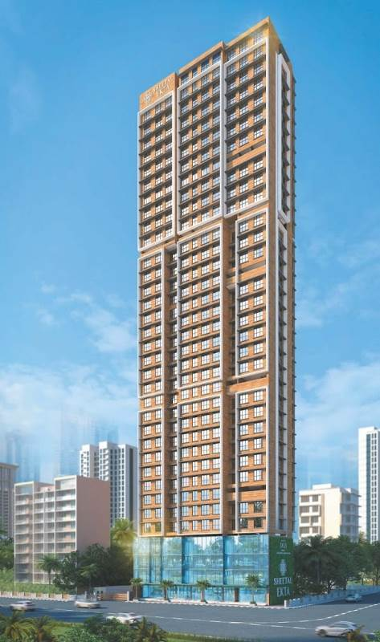

Details of the property under consideration:

Name of Project: “Sheetal Ekta”

"Sheetal Ekta", Proposed Redevelopment of existing building No. 18 – A & B, known as
Dindoshi Ekta CHSL on Plot bearing S. No. 31 & 39, CTS. No. 110(pt.) & 146 (pt.),
Shivdham Complex, Gen. A. K. Vaidya Marg, Village – Dindoshi, Malad (East),
Mumbai – 400 097, State – Maharashtra, Country – India

Latitude Longitude: 19°10'32.1"N 72°51'40.3"E

Intended User:

State Bank of India
SME Chembur Branch
Unit No. 11, Building No. 11, Ground Floor, Corporate Park, Sion Trombay Road,
Chembur, Mumbai, Pin Code – 400 071, State - Maharashtra, Country – India

Vastu/SBI/Mumbai/10/2024/12027/2308772
23/12-312-PY
Date: - 21.10.2024

THIRD LENDERS INDEPENDENT ENGINEER REPORT

To,
State Bank of India
SME Chembur Branch
Unit No. 11, Building No. 11,
Ground Floor, Corporate Park,
Sion Trombay Road, Chembur,
Mumbai, Pin Code – 400 071,
State - Maharashtra, Country – India

Subject: Construction of Proposed Redevelopment of existing building No. 18 – A & B, known as Dindoshi Ekta CHSL on Plot bearing S. No. 31 & 39, CTS. No. 110(pt.) & 146 (pt.), Shivdham Complex, Gen. A. K. Vaidya Marg, Village – Dindoshi, Malad (East), Mumbai – 400 097, State – Maharashtra, Country – India.

Ref: You’re Request for Lenders Independent Engineer Report of under Construction Building.
Dear Sir,
- As per your instruction, we have inspected the under-construction Rehab and Sale Building project situated on plot bearing C S. No. 31 & 39, CTS. No. 110(pt.) & 146 (pt.), Shivdham Complex, Gen. A. K. Vaidya Marg, Village – Dindoshi, Malad (East), Mumbai – 400 097, State – Maharashtra, Country – India which is being developed by M/s. DGS Township Pvt. Ltd. in order to give the physical progress at site and to certify cost incurred towards project as on 30/03/2024.
- The Construction work as per approved plan was in progress during the site visit on 06th July 2024.
- Status of work:
- For Sales Building (Wing A & B): 20th floor slab work is completed, Ground to 12th Floor & 14th & 15th floor Blockwork, Plaster work, Ground to 3rd tiling, flooring, door and windows, electrical work, plumbing work, Lift, firefighting, painting, sanitary fitting work are completed. 21st floor shuttering work is in progress.
- As per cost incurred certificate issued by CA Certificate actual total expenditure occurred as on 30/096/2024 is ` 79.71 Cr. for Commercial cum Residential of Sale Building (Wing A & B) is proposed of Basement + Ground Floor + 1st to 33rd Upper Floors.
- Overall financial progress as per C.A. certificate including land cost as on 30/09/2024 is 68.44% estimated cost of project.
- Overall Physical progress of the sale building construction as on 07/10/2024 is 41.37% as per physical site inspection.

- Overall Physical progress of the sale building construction including Mivan Material on Site as on 07/10/2024 is 43.75%.

- Construction Cost of the sale building construction including Mivan Material, other material on site & Advance payment to the Vendors till 30/09/2024 is 56.06% as per bills.

DECLARATION
- The information furnished in the report is based on our 3rd site visit Dated 07/10/2024 & Document Provided by Client.
- Vastukala 2nd LIE Report of the project dated 21/10/2024.
- Vastukala Project Report of the project dated 18/09/2023.
- Vastukala Cost Vetting Report dated 18/09/2023.
- I have no direct and indirect interest in the property examined for report.
- I have not been found guilty of misconduct in my professional capacity.

Manoj B. Chalikwar
Registered Valuer
Chartered Engineer (India)
Reg. No. IBBI/RV/07/2018/10366

Encl.: LIE report

Purpose & Methodology
• State Bank of India Banks and financial institutions require monitoring & an independent review of the progress of the sanctioned projects
VCIPL undertakes such study to independently review the progress of the project and put forward a comprehensive analysis

Advantages:
- Assurance on present practices
- Identification of risk
- Analyzing the performance of third parties
- Recommendations

The Methodology
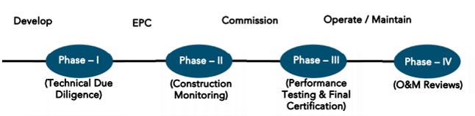
THIRD LENDERS INDEPENDENT ENGINEER REPORT
OF
"SHEETAL EKTA"

"Sheetal Ekta", Proposed Redevelopment of existing building No. 18 – A & B, known as Dindoshi Ekta CHSL on Plot bearing S. No. 31 & 39, CTS. No. 110(pt.) & 146 (pt.), Shivdham Complex, Gen. A. K. Vaidya Marg, Village – Dindoshi, Malad (East), Mumbai – 400 097, State – Maharashtra, Country – India

Latitude Longitude: 19°10'32.1"N 72°51'40.3"E

NAME OF DEVELOPER: M/s. DGS Township Pvt. Ltd.
Pursuant to instructions from State of India, SME Chembur Branch, Chembur we have duly visited, inspected, surveyed & assessed the above said property on 07th October 2024 to determine the fair & reasonable market value of the said property/project as on Quarter ending 30th September 2024 for LIE purpose.

1. Location Details:
Proposed Redevelopment of existing building No. 18 – A & B, known as Dindoshi Ekta CHSL on Plot bearing S. No. 31 & 39, CTS. No. 110(pt.) & 146 (pt.), Shivdham Complex, Gen. A. K. Vaidya Marg, Village – Dindoshi, Malad (East), Mumbai – 400 097. It is about 2.60 Km. travelling distance from Malad (East) Railway station. Surface transport to the property is by buses, taxis & private vehicles. The property is in developed locality. All the amenities like shops, banks, hotels, markets, schools, hospitals, etc. are all available in the surrounding locality. The area is higher middle class & developed.

2. Developer Details:
Name of builder | M/s. DGS Township Pvt. Ltd.
Project Rera Registration Number | P51800051884
Registered office address | DGS house, 1st floor, Sheetal Krupa, Aarey Road, Walawalkar Street, Goregaon (E), Mumbai – 400 063, State - Maharashtra, Country – India
Contact details | Contact Person:  Mr. Prabudh Khandelwal (Consultants)  Mobile No. 7738001775  Mr. Deep Shah (Consultants)  Mobile No. 7977861026
E – mail ID and website
3. Boundaries of the Property:
Direction | Particulars
On or towards North | Aster Tower
On or towards South | Road & Omkar CHSL
On or towards East | Sagar Society
On or towards West | Khatu Shyam Mandir Road

Introduction
As per Information on site M/s. DGS Township Pvt. Ltd. has acquired land by Developer Agreement dated 27.03.2021 through registered agreement vide No. BRL-9-4567-2021 dated 27.03.2021 admeasuring area is 1,128.58 Sq. M. bearing S. No. 31 & 39, CTS. No. 110(pt.) & 146 (pt.).
For the Proposed Commercial cum Residential (Rehab cum Sale) Building.

Area Statement:

Land:
Date | Particular | Area in Sq. M.
27.03.2021 | S. No. 31 & 39, CTS. No. 110(pt.) & 146 (pt.) | 1,128.58
TOTAL |  | 1,128.58

- Copy of Developer Agreement dated 27.03.2021 between M/s. Dindoshi Ekta Co-operative Housing Society Ltd. (The Society) and M/s. DGS Township Pvt. Ltd. (The Developers) through registered agreement vide No. BRL-9-4567-2021 dated 27.03.2021.
- Copy of Deed of Rectification cum Supplementary Agreement dated 29.04.2022 between M/s. Dindoshi Ekta Co-operative Housing Society Ltd. (The Owner) and M/s. DGS Township Pvt. Ltd. (The Developers) through registered agreement vide No. BLR-9-7335-2022 dated 29.04.2022.
- Copy of Special Power of Attorney through registered agreement vide No. BLR-9-12120-2021 dated 24.09.2021, M/s. Dindoshi Ekta Co-operative Housing Society Ltd. (The Society/ Executants) appoints Mr. Surajdev D. Shukla director of M/s. DGS Township Pvt. Ltd.

Building Area:

As per Approved Plan:
A | AREA STATEMENT
1 | Area of the plot (As per MHADA NOC & Demarcation) | 1,128.58
2 | Deduction for
a | Road Set back area | 34.25
b | Proposed Road | -
c | Any reservation | -
d | % Amenity space as per DCR 56 / 57 (Sub plot) | -
e | Other
 | Total ( a + b + c + d + e) | 34.25
3 | Balance Area of the plot (1 – 2) | 1,094.33
4 | Deduction for 15% recreational ground | -
 | 10% Amenity space (If deductible for IND)
5 | Net Area of Plot (3 – 4) | 1,094.33
6 | Additions for FSI purpose
2a | 100% for DP Road
2b | 100% for Set – back | 34.25
 | Total (2a + 2b) | 34.25
7 | Total Area (5 + 6) | 1,128.58
8 | FSI Permissible | 3.00
9 | - Permissible Floor Area (7 X 8) | 3,385.74
 | - Additional Layout FSI | 3,760.00
 | Total Permissible Area 9 (i) + 9 (ii) | 7,145.74
10 | Proposed Built up Area | 6,436.21
11 | Excess Balcony Area taken in floor space index | N.A.
12 | Total Proposed Area (10 + 11) | 6,436.21
B | Details of FSI Availed as per DCR 35 (4)
1 | Fungible Built up area component proposed vide DCR 35 (4) for purely residential = OR < (D(i) X 0.35) | 172.82
2 | Fungible Built up area component proposed vide DCR 35 (4) for non – residential = OR < (12 X 0.20) | 615.34
3 | Total Fungible Built up area vide DCR 35 (4) | 788.16
4 | Total BUA proposed including fungible compensatory area (12 + B(3)) | 7,224.37
5 | Permissible fungible area | 2,501.00
C | Prorata shares as per MHADA
1 | Prorata share as per letter No. CO/MB/REE/NOC/F-337/84 X 40 = 3,360 M. | 3,760.00
2 | Total Gross Built up area permissible | 9,646.74
3 | Total Gross Built up area proposed | 7,224.37
4 | No. CO/MB/REF/NOC/F-337/1047/2019
D | Tenement Statement
i | Total Gross Built up area proposed | 7,224.37
ii | Less Deduction of Non – Residential area (Shop, etc.) | 1,799.71
iii | Area available for tenements | 5,424.66
iv | FSI consumed on net holding | -
v | Fungible FSI consumed on net holding | -
vi | Tenements permissible | 381 nos.
vii | Tenements proposed | 60 nos.
viii | Tenements existing
 | Total Tenements on the plot
E | Parking Statement
i | Parking required by regulations for | 51 nos.
 | Car / Scooter / Motor cycle | As per area statement
 | Outsiders (visitors)
ii | Covered garages permissible
iii | Covered garages provided
 | Car
 | Scooter / Motor Cycle
 | Outsiders (visitors)
iv | Total Parking Provided | 77 nos.
F | Transport Vehicles parking
i | Spaces for transport vehicles parking required by regulations
ii | Total no. of transport vehicles parking spaces provided

As per Architect Drawing Plan/ Concession Plan:
A | AREA STATEMENT
1 | Area of the plot (As per MHADA NOC & Demarcation) | 1,128.58
2 | Deduction for
a | Road Set back area | 34.25
b | Proposed Road | -
c | Any reservation | -
d | % Amenity space as per DCR 56 / 57 (Sub plot) | -
e | Other
 | Total ( a + b + c + d + e) | 34.25
3 | Balance Area of the plot (1 – 2) | 1,094.33
4 | Deduction for 15% recreational ground | -
 | 10% Amenity space (If deductible for IND)
5 | Net Area of Plot (3 – 4) | 1,094.33
6 | Additions for FSI purpose
2a | 100% for DP Road
2b | 100% for Set – back | 34.25
 | Total (2a + 2b) | 34.25
7 | Total Area (5 + 6) | 1,128.58
8 | FSI Permissible | 3.00
9 | - FSI credit available by development right (restricted to % of the balance area vide 3 above) | -
 | Additions for FSI purpose
 | - 33% as per DCR 32 (2754.57 X 33%)
 | - External TDR (As per App. VII – B) (67%)
 | - Other
 | Total
10 | - Permissible Floor Area (7 X 8) + 9 | 3,385.74
 | - Additional Layout FSI | 3,760.00
 | Total Permissible Area 10 (i) + 10 (ii) | 7,145.74
11 | Proposed Built up Area | 7,120.51
 | - Existing Floor Area | N.A.
12 | Excess Balcony Area taken in floor space index | N.A.
13 | Total Proposed Area (10 + 11 + 12)
B | Details of FSI Availed as per DCR 35 (4)
1 | Fungible Built up area component proposed vide DCR 35 (4) for purely residential = OR < (D(i) X 0.35) | 2,124.31
2 | Fungible Built up area component proposed vide DCR 35 (4) for non – residential = OR < (12 X 0.20) | 367.87
3 | Total Fungible Built up area vide DCR 35 (4) | 2,492.18
4 | Total BUA proposed including fungible compensatory area (12 + B(3)) | 9,612.69
C | Prorata shares as per MHADA
1 | Prorata share as per letter No. CO/MB/REE/NOC/F-337/84 X 40 = 3,360 M. | 3,760.00
2 | Total Gross Built up area permissible | 13,372.69
3 | Total Gross Built up area proposed | 9,612.69
4 | No. CO/MB/REF/NOC/F-337/1047/2019
D | Tenement Statement
i | Total Gross Built up area proposed | 9,612.69
ii | Less Deduction of Non – Residential area (Shop, etc.) | 1,418.94
iii | Area available for tenements | 8,193.75
iv | FSI consumed on net holding | -
v | Fungible FSI consumed on net holding | -
vi | Tenements permissible | 381 nos.
vii | Tenements proposed | 125 nos.
viii | Tenements existing
 | Total Tenements on the plot
E | Parking Statement
i | Parking required by regulations for | 79 nos.
 | Car / Scooter / Motor cycle | As per area statement
 | Outsiders (visitors)
ii | Covered garages permissible
iii | Covered garages provided
 | Car
 | Scooter / Motor Cycle
 | Outsiders (visitors)
iv | Total Parking Provided | 111 nos.
F | Transport Vehicles parking
i | Spaces for transport vehicles parking required by regulations
ii | Total no. of transport vehicles parking spaces provided

List of Approvals:

- Copy of Intimation of Approval (IOA) Letter No. MH / EE / B. P. Cell / GM / MHADA – 61 / 1216 / 2022 dated 23.12.2022 issued by Maharashtra Housing and Area Development Authority (MHADA).
- Copy of Approved Plan No. MHADA – 61 / 1216 / 2022 dated 23.12.2022 issued by Maharashtra Housing and Area Development Authority (MHADA).
Approved upto: Basement + Ground Floor + 1st to 18th Upper Floors
- Copy of Building Concession Plan dated 30.07.2022 issued by Maharashtra Housing and Area Development Authority (MHADA).
Sanctioned Upto: Basement + Ground Floor + 1st to 33rd Upper Floors
- Copy of 1st Commencement Certificate No. MH/EE/(BP)/GM/MHADA-61/1216/2023/CC/1/New dated 22.05.2023 valid upto 21.05.2024 issued by Maharashtra Housing and Area Development Authority (MHADA).
(This CC is endorsed for the work for Top of Plinth level (i.e., height upto 0.30. mts AGL) as per approved IOA dated 23.12.2022)
- Copy of 2nd Further Commencement Certificate No. MH/EE/(BP)/GM/MHADA-61/1216/2023/FCC/1/New dated 20.09.2023 valid upto 21.05.2024 issued by Maharashtra Housing and Area Development Authority (MHADA).
(This CC is Further extended upto Top of 8th upper floor i.e., for building comprising of Basement for Shops with separate internal staircase from above shops + Ground Floor for Shops and parking tower system for Car – Parks + 1st to 3rd floor Offices (Rehab & Sales) + Service Floor (Between 3rd & 4th Floor and) + 4th Floor to 8th Floor for residential users having BUA adm. 3,585.01 Sq. M. with height 33.25 M. as per last approved IOA plans issued vide / no. MH/EE/(B.P.) Cell/GM/MHADA – 61/1216/2022 dated 23.12.2022)
- Copy of 3rd Further Commencement Certificate No. MH/EE/(BP)/GM/MHADA-61/1216/2024/FCC/1/New dated 18.04.2024 valid upto 21.05.2024 issued by Maharashtra Housing and Area Development Authority (MHADA).
(This CC is Further extended from 9th floor to top of 19th upper floors with height 70.43 mts. As per lasr approved amended plans issued dated 29.02.2024)

LEVEL OF COMPLETION:
For Sales Building (Wing A & B): 20th floor slab work is completed, Ground to 12th Floor & 14th & 15th floor Blockwork, Plaster work, Ground to 3rd tiling, flooring, door and windows, electrical work, plumbing work, Lift, firefighting, painting, sanitary fitting work are completed. 21st floor shuttering work is in progress.

Sales Building (Wing A & B)
Sr. | Floor No. | Construction Area in Sq. M. | Completed Area in Sq. M. | Work Completion as per 2nd LIE Report | Work Completion as on 07.10.2024
1 | Excavation & Shore Piling |  |  | Work is completed | Work is completed
2 | Basement Floor | 438.74 | 438.74 | Slab work is completed | Slab work, block work, plaster work, flooring, tiling work, electrical & plumbing, door & windows, lift, paintaing, fire fighting & santiary fitting work are completed
3 | Ground Floor | 486.07 | 486.07 | Slab work, block work, plaster work, flooring, tiling work, electrical & plumbing, door & windows work are completed | Slab work, block work, plaster work, flooring, tiling work, electrical & plumbing, door & windows, lift, paintaing, fire fighting & santiary fitting work are completed
4 | 1st Floor | 514.07 | 514.07 | Slab work, block work, plaster work, flooring, tiling work, electrical & plumbing, door & windows work are completed | Slab work, block work, plaster work, flooring, tiling work, electrical & plumbing, door & windows, lift, paintaing, fire fighting & santiary fitting work are completed
5 | 2nd Floor | 514.07 | 514.07 | Slab work, block work, plaster work, flooring, tiling work, electrical & plumbing, door & windows work are completed | Slab work, block work, plaster work, flooring, tiling work, electrical & plumbing, door & windows, lift, paintaing, fire fighting & santiary fitting work are completed
6 | 3rd Floor | 514.07 | 514.07 | Slab work, blockwork, plaster work & door and window frame work is completed | Slab work, block work, plaster work, flooring, tiling work, electrical & plumbing, door & windows, lift, paintaing, fire fighting & santiary fitting work are completed
7 | 4th Floor | 459.08 | 459.08 | Slab work & 80% Block work is completed | Slab work, Block work & Plaster work is completed
8 | 5th Floor | 459.08 | 459.08 | Slab work & 80% Block work is completed | Slab work, Block work & Plaster work is completed
9 | 6th Floor | 465.64 | 465.64 | Slab work & 80% Block work is completed | Slab work, Block work & Plaster work is completed
10 | 7th Floor | 459.08 | 459.08 | Slab work is completed | Slab work, Block work & Plaster work is completed
11 | 8th Floor | 459.08 | 459.08 | Slab work is completed | Slab work, Block work & Plaster work is completed
12 | 9th Floor | 459.08 | 459.08 | Slab work is completed | Slab work, Block work & Plaster work is completed
13 | 10th Floor | 459.08 | 459.08 | Slab work is completed | Slab work, Block work & Plaster work is completed
14 | 11th Floor | 459.08 | 459.08 | Slab work is completed | Slab work, Block work & Plaster work is completed
15 | 12th Floor | 459.08 | 459.08 | Slab work is completed | Slab work, Block work & Plaster work is completed
16 | 13th Floor | 465.64 | 465.64 | Slab work is completed | Slab work is completed
17 | 14th Floor | 459.08 | 459.08 | Shuttering work is in progress | Slab work, Block work & Plaster work is completed
18 | 15th Floor | 459.08 | 459.08 |  | Slab work, Block work & Plaster work is completed
19 | 16th Floor | 459.08 | 459.08 |  | Slab work is completed
20 | 17th Floor | 459.08 | 459.08 |  | Slab work is completed
21 | 18th Floor | 459.08 | 459.08 |  | Slab work is completed
22 | 19th Floor | 459.08 | 459.08 |  | Slab work is completed
23 | 20th Floor | 468.19 | 468.19 |  | Slab work is completed
24 | 21st Floor | 459.08 |  |  | Shuttering work is in progress,
25 | 22nd Floor | 459.08
26 | 23rd Floor | 459.08
27 | 24th Floor | 460.45
28 | 25th Floor | 460.45
29 | 26th Floor | 460.45
30 | 27th Floor | 467.98
31 | 28th Floor | 462.33
32 | 29th Floor | 462.33
33 | 30th Floor | 462.33
34 | 31st Floor | 462.33
35 | 32nd Floor | 462.33
36 | 33rd Floor | 459.65
37 | Terrace Floor / OHT / LMR | 114.39
Total |  | 16,405.79 | 10,293.54

Details of the Project as Financed By SBI:

Estimated Project Cost: (As per Cost Vetting Report)
Particulars | Estimated Cost (in Cr.)
Land & Stamp Cost | 1.56
Rent Cost | 14.71
Construction Cost of Rehab cum Sale Building | 57.23
Approval Cost including Premium Cost / FSI / GOM Charges / fees & TDR Cost | 27.73
Architect Cost, RCC & Other Professional Cost | 1.14
Administrative Cost | 2.86
Marketing Cost | 2.75
Interest Cost (Bank Loan) | 8.49
Total | 116.47

Project Cost: (as per C.A. Certificate)
Particulars | Incurred Cost (In Cr.) 30.06.2024 by M/s. Vinay Tiwari & Associates | Incurred Cost (In Cr.) 30.06.2024 by M/s. Vinay Tiwari & Associates | Net
Land & Stamp Cost | 1.56 | 1.56 | -
Rent Cost | 11.32 | 11.32 | -
Construction Cost of Rehab cum Sale Building | 32.08 | 22.47 | 11.10
Approval Cost including Premium Cost / FSI / GOM Charges / fees & TDR Cost | 28.20 | 28.71 | -0.51
Architect Cost, RCC & Other Professional Cost | 0.87 | 0.87 | -
Administrative Cost | 1.75 | 1.40 | 0.31
Marketing Cost | 1.37 | 1.09 | 0.28
Interest Cost (Bank Loan) | 1.11 | 0.50 | 0.61
Total | 78.27 | 67.92 | 11.79
- The Builder has incurred about 32.08 Cr. as construction cost, 28.20 Cr. for approval of project, 1.75 Cr. for admin cost, 1.37 Cr. for marketing Cost, 1.11 Cr. for interest cost till 30.09.2024 as per C.A. certificate issued by M/s. Vinay Tiwari & Associates dated 15.10.2024.

Project Cost: (as per Bills):
Particulars | Incurred Cost in ` Cr.
 | 30.09.2024 as per Bill (Inclusive GST) | 30.06.2024 as per Bill (Inclusive GST) | Net
Land Cost | 1.56 | 1.56 | -
Rent Cost | 11.32 | 11.32 | -
Construction cost of Rehab cum Sale Building | 32.08 | 26.87 | 5.22
Approval Cost including Premium Cost / FSI / GOM Charges / fees & TDR Cost | 28.20 | 28.71 | -0.51
Architect Cost, RCC & Other Professional Cost | 0.87 | 0.87 | -
Administrative Cost | 1.75 | 1.40 | 0.35
Marketing Cost | 1.37 | 1.09 | 0.28
Interest Cost | 1.11 | 0.50 | 0.61
Total | 78.27 | 72.32 | 5.95
Note:.

Land Cost:
Sr. No. | Agreement Name | Date | Particulars | Total Cost in ` | Incurred Cost in `
1 | Development Agreement | 3/27/2019 | Stamp Duty | 1,44,97,980.00 | 1,44,97,980.00
2 |  |  | Reg. Fees | 30,000.00 | 30,000.00
3 |  |  |  | 2,000.00 | 2,000.00
4 | Rectification Cum Supplementary Deed | 4/29/2022 | Stamp Duty | 10,86,200.00 | 10,86,200.00
5 |  |  | Reg. Fees | 30,000.00 | 30,000.00
6 | Special Power of Attorney | 3/27/2021 | Stamp Duty | 500.00 | 500.00
7 |  |  | Reg. Fees | 740.00 | 740.00
 | TOTAL |  |  | 1,56,47,420.00 | 1,56,47,420.00
As per agreement.
Summary of Bills
Sr. No. | Particulars | Amount in `  (till 30.09.2024) | Amount in ` (in Cr.) | Amount in `  (till 30.06.2024) | Amount in ` (in Cr.) | Net
1 | Construction Cost of Rehab cum Sale Building | 32,08,48,447.00 | 32.08 | 26,86,55,404.00 | 26.87 | 5.22
2 | Rent Cost | 11,32,01,250.00 | 11.32 | 11,31,65,000.00 | 11.32 | -
3 | Premium Cost / FSI / GOM Charges / fees / security Deposits & TDR Cost | 28,20,02,500.00 | 28.20 | 28,70,98,450.00 | 28.71 | -0.51
4 | Professional Cost | 87,29,352.00 | 0.87 | 87,05,250.00 | 0.87 | -
5 | Administrative Cost | 1,74,58,706.00 | 1.75 | 1,39,94,750.00 | 1.40 | 0.35
6 | Marketing Cost | 1,37,01,550.00 | 1.37 | 1,09,15,000.00 | 1.09 | 0.28
TOTAL |  | 75,59,41,805.00 | 75.59 | 50,29,56,705.00 | 50.30 | 5.34
Note: Bills were provided by the client up to 30.09.2024

Interest Cost:
Sr. No | Particulars | Estimate Amount in ` | Incurred Amount in ` (till 30.09.2024) | Incurred Amount in ` (till 30.06.2024) | Difference | Balance Amount in `
1 | Interest Cost | 8,49,00,000.00 | 1,11,00,000.00 | 50,00,000.00 | 61,00,000.00 | 7,38,00,000.00
TOTAL |  | 8,49,00,000.00 | 1,11,00,000.00 | 50,00,000.00 | 61,00,000.00 | 7,38,00,000.00

Cost of Construction as on 07th October 2024

Rehab cum Sales Building (Wing A & B)
Sr. | Floor | Total Construction Area in Sq. M. | Completed Area in Sq. Ft. | Rate per Sq. Ft. | Full Value after completion | % of work completed | Actual Expenditure till date in `
1 | Excavation Cost |  |  |  | 24,608,686.00 | 100% | 24,608,686.00
2 | Basement Floor | 438.74 | 438.74 | 30,000.00 | 13,162,092.00 | 98% | 1,28,98,850.16
3 | Ground Floor | 486.07 | 486.07 | 30,000.00 | 14,581,992.00 | 98% | 1,42,90,352.16
4 | 1st Floor | 514.07 | 514.07 | 30,000.00 | 15,421,992.00 | 98% | 1,51,13,552.16
5 | 2nd Floor | 514.07 | 514.07 | 30,000.00 | 15,421,992.00 | 98% | 1,51,13,552.16
6 | 3rd Floor | 514.07 | 514.07 | 30,000.00 | 15,421,992.00 | 98% | 1,51,13,552.16
7 | 4th Floor | 459.08 | 459.08 | 30,000.00 | 13,772,292.00 | 65% | 89,51,989.80
8 | 5th Floor | 459.08 | 459.08 | 30,000.00 | 13,772,292.00 | 65% | 89,51,989.80
9 | 6th Floor | 465.64 | 465.64 | 30,000.00 | 13,969,200.00 | 65% | 90,79,980.00
10 | 7th Floor | 459.08 | 459.08 | 30,000.00 | 13,772,292.00 | 65% | 89,51,989.80
11 | 8th Floor | 459.08 | 459.08 | 30,000.00 | 13,772,292.00 | 65% | 89,51,989.80
12 | 9th Floor | 459.08 | 459.08 | 30,000.00 | 13,772,292.00 | 65% | 89,51,989.80
13 | 10th Floor | 459.08 | 459.08 | 30,000.00 | 13,772,292.00 | 65% | 89,51,989.80
14 | 11th Floor | 459.08 | 459.08 | 30,000.00 | 13,772,292.00 | 65% | 89,51,989.80
15 | 12th Floor | 459.08 | 459.08 | 30,000.00 | 13,772,292.00 | 55% | 75,74,760.60
16 | 13th Floor | 465.64 | 465.64 | 30,000.00 | 13,969,200.00 | 55% | 76,83,060.00
17 | 14th Floor | 459.08 | 459.08 | 30,000.00 | 13,772,292.00 | 58% | 79,87,929.36
18 | 15th Floor | 459.08 | 459.08 | 30,000.00 | 13,772,292.00 | 58% | 79,87,929.36
19 | 16th Floor | 459.08 | 459.08 | 30,000.00 | 13,772,292.00 | 55% | 75,74,760.60
20 | 17th Floor | 459.08 | 459.08 | 30,000.00 | 13,772,292.00 | 55% | 75,74,760.60
21 | 18th Floor | 459.08 | 459.08 | 30,000.00 | 13,772,292.00 | 55% | 75,74,760.60
22 | 19th Floor | 459.08 | 459.08 | 30,000.00 | 13,772,292.00 | 50% | 68,86,146.00
23 | 20th Floor | 468.19 | 468.19 | 30,000.00 | 14,045,700.00 | 50% | 70,22,850.00
24 | 21st Floor | 459.08 |  | 30,000.00 | 13,772,292.00
25 | 22nd Floor | 459.08 |  | 30,000.00 | 13,772,292.00
26 | 23rd Floor | 459.08 |  | 30,000.00 | 13,772,292.00
27 | 24th Floor | 460.45 |  | 30,000.00 | 13,813,500.00
28 | 25th Floor | 460.45 |  | 30,000.00 | 13,813,500.00
29 | 26th Floor | 460.45 |  | 30,000.00 | 13,813,500.00
30 | 27th Floor | 467.98 |  | 30,000.00 | 14,039,400.00
31 | 28th Floor | 462.33 |  | 30,000.00 | 13,869,900.00
32 | 29th Floor | 462.33 |  | 30,000.00 | 13,869,900.00
33 | 30th Floor | 462.33 |  | 30,000.00 | 13,869,900.00
34 | 31st Floor | 462.33 |  | 30,000.00 | 13,869,900.00
35 | 32nd Floor | 462.33 |  | 30,000.00 | 13,869,900.00
36 | 33rd Floor | 459.65 |  | 30,000.00 | 13,789,500.00
37 | Terrace / OHT | 114.39 |  | 30,000.00 | 3,431,700.00
38 | Sub Total | 16,405.79 |  |  | 516,782,410.00 |  | 23,67,49,411.00
39 | Parking | 111.00 |  | 500,000.00 | 55,500,000.00
TOTAL |  | 16,405.79 | 10,293.54 |  | 572,282,410.00 | 41.37% | 23,67,49,411.00

Note: Details of work completed is as per site visit dated 07.10.2024 but report is prepared for 30th September 2024.

Particulars | Estimated Cost  (In Cr.) | Incurred Cost (in Cr.)
 |  | Issued dated 15.10.2024 till 30.09.2024 as per CA | As per Bills upto 30.09.2024 | As per Bills upto 30.06.2024 | Net
Land Cost | 1.56 | 1.56 | 1.56 | 1.56 | -
Rent Cost | 14.71 | 11.32 | 11.32 | 11.32 | -
Construction cost of Rehab cum Sale Building | 57.23 | 32.08 | 32.08 | 26.87 | 5.22
Approval Cost including Premium Cost / FSI / GOM Charges / fees & TDR Cost | 27.73 | 28.20 | 28.20 | 28.71 | -0.51
Architect Cost, RCC & Other Professional Cost | 1.14 | 0.87 | 0.87 | 0.87 | -
Administrative Cost | 2.86 | 1.75 | 1.75 | 1.40 | 0.35
Marketing Cost | 2.75 | 1.37 | 1.37 | 1.09 | 0.28
Interest Cost | 8.49 | 1.11 | 1.11 | 0.50 | 0.61
Total | 116.47 | 78.27 | 78.27 | 72.32 | 5.95

Note:
We have considered Other Expenses, Printing & Stationery is consider in Admininstrative cost header but CA has considered them in cost of construction header .
We have considered Testing Charges, Geotechinal Report cost is consider in Professional sot header but CA has considered them in cost of construction header .

For Sale Building:
As per plinth area, calculation the work completed is up to 41.37% of total work, which comes to ` 23.67 Cr. for Rehab cum Sale building. However, company has incurred cost of ` 32.08 Cr. till 30.09.2024 as per bill which is inclusive of major purchase cost of 1.36 Cr. for Mivan Shuttering material, 7.05 Cr. for onsite material & advance payment to the vendors.

Comparison of Cost incurred on dated 30.09.2024 & 30.06.2024
Particulars | 30.09.2024 as per Bill | 30.06.2024 as per Bill | Net | % of net amount
Land Cost | 1.56 | 1.56 | - | 0.00%
Rent Cost | 11.32 | 11.32 | - | 0.00%
Construction cost of Rehab cum Sale Building | 32.08 | 26.87 | 5.22 | 6.67%
Approval Cost including Premium Cost / FSI / GOM Charges / fees & TDR Cost | 28.20 | 28.71 | -0.51 | -0.65%
Architect Cost, RCC & Other Professional Cost | 0.87 | 0.87 | - | 0.00%
Administrative Cost | 1.75 | 1.40 | 0.35 | 0.45%
Marketing Cost | 1.37 | 1.09 | 0.28 | 0.36%
Interest Cost | 1.11 | 0.50 | 0.61 | 0.78%
Total | 78.27 | 72.32 | 5.95 | 7.60%

% of Fund Utilised till 30th September 2024
Particulars | Estimated Cost (in Cr.) | Incurred Cost as on 30.09.2024 | % of Incurred Cost | % of Estimated Project Cost
Land & Stamp Cost | 1.56 | 1.56 | 100.30% | 1.34%
Rent Cost | 14.71 | 11.32 | 76.96% | 9.72%
Construction Cost of Sale Building | 57.23 | 32.08 | 56.06% | 27.55%
Approval Cost including Premium Cost / FSI / GOM Charges / fees & TDR Cost | 27.73 | 28.20 | 101.70% | 24.21%
Architect Cost, RCC & Other Professional Cost | 1.14 | 0.87 | 76.57% | 0.75%
Administrative Cost | 2.86 | 1.75 | 61.04% | 1.50%
Marketing Cost | 2.75 | 1.37 | 49.82% | 1.18%
Interest Cost (Bank Loan) | 8.49 | 1.11 | 13.07% | 0.95%
Total | 116.47 | 78.27 | 67.20% | 67.20%
Based on above Calculation it is found that total Project cost incurred is 67.20% of the Total Project Cost.

Means of Finance:
Sr. No. | Particulars | Exp. Cumulative (Cr.)
 | Equity share capital / Quassi Loan from Promoter | 15.00
 | Unsecured Loan | 8.27
 | Sales (Advance from customer) | 39.73
 | Bank Laon Amount | 23.06
 | Vendors Payable
 | Total | 86.06
The Details of the Means of Finance are provided by Client as on 30.09.2024.

Mandatory Arrangements:
Sr. No. | Particulars | Status
 | Rainwater Harvesting | To be executed after RCC Structure
 | Firefighting System | To be executed after RCC Structure
 | Solid Waste Management | To be executed after RCC Structure

Quality of Construction:
Sr. No. | Particulars | Status
 | Soundness of Structures | Executing as per approved Structural Design
 | Look of Structures | Good
 | Quality of Material Used | Good
 | Safety Measures for Construction/labour | Taken Care by Contractor

Schedule V/s. Actual Progress:
Activity | Date of Implementation | Date of Completion | Status
Land |  |  | Completed
Development of Land |  |  | Completed
Foundation Work |  |  | Completed
Ground Floor Slab |  |  | Slab work is Completed
1st Floor Slab |  |  | Slab work is Completed
2nd Floor Slab |  |  | Slab work is Completed
3rd Floor Slab |  |  | Slab work is Completed
4th Floor Slab |  |  | Slab work is Completed
5th Floor Slab |  |  | Slab work is Completed
6th Floor Slab |  |  | Slab work is Completed
7th Floor Slab |  |  | Slab work is Completed
8th Floor Slab |  |  | Slab work is Completed
9th Floor Slab |  |  | Slab work is Completed
10th Floor Slab |  |  | Slab work is Completed
11th Floor Slab |  |  | Slab work is Completed
12th Floor Slab |  |  | Slab work is Completed
13th Floor Slab |  |  | Slab work is Completed
14th Floor Slab |  |  | Slab work is Completed
15th Floor Slab |  |  | Slab work is Completed
16th Floor Slab |  |  | Slab work is Completed
17th Floor Slab |  |  | Slab work is Completed
18th Floor Slab |  |  | Slab work is Completed
19th Floor Slab |  |  | Slab work is Completed
20th Floor Slab |  |  | Slab work is Completed
21st Floor Slab
22nd Floor Slab
23rd Floor Slab
24th Floor Slab
25th Floor Slab
26th Floor Slab
27th Floor Slab
28th Floor Slab
30th Floor Slab
31st Floor Slab
32nd Floor Slab
33rd Floor Slab
Block work / Internal Plaster work |  |  | Ground Floor + 12th Floor & 14th & 15 Block work is completed
Terrace Parapet wall / Overhead water tank / Lift Machine room / compound wall / External Plaster work
Electric Work |  |  | Ground Floor + 3rd Floor work is completed
Water Proofing |  |  | Ground Floor + 3rd Floor work is completed
Plumbing Work |  |  | Ground Floor + 3rd Floor work is completed
Tiling / Marble Flooring |  |  | Ground Floor + 3rd Floor work is completed
Door Frames |  |  | Ground Floor + 3rd Floor work is completed
Window Installation |  |  | Ground Floor + 3rd Floor work is completed
Staircase Flooring |  |  | Ground Floor + 3rd Floor work is completed
Staircase Railing |  |  | Ground Floor + 3rd Floor work is completed
Refuge Area Flooring
Internal Painting |  |  | Ground Floor + 3rd Floor work is completed
External Painting |  |  | Ground Floor + 3rd Floor work is completed
Lift Work |  |  | Ground Floor + 3rd Floor work is completed
Fire Fighting Installation |  |  | Ground Floor + 3rd Floor work is completed
Stack Parking
CP Fitting & Sanitary Work |  |  | Ground Floor + 3rd Floor work is completed
Final Finishing & Fitting
Developer has not provided the work schedule.

Action initiated to complete the project in time:
For Sales Building (Wing A & B): 20th floor slab work is completed, Ground to 12th Floor & 14th & 15th floor Blockwork, Plaster work, Ground to 3rd tiling, flooring, door and windows, electrical work, plumbing work, Lift, firefighting, painting, sanitary fitting work are completed. 21st floor shuttering work is in progress.

Comments related to cost overrun if any:
The cost of Project is ` 116.47 Cr.

Balance investment required for completion of project:
We opinion amount of ` 38.20 Cr. Will be required to complete the Project.

Mandatory Approval Status:
Sr. No. | Particulars | Name of Department | Status | Order Details
1 | Letter of Intent (LOI) Building | Slum Rehabilitation Authority (SRA) | Obtained and available at site | No. MH / EE / B. P. Cell / GM / MHADA – 61 / 1216 / 2022 dated 23.12.2022
2A | Rehab cum | Maharashtra Housing and Area Development Authority (MHADA). | Obtained and available at site | MHADA – 61 / 1216 / 2022 dated 23.12.2022  Approved upto:  Wing A & B: Ground Floor + 1st to 33rd Upper Floors
2B | Amended Rehab cum Sale Building Approved Plan | Maharashtra Housing and Area Development Authority (MHADA). | Pending
3A | First C.C. of Rehab cum Sale Building | Maharashtra Housing and Area Development Authority (MHADA). | Obtained and available at site | MH/EE/(BP)/GM/MHADA-61/1216/2023/CC/1/New dated 22.05.2023 valid upto 21.05.2024.  (This CC is endorsed for the work for Top of Plinth level (i.e., height upto 0.30. mts AGL) as per approved IOA dated 23.12.2022)
3B | Second C.C. of Rehab cum Sale Building | Maharashtra Housing and Area Development Authority (MHADA). | Obtained and available at site | MH/EE/(BP)/GM/MHADA-61/1216/2023/FCC/1/New dated 20.09.2023 valid upto 21.05.2024.  (This CC is Further extended upto Top of 8th upper floor i.e., for building comprising of Basement for Shops with separate internal staircase from above shops + Ground Floor for Shops and parking tower system for Car – Parks + 1st to 3rd floor Offices (Rehab & Sales) + Service Floor (Between 3rd & 4th Floor and) + 4th Floor to 8th Floor for residential users having BUA adm. 3,585.01 Sq. M. with height 33.25 M. as per last approved IOA plans issued vide / no. MH/EE/(B.P.) Cell/GM/MHADA – 61/1216/2022 dated 23.12.2022)
3C | Third C.C. of Rehab cum Sale Building | Maharashtra Housing and Area Development Authority (MHADA). | Obtained and available at site | MH/EE/(BP)/GM/MHADA-61/1216/2024/FCC/1/New dated 18.04.2024 valid upto 21.05.2024 (This CC is Further extended from 9th floor to top of 19th upper floors with height 70.43 mts. As per lasr approved amended plans issued dated 29.02.2024)
3D | Fourth C.C. of Rehab cum Sale Building | Maharashtra Housing and Area Development Authority (MHADA). | Pending
5A | Occupancy of Rehab cum Sale Building | Maharashtra Housing and Area Development Authority (MHADA). | Pending (Project is not completed)

Documents Required for Occupancy Certificate
- Notice u/s 337/342 of MMC Act, 1888 in prescribed format & application u/s 44/69 of MR&TP Act, 1966 along with complete set of plans (15 sets or as required in) as prescribed in the regulation 5(2) of DCR-1991, indicating therein the prominent roads, landmarks in the neighbourhood near the site under reference on the location plan as well as block plan.
- Form of supervision by Architect / Licensed Surveyor (L.S.) / Structural Engineer / Site Supervisor in the prescribed proforma.
- ULC Clearance if necessary.
- Property Register Card in words and in the name of applicant, issued along with City Survey Plan/ True Extract.
- Triangulation calculation for area of the plot, & Architect / L.S.'s certificate for area of the plot as prescribed in regulation 5(3 (ii) (c) of DCR-1991.
- Owner/ applicant's affidavit for area of the plot.
- Certified copy of General Body Resolution of Society wherever applicable or as the conditions may be.
- In case of GOVT. / MCGM land, NOC from Collector/ Concern Authority of Govt. / Estate dept. of MCGM.
- Survey Remarks & or B form from T.P.
- In case plot is to be developed by deriving a "Right of Way", a registered agreement from the concerned owner.
- Copy of approved layout / sub-division / Amalgamation along with terms & conditions.
- In case of no cutting of trees, Self-certification by Consultants & Developer for the same along with plan showing the details of tree on plot duly certified by both Architect/ L.S. & Developer.
- Formation level of Roads from E.E. (Roads) dept.
- Invert level of nearby manhole from E.E (Sewerage Operation) dept.
- Invert level remarks from E.E. (S.W.D.) dept. / Survey Remarks.
- Nalla Remarks from E.E. (S.W.D.) Dept., wherever required.
- Digitally signed, appointment and acceptance of all consultants appointed by developer, such as,
- Structural Engineer
- Site Supervisor
- Licensed Plumber (SWD, Water, and SP)
- Public Health Consultant (Rainwater Harvesting/PCO/SWM).
- Mech. & Elect. Consultant.
- Road Construction.
- Fire Safety.
- Traffic/parking.
- Horticulturist.
- Digitally signed, Remarks, design, planning, etc. from the respective consultant for the following.
- Third party certification parking arrangement and maneuverability.
- Internal SWD.
- Internal Water works and Rainwater harvesting.
- Internal Drainage Works.
- Internal Mechanical & Electrical.
- Structural design & plan showing the structural details for the proposed building.
- Detail Plan & Design for Sewerage Treatment Plant from consultant, wherever required.
- Internal Road.
- Horticulture.
- Solid Waste Management Plan.
- Registered comprehensive undertaking/ declaration from the developer agreeing to the Terms & Conditions of the approval.
- Copies of plan showing Demarcation for Regular/ sanctioned/ proposed lines and reservations through A.E. (Survey) jointly with DILR.
- Identification proforma with PAN Card of applicant, all consultants, Architects/L.S.

Status Insurance Coverage:
Information not provided

Assumptions & Remarks:
- The adequacy of Engineering / Structural design is beyond the scope of our assignment.
- Estimated project completion date is 31/05/2027 for Rehab cum Sales Building respectively. The cost is certified based on the assumptions that the project will be completed within period. Few assumptions were made regarding inflation & cost rise etc. during construction period.

Manoj B. Chalikwar
Registered Valuer
Chartered Engineer (India)
Reg. No. IBBI/RV/07/2018/10366

About the Project:
1. Introduction
a) | Project Name  (With Address & Phone Nos.) | "Sheetal Ekta", Proposed Redevelopment of existing building No. 18 – A & B, known as Dindoshi Ekta CHSL on Plot bearing S. No. 31 & 39, CTS. No. 110(pt.) & 146 (pt.), Shivdham Complex, Gen. A. K. Vaidya Marg, Village – Dindoshi, Malad (East), Mumbai – 400 097, State – Maharashtra, Country – India.  Contact Person:  Mr. Prabudh Khandelwal (Consultants)  Mobile No. 7738001775  Mr. Deep Shah (Consultants)  Mobile No. 7977861026
b) | Purpose of Valuation | As per request from State Bank of India, SME Chembur Branch to assess fair market value of the Project for LIE purpose.
c) | Date of Inspection of Property | 07.10.2024
d) | Date of LIE Report | 21.10.2024
e) | Name of the Developer of Property  (in case of developer built properties) | M/s. DGS Township Pvt. Ltd.  DGS house, 1st floor, Sheetal Krupa, Aarey Road, Walawalkar Street, Goregaon (E), Mumbai – 400 063, State - Maharashtra, Country – India
2. Physical Characteristics of the Property
a) | Location of the Property | "Sheetal Ekta", Proposed Redevelopment of existing building No. 18 – A & B, known as Dindoshi Ekta CHSL on Plot bearing S. No. 31 & 39, CTS. No. 110(pt.) & 146 (pt.), Shivdham Complex, Gen. A. K. Vaidya Marg, Village – Dindoshi, Malad (East), Mumbai – 400 097, State – Maharashtra, Country – India.
 | Brief description of the property
TYPE OF THE BUILDING
- Sale Building
No. of Floors | Ground Floor + 1st to 33rd Upper Floors
Building type | Commercial cum Residential of Rehab cum Sale Building

Rehab cum Sale Building work is given on contract based for RCC contract. Developer has grant to the contractor do the work of construction and completion includes Concrete work, Reinforcement work, Masonry, Internal Plaster, External Plaster and other miscellaneous work such as repairing, joints b/w concrete and masonry surface, etc. Bill must be paid on measurement of construction area exclusive of Steel, Cement & other construction material.
Lift & lift installation contract is not finalized till now.
Firefighting work contract is not finalized.

PROPOSED DATE OF COMPLETION & FUTURE LIFE:
Expected completion date as per RERA is 31st March 2027

ABOUT PROJECT:
Nestled in the heart of Mumbai's bustling Goregaon East, DGS Sheetal Regalia stands as a remarkable residential complex that combines luxury, convenience, and modern living. Situated in close proximity to the renowned Oberoi Mall, this upscale residential development offers a range of amenities and features that cater to the desires of discerning urban dwellers. With its strategic location, impeccable design, and top-notch facilities, for those seeking a lavish and comfortable lifestyle.
DGS Sheetal Ekta by D G S Township is a newly launched project in the Mumbai Andheri-Dahisar, offering spacious apartments in a mid-range budget. This affordable luxury project brings you apartments in Dindoshi, which are scheduled for possession in May, 2027. DGS Sheetal Ekta Mumbai Andheri-Dahisar is a RERA-registered project with registration number P51800051884. With all the basic amenities available, DGS Sheetal Ekta offers comfort and a lifestyle at a reasonable price.
 | Postal Address of the Property | "Sheetal Ekta", Proposed Redevelopment of existing building No. 18 – A & B, known as Dindoshi Ekta CHSL on Plot bearing S. No. 31 & 39, CTS. No. 110(pt.) & 146 (pt.), Shivdham Complex, Gen. A. K. Vaidya Marg, Village – Dindoshi, Malad (East), Mumbai – 400 097, State – Maharashtra, Country – India.
 | Area of the plot/land  (Supported by a plan) | Net Plot area = 1,094.33 Sq. M.
 | Type of Land: Solid, Rocky, Marsh land, reclaimed land, Water-logged, Land locked. | Solid land
 | Independent access/approach to the property etc. | Yes
 | Google Map Location of the Property with a neighborhood layout map | Provided
 | Details of roads abutting the property | Proposed road of 30 M wide road
 | Description of adjoining property | Located in Higher Middle-class locality
 | Plot No. Survey No. | S. No. 31 & 39, CTS. No. 110(pt.) & 146 (pt.),
 | Ward/Village/Taluka | Village – Dindoshi, Taluka – Borivali
 | Sub-Registry/Block | Mumbai Suburban
 | District | District - Mumbai Suburban
b) | Boundaries of the Plot
 | As per Agreement | As per RERA Certificate | Actual
North | Aster Tower CHS & Road | CTS No. 146 | Aster Tower
South | Onkar CHS | Road | Road & Omkar CHSL
East | Darshan CHS | Road | Sagar Society
West | Khaatu Shyam Mandir Marg | CTS No. 104A | Khatu Shyam Mandir Road

4. Document Details and Legal Aspects of Property:
a) | Ownership Documents (Building Permission, Commencement Certificate & Status of Plan)
 | Sale Deed, Gift Deed, Lease Deed
 | - Copy of Developer Agreement dated 27.03.2021 between M/s. Dindoshi Ekta Co-operative Housing Society Ltd. (The Society) and M/s. DGS Township Pvt. Ltd. (The Developers) through registered agreement vide No. BRL-9-4567-2021 dated 27.03.2021.
 | - Copy of Deed of Rectification cum Supplementary Agreement dated 29.04.2022 between M/s. Dindoshi Ekta Co-operative Housing Society Ltd. (The Owner) and M/s. DGS Township Pvt. Ltd. (The Developers) through registered agreement vide No. BLR-9-7335-2022 dated 29.04.2022.
 | - Copy of Special Power of Attorney through registered agreement vide No. BLR-9-12120-2021 dated 24.09.2021, M/s. Dindoshi Ekta Co-operative Housing Society Ltd. (The Society/ Executants) appoints Mr. Surajdev D. Shukla director of M/s. DGS Township Pvt. Ltd.
 | - Copy of Intimation of Approval (IOA) Letter No. MH / EE / B. P. Cell / GM / MHADA – 61 / 1216 / 2022 dated 23.12.2022 issued by Maharashtra Housing and Area Development Authority (MHADA).
- Copy of Approved Plan No. MHADA – 61 / 1216 / 2022 dated 23.12.2022 issued by Maharashtra Housing and Area Development Authority (MHADA).

Approved upto: Basement + Ground Floor + 1st to 18th Upper Floors
- Copy of Building Concession Plan dated 30.07.2022 issued by Maharashtra Housing and Area Development Authority (MHADA).

Sanctioned Upto: Basement + Ground Floor + 1st to 33rd Upper Floors
- Copy of 1st Commencement Certificate No. MH/EE/(BP)/GM/MHADA-61/1216/2023/CC/1/New dated 22.05.2023 valid upto 21.05.2024 issued by Maharashtra Housing and Area Development Authority (MHADA).

(This CC is endorsed for the work for Top of Plinth level (i.e., height upto 0.30. mts AGL) as per approved IOA dated 23.12.2022)
- Copy of 2nd Further Commencement Certificate No. MH/EE/(BP)/GM/MHADA-61/1216/2023/FCC/1/New dated 20.09.2023 valid upto 21.05.2024 issued by Maharashtra Housing and Area Development Authority (MHADA).

(This CC is Further extended upto Top of 8th upper floor i.e., for building comprising of Basement for Shops with separate internal staircase from above shops + Ground Floor for Shops and parking tower system for Car – Parks + 1st to 3rd floor Offices (Rehab & Sales) + Service Floor (Between 3rd & 4th Floor and) + 4th Floor to 8th Floor for residential users having BUA adm. 3,585.01 Sq. M. with height 33.25 M. as per last approved IOA plans issued vide / no. MH/EE/(B.P.) Cell/GM/MHADA – 61/1216/2022 dated 23.12.2022)
 | - Copy of Fire NOC Certificate No. FB/HR/R-4/81 dated 14.07.2022 issued Municipal Corporation of Greater Mumbai, Mumbai Fire Brigade.
 | - Copy of No Objection Certificate for Height Clearance NOC ID No. JUHU/WEST/B/010523/735495 dated 30.01.2023 valid upto 29.01.2031 issued by Airports Authority of India.
 | - Copy of Geotechnical Investigation Report dated April 2023 issued by M/s. Geocon International Pvt. Ltd.
 | - Copy of CA Certificate dated 17.12.2023 issued by M/s. Rajpurohit & Tiwari Chartered Accountants.
 | - Copy of RERA Certificate No. P51800051884 dated 07.07.2023 issued by Maharashtra Real Estate Regulatory Authority (MAHRERA).
 | - Copy of Sewerage NOC Certificate No. Dy.CWE/SP/125/P/N dated 08.02.2023 issued by Municipal Corporation of Greater Mumbai, Chief Engineer (Sewerage Project).
 | - Copy of Hydraulic NOC Certificate No. HE/744/EEWW (P & R)/NOC dated 27.01.2023 issued by Municipal Corporation of Greater Mumbai, Hydraulic Engineer’s Department.
 | - Copy of CA Certificate dated 30.03.2024 till 29.02.2024 issued by M/s. Rajpurohit & Tiwari Chartered Accountants.
 | - Bills upto 30.03.2024
 | - Copy of CA Certificate dated 17.07.2024 issued by M/s. Vinay Tiwari & Associates.
 | - Copy of Bills from 01.04.2024 to 30.06.2024
- Copy of 3rd Further Commencement Certificate No. MH/EE/(BP)/GM/MHADA-61/1216/2024/FCC/1/New dated 18.04.2024 valid upto 21.05.2024 issued by Maharashtra Housing and Area Development Authority (MHADA).
(This CC is Further extended from 9th floor to top of 19th upper floors with height 70.43 mts. As per last approved amended plans issued dated 29.02.2024)

b) | Documents verified for present LIE report
 | - Copy of CA Certificate dated 15.10.2024 issued by M/s. Vinay Tiwari & Associates.
 | - Copy of Bills from 01.07.2024 to 30.09.2024

Actual Site Photographs As on 07.10.2024
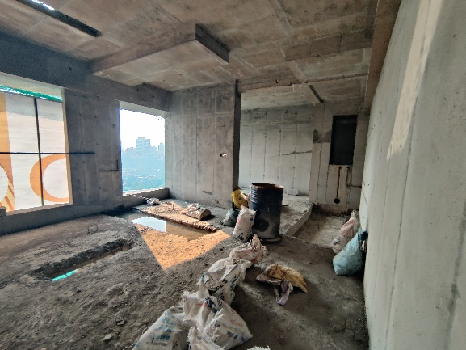
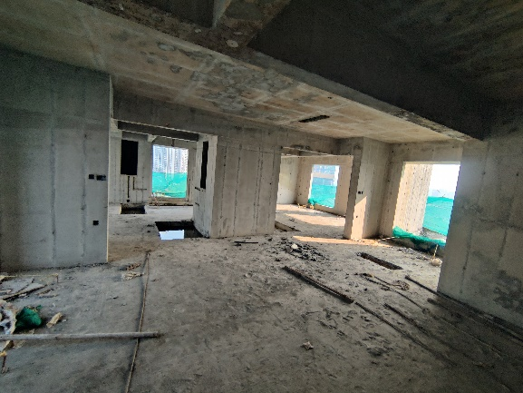
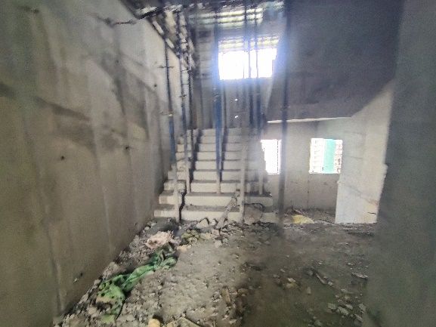
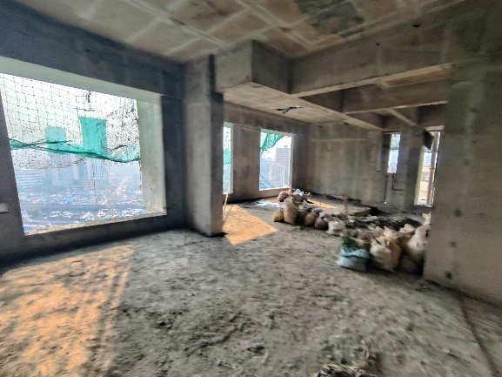
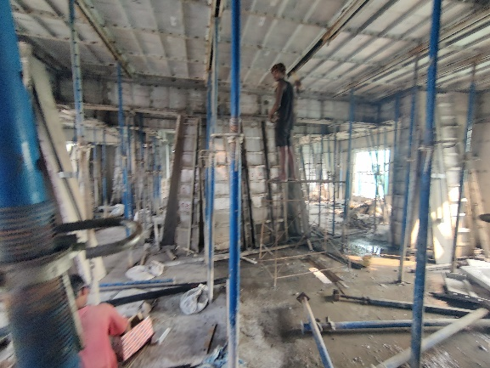
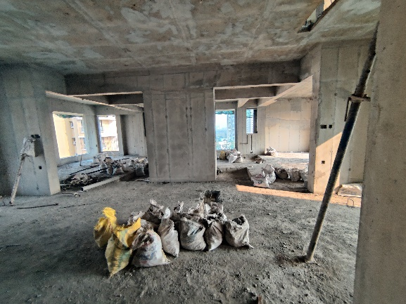
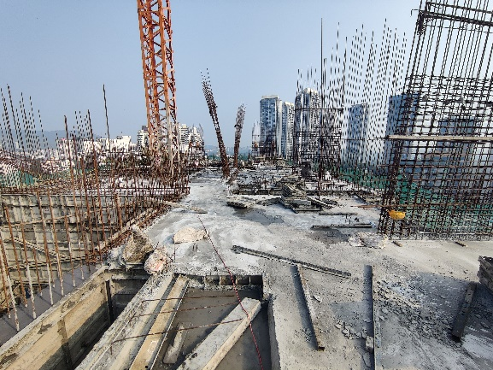
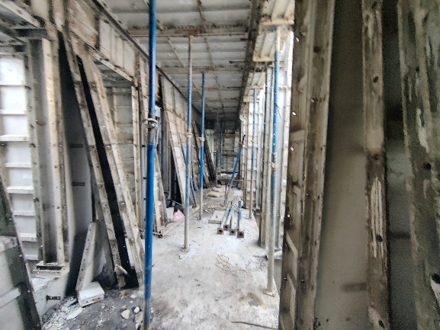
Actual Site Photographs As on 07.10.2024
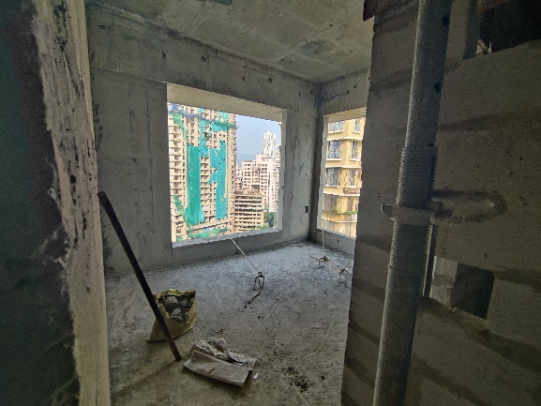
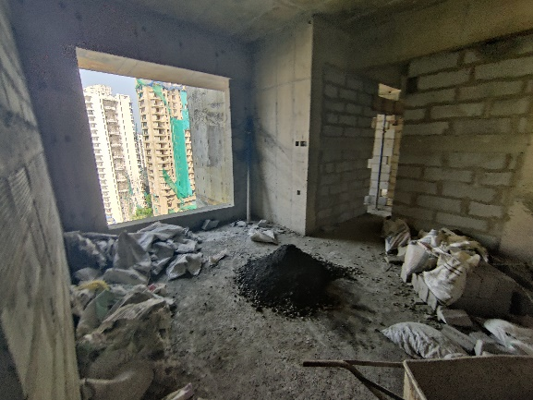
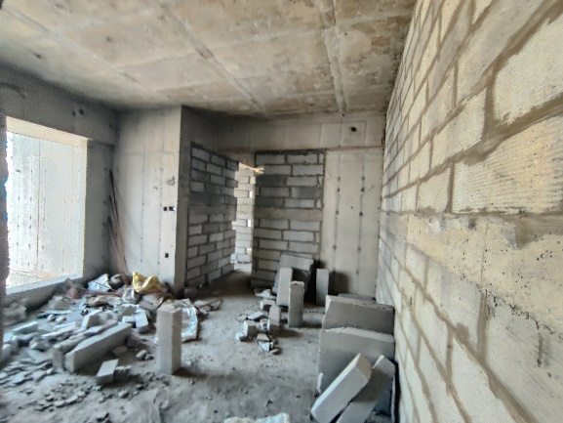
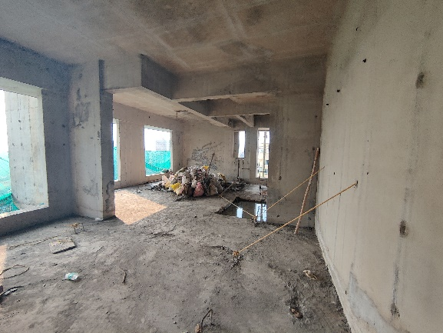
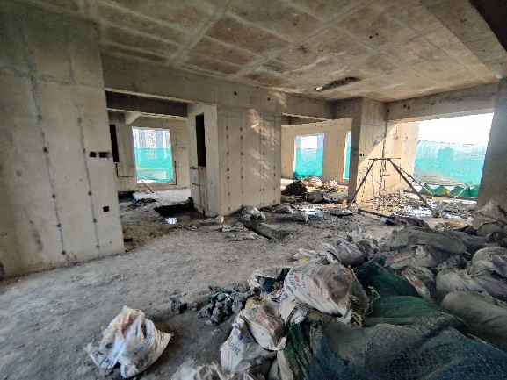
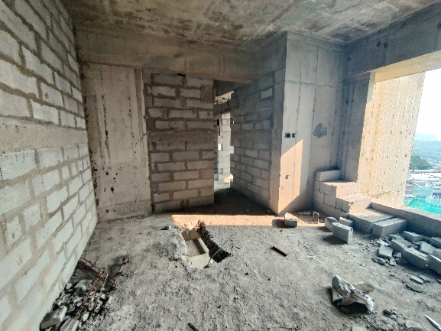
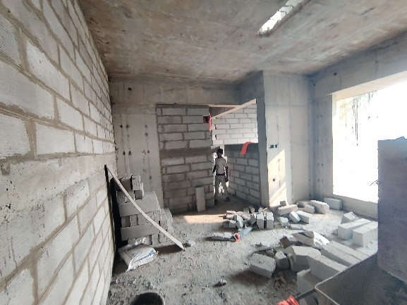
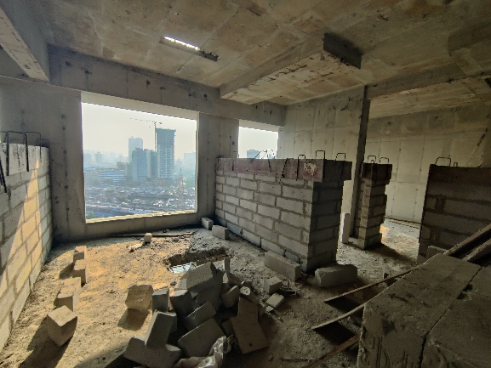
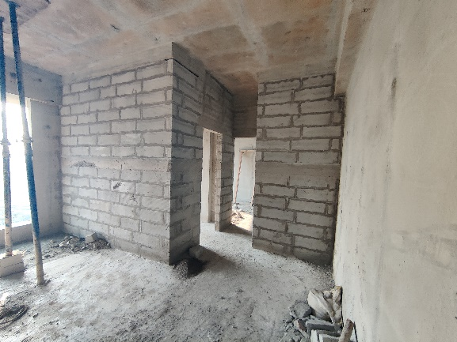
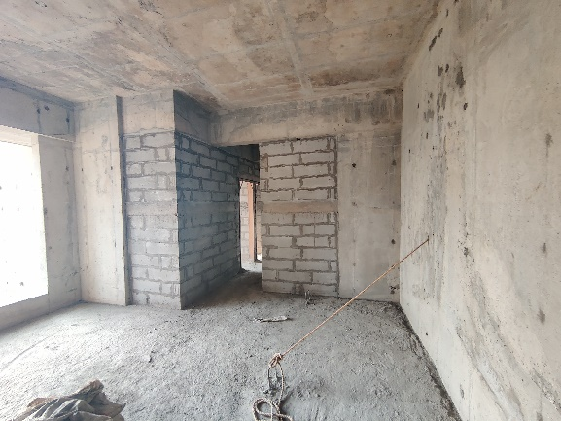
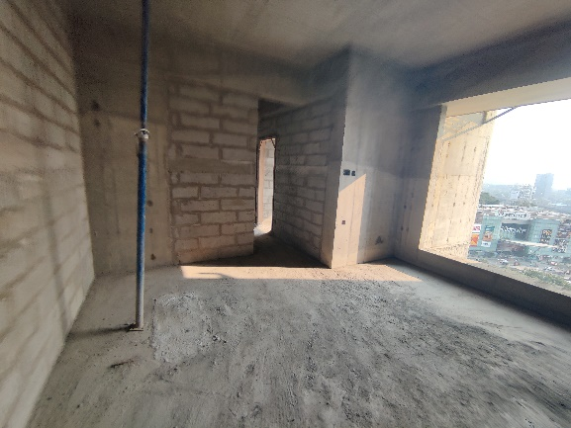
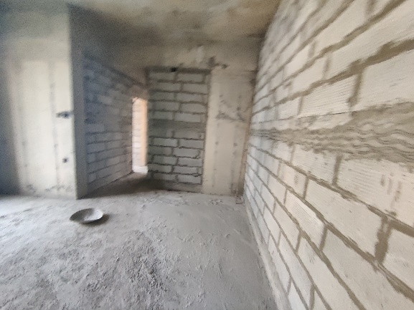
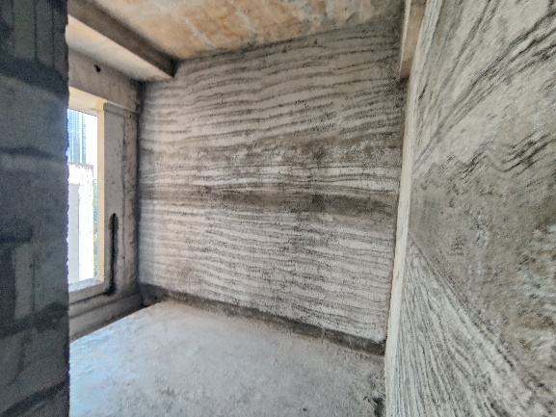
Actual Site Photographs As on 07.10.2024

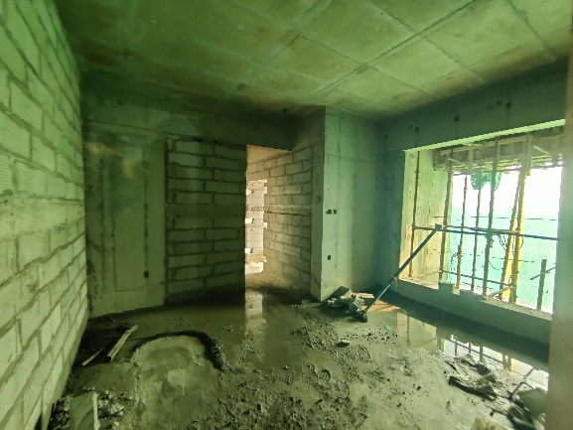
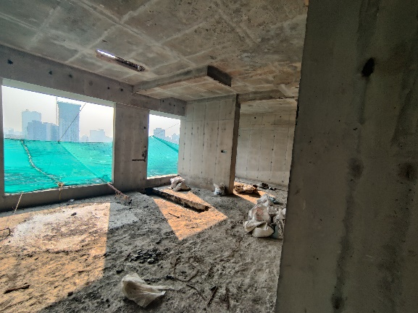
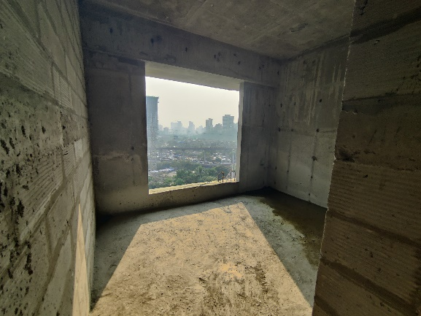
Actual Site Photographs As on 07.10.2024
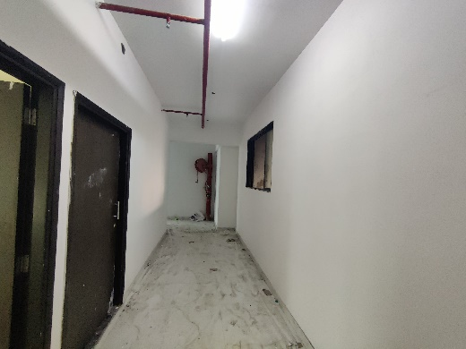
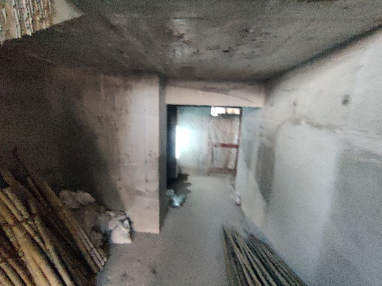
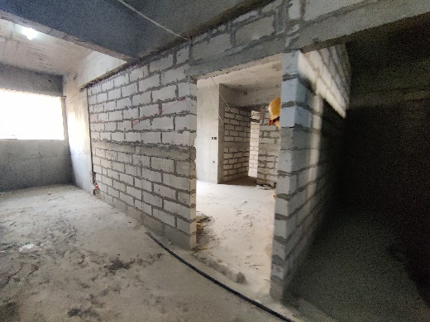

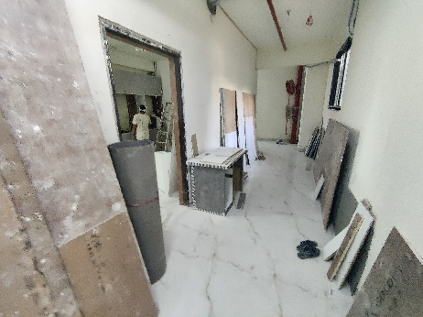
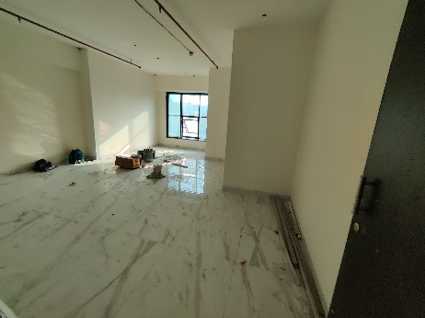
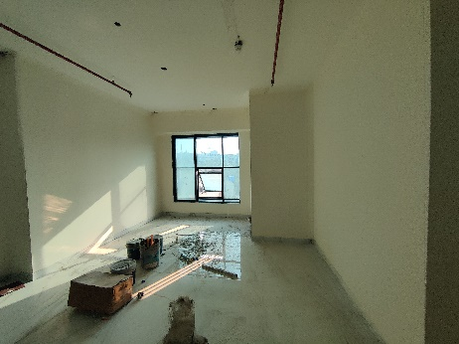
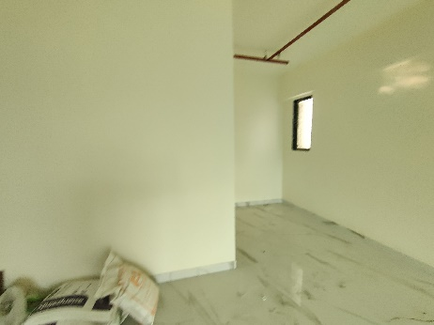
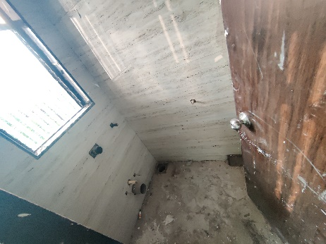
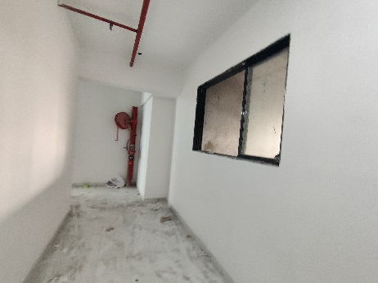
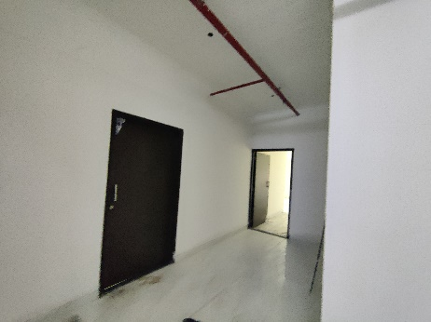
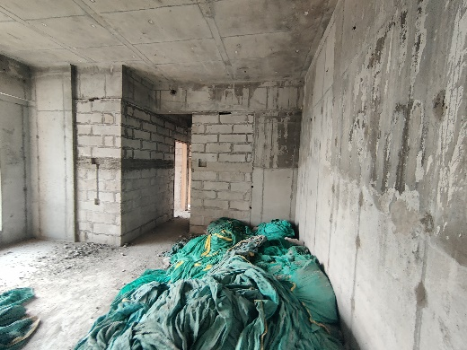
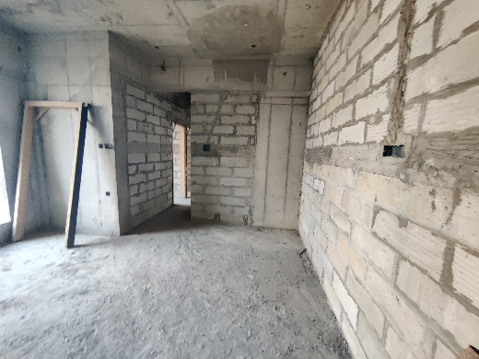
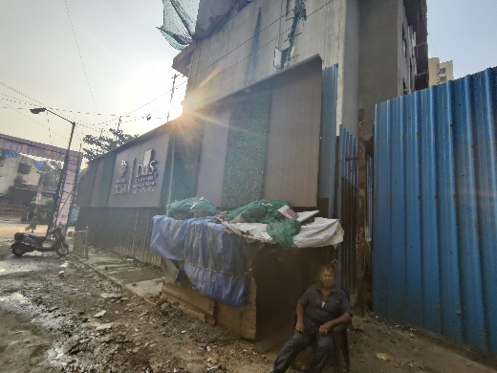
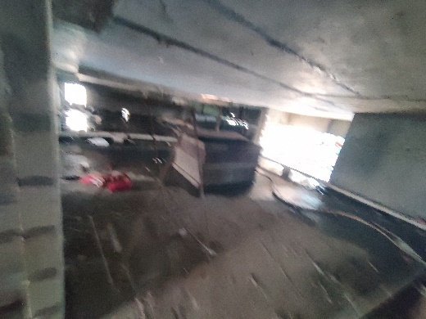
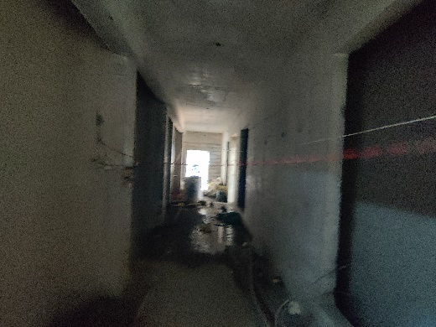
Actual Site Photographs As on 07.10.2024
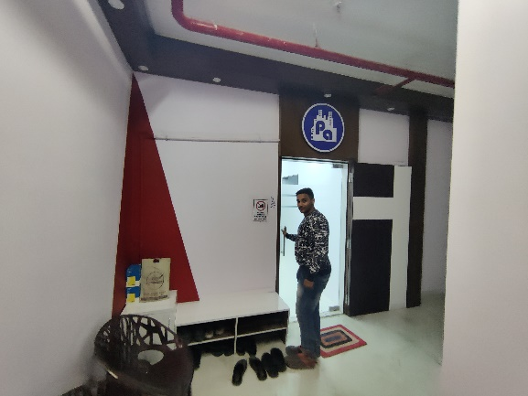
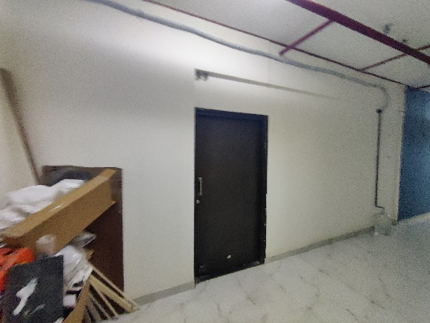
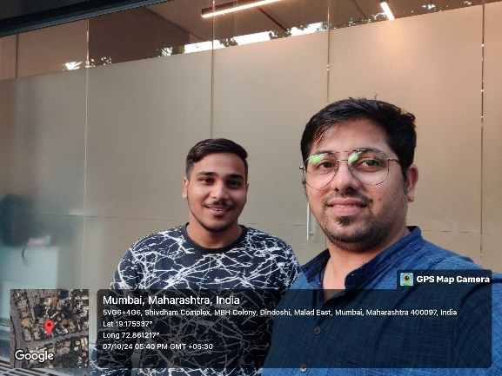
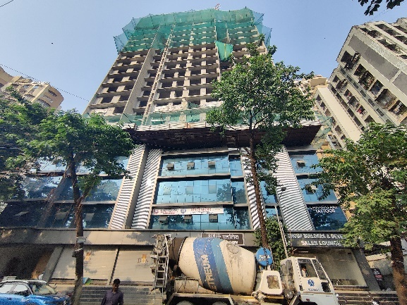
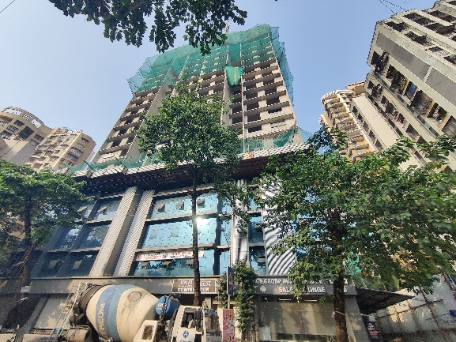

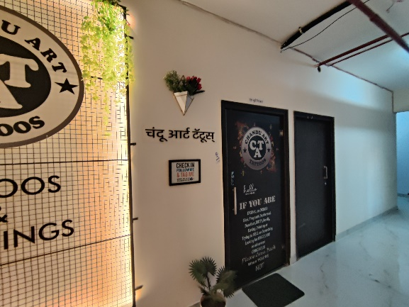

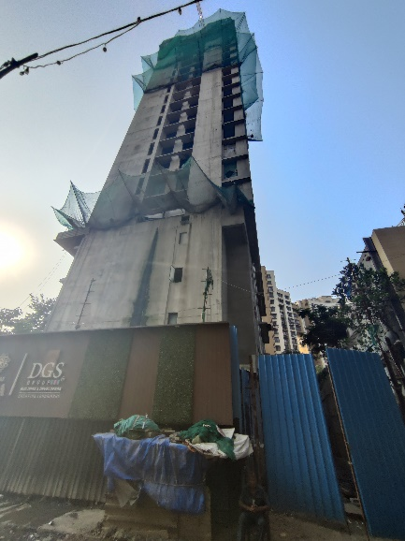
Route Map of the property
Site u/r
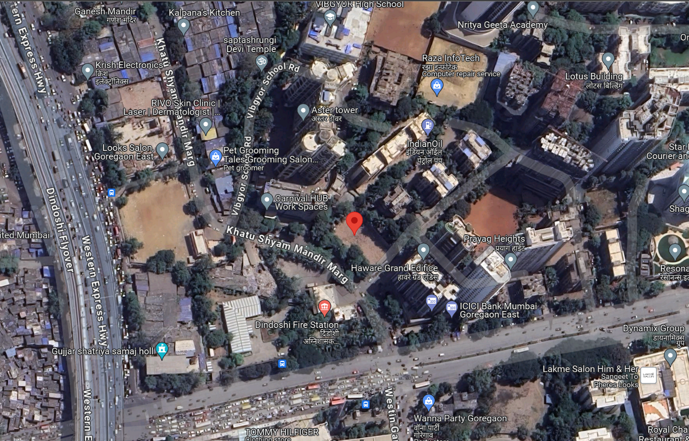

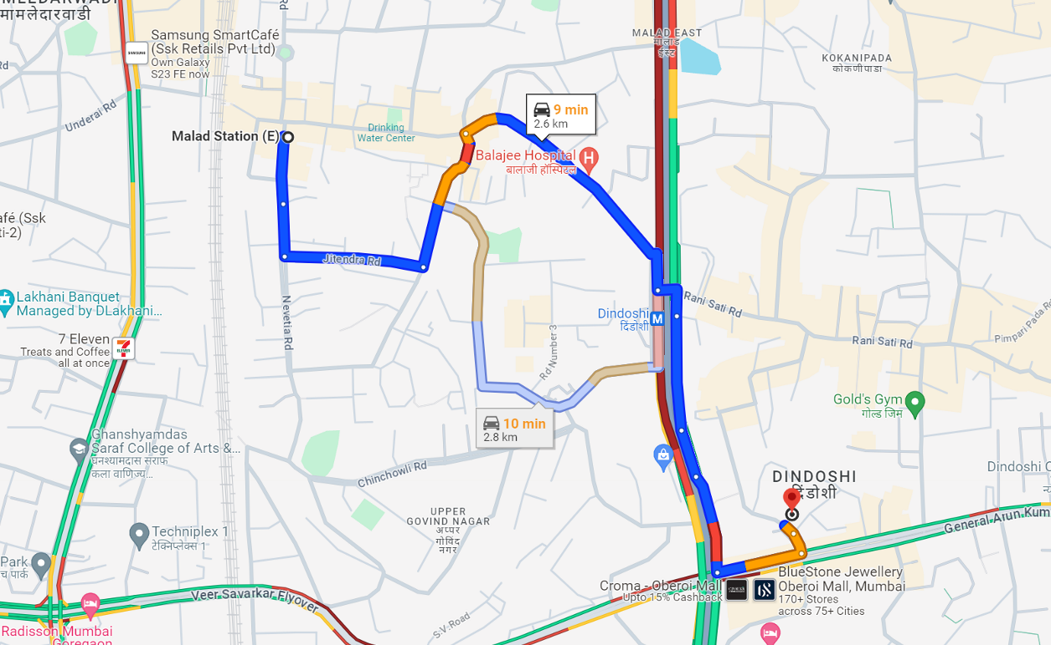

Latitude Longitude: 19°10'32.1"N 72°51'40.3"E

Note: The Blue line shows the route to site from nearest railway station (Malad– 2.60 Km.)
CA Certificate Dated 30.09.2024 till 15.10.2024
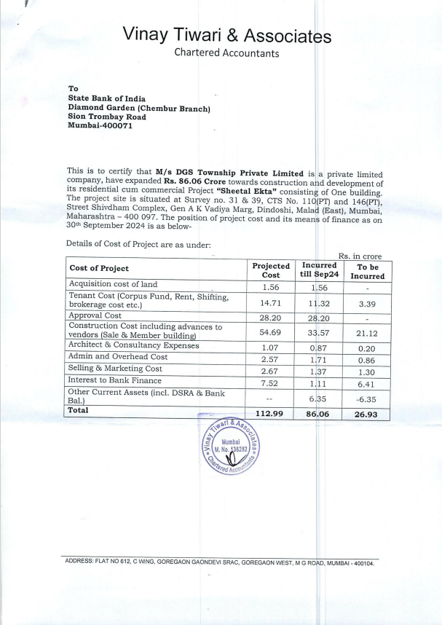

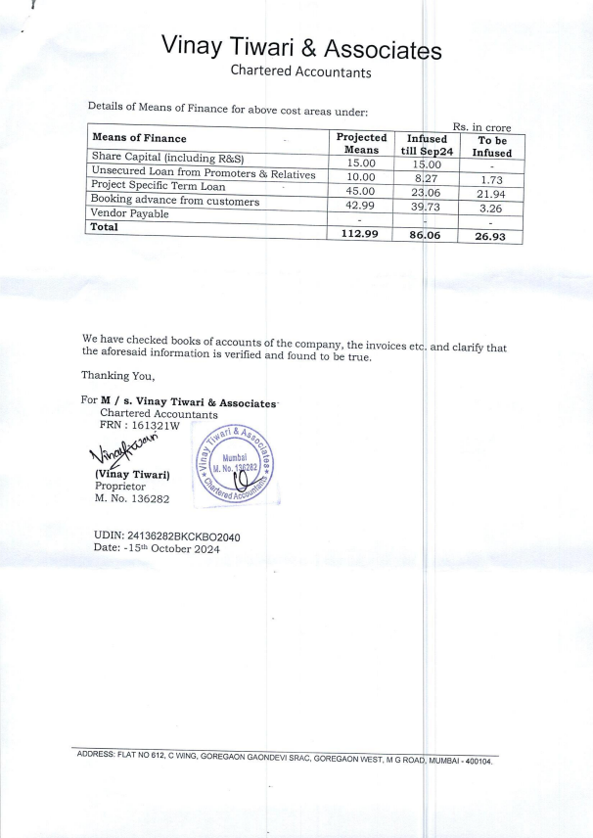
CA Certificate Dated 30.09.2024 till 15.10.2024

