Vastu/Nashik/06/32014/2301224
22/20-325-RYBS
Date: 23.10.2024

To,
The Branch Manager,
Bank of Baroda
Regional Office
BSNL Building, Datta Mandir Road, Nashik Road,
Nashik, PIN – 422 101, State - Maharashtra, Country - India.

Sub: Vetting of Extra Amenities

Sir,

With reference to above subject, we have evaluated the Extra Amenities For Residential Flat No. 404, 4th Floor, " Shivganga Avenue-D ", Near Marigold Bungalow, Narhari Nagar, Pathardi Phata, Plot No. 17+18, Pakhal Road, Village - Pathardi, Taluka - Nashik, District - Nashik, Nashik, PIN Code - 422 010, State - Maharashtra, Country - India belongs to M/s. Shivprasad Enterprises, Partnership Firm. Name of Proposed Purchaser is Shri. Vikas Somnath Chaudhari & Sau. Mayuri Vikas Chaudhari.

We have verified the rates quoted as per current market rates. Details of Extra Amenities considered as per copy of Extra Amenities Agreement between Shri. Vikas Somnath Chaudhari & Sau. Mayuri Vikas Chaudhari (First Party). Shri. Tirtha Bharatbhai Ghajipara (Second Party) received on dated. 29.10.2024. The Extra Amenities amount is Rs. 2,80,000/- (Rupees Two Lakh Eighty Thousand Only)

The said Cost Vetting Certificate is valid upto next 6 months Only.

Thanking you

Sincerely yours

Manoj B. Chalikwar
Registered Valuer
Chartered Engineer (India)
Reg. No. CAT-I-F-1763
Reg. No. IBBI/RV/07/2018/10366
BOB Empanelment No.: ZO:MZ:ADV:46:941
Encl: Valuation report.

Agreement for Extra Amenities
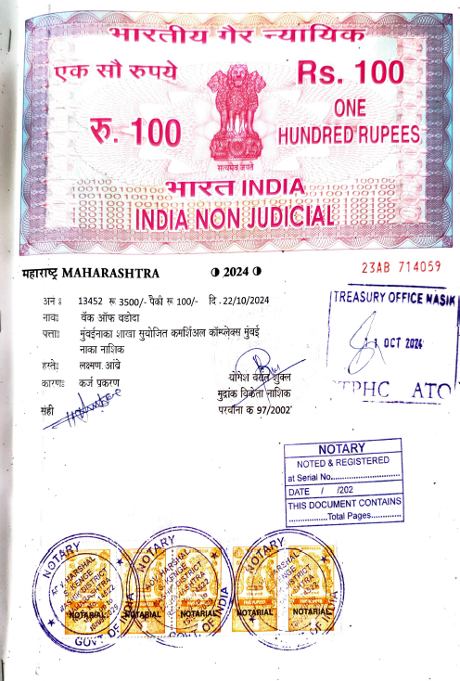
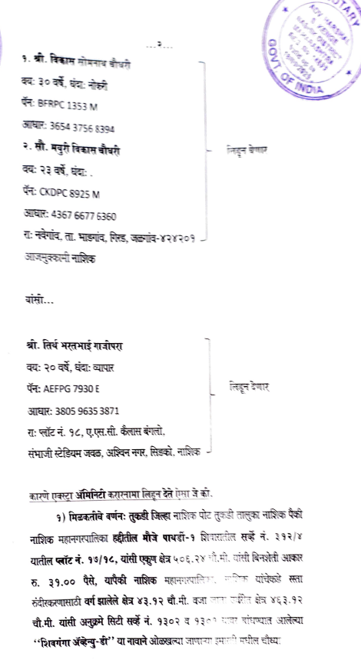

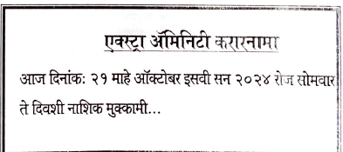

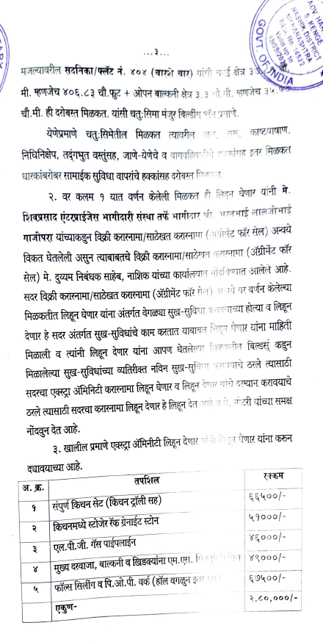
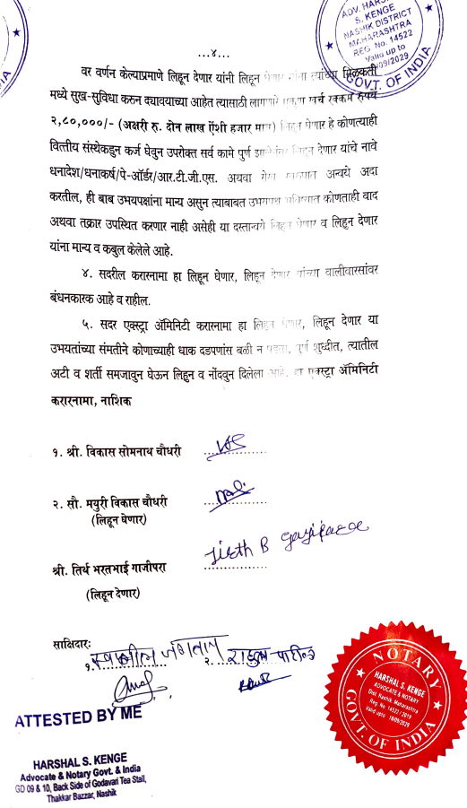

The Extra Amenities amount is Rs. 2,80,000/- (Rupees Two Lakh Eighty Thousand Only)

