Vastu/Nashik/08/2024/010634/2308297
23/2-303-RPBS
Date: 22.10.2024

To, `
The Branch Manager,
Bank of Baroda
Regional Office Nashik Road Branch
BSNL Building, Datta Mandir Road, Nashik Road,
Nashik -422 101, State - Maharashtra, Country - India.

Sub: Vetting of Extra Amenities

Sir,

With reference to above subject, we have evaluated the Extra Amenities for Residential Flat No. 714, 7th Floor, "Shivalik Siddhi", Next to Indoline Furniture, Plot No. 2+3+4, Saigram Nagar, Ambad - Uttam Nagar Road, Village - Ambad Khurd, Taluka - Nashik, District - Nashik, 422010, State - Maharashtra, India belongs to M/s.Yogeshwar Realty. Name of Proposed Purchaser is Mr.Kiran Prabhakar Dandge & Sanjivani Kiran Dandge

We have verified the rates quoted as per current market rates. Details of work and Extra Amenities considered as per copy of Agreement for Extra Amenities Between Mr.Kiran Prabhakar Dandge & Sanjivani Kiran Dandge. (First Party) and Sau.Sunita Suresh Sonawane (Second Party) received on dated 19.10.2024. The Extra Amenities amount is Rs.7,09,000/- (Rupees Seven Lakh Nine Thousand Only.)

The said Cost Vetting Certificate is valid upto next 6 months Only.

Thanking you

Sincerely yours

Manoj B. Chalikwar
Registered Valuer
Chartered Engineer (India)
Reg. No. CAT-I-F-1763
Reg. No. IBBI/RV/07/2018/10366
BOB Empanelment No.: ZO:MZ:ADV:46:941
Encl: Valuation report.

Agreement for Extra Amenities
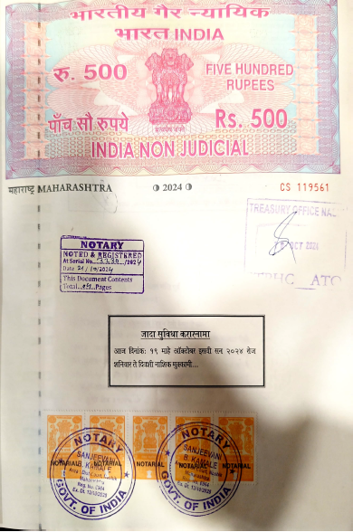
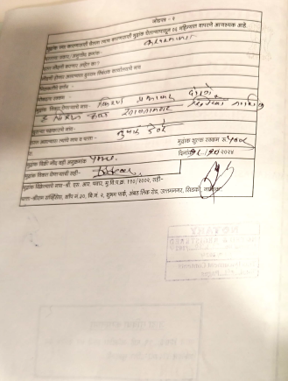

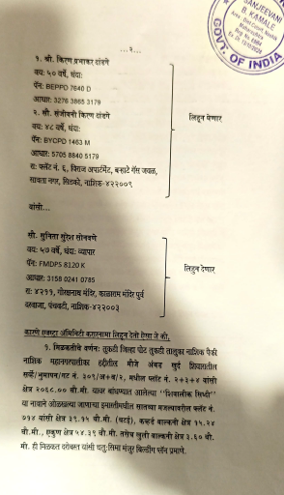
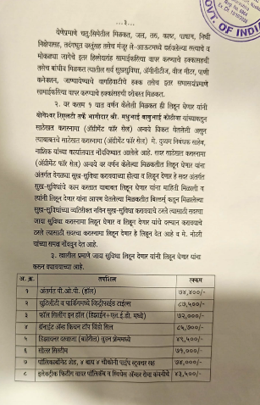

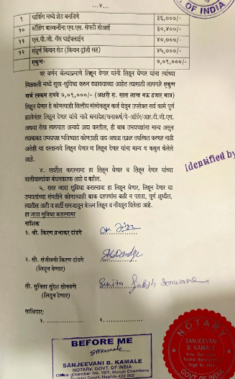

The Extra Amenities amount is Rs.7,09,000/- (Rupees Seven Lakh Nine Thousand Only.)

