Vastu/Nashik/07/2024/0010070/2307330
22/7-334-RPBS
Date: 21.10.2024

To, `
The Branch Manager,
Bank of Baroda
Regional Office Nashik Road Branch
BSNL Building, Datta Mandir Road, Nashik Road,
Nashik -422 101, State - Maharashtra, Country - India.

Sub: Vetting of Extra Work

Sir,

With reference to above subject, we have evaluated the Extra Work for Residential Flat No. 20, 4th Floor, "Varad Laxmi Apartment", Behind Ganesh Vyayam Shala, Ganesh Nagar, Plot No. 4+5+6, Old Saikheda Road, Village - Dasak, Taluka - Nashik, District - Nashik, Nashik, PIN Code - 422 101, Country - India belongs to M/s. Shirish Developers Partnership Firm. Name of Proposed Purchaser is Shri. Shatrughna Shantaram Kangane & Sau. Suvarna Shatrugha Kangane.

We have verified the rates quoted as per current market rates. Details of Extra Work considered as per copy of Agreement for Extra Work issued by to Mr. Shatrughna Shantaram Kangane & Mrs. Suvarna Shatrugha Kangane (First Party) and Mr. Ganesh Prabhakar Sanap (Second Party) received on dated 17.10.2024. The Extra Work amount is Rs.6,88,000/- (Rupees Six Lakh Eighty Eight Thousand Only.)

The said Cost Vetting Certificate is valid upto next 6 months Only.

Thanking you

Sincerely yours

Manoj B. Chalikwar
Registered Valuer
Chartered Engineer (India)
Reg. No. CAT-I-F-1763
Reg. No. IBBI/RV/07/2018/10366
BOB Empanelment No.: ZO:MZ:ADV:46:941
Encl: Valuation report.

Extra Work Agreement

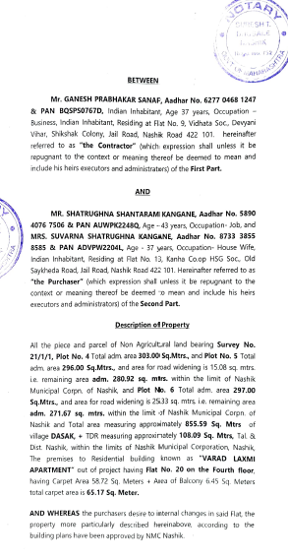

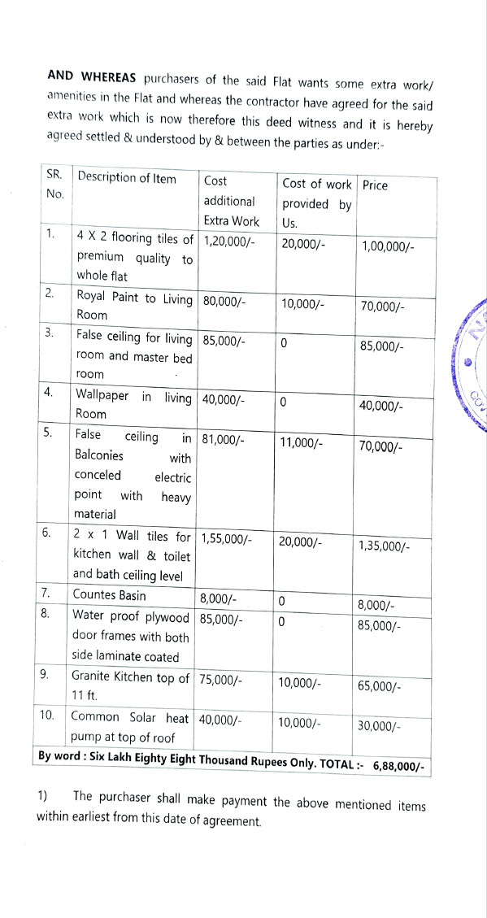


The Extra Work amount is Rs.6,88,000/- (Rupees Six Lakh Eighty Eight Thousand Only.)

