Vastu/Nashik/09/2024/011339/2308273
21/6-279-CCRJ
Date: 09.10.2024

To,
The Assistant General Manager,
Bank of Baroda
RO Nashik
BSNL Building, Datta Mandir Road, Nashik Road, Nashik
422101.

Sub: Vetting of Estimate

Sir,

With reference to above subject, we have evaluated the Estimate for Residential East Side Land and Proposed Bungalow on Plot No.12, Ground + Third Floor, Survey No.516/1, Near Ganesh Mandir, Balwant Nagar, Village- Satpur , Taluka –Nashik, District – Nashik, Pin Code – 422 007, State - Maharashtra, Country – Indiabelongs Shri.Balkrushna Tukaram Sonawane & Shri.Kushal Balkrushna Sonawane.

We have verified the rates quoted as per current market rates. Details of Estimate considered as per copy of Estimate Provided by Thinking Space received on dated.23.09.2024. The Estimate amount is Rs. 96,80,000/- (Rupees Ninety Six Lakh Eighty Thousand Only.)

Note:1) The said Cost Vetting Certificate is valid upto next 6 months Only.

Thanking you

Sincerely yours

Manoj B. Chalikwar
Registered Valuer
Chartered Engineer (India)
Reg. No. CAT-I-F-1763
Reg. No. IBBI/RV/07/2018/10366
BOB Empanelment No.: ZO:MZ:ADV:46:941
Encl: Valuation Report

Estimate
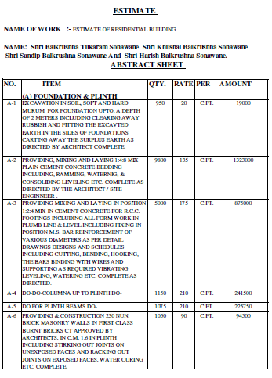
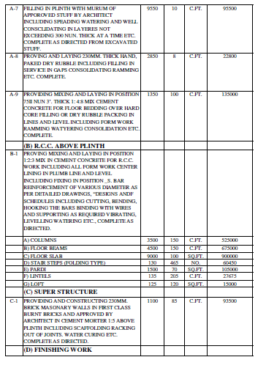

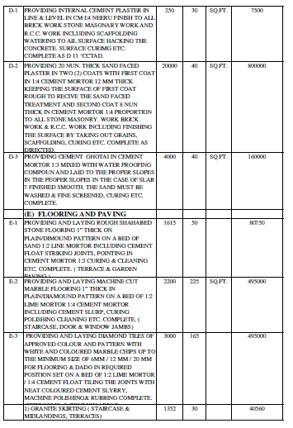
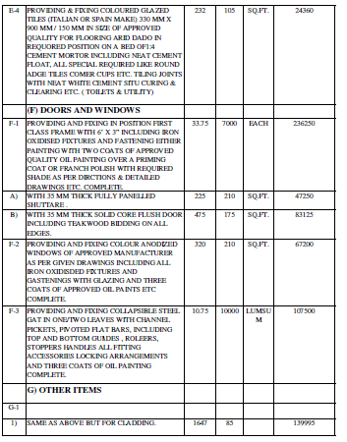

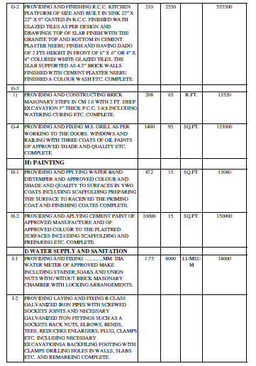
Estimate
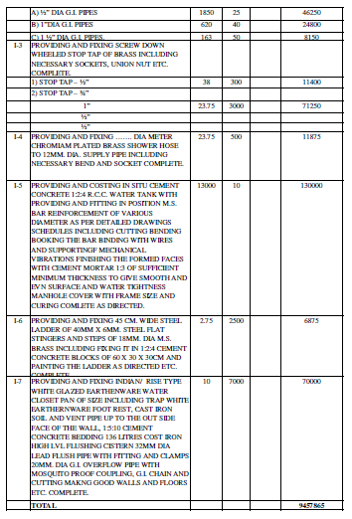

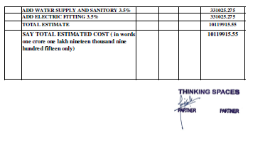
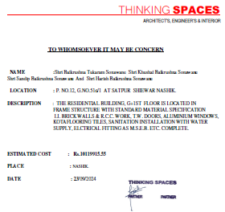

The Estimate amount is Rs. 96,80,000/- (Rupees Ninety Six Lakh Eighty Thousand Only.)

