Vastu/Nashik/06/32014/2301224
22/20-325-RYBS
Date: 09.10.2024

To,
The Branch Manager,
Bank of Baroda
Regional Office
BSNL Building, Datta Mandir Road, Nashik Road,
Nashik, PIN – 422 101, State - Maharashtra, Country - India.

Sub: Vetting of Extra Work

Sir,

With reference to above subject, we have evaluated the Extra Work For Residential Flat No. 01, 1st Floor, "Shivam Pride", Behind Yogesh Beer Bar & Restaurant, Plot No. 5 (Old Plot No. 48) Grampanchayat Milkat No. 630, Mumbai - Agra Road, Village - Jaulake Dindori, Taluka - Dindori, District - Nashik, Nashik, PIN Code - 422 206, Country - India
belongs to Shri. kailas Shantaram Gavli & Sau. Manisha Kailas Gavli.

We have verified the rates quoted as per current market rates. Details of Extra Work considered as per copy of Extra Work Agreement between Shri. kailas Shantaram Gavli & Sau. Manisha Kailas Gavli (First Party). Shri. Ranjan Kumar Ramji Prasad (Second Party) received on dated.04.10.2024. The Extra Work amount is Rs. 3,91,000/- (Rupees Three Lakh Ninety One Thousand Only)

The said Cost Vetting Certificate is valid upto next 6 months Only.

Thanking you

Sincerely yours

Manoj B. Chalikwar
Registered Valuer
Chartered Engineer (India)
Reg. No. CAT-I-F-1763
Reg. No. IBBI/RV/07/2018/10366
BOB Empanelment No.: ZO:MZ:ADV:46:941
Encl: Valuation report.

Agreement for Extra Work
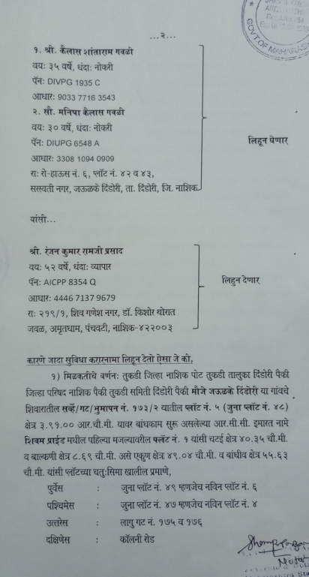
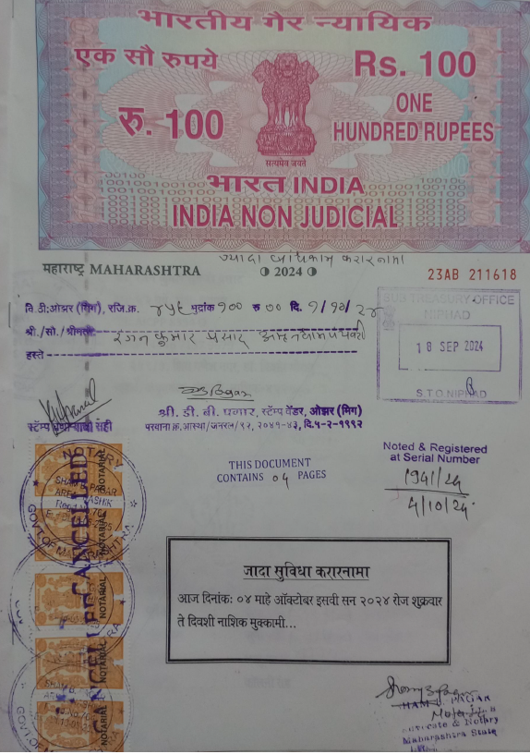

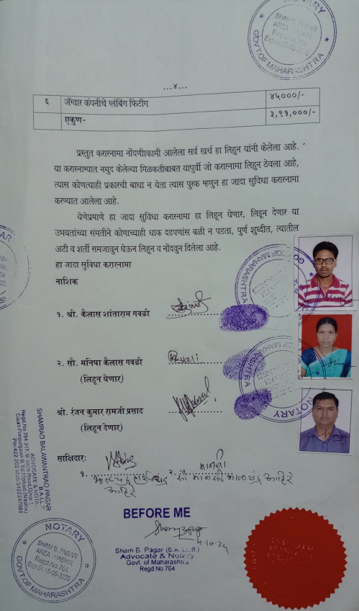
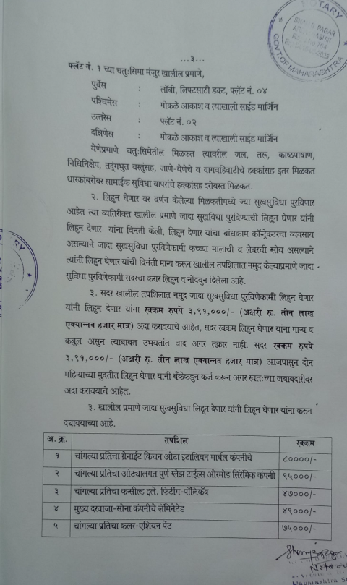

The Extra Work amount is Rs. 3,91,000/- (Rupees Three Lakh Ninety One Thousand Only)

