Vastu/Nashik/08/2024/011673/2308556
08/15-96 -RPBS
Date: 08.10.2024

To, `
The Branch Manager,
Bank of Baroda
Regional Office Nashik Road Branch
BSNL Building, Datta Mandir Road, Nashik Road,
Nashik -422 101, State - Maharashtra, Country - India.

Sub: Vetting of Extra Amenities

Sir,

With reference to above subject, we have evaluated the Extra Amenities for Residential Row Bungalow on Plot No. 57, Ground Floor + First Floor, "Kalanagar Row Bungalow", Survey No. 126/ 3/ 2 Part, Opp. to Sushil Nagari Co-Op Housing Society, Asha Nagar, Village – Mhasrul, Taluka - Nashik & District - Nashik, PIN Code - 422 003, State - Maharashtra, Country - India belongs to Name of Proposed Purchaser: Shri. Rohit Prakash Ingle & Sau.Rani Sanket Ingle. Name of Owner: Shri. Karan Rajendra Bhamre.

We have verified the rates quoted as per current market rates. Details of work and Extra Amenities considered as per copy of Agreement for Extra Amenities issued by to Shri. Rohit Prakash Ingle & Sau. Rani Sanket Ingle (First Party) and Shri. Virendra Sadashiv Bhamare (Second Party) received on dated 03.09.2024. The Extra Amenities amount is Rs.3,70,000/- (Rupees Three Lakh Seventy Thousand Only.)

The said Cost Vetting Certificate is valid upto next 6 months Only.

Thanking you

Sincerely yours

Manoj B. Chalikwar
Registered Valuer
Chartered Engineer (India)
Reg. No. CAT-I-F-1763
Reg. No. IBBI/RV/07/2018/10366
BOB Empanelment No.: ZO:MZ:ADV:46:941
Encl: Valuation report.

Agreement for Extra Amenities
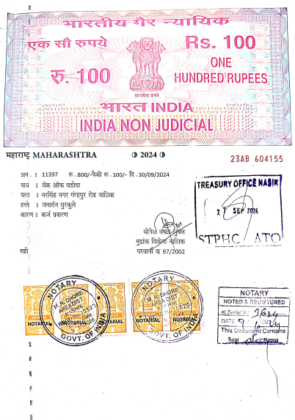
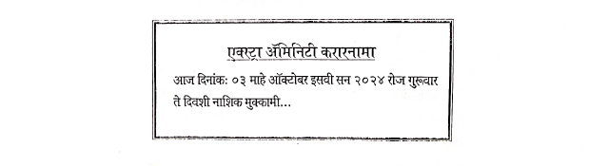

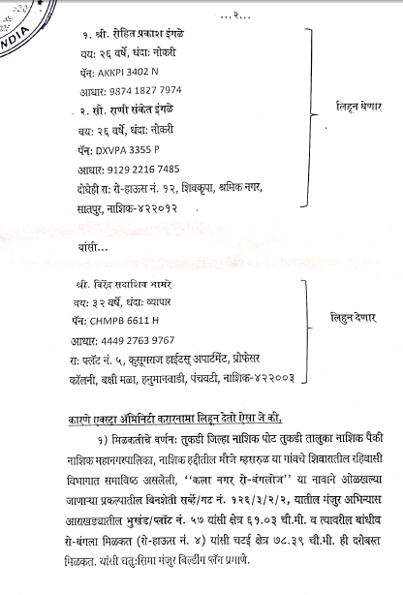

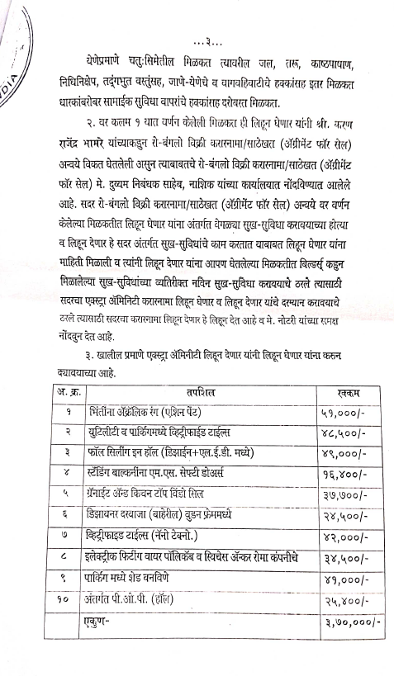
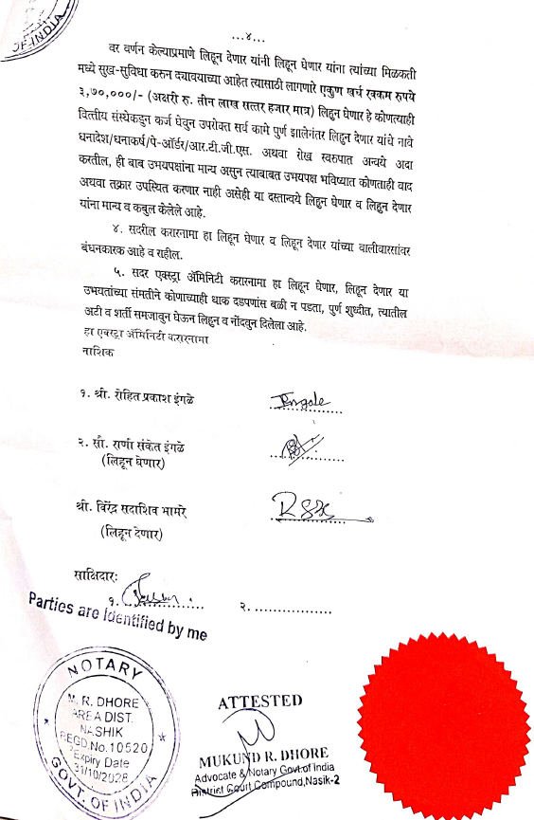

The Extra Amenities amount is Rs.3,70,000/- (Rupees Three Lakh Seventy Thousand Only.)

