COST VETTING REPORT
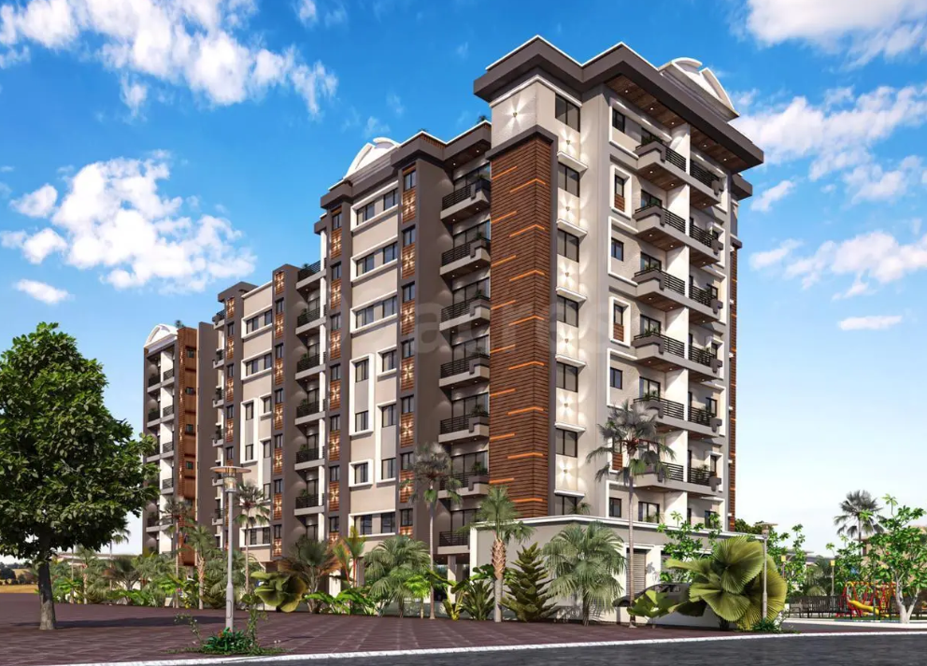

Details of the property under consideration:

Name of Project: "Mali Avenue"

"Mali Avenue", Revised & Proposed residential building on S. No. 18, Hissa No. 4 of Village – Bhal, Tal – Ambernath, Dist - Thane (East), Mumbai – 421 306, State – Maharashtra, Country – India.

Latitude Longitude: 19°11'44.1"N 73°08'12.6"E

Valuation Done for:
State Bank of India
Commercial Branch (Vile Parle)

3rd Floor, B.N. Agarwal Commercial Complex, Monghibai Road, Vile Parle (East)

Mumbai, Pin Code – 400 057, State - Maharashtra, Country – India.

Vastu/SBI/Mumbai/10/2024/11671/2308766
23/06-306-PY
Date: 22.10.2024

To,
The Branch Manager,
State Bank of India
Commercial Branch (Vile Parle),
3rd Floor, B.N. Agarwal Commercial Complex,
Monghibai Road, Vile Parle (East)
Mumbai, Pin Code – 400 057,
State - Maharashtra, Country – India.

Sub: Cost Vetting Report for " Mali Avenue " at Bhal, Ambernath, Pin Code – 421 306.

Dear Sir, In accordance with your letter of engagement as stated above, we enclose our Report on Cost Vetting Report for "Mali Avenue", Revised & Proposed residential building on S. No. 18, Hissa No. 4 of Village – Bhal, Tal – Ambernath, Dist - Thane (East), Mumbai – 421 306, State – Maharashtra, Country – India. M/s. Mali Infra is proposing residential building on S. No. 18, Hissa No. 4 of Village – Bhal, Tal – Ambernath, Dist - Thane (East), Mumbai – 421 306, State – Maharashtra, Country – India. Project is comprising Rehab & Sale Building.
Residential of Sale Building is proposed of Ground Floor + 1st to 7th Upper Floors with total RERA carpet area of 28,885.97 Sq. Ft. which consists 1 BHK, with 40 nos. of Sell flats, 22 Landowner Flat providing with Society Office, & Other Amenities. In this regard, SBI, Parle Square Building,3rd Floor, B.N. Agarwal Commercial Complex, Monghibai Road, Vile Parle (East), Mumbai, Pin Code – 400 057, has approached Vastukala Consultants (I) Pvt. Ltd. (VCIPL) to conduct a Project Valuation of the said project.
In this regard, SBI, Commercial Branch (Vile Parle), 3rd Floor, B.N. Agarwal Commercial Complex, Monghibai Road, Vile Parle (East), Mumbai, Pin Code – 400 057 has approached Vastukala Consultants (I) Pvt. Ltd. (VCIPL) to conduct a Cost Vetting of the said project.
Our analysis of the cost vetting is enclosed in this report. This Report forms an integral whole and cannot be split in parts. The outcome of the report/ study can only lead to proper conclusions if the Report as a whole is taken into account.

The information used by Vastukala Consultants (I) Pvt. Ltd. (VCIPL) in preparing this report has been obtained from a variety of sources and other relevant documents provided by the client & bank. As agreed, we have performed our cost vetting exercise with the data available related to the business, considering the market prospects and projections. Our results are dependent on documents provided by client & bank, the underlying assumptions, which has been analyzed at a broader level by VCIPL while assessing their reasonableness.
Total Project Cost for the completion of Project will be ` 11.71 Cr.

For Vastukala Consultants (I) Pvt. Ltd.

Manoj B. Chalikwar
Registered Valuer
Chartered Engineer (India)
Reg. No. IBBI / RV / 07/2018/10366
Reg. No. CAT-I-F-1763
SBI Empanelment No.: SME/TCC/38/IBBI/3
About the Project:
Proposed residential building on S. No. 18, Hissa No. 4 of Village – Bhal, Tal – Ambernath, Dist - Thane (East), Mumbai – 421 306, State – Maharashtra, Country – India. It is about 6.50 KM travelling distance from Kalyan Railway station.

Area Statement as per Approved Plan
 | Area Statement | Sq. Mt.
1 | Area of the Plot | 1,750.50
 | (Minimum Area of A,B,C to be Considered)
a. | As per Ownership document (7/12, CTS Extract) | 1,820.00
b. | As per Measurement Sheet | 1,750.50
c. | As per Site
2 | Deduction For.
a. | proposed D.P./ D.P. Road widening Area (6 M.W. Existing Road) | 62.50
b. | Any Reservation (PG 13) | 247.50
 | Total a + b | 310.00
3 | Gross area of plot (1-2) | 1,440.50
4 | Amenity Space if applicable
a. | Required | -
b. | Adjustment of 2(B) if Any | 247.50
c. | Balanced Proposed
5 | Balanced plot Area (3-4 C) | 1,440.50
6 | Recreation open space (if Applicable)
a. | Required | -
b. | Proposed | -
7 | Internal Road Area
8 | plottable Area (If Applicable)
9 | Built up Area with reference to basic F.S.I. as per front road width. (1440.50 x 1.1) | 1,584.55
10 | Additional of FSI on payment of premium
a. | Maximum Permissible premium FSI Based on Road width/TOD Zone | -
b. | Proposed FSI on payment of premium | -
11 | Insitu FSI/TDR loading | -
a. | In-situ area against DP road [2.0 x Sr. No. 2 (A)] if any | 125.00
b. | In-situ area against Amenity Space if Handed over [2.0 Or 1.85 x Sr. No. 4 (B) And Or C] | 495.00
c. | TDR Area Permissible TDR Proposed | -
d. | Total Insitu/TDR Loading proposed [11(a) + (b) + ©] | 620.00
12 | Additional FSI Area
13 | Total Entitlement of FSI in proposal
a. | [9+10(b) + 11(d) or 12 whichever is applicable | 2,204.55
b. | Common area of FSI upto 80% of Commercial (Permissible) (16029/1.8x0.8) (160.29/1.8=89.05 x0.8 = 71.24) Proposed 71.24 | 71.24
c. | Common Area of FSI upto 60% of residential area (Permissible)(2204.55 - 89.05=2,115.50 x0.6 = 1269.30. Proposed 1269.30 | 1,269.30
d. | Total Entitlement (a + b + c) | 3,545.09
14 | Maximum utilization of FSI (Building Potential) Permissible as per road width [(As per Regulation No. 6.1 or 6.2 or 6.3 or 6.4 As applicable) x 1.6). | 3,545.12
15 | Total Built Up Area in proposed excluding Area At Sr. No. 17b | 3,542.93
a. | Existing Built Up Area | -
b. | Proposed Built-up Area (AS per P-Line) | 3,542.93
c. | Total (a + b) | 3,542.93
16 | FSI consumed (15/13) (Should Not be more than serial No. 14 Above) | 0.99
17 | Area for inclusive housing, If Any | N/A
a. | Required (20% of Sr. No. 5) | -
b. | Proposed | -

Construction Area as per Approved Plan for Sale Building

Sr. No. | Floor | Built Up Area in Sq. M. | Lift Area in Sq. M. | Other Area in Sq. M. | Total Area in Sq. M. | Total Area in Sq. Ft.
1 | Ground Floor | 160.29 | 9.86 | 322.94 | 493.09 | 5,307.58
2 | 1st Floor | 483.23 | 9.86 | - | 493.09 | 5,307.58
3 | 2nd Floor | 483.23 | 9.86 | - | 493.09 | 5,307.58
4 | 3rd Floor | 483.23 | 9.86 | - | 493.09 | 5,307.58
5 | 4th Floor | 483.23 | 9.86 | - | 493.09 | 5,307.58
6 | 5th Floor | 483.23 | 9.86 | - | 493.09 | 5,307.58
7 | 6th Floor | 483.23 | 9.86 | - | 493.09 | 5,307.58
8 | 7th Floor | 483.23 | 9.86 | - | 493.09 | 5,307.58
9 | Terrace | - | 29.06 | - | 29.06 | 312.76
TOTAL |  | 3,542.90 | 107.90 | 322.94 | 3,973.74 | 42,773.38

Project Cost
Sr. No. | Particulars | Total Estimated Amount in ` | Total Estimated Amount  in ` Cr.
1 | Land Cost
 | Acquisition Cost of Land or Development Rights, and Legal Cost. | 19,00,500.00 | 0.19
 | Rent to Tenants, Lease premium, Lease Rent, interest cost incurred or payable on Land Cost | - | -
 | Amount of Premium payable to obtain development rights, FSI, additional FSI, fungible area, and any other incentive under DCR from Local Authority or State Government or any Statutory Authority. | 39,90,891.00 | 0.40
 | Acquisition cost of TDR (if any) | - | -
2 | Cost of Construction
 | Estimated construction cost of rehab cum sale building including site development and infrastructure for the same. | 8,74,22,368.00 | 8.74
 | On site expenditure for development of entire project excluding cost of construction as per(i) above,
a. | Architect Fees & Consultant fees | 43,71,118.00 | 0.44
b. | Admin Cost includes salaries, site overheads, development works, cost of services (including water, electricity, sewerage, drainage, layout roads etc.), cost of machineries and equipment including its hire and maintenance cost, consumables etc. All costs directly incurred to complete the construction of the entire phase of the project registered. | 34,96,895.00 | 0.35
c. | Marketing Cost | 32,56,486.00 | 0.33
3 | Interest during the Project | 1,00,00,000.00 | 1.00
4. | Contingency Charges | 26,22,671.00 | 0.26
 | GRAND TOTAL: | 11,70,60,929.00 | 11.71

Manoj B. Chalikwar
Registered Valuer
Chartered Engineer (India)
Reg. No. IBBI / RV / 07/2018/10366
Reg. No. CAT-I-F-1763
SBI Empanelment No.: SME/TCC/38/IBBI/3
Comments on each element of Cost of Project: -
- Land Cost:
As per Present Ready Reckoner rate the Project Land Value is ` 0.60 Cr. considering Land Rate @ ` 4,180.00 per Sq. M. & Net Plot Area of 1440.50 Sq. M.
As per document purchase cost of land & stamp duty cost is ` 19,00,500.00 i.e., ` 0.19 Cr. which is 1.62% of Total Project Cost.
Sr. No. | Date | Document Name | Description | Total Cost in ` | Incurred Cost in `
1 | 7/24/2023 | Developer Agreement | Purchase Cost | 400,000.00 | 400,000.00
2 | 7/24/2023 | Developer Agreement | Stamp Duty | 14,68,400.00 | 14,68,400.00
3 | 7/24/2023 | Developer Agreement | Reg. Fees | 30,000.00 | 30,000.00
4 | 7/24/2023 | Developer Agreement | Reg. Fees | 1,000.00 | 1,000.00
5 | 7/24/2023 | Power of Attorney | Stamp Duty | 500.00 | 500.00
6 | 7/24/2023 | Power of Attorney | Reg. Fees | 100.00 | 100.00
7 | 7/24/2023 | Power of Attorney | Reg. Fees | 500.00 | 500.00
Total |  |  |  | 19,00,500.00 | 19,00,500.00

- Building Cost of Construction for Sale Building:
Construction Area of Sale Building = 3,973.74 Sq. M. i.e., 42,773.38 Sq. Ft.
Total estimated cost for construction of Building (includes cost of RCC work, manpower, lift, material, painting, finishing work, site development, etc.) is ` 8,74,22,368.00 i.e., ` 8.74 Cr. which comes ` 22,000.00 per Sq. M. on construction area for building.
The total construction area is 3,973.74 Sq. M. i.e., 42,773.38 Sq. Ft., projected cost of ` 8.74 Cr is 74.68% of total project cost
VCIPL opinion the construction cost of 22,000/- Per Sq. M. which is in line with Market-Trend.
Particulars | Rate per Sq. Ft.
Excavation Work | 2,000.00
Total RCC Work | 10,000.00
Final Finishing Work | 6,000.00
Other Work | 4,000.00
Cost of Construction | 22,000.00

- Approval Charges:
The Total Approval Cost (Fungible Cost & Development Cess Premium & TDR Cost) as per challan provided by the developer will be ` 39,90,891.00 i.e., ` 0.40 Cr. which is 3.41% of Total Project Cost.
As per information provided by developer.
S. No. | Nature of Charges | Estimated Cost in ` | Incurred Cost in `
1 | KDMC Charges | 32,33,694.00 | 32,33,694.00
2 | Fire NOC | 2,57,197.00 | 2,57,197.00
3 | OC Charges | 5,00,000.00 | -
Total |  | 39,90,891.00 | 34,90,891.00

- Architect Cost, RCC & Other Professional Charges:
The total Architect charges of ` 43,71,118.00 i.e., ` 0.44 Cr. is 5.0% of total construction cost building & it is line up with Market trend.
The professional charge consists of Architect & Legal which in market is in the range of 2% - 5% of Total Construction cost of the project.

- Administrative Expenses:
Salaries, site overheads, development works, cost of services (including water, electricity, sewerage, drainage, layout roads etc.), cost of machineries and equipment including its hire and maintenance cost, consumables etc. All costs directly incurred to complete the construction of the entire phase of the project registered is estimated 4% of total construction cost Building which comes to ` 34,96,895.00 i.e., ` 0.35 Cr.
The admin charges which in market is in the range of 4% - 6% of Total Construction cost of the project.

- Marketing Expenses:
Marketing costs directly incurred to complete the construction of the entire phase of the project registered is estimated at 2% of total Sale income from the project which comes to ` 32,56,486.00 i.e., ` 0.33 Cr.
The marketing charge consists of brokerage & commission which in market is in the range of 1% - 3% of Total Sale income of the property.

- Interest Costs:
The Interest cost for the term loan is ` 1,00,00,000.00 i.e., ` 1.00 Cr., which is 8.54% of total project cost.
As per information provided by the client.

- Contingency Costs:
The contingency charges estimated at 3% of total cost of construction which comes to ` 26,22,671.00 i.e., ` 0.26 Cr.
Observation and Construction: -
Total estimated cost of project i.e., ` 28,83,77,104.00 (Rupees Twenty – Eight Crore Eighty – Three Lakh Seventy – Seven Thousand One Hundred Four Only) i.e., ` 28.84 Cr. is fair & reasonable.
The project cost is including land premium payable to concern authorities, TDR Cost, Fungible FSI Premium, Cost of Construction of Sale Building, professional charges on site expenses including admin & marketing expenses, premiums / charges to be paid to competent authority and Bank interest, etc. we have not independently verified interest cost hence not consider in cost vetting.
As per present sanctioned building plan, permissible built-up area on the said plot is 3,542.93 Sq. M. The sale building (Wing A & B) is presently approved for Ground Floor + 1st to 7th Upper Floors only.
Total estimated cost of construction of Sales building is ` 8,74,22,368.00 i.e., ` 8.74 Cr. which comes ` 22,000.00 per Sq. M. on construction area for building, which is fair & reasonable considering the present status of project, type & quality of construction & specification of the building materials to be used, height of the structure, amenities to be provided in proposed building.

Assumptions & Remarks-
- The adequacy of Engineering / Structural design is beyond the scope of our assignment.
- Estimated project completion date is 31/07/2025. The cost is certified based on the assumptions that the project will be completed within time frame. Few assumptions are made regarding inflation & cost rise etc. during construction period.

Photo copy of following document is provided to us & this report should be read along with it:
- Copy of Power of Attorney between Ladku R Mhatre & other land Owners (Land Owners) AND Mr. Jethalal G Mali & Partner (Developers), through registered Agreement No. UHN-2/10221/2023.
- Copy of Legal title report dated 11.12.2023 issued by Mr. Dilip K. Gandhi (B. Com, LL.B.)
- Copy of Development agreement between Ladku Rajaram Mhatre 7 other 8 people (Land Owner) AND M/s. Mali Infra (Developer) through registered Doc. UHN1/10220/2023, dated 24.07.2023.
- Copy of Approved Plan No. KDMC/TPD/BP/27Village/2023-24/18 dated 01.12.2023 issued by Kalyan Dombivali Municipal Corporation.
Ground Floor + 1st Floor to 7th Upper floor.
- Copy of Commencement Certificate No. KDMC/TPD/BP/27Village/2023-24/18 dated 01.12.2023 issued by Kalyan Dombivali Municipal Corporation.
(This CC is endorsed for the work for up to A Wing - Stilt (P) & Ground Floor (P) + 1st Floor to 7th Floor (Residential & Commercial) & B Wing – Stilt + 1st Floor to 7th Residential Floor)
- Copy of Architects Certificate issued by Genesis Architects dated 02.10.2024.
- Copy of Engineer’s Certificate dated 12.08.2024, issued by Atul Kudtarkar and Associates Pvt. Ltd.
- Copy of NA order dated 17.05.2023. issued by Tahasildar Office, Ambernath.
- Copy of Fire NOC dated 27.06.2023, issued by Kalyan Dombivli Municipal Corporation, through Document No. Fire/HQ/KDMC/OW/2023/E-219.
- Copy of CA Certificate dated 14.09.2024 issued by Pratik N Pandya & Co.
- Copy of RERA Certificate No. P51700055096 dated 29.02.2024 issued by Maharashtra Real Estate Regulatory Authority (MAHRERA).
- Copy of 7/12 extract.

Actual Site Photographs
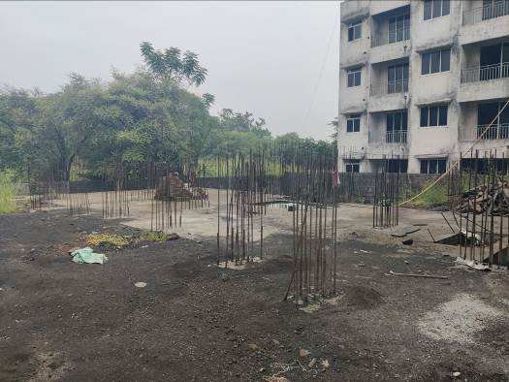
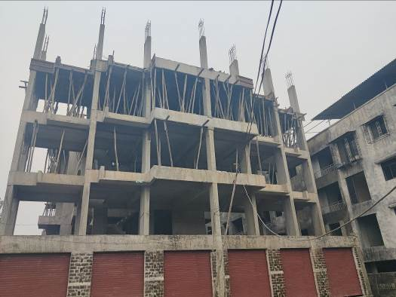
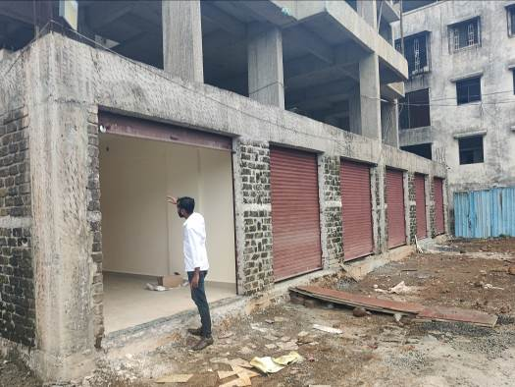

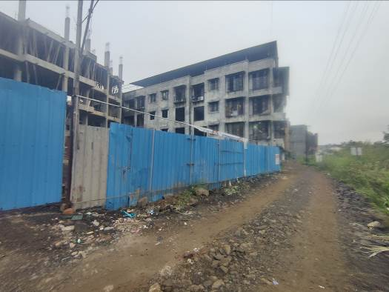

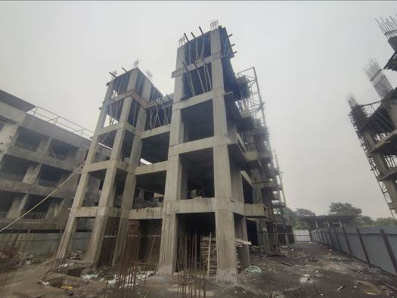
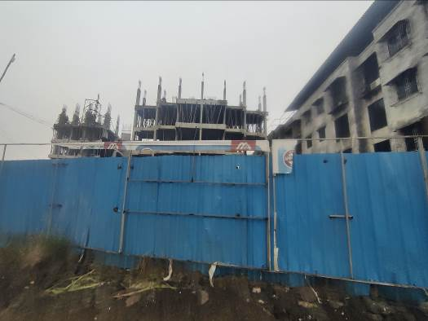

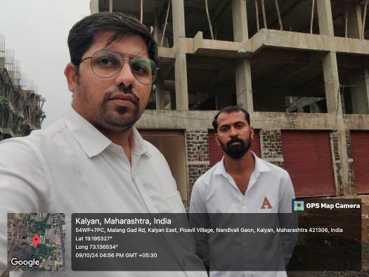


Route Map of the property
Site u/r
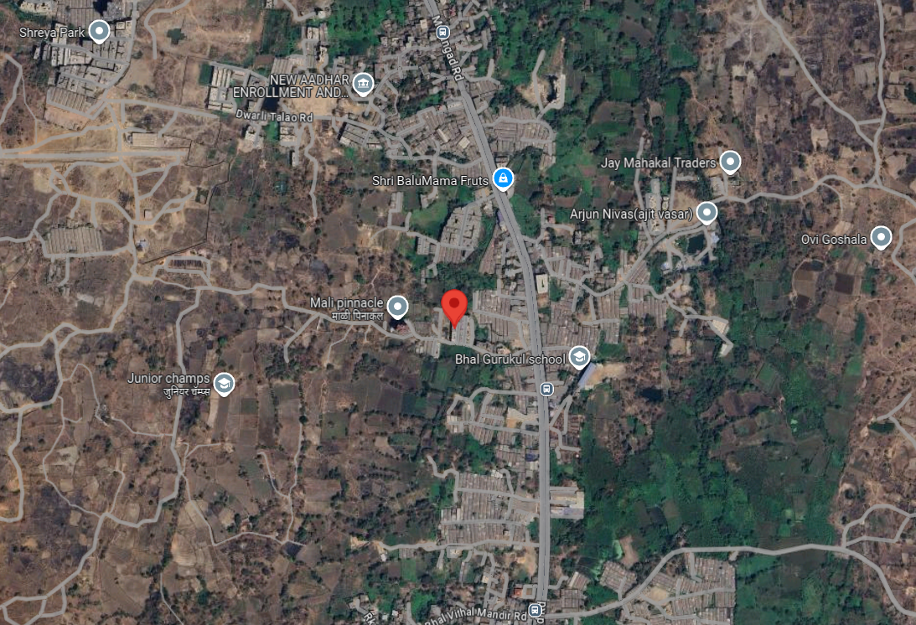

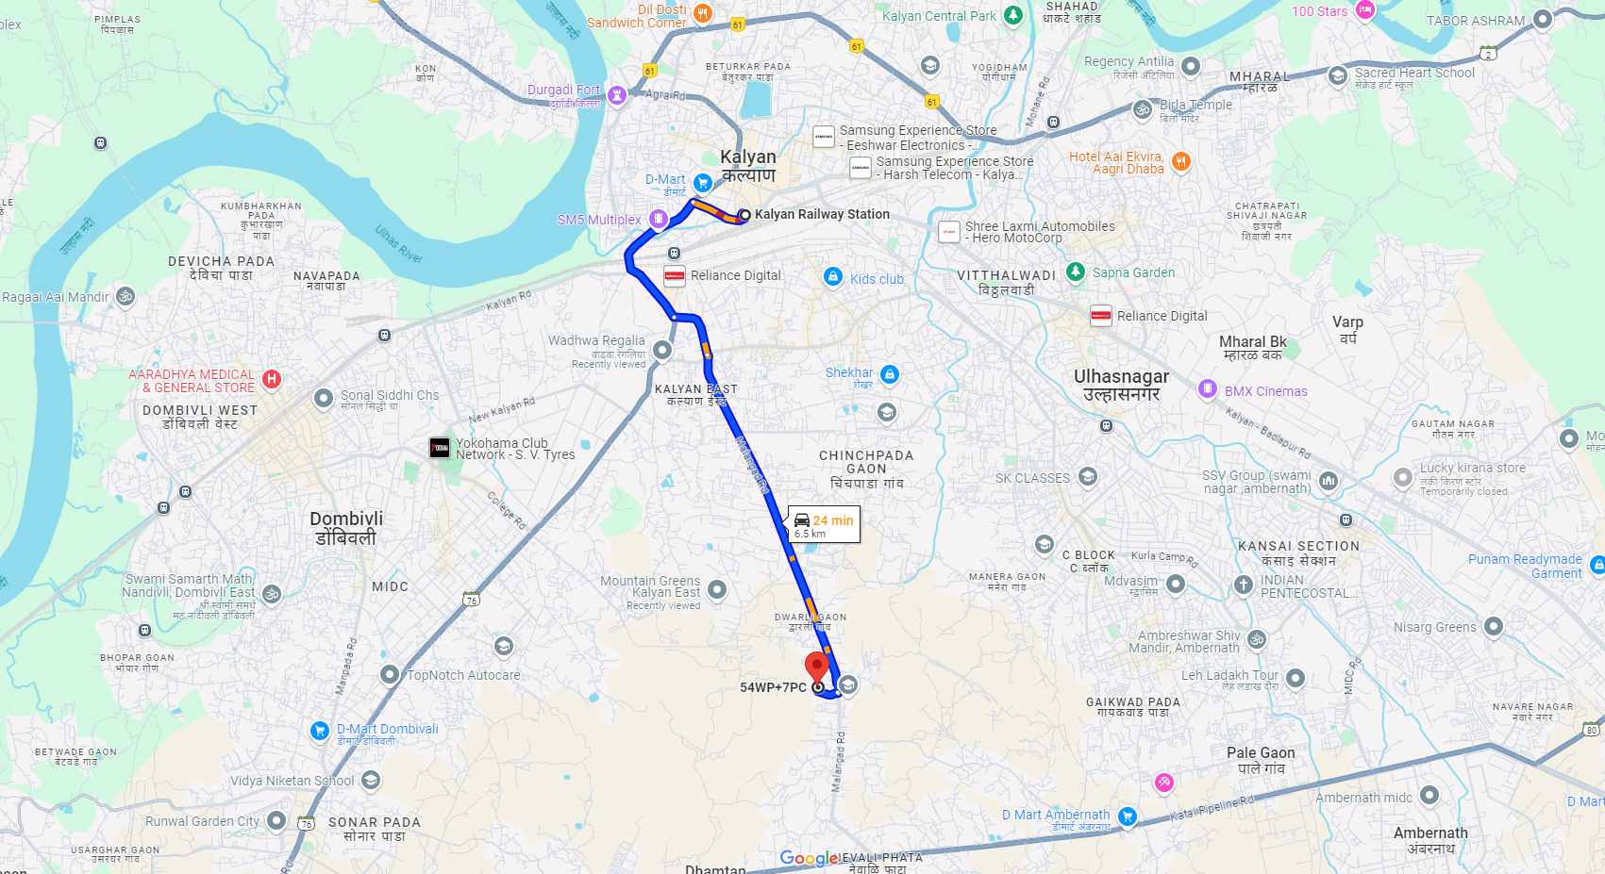

Latitude Longitude: 19°11'44.1"N 73°08'12.6"E
Note: The Blue line shows the route to site from nearest railway station (Kalyan – 6.50 KM)

