Vastu/Nashik/09/2024/011004/2308013
02/19-19-RPBS
Date: 04.10.2024

To, `
The Branch Manager,
Bank of Baroda
Regional Office Nashik Road Branch
BSNL Building, Datta Mandir Road, Nashik Road,
Nashik -422 101, State - Maharashtra, Country - India.

Sub: Vetting of Extra Amenities

Sir,

With reference to above subject, we have evaluated the Extra Amenities for Residential Flat No. K-601, 6th Floor, Wing - K, "Shilpa Anandvan", Beside Sant Tukaram Maharaj Jogging Track , Shivaji Nagar, Sant Narhari Maharaj Road, Village - Gangapur, Taluka - Nashik, District - Nashik belongs to Mr.Satveersingh Trilochansingh Pawar & Mrs.Jasbir Kaur Trilochansingh Pawar

We have verified the rates quoted as per current market rates. Details of work and Extra Amenities considered as per copy of Agreement for Extra Amenities between Mr.Satveersingh Trilochansingh Pawar & Mrs.Jasbir Kaur Trilochansingh Pawar. (First Party) and Shri.Sagar Shrikant Kasar (Second Party) received on dated 04.10.2024. The Extra Amenities amount is Rs.2,20,000/- (Rupees Two Lakh Twenty Thousand Only.)

The said Cost Vetting Certificate is valid upto next 6 months Only.

Thanking you

Sincerely yours

Manoj B. Chalikwar
Registered Valuer
Chartered Engineer (India)
Reg. No. CAT-I-F-1763
Reg. No. IBBI/RV/07/2018/10366
BOB Empanelment No.: ZO:MZ:ADV:46:941
Encl: Valuation report.

Agreement for Extra Amenities
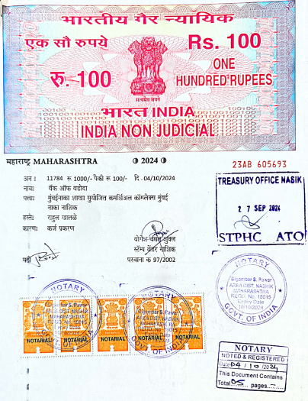
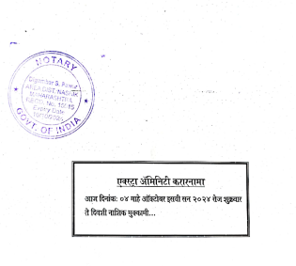

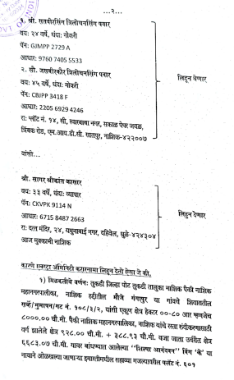
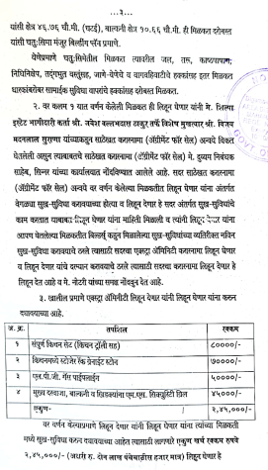

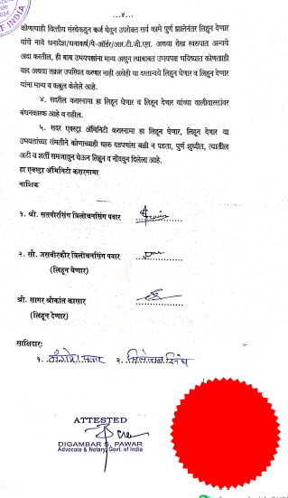

The Extra Amenities amount is Rs.2,20,000/- (Rupees Two Lakh Twenty Thousand Only.)

