Valuation Report of the Immovable Property

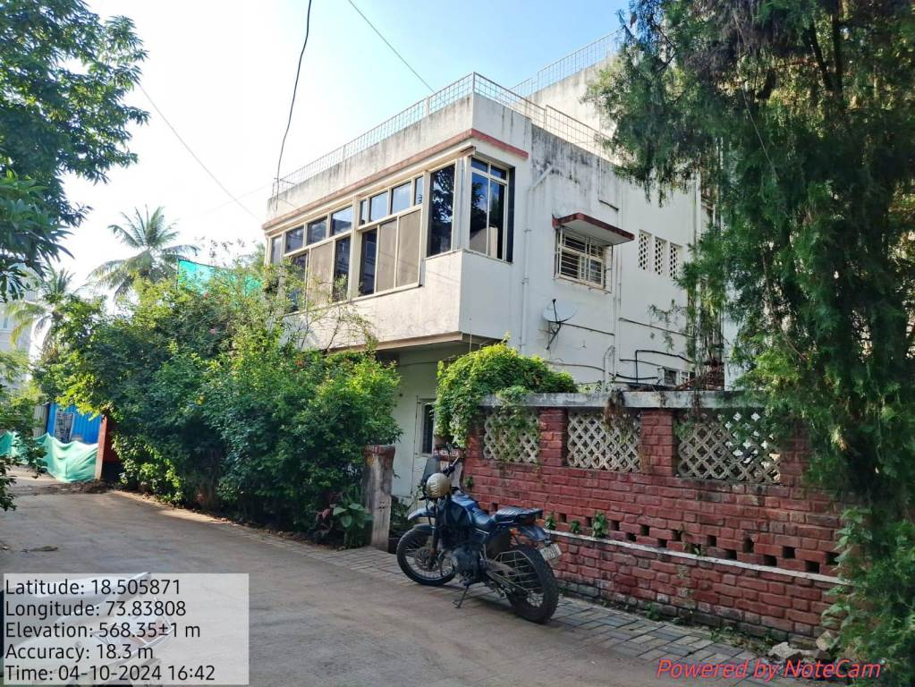

Details of the property under consideration:

Name of Owner: Shri. Prashant Suresh Pardeshi

Name of Proposed Purchaser: Darewar Tulana Pandurang & Vivek Shantaram Arote

Residential Bungalow on 1st & 2nd Floor, Plot 11, “Rushikesh Property”, Shree Gokul Co-op. Hsg. Soc. Ltd. Survey No. 127/A, Final Plot No. 560, Navi Peth, TPS Scheme No. 3, Near Mhatre Bridge, Village - Parvati Taluka - Haveli, District - Pune, PIN - 411 030, State - Maharashtra, Country - India.

Latitude Longitude - 18°30'21.6"N 73°50'16.5"E

Intended User:

State Bank of India
RASMECCC Panvel
Shop No 5, Ground Floor, Sharda Terrace, Plot No 65, Sector-11, CBD Belapur,
Navi Mumbai, Taluka & District - Thane, State - Maharashtra, Country - India

Vastu/Mumbai/10/2024/11566/2308551
08/10-91-JABS

Date: 08.10.2024

VALUATION OPINION REPORT

This is to certify that the property bearing Residential Bungalow on 1st & 2nd Floor, Plot 11, “Rushikesh Property”, Shree Gokul Co-op. Hsg. Soc. Ltd. Survey No. 127/A, Final Plot No. 560, Navi Peth, TPS Scheme No. 3, Near Mhatre Bridge, Village - Parvati Taluka - Haveli, District - Pune, PIN - 411 030, State - Maharashtra, Country - India belongs to Shri. Prashant Suresh Pardeshi. Name of Proposed Purchaser is Darewar Tulana Pandurang & Vivek Shantaram Arote.

Considering various parameters recorded, existing economic scenario, and the information that is available with reference to the development of neighbourhood and method selected for valuation, we are of the opinion that, the property premises can be assessed for this particular purpose at ₹ 1,74,89,124.00 (Rupees One Crore Seventy Four Lakhs Eighty Nine Thousand One Hundred Twenty Four only).
Boundaries of the property

North | : | Plot No. 15
South | : | Internal Road
East | : | Plot No. 10
West | : | Plot No. 12

The valuation of the property is based on the documents produced by the concern. Legal aspects have not been taken into considerations while preparing this valuation report.

Hence certified

Manoj Chalikwar
Govt. Reg. Valuer
Chartered Engineer (India)
Reg. No. IBBI/RV/07/2018/10366
State Bank of India Empanelment No.: SME/TCC/2021-22/86/3
Encl: Valuation report.
Vastukala Consultants (I) Pvt. Ltd.
B1-001, U/B Floor, Boomerang, Chandivali Farm Road, Powai, Andheri (East), Mumbai – 400 072

To,
The Branch Manager
State Bank of India
RASMECCC Panvel
Shop No. 5, Ground Floor
Sharda Terrace, Plot No 65
Sector-11, CBD Belapur
Navi Mumbai, Taluka & District - Thane
State - Maharashtra, Country - India.

Name of Owner: Shri. Prashant Suresh Pardeshi

Name of Proposed Purchaser: Darewar Tulana Pandurang & Vivek Shantaram Arote

Valuation Report of Immovable Property

1. | Customer Details
 | Name(s) of the owner(s). |  |  |  |  | Name of Owner: Shri. Prashant Suresh Pardeshi  Name of Proposed Purchaser: Darewar Tulana Pandurang & Vivek Shantaram Arote.
 | Application No.
2 | Property Details
 | Address |  |  |  |  |  |  | Residential Bungalow on 1st & 2nd Floor, Plot 11, “Rushikesh Property”, Shree Gokul Co-op. Hsg. Soc. Ltd. Survey No. 127/A, Final Plot No. 560, Navi Peth, TPS Scheme No. 3, Near Mhatre Bridge, Village - Parvati Taluka - Haveli, District - Pune, PIN - 411 030, State - Maharashtra, Country - India.
 | Nearby Landmark / Google Map Independent access to the property |  |  |  |  |  |  | Landmark: Near Mhatre Bridge  Latitude Longitude - 18°30'21.6"N 73°50'16.5"E
3 | Document Details |  |  |  | Name of Approving Authority
 | Layout Plan |  | No |  | - |  |  |  |  |  |  |  |  |  |  | Approval No. |  |  |  |  |  |  |  |  | -
 | Building Plan |  | Yes |  | Pune Municipal Corporation |  |  |  |  |  |  |  |  |  |  | Approval No. |  |  |  |  |  |  |  |  | 3295/15 dated21.10.2015 (Extension Plan)
 | Construction Permission |  | No |  | - |  |  |  |  |  |  |  |  |  |  | Approval No. |  |  |  |  |  |  |  |  | -
 | Occupancy Certificate (Ground Floor) |  | Yes |  | Pune Municipal Corporation |  |  |  |  |  |  |  |  |  |  | Approval No. |  |  |  |  |  |  |  |  | 538 dated 15/04/1986
 | Occupancy Certificate (1st & 2nd Floor) |  | Yes |  | Pune Municipal Corporation |  |  |  |  |  |  |  |  |  |  | Approval No. |  |  |  |  |  |  |  |  | OCC/0599/16 dated 13.07.2016
 | Legal Documents |  | Yes |  | - Copy of Agreement for Sale, Registration No. 2876/2006, dated 11/05/2006 between Mrs. Rekha Dilip Bavadekar (the Transferor or Vendor) AND Shri. Prashant Suresh Pardeshi (the Transferee or Purchaser)
 |  |  |  |  | - Copy of Index II, Registration NO. 11037-2018, dated 21/07/2018 between Kshitish Digambar Kulkarni (Seller) AND Prashant Suresh Pardeshi & Neeta Prashant Pardeshi (Purchaser)
 |  |  |  |  | - Copy of Pan Card No. BAGPD5730B of Proposed Purchaser Darewar Tulana Pandurang.
 |  |  |  |  | - Copy of Pan Card No. BUMPA2333M of Proposed Purchaser Vivek Shantaram Arote.
 |  |  |  |  | - Copy of No Dues Certificate (Property Tax) dated 03.10.2024 in the name of Prashant Suresh Pardeshi. Property ID – O/301/02640002, issued by Pune Municipal Corporation, Pune.
 |  |  |  |  | - Copy of Property Tax Paid Details dated 03/10/2014 in the name of Shri. Prashant Suresh Pardeshi issued by Pune Municipal Corporation, Pune.
4. | Physical Details of Building
 | Adjoining Properties |  | East |  |  |  |  |  |  |  |  | West |  |  |  |  |  |  |  |  | North |  |  |  |  |  |  |  | South
 | As on site |  | Plot No. 10 |  |  |  |  |  |  |  |  | Plot No. 12 |  |  |  |  |  |  |  |  | Plot No. 15 |  |  |  |  |  |  |  | Internal Road
 | As per document |  | Plot No. 10 |  |  |  |  |  |  |  |  | Plot No. 12 |  |  |  |  |  |  |  |  | Plot No. 15 |  |  |  |  |  |  |  | Internal Road
 | Bungalow Boundaries
 | As on site |  | Plot No. 10 |  |  |  |  |  |  |  |  | Plot No. 12 |  |  |  |  |  |  |  |  | Plot No. 15 |  |  |  |  |  |  |  | Internal Road
 | As per document |  | Plot No. 10 |  |  |  |  |  |  |  |  | Plot No. 12 |  |  |  |  |  |  |  |  | Plot No. 15 |  |  |  |  |  |  |  | Internal Road
 | Matching of Boundaries |  | - |  |  |  |  |  |  | Plot Demarcated |  |  |  |  |  |  | Yes |  |  | Approved land use |  |  |  |  |  | Residential |  |  | Type of Property |  |  |  | Residential
 | No. of rooms |  | Living |  |  |  | 1 |  | Bedrooms |  |  |  |  | 4 |  |  |  | Toilets |  |  |  | 4 |  | Kitchen |  |  |  | 1 |  |  | Terrace |  |  | 2
 | Car Parking Facility |  | Covered Parking Space
 | Total no. of Floors | Ground + 2 upper floors |  |  |  | Floor on which the property is located |  |  |  | 1st & 2nd Floor |  |  | Approx. Age of the property |  |  |  |  |  |  |  | Ground Floor 1986 (As per Occupancy Certificate)1st & 2nd Floor 2016 (As per Occupancy Certificate) |  |  |  |  |  | Residual age of the property |  |  | 32 Years Subject to proper, preventive periodic maintenance & structural repairs. |  |  | Type of Structure :R.C.C. Framed Structure
5 | Tenure / Occupancy Details
 | Status of Tenure |  | Vacant |  |  |  |  |  |  |  | No. of years of Occupancy |  |  |  |  |  |  |  | - |  |  |  |  |  |  | Relationship of tenant or owner |  |  |  |  | N. A
 | Present/Expected Income from the property |  |  |  |  |  |  |  |  |  | ` 40,000.00 Expected rental income per month.
6. | Stage of Construction
 | Stage of construction |  | Completed
 | If under construction, extent of completion
 | N. A
7. | Violations if any observed
 | Nature and extent of violations |  |  |  |  |  |  |  |  |  |  |  |  |  | -
8 | Area Details of the Property
 | Site Area |  | Carpet Area of 1st & 2nd Floor in Sq. Ft. = 1,789.00  (Area as per Actual Site Measurement)
 | Plinth Area |  | (Area as per Approved Building Plan)
  Floor | Existing Built-up Area in Sq. Ft. | Proposed Built-up Area in Sq. Ft. | Total
  First | 777.00 | 238.00 | 1,015.00
  Second | - | 637.00 | 637.00
  Encl. Balcony | - | 29.00 | 29.00
  Total | 777.00 | 904.00 | 1,681.00
 | Carpet Area |  | -
 | Saleable Area |  | -
 | Remarks |  | - The said bungalow, ground floor and part 1st floor is constructed in the year of 1986  - Further extension on part 1st floor and 2nd floor construction in the year of 2016 as per occupancy certificate.  - As per site inspection found extra columns and beams constructed for supporting the load for the above floors and the same is shown in the revised and extension approved plan also. Hence the Residual age of the property considered 10 years more Subject to proper, preventive periodic maintenance & structural repairs.  - As per documents 50% land share belonging to Shri. Prashant Suresh Pardeshi.  - Ground Floor area is not considered for this valuation purpose.
9 | Valuation
 | - Mention the value as per Government Approved Rates also
 | Guideline rate obtained from the Stamp Duty Ready Reckoner |  |  |  |  |  |  |  |  |  |  |  |  |  |  | ` 82,118.00 per Sq. M. i.e., ` 7,629.00 per Sq. Ft.
 | Guideline rate obtained from the Stamp Duty Ready Reckoner (After Depreciation) |  |  |  |  |  |  |  |  |  |  |  |  |  |  | ` 69,905.00 per Sq. M. i.e., ` 6,494.00 per Sq. Ft.
 | - In case of variation of 20% or more in the valuation proposed by the valuer and the Guideline value provided in the State Govt. notification or Income Tax Gazette justification on variation has to be given.
 | Considering the above indicator of sale, current market conditions, demand and supply position, Residential Bungalow on 1st & 2nd Floor size, location, upswing in real estate prices, sustained demand for Residential Bungalow on 1st & 2nd Floor, all-round development of commercial and residential application in the locality etc. We estimate ` 10,404.00 rate per Sq. Ft. on Built-up Area after depreciation.
 | Summary of Valuation
 | - Guideline Value
 |  |  |  |  |  |  |  |  |  |  |  |  |  |  |  | Area in Sq. Ft. |  |  |  |  |  |  | Rate in ` |  |  |  |  |  |  |  |  | Value in `
 | Built up area |  |  |  |  |  |  |  |  |  |  |  |  |  |  | 1,681.00 |  |  |  |  |  |  | 6,494.00 |  |  |  |  |  |  |  |  | 1,09,16,414.00
 | - The Total Value / Fair Market Value of the Property
 |  |  |  |  |  |  |  |  |  |  |  |  |  |  |  | Area in Sq. Ft. |  |  |  |  |  |  | Prevailing Market Rate in ` |  |  |  |  |  |  |  |  | Value in `
 | Built-up Area |  |  |  |  |  |  |  |  |  |  |  |  |  |  | 1,681.00 |  |  |  |  |  |  | 10,404.00 |  |  |  |  |  |  |  |  | 1,74,89,124.00
 | - Fair Market value |  |  |  |  |  |  |  |  |  |  |  |  |  |  | ` 1,74,89,124.00
 | - Realizable value |  |  |  |  |  |  |  |  |  |  |  |  |  |  | ` 1,71,39,342.00
 | - Forced/ Distress Sale value |  |  |  |  |  |  |  |  |  |  |  |  |  |  | ` 1,39,91,299.00
 | - Insurable Value of the Assets |  |  |  |  |  |  |  |  |  |  |  |  |  |  | ` 47,06,800.00
10 | Assumptions /Remarks
 | - Qualiﬁcation in TIR / Mitigation Suggested, if any |  |  |  |  |  |  |  |  | TIR not provided
 | - Property is SARFAESI compliant |  |  |  |  |  |  |  |  | No
 | - Whether property belongs to social infrastructure like hospital, school, old age home etc. |  |  |  |  |  |  |  |  | No
 | - Whether entire piece of land on which the unit is set up/property is situated has been mortgaged or to be mortgaged |  |  |  |  |  |  |  |  | Information not available
 | - Details of last two transaction in the locality / area to be provided, if available |  |  |  |  |  |  |  |  | Details Attached
 | - Any other aspect which has relevance on the value or marketability of the property |  |  |  |  |  |  |  |  | Location, development of surrounding area, type of construction, construction speciﬁcations, age of building, condition of the premises & building, facilities provided and its prevailing market rate.
11 | Declaration |  |  |  |  |  |  |  |  | - The property was inspected by my authorized representative personally on 04.10.2024.  - The undersigned does not have any direct / indirect interest in the above property.  - The information furnished herein is true and correct to the best of our knowledge.  - I have submitted Valuation report directly to the Bank
12 | Name, address & signature of valuer |  |  | Vastukala Consultants (I) Pvt. Ltd.  B1-001, U/B Floor, Boomerang, Chandivali Farm Road, Powai, Andheri (East), Mumbai - 400 072
12 |  |  |  |  |  |  |  |  |  |  |  |  |  |  |  |  | Manoj Chalikwar  Govt. Reg. Valuer  Chartered Engineer (India)  Reg. No. IBBI/RV/07/2018/10366  State Bank of India Empanelment No.: SME/TCC/2021-22/86/3 |  |  |  |  |  |  |  |  |  |  |  |  |  |  | Date of valuation:  07.10.2024
13 | Enclosures
 | Layout plan sketch of the area in which the property is located with latitude and longitude |  |  |  |  |  |  |  |  |  |  |  |  |  |  |  | Not Provided
 | Building Plan |  |  |  |  |  |  |  |  |  |  |  |  |  |  |  | Provided
 | Floor Plan |  |  |  |  |  |  |  |  |  |  |  |  |  |  |  | Not Provided
 | Photograph of the property |  |  |  |  |  |  |  |  |  |  |  |  |  |  |  | Attached
 | Certified copy of the approved / sanctioned plan wherever applicable from the concerned office |  |  |  |  |  |  |  |  |  |  |  |  |  |  |  | Not Provided
 | Google Map location of the property |  |  |  |  |  |  |  |  |  |  |  |  |  |  |  | Attached
 | Price trend of the Property in the locality/city from property search sites viz Magickbricks.com,  99Acres.com, Makan.com etc |  |  |  |  |  |  |  |  |  |  |  |  |  |  |  | Attached
 | Any other relevant documents/ extracts |  |  |  |  |  |  |  |  |  |  |  |  |  |  |  | N.A.

As a result of my appraisal and analysis, it is my considered opinion that the Fair market value of the above property is ` 1,74,89,124.00 (Rupees One Crore Seventy Four Lakhs Eighty Nine Thousand One Hundred Twenty Four only). The Realizable Value of the above property is ` 1,71,39,342.00 (Rupees One Crore Seventy One Lakhs Thirty Nine Thousand Three Hundred Forty Two Only). and The Distress value ` 1,39,91,299.00 (Rupees One Crore Thirty Nine Lakhs Ninety One Thousand Two Hundred Ninety Nine only).

Place: Mumbai
Date: 08.10.2024

Manoj Chalikwar
Govt. Reg. Valuer
Chartered Engineer (India)
Reg. No. IBBI/RV/07/2018/10366
State Bank of India Empanelment No.: SME/TCC/2021-22/86/3

The undersigned has inspected the property detailed in the Valuation Report dated _______________________

on ____________________. We are satisfied that the fair and reasonable market value of the property is

`_________________________ (Rupees ________________________________________________________

________________________________________only).

Date
Signature
(Name & Designation of the Inspecting Official/s)

Countersigned
(BRANCH MANAGER)

Enclosures
 | Declaration-cum-undertaking from the valuer (Annexure- IV) | Attached
 | Model code of conduct for valuer - (Annexure - V) | Attached

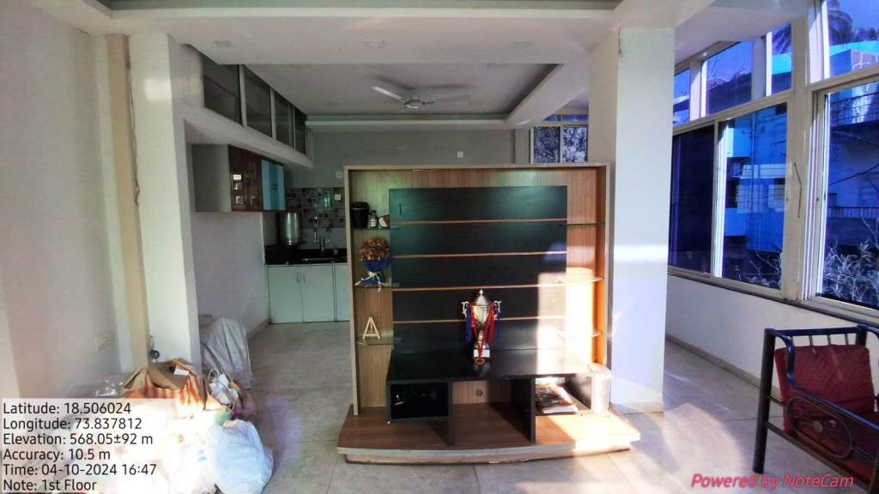
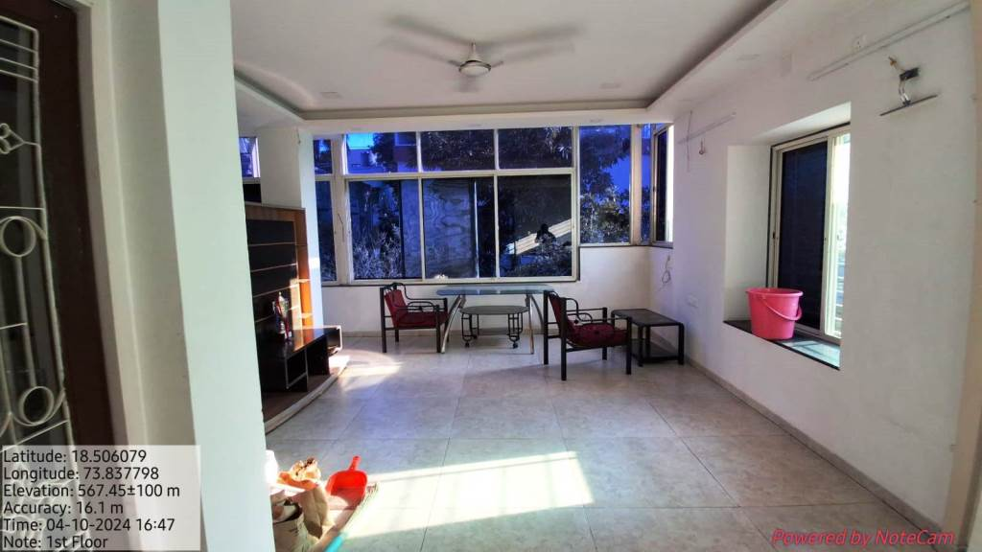
Actual site photographs

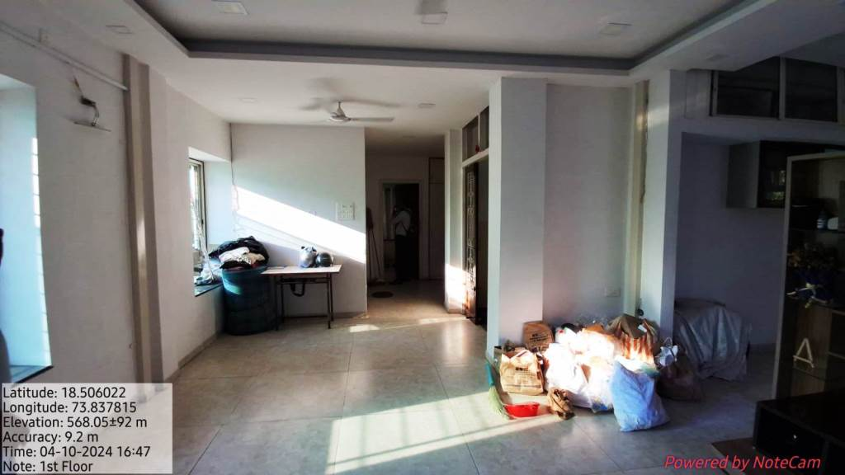
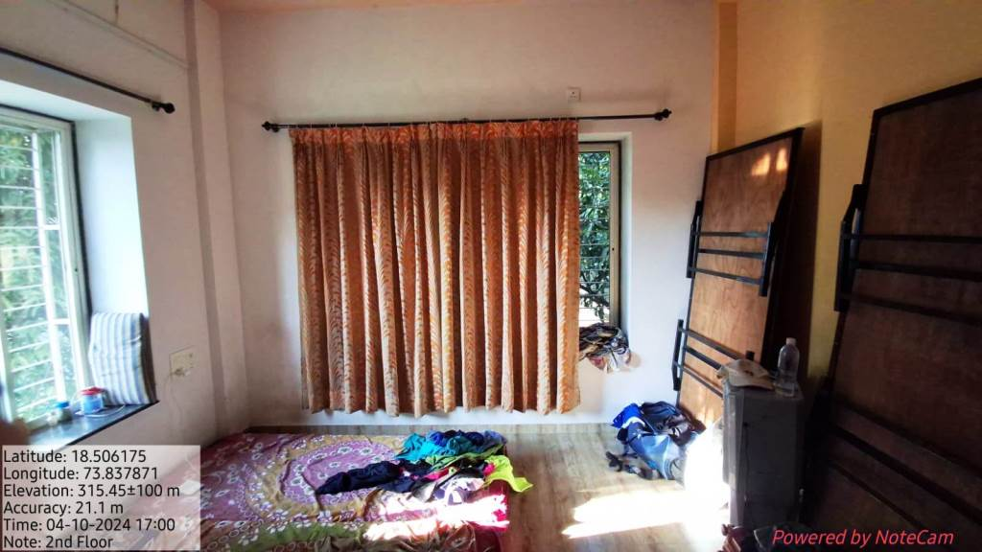

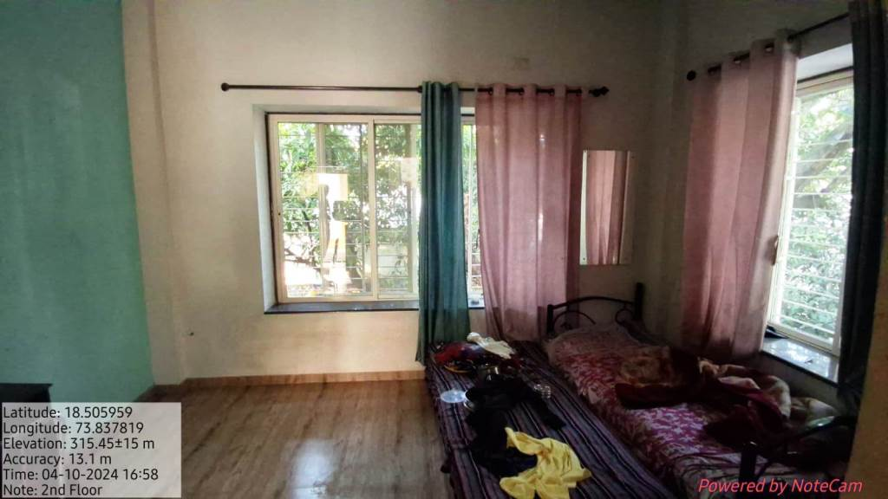
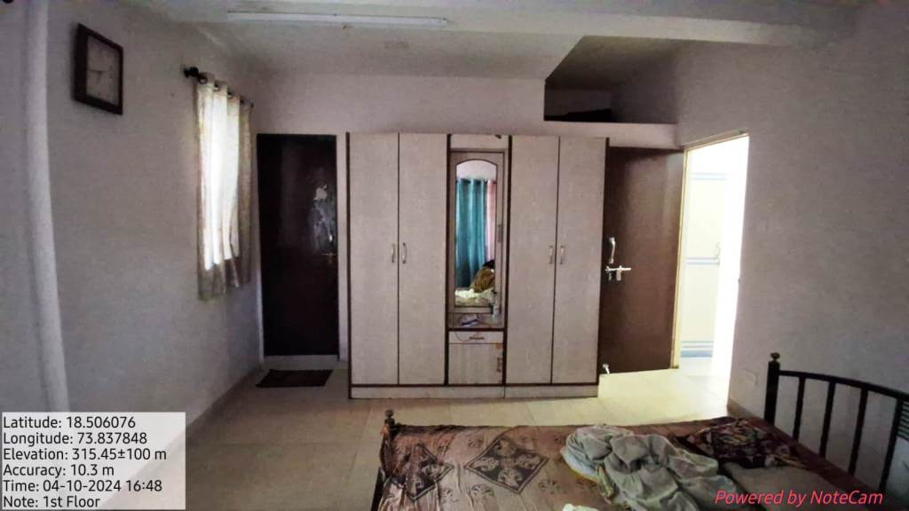

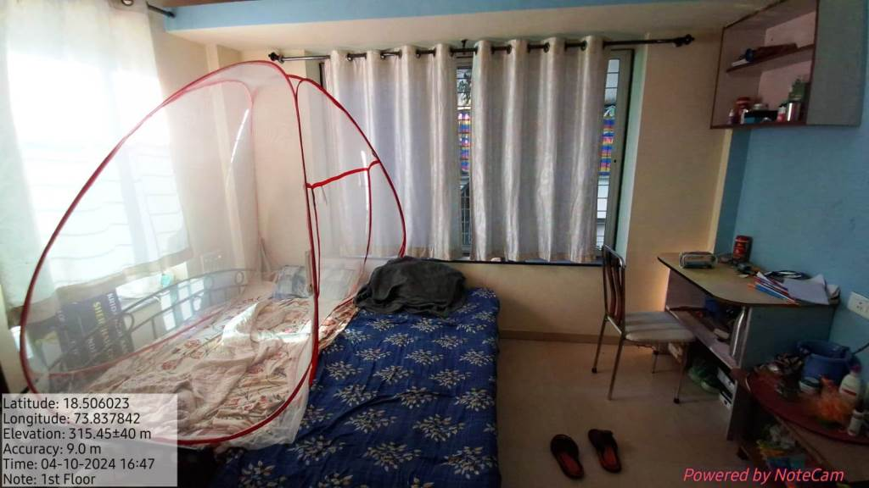
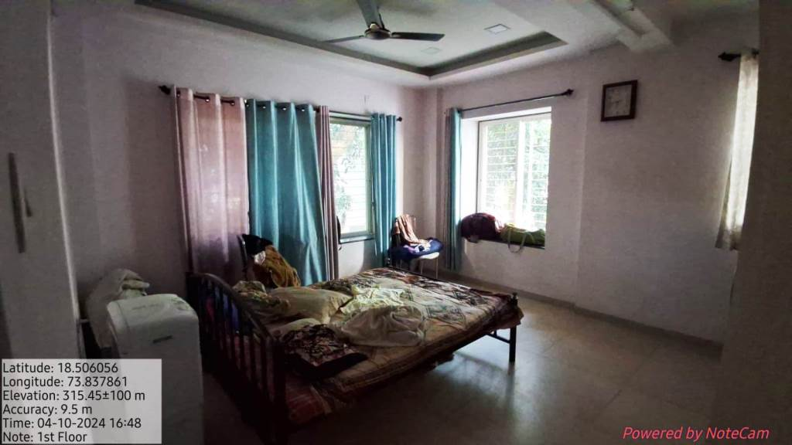

Actual site photographs
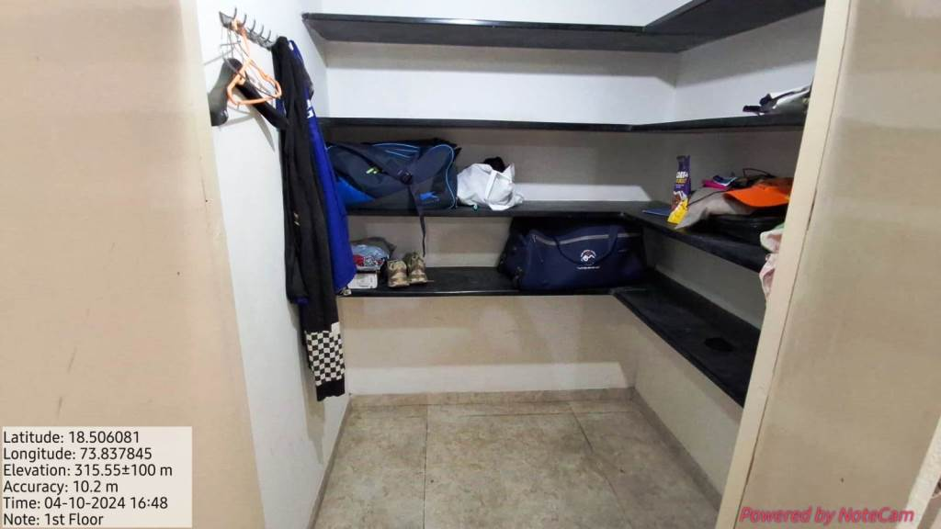
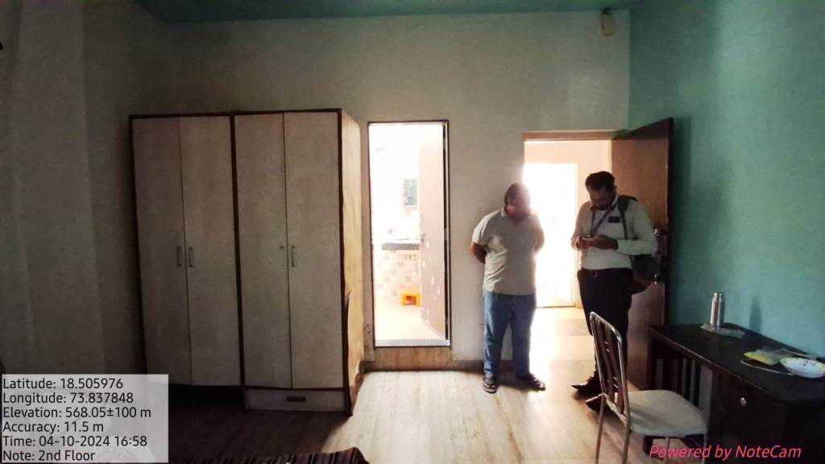
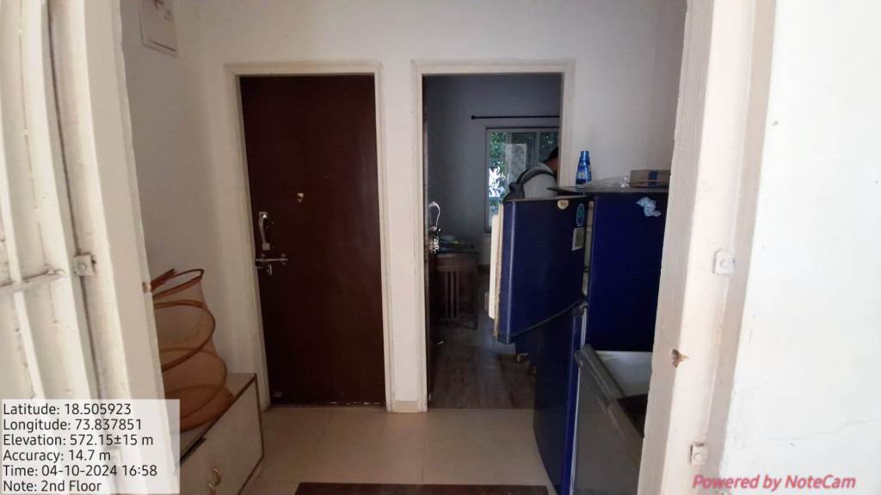
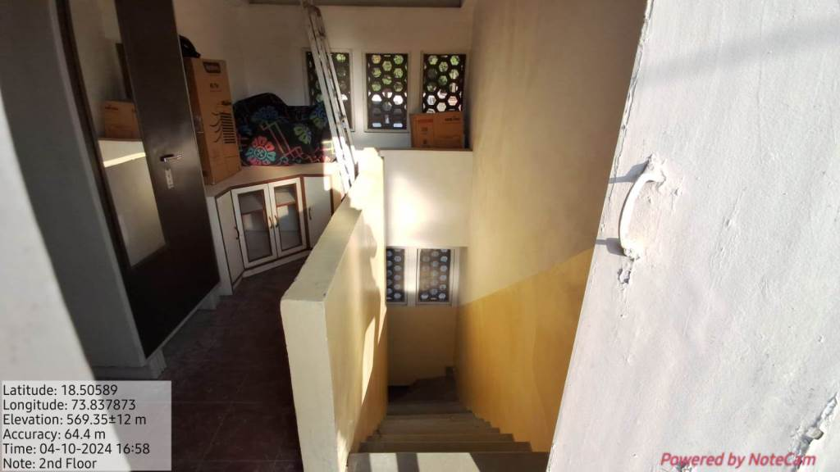
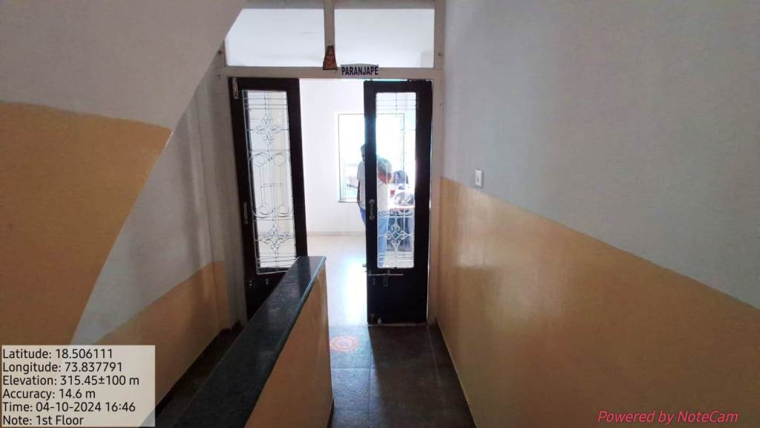
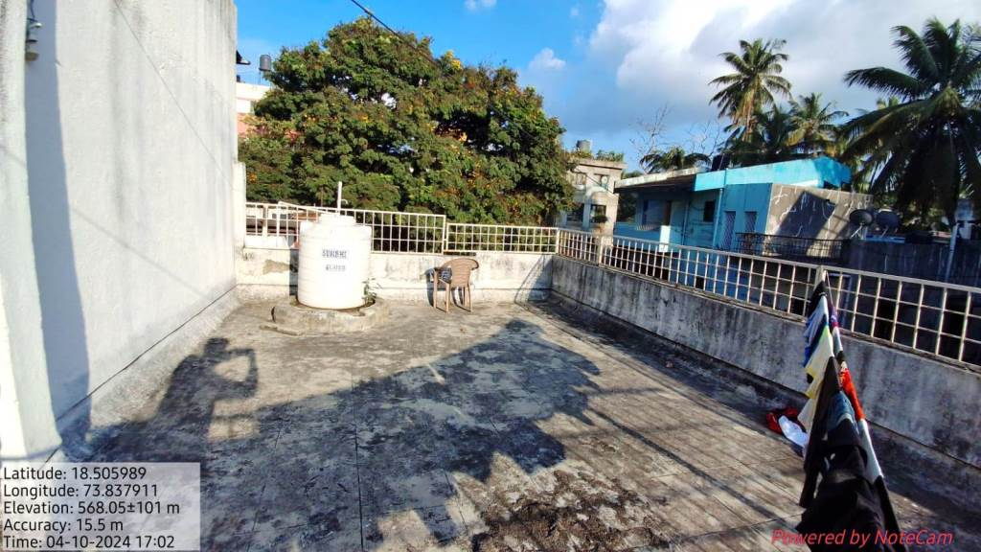
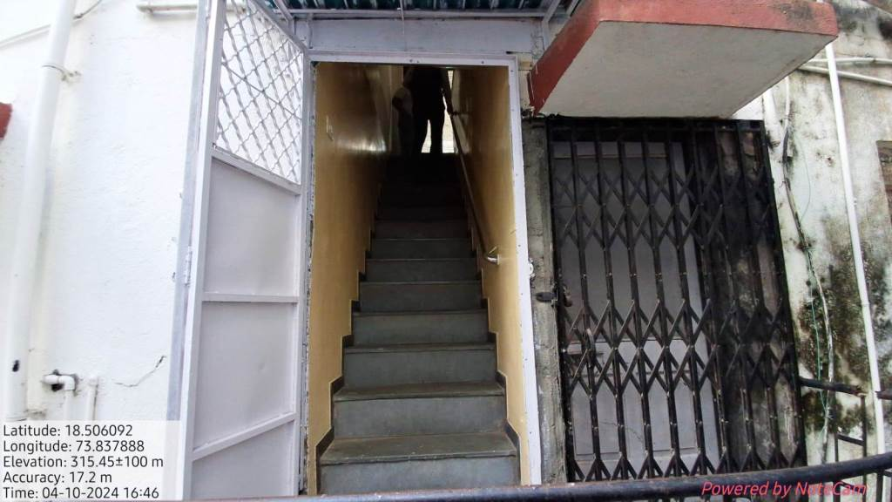
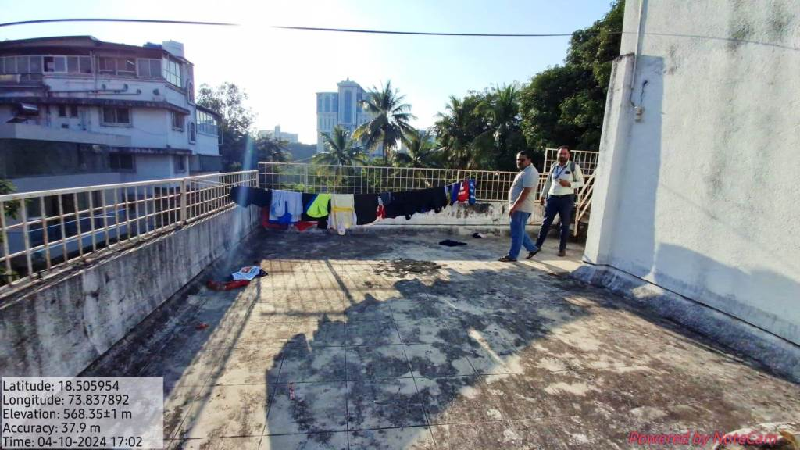
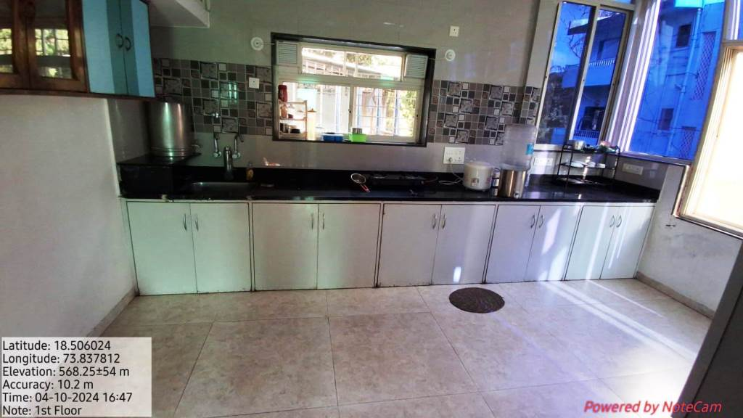
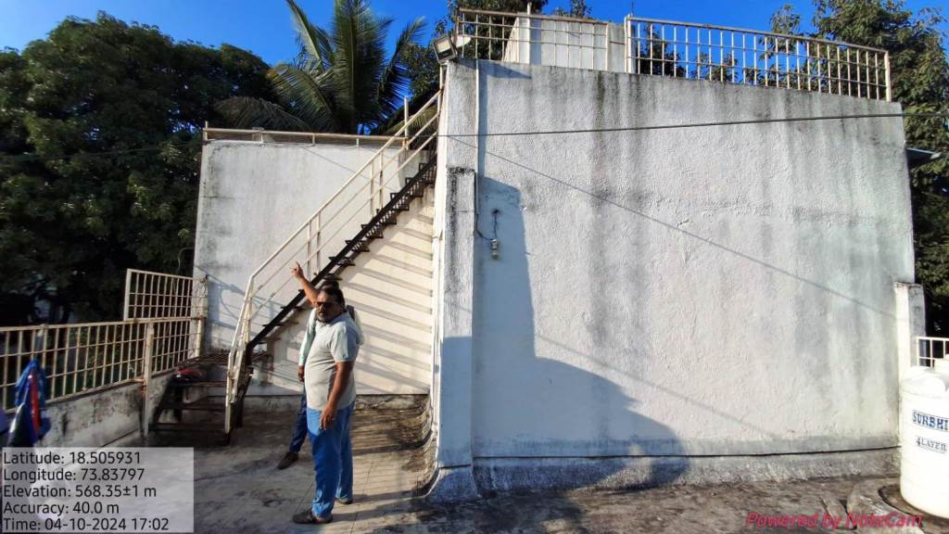
Actual site photographs
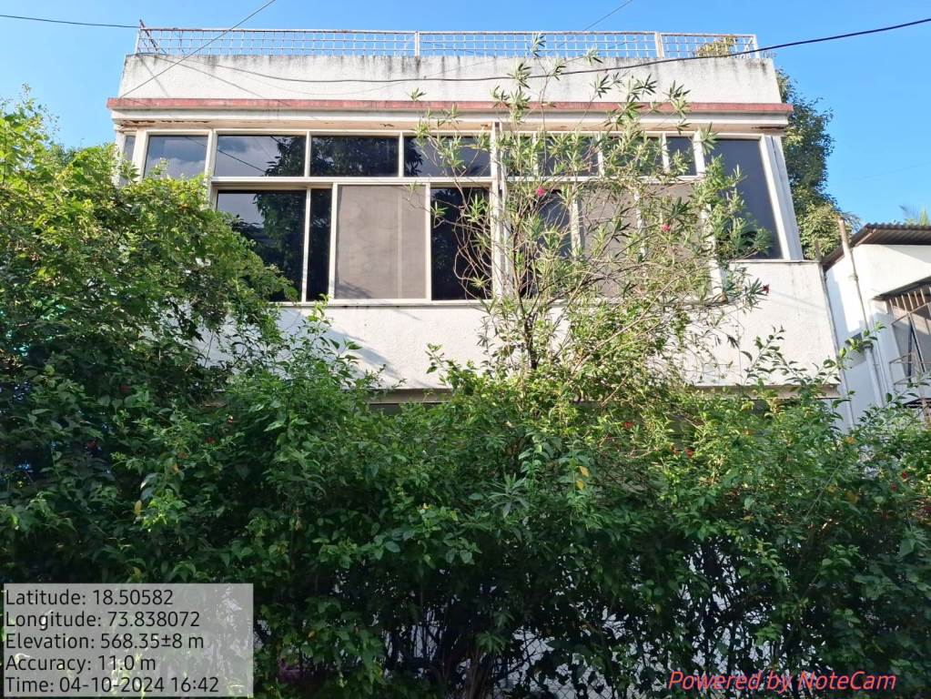
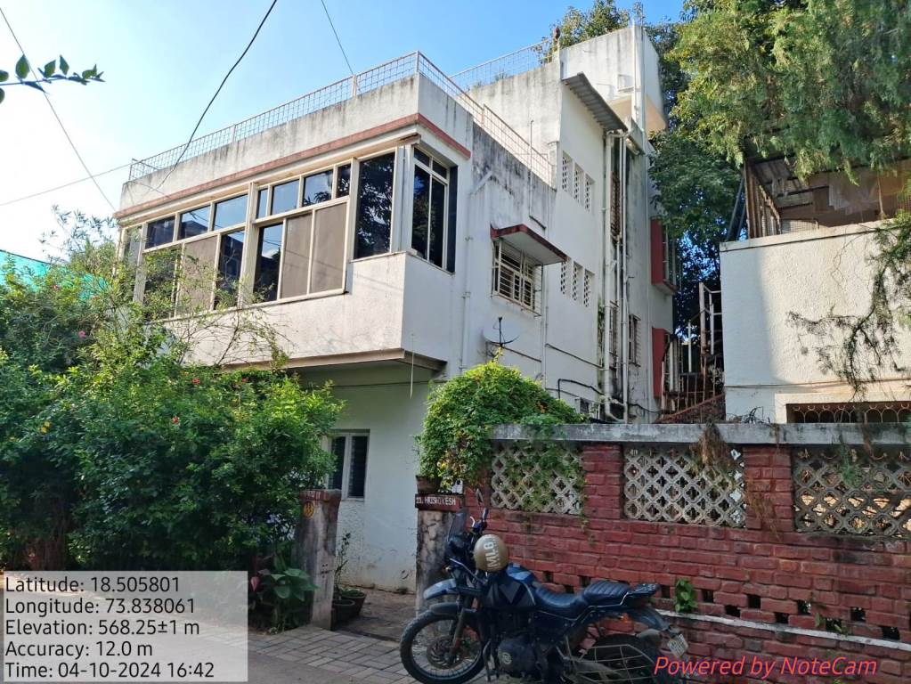
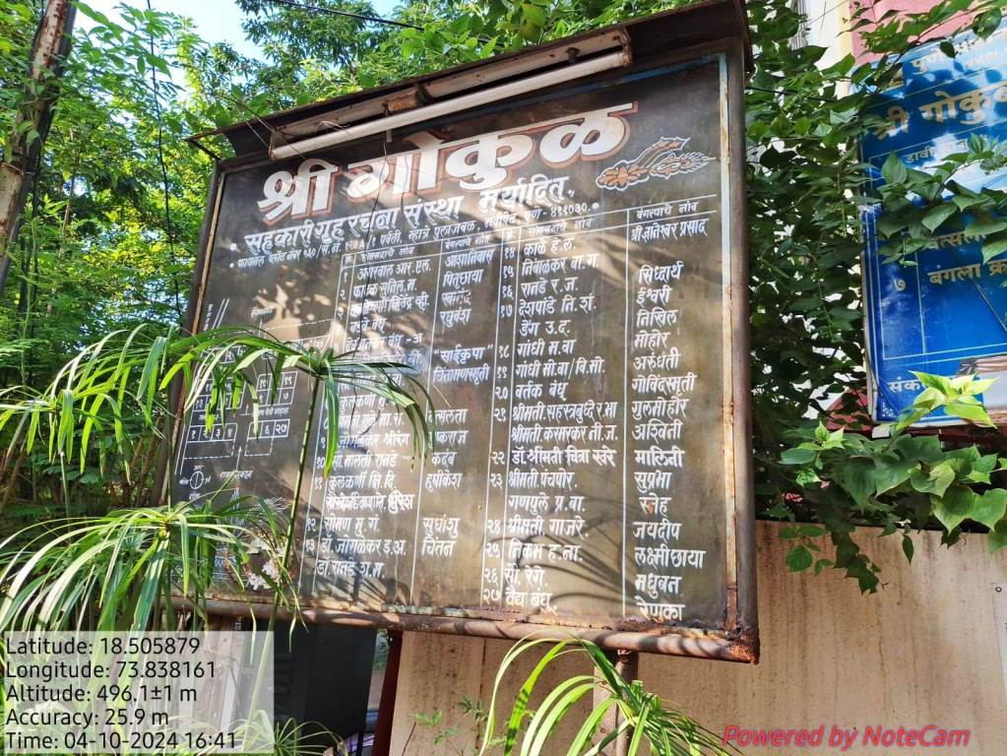
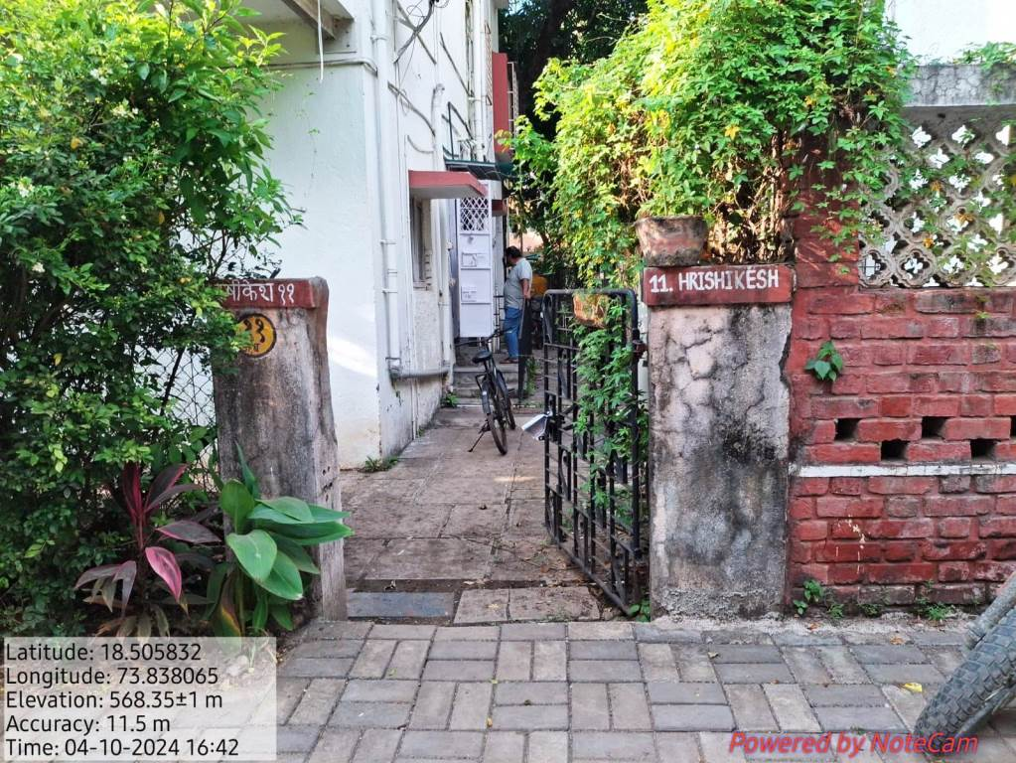
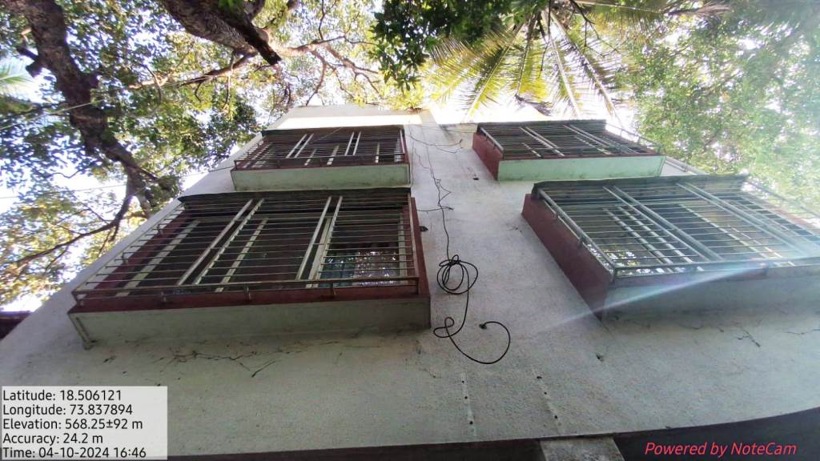
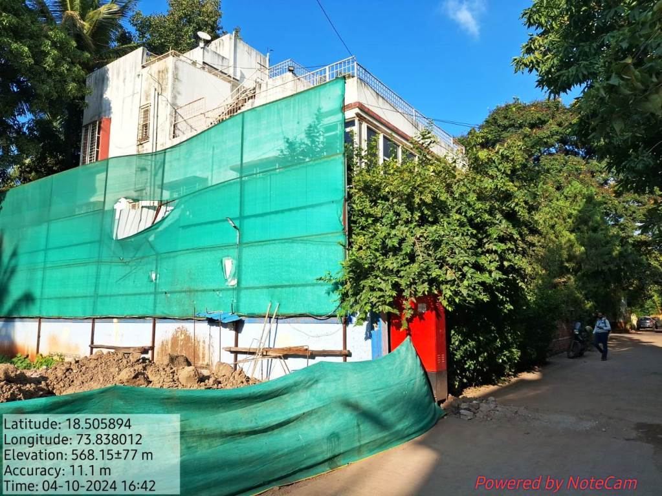
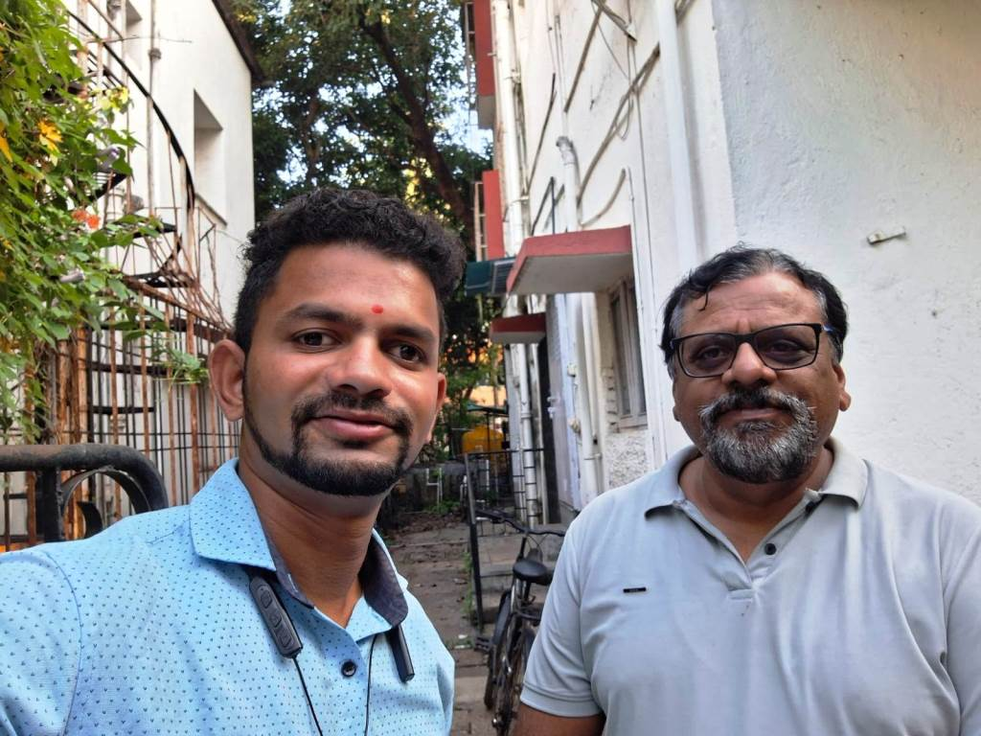
Route Map of the property
Site u/r
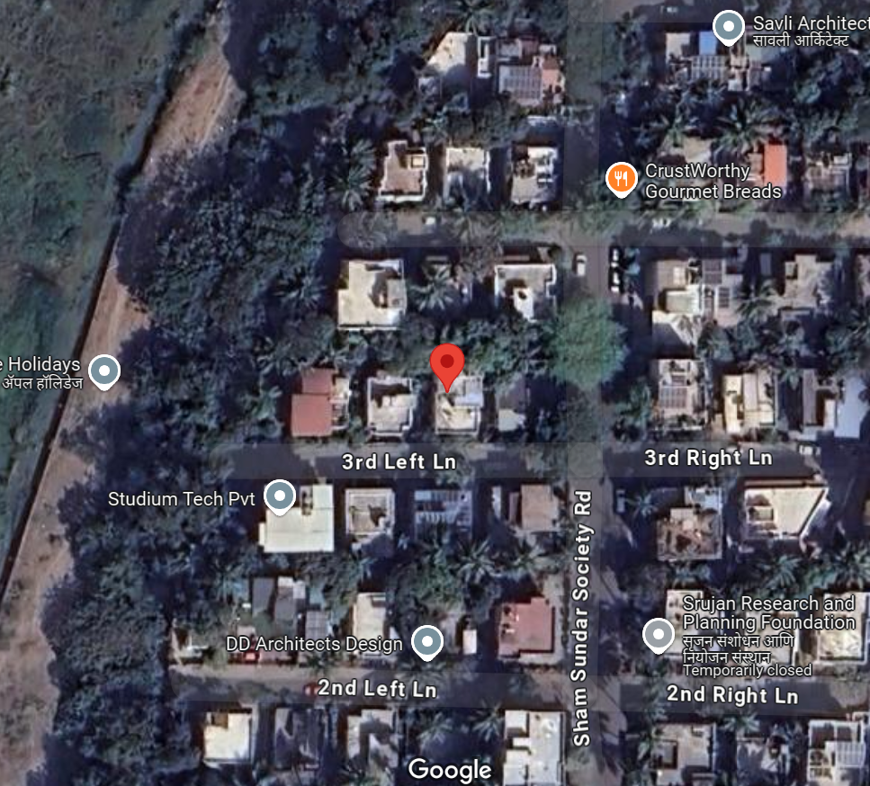


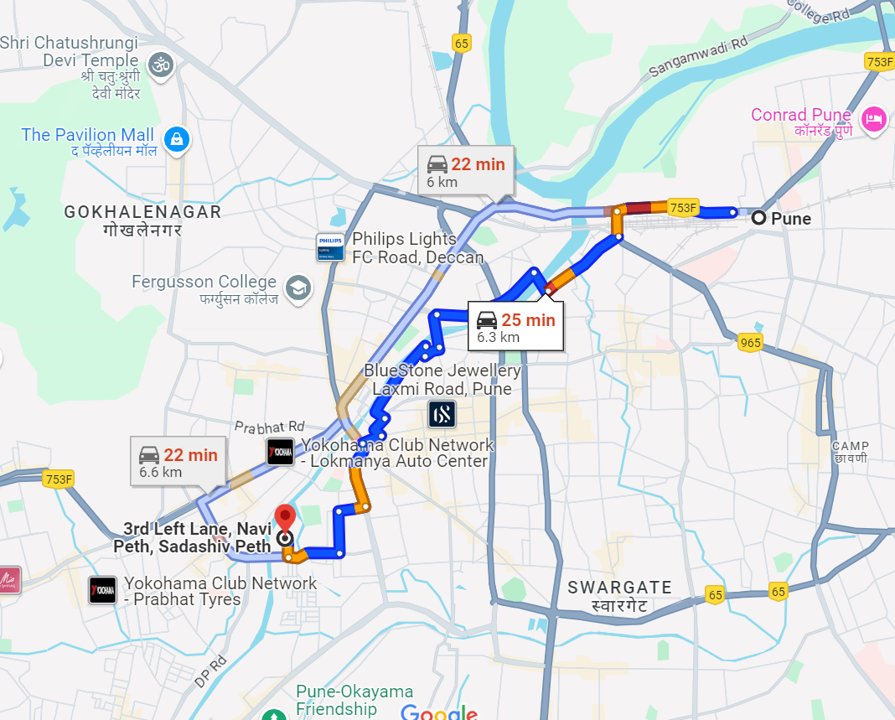

Latitude Longitude - 18°30'21.6"N 73°50'16.5"E

Note: The Blue line shows the route to site from nearest railway station (Pune – 6.3km.)
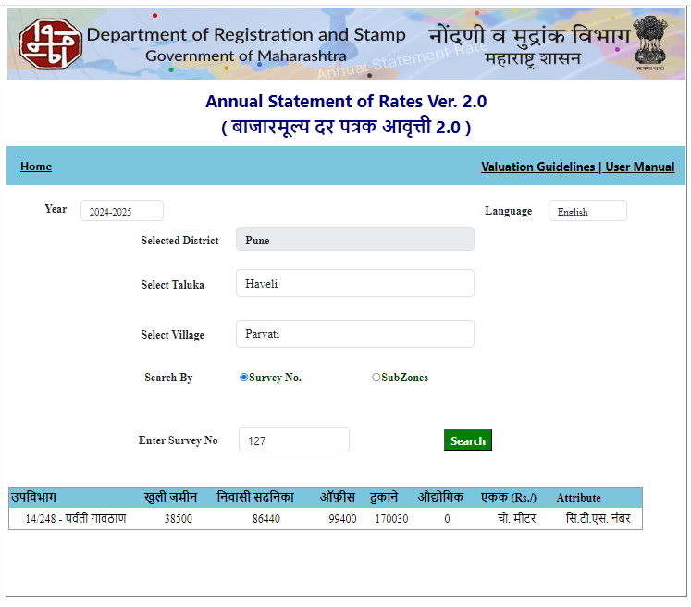
Ready Reckoner Rate

Stamp Duty Ready Reckoner Market Value Rate for Bungalow on 1st & 2nd Floor | 86,440.00
5% Decrease for property located on 1st & 2nd floors | 4,322.00
Stamp Duty Ready Reckoner Market Value Rate (After Increase) A) | 82,118.00 | Sq. M. | 7,629.00 | Sq. Ft.
Stamp Duty Ready Reckoner Market Value Rate for Land (B) | 38,500.00
The difference between land rate and building rate (A – B = C) | 43,618.00
Depreciation Percentage as per table (D) [100% - 28%]  (Age of the Building – 28 Years) | 72%
Rate to be adopted after considering depreciation [B + (C x D)] | 69,905.00 | Sq. M. | 6,494.00 | Sq. Ft.
Multi-Storied building with Lift
The following table gives the valuation of residential building / Bungalow on 1st & 2nd Floor / commercial unit / office in such building on above floor where there is no lift. Depending upon the floor, ready reckoner rates will be reduced.

 | Floor on which Bungalow on 1st & 2nd Floor is Located | Rate to be adopted
a) | Ground Floor / Stilt / Floor | 100%
b) | First Floor | 95%
c) | Second Floor | 90%
d) | Third Floor | 85%
e) | Fourth Floor and above | 80%

Price Indicators
Property | 3 BHK for Sale in Navi Peth, Pune
Source | magicbricks
Floor
 | Carpet | Built Up | Saleable
Area | 3,300.00 | 3,960.00 | 4,752.00
Percentage | - | 20% | 20%
Rate Per Sq. Ft. | ₹ 12,879.00 | ₹ 10,732.00 | ₹ 8,944.00
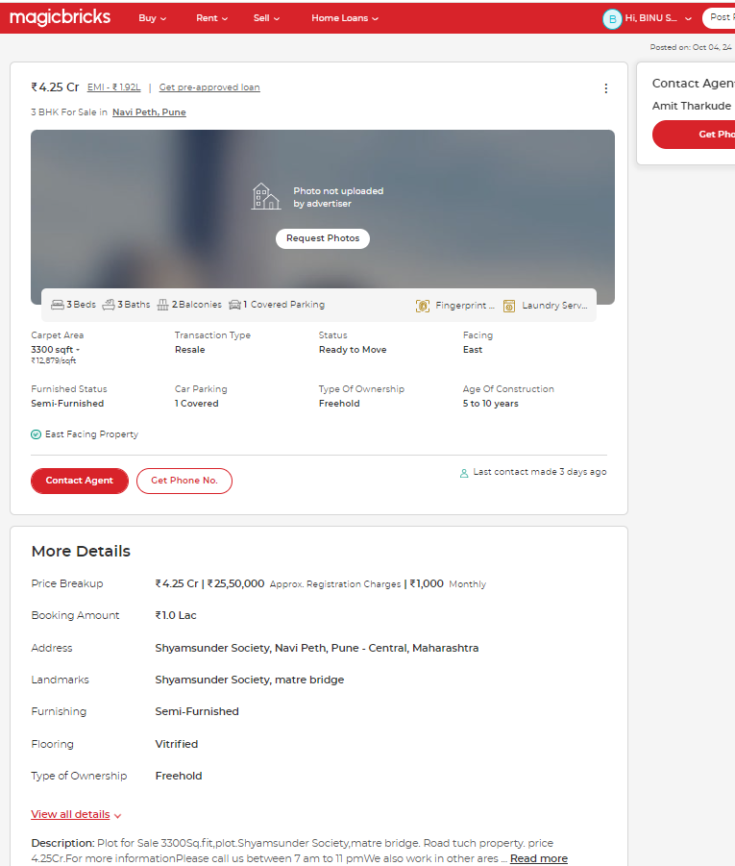
Price Indicators
Property | 4 BHK for Sale in Navi Peth, Pune
Source | magicbricks
Floor
 | Carpet | Built Up | Saleable
Area | 3,800.00 | 4,560.00 | 5,472.00
Percentage | - | 20% | 20%
Rate Per Sq. Ft. | ₹ 17,105.00 | ₹ 14,254.00 | ₹ 11,879.00
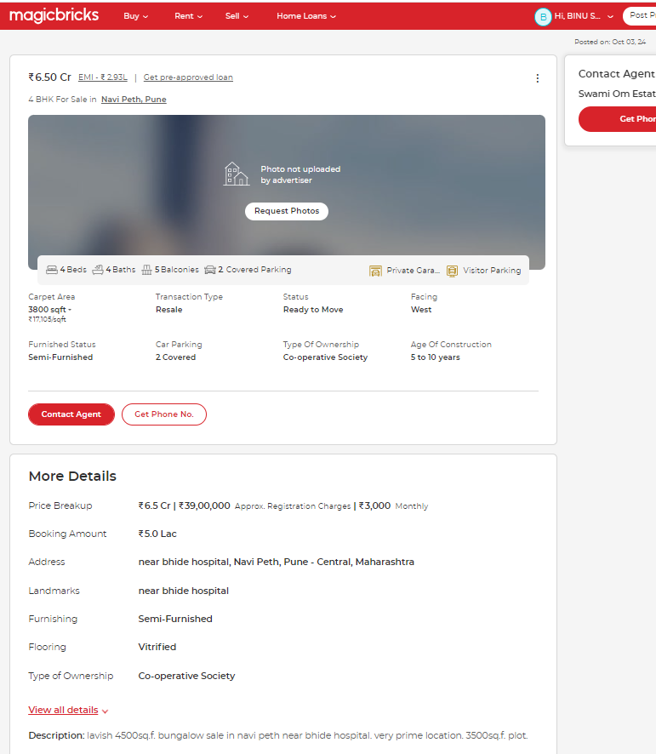
Sale Instance
Property | Apartment / Bungalow
Source | INDEX II
Floor | -
 | Carpet | Built Up | Saleable
Area | 962.30 | 1154.76 | -
Percentage | 20% | - | -
Rate Per Sq. Ft. | ₹ 15,588.00 | ₹ 12,990.00 | -
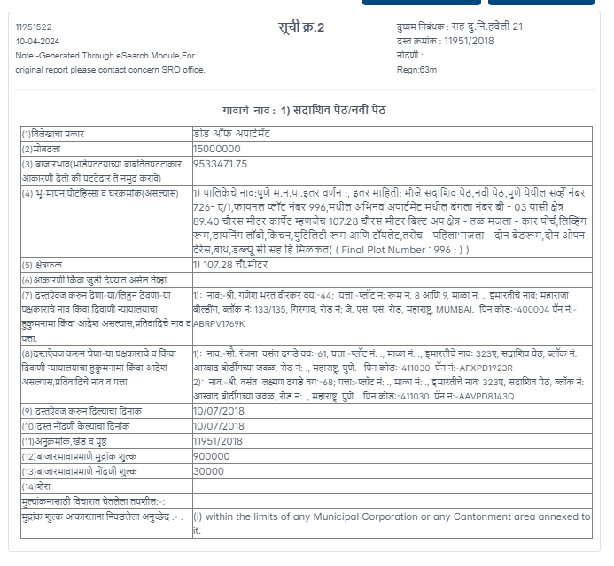

Justification for price / rate
The Market Value of the property is based on facts of markets discovered by us during our enquiries, however the government rate value in this case is less than the market value arrived by us. We are of the opinion that the value arrive by us will prove to be correct if an Auction of the subject property is carried out. As far as Market Value in Property documents is concerned, it is not possible to comment on same, may be government rates are fixed by sampling during same point of time in part and whereas, Market values change every month.
In most of the cases the actual deal amount or Transaction value is not reflected in Property documents because of various Market practices. As Valuer, we always try to give a value which is correct reflection of actual transaction value irrespective of any factors in market.

DECLARATION-CUM-UNDERTAKING

I, Manoj Chalikwar son of Shri. Baburao Chalikwar do hereby solemnly affirm and state that:

- I am a citizen of India.

- I will not undertake valuation of any assets in which I have a direct or indirect interest or become so interested at any time during a period of three years prior to my appointment as valuer or three years after the valuation of assets was conducted by me.

- The information furnished in my valuation report dated 08.10.2024 is true and correct to the best of my knowledge and belief and I have made an impartial and true valuation of the property.

- I/ my authorized representative has personally inspected the property on 04.10.2024. The work is not sub - contracted to any other valuer and carried out by myself.

- Valuation report is submitted in the format as prescribed by the bank.

- I have not been depanelled / delisted by any other bank and in case any such depanelment by other banks during my empanelment with you, I will inform you within 3 days of such depanelment.

- I have not been removed / dismissed from service / employment earlier.

- I have not been convicted of any offence and sentenced to a term of imprisonment

- I have not been found guilty of misconduct in my professional capacity.

- I have not been declared to be unsound mind

- I am not an undischarged bankrupt, or has not applied to be adjudicated as a bankrupt;

- I am not an undischarged insolvent.

- I have not been levied a penalty under section 271J of Income-tax Act, 1961 (43 of 1961) and time limit for filing appeal before Commissioner of Income-tax (Appeals) or Income-tax Appellate Tribunal, as the case may be has expired, or such penalty has been confirmed by Income-tax Appellate Tribunal, and five years have not elapsed after levy of such penalty

- I have not been convicted of an offence connected with any proceeding under the Income Tax Act 1961, Wealth Tax Act 1957 or Gift Tax Act 1958 and

- My PAN Card number as applicable is AERPC9086P

- I undertake to keep you informed of any events or happenings which would make me ineligible for empanelment as a valuer

- I have not concealed or suppressed any material information, facts and records and I have made a complete and full disclosure

- I have read the Handbook on Policy, Standards and procedure for Real Estate Valuation, 2011 of the IBA and this report is in conformity to the "Standards" enshrined for valuation in the Part - B of the above handbook to the best of my ability.

- I have read the International Valuation Standards (IVS) and the report submitted to the Bank for the respective asset class is in conformity to the "Standards" as enshrined for valuation in the IVS in "General Standards" and "Asset Standards" as applicable. The valuation report is submitted in the prescribed format of the bank.

- I abide by the Model Code of Conduct for empanelment of valuer in the Bank. (Annexure V - A signed copy of same to be taken and kept along with this declaration)

- I am valuer registered with Insolvency & Bankruptcy Board of India (IBBI)

- My CIBIL Score and credit worthiness is as per Bank's guidelines.

- I am the Director of the company, who is competent to sign this valuation report.

- I will undertake the valuation work on receipt of Letter of Engagement generated from the system (i.e. LLMS / LOS) only.

- Further, I hereby provide the following information.
Sr. No. | Particulars | Valuer comment
1 | Background information of the asset being valued; | The property under consideration is proposed to be purchased by Darewar Tulana Pandurang & Vivek Shantaram Arote from Shri. Prashant Suresh Pardeshi as informed.
2 | Purpose of valuation and appointing authority | As per the request from State Bank of India, RASMECCC Panvel to assess Fair Market Value of the property for banking purpose.
3 | Identity of the Valuer and any other experts involved in the valuation; | Manoj Chalikwar - Regd. Valuer  Abhiraj Bhagat - Site Engineer  Binumon Moozhickal - Technical Manager  Jayaraja Acharya - Technical officer
4 | Disclosure of Valuer interest or conflict, if any; | We have no interest, either direct or indirect, in the property valued. Further to state that we do not have relation or any connection with property owner / applicant directly or indirectly. Further to state that we are an independent Valuer and in no way related to property owner / applicant
5 | Date of appointment, valuation date and date of report; | Date of Appointment - 04.10.2024  Valuation Date - 08.10.2024  Date of Report - 08.10.2024
6 | Inspections and/or investigations undertaken; | Physical Inspection done on 04.10.2024
7 | Nature and sources of the information used or relied upon; | - Market Survey at the time of site visit  - Ready Reckoner rates / Circle rates  - Online search for Registered Transactions  - Online Price Indicators on real estate portals  - Enquiries with Real estate consultants  - Existing data of Valuation assignments carried out by us
8 | Procedures adopted in carrying out the valuation and valuation standards followed; | Comparative Sales Method / Market Approach
9 | Restrictions on use of the report, if any; | This valuation is for the use of the party to whom it is addressed and for no other purpose. No responsibility is accepted to any third party who may use or rely on the whole or any part of this valuation. The valuer has no pecuniary interest that would conflict with the proper valuation of the property.
10 | Major factors that were taken into account during the valuation. | Current market conditions, demand and supply position, Bungalow size, location, sustained demand for such Bungalow, all round development of residential and commercial application in the locality etc.
11 | Major factors that were not taken into account during the valuation. | Nil
12 | Caveats, limitations, and disclaimers to the extent they explain or elucidate the limitations faced by valuer, which shall not be for the purpose of limiting his responsibility for the valuation report. | Attached
ASSUMPTIONS, DISCLAIMERS, LIMITATIONS & QUALIFICATIONS

Value Subject to Change
The subject appraisal exercise is based on prevailing market dynamics as on 8th October 2024 and does not take into account any unforeseeable developments which could impact the same in the future.
Our Investigations
We are not engaged to carry out all possible investigations in relation to the subject property. Where in our report we identify certain limitations to our investigations, this is to enable the reliant party to instruct further investigations where considered appropriate or where we recommend as necessary prior to reliance. Vastukala Consultants India Pvt. Ltd. (VCIPL) is not liable for any loss occasioned by a decision not to conduct further investigations.
Assumptions
Assumptions are a necessary part of undertaking valuations. VCIPL adopts assumptions for the purpose of providing valuation advise because some matters are not capable of accurate calculations or fall outside the scope of our expertise, or out instructions. The reliant party accepts that the valuation contains certain specific assumptions and acknowledge and accept the risk of that if any of the assumptions adopted in the valuation are incorrect, then this may have an effect on the valuation.
Information Supplied by Others
The appraisal is based on the information provided by the client. The same has been assumed to be correct and has been used for appraisal exercise. Where it is stated in the report that another party has supplied information to VCIPL, this information is believed to be reliable but VCIPL can accept no responsibility if this should prove not to be so.
Future Matters
To the extent that the valuation includes any statement as to a future matter, that statement is provided as an estimate and/or opinion based on the information known to VCIPL at the date of this document. VCIPL does not warrant that such statements are accurate or correct.
Map and Plans
Any sketch, plan or map
this report is included to assist the reader while visualizing the property and assume no responsibility in connection with such matters.
Site Details
Based on inputs received from Client's representative and site visit conducted, we understand that the subject property is a Residential Bungalow on 1st & 2nd Floor admeasuring 1,681.00 Sq. Ft. Built-up area. The property is owned by Shri. Prashant Suresh Pardeshi. Name of Proposed Purchaser is Darewar Tulana Pandurang & Vivek Shantaram Arote Further, VCIPL has assumed that the subject property is free from any encroachment and is available as on the date of the appraisal.
Property Title
Based on our discussion with the Client, we understand that the property is in the name of Shri. Prashant Suresh Pardeshi. Name of Proposed Purchaser is Darewar Tulana Pandurang & Vivek Shantaram Arote For the purpose of this appraisal exercise, we have assumed that the subject property has a clear title and is free from any encumbrances, disputes and claims. VCIPL has made no further enquiries with the relevant local authorities in this regard and does not certify the property as having a clear and marketable title. Further, no legal advice regarding the title and ownership of the subject property has been obtained for the purpose of this appraisal exercise. It has been assumed that the title deeds are clear and marketable.
Environmental Conditions
We have assumed that the subject property is not contaminated and is not adversely affected by any existing or proposed environmental law and any processes which are carried out on the property are regulated by environmental legislation and are properly licensed by the appropriate authorities.
Town Planning
The permissible land use, zoning, achievable FSI, area statement adopted for purpose of this valuation is based on the information provided by the Client's representative and the same has been adopted for this valuation purpose. VCIPL has assumed the same to be correct and permissible. VCIPL has not validated the same from any authority.
Area
Based on the documents, we understand that the subject property is a Residential Bungalow on 1st & 2nd Floor admeasuring 1,681.00 Sq. Ft. Built-up area.
Condition & Repair
In the absence of any information to the contrary, we have assumed that there are no abnormal ground conditions, nor archaeological remains present which might adversely affect the current or future occupation, development or value of the property. The property is free from rat, infestation, structural or latent defect. No currently known deleterious or hazardous materials or suspect techniques will be used in the construction of or subsequent alteration or additions to the property and comments made in the property details do not purport to express an opinion about, or advise upon, the condition of uninspected parts and should not be taken as making an implied representation or statement about such parts.

Valuation Methodology
For the purpose of this valuation exercise, the valuation methodology used is Direct Comparison Approach Method and proposed Current use / Exiting use model is used for analysing development potential.
The Direct Comparison Approach involves a comparison of the property being valued to similar properties that have actually been sold in arms - length transactions or are offered for sale. This approach demonstrates what buyers have historically been willing to pay (and sellers willing to accept) for similar properties in an open and competitive market and is particularly useful in estimating the value of the Office and properties that are typically traded on a unit basis.
In case of inadequate recent transaction activity in the subject micro-market, the appraiser would collate details of older transactions. Subsequently, the appraiser would analyse rental / capital value trends in the subject micro-market in order to calculate the percentage increase / decrease in values since the date of the identified transactions. This percentage would then be adopted to project the current value of the same.
Where reliance has been placed upon external sources of information in applying the valuation methodologies, unless otherwise specifically instructed by Client and/or stated in the valuation, VCIPL has not independently verified that information and VCIPL does not advise nor accept it as reliable. The person or entity to whom the report is addressed acknowledges and accepts the risk that if any of the unverified information in the valuation is incorrect, then this may have an effect on the valuation.
Not a Structural Survey

We state that this is a valuation report and not a structural survey.
Other

All measurements, areas and ages quoted in our report are approximate.

Legal

We have not made any allowances with respect to any existing or proposed local legislation relating to taxation on realization of the sale value of the subject property. VCIPL is not required to give testimony or to appear in court by reason of this appraisal report, with reference to the property in question, unless arrangement has been made thereof. Further, no legal advice on any aspects has been obtained for the purpose of this appraisal exercise.
Property specific assumptions
Based on inputs received from the client and site visit conducted, we understand that the subject property is a Residential Bungalow on 1st & 2nd Floor, admeasuring 1,681.00 Sq. Ft. Built-up area.

ASSUMPTIONS, CAVEATS, LIMITATION AND DISCLAIMERS
- We assume no responsibility for matters of legal nature affecting the property appraised or the title thereto, nor do we render our opinion as to the title, which is assumed to be good and marketable.
- The property is valued as though under responsible ownership.
- It is assumed that the property is free of liens and encumbrances.
- It is assumed that there are no hidden or unapparent conditions of the subsoil or structure that would render it more or less valuable. No responsibility is assumed for such conditions or for engineering that might be required to discover such factors.
- There is no direct/ indirect interest in the property valued.
- The rates for valuation of the property are in accordance with the Govt. approved rates and prevailing market rates.
(Annexure - V)

MODEL CODE OF CONDUCT FOR VALUERS

Integrity and Fairness
- A valuer shall, in the conduct of his/its business, follow high standards of integrity and fairness in all his/its dealings with his/its clients and other valuers.
- A valuer shall maintain integrity by being honest, straightforward, and forthright in all professional relationships.
- A valuer shall endeavour to ensure that he/it provides true and adequate information and shall not misrepresent any facts or situations.
- A valuer shall refrain from being involved in any action that would bring disrepute to the profession.
- A valuer shall keep public interest foremost while delivering his services.
Professional Competence and Due Care
- A valuer shall render at all times high standards of service, exercise due diligence, ensure proper care and exercise independent professional judgment.
- A valuer shall carry out professional services in accordance with the relevant technical and professional standards that may be specified from time to time.
- A valuer shall continuously maintain professional knowledge and skill to provide competent professional service based on up-to-date developments in practice, prevailing regulations / guidelines and techniques.
- In the preparation of a valuation report, the valuer shall not disclaim liability for his/its expertise or deny his/its duty of care, except to the extent that the assumptions are based on statements of fact provided by the company or its auditors or consultants or information available in public domain and not generated by the valuer.
- A valuer shall not carry out any instruction of the client insofar as they are incompatible with the requirements of integrity, objectivity and independence.
- A valuer shall clearly state to his client the services that he would be competent to provide and the services for which he would be relying on other valuers or professionals or for which the client can have a separate arrangement with other valuers.
Independence and Disclosure of Interest
- A valuer shall act with objectivity in his/its professional dealings by ensuring that his/its decisions are made without the presence of any bias, conflict of interest, coercion, or undue influence of any party, whether directly connected to the valuation assignment or not.
- A valuer shall not take up an assignment if he/it or any of his/its relatives or associates is not independent in terms of association to the company.
- A valuer shall maintain complete independence in his/its professional relationships and shall conduct the valuation independent of external influences.
- A valuer shall wherever necessary disclose to the clients, possible sources of conflicts of duties and interests, while providing unbiased services.
- A valuer shall not deal in securities of any subject company after any time when he/it first becomes aware of the possibility of his / its association with the valuation, and in accordance with the Securities and Exchange Board of India (Prohibition of Insider Trading)Regulations,2015 or till the time the valuation report becomes public, whichever is earlier.
- A valuer shall not indulge in "mandate snatching" or offering "convenience valuations" in order to cater to a company or client's needs.
- As an independent valuer, the valuer shall not charge success fee.
- In any fairness opinion or independent expert opinion submitted by a valuer, if there has been a prior engagement in an unconnected transaction, the valuer shall declare the association with the company during the last five years.
Confidentiality
- A valuer shall not use or divulge to other clients or any other party any confidential information about the subject company, which has come to his / its knowledge without proper and specific authority or unless there is a legal or professional right or duty to disclose.
Information Management
- A valuer shall ensure that he/ it maintains written contemporaneous records for any decision taken, the reasons for taking the decision, and the information and evidence in support of such decision. This shall be maintained so as to sufficiently enable a reasonable person to take a view on the appropriateness of his /its decisions and actions.
- A valuer shall appear, co-operate and be available for inspections and investigations carried out by the authority, any person authorised by the authority, the registered valuers organisation with which he/it is registered or any other statutory regulatory body.
- A valuer shall provide all information and records as may be required by the authority, the Tribunal, Appellate Tribunal, the registered valuers organisation with which he/it is registered, or any other statutory regulatory body.
- A valuer while respecting the confidentiality of information acquired during the course of performing professional services, shall maintain proper working papers for a period of three years or such longer period as required in its contract for a specific valuation, for production before a regulatory authority or for a peer review. In the event of a pending case before the Tribunal or Appellate Tribunal, the record shall be maintained till the disposal of the case.

Gifts and hospitality:
- A valuer or his / its relative shall not accept gifts or hospitality which undermines or affects his independence as a valuer. Explanation: For the purposes of this code the term 'relative' shall have the same meaning as defined in clause (77) of Section 2 of the Companies Act, 2013 (18 of 2013).
- A valuer shall not offer gifts or hospitality or a financial or any other advantage to a public servant or any other person with a view to obtain or retain work for himself / itself, or to obtain or retain an advantage in the conduct of profession for himself / itself.
Remuneration and Costs.
- A valuer shall provide services for remuneration which is charged in a transparent manner, is a reasonable reflection of the work necessarily and properly undertaken, and is not inconsistent with the applicable rules.
- A valuer shall not accept any fees or charges other than those which are disclosed in a written contract with the person to whom he would be rendering service.
Occupation, employability and restrictions.
- A valuer shall refrain from accepting too many assignments, if he/it is unlikely to be able to devote adequate time to each of his/ its assignments.
- A valuer shall not conduct business which in the opinion of the authority or the registered valuer organisation discredits the profession.
Miscellaneous
- A valuer shall refrain from undertaking to review the work of another valuer of the same client except under written orders from the bank or housing finance institutions and with knowledge of the concerned valuer.
- A valuer shall follow this code as amended or revised from time to time.

Place: Mumbai
Date: 08.10.2024

Manoj Chalikwar
Govt. Reg. Valuer
Chartered Engineer (India)
Reg. No. IBBI/RV/07/2018/10366
State Bank of India Empanelment No.: SME/TCC/2021-22/86/3

