Vastu/Nashik/09/2024/011565/2308453
30/24-459 -RPBS
Date: 30.09.2024

To,
The Assistant General Manager,
Bank of Baroda
Regional Office
BSNL Building, Datta Mandir Road, Nashik Road,
Nashik, PIN – 422 101, State - Maharashtra, Country - India.

Sub: Vetting of Estimate

Sir,

With reference to above subject, we have evaluated the Estimate for Residential Land and Proposed Bungalow on Plot No.14, Basement + Ground + First Floor, Survey No.153/1/2, Behind Orient Guest House and Marriage Lawns, Lam Road, Village- Sansari, Taluka – Nashik, District – Nashik, Pin Code – 422 401, State - Maharashtra, Country – India belongs to Mr. Narendrasing Ajitsing Patil.

We have verified the rates quoted as per current market rates. Details of Estimate considered as per copy of Estimate provided to us by Client of Architecture Vasudev M. Pagare dated.25.09.2024. The Estimate amount is Rs.76,85,785/- (Rupees Seventy-Six Lakh Eighty-Five Thousand Seven Hundred Eighty-Five Only).
After Considering Amenities Taken by Architect & Copy of Estimate Given to us by Owner, we have reached to Conclusion That the Above Estimate is
Rs.74,00,000/- (Rupees Seventy-Four Lakh Only)

Note: 1) The said Cost Vetting Certificate is valid upto next 6 months Only.
2) It is Advisable to get periodic work completion status prior to disbursement of loan.

Thanking you

Sincerely yours

Manoj B. Chalikwar
Registered Valuer
Chartered Engineer (India)
Reg. No. CAT-I-F-1763
Reg. No. IBBI/RV/07/2018/10366
BOB Empanelment No.: ZO:MZ:ADV:46:941
Encl: Valuation report

Estimate
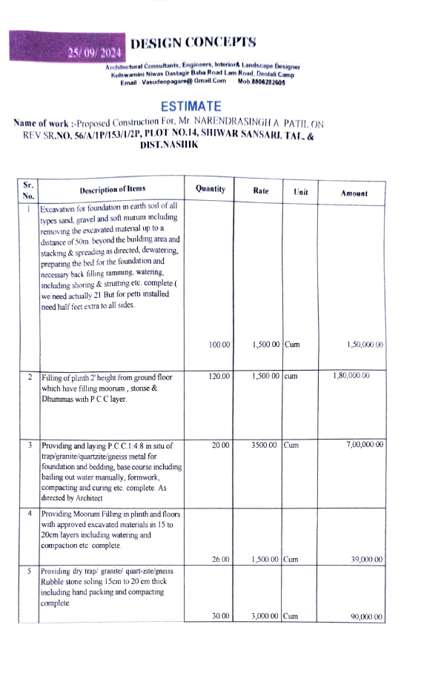
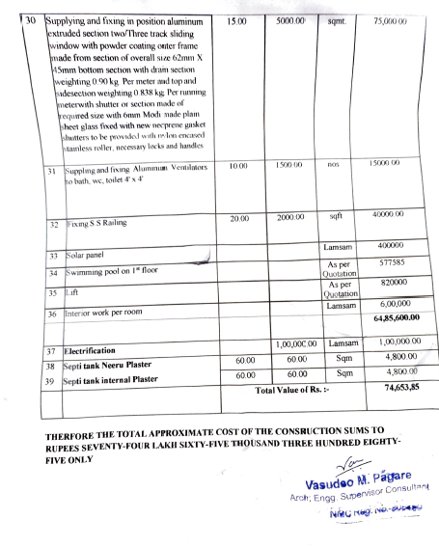

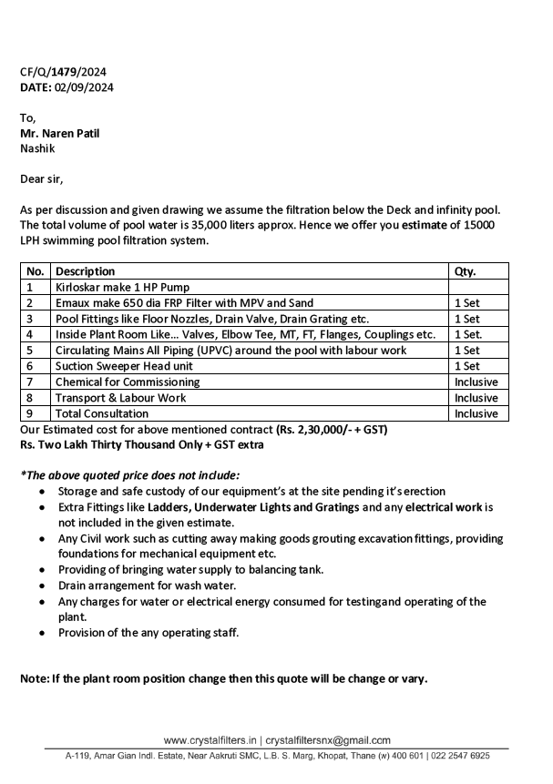
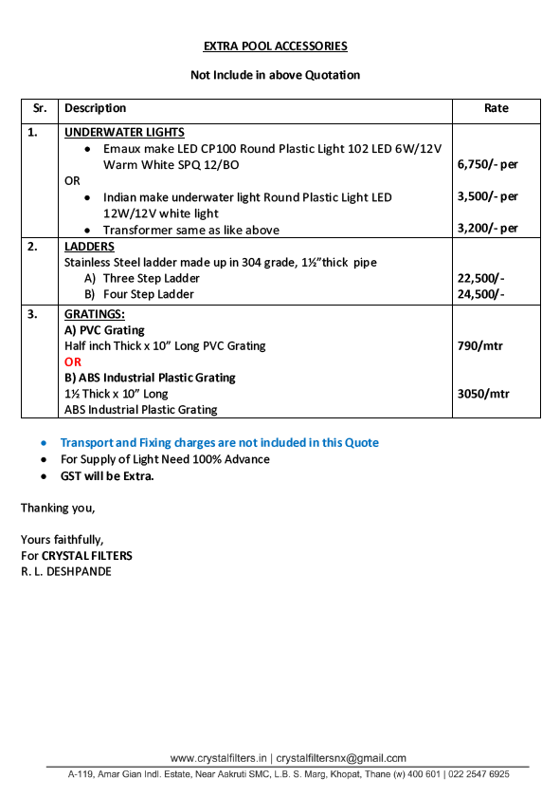

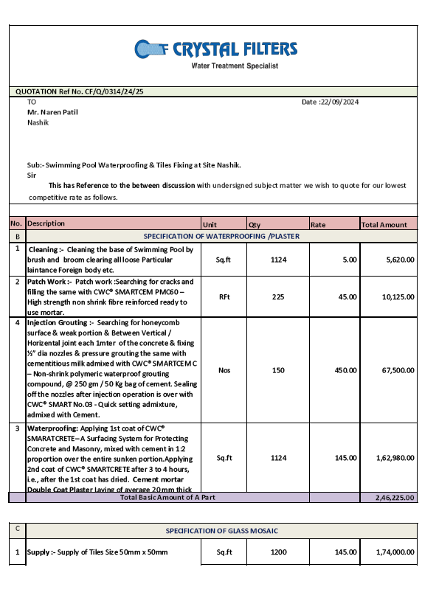
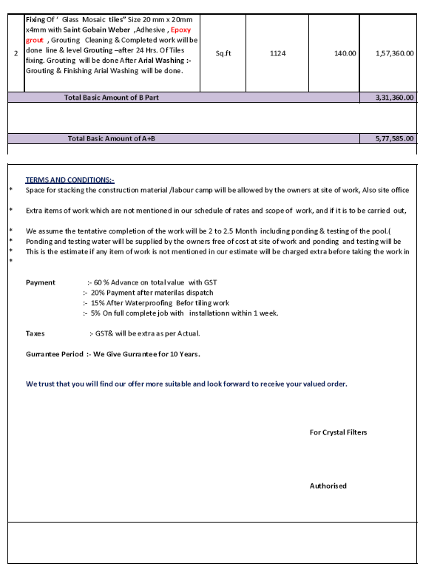

.

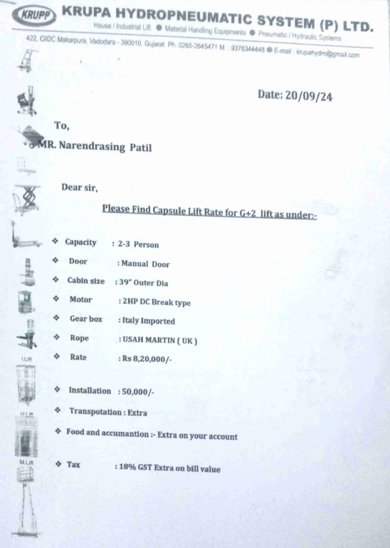
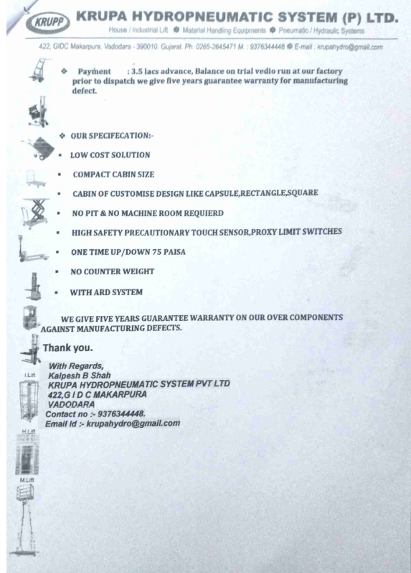

The Estimate amount is Rs.74,00,000/- (Rupees Seventy-Four Lakh Only)

