Vastu/Nashik/08/2024/010863/2307900
27/19-378-RPBS
Date: 30.09.2024

To, `
The Branch Manager,
State Bank of lndia
RACPC Nashik
1st Floor, Patel Plaza, N.D.Patel Road, Opp BSNL,
Landmark Seawoods Navratna Hotel Nashik-422001.

Sub: Vetting of Extra Amenities

Sir,

With reference to above subject, we have evaluated the Vetting of Extra Amenities Agreement for Residential Land and Bungalow on Plot No.15, Ground+ First Floor, Survey No.306/1/3/1, Near Rising Stars English Medium School, Jatra Nandur Link Road, Village – Adgaon , Taluka - Nashik, District - Nashik, PIN Code - 422 003,State - Maharashtra, Country - India belongs to Shri.Rajendra Annasaheb Gayakwad Name of Proposed Purchaser : Priyanka Rajendra Dusane.

We have verified the rates quoted as per current market rates. Details of work and Extra Amenities considered as per copy of Extra Amenities Agreement Between Shri.Ashok Dhundu Khairnar (First Party) Priyanka Rajendra Dusane (Second Party) received on dated 30.09.2024 The Vetting of Extra Amenities amount is Rs.11,70,000/- (Rupees Eleven Lakh Seventy Thousand Only)

The said Cost Vetting Certificate is valid upto next 6 months Only.

Thanking you

Sincerely yours

Manoj B. Chalikwar
Registered Valuer
Chartered Engineer (India)
Reg. No. CAT-I-F-1763
Reg. No. IBBI/RV/07/2018/10366
BOB Empanelment No.: ZO:MZ:ADV:46:941
Encl: Valuation report.
Vetting of Extra Amenities Agreement
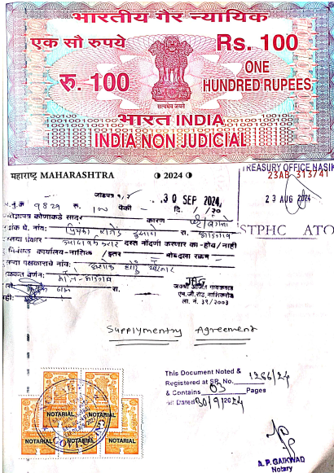
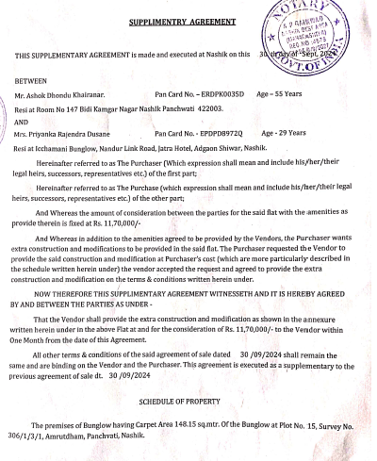

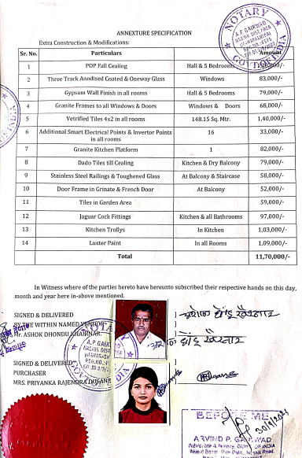
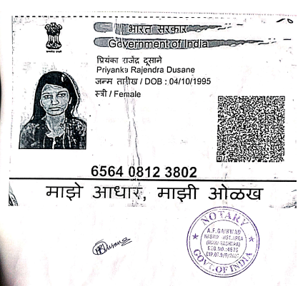

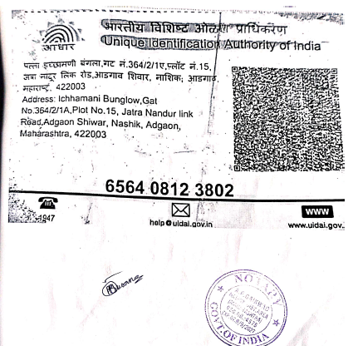
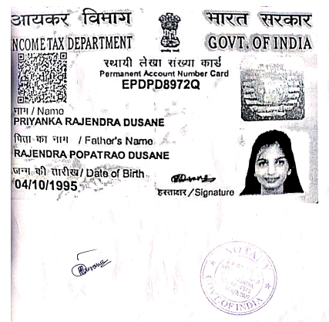

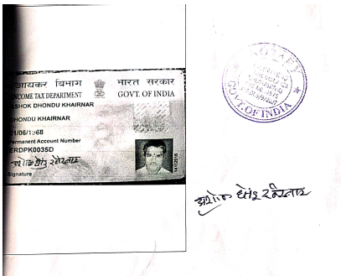
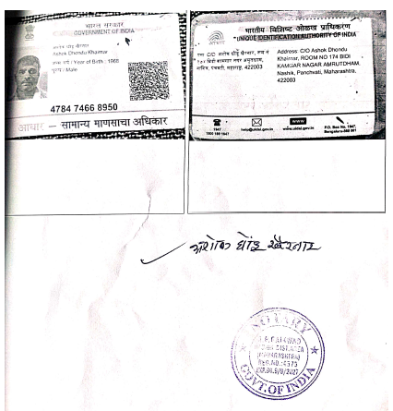

The Extra Amenities amount is Rs.11,70,000/- (Rupees Eleven Lakh Seventy Thousand Only)

