Valuation Report of the Immovable Property

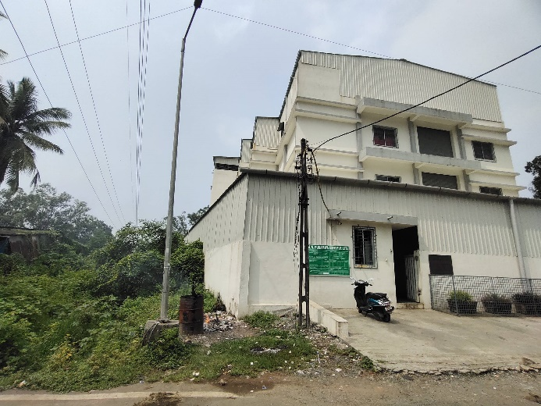

**Details of the property under consideration:**

Name of Owner: **M/s. Punamiya Exim Pvt. Ltd.**

**Industrial Land & Building** on Plot No. 828/A, Near Bharat Timber, **"GIDC Industrial Area",**

PO - Umbergaon, Taluka – Umbergaon, District – Valsad - 396171, State – Gujarat, Country – India

# Latitude Longitude - 20°10'32.7"N 72°46'33.6"E

# 

**Intended user:**

**Cosmos Bank**

**Borivali MRO A-2 Branch**

Shop No. 12 & 14, Mayfair, Ramdas Sutrale Marg, Opp. Chandawarkar Road,

Borivali (West), Mumbai - 400 092, State – Maharashtra, Country – India

Vastu/Mumbai/10/2024/011535/2308611

14/6-151-AU Date: 14.10.2024

# VALUATION OPINION REPORT

The property bearing Industrial Land & Building on Plot No. 828/A, Near Bharat Timber, "GIDC Industrial Area", P O - Umbergaon, Taluka – Umbergaon, District – Valsad - 396171, State – Gujarat, Country – India belongs to M/s. Punamiya Exim Pvt. Ltd.

|  |  |  |
| --- | --- | --- |
| **Boundaries of the property.** | | |
| North | : | Internal Road | |
| South | : | Plot No. C1 / 804 | |
| East | : | Plot No. C1 / 828 | |
| West | : | J Type shed and other units | |

Considering various parameters recorded, existing economic scenario, and the information that is available with reference to the development of neighborhood and method selected for valuation, we are of the opinion that, the property premises can be assessed and valued for banking purpose as below –

|  |  |
| --- | --- |
| **Particulars** | **Value (`)** |
| **Fair Market Value** | **2,68,17,790.00** |
| **Realizable Value** | **2,41,36,011.00** |
| **Distress Sale Value** | **2,14,54,232.00** |
| **Insurable value** | **1,51,36,783.00** |

The valuation of the property is based on the documents produced by the concern. Legal aspects have not been taken into considerations while preparing this valuation report.

Hence certified

## Manoj B. Chalikwar

Registered Valuer

Chartered Engineer (India)

Reg. No. IBBI / RV / 07/2018/10366

Reg. No. CAT-I-F-1763

Encl: Valuation report in Form – 01

Industrial Land & Building on Plot No. 828/A, Near Bharat Timber, **"GIDC Industrial Area"**,

P O - Umbergaon,Taluka – Umbergaon District – Valsad - 396171, State – Gujarat, Country – India

*Form 0-1*

*(See Rule 8 D)*

REPORT OF VALUATION OF IMMOVABLE PROPERTY (OTHER THAN AGRICULTURAL LANDS, PLANTATIONS, FORESTS, MINES AND QUARRIES)

GENERAL:

|  |  |  |  |
| --- | --- | --- | --- |
| 1 | Purpose for which the valuation is made | | To assess the Fair Market Value as on 14.10.2024 for Bank loan Purpose |
| 2 | Date of inspection | | 01.10.2024 |
|  | Name of the owner/ owners | | **M/s. Punamiya Exim Pvt. Ltd.** |
| 4 | If the property is under joint ownership / co-ownership, share of each such owner. Are the shares undivided? | | Pvt. Ltd. Co. Ownership |
| 5 | Brief description of the property | | Industrial Land & Building on Plot No. 828/A, Near Bharat Timber, **"GIDC Industrial Area"**, P O - Umbergaon, Taluka – Umbergaon District – Valsad - 396171, State – Gujarat, Country – India |
| 6 | Location, street, ward no | | GIDC Road |
| 7 | Survey/ Plot no. of land | | Plot No. 828 / A |
| 8 | Is the property situated in residential/ commercial/ mixed area/ industrial area? | | Industrial area |
| 9 | Classification of locality-high class/ middle class/poor class | | Middle Class |
| 10 | Proximity to civic amenities like schools, Hospitals, Offices, market, cinemas etc. | | All the amenities are available in the vicinity |
| 11 | Means and proximity to surface communication by which the locality is served | | Served by Buses and Private cars |
|  | *LAND* | |  |
| 12 | Area of land supported by documentary proof. Shape, dimension and physical features | | Plot area – 1,001.09 Sq. M.  (Area as per Approved Plan / Lease Deed) |
| 13 | Roads, Streets or lanes on which the land is abutting | | 16.00 M. wide road |
| 14 | If freehold or leasehold land | | Leasehold |
| 15 | If leasehold, the name of Lessor/lessee, nature of lease, date of commencement and termination of lease and terms of renewal of lease. | | Lessor – GIDC  Lessee - M/s. Punamiya Exim Pvt. Ltd.  For the period of 99 years commencing from 21.01.1984. Balance lease period is 59 years. |
| (i) Initial premium | | Details not available |
| (ii) Ground rent payable per annum | | Details not available |
| (iii) Unearned increase payable to the Lessor in the event of sale or transfer | | Details not available |
| 16 | Is there any restriction covenant in regard to use of land? If so attach a copy of the covenant. | | Industrial |
| 17 | Are there any agreements of easements? If so, attach a copy of the covenant | | Information not available |
| 18 | Does the land fall in an area included in any Town Planning Scheme or any Development Plan of Government or any statutory body? If so, give Particulars. | | GIDC |
| 19 | Has any contribution been made towards development or is any demand for such contribution still outstanding? | | Information not available |
| 20 | Has the whole or part of the land been notified for acquisition by government or any statutory body? Give date of the notification. | | No |
| 21 | Attach a dimensioned site plan | | Copy of Approved Plan dated 03.02.2022 issued by GIDC. |
|  | *IMPROVEMENT* | |  |
| 22 | Attach plans and elevations of all structures standing on the land and a lay-out plan. | | Copy of Approve Plan dated 03.02.2022 issued by GIDC. |
| 23 | Furnish technical details of the building on a separate sheet (The Annexure to this form may be used) | | Attached |
| 24 | Is the building owner occupied/tenanted/both? | | Owner Occupied |
|  | If the property owner occupied, specify portion and extent of area under owner-occupation | | Owner Occupied |
| 25 | What is the Floor Space Index permissible and Percentage actually utilized? | | As per Approved Plan   |  |  |  | | --- | --- | --- | | **Particulars** | **Permissible**  **F.S.I.** | **Consumed**  **F.S.I.** | | Plot No.828/A | 1396.63 Sq. M. | (1396.63/1001.09) = 1.395 | |
| 26 | *RENTS* | |  |
|  | (i) | Names of tenants/ lessees/ licensees, etc. | N.A. |
|  | (ii) | Portions in their occupation | N.A. |
|  | (iii) | Monthly or annual rent/ compensation / license fee, etc. paid by each | N.A. |
|  | (iv) | Information not available | N.A. |
| 27 | Are any of the occupants related to, or close to business associates of the owner? | | N.A. |
| 28 | Is separate amount being recovered for the use of fixtures, like fans, geysers, refrigerators, cooking ranges, built-in wardrobes, etc. or for services charges? If so, give details | | N.A. |
| 29 | Give details of the water and electricity charges, if any, to be borne by the owner | | Information not available |
| 30 | Has the tenant to bear the whole or part of the cost repairs and maintenance? Give particulars | | N.A. |
| 31 | If a lift is installed, who is to bear the cost of maintenance and operation- owner or tenant? | | N.A. |
| 32 | If a pump is installed, who is to bear the cost of maintenance and operation- owner or tenant? | | N.A. |
| 33 | Who has to bear the cost of electricity charges for lighting of common space like entrance hall, stairs, passage, compound, etc. owner or tenant? | | N.A. |
| 34 | What is the amount of property tax? Who is to bear it? Give details with documentary proof | | Information not available |
| 35 | Is the building insured? If so, give the policy no., amount for which it is insured and the annual premium | | Information not available |
| 36 | Is any dispute between landlord and tenant regarding rent pending in a court of rent? | | N.A. |
| 37 | Has any standard rent been fixed for the premises under any law relating to the control of rent? | | As per G.I.D.C. norms |
|  | *SALES* | |  |
| 38 | Give instances of sales of immovable property in the locality on a separate sheet, indicating the Name and address of the property, registration No., sale price and area of land sold. | | As per sub registrar of assurance |
| 39 | Land rate adopted in this valuation | | ` 8,000.00 Per Sq. M. |
| 40 | If sale instances are not available or not relied up on, the basis of arriving at the land rate | | Online Price Indicators, Location, development of surrounding area, type of land and construction, construction specifications, age of building, condition of the premises & building, facilities provided and its prevailing market rate. |
|  | *COST OF CONSTRUCTION* | |  |
| 41 | Year of commencement of construction and year of completion | | |  |  | | --- | --- | | **Items** | **Year Of Const.** | | **RCC Factory Building** |  | | Ground Floor | 2022 | | First Floor | 2022 | | **Security Cabin** | 2022 |   (As per Approved Plan) |
| 42 | What was the method of construction, by contract / By employing Labour directly / both? | | Information Not available |
| 43 | For items of work done on contract, produce copies of agreements | | Information Not available |
| 44 | For items of work done by engaging Labour directly, give basic rates of materials and Labour supported by documentary proof. | | Information Not available |

*PART II- VALUATION*

GENERAL:

Under the instruction of Cosmos Bank, Borivali MRO A – 2, to assess fair market value as on **14th October 2024** for Industrial Land & Building on Plot No. 828/A, Near Bharat Timber, **"GIDC Industrial Area"**, P O - Umbergaon, Taluka – Umbergaon District – Valsad - 396171, State – Gujarat, Country – India belongs to **M/s. Punamiya Exim Pvt. Ltd.**

We are in receipt of the following documents:

|  |  |
| --- | --- |
|  | Copy of Final Agreement for Sale dated 21.07.2023 (Notary) between M/s. Bajj Infra (Vendor) and M/s. Punamiya Exim Pvt. Ltd. (Purchaser). |
|  | Copy of Lease Deed dated 17.08.2023 between GIDC (Lessor) and M/s. Punamiya Exim Pvt. Ltd. (Lessee). |
|  | Copy of Digital Approved Plan dated 03.02.2022 issued by GIDC. |
|  | Copy of Approval Letter for Plan vide No. GIDC / XEN / VA / 001175 dated 16.02.2022 issued by GIDC. |
|  | Copy of Udyam Registration Certificate dated 17.06.2023 issued by Ministry of Micro, Small and Medium Enterprises, Government of India |
|  | Copy of Electricity Bill dated 19.09.2024, Consumer No. 05701074099 |

**Land:**

The plot under valuation is leasehold industrial plot of GIDC. It is on lease for the period of 99 years commencing from 21.01.1984. Balance lease period is 60 years. It is at 4.1 KM. travel distance from Umbergaon Railway station.

**As per Approved Plan & Lease Deed the Plot area is 1,001.09 Sq. M. which is considered for valuation.**

**Structure:**

As per actual site, there is Ground + 2 upper floor factory building. It is a R.C.C. Framed Structure.

|  |  |  |  |
| --- | --- | --- | --- |
| **Particulars** | **Approx. Height**  **In M.** | **Composition** | **Carpet area as per site measurement**  **(Sq. M.)** |
| **Factory building** |  |  |  |
| Ground Floor | 4.88 | Working area + Lab + Admin Building + File Room + Printing area | 5,310.00 |
| Mezzanine at ground |  |  | 524.74 |
| First Floor | 4.27 | Working area + Washroom | 5,310.00 |
| Second Floor | 4.27 | Working area + Guest room | 5,310.00 |
| Toilet | 2.12 |  | 72.00 |
| Security Cabin | 2.12 |  | 53.55 |

The factory is finished partly Kota Stone tiles flooring and Partly Plain Cement flooring. 6" thick B. B. Masonry internal walls with cement plastering. Amenities such as Power coated sliding windows, Glass Wooden frame door with M. S. Rolling Shutter, partly industrial and Partly Concealed type Wiring and plumbing.

**As per Approved Plan, the construction area as under and considered for valuation –**

|  |  |
| --- | --- |
| Particulars | Built up Area in Sq. M. |
| Factory building – Ground + 2 upper floors | 1,478.79 |
| Security cabin | 6.25 |

**Valuation as on 14th October 2024:**

1. **Land Valuation**

|  |  |  |  |
| --- | --- | --- | --- |
| **Particulars** | **Area in Sq. M.** | **Rate per Sq. M.** | **Value in `** |
| Plot No. 828/A | 1,001.09 | 9,000.00 | 90,09,810.00 |
| **Total** | | | **90,09,810.00** |

1. **Valuation of Structures.**

The Built-up area of the building : As per valuation table below

**Deduct Depreciation:**

Year of Construction of the building : As mentioned below

Expected total life of building : As mentioned below

Age of the building as on 2024 : As mentioned below

|  |  |  |  |
| --- | --- | --- | --- |
| **Particulars** | **Year of Construction** | **Expected total life of building** | **Age of the building as on 2024** |
| Factory building – Ground + 2 upper floors | 2022 | 58 Years | 2 Years |
| Security cabin | 2022 | 58 Years | 2 Years |

Cost of Construction : As per valuation table below

Depreciation : As per valuation table below

Amount of depreciation : As per valuation table below

**Depreciated cost of construction** : As per valuation table below

|  |  |  |  |  |
| --- | --- | --- | --- | --- |
| **Particulars** | **Built up Area in**  **Sq. M.** | **Estimated Replacement Rate in `** | **Depreciated Replacement Rate in `** | **Depreciated Replacement Value in `** |
| Factory building – Ground + 2 upper floors | 1,478.79 | 12,000.00 | Nil | 1,77,45,480.00 |
| Security cabin | 6.25 | 10,000.00 | Nil | 62,500.00 |
| **Total** |  |  | **TOTAL** | **1,78,07,980.00** |

**GUIDELINE VALUE:**

|  |  |
| --- | --- |
| G.I.D.C. Circle Rate for Land per Sq. M. | ` 1,990.00 |

|  |  |
| --- | --- |
| **Particulars** | **Value (`)** |
| **Plot area** | 1,001.09 |
| **Rate per Sq. M.** | 1,990.00 |
| **Land Value** | **19,92,169.00** |
| **Building Value** (As per valuation table) | **1,78,07,980.00** |
| **TOTAL** | **1,98,00,149.00** |

**TOTAL VALUE OF THE PROPERTY:**

|  |  |
| --- | --- |
| **Particulars** | **Value (`)** |
| **Land** | **90,09,810.00** |
| **Buildings** | **1,78,07,980.00** |
| **Fair Market Value** | **2,68,17,790.00** |
| **Realizable Value** | **2,41,36,011.00** |
| **Distress Sale Value** | **2,14,54,232.00** |
| **Insuranble Value** | **1,51,36,783.00** |

Taking into consideration above said facts, we can evaluate the value of Industrial Land & Building on Plot No. 828/A, Near Bharat Timber, **"GIDC Industrial Area"**, P O - Umbergaon, Taluka – Umbergaon District – Valsad - 396171, State – Gujarat, Country – India for this particular purpose at **` 2,68,17,790.00 (Amount in words Rupees Two Crore Sixty Eight Lakh Seventeen Thousand Seven Hundred Ninety Only)** as on **14th October 2024.**

**NOTES**

1. I, Manoj B. Chalikwar with my experience and ability to judgment I am of the considered opinion that the fair market value of the property as on 14th October 2024 is ` 2,68,17,790.00 (Amount in words Rupees Two Crore Sixty Eight Lakh Seventeen Thousand Seven Hundred Ninety Only).
2. Value varies with time and purpose and hence this value should not be referred for any purpose other than mentioned in this report.
3. This valuation is done on the basis of information, which the valuer has obtained by information provided by the client about the premises and location of the surrounding area and also prevailing rates in the surrounding area, and further subject to document as mentioned in valuation report.
4. This valuer should not be held responsible for authentication of documents, clear title and other such related matters. For that purpose, Latest Legal Opinion should be sought.

*PART III- DECLARATION*

I hereby declare that

* + 1. The information furnished in part I is true and correct to the best of my knowledge and belief;
    2. I have no direct or indirect interest in the property valued:

ANNEXURE TO FORM 0-1

Technical details Main Building

|  |  |  |
| --- | --- | --- |
| 1. | No. of floors and height of each floor | As per brief description |
| 2. | Plinth area floor wise as per IS- 1225 | Plot Area = 1,001.09 Sq. M.  Structure - As per valuation table |
| 3 | Year of construction | Year - 2022  (As per Approved Plan) |
| 4 | Estimated future life | 59 Years Subject to proper, preventive periodic maintenance and structural repairs. |
| 5 | Type of construction- load bearing walls/RCC frame/ steel frame | As per brief description |
| 6 | Type of foundations | R.C.C. with AC sheet roofing |
| 7 | Walls | All external walls are 9” thick and partition walls are 6” thick. |
| 8 | Partitions | 6” thick brick wall |
| 9 | Doors and Windows | As per brief description |
| 10 | Flooring | As per brief description |
| 11 | Finishing | Internal walls are finished with Neeru Finish. External walls are finished with sand faced plaster. |
| 12 | Roofing and terracing | RCC slabs and A.C. sheet roofing on top |
| 13 | Special architectural or decorative features, if any | No |
| 14 | |  |  | | --- | --- | | (i) | Internal wiring – surface or conduit | | (ii) | Class of fittings: Superior/ Ordinary/ Poor. | | Partly Concealed wiring and Partly Open Industrial type wiring  Ordinary |
| 15 | Sanitary installations   |  |  | | --- | --- | | (i) | No. of water closets | | (ii) | No. of lavatory basins | | (iii) | No. of urinals | | (iv) | No. of sinks |   Class of fittings: Superior colored / superior white/ordinary. | As per requirement having ordinary class of fitting |
| 16 | Compound wall  Height and length  Type of construction | Compound wall of R.C.C. columns with Brick Masonry wall |
| 17 | No. of lifts and capacity | No Lift |
| 18 | Underground sump – capacity and type of construction | R.C.C. |
| 19 | Over-head tank Location, capacity Type of construction | R.C.C. |
| 20 | Pumps- no. and their horse power | Provided as per requirement |
| 21 | Roads and paving within the compound approximate area and type of paving | Concrete cement finish in open spaces, etc. |
| 22 | Sewage disposal – whereas connected to public sewers, if septic tanks provided, no. and capacity | Connected to G.I.D.C. sewer line |
| 23 | General Remarks |  |
|  | *For the purpose of valuation, we have considered the Plot area and constructed area as per Approved Plan.* | |

**Actual site photographs**

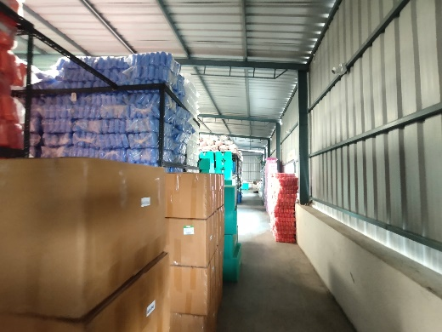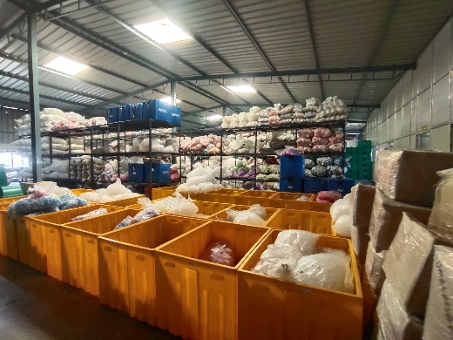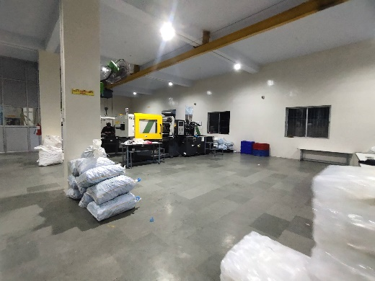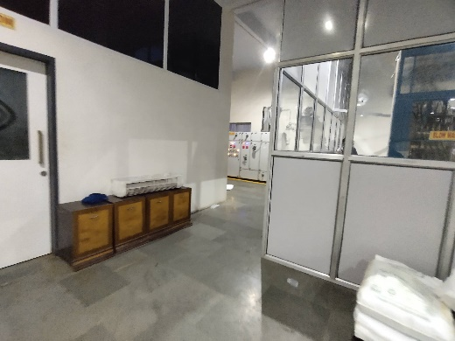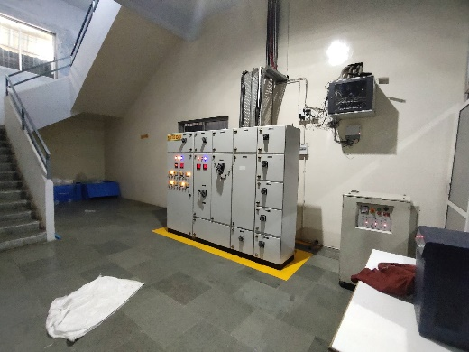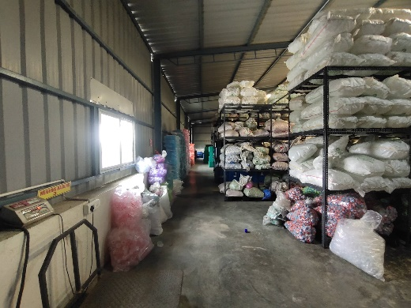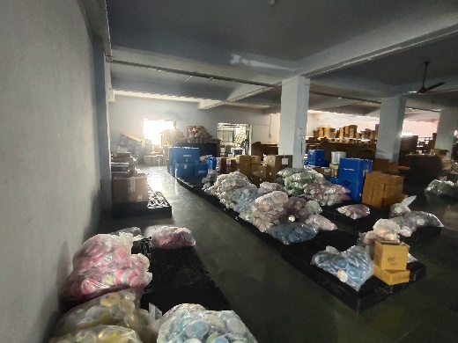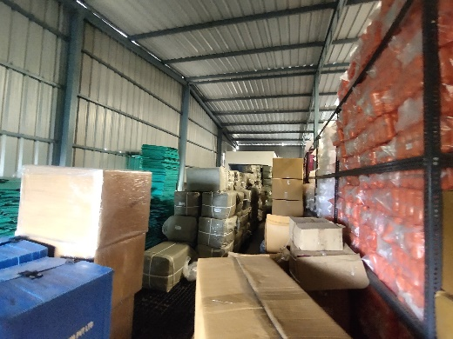

**Actual site photographs**

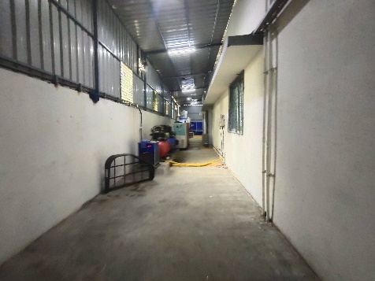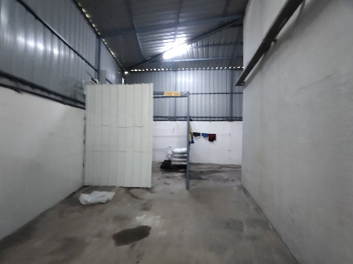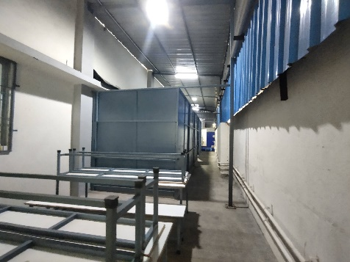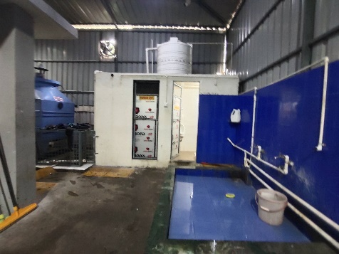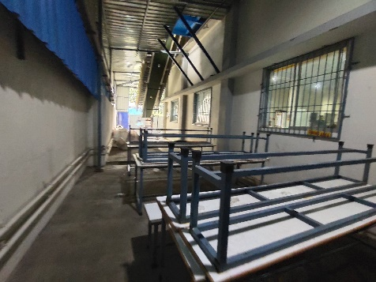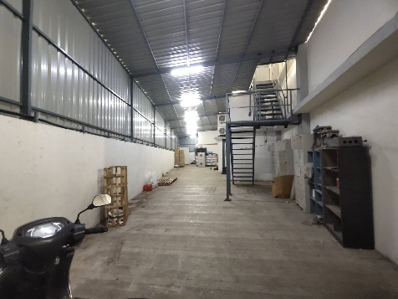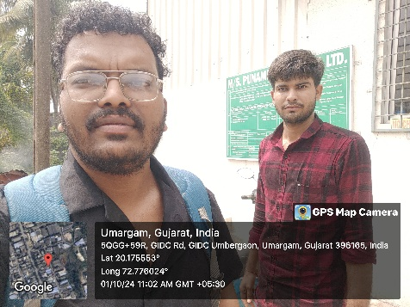

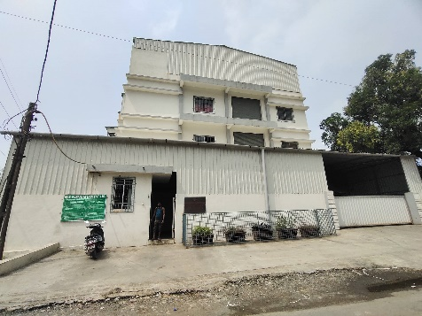

**Route Map of the property**

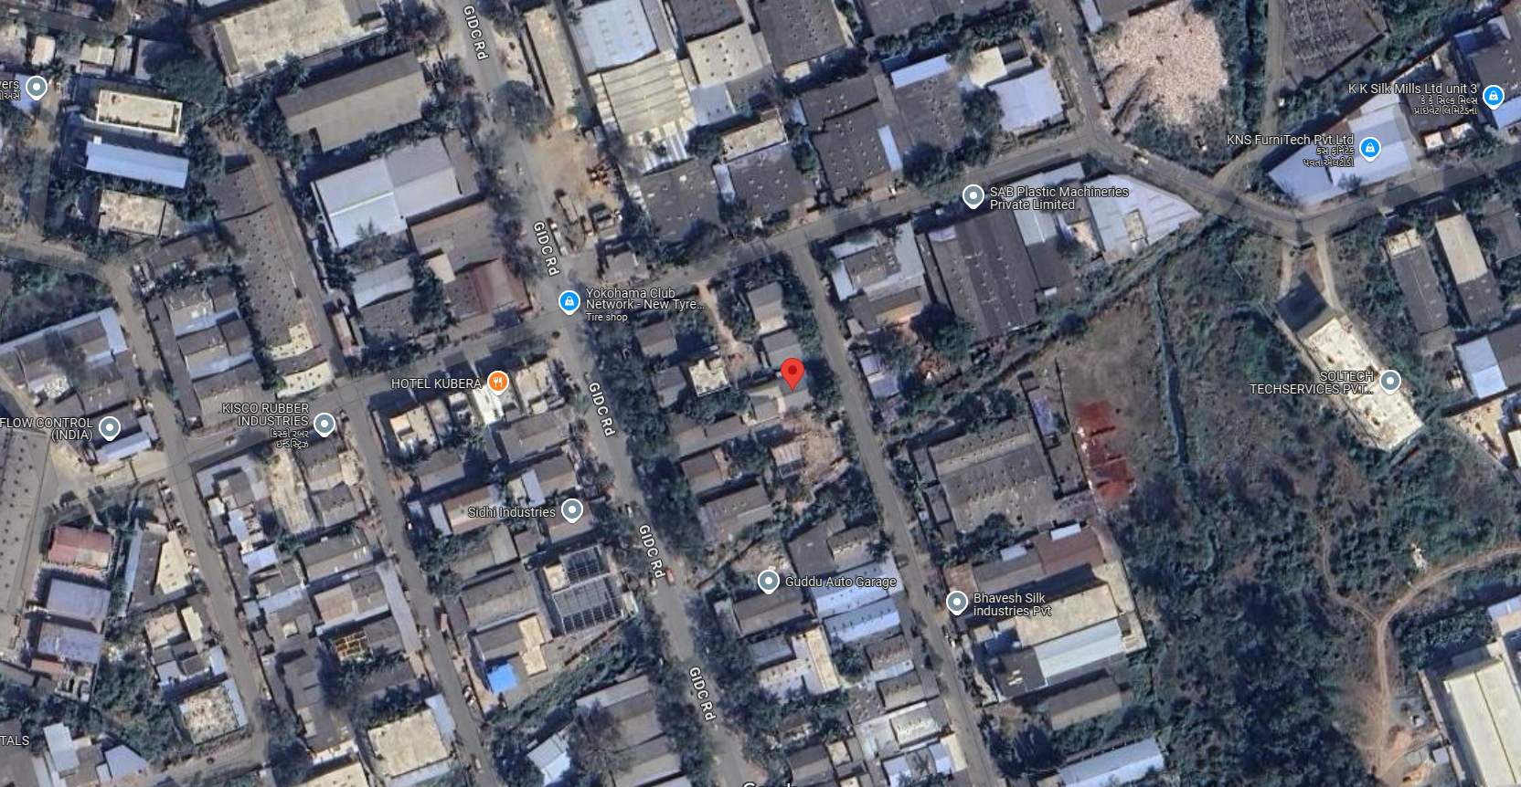**Site u/r**

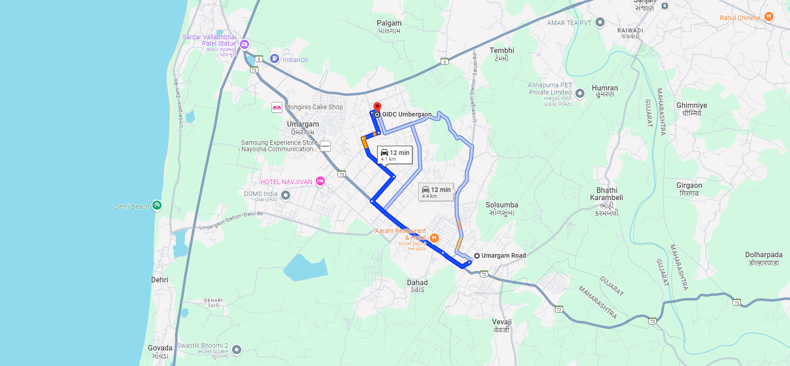

# Latitude Longitude - 20°10'32.7"N 72°46'33.6"E

**Note:** The Blue line shows the route to site from nearest Railway Station (Umbergaon – 4.1 KM.)

**G.I.D.C. CIRCLE RATE**

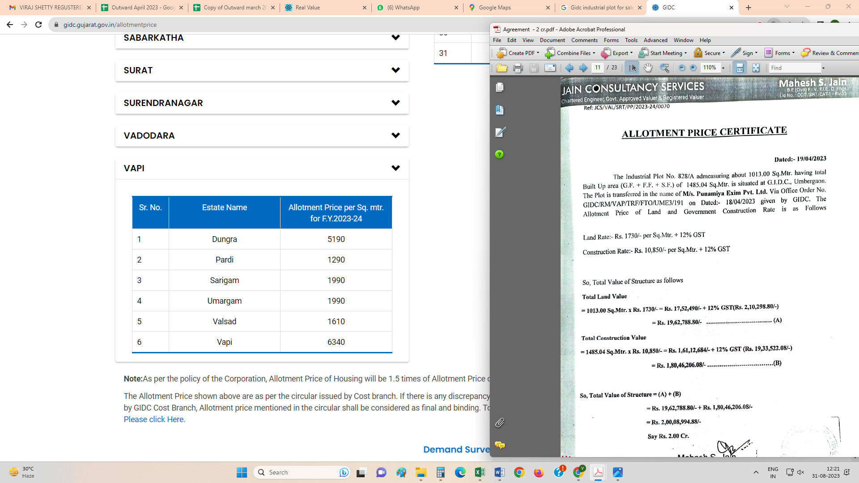

**Price Indicators**

|  |  |  |
| --- | --- | --- |
| **Property** | Industrial Land | |
| **Source** | https://www.RealEstateIndia.com/ | |
| **Particulars** | **Area in Sq. M.** | **Rate per Sq. M.** |
| Industrial Land | 4,610.00 | `13,000.00 |

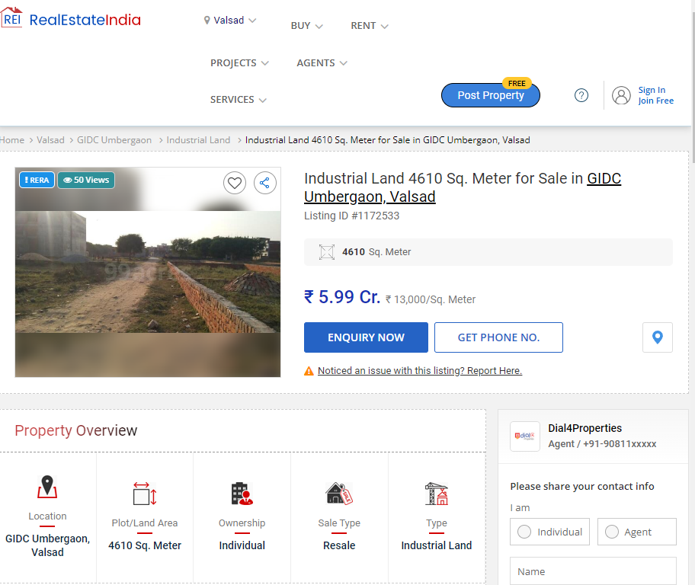

**Price Indicators**

|  |  |  |
| --- | --- | --- |
| **Property** | Industrial Land | |
| **Source** | https://www.RealEstateIndia.com/ | |
| **Particulars** | **Area in Sq. M.** | **Rate per Sq. M.** |
| Industrial Land | 11,453.00 | ` 6,456.00 |

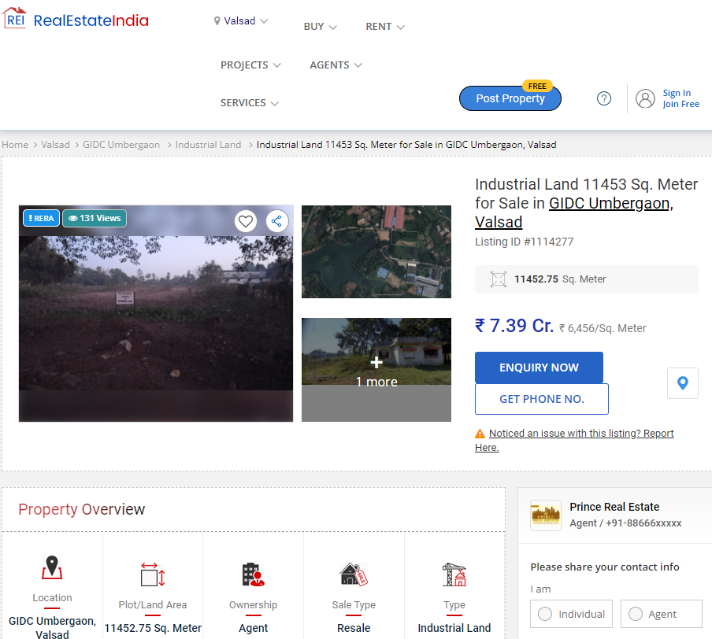

**DEFINITION OF VALUE FOR THIS SPECIFIC PURPOSE**

This exercise is to assess **Fair Market Value** of the property under reference as on **14th October 2024.**

The term **Fair Market Value** is defined as

*“The most probable price, as of a specified date, in cash, terms equivalent to cash, or in other precisely revealed terms for which the specified property rights would sell after reasonable exposure in a competitive market under all conditions requisite to a fair sale, with the buyer and seller each acting prudently knowledgeably and for self-interest assuming that neither is under undue duress”.*

Fundamental assumptions and conditions presumed in this definition are:

1. Buyer and seller are motivated by self-interest.

2. Buyer and seller are well informed and are acting prudently.

3. The property is exposed for a reasonable time on the open market.

4. Payment is made in cash or equivalent or in specified financing terms.

#### UNDER LYING ASSUMPTIONS

1. We assume no responsibility for matters of legal nature affecting the property appraised or the title thereto, nor do we render our opinion as to the title, which is assumed to be good and marketable.

2. The property is valued as though under responsible ownership.

3. It is assumed that the property is free of liens and encumbrances.

4. It is assumed that there are no hidden or unapparent conditions of the subsoil or structure that would render it more or less valuable. No responsibility is assumed for such conditions or for engineering that might be required to discover such factors.

5. There is no direct/ indirect interest in the property valued

6. The rates for valuation of the property are in accordance with the Govt. approved rates and prevailing market rates.

## Manoj B. Chalikwar

Registered Valuer

Chartered Engineer (India)

Reg. No. IBBI / RV / 07/2018/10366

Reg. No. CAT-I-F-1763